Supppose we have a data which contains numbers with suffix DR and CR.
It would be difficult to analyse the data in such format.
But wait I have come up with very easy solution which can be used to clean the data therefore making analysing easily.
Suppose we have a data of Trade receivables where DR will depicit a positive balance ad CR will depicit a negative balance and we want to remove the suffix. Please refer the below steps:

- Remove all the DR suffix:
- Select the data and press CTRL +H Replace dialog box will appear , In box Find what write dr and in Replace box keep blank.
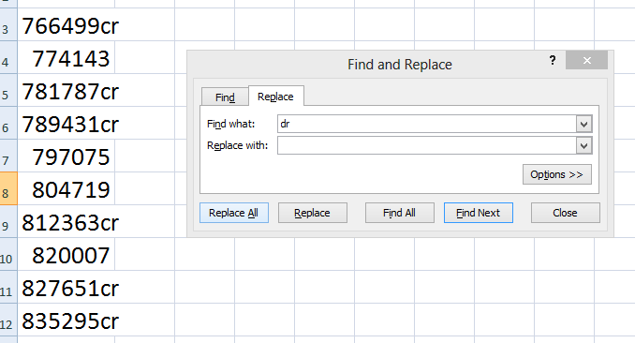

- Press Replace All.
Result will be as follows:

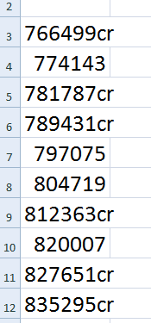
We can see all Dr suffix has been removed.

2) We will replace all CR suffix with a – sign
- Select the data and press CTRL +H Replace dialog box will appear , In box Find what write CR and in Replace box give – sign.
Result would be as follows:
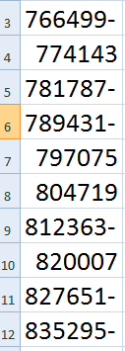
Step 3: Replace – and turn it in a negative number
- Select the data
- Go to Data tab
- Go to Text to column tab
Shorcut: Alt + A+E

Following dialog box will appear:
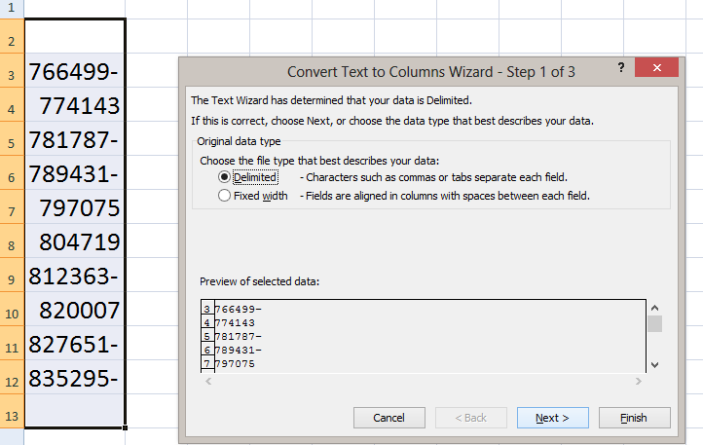

- Click on Next.
Following dialog box will appear:

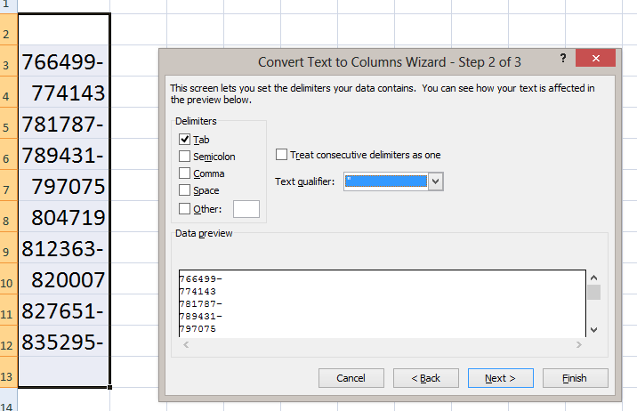

- Click on Next.
Following box will appear
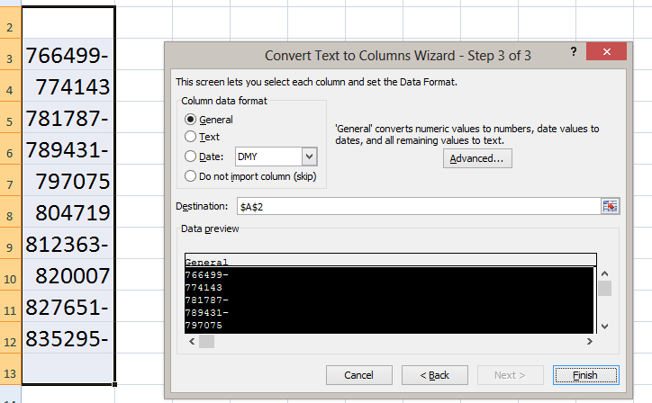

- Click on Finish
And the Solution will appear as follows:

