Have you heard about Horizontal Sorting (Sort Left to right)??
Sometime data demands us to re arrange the Columns from Left to Right , then instead of using cut and Paste we can do horizontal sorting and do smart work.
Refer the following steps:
Data TabSortOptionsIf your data has header check the option given Sort Left to Right

Shortcut - ALT-A-S
Demo
First of all give serial number as per sorting requirement. Like in given data Country name should be the first column so number given is 1, then client name should be in second column and so on. Refer below
Note: Giving such number also helps you to know the original arrangement

Then select the data, go to options as given below:
Option Dialog box will appear as follows:
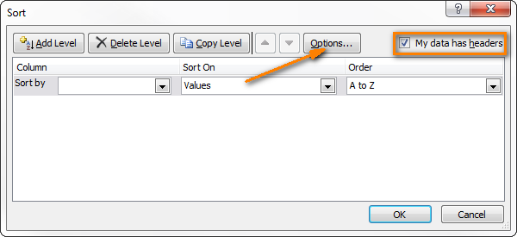
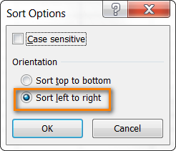
Click on OK.

Output

