Recovery of Files & folders in USB / Pen drive from Hidden Mode

Now a days we professionals, students and officials are facing the problem of data corruption from USB drive due to malware or back dated software issue. We use USB drive to store data. But the problems arise when you prepare some project in home for presentation and when you use it in your work place whole folders and files are not showing properly. But if you notice its properties option it shows that the USB drive has still your data. If go to search option and type the name of your file you easily get it.
But the main issue when you have more files then you can’t recognize the exact files and folders. Generally in some programs your files became hidden. So you need to unhide the options.
The processes are:
In Desktop click
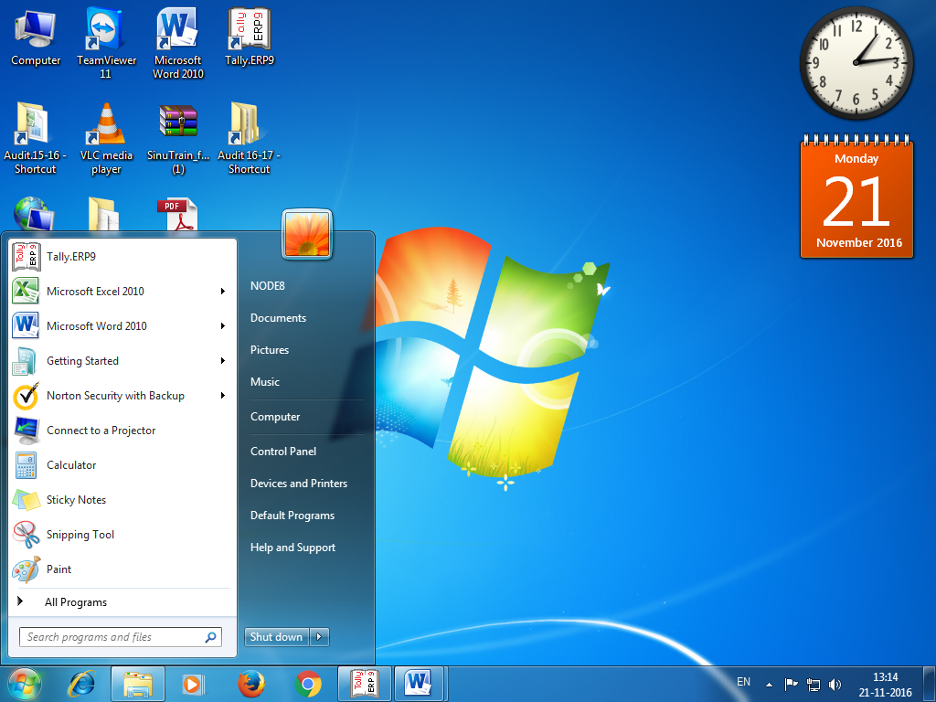
Type “Run”
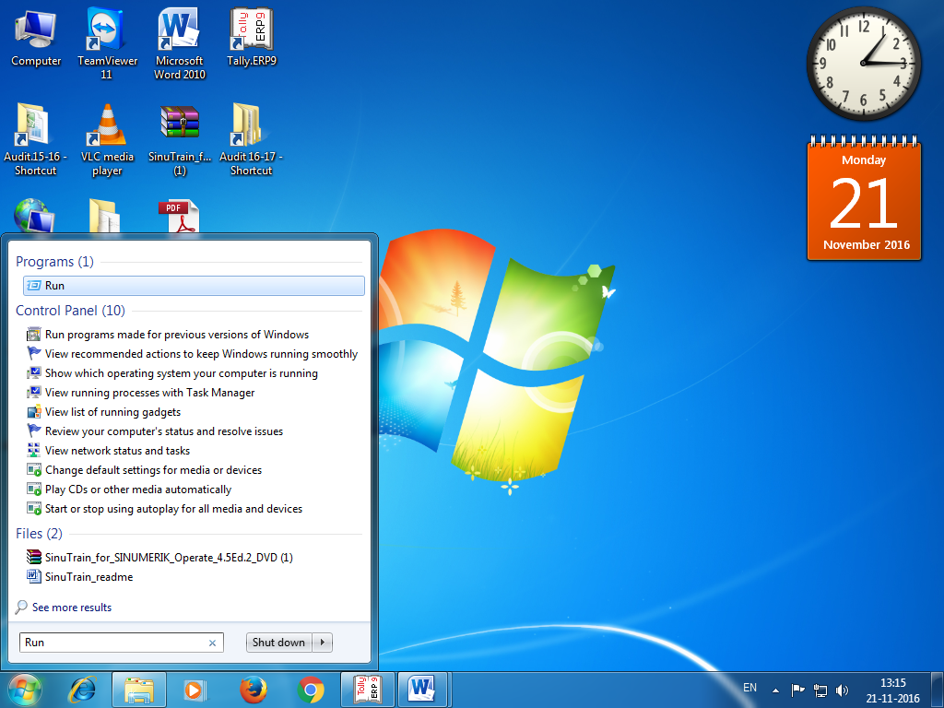
Press enter key, a window will open
Type again cmd
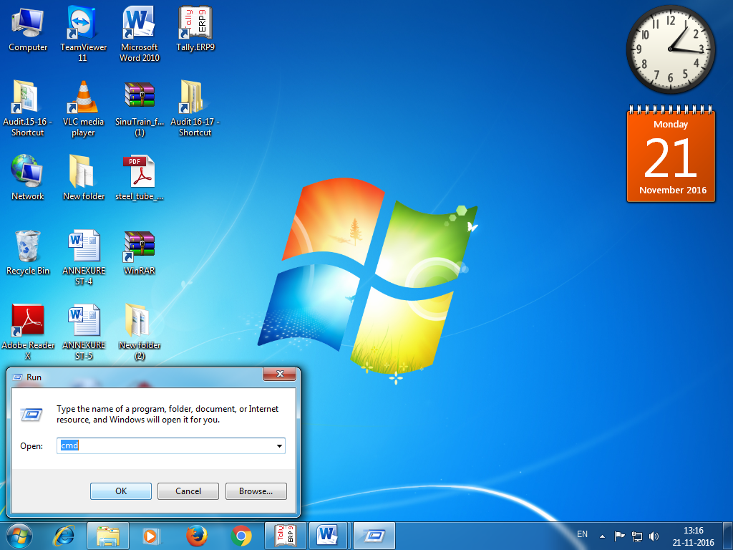
Command Prompt box will open
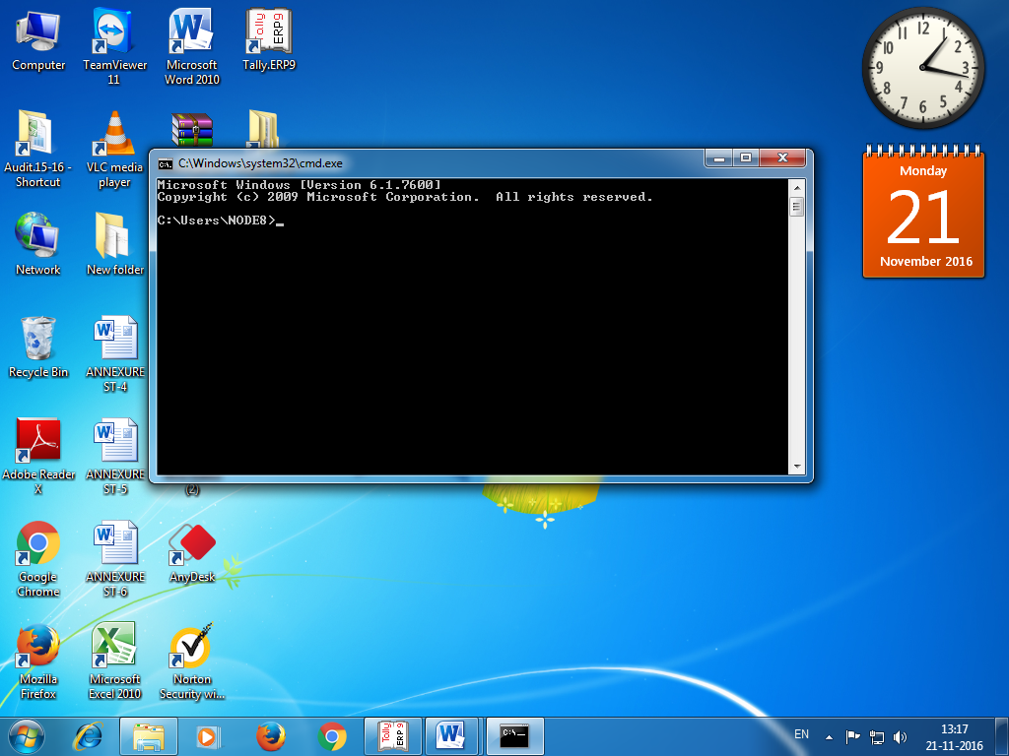
Now assume your pen drive letter as H:
Type this command.
attrib -h -r -s /s /d h:\*.*
Press Enter by replacing your USB / Pen drive letter by g.
Now check your pen drive for the files & folders.

