Encrypting ZIP file without any Software
Encryption is a process in which one can apply password to his file (excel/word/PDF/Zip/other formats) and then that particular file can be viewed /accessed only if user have password for that particular encrypted file.
Below steps help us to encrypt any ZIP (compressed) file without use of any software.
Please follow below step to encrypt your file:
Right Click on any file (whether word/excel/notepad etc) that you want to ZIP/Compress/Select Zip or 7-Zip option/Select Add to archive.
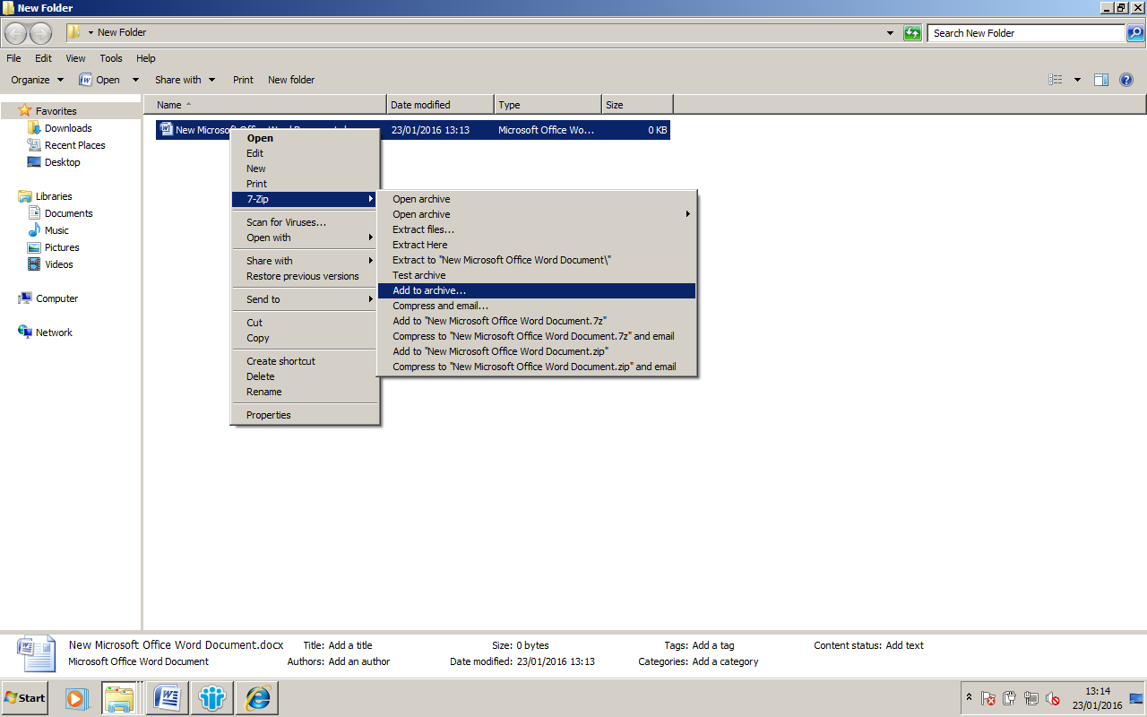

Enter password. Re-enter same password as per below screen-shot.
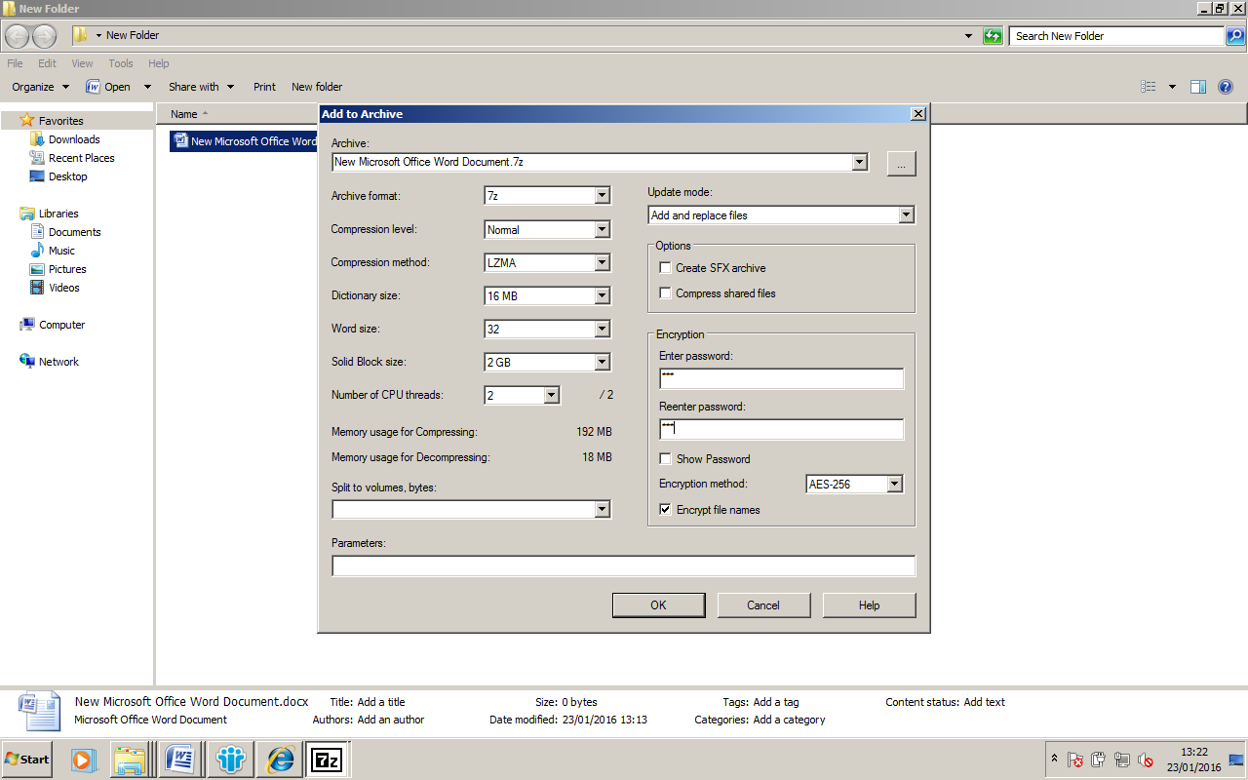
So next time when you will try to extract the file, windows will prompt for password. On entering valid password only, file(s) can be extracted.
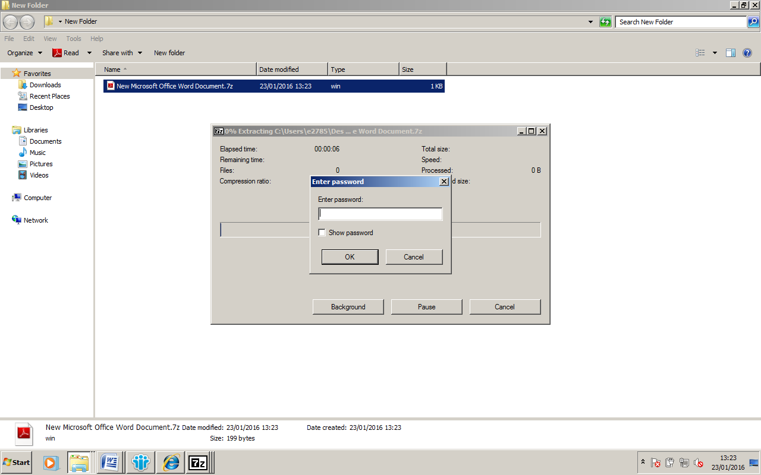

Please provide your suggestions/queries at hemangdoshi99@yahoo.co.in
Prepared by: CA Hemang Doshi, CISA

