Encrypting Excel file without any Software
Encryption is a process in which one can apply password to his file (excel/word/PDF/Zip/other formats) and then that particular file can be viewed /accessed only if user have password for that particular encrypted file.
Below steps help us to encrypt any Excel file without use of any software. Please note that encrypting a excel file is different from ‘Protect Sheet’ option available in ‘Review’ Tab. In case of ‘Protect Sheet’ option, though editing rights are restricted, however content of the file can be viewed by any one. Using ‘Encrypt Document ‘option one can protect the content of the file itself from unauthorized view/access.
Please follow below step to encrypt your Excel file:

G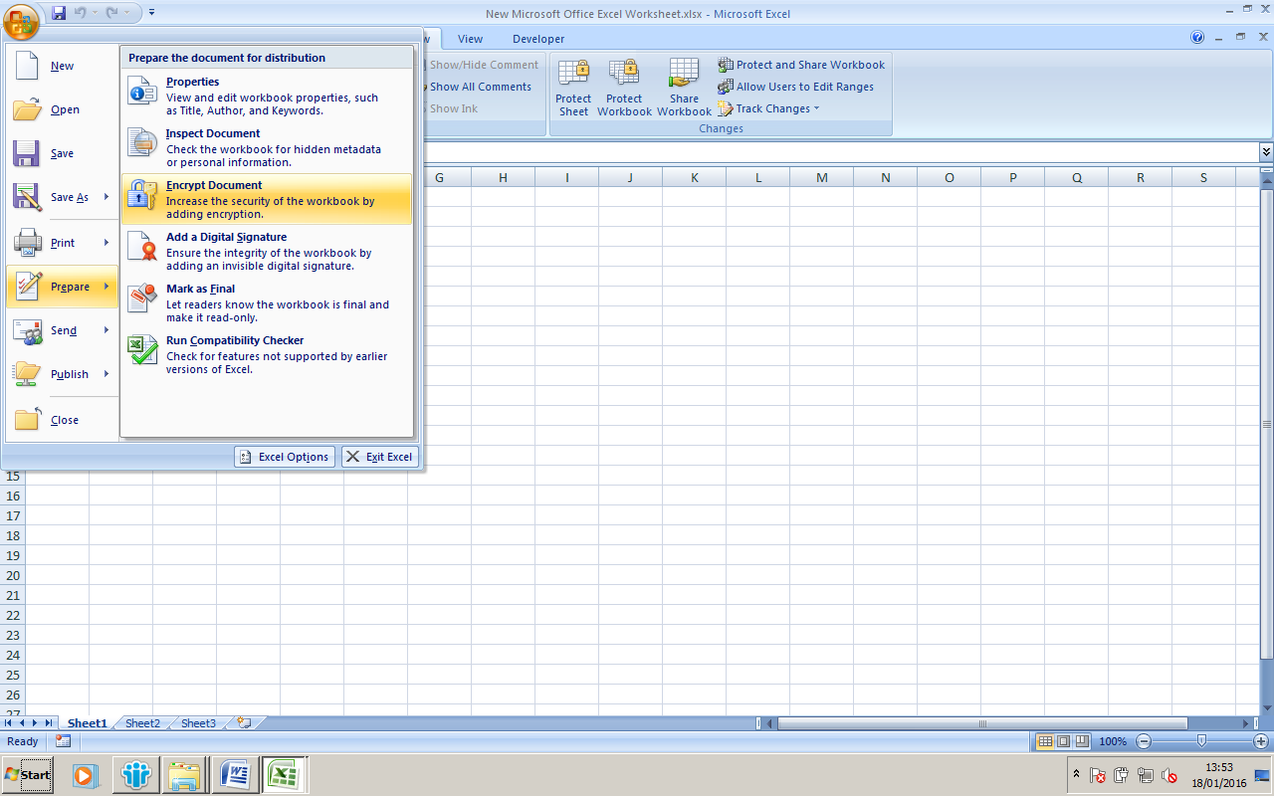
Go to Office Button/Prepare/Encrypt Document option.

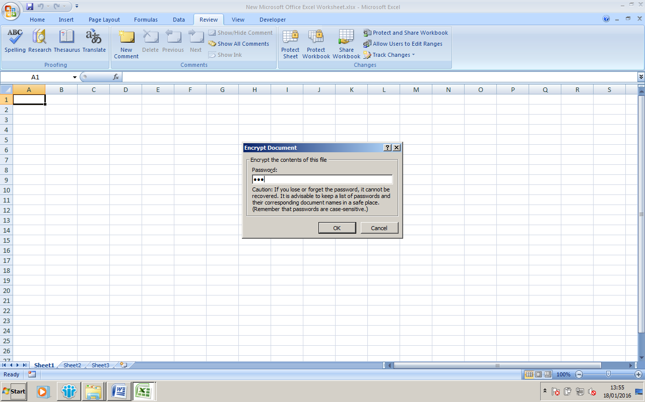

Window will prompt for Password as per above screen Shot. Enter your desire password and press OK tab.

It will again prompt for re-enter password. Re-enter same password, press OK tab and save file.

Next time when you will open that particular file, it will ask for password to open the file. Please note that you cannot view the file without valid password.

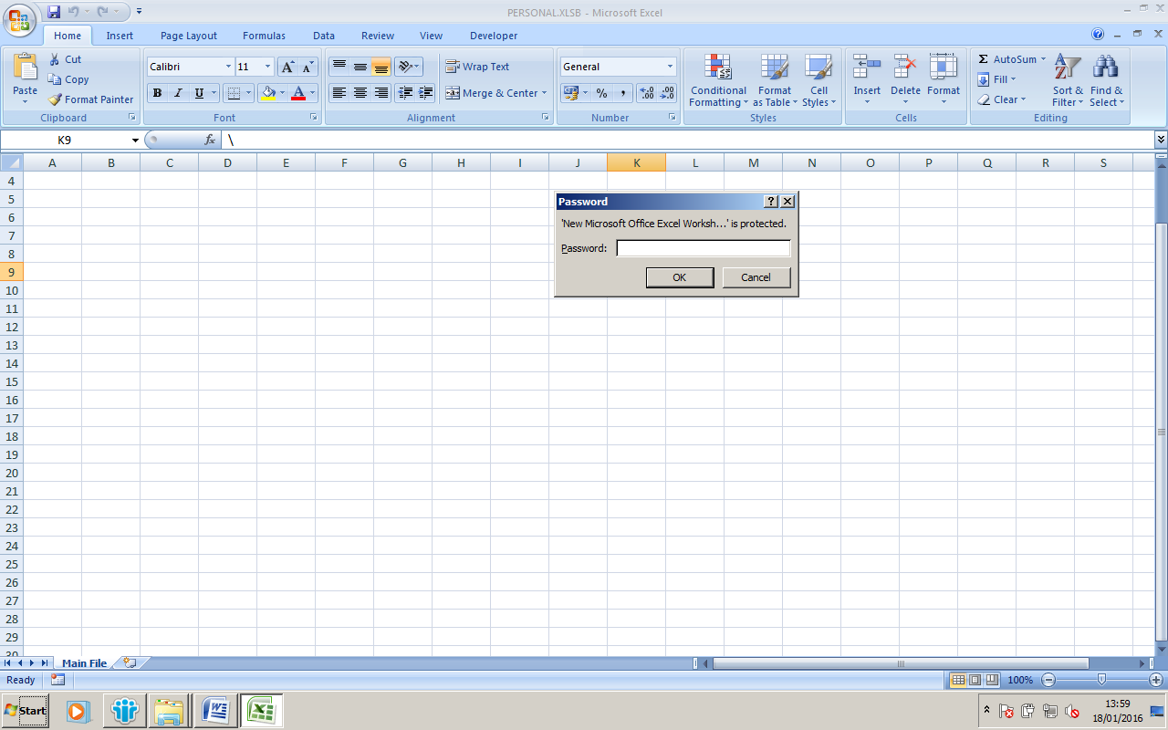
Please provide your suggestions/queried at hemangdoshi99@yahoo.co.in
Prepared by: CA Hemang Doshi, CISA

