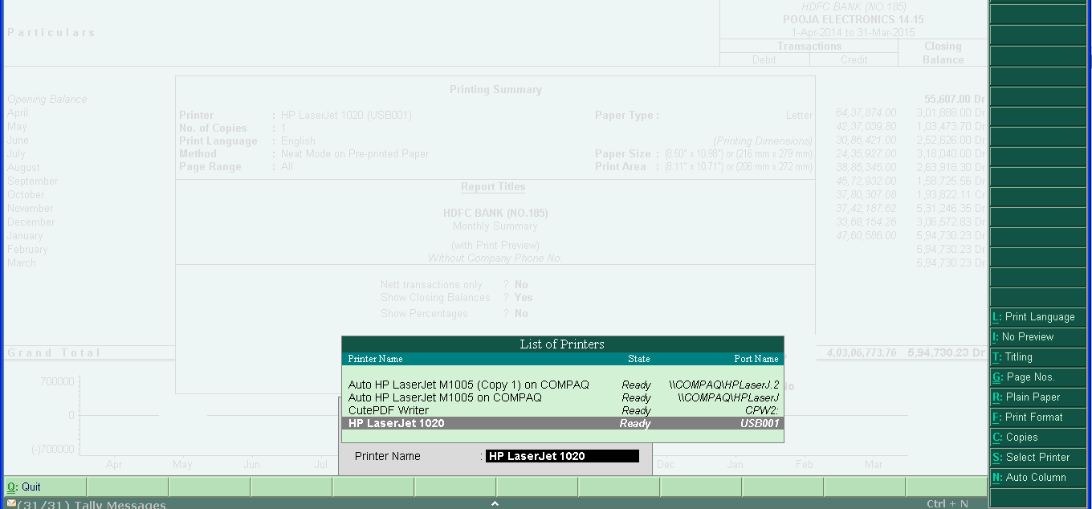
HOW TO PRINT ON BOTH PAGES IN TALLY ERP 9
1. Open Tally ERP 9, press ‘Alt+P’ for print, and then press ‘Alt+S’, select your printer, press enter.

2. Click on Finishing tab, check on Print on Both Sides (Manually), press OK.
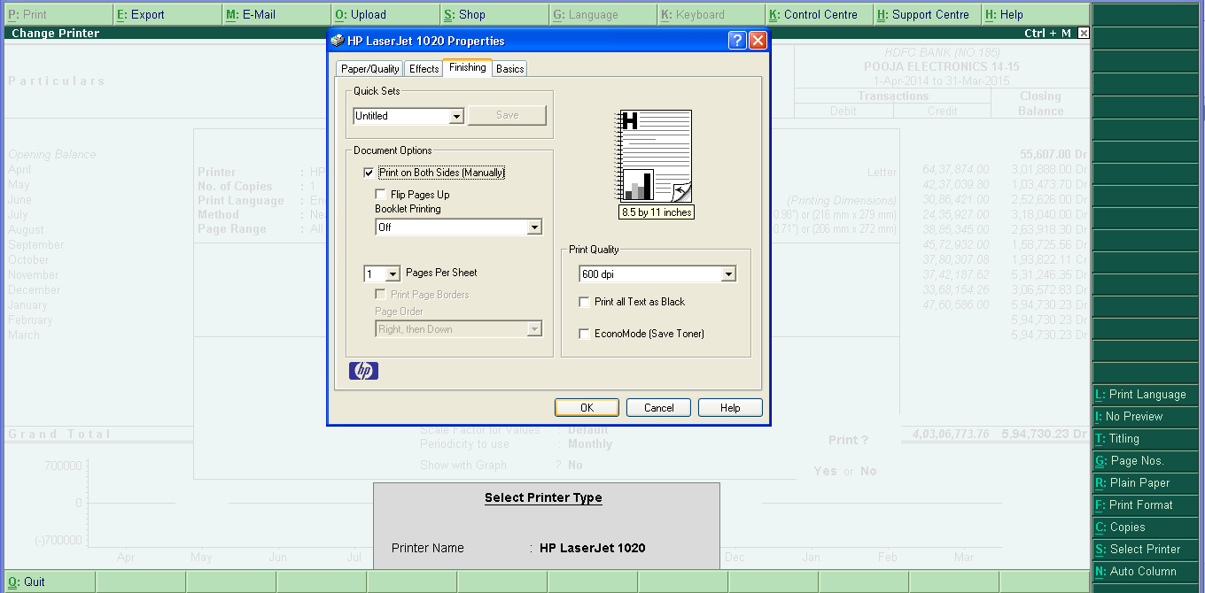
3. And you are done. Press Alt+P to print doucment.

