Cloud Computing

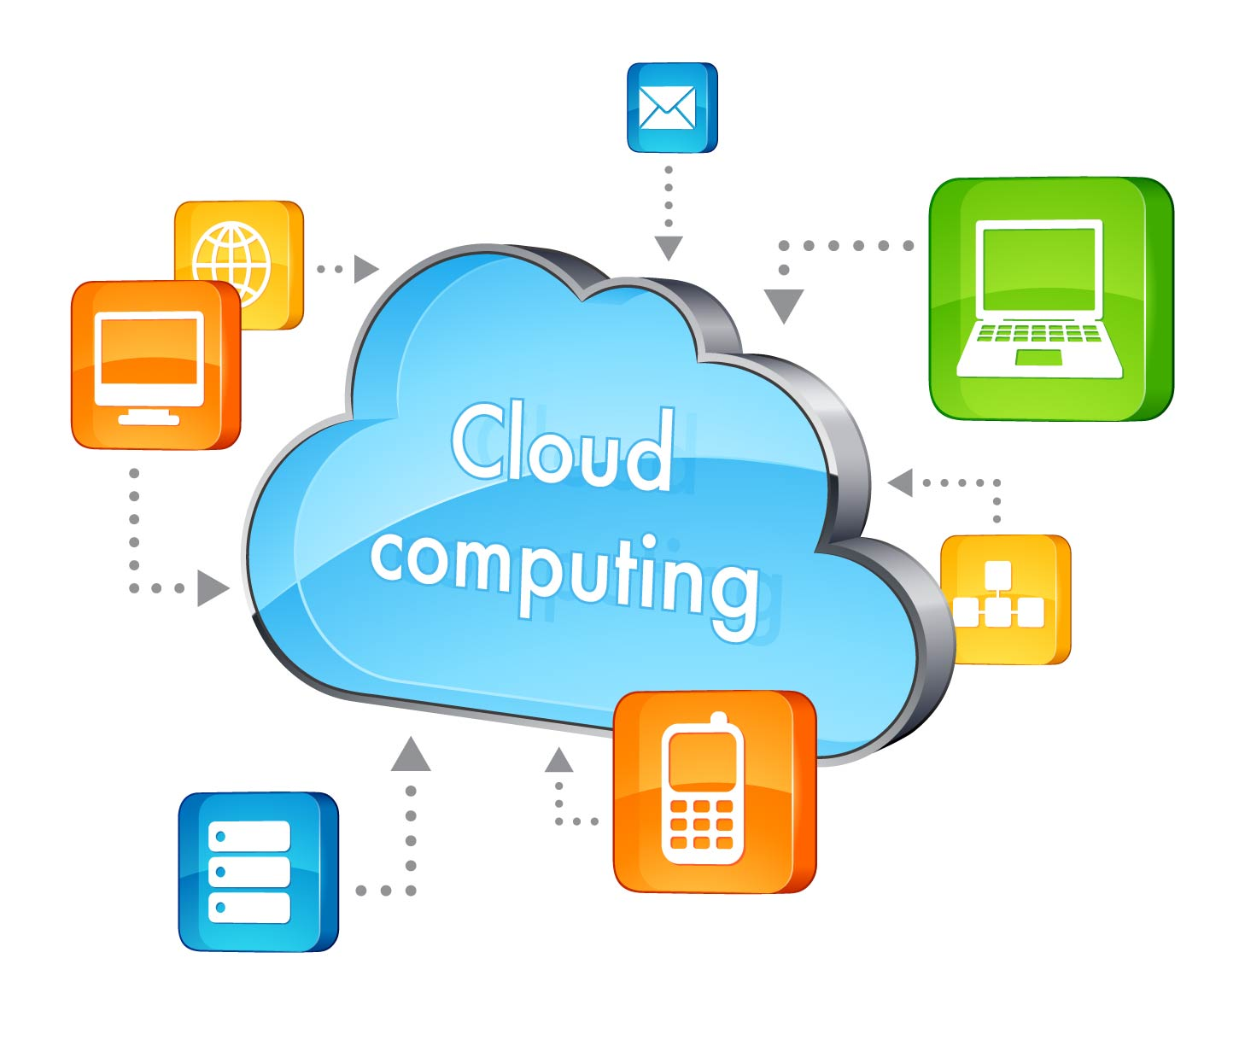

Cloud computing
Today is the age of information technology. The facets of work and personal life are moving towards the concept of availability of everything online. Understanding this trend, the big and giant web based companies like Google, Amazon, Salesforce.com came with a model named “Cloud Computing “ the sharing of web infrastructure to deal with the internet data storage, scalability and computation. This is the one of the most emerging concept in the I.T Field.

The phrase cloud computing means the “internet based computing”. It is expression used to describe a variety of different computing concepts that involve a large number of computers that are connected through a real time communication network. Cloud computing is a type of computing that relies on sharing computing resources.

A cloud is a powerful combination of cloud computing, networking, storage, management solutions, and business applications that facilitate a new generation of IT and consumer services. These services are available on demand and are delivered economically without compromising security or functionality.

Main advantage of cloud computing is that you don’t need to store the data on your computer. All the data is saved in one server through which all the devices are connected. So that, you can access your data from anywhere. In the server all the applications are installed so that you don’t need to install the software in all other computer.

Key Components of cloud computing mechanism:-
- There are the three main components:
- Application- With the help of this part cloud model of software architecture can eliminates the need to install the software on every computers or devices. So that cost of installing software on each computer can be reduced. Even the cost of software maintenance can be reduced. e.g. Google docs that allow you to access your word, excel, power point files online and you can even edit them online so that you don’t need to install M.S Office package in your system

- Platform- it facilitates deployment of application without cost and complexity of installing software and hardware in your computer e.g. Google app engine(Google play store)

- Infrastructure- a platform virtualization environment, as a service. You can host your content to the server. E.g. renting cloud space like Google drive, Drop box etc.

Cloud services models:-
- Based on the Nature of the cloud services it can be divided in to 3 parts:-
- Infrastructure As A Service (IAAS):- infrastructure as a service means service of providing cyber space to the consumer so that client don’t need to buy resources that fully outsourced from service providers. In this storage, network capacity, computing resources etc are provided. E.g.
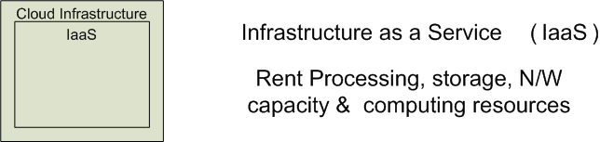




- Platform As A Service (PAAS) :- Platform as a service means space is provided so that developer can develop their own software. In this OS, programming language execution environment is provided through which developer can run their application on clod network.

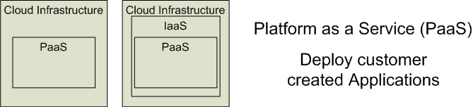


- Software As A Service (SAAS) :- It means that any software are provided to customer as a services so that instead of buying the software ,such services are fully outsourced. So that cost of software can be reduced. E.g. Lotus Live, salesforce.com


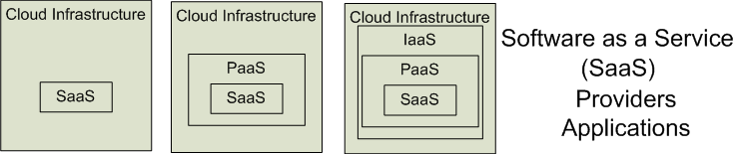


Key Characteristics and features:-
- No location restriction: - The main and foremost characteristic of the Cloud Storage is any where access. You can access your data from anywhere in the world from internet connected devices.
- Reduces capital expenditure: - The advantage of cloud computing is in SAAS client doesn’t need to install software in your computer but the benefit of the software can be availed. So capital expenditure on software and hardware can be reduced.
- Security:- As the data are saved on the remote computer you do not need to worry about security even there is no need to purchase antivirus software, however we purchase it for more better security.
- On demand services:- The on-demand and self-service aspects of cloud computing mean that a consumer can use cloud services as needed without any human interaction with the cloud provider.
- Remotely hosted:- all the services and data are hosted on remote servers.
- Ubiquitous:- services or data are available from anywhere.
- Multi-Sharing:-With the cloud working in a distributed and shared mode, multiple users and applications can work more efficiently with cost reductions by sharing common infrastructure.
- High availability and reliability:- -Availability of servers is high and more reliable as the chances of infrastructure failure are minimal.
- Technical Support:-A good cloud computing provider will offer round the clock technical support. Think Grid customers, for instance, are assigned one of our support pods, and all subsequent contact is then handled by the same small group of skilled engineers, who are available 24/7. This type of support model allows a provider to build a better understanding of your business requirements, effectively becoming an extension of your team.
- Disaster Recovery / Backup:-Recent research has indicated that around 90% of businesses do not have adequate disaster recovery or business continuity plans, leaving them vulnerable to any disruptions that might occur. In cloud computing you don’t have to worry about worry about data backup or disaster recovery, as this is taken care of as part of the service. Files are stored twice at different remote locations to ensure that there's always a copy available 24 hours a day, 7 days per week.

Types of Cloud network:-
- There are 4 types of Cloud Network.
- Public Cloud:- Public Cloud service is a such a type of service which is available to any subscriber with an internet connection. There is almost nil capital Expenditure for using this. It is not restricted to any organization. e.g. salesforce.com, Google’s cloud services, Amazon web service etc.
- Private cloud:- private cloud is restricted to any particular organization. If any organization wants customized services according to their requirement than this model is suitable. It mostly suitable for MNCs having huge budget for IT.
- Community cloud:- Community cloud shares infrastructure between several organizations from a specific community with common concerns (security, compliance, jurisdiction, etc. whether managed internally or by a third-party and hosted internally or externally.
- Hybrid cloud:- It is the combination of two or more types of cloud models. With help of Hybrid cloud limitation of the other cloud model can be eliminated and the advantage of different cloud model can be availed.

Indian Scenario regarding Cloud Computing:-
- India is growing at faster pace in information technology sector thereby showing a great potential for the cloud computing services.
- India and China are two major players in the cloud computing arena. Subscription based service model and cost effectiveness are two important factors that drive more and more companies and SMEs to enter and utilize cloud based application.
- As said by Mr. Som Mittal , president of NASSCOM “Cloud computing is reshaping Indian IT market by generating new opportunities for IT providers and driving changes in traditional IT offerings..”
- According to Springboard Research report (Jan 2009) SAAS India i.e. software as a service in India will register a compounded annual growth rate of 76% in the time period of 2007-2011. Cloud computing services has huge opportunity in Indian market due to the large number of Small and Medium businesses (SMBs) which is at around 35 million and they want easy to use , reliable and scalable application that helps them to grow and expand their business. This makes India as the fastest growing SAAS market in Asia Pacific region.
- Salesforce.com ‘software as a service’ provider started its services in India in September 2005 and since then the adoption rate of cloud computing is increasing.
- Seeing SAAS success on September 2008 IBM launched cloud computing center in India at Bangalore. This center will cater to the increasing demand of web based infrastructure sharing services.
- IBM India collaborated with IIT Kanpur to come up with some new developments in computing that will help in academic advancement. Bharti Airtel has launched the cloud computing services with their NetPc model and other giant companies like Reliance Communications, TCS, HCL technologies, Wipro, Netmagic, Verizon, Novatium etc. have also launched cloud computing services in India.
- According to CISCO cloud traffic will be six times by 2016. Many companies are making huge budget for Cloud storage technology for their business.
- The rapid changes in the domestic information technology (IT) market have paved way for related segments to grow exponentially over the past few years. The public cloud services market in India is expected to touch US$ 443 million in 2013, growing by 36 per cent from US$ 326 million in 2012. Infrastructure as a Service (IaaS) continues to be the fastest growing segment of the public cloud services market in India at US$ 43.1 million in 2012. The segment is expected to grow 39.6 per cent in 2013 to US$ 60.2 million. Software as a Service (SaaS), however, continues to be the largest segment of the cloud services market in India, accounting for 36 per cent of the total market in 2012.
- It is expected that US$ 4.2 billion will be spent on cloud services in India from 2013 till 2017. With more and more people willing to take the entrepreneurial plunge and overall rise in IT spending by Indian firms, it opens a wide playfield for the companies offering cloud computing solutions in the Indian market.
- In year 2010 Microsoft India said that “it sees the India as global hub for cloud computing, the concept of renting computing power that has taken the technology world by storm. India will not only see a surge in cloud computing services but companies all over the world will look to India to cloud computing.”

Disadvantage of Cloud Computing:-
- Privacy/ Confidentiality:- This is one of the major disadvantage of the cloud computing. Because privacy is the major concern to any organization. In the cloud computing data is saved in to service provider’s server so the data cannot be accessed by anyone except service provider. So there is always little bit risk of confidential matter.
- Customization:- In public cloud customization is not possible. Subscriber can not avail the services according to its own requirement. If it wants customized services then the private cloud is the only option but in that capital expenditure will increase.
- Security:- Here Security is also the major concern although any cloud service provider take highest step for the security policy but there can never be 100% security assurance. So there is always minor risk of security.
- Continuous requirement of Internet Connection:- In cloud computing all the data are saved in remote servers. So you need to have internet access to get the services. In India this is the major problem because internet is not yet available everywhere and there is no Wi-Fi enabled areas and even you require large volume of data which may cost you money.
- Dependency:- In this field there are few service providers so there is monopolized environment. We have to depend on those internet giant to avail the services.

Conclusion:-
SWOT analysis
Strength | Weakness
Best IT development | Internet connection not available every where
Sufficient IT resources | No Wi-Fi enabled areas
Many giant companies sees growth in India | Lack of awareness
Opportunities | Threats
Have strong potential of development | Monopoly situation
Yet Cloud computing services are not used by every business. It can be increased

After SWOT analysis we can say that although there few disadvantages/ threats of cloud computing but its advantages overcome its disadvantages. We can say cloud computing has much potential and it may become essential.

Thanks & Regards,
Smit S Shah.
CA Final Student
(Ahmedabad)
Follow my blog www.knowledge4ca.blogspot.com
Refrences:
Google and various other websites of Amazon web services, salesforce.com, CISCO, Microsoft Azure, Google app engine etc.
Wikipedia
Economic times and few other newspapers
Cloud Computing: Finding the Silver Lining, Not the Silver Bullet. http://www.sei.cmu.edu/newsitems/cloudcomputing.cfm
NIST, U.S “Definition of cloud computing” September edition
Abstract from report of IIT Allahabad on “Scope cloud computing in India”
Abstract from report of Naraini group of Collages, Haryana on “Impact and challenges of cloud computing in current scenario”
Even Reference of my knowladge

