To create House Bank

Transaction code: FI12

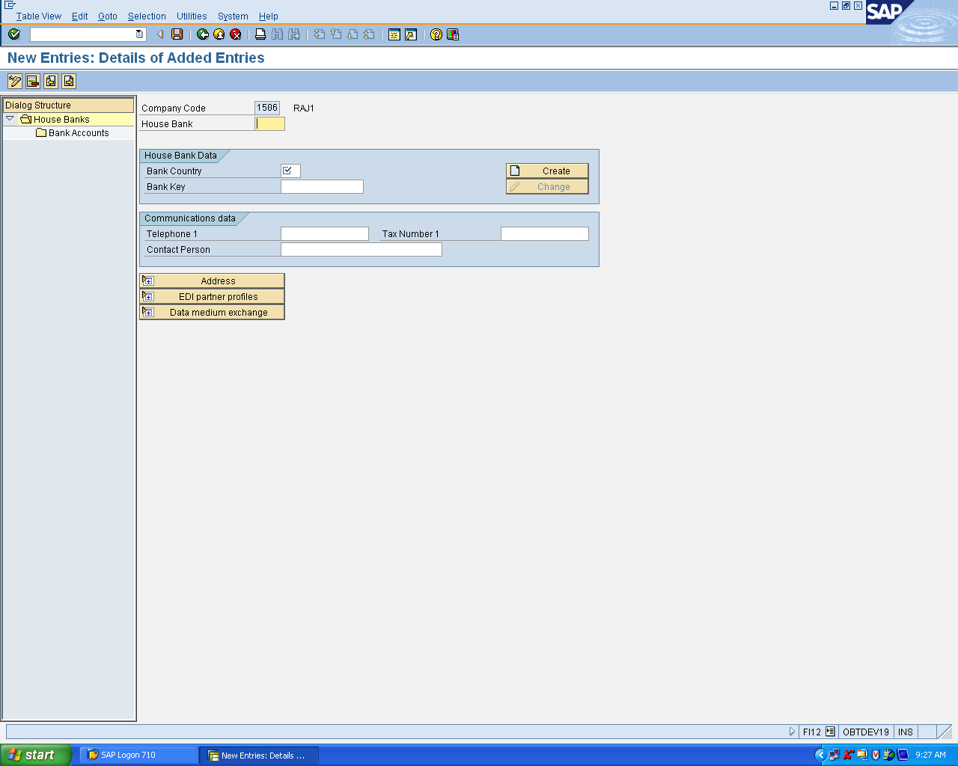

Inputs:
Example:
House Bank : SBI
Bank Country: IN
Bank Key SBIHYD - You can give any name related to bank
Click on Create Button ( You will get one more popup window as shown below.

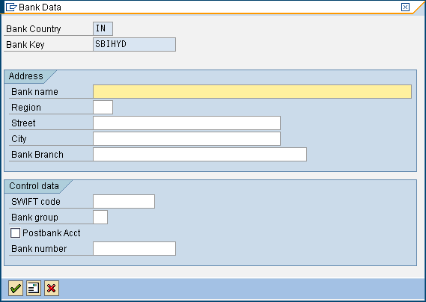

Give the input

Bank name : State Bank of India
Region : Not Mandatory
Street : Abids
City : Hyderabad
Bank Branch : MAIN BRANCH

Click on continue button

Save

After save Click on Bank accounts

You will get one more screen as shown below.

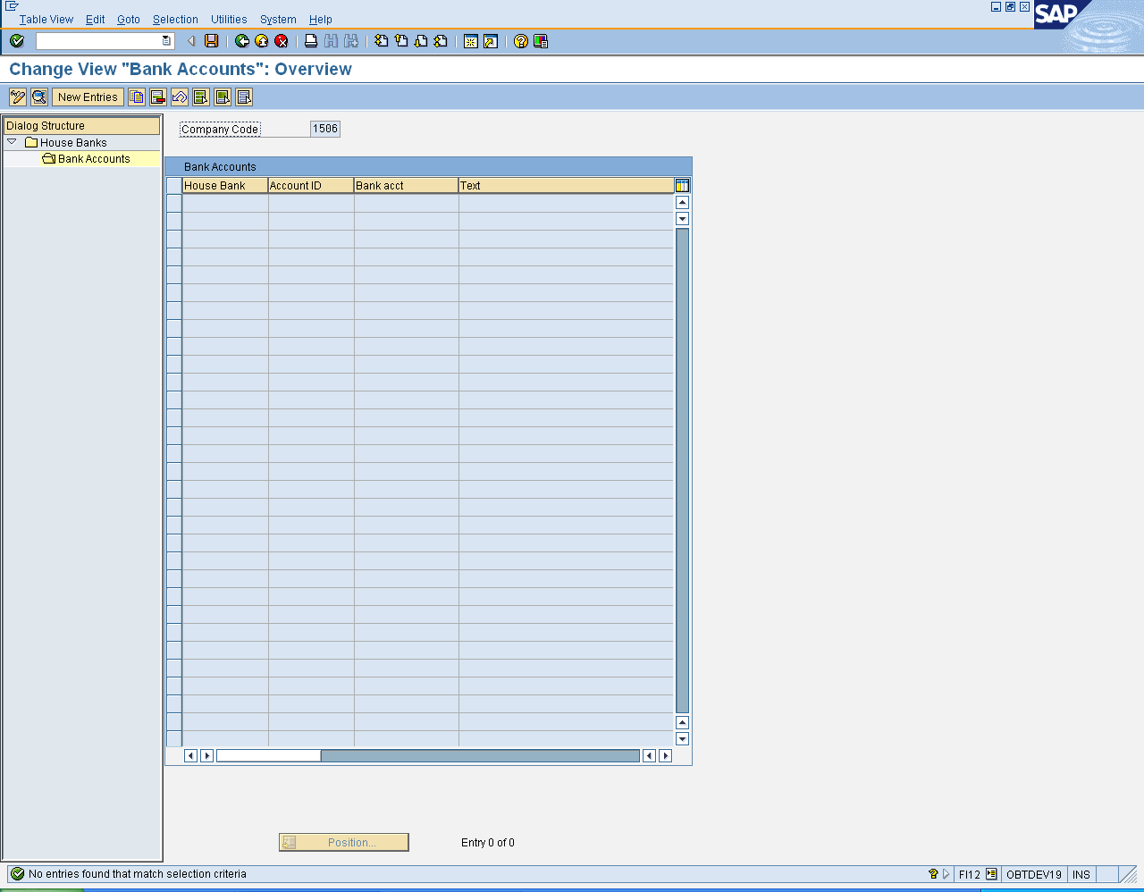

Click on New Entries

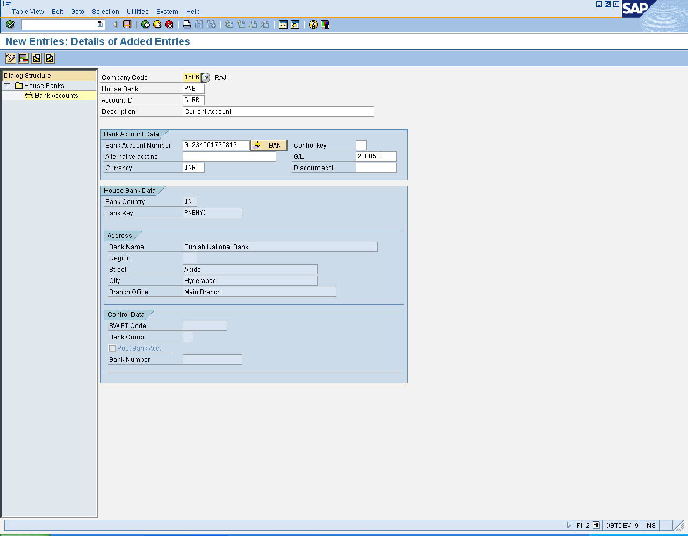

Give the input in the above screen like this
House Bank appears automatically
You need to give account id
Account ID CURR
Description Current Account

Bank Account Number 01234561725812 ( Your Bank Account)
G/L 200050 ( Specify you GL account to which you are assigning the current account)

Save

House Bank has been created.

