As we know that I current era almost all documents are being digitalized through signature by Digital signature electronically, as a common man how we ensure that the signature by which authentication is being made are valid.
Here is a way to check the certificate to verify, you also can check your private key in your laptop/ desktop.
Once we take digital signature it is issued with private key which is hold by the subscriber and corresponding public key are issued to various authorities. Once u will install in your desktop its automatically launch in your laptop.
- Follow the procedure.
- Open Internet Explorer
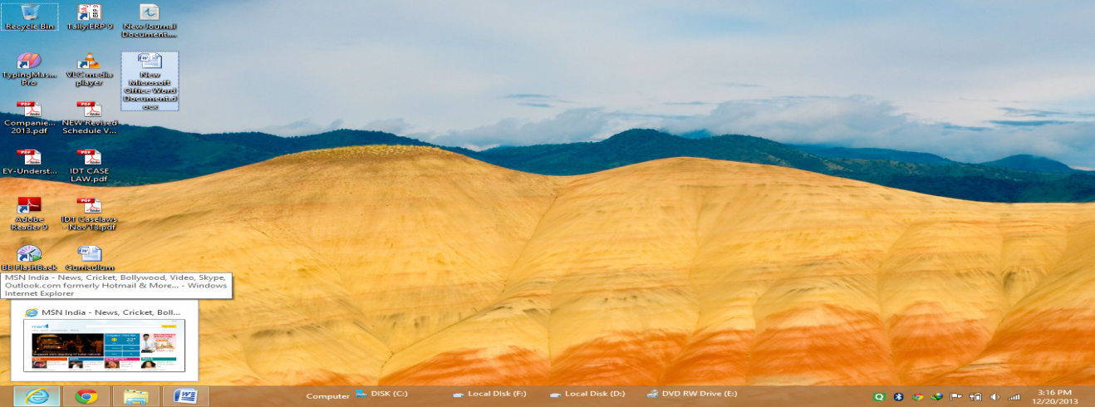
- Go to internet Option
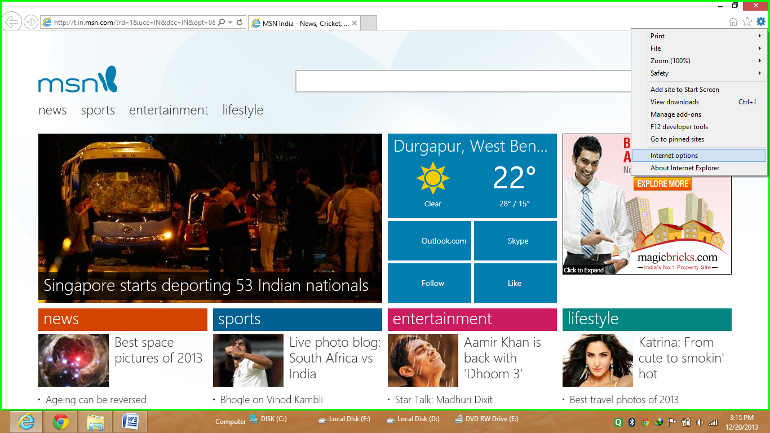
- Go to Content
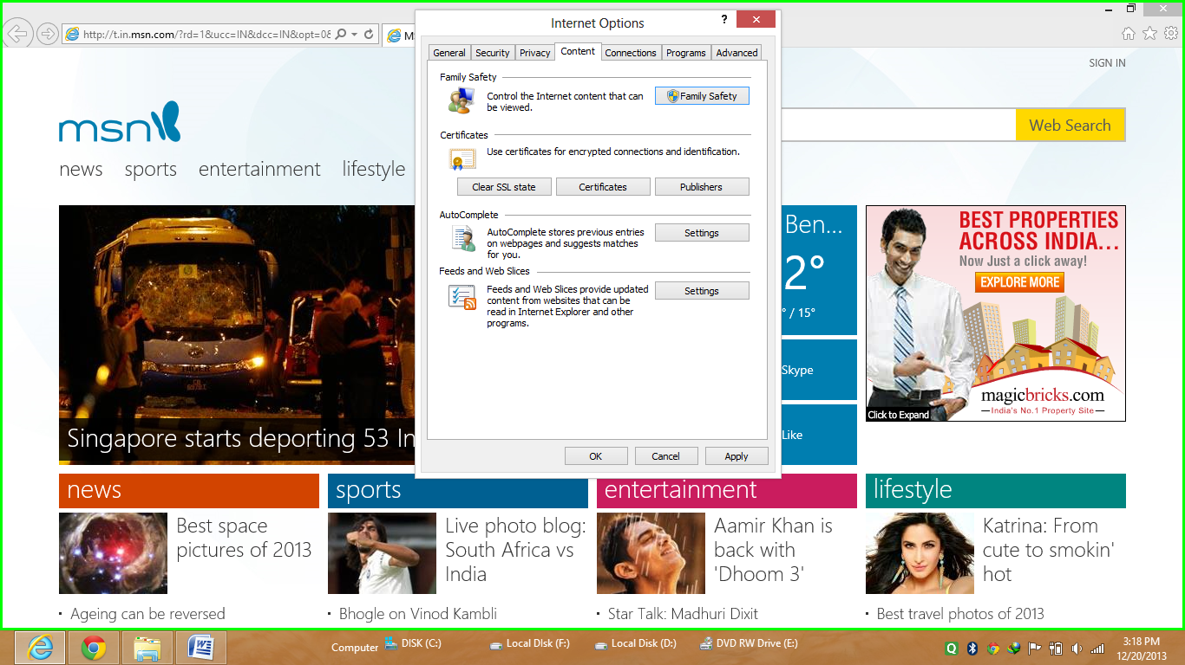
Click on Certificate and click on Trusted Root Certificate
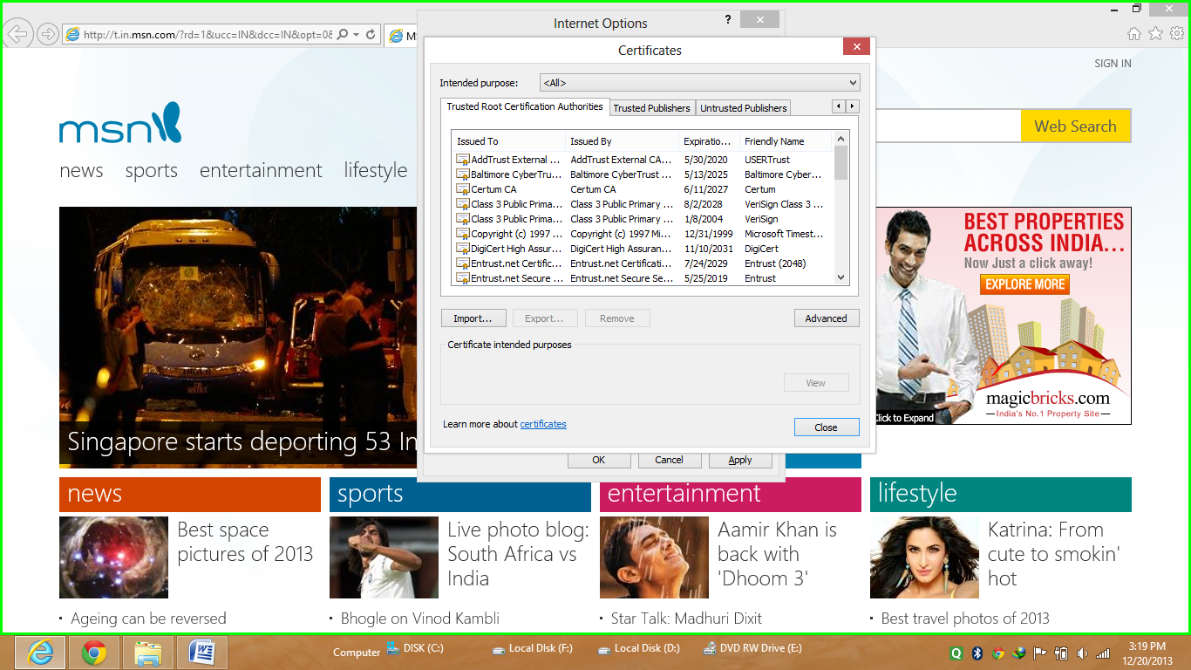
Now you can view any certificate and their details
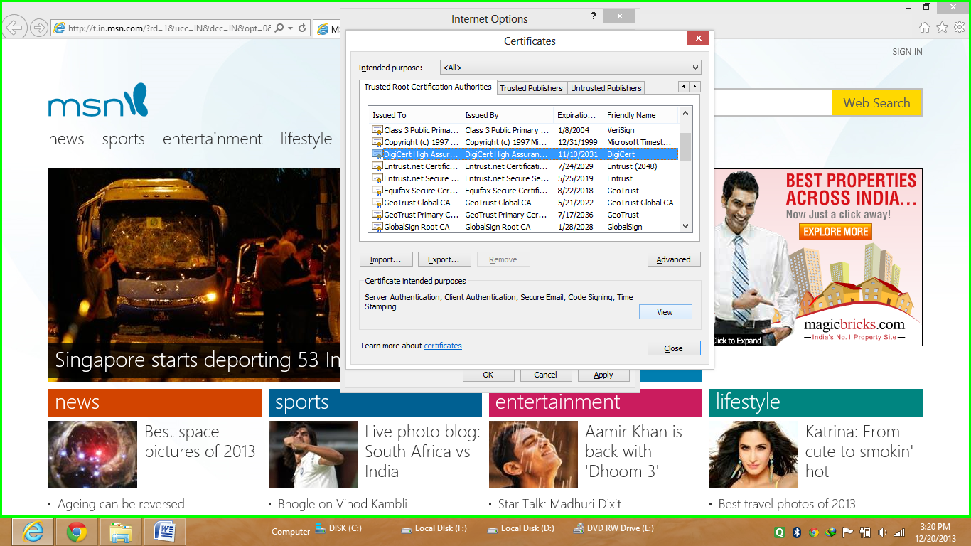

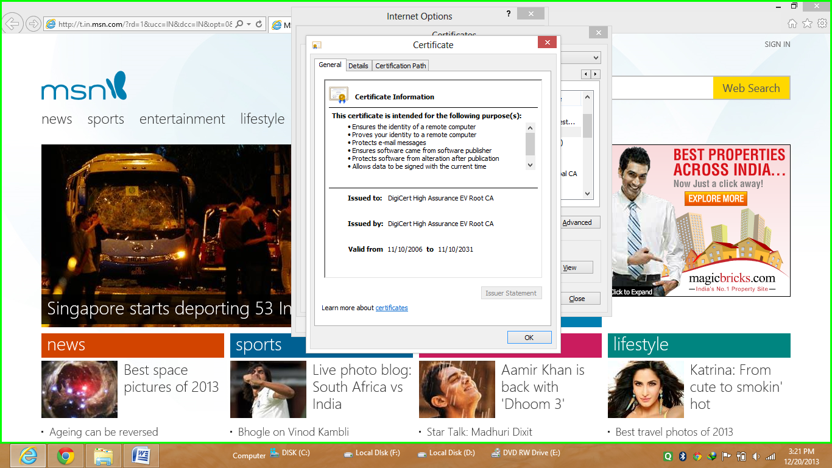
If u wants to see their public key you have to just click on Details and then Public key
You will find all details. IF anyone wants to know more about Digital Signature you can mail me at My Mail Id –sarojkumar@icai.org

