To compress any jpb file –
- Open jpb file with microsoft office picture manager
- Click on picture menu
- Click on compress picture
- Click on documents
- Click on “ok” as given below arrow
- Save file and close
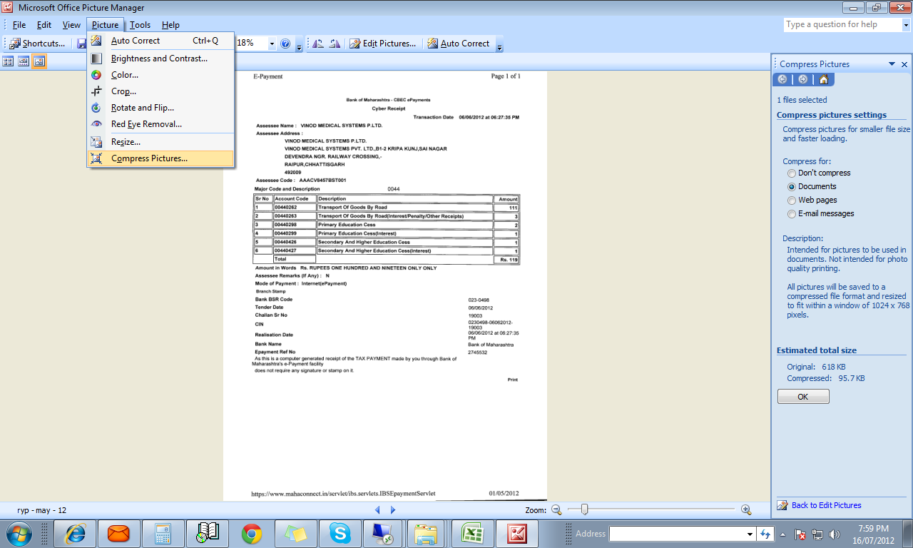
- Your file size 50 to 80 persent will be compress

