Step 1: Open Notepad and paste the following text into a new document:
Dim message, sapi
message=InputBox(“Enter the text you want spoken”,”Speak This”)
Set sapi=CreateObject(“sapi.spvoice”)
sapi.Speak message
It should basically look something like this:
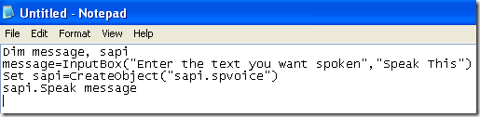
Now when you go to save the file, give it any name, but make sure you also type .VBS after the name. Also, for the Save as type box, choose All files instead of the default Text Documents.
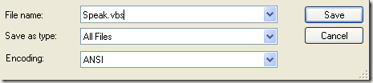
Now double-click on the VBS file and you should see a input box where you can type in the text you want spoken! Go ahead and type something and click OK.
