- First of all open your CAclubindia Profile Page
- 2. Than click on edit button as shown in the below pic

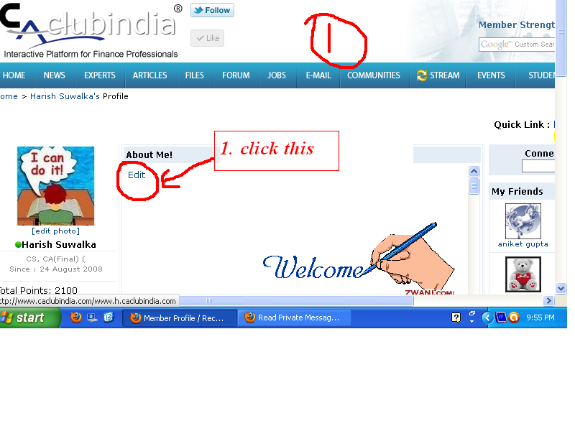

- As the next step click on the source button as per the below picture
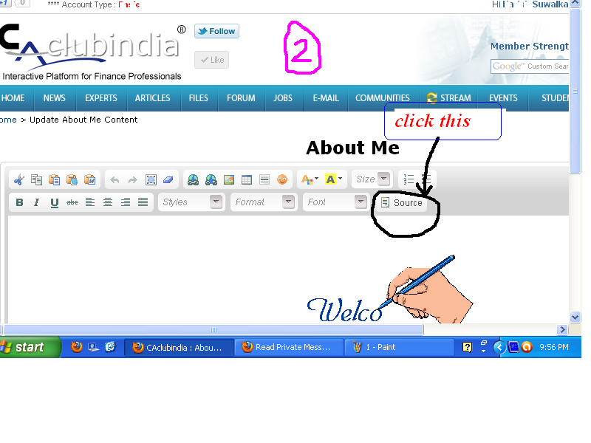

- After that copy the code given below(without quotes), and paste on the place shown in pic (paste on the top)
“<a href="www.h.caclubindia.com"><img alt="Welcome to MY Profile" border="0" src="http://images.zwani.com/graphics/welcome/images/welcome134.gif" /></a> ”
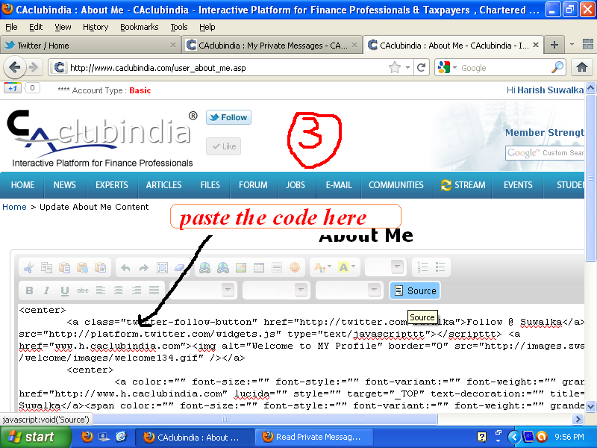

Try this, I think it is easy

