This
Project Report on Enterprise Resource Planning

GAIL (India) Limited
Sector-1, Noida Info HUB
+918447303701

6/9/2011
Mohit Saxena
This document is about the basic structure of SAP in context to GAIL with regard to its various Business Process, SAP Landscape and Operational Aspects of Financial Module of SAP.

I. SAP Landscape:- 6
II. SAP Modules:- 7
SAP has different Modules which are given below:- 7
A. Financial (FI) 7
B. Controlling (CO) 7
C. Sales & Distribution (SD) 7
D. Material Management (MM) 7
E. Production Planning (PP) 7
F. Plant Maintenance (PM) 7
G. Quality Management (QM) 7
H. Project System (PS) 7
I. Human Resource (HR) 7
J. BASIS & ABAP 7
III. Financial Accounting:- 8
Financial Accounting consists of several components:- 8
A. General Ledger: - 8
This accounting function uses charts of accounts. 8
Provide automatic functions that evaluate list of receivables and payable according to due date, helps to prepare annual/monthly closing of accounts. It helps in timely presentation of Balance sheet and P/L account to its stake holders. 8
B. Account receivables: - 8
On line accounting for customer’s invoice, customer’s related account, transaction. It is totally integrated with sales & distribution. Its data include Customer Balance. 8
C. Account payables: - On line stores account and vendors payments. It is integrated with material management. Its Data includes payment of all types of bill of contractors:- 8
D. Asset management: - 9
Asset Management includes three aspects- 9
E. Investment management: - 9
It monitors Capital Expenditure and Capital Work-in-Progress Accounting. 9
A. General Ledger: - 9
Given below is the main window of General Ledger. 9
We have to go in blank box and write “Fb50” and then normal window given below appears. After this we go in following manner: - 11
There is an option in SAP for “parking” a document instead of posting when user don’t have posting rights or document required to be checked by any higher authority, then he park the document for authorization of Higher Authorities. 14

Financial Module of ERP
  - Acknowledgement
  - Apart from my efforts, the success of this project depends largely on the encouragement and guidelines of many others. I take this opportunity to express my gratitude to the people who have been instrumental in the successful completion of this project.
  - I would like to show my appreciation to Shri Chinari Saroj and Shri Atul Saxena. Without their encouragement and guidance this project would not have materialized

  - Executive Summary
  - GAIL (India) ltd has diversified into 9 different businesses with a turnover of ` 32,459 Crores Financial Year 2010-11. These are-
  - (1) - Corporate services
  - (2)- Natural gas trading
  - (3)- Transmission services
  - (4)- Exploration & production
  - (5)- Petrochemicals
  - (6)- LPG& other liquid hydrocarbons
  - (7)- Telecommunication
  - (8)- City gas distribution
- To integrate all these businesses GAIL introduce (SAP, ERP)
- For segment reporting and profitability analysis of various businesses the ERP system was designed and each business segment was assigned with company code in the system.
- COMPANY CODE is an independent accounting entity.
COMPANY CODE | COMPANY CODE DESCRIPTION
1000 | Corporate Services
2000 | Natural Gas Trading
3000 | Transmission Services
4000 | Exploration & Production
5000 | Petrochemicals
6000 | LPG & Other Liquid Hydrocarbon
7000 | Gail telecommunication
7500 | City Gas Distribution
8000 | Power Sector

  - ERP IMPLEMENTATION
- ERP is a software solution that integrates information and business processes. It enables information entered into the system to be shared throughout the organization.
- The entire logic of ERP software encompasses all the business activities into the single business package, wherein all transactions are recorded.
- Essence, ERP is a total business package that allows automation and integration of all business processes access to information in real time environment.
- After implementation of ERP paper work is reduced to great extent.
- Information flow & secondary data generation would be synchronized, systematic and instantaneous.

SAP Landscape:-
On a broad basis SAP is divided into five parts and each part has defined different clients for them.

- Development | Client 100
- Testing | Client 190
- Quality Testing | Client 210
- Production | Client 300
- Sand Box | Not maintained in GAIL (India) Ltd.

SAP Modules:-

SAP has different Modules which are given below:-

Financial (FI)

Controlling (CO)

Sales & Distribution (SD)

Material Management (MM)

Production Planning (PP)

Plant Maintenance (PM)

Quality Management (QM)

Project System (PS)

Human Resource (HR)

BASIS & ABAP

Financial Accounting:-

Financial Accounting consists of several components:-

General Ledger: -

This accounting function uses charts of accounts.

Provide automatic functions that evaluate list of receivables and payable according to due date, helps to prepare annual/monthly closing of accounts. It helps in timely presentation of Balance sheet and P/L account to its stake holders.

Account receivables: -

On line accounting for customer’s invoice, customer’s related account, transaction. It is totally integrated with sales & distribution. Its data include Customer Balance.

Account payables: - On line stores account and vendors payments. It is integrated with material management. Its Data includes payment of all types of bill of contractors:-
    - Suppliers
    - Employees
    - Statutory authorities

Asset management: -

Asset Management includes three aspects-

Project capitalization

Asset accounting

Depreciation

Project capitalization is integrated with P&S module for plant or project capitalization. Asset booking integrated with investment module. Depreciation is calculated on periodical basis. It is integrated with final accounts.

Investment management: -

It monitors Capital Expenditure and Capital Work-in-Progress Accounting.

General Ledger: -

Given below is the main window of General Ledger.

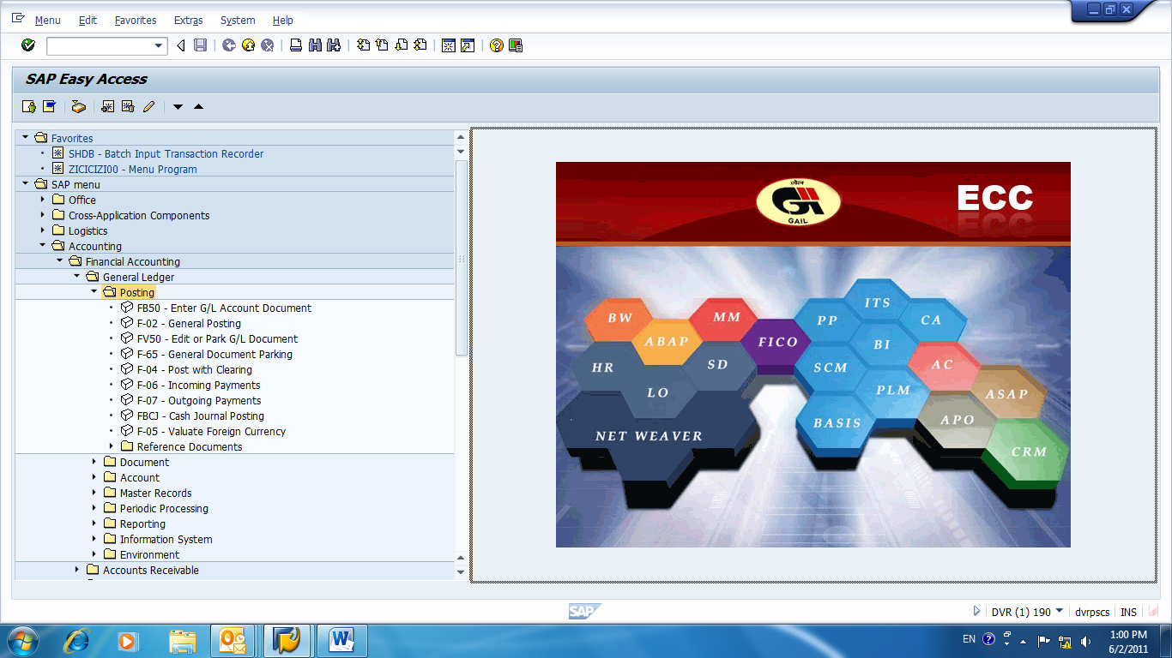

FB-50 Enter GL Account Detail:-

We have to go in blank box and write “Fb50” and then normal window given below appears. After this we go in following manner: -

Enter Date

G/L Account Number

D/C

Amount

Business Area

Finally Cost Center

In between it can ask for Tax Code, if no Tax applicable then write “v0”

Then press save option above

Then press enter it will show you document No. at the bottom of window and at the right hand side of upper window in “Amount Information” Total debit Credit shown to us.

Don’t forget to select the selected entry fields before saving and then it shows or generate the document number at the bottom of window.

Green indicator at the Top right Hand Side window of G/L Account Document shows that entry is ready for posting and contains no error.

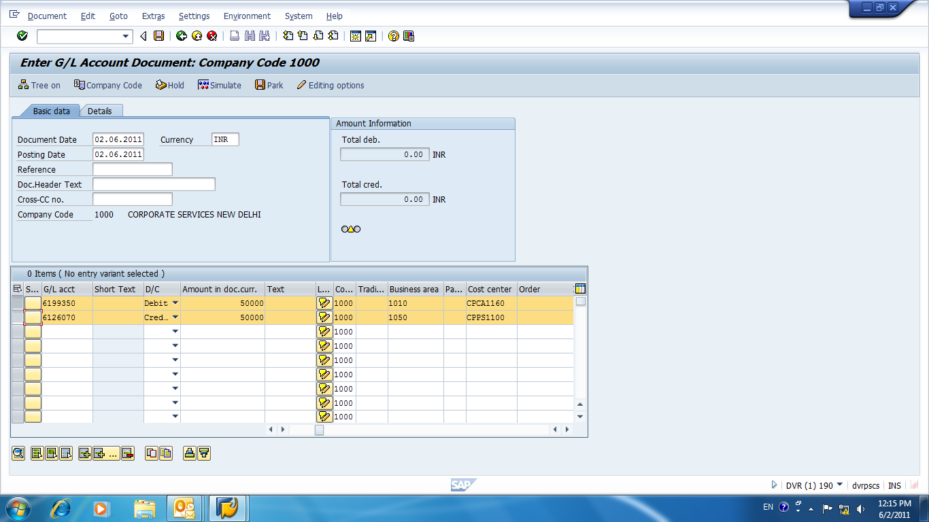
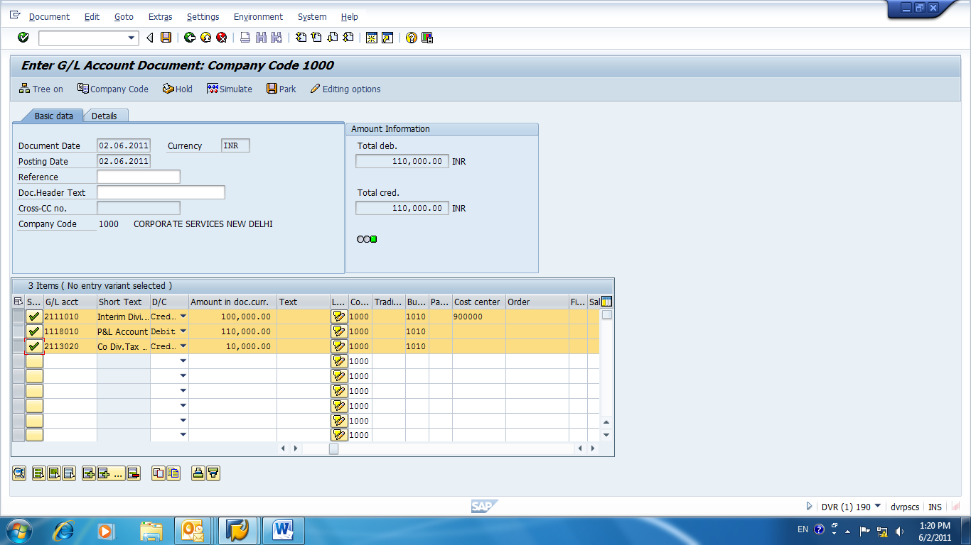

After above windows press back in above list and come out of the window. Now to view the above created document, go in blank column above and write “fb03”

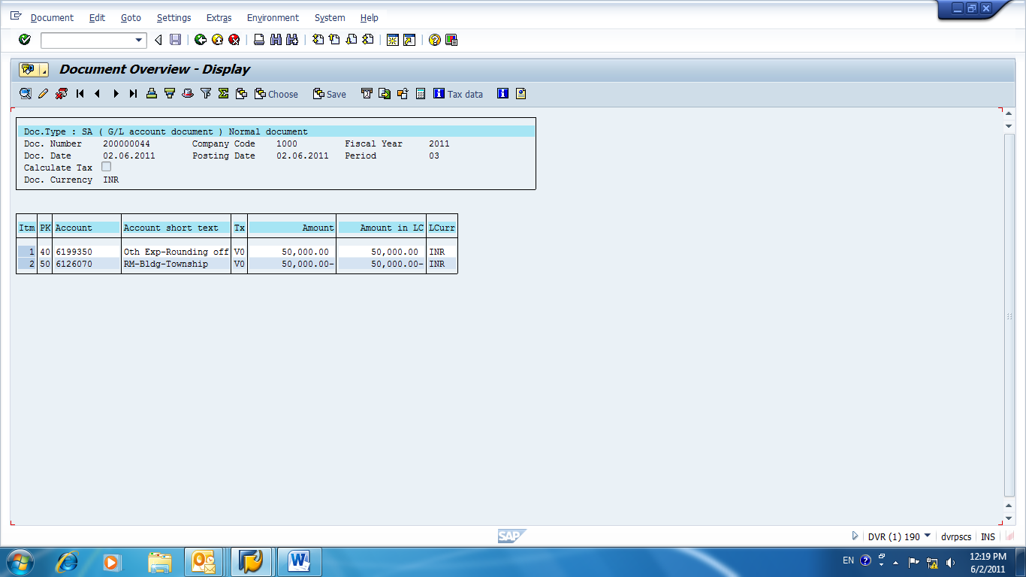

PARK DOCUMENTS:-

There is an option in SAP for “parking” a document instead of posting when user don’t have posting rights or document required to be checked by any higher authority, then he park the document for authorization of Higher Authorities.

Here 1st window is specialized window for Edit or Parking GL Document by pressing “FV50”.

On the other hand, 2nd window is normal posting GL window which we have seen above having Parking Option.

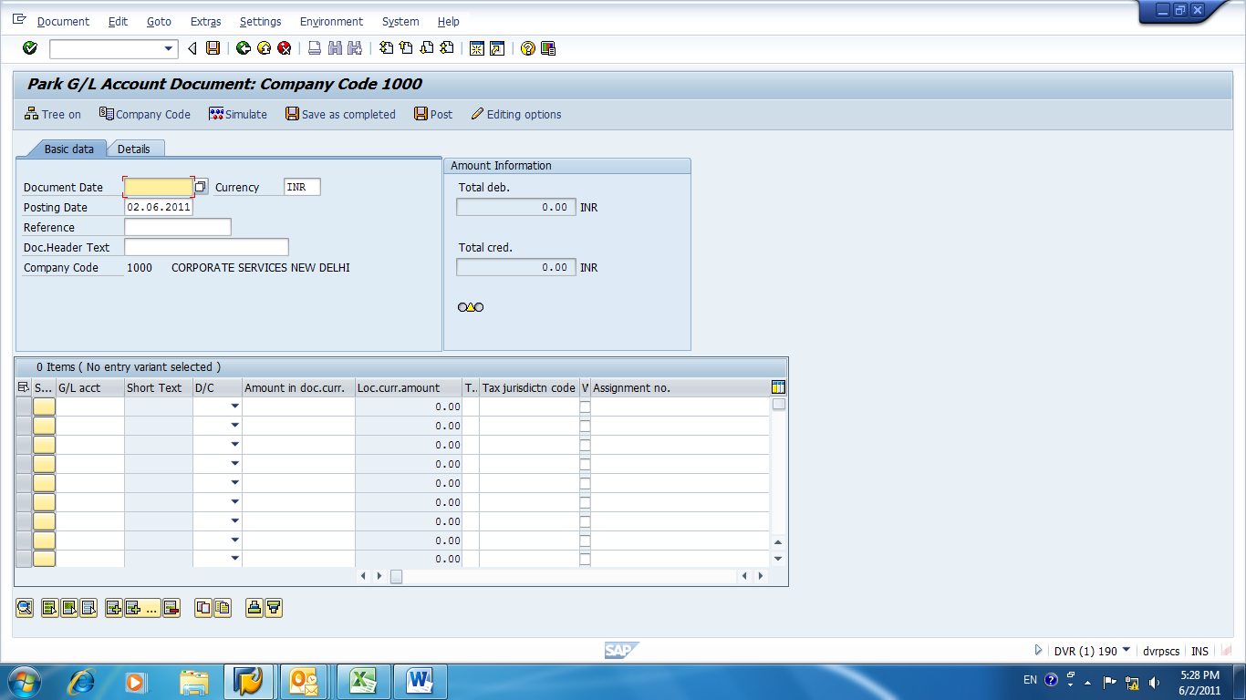

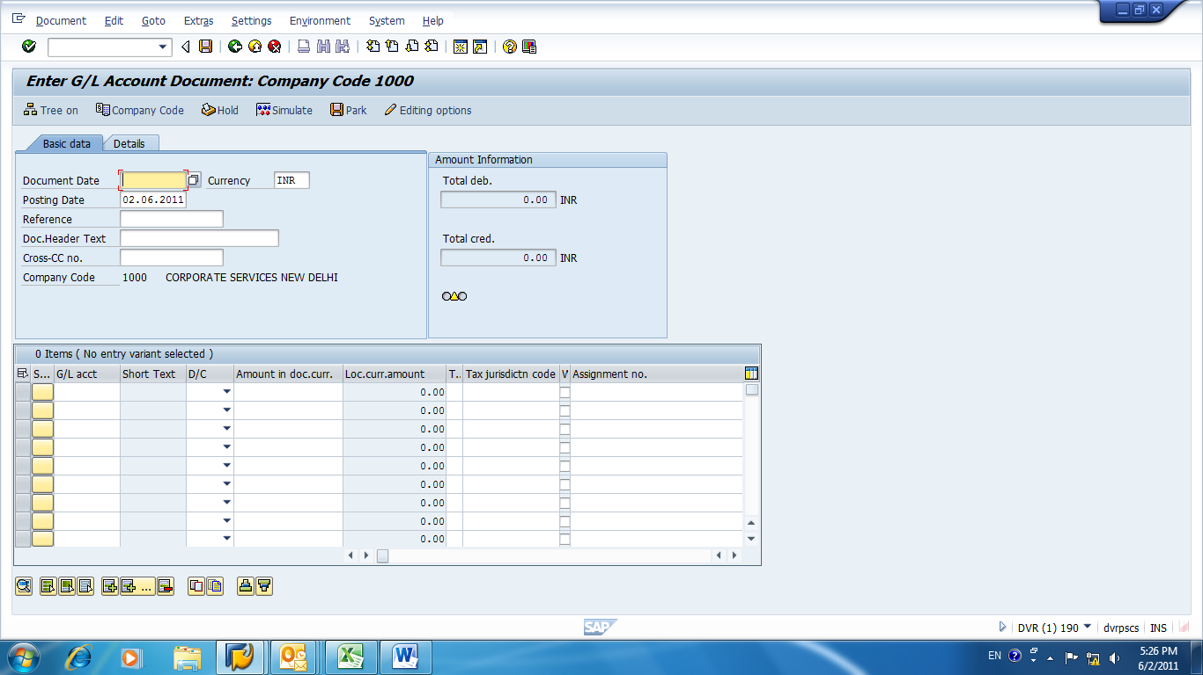

Press “FBV0” for opening this window in blank box. Now press enter then next window will appear.

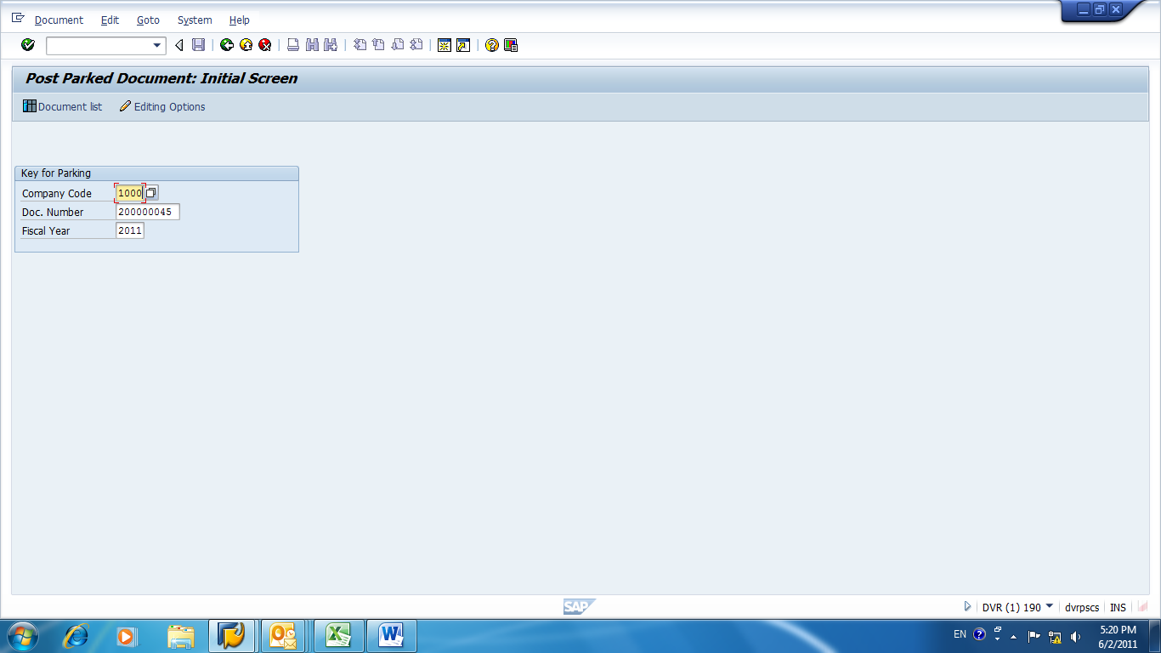

After pressing “enter”, this window will appear to us and we can post this document from post option here. We can access this window by pressing “FBV0”.

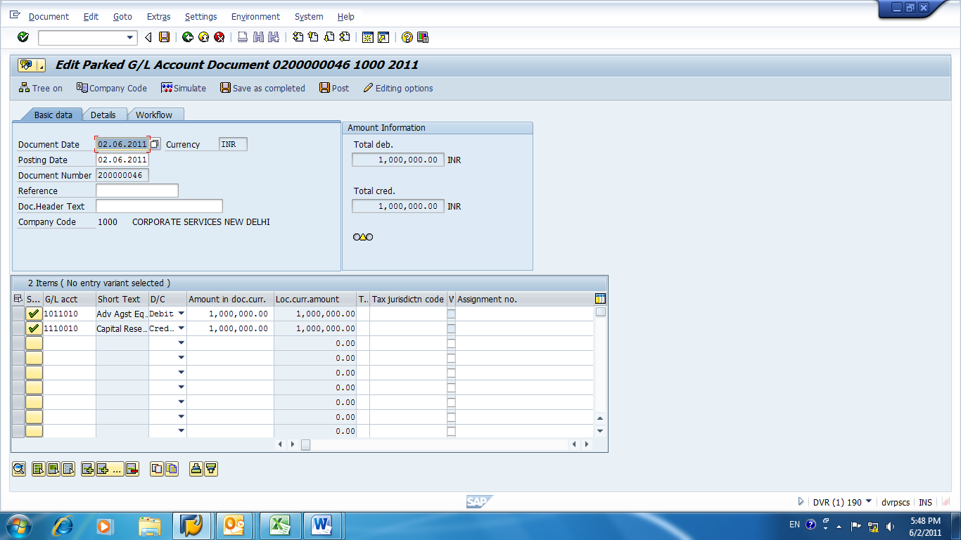

GENERAL DOCUMENT PARKING: -

We can access this window by pressing “F-65” in the blank box. Rest functions are same as in G/L Document Parking.

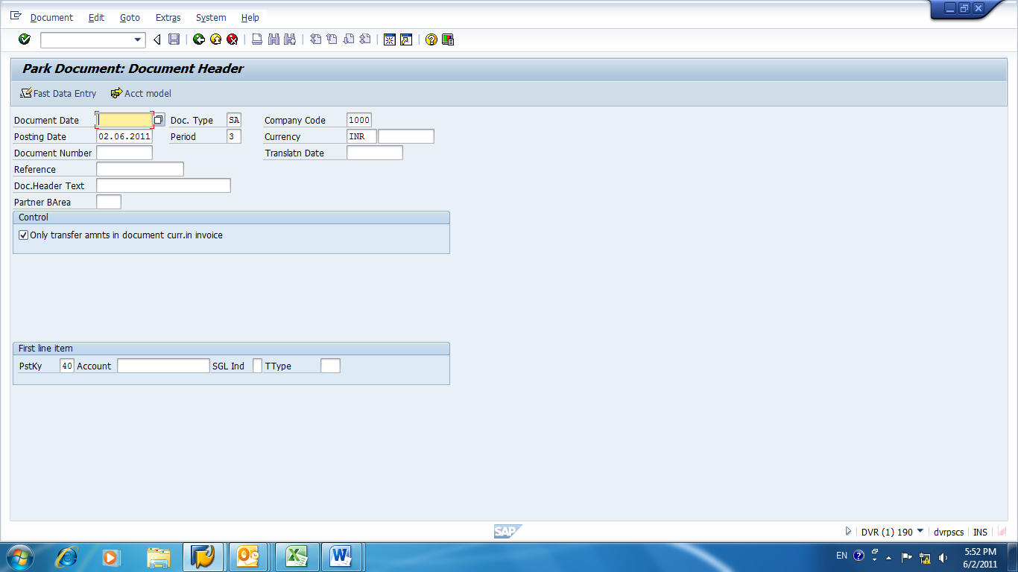

GENERAL POSTING: -

For General posting we have to write “f-02” in the blank box and we can access the window given below. After that we have to assign all necessary fields, in which Tick mark is showing, it indicates necessary fields:-

Document date

Company code

Currency

Posting Key

Account GL Code, & then

Press enter

Next window will appear

Here we assign Amount, Business Area and next entry’s Posting Key and GL Code.

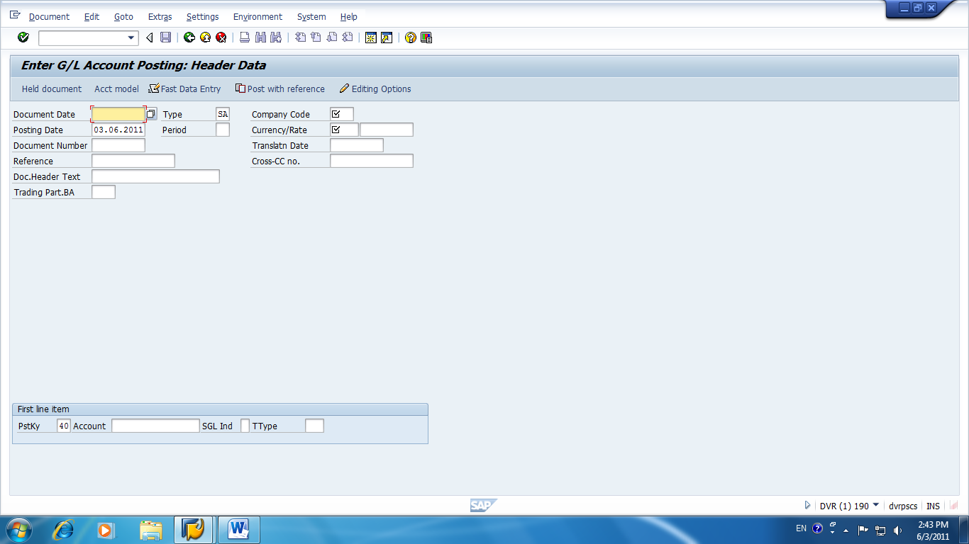

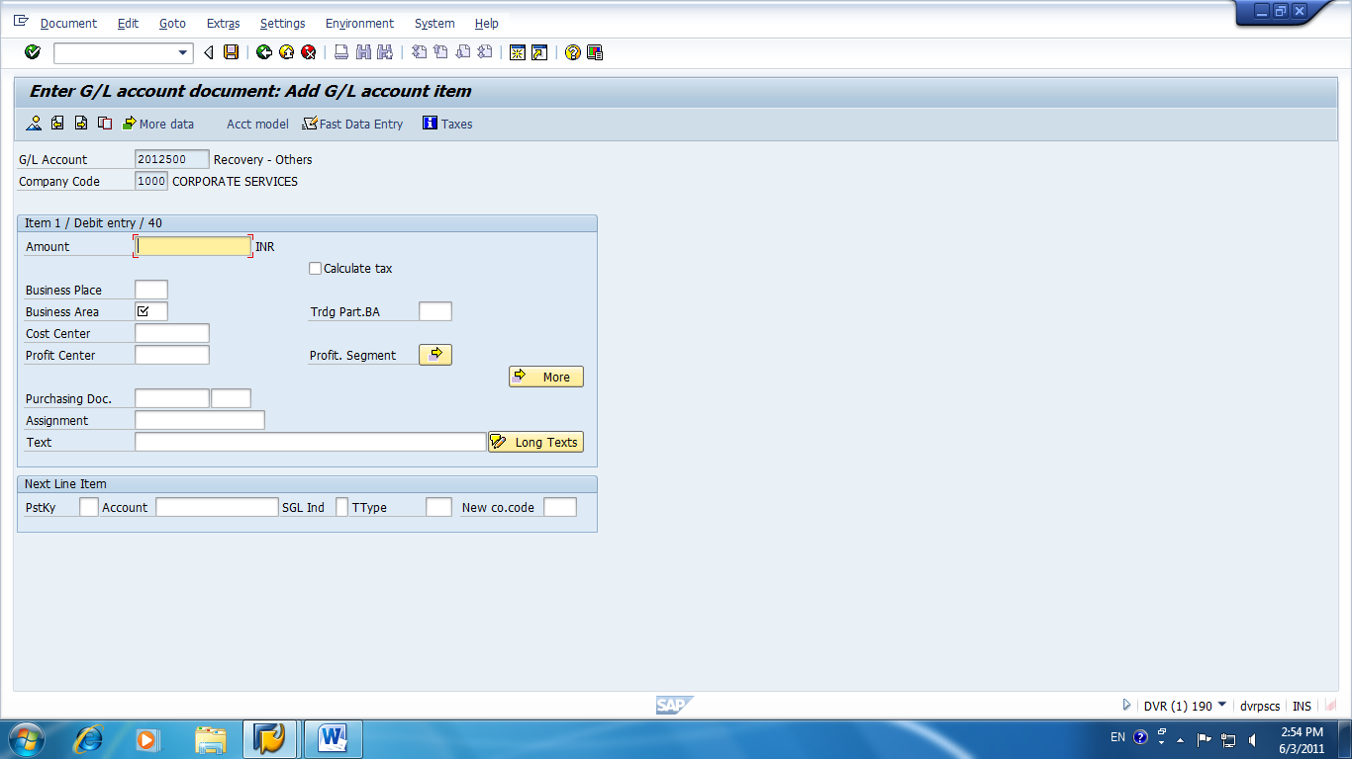

POSTING WITH CLEARING: -

For “posting with clearing” we have to type “f-04” then the blank box then this window given below will appear. Then we proceed in the manner given below.

First Type “fbl3n” for Display G/L Account

Then select G/L Code, for e.g. “3710010”

Select Dynamic Selection & then Open Items and Execute

Click on Assignment and then sort in ascending or descending order.

Note down the Assignment numbers, for e.g. “00090648”; ”00015533”; “00015510.

Now type “f-04” in blank box

Select Transfer Posting with clearing

Then choose Open Item, GL Code and Put Assignment number

Process Open Items

Then go to Residual Items and Simulate

Put narration in Blue Color Entry

Go to “More Data” and put Personnel No. without “000”

Then Post.

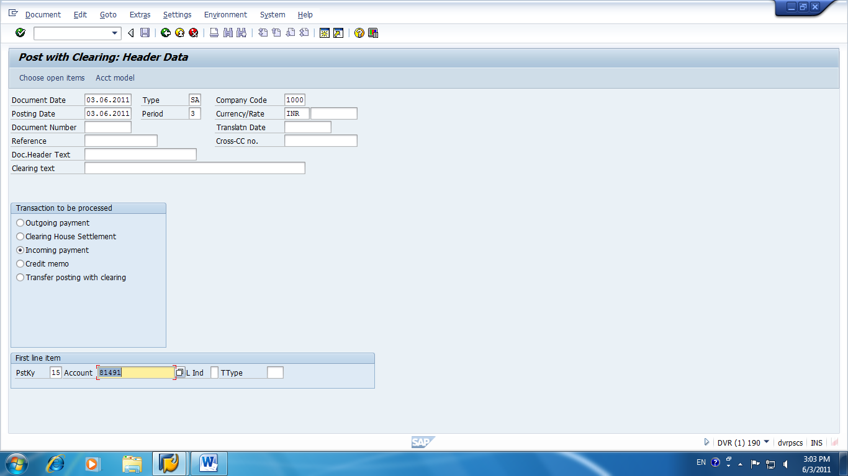

CASH JOURNAL POSTING: -
This option is used to post Cash Entries. Let’s see how we proceed to operate this facility:-

Type “fbcj” in blank box

Select Business Transaction

Put Amount in the column specified

Enter GL Code

Select Cost Centre

Then, Click Post

Automatic Valuation of Foreign Currency: -
This facility is used for automatic valuation of Foreign Currency. Let’s see how we use this facility.

Press “f.05” in the blank box and you will get the desired window.

BANK:-

To create House Bank, write “fi01” in blank box field.

After Pressing enter next window will appear here we have to specify

For Bank Country we have to specify “in” for India.

In bank key, we write suppose “002” is code for SBI after writing “002” MICR Code of SBI Branch.

After pressing enter new window will appear where we have to specify Brach details:-

Branch Address

Branch Name

City/district

In SWIFT Code column we write IFSC Code.

In Bank Number we write MICR Code it should be of 5 digits, otherwise we add “0” before it to make 5 digits.

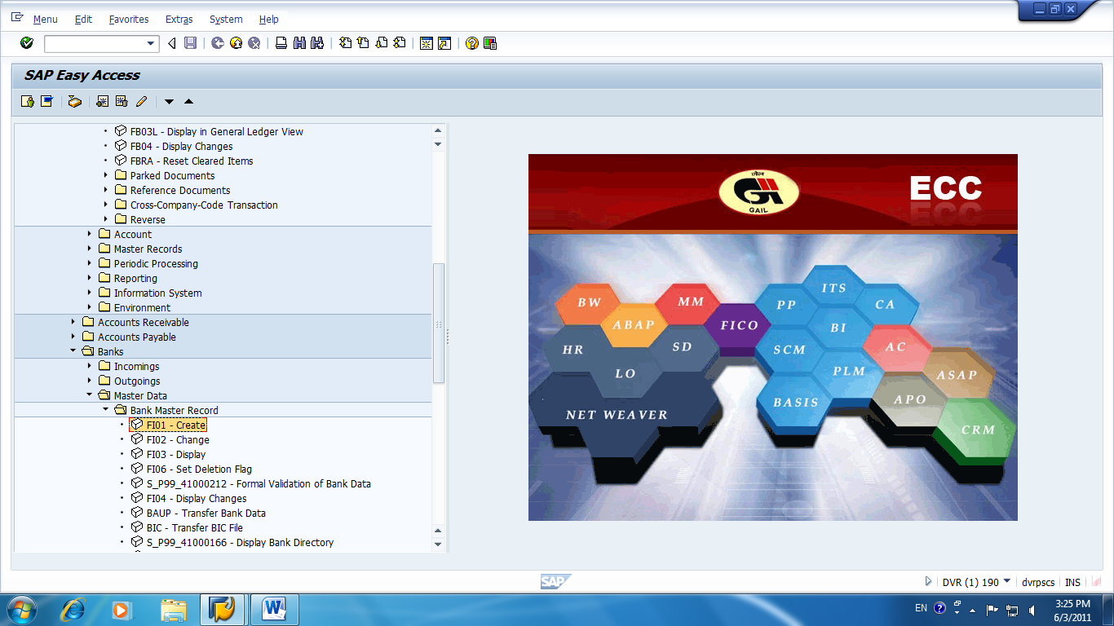

Bank Mapping steps are as follows:-

Create Bank Master data in Client 190 with T-code “fbzp”;

Then we create Bank key in Client 100;

Then, we save a request no. generated in client 100;

We go to client 190 and transport the data with T-code “scc1”;

Then, we create GL Code with T-code “fs00”;

Check Lots are created with T-Code “fchi”;

In last we map Business Area for Bank A/c GL Code with T-code “yrfx”.

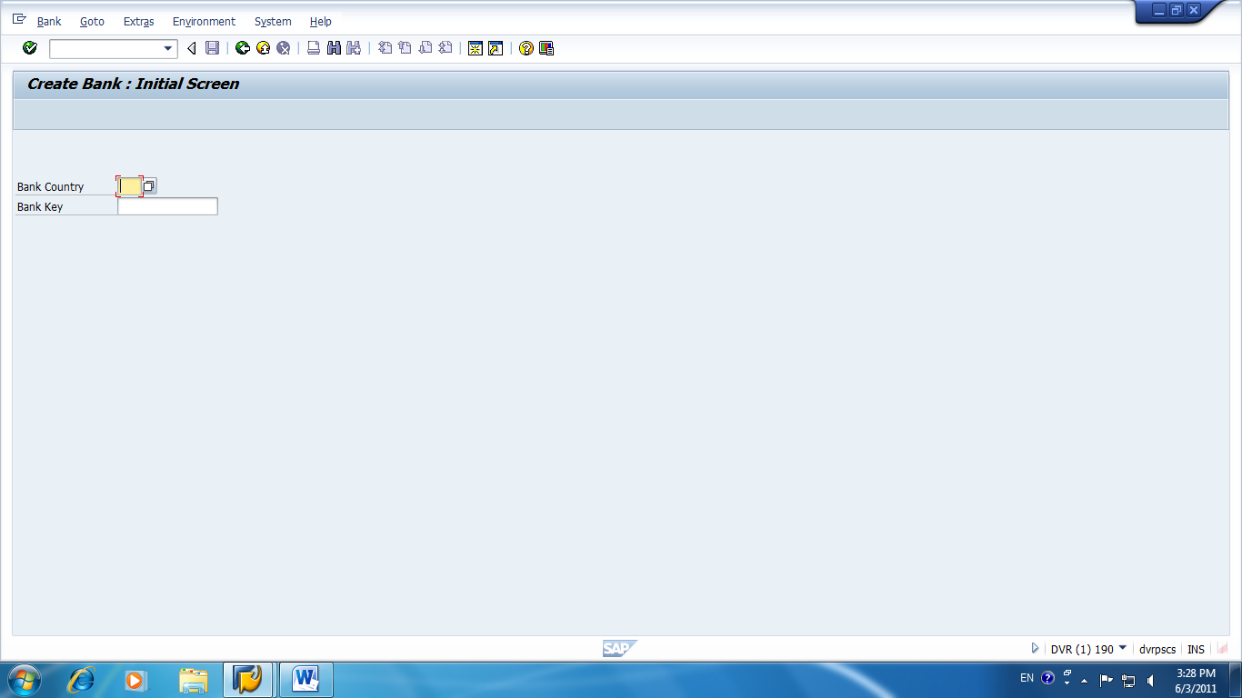
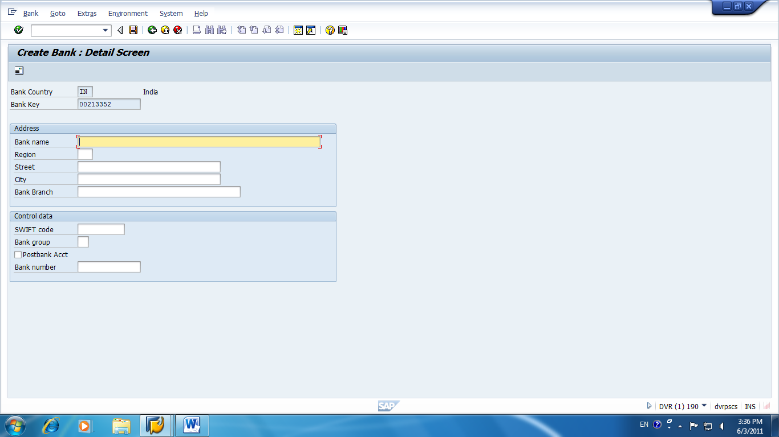

VIEW REPORTS:-

Trial Balance report:-

To view Trial balance selects the option which is in” YELLOW color” in the given below window.

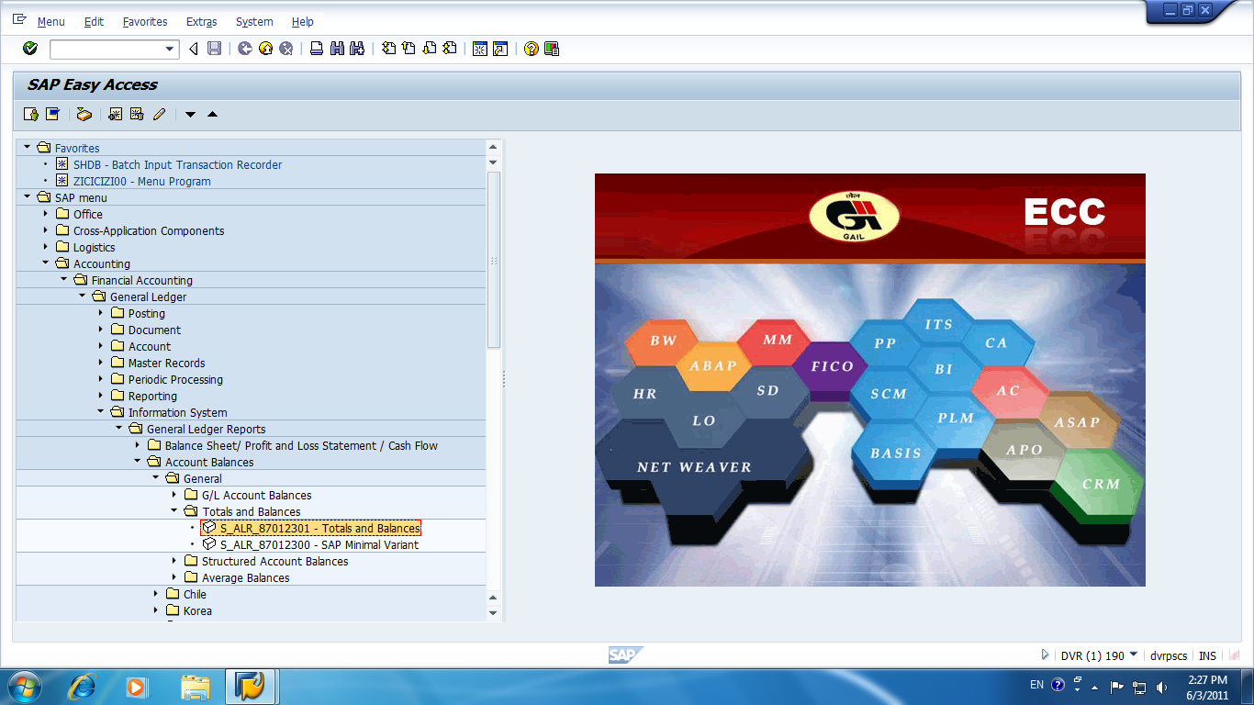

In the given below we used to define our requirements for displaying trail- balance. Here we assign Company Code and the time period for which we want Trial report.

After providing details we select “Execute” option given in the window.

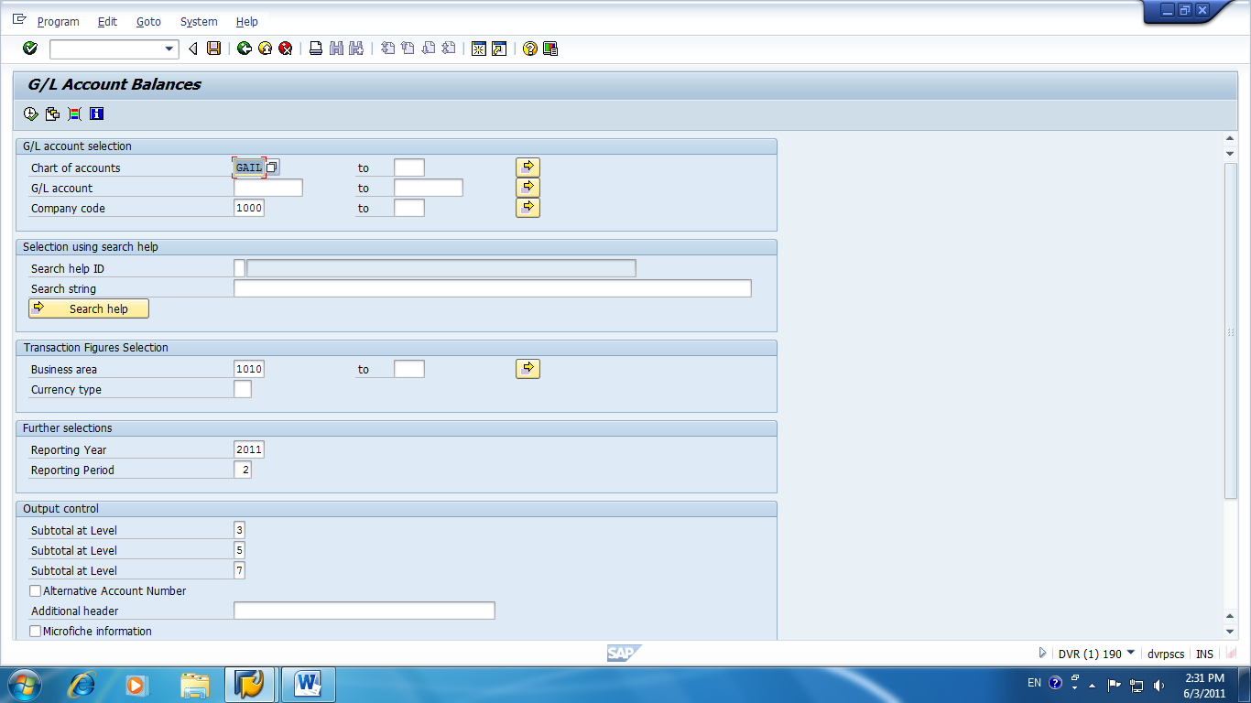

After selecting the option we can access Trial report.

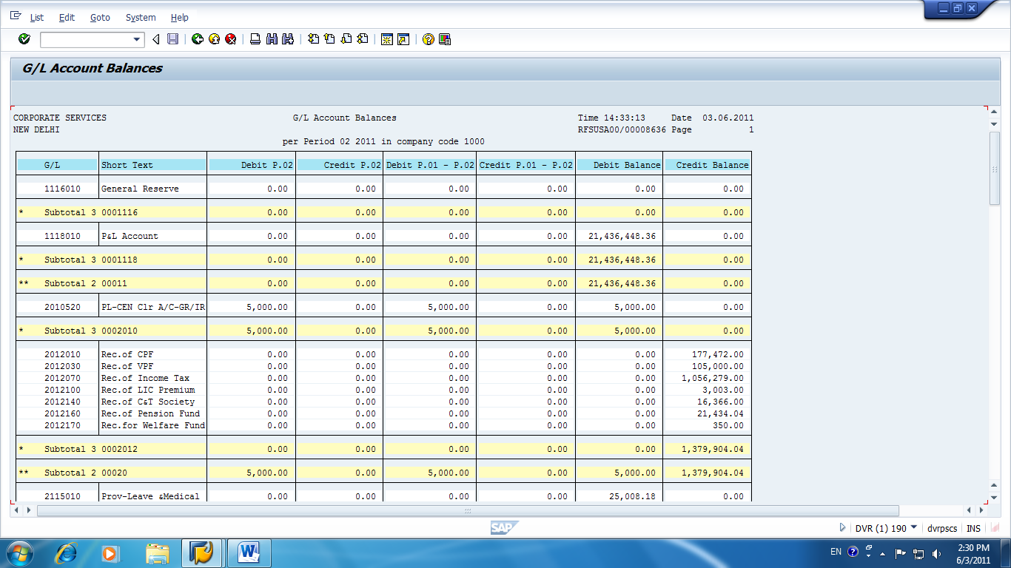

This is Part- I, shortly I upload the next updated file.
Regards,
Mohit Saxena.

