TO IMPORT DATA FROM TALLY TO MS EXCEL
- Open tally → Select Company → Display the Data Window you want to import → Change period
For Example: Display → Account → Purchase Register → F2
From : 01/04/2007
To : 30/06/2007
In case you have to import purchases amount with Input Vat, Press F5 →Select “Yes” or “No” as per your needs.
Than your tally window will look like this:
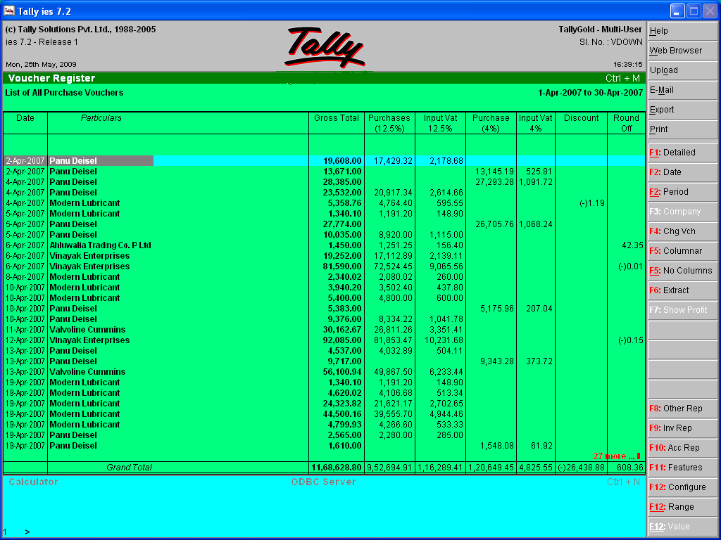
- Click on Export or Press Alt + E
- In the Export window Select ASCII (COMMA DELIMITED) as File Format, If not selected
- Name the Data
- Press Entre a few time till the Export Window does not disappeared.
- Minimize Tally
- Open Ms Excel → Open Files → Select the Drive in which Tally Data exists → Click on Tally →Select Text Files in Types of Files→ Select the text file you named in export window→ click on Open
- Select Delimited in Text Import Wizard:

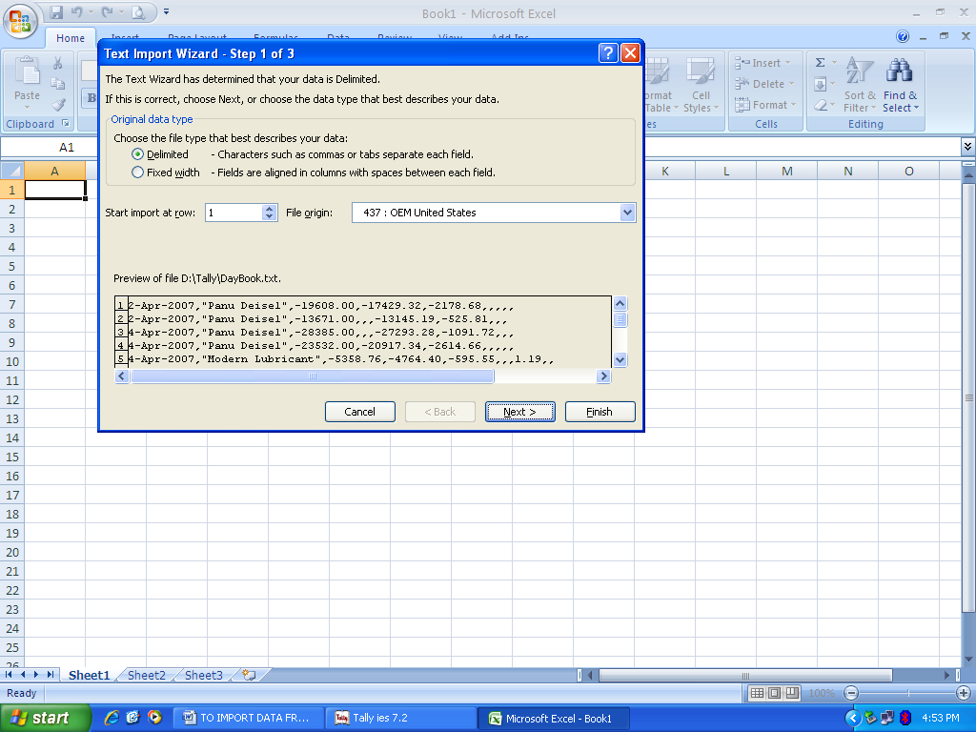

- Click on Next → Select Comma in delimiters → Click on Next → Click on Finish.
- Adjust the column widths→ Name the Headings
- All the numeric figures will be in negative. You can make them positive by multiplying all the figures with -1.
- Filter the Data
- For totaling the filtered data, first filter the data by Date or Particular →Point the cursor just below the numeric figures→ Press Alt+(=) → Press Entre.

Is this helpful for you?
If you have any suggestion, please write to me at nishant2311@icai.org

