Denying access to previous Financial Year’s Data

Objectives:
As mentioned in the email, this document acts as a ‘Self Help Guide’ for denying access to users for last/previous financial year using ‘Security Module’ in Tally. By the end of this guide, you would have learnt to:
- Alter user rights configuration
- Deny access to last/previous financial year
- Secure last financial year data

Who can configure?
- Customers using Security module
- Customers who have created users such as Data Entry, Accountant, Manager, etc.

What are the benefits of this function?
- Denying access to lower level users
- Users will not be able to create/alter transactions of the last financial year
- Audited/finalized last financial transactions remain secure

Walk through in Tally:

Let us consider the example of a company created in Tally:

- Company financial year/books beginning from 1-1-2008
- Created users are:
  - Administrator/Manager > All rights
  - Accountant > Voucher Entry and Reports
  - Data Entry Operator > Voucher entry only
  - Others > With allowed configuration
- Vouchers entered from January 2008 to December 2008
- Started voucher entry for new financial year 2009
- Completed audit/finalized all transactions for the financial year 2008

Note: In the above example we have taken two financial years, but you may have data for more than two years.

Let us now see how we can disallow access to the financial year of 2008 for lower level users such as Accountant, Data entry operator and others.

- Select the company and login as ‘Administrator’, then go to Alt F3 Cmp Info > Security Control > Types of Security > Select one user level:
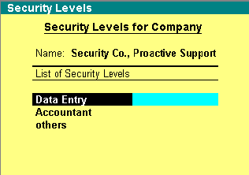

Data Entry level with configuration:
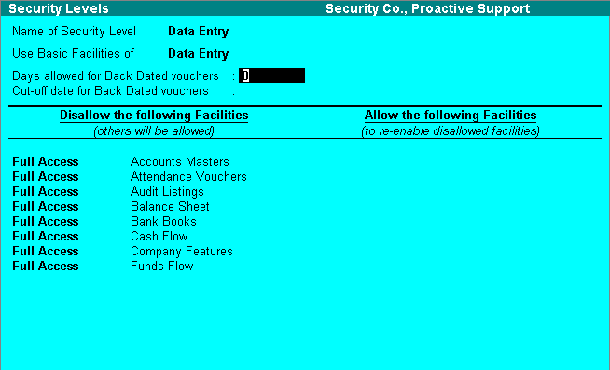

Set the conditions as shown:

- Days allowed for Back Dated vouchers = 365 days
- Cut-off date for Back Dated vouchers = last day of previous financial year, in the above example it is 31-12-2008
- Under Disallow facilities add Full Access = Back Dated Vouchers.

Note: You can set these conditions for other levels also to restrict their access.
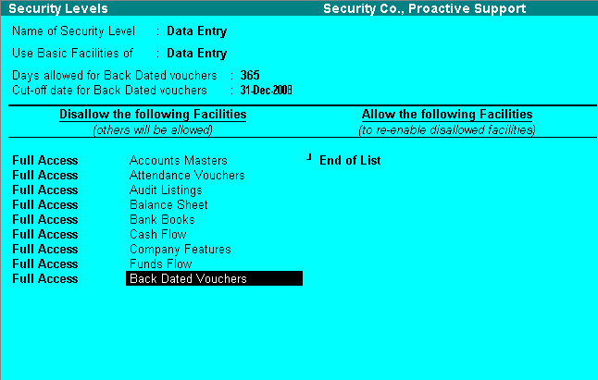

Accept the screen to save the changes.

- Close/shut the company and re-open with a user name and password of the ‘Data Entry’ level. Press Alt F2 and select both the financial years.

- Create/alter vouchers of the previous financial year

Creating a voucher dated 31-12-2008:
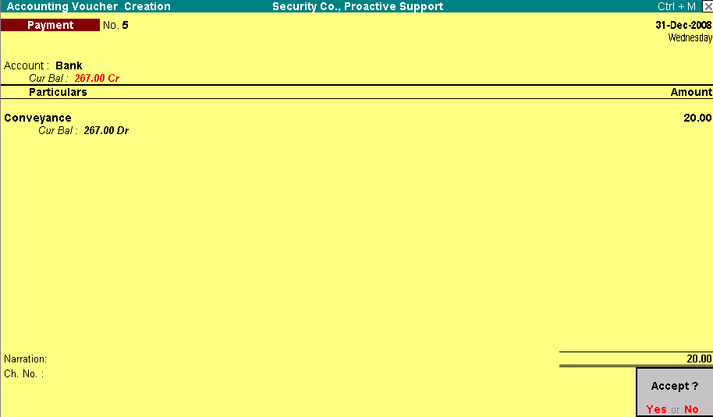

While saving the voucher, the application displays an error message ‘No Access Allowed’.
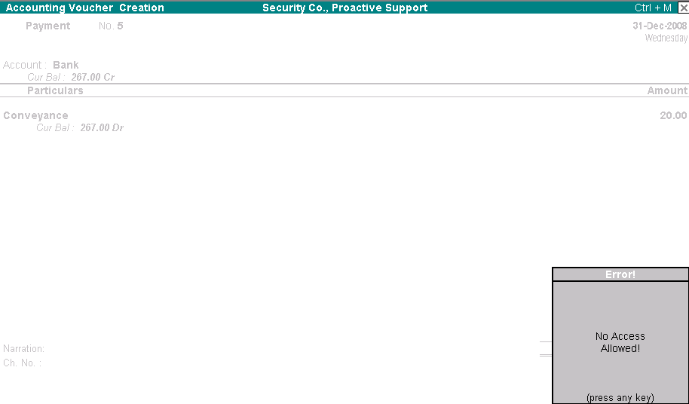

Altering vouchers for the financial year 2008:
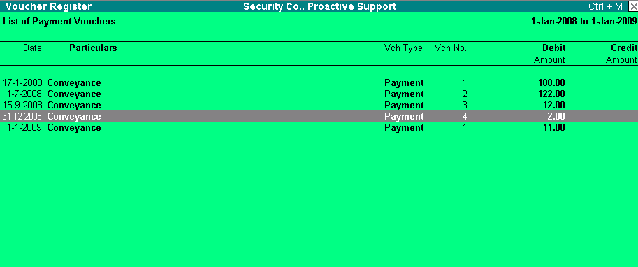
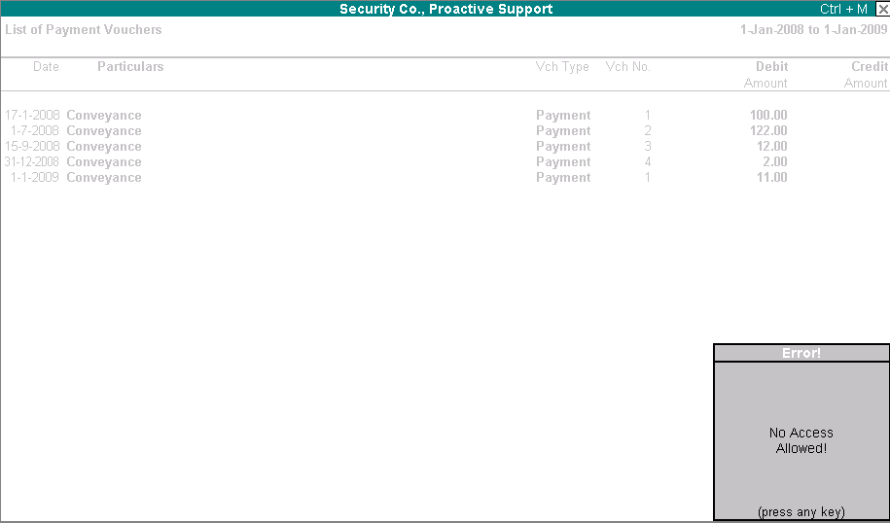
Tally will not allow you to access the vouchers of the previous financial year.

- Create/alter current financial vouchers: You can create/alter vouchers for the current financial year.

Useful Information:
- Access Tally Support through:
  - Online Chat: Login to Tally website http://tallysolutions.ae and click ‘Chat’ button or select below link
http://experts.tallysolutions.com/cgi-bin/chat/livedeptchoose.pl?referer=http://www.tallysolutions.ae/index.shtml
  - Email: Send your Tally queries to support@tallysolutions.com

Note:
For feedback/suggestions/clarifications regarding this communication, please write to support@tallysolutions.com

