Notes

Financial and Corporate Finance Concepts

Financial Statements
Balance Sheet (Financial Position)
A balance sheet is a financial statement that summarizes a company's assets, liabilities and shareholders' equity at a specific point in time. These three balance sheet segments give investors an idea as to what the company owns and owes, as well as the amount invested by shareholders.

Profit and Loss (Financial Status)
A profit and loss statement (P&L) is a financial statement that summarizes the revenues, costs and expenses incurred during a specific period of time, usually a fiscal quarter or year.
Depreciation
Depreciation is an accounting method of allocating the cost of a tangible asset over its useful life.

Minimum alternate tax
The result of such exemptions, deductions, and other incentives under the Income-Tax Act in the form of liberal rates of depreciation is the emergence of zero tax companies, which in spite of having high book profit are able to reduce their taxable income to nil. In order to bring such companies under the I-T net, Section 115JA was introduced from assessment year 1997-98. Now, all companies having book profits under the Companies Act shall have to pay a minimum alternate tax at 18.5%.MAT is a way of making companies pay minimum amount of tax. It is applicable to all companies except those engaged in infrastructure and power sectors. Income arising from free trade zones, charitable activities, investments by venture capital companies are also excluded from the purview of MAT. However, foreign companies with income sources in India are liable under MAT.
Retained earning
Retained earnings refer to the percentage of net earnings not paid out as dividends, but retained by the company to be reinvested in its core business, or to pay debt. It is recorded under shareholders' equity on the balance sheet. The formula calculates retained earnings by adding net income to, or subtracting any net losses from, beginning retained earnings, and subtracting any dividends paid to shareholders.

Fixed Income Security
A fixed-income security is an investment that provides a return in the form of fixed periodic payments and the eventual return of principal at maturity. Unlike a variable-income security, where payments change based on some underlying measure such as short-term interest rates, the payments of a fixed-income security are known in advance.

Examples- treasury Bill , Certificates of deposits, Preferred stocks

Mutual Funds
A mutual fund is an investment vehicle made up of a pool of funds collected from many investors for the purpose of investing in securities such as stocks, bonds, money market instruments and similar assets. Mutual funds are operated by money managers, who invest the fund's capital and attempt to produce capital gains and income for the fund's investors. A mutual fund's portfolio is structured and maintained to match the investment objectives stated in its prospectus.

Net Present Value
Net Present Value (NPV) is the difference between the present value of cash inflows and the present value of cash outflows. NPV is used in capital budgeting to analyze the profitability of a projected investment or project.
A positive net present value indicates that the projected earnings generated by a project or investment (in present dollars) exceeds the anticipated costs (also in present dollars). Generally, an investment with a positive NPV will be a profitable one and one with a negative NPV will result in a net loss. This concept is the basis for the Net Present Value Rule, which dictates that the only investments that should be made are those with positive NPV values.

Internal Rate of Return
Internal rate of return (IRR) is a metric used in capital budgeting measuring the profitability of potential investments. Internal rate of return is a discount rate that makes the net present value (NPV) of all cash flows from a particular project equal to zero.
Higher the IRR more profitable is the project
Mark to Market
Mark to market (MTM) is a measure of the fair value of accounts that can change over time, such as assets and liabilities. Mark to market aims to provide a realistic appraisal of an institution's or company's current financial situation.
2. The accounting act of recording the price or value of a security, portfolio or account to reflect its current market value rather than its book value.
3. When the net asset value (NAV) of a mutual fund is valued based on the most current market valuation.

Wholesale price index
The wholesale price index is an index that measures and tracks the changes in the price of goods in the stages before the retail level. WPI shows the average price change of goods included in the index and is often expressed as a ratio or percentage, and the change is one indicator of a country's level of inflation. Although many countries and organizations use WPI, many other countries, including the United States, use the producer price index instead.
WPI compares the total costs of the goods being considered in one year with the total costs of goods in the base year. To illustrate, imagine 2010 is the base year. The total prices for that year are equal to 100 on the scale. Prices from another year are compared to that total and expressed as a percentage of change. For example, if the total price of the goods under consideration in 2010 was $4,300, and the total for 2015 is $5,000, the WPI for 2015 with a base year of 2010 is 116, indicating an increase of 16%.
Consumer Price Index
The Consumer Price Index (CPI) is a measure that examines the weighted average of prices of a basket of consumer goods and services, such as transportation, food and medical care. It is calculated by taking price changes for each item in the predetermined basket of goods and averaging them. Changes in the CPI are used to assess price changes associated with the cost of living; the CPI is one of the most frequently used statistics for identifying periods of inflation or deflation.
Cost of Capital
The cost of funds used for financing a business. Cost of capital depends on the mode of financing used – it refers to the cost of equity if the business is financed solely through equity, or to the cost of debt if it is financed solely through debt. Many companies use a combination of debt and equity to finance their businesses, and for such companies, their overall cost of capital is derived from a weighted average of all capital sources, widely known as the weighted average cost of capital (WACC). Since the cost of capital represents a hurdle rate that a company must overcome before it can generate value, it is extensively used in the capital budgeting process to determine whether the company should proceed with a project.
WACC
Weighted average cost of capital (WACC) is a calculation of a firm's cost of capital in which each category of capital is proportionately weighted.
All sources of capital, including common stock, preferred stock, bonds and any other long-term debt, are included in a WACC calculation. A firm’s WACC increases as the beta and rate of return on equity increase, as an increase in WACC denotes a decrease in valuation and an increase in risk.
Time Value of Money
The time value of money (TVM) is the idea that money available at the present time is worth more than the same amount in the future due to its potential earning capacity. This core principle of finance holds that, provided money can earn interest, any amount of money is worth more the sooner it is received. TVM is also referred to as present discounted value.

Valuation, Risk and FMI Concepts
Enterprise Value
Enterprise Value, or EV for short, is a measure of a company's total value, often used as a more comprehensive alternative to equity market capitalization. The market capitalization of a company is simply its share price multiplied by the number of shares a company has outstanding. Enterprise value is calculated as the market capitalization plus debt, minority interest and preferred shares, minus total cash and cash equivalents. Often times, the minority interest and preferred equity is effectively zero, although this need not be the case.

EV = Market Cap+Debt-cash and cash equi

Market Cap = No of shares o/s * market value per share

Systematic Risk
The risk inherent to the entire market or an entire market segment. Systematic risk, also known as “undiversifiable risk,” “volatility” or “market risk,” affects the overall market, not just a particular stock or industry. This type of risk is both unpredictable and impossible to completely avoid. It cannot be mitigated through diversification, only through hedging or by using the right asset allocation strategy.

Beta>1 then investment has more systematic risk than the market and vice versa

Unsystematic Risk
Company- or industry-specific hazard that is inherent in each investment. Unsystematic risk, also known as “nonsystematic risk,” "specific risk," "diversifiable risk" or "residual risk," can be reduced through diversification. By owning stocks in different companies and in different industries, as well as by owning other types of securities such as Treasuries and municipal securities, investors will be less affected by an event or decision that has a strong impact on one company, industry or investment

Risk Premium
A risk premium is the return in excess of the risk-free rate of return an investment is expected to yield; an asset's risk premium is a form of compensation for investors who tolerate the extra risk, compared to that of a risk-free asset, in a given investment. For example, high-quality corporate bonds issued by established corporations earning large profits have very little risk of default. Therefore, such bonds pay a lower interest rate, or yield, than bonds issued by less-established companies with uncertain profitability and relatively higher default risk.

Net Asset Value
Net asset value (NAV) is value per share of a mutual fund or an exchange-traded fund (ETF) on a specific date or time. With both security types, the per-share dollar amount of the fund is based on the total value of all the securities in its portfolio, any liabilities the fund has and the number of fund shares outstanding.
Return on Equity or Return on Net Worth
Return on equity (ROE) is the amount of net income returned as a percentage of shareholders equity. Return on equity measures a corporation's profitability by revealing how much profit a company generates with the money shareholders have invested.
ROE is expressed as a percentage and calculated as:
Return on Equity = Net Income/Shareholder's Equity
Net income is for the full fiscal year (before dividends paid to common stock holders but after dividends to preferred stock.) Shareholder's equity does not include preferred shares.

Return on Assets
Return on assets (ROA) is an indicator of how profitable a company is relative to its total assets. ROA gives an idea as to how efficient management is at using its assets to generate earnings. Calculated by dividing a company's annual earnings by its total assets, ROA is displayed as a percentage. Sometimes this is referred to as "return on investment".
The formula for return on assets is: Net Income/Total Assets
Return on Assets (ROA)
Note: Some investors add interest expense back into net income when performing this calculation because they'd like to use operating returns before cost of borrowing.
Interest rate risk
The interest rate risk is the risk that an investment's value will change due to a change in the absolute level of interest rates, in the spread between two rates, in the shape of the yield curve, or in any other interest rate relationship. Such changes usually affect securities inversely and can be reduced by diversifying investing in fixed-income securities with different durations) or hedging (such as through an interest rate swap).

Economic Value Added – EVA
Economic value added (EVA) is a measure of a company's financial performance based on the residual wealth calculated by deducting its cost of capital from its operating profit, adjusted for taxes on a cash basis. EVA can also be referred to as economic profit, and it attempts to capture the true economic profit of a company. This measure was devised by Stern Stewart and Co.
Net Interest Margin
Net interest margin is a performance metric that examines how successful a firm's investment decisions are compared to its debt situations. A negative value denotes that the firm did not make an optimal decision, because interest expenses were greater than the amount of returns generated by investments.
NIM – (Investment Income – Investment Expenses)/ Average Earning Assets
Net Interest Income
Net interest income is the difference between the revenue that is generated from a bank's assets and the expenses associated with paying out its liabilities. A typical bank's assets consist of all forms of personal and commercial loans, mortgages and securities. The liabilities are the customer deposits. The excess revenue that is generated from the interest earned on assets over the interest paid out on deposits is the net interest income.
Consumer Confidence
Consumer confidence is an economic indicator that measures the degree of optimism that consumers feel about the overall state of the economy and their personal financial situation.

Asset-Backed Security - ABS
An asset-backed security (ABS) is a financial security backed by a loan, lease or receivables against assets other than real estate and mortgage-backed securities. For investors, asset-backed securities are an alternative to investing in corporate debt.
An ABS is essentially the same thing as a mortgage-backed security, except that the securities backing it are assets such as loans, leases, credit card debt, a company's receivables, royalties and so on and not mortgage-based securities.

Index of Industrial Production
The Index of Industrial Production (IIP) is an index for India which details out the growth of various sectors in an economy such as mining, electricity and manufacturing. The all India IIP is a composite indicator that measures the short-term changes in the volume of production of a basket of industrial products during a given period with respect to that in a chosen base period. It is compiled and published monthly by the Central Statistical Organisation (CSO) six weeks after the reference month ends.
The level of the Index of Industrial Production (IIP) is an abstract number, the magnitude of which represents the status of production in the industrial sector for a given period of time as compared to a reference period of time. The base year was at one time fixed at 1993–94 so that year was assigned an index level of 100. The current base year is 2004–2005.
The Eight Core Industries comprise nearly 38 % of the weight of items included in the Index of Industrial Production (IIP). These are Electricity, steel, refinery products, crude oil, coal, cement, natural gas and fertilisers.

Double Taxation Avoidance Agreement
Suppose a person, from say India, moves to foreign land to make a living. He leaves behind some residential property, land, or investments of any other sort which are also a source of his income. Now this investment will be taxed not only in India but also the foreign land where he resides, as earning from India will be added to calculate total global earning and then taxed in his country of residence. So eventually he is paying tax twice on the same income. To avoid this we have a treaty called DTAA which India has signed with over 80 countries. The precise manner in which one is exempted from paying the tax twice varies from one treaty to another. For instance the resident country may exempt the income earned in the foreign land or may grant credit for the tax paid.

Stock Selection Criteria
Objectives
The objective of stock selection criteria is to:
(1) maximize the total return on investment (appreciation plus any dividends received) for the targeted holding period
(2) limit risk (according to an individual's risks tolerance levels)
(3) maintain an appropriate degree of portfolio diversification.
Selection components
The analytical components utilized by investors as stock selection criteria may include one or more of the following :-

Sector analysis
Sector analysis involves identification and analysis of various industries or economic sectors that are likely to exhibit superior performance. Academic studies indicate that the health of a stock's sector is as important as the performance of the individual stock itself. In other words, even the best stock located in a weak sector will often perform poorly because that sector is out of favor. Each industry has differences in terms of its customer base, market share among firms, industry growth, competition, regulation and business cycles. Learning how the industry operates provides a deeper understanding of a company's financial health. One method of analyzing a company's growth potential is examining whether the amount of customers in the overall market is expected to grow. In some markets, there is zero or negative growth, a factor demanding careful consideration. Additionally, market analysts recommend that investors should monitor sectors that are nearing the bottom of performance rankings for possible signs of an impending turnaround.

Quantitative cumulative value analysis
Quantitative cumulative value analysis: This method is also commonly referred to as fundamental analysis. Fundamental analysts consider past records of assets, earnings, sales, products, management, and markets in predicting future trends in these indicators and how they may affect a company’s future success or failure. By appraising a firm’s prospects, these analysts determine a stock’s intrinsic value and assess whether a particular stock or group of stocks is undervalued or overvalued at the current market price. If the intrinsic value is more than the current share price, then this stock would appear to be undervalued and a possible candidate for investment. While there are several different methods for determining intrinsic value, the underlying premise is that a company is worth the sum of its discounted cash flows (DCF). The DCF is the value of future expected cash receipts and expenditures at a common date, which is calculated using net present value or internal rate of return. This means a company is worth the combined sum of its future profits, while at the same time being discounted in consideration of the time value of money. This value, as determined by the discounted cash flow analysis or its equivalents, consists of two components:
- Current value ratios, such as the price-earnings (P/E) ratio and price-book (P/B) ratio.[3] The PE ratio, also called the multiple, gives investors an idea of how much they are paying for a company’s earning power. The higher the PE, the more investors are paying, and therefore the more earnings growth they are expecting. High PE stocks – those with multiples over 20 – are typically young, fast-growing companies. P/B is the ratio of a stock’s price to its book value per share. A stock selling at a high PB ratio, such as 3 or higher, may represent a popular growth stock with minimal book value. A stock selling below its book value may attract value-oriented investors who think that the company’s management may undertake steps, such as selling assets or restructuring the company, to unlock hidden value on the company’s balance sheet.

- Earnings growth which may be reflected in measures like the Prospective Earnings Growth (PEG) ratio. The PEG ratio is a projected one-year annual growth rate, determined by taking the consensus forecast of next year’s earnings, less the current year’s earnings, and dividing the result by the current year’s earnings.

Management issues
Management issues involves examining perceptions about management and perceptions by management. It includes various qualitative judgments regarding the competence of current and prospective company management, as well as issues related to insider buying, future strategies to increase operations and market share. Most large companies compensate executives through a combination of cash, restricted stock and options. It is a positive sign when members of management are also shareholders. When management makes large purchases of their own stock with private funds, it may indicate that management insiders feel the company is undervalued, or that a favorable company event will occur soon. Another way to get a feel for management capability is to examine how executives performed at other companies in the past. Warren Buffett has several recommendations for investors who want to evaluate a company’s management as a precursor to possible investment in that company’s stock. For example, he advises that one way to determine if management is doing a good job is to evaluate the company's return on equity, instead of their earnings per share (the portion of a company’s profit allocated to each outstanding share of common stock). "The primary test of managerial economic performance is achievement of a high earnings rate on equity capital employed (without undue leverage, accounting gimmickry, etc.) and not the achievement of consistent gains in earnings per share." Buffett notes that because companies usually retain a portion of their earnings, the assets a profitable company owns should increase annually. This additional cash allows the company to report increased earnings per share even if their performance is deteriorating. He also emphasizes investing in companies with a management team that is committed to controlling costs. Cost-control is reflected by a profit margin exceeding those of competitors. Superior managers "attack costs as vigorously when profits are at record levels as when they are under pressure". Therefore, be wary of companies that have opulent corporate offices, unusually large corporate staffs and other signs of bloat. Additionally, Buffett suggests investing in companies with honest and candid management, and avoiding companies that have a history of using accounting gimmicks to inflate profits or have misled investors in the past.

Stocks with high P/E ratios can be overpriced. Is a stock with a lower P/E always a better investment than a stock with a higher one?

The short answer? No. The long answer? It depends.
The price-to-earnings ratio (P/E ratio) is calculated as a stock's current share price divided by its earnings per share (EPS) for a twelve-month period (usually the last 12 months, or trailing twelve months (TTM)). Most of the P/E ratios you see for publicly-traded stocks are an expression of the stock's current price compared against its previous twelve months' earnings.
A stock trading at $40/share with an EPS (ttm) of $2 would have a P/E of 20 ($40/$2), as would a stock priced at $20/share with an EPS of $1 ($20/$1). These two stocks have the same price-to-earnings valuation - in both cases investors pay $20 for each dollar of earnings.
But, what if a stock earning $1 per share was trading at $40/share? Now we'd have a P/E ratio of 40 instead of 20, which means the investor would be paying $40 to claim a mere $1 of earnings. This seems like a bad deal, but there are several factors which could mitigate this apparent overpricing problem.
First, the company could be expected to grow revenue and earnings much more quickly in the future than companies with a P/E of 20, thus commanding a higher price today for the higher future earnings. Second, suppose the estimated (trailing) earnings of the 40-P/E company are very certain to materialize, whereas the 20-P/E company's future earnings are somewhat uncertain, indicating a higher investment risk. Investors would incur less risk by investing in more certain earnings instead of less certain ones, so the company producing those sure-thing earnings again commands a higher price today.
Secondly, it must also be noted that average P/E ratios tend to vary from industry to industry. Typically, P/E ratios of companies in very stable, mature industries which have more moderate growth potential have lower P/E ratios than companies in relatively young, quick-growing industries with more robust future potential. Thus, when an investor is comparing P/E ratios from two companies as potential investments, it is important to compare companies from the same industry with similar characteristics. Otherwise, if an investor simply purchased stocks with the lowest P/E ratios, they would likely end up with a portfolio full of utilities stocks and similar companies, which would leave them poorly diversified and exposed to more risk than if they had diversified into other industries with higher-than-average P/E ratios. (To read more on P/E ratios, see Understanding The P/E Ratio and Analyze Investments Quickly With Ratios.)
However, this doesn't mean that stocks with high P/E ratios cannot turn out to be good investments. Suppose the same company mentioned earlier with a 40-P/E ratio (stock at $40, earned $1/share last year) was widely expected to earn $4/share in the coming year. This would mean (if the stock price didn't change) the company would have a P/E ratio of only 10 in one year's time ($40/$4), making it appear very inexpensive.
The important thing to remember when looking at P/E ratios as part of your stock analysis is to consider what premium you are paying for a company's earnings today, and determine if the expected growth warrants the premium. Also compare it to its industry peers to see its relative valuation to determine whether the premium is the worth the cost of the investment.
Now that you have an understanding of the P/E ratio in terms of stock valuation, learn how the PEG Ratio can help investors price a company based on its future growth potential in

How To Use The P/E Ratio And PEG To Tell A Stock's Future
It is common practice for investors to use the price-to-earnings ratio (P/E ratio or price multiple) to determine if a company's stock price is over or undervalued. Companies with a high P/E ratio are typically growth stocks. However, their relatively high multiples do not necessarily mean their stocks are overpriced and not good buys for the long term.
There are two primary components here, the market value (price) of the stock and the earnings of the company. Earnings are very important to consider. After all, earnings represent profits, and that's what every business strives for. Earnings are calculated by taking the hard figures into account: revenue, cost of goods sold (COGS), salaries, rent, etc. These are all important to the livelihood of a company. If the company isn't using its resources effectively it will not have positive earnings, and problems will eventually arise. Learn more about how to use the price-to-earnings ratio to reveal a stocks real market value. Read Profit With The Power Of Price-To-Earnings.)
The relationship between the price/earnings ratio and earnings growth tells a more complete story than
the P/E on its own. This is called the PEG ratio and is formulated as:

PEG ratio
*The number used for annual growth rate can vary. It can be forward (predicted growth) or trailing, and either a one- to five-year time span. Check with the source providing the PEG ratio to see what kind of number they use.
Looking at the value of PEG of companies is similar to looking at the P/E ratio: A lower PEG means the stock is more undervalued.

Comparative Value
Let's demonstrate the PEG ratio with an example. Say you are interested in buying stock in one of two companies. The first is a networking company with 20% annual growth in net income and a P/E ratio of 50. The second company is in the beer brewing business. It has lower earnings growth at 10% and its P/E ratio is also relatively low at 15. (There are many other common ratios to use when comparing stocks, such as the P/S ratio. Learn more in How To Use Price-To-Sales Ratios To Value Stock.)
Many investors justify the stock valuations of tech companies by relying on the assumption that these companies have enormous growth potential. Can we do the same in our example?

Networking Company:
P/E ratio (50) divided by the annual earnings growth rate (20) = PEG ratio of 2.5
Beer Company:
P/E ratio (15) divided by the annual earnings growth rate (10) = PEG ratio of 1.5
The PEG ratio shows us that, when compare to the beer company, the always-popular tech company doesn't have the growth rate to justify its higher P/E, and its stock price appears overvalued.

The Bottom Line
Subjecting the traditional P/E ratio to the impact of future earnings growth produces the more informative PEG ratio. The PEG ratio provides more insight about a stock's current valuation. By providing a forward-looking perspective, the PEG is a valuable evaluative tool for investors attempting to discern a stock's future prospects.
(Every investor wants an edge in predicting a company's future, but a company's earnings guidance statements may not be a reliable source. To learn more, read Can Earnings Guidance Predict The Future?)

DDM Stable Growth rate
The second issue relates to what growth rate is reasonable as a 'stable' growth rate. As noted in Chapter 12, this growth rate has to be less than or equal to the growth rate of the economy in which the firm operates. This does not, however, imply that analysts will always agree about what this rate should be even if they agree that a firm is a stable growth firm for three reasons.
•Given the uncertainty associated with estimates of expected inflation and real growth in the economy, there can be differences in the benchmark growth rate used by different analysts, i.e., analysts with higher expectations of inflation in the long term may project a nominal growth rate in the economy that is higher.
•The growth rate of a company may not be greater than that of the economy but it can be less. Firms can becomes smaller over time relative to the economy.
•There is another instance in which an analyst may be stray from a strict limit imposed on the 'stable growth rate'. If a firm is likely to maintain a few years of 'above-stable' growth rates, an approximate value for the firm can be obtained by adding a premium to the stable growth rate, to reflect the above-average growth in the initial years. Even in this case, the flexibility that the analyst has is limited. The sensitivity of the model to growth implies that the stable growth rate cannot be more than 1% or 2% above the growth rate in the economy. If the deviation becomes larger, the analyst will be better served using a two-stage or a three-stage model to capture the 'super-normal' or 'above-average' growth and restricting the Gordon growth model to when the firm becomes truly stable.

What is the 'Intrinsic Value'
The intrinsic value is the actual value of a company or an asset based on an underlying perception of its true value including all aspects of the business, in terms of both tangible and intangible factors. This value may or may not be the same as the current market value. Additionally, intrinsic value is primarily used in options pricing to indicate the amount an option is in the money.

Zero Coupon Bonds
Zero Coupon Bonds are the bonds which doesn’t make any interest payments till maturity i.e. it is a one time cash inflow at the time of maturity. It is issued by government as well as corporates. Government Zero coupon bonds are exempted from tax but in case of corporate zero coupon bonds investors have to pay tax on income which they will receive only at maturity

Nominal Rate Of Return
A nominal rate of return is the amount of money generated by an investment before factoring in expenses such as taxes, investment fees and inflation. For example, detailed data on a mutual fund might show the fund's nominal rate of return as 10% but also show its return after taxes on distributions and sales of fund shares as only 7%. Investors must look beyond an investment's nominal rate of return to get a true idea of an investment's likely earnings.

Risk-Free Rate of Return
The risk-free rate of return is the theoretical rate of return of an investment with zero risk. The risk-free rate represents the interest an investor would expect from an absolutely risk-free investment over a specified period of time.

Net Asset Value - NAV
Net asset value (NAV) is value per share of a mutual fund or an exchange-traded fund (ETF) on a specific date or time. With both security types, the per-share dollar amount of the fund is based on the total value of all the securities in its portfolio, any liabilities the fund has and the number of fund shares outstanding. In the context of mutual funds, NAV per share is computed once per day based on the closing market prices of the securities in the fund's portfolio. All of the buy and sell orders for mutual funds are processed at the NAV of the trade date. However, investors must wait until the following day to get the trade price. Mutual funds pay out virtually all of their income and capital gains. As a result, changes in NAV are not the best gauge of mutual fund performance, which is best measured by annual total return. Because ETFs and closed-end funds trade like stocks, their shares trade at market value, which can be a dollar value above (trading at a premium) or below (trading at a discount) NAV. ETFs have their NAV calculated daily at the close of the market for reporting purposes, but they also calculate intra-day NAV multiple times per minute in real time.

Example Mutual Fund Net Asset Value Calculation
The formula for a mutual fund's NAV calculation is straightforward:
NAV = (assets - liabilities) / number of outstanding shares
In this context, assets include total market value of the fund's investments (priced using the closing price of all the assets on the day the NAV is calculated), cash and cash equivalents, receivables and accrued income. Liabilities equal total short-term and long-term liabilities, plus all accrued expenses, such as staff salaries, utilities and other operational expenses.
For example, a mutual fund has $100 million of investments, based on the day's closing prices for each individual asset. It also has $7 million of cash and cash equivalents on hand, as well $4 million in total receivables. Accrued income for the day is $75,000. The fund has $13 million in short-term liabilities and $2 million in long-term liabilities. Accrued expenses for the day are $10,000. The fund has 5 million shares outstanding. The NAV is calculated as:
NAV = (($100,000,000 + $7,000,000 + $4,000,000 + $75,000) - ($13,000,000 + $2,000,000 + $10,000)) / 5,000,000 = ($111,075,000 - $15,010,000) / 5,000,000 = $19.21
In practice, the expenses many be numerous; operating expenses, management expenses, distribution and marketing expenses, transfer agent fees, custodian and audit fees are all included.

SAPM Concepts
Security Market Line
The security market line (SML) is a line drawn on a chart that serves as a graphical representation of the capital asset pricing model (CAPM), which shows different levels of systematic, or market, risk of various marketable securities plotted against the expected return of the entire market at a given point in time. Also known as the "characteristic line," the SML is a visual of the capital asset pricing model (CAPM), where the x-axis of the chart represents risk in terms of beta, and the y-axis of the chart represents expected return. The market risk premium of a given security is determined by where it is plotted on the chart in relation to the SML.
The security market line is commonly used by investors in evaluating a security for inclusion in an investment portfolio in terms of whether the security offers a favorable expected return against its level of risk. When the security is plotted on the SML chart, if it appears above the SML, it is considered undervalued because the position on the chart indicates that the security offers a greater return against its inherent risk. Conversely, if the security plots below the SML, it is considered overvalued in price because the expected return does not overcome the inherent risk.
Capital Market Line
The capital market line (CML) appears in the capital asset pricing model to depict the rates of return for efficient portfolios subject to the risk level (standard deviation) for a market portfolio and the risk-free rate of return.
The capital market line is created by sketching a tangent line from the intercept point on the efficient frontier to the place where the expected return on a holding equals the risk-free rate of return. However, the CML is better than the efficient frontier because it considers the infusion of a risk-free asset in the market portfolio.
Efficient Frontier
The efficient frontier is the set of optimal portfolios that offers the highest expected return for a defined level of risk or the lowest risk for a given level of expected return. Portfolios that lie below the efficient frontier are sub-optimal, because they do not provide enough return for the level of risk. Portfolios that cluster to the right of the efficient frontier are also sub-optimal, because they have a higher level of risk for the defined rate of return.
Assume a risk-seeking investor uses the efficient frontier to select investments. The investor would select securities that lie on the right end of the efficient frontier. The right end of the efficient frontier includes securities that are expected to have a high degree of risk coupled with high potential returns, which is suitable for highly risk-tolerant investors. Conversely, securities that lie on the left end of the efficient frontier would be suitable for risk-averse investors.

Financial Ratios
Balance Sheet Ratios
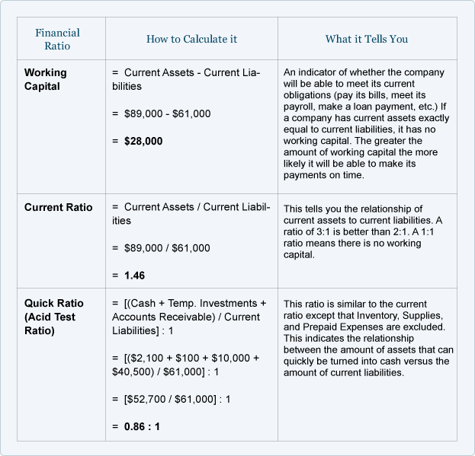
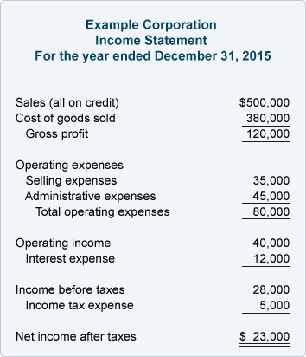
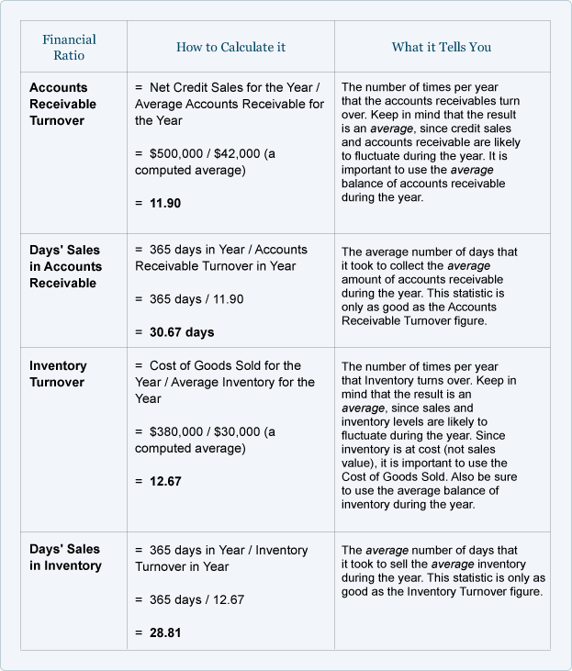
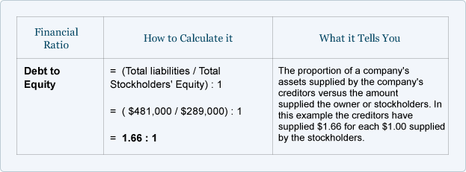
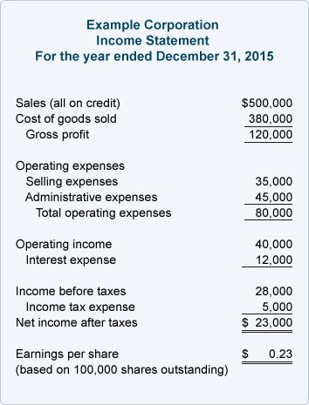

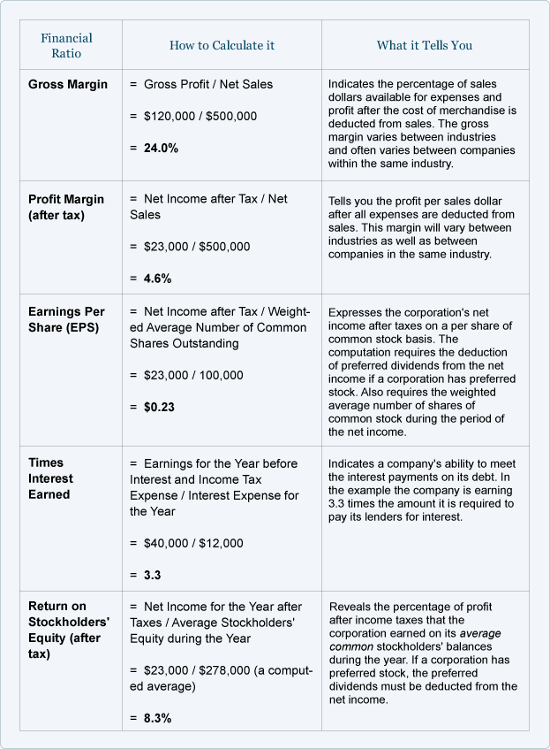
BEHAVIOURAL FINANCE CYCLE FROM BOOM TO BUST
Reluctancy
It is worth starting with the word that occurs at both the start and end of the chart: reluctance. This is the ‘default’ state of most investors. In normal circumstances we fear taking a risk and getting it wrong, more than we fear missing out. This reluctance to get involved is compounded by another strong behavioural effect: loss aversion. Simply put, when we make decisions, “losses loom larger than gains” 6 – we believe we will feel more emotional pain from losing a certain amount than the pleasure we experience from gaining the same amount. This may seem intuitive, but it has huge implications for investors. The proportion of loss we perceive for the same portfolio can be manipulated by how returns are presented to us.
Optimism to (irrational) exuberance: herding and fear of missing out
As markets pick up and the economy enters a positive phase, our natural state of reluctance diminishes. Enough good news stories about successful investments, and friends telling you how well they’ve done in the markets, and our fear of failure quickly turns into a fear of missing out. Our natural aversion to loss may now cause us to take action to increase short-term emotional comfort, this time by entering the market. This now feels comfortable because we’re with the herd, not against it; and because the sustained period of positive results has helped to blur our recollections of losses and perceptions of risk (ironically, just when markets have furthest to fall). The more psychologically immediate loss is now the thought of not getting great returns when everyone around you is profiting from their investments.
In one sense the costs of this enthusiasm can be less detrimental than perennial reluctance. Buying high certainly reduces returns, but as long as you subsequently stick with it, eventually average returns will turn positive, which is better than the zero excess returns of being out of the market altogether. However, buying at the top also has the effect of making subsequent short-term experiences far more unpleasant, increasing the chance of compounding these costs with further emotionally driven decisions.
Denial to panic: reference points and endowment effects
The point at which we enter the markets fixes in our minds a reference point against which we judge further gains and losses. Should we enter at the top, a great deal of our future experience will be of loss. Since we’re so averse to losses, this frequently means that at the very point when objective evaluation of negative information is most useful to us, we take steps to shield ourselves from it.
So at the top, investors often have high expectations and decisions have a high emotional component. When reality starts to intervene, investors start to shield themselves psychologically from the bad news, and move into denial. This reluctance to sell often has the effect of keeping markets artificially high for a while, allowing the bad news to accumulate. No one wants to sell at a loss and so instead of falling, volumes dry up. This is particularly evident in markets for large, indivisible, illiquid assets that form a significant part of investors’ total wealth, and which have a strong emotional component – that is, residential property. But sooner or later some investors will be forced to sell, bursting the dam and precipitating falling prices. Investors then move on from denial to fear, desperation and panic.
Capitulation to reluctance: expensive comfort and the anxiety premium
On the way down, loss aversion and denial tends to cause investors to hold on to their investments. As their portfolio plummets, the emotional pain of selling at a loss increases too, but at a diminishing rate. Losing 5% hurts, but the first 5% hurts the most. Once you’ve already lost 30%, the difference between -35% and -30% feels less significant than the difference between -5% and no loss at all.9 Meanwhile, the emotional stress of sticking with falling investments, combined with the fear of even greater losses ahead, builds up and takes its toll.
Some investors sell at a loss because they’re forced to by a lack of liquidity, inducing the forced sales that often precipitate the rapid decline.10 11 But most of the time when investors sell in crises, it is not because they have run out of financial liquidity (at least, seldom to the extent of needing to liquidate their entire portfolio). More often the investor, rather than running out of financial solvency, depletes their reserve of emotional liquidity, and lacks the emotional resilience to hold their investments through the stress, fear and anxiety. Eventually the depletion of emotional liquidity, anxiety and fear of further losses trumps the aversion to realising losses already sustained.
In crises, we sell far more because we are scared, stressed and anxious than genuinely in need of our wealth to be in cash. This is not ‘irrational’ – it is perfectly reasonable to capitulate in order to remove the extreme anxiety of staying invested in a falling market – it’s just really, really expensive. Once you exit the market for emotional reasons, you can’t quickly and easily get back to optimism, but have to gradually claw your way back through despondency, depression, apathy, indifference… and reluctance. This can take many years, and in the process you miss out on the recovery from the bottom, which can often be both fast and powerful.
And, unfortunately, it is when markes are panicked, anxious or fatigued that the potential upside is greatest. Those investors who can overcome these short-term needs can capitalise on the anxiety and myopia of the rest. But, of course, it is at such times when this is most difficult. After a costly ride through the emotional cycle, we end up once again at RELUCTANCE, the baseline we started from, which causes us to forgo returns by not putting our wealth to work.
Masala bonds
Masala bonds are bonds issued outside India but denominated in Indian Rupees, rather than the local currency. But at maturity it is received in terms of local currency. As it is rupee denominated bond the risk will be borne by the investor. The issuer does not carry any currency risk by issuing this bond in the foreign market.
For example
Price of a bond in Rupee terms - 1050
INR/USD rate on investment date -60
Amount Invested in USD ($) -17.5
Redemption Amount in Rupee terms -1110
INR/USD rate on Redemption date -70
Redemption amount in USD ($) -15.85
The investor pays $17.5 and receives $15.85. The loss of $1.65 on his investment due to fluctuation in exchange rate has to be borne by the investor.

List of Companies Issuing Masala Bonds
HDFC , Yes Bank , Power Finance Corporation , IRFC
Listed in London Stock Exchange
If inflation increases , Interest rates decreases

Multibagger Stocks
A stock that doubles its price is called two-bagger while if the price grows 10-times, it would be called a 10-bagger. Thus, multibaggers are stocks whose prices have risen multiple times their initial investment
These are essentially stocks that are undervalued and have strong fundamentals, thus presenting themselves as great investment options. Multibagger stock companies are strong on corporate governance and have businesses that are scalable within a short span of time.

Approaches to identify a Multibagger

1) Buying Stocks With Low Price In Relation To Earnings
Investing in low price to earnings ratio (P/E ratio) stocks has been around for about a century now. Low P/E ratio segment contains stocks which are yet to be recognized by general market participants and therefore, available at low valuations. Investing stock that are priced low in relation to earnings includes investments in companies are expected to grow in the future. It is also preferable to similar priced company whose earnings are not expected to grow.

2) Buying Stocks With Low Price in Relation to Book Value
Price to book value is arrived at by dividing the market price of a share with the respective company's book value per share. P/B is a method for finding low-priced stocks that the market has neglected. Stocks priced at less than book value are purchased on the assumption that, in time, their market price will reflect at least their stated book value.
Two Things a Low P/B tells us :

3) Buying Stocks With Low Price in Relation to Liquidating Value
Buy stocks at a cost less than their NCAV(Net Current Asset Value)-a stock selection technique successfully employed by Benjamin Graham. Why only CURRENT ASSETS because they can converted into cash within a year, thus, a good measure of the company’s worth if it were to be liquidated.

4) Buying Stocks Using Benjamin Graham’s Magic Multiple
It is multiple of a stock’s P/E and its P/BV. Since this multiples combines the most important valuation ratio and gives a much clear picture, it came to be known as Graham’s magic multiple. Helps to avoid confusion when one ratio indicates that stock is cheap and other indicate stock is costly.

Other Approaches
5) Debt Free / Low Debt Companies
6) Check Operating Performance
7) EPS Growth Vs. Stock Price
8) Eye on Investments and Structural Changes of the company
9) Stocks with Unique Business Model

Headwind and Tailwinds
Tailwind
From an aviation perspective, a tailwind is wind pushing the tail of the aircraft and helping it go faster.
In business, the term “tailwinds” refers to or describes a situation or condition that will move growth, revenues, or profits higher. For example, lower gasoline prices will reduce the forecasted transportation costs of a manufacturing business and therefore increase profitability.

Examples
- Make in India campaign will prove to be tailwind by increasing investment in India and increasing consumption.
- New technology developments expected over the next five years;
- The 7th pay commission could help boost spending and increase consumption boosting the underutilized production capacity.
- Negative interest rates introduced by Bank of Japan have resulted in borrowing in Yen and euros to buy Rupee denominated assets. If this risk pays off it could give a kick start to the Indian economy.
- Introduction of GST.
- Good Monsoon- Will result in the increase in the demand of rural products.
- Indian Railways
- Indian Government to raise money for infrastructure expansion from LIC

Headwinds
From an aviation perspective, a headwind is wind pushing against the front of the aircraft which slows it down. In business, the term “headwinds” are the opposite of the tailwinds. Headwinds in business are situations or conditions that make growth harder. For example, Coca-Cola announced that they are forecasting their earnings to plunge by 55%. One of the reasons is the “tailwind” of a healthier consumer base looking at lifestyle and fitness more than ever.
Examples of Headwinds
- BREXIT affected all the economies and Indian economy was no exception
- FED’s proposal to increase Interest rates in an attempt to boost their economy by increasing consumption and demand. This may result in outflow of Capital from Emerging economies like India. Such outflow will adversely affect India’s FX reserves.
- Panama Papers – Shows huge black money stashed in foreign countries resulting in a loss of forex to India.
- US Elections – the result will have great impact on the economy.
- Italy Referendum may result in tear of EU apart.
- Recession taking place after every 8.5years, resulting into no growth.
- The Chinese currency is still highly over valued by 25-30% and the manufacturing sector is not performing too well in China. However, from the Indian point of view Indian imports from China are 7 times higher than its exports and India does not have the capacity to compete with China and become a world growth driver.

Carry Trade
A carry trade is a strategy in which an investor BORROWS money at a LOW INTEREST RATE in order to INVEST in an asset that is likely to provide a HIGHER RETURN. .This strategy is very common in the foreign exchange market.
A currency carry trade is a strategy in which an investor sells a certain currency with a relatively low interest rate and uses the funds to purchase a different currency yielding a higher interest rate. A trader using this strategy attempts to capture the difference between the rates, which can often be substantial, depending on the amount of leverage used. Difference in interest rates comes about as a result of different central bank actions. For example, the central bank in one country may lower interest rates to stimulate the economy, while a central bank in another country might keep interest rates high to fight inflation.

Risk in Carry Trade
The big risk in a carry trade is the uncertainty of exchange rates. If the U.S. dollar were to fall in value relative to the Japanese yen, the trader runs the risk of losing money. Also, these transactions are generally done with a lot of leverage, so a small movement in exchange rates can result in huge losses unless the position is hedged appropriately.

Example of Carry Trade
Rate in Japan – 0.5%
Rate in US – 4%
Exchange rate – 1 dollar = 115 yen
Trader borrows yen and converts into dollars. He would then invest those dollars into a security paying US rate
Assuming the trader borrows 50 million yen
Rate in Japan – 0.5%
Rate in US – 4%
Exchange rate – 1 dollar = 115 yen
Trader borrows yen and converts into dollars. He would then invest those dollars into a security paying US rate
Assuming the trader borrows 50 million yen

Quantitative Easing
QE1 (December 2008). In December 2008, the Fed started buying longer-term Treasury securities as well as the debt and the mortgage-backed securities (MBS) of Fannie Mae and Freddie Mac, two government-sponsored enterprises (GSEs).The Fed announced it would purchase up to $100 billion of the GSEs’ debt and up to $500 billion of their MBS from both banks and the GSEs themselves.

QE2 (November 2010). In November 2010, the Fed announced that it would purchase $75 billion per month of longer-termed Treasuries, for a total of $600 billion. These purchases were to be concentrated in Treasury securities with maturities of two to 10 years, though the Fed also intended to purchase some shorter-term and some longer-term securities.

QE3 (September 2012). In September 2012, the Fed announced its third round of easing, now referred to as QE3. Under QE3, the Fed’s combined securities purchases (long-term Treasuries, GSE debt, and MBS) were increased to approximately $85 billion per month. Unlike its counterparts, QE3 was an open-ended commitment. Rather than commit to purchasing a fixed amount of securities by a certain date, the Fed declared that it would make purchases until it decided that the labor market had sufficiently improved.

