Ind AS for Banks: Broad Overview
Compiled By CA SumatSinghal

Ind AS
- Over View of Ind AS
- Ind AS 109: Financial Instruments
-Impairment with focus on Expected Credit Loss(ECL)
-Basel Vs Ind As 109

A ride into the IND AS
What's IND AS?
IND AS is simply IFRS packed with a different punch, an Indian punch!!
They are the "converged" version of IFRS. By "converged" we mean to say that they are IFRS that are modified into Indian context. They are IFRS that are made more "desi".
The modifications that are made are named "Carve-Outs". So this is where the famous equation is born== "IFRS - Carve Outs = IND AS"
Why we are so worried about Ind As

When are we going to go onboard?
In line with the global trend, the finance minister in his budget speech 2014 announced the decision of adoption of Indian Accounting Standards (IND AS) converged with International Financial Reporting Standards (IFRS) by public entities in India, in a phased manner, beginning from the financial year 2016-17. The ministry of corporate affairs (MCA) vide its notification dated January 18, 2016 has announced a roadmap for implementation of IND AS by the banks from April 1, 2018 with comparatives for 2017-18. The reserve Bank of India (RBI) vide its notification dated February 11, 2016 has advised banks to set up a Steering Committee headed by an Executive Director to initiate the transition process and the Audit Committee of the Board to oversee the progress in implementation and report th the board every quarter.
Need and benefits for Banks
Commercial banks in India face challenges on IND AS adoption on two counts:
- Analysis and interpretation of IND AS- compliant corporate financial statements for lending decisions, and
- Adoption of IND AS for financial reporting purposes.
The convergence process in banks is likely to entail several changes to existing Board approved policies, financial reporting, financial systems, people management , including major changes in IT system and software. The financial impact of convergence for banks will be significant.
Broad Impact of Ind AS Adoption
- Accounting & Reporting
- Adoption of fair value measurement
- Implications and computation of Effective Interest Rate
- Loan/Investment impairment
- De-recognition of Financial Assets
- Derivatives and Hedge Accounting
- Consolidation of Financial Statements
This is also called as famous Five:

- Beyond Accounting & Reporting
Business:- | Accounting, Tax & Reporting:- | System & Process:- | People & Change:-
-Impact on earnings & net worth- Communication with Internal & External Stakeholders  -Segment Reporting & MIS  -Internal management Reporting  - Impact on contractual terms  -Debt Covenants | -Efforts for converting Opening balance sheet  - Develop new accounting policies & practices  - Increased Judgement & Estimates  -Impact on taxation, along with the new income  -Computation of disclosure Standards | -Identify information and data “gaps” for implementation  -Revised chart of accounts  -Extensive disclosures- Qualitative & Quantitative  -ICDS Consideration | - Training & Development  -Impact on compensation Plan  -Managing the first time implemenattion
Major IND AS going to affect Commercial Banks
- Presentation of Financial Statements IND AS 1
- Consolidated Financial Statements IND AS 110
- Financial Instruments – IND AS 32, IND AS 109, IND AS 107
- Fair Value Measurement- IND AS 113
- First Time adoption of IND AS – IND AS 101
IND AS- Board of Directors & Audit Committee
Clause 49 of teh listing agreement requires that CEO/CFO will certify to the bOardrhat they accept responsibility for estabilishing and maintain internal controls for financial reporting and that hey have evaluated the effectiveness of internal control systems of the company pertaining to the financial reporting.
Section 134
In the case of a listed company, the Directors’ Responsibility states that directors, have laid down IFC to be followed by the company and that such controls are adequate and operating effectively.
Section 143
The auditor’s report should also state whether the company has adequate IFC system in place and the operating effectiveness of such controls
Sec 177
Audit committee may call for comments of auditors about internal control systems before their submission to the Board and may also discuss any related issues with the internal and statutory auditors and the management of the company.
Sch IV
The independent directors should satisfy themselves on the integrity of financial information and ensure that financial controls and systems of risk management are robust and defensible.
Rule 8(5)(viii) of the Companies (Accounts) Rules, 2014 –
The director’s report should contain details in respect of adequacy of internal financial controls with reference to the financial reporting.
- First Financial Statements based on IND AS is very significant as all estimates and accounting policies will be decided by the management.

- Audit Opinion on Internal Financial Control over Financial Reporting. Careful Assessment will be required from IND AS perspective.

The inevitable question, how many standards are there?
There are 39 IND AS in all. And they are not given sweet and cute numbering like IndAS 1, IndAS2 etc. They are grouped based on the areas they deal with.
So this is a quick, short introduction about the IND AS.
"Accounting Standards are basic accounting principles that are codified".
How are the IND AS numbered? Why are they not in simple sequence?
The answer to the question needs a brief look into the history of IFRS.
Initially, the IASB, the International standard setting body, has been naming the standards as IAS 1, IAS 2 etc.
All of a sudden, the international body has a dawn of realization and has started revising its conceptual framework. Simply saying, IASB started thinking differently, thanks to the big brother, the US, among others.
It is then that the body started issuing a whole new set of standards, all over again. These are being named IFRS 1, IFRS 2 etc.
Once an IFRS is issued, the corresponding IAS is removed and the IFRS takes its place.
just take an example:
Earlier there used to be IAS 22 on Business Combinations. After the "dawn of realization", IASB issued a new standard on the topic and it is numbered as IFRS 3. The moment IFRS 3 is born, IAS 22 is killed.
While India is busy getting it aligned with IFRS, IASB itself is busy still issuing new standards after new standards.
So if you come across a standard that is numbered IAS xx, it means that it is an old standard issued by IASB and is not yet killed by a new IFRS. It's like a survivor!! And if there is a standard that's an IFRS xx, it means a new standard by IASB.
That finishes our foreign trip. Let's come back home:
In India, ASB of ICAI has been writing down its own desi version of International Standards. They were numbered simply like IndAS 1, IndAS 2 etc.
All of a sudden came, the dawn of realization by IASB and the IFRS started coming.
Indians got a different idea.
We didn't change the prefix like the other guys did. we changed the numbers!! We started numbering them as IndAS 101, IndAS 102 etc.
Take the above example of IFRS 3- Business Combinations, for us it is Ind AS 103!! As simple as that!! We have started numbering the new set from 101

So let us see what we have learnt. Following are the prefixes and the corresponding history attached:
IAS -- A standard by IASB issued before the "dawn" and is not yet replaced by an IFRS.
IFRS-- A standard by IASB after the "dawn".
IndAS - 1-40 -- Standards that correspond to IAS above
IndAS - 10x -- Standards that correspond to IFRS above.
Except the history behind the standard there is no reasonable logic behind the numbering.
Unlike the Standards on Auditing which have a very good structure of numbering, the accounting standards are numbered unclearly.
Now lets move into the "Framework for Preparation and Presentation of Financial Statements in accordance with Indian Accounting Standards"... or simply, "The Framework".
It is very essential before we actually begin the IND AS because the framework is the core of the whole concept.

Financial Instruments Standards- Over view
Currently under Indian GAAP, there is no comprehensive literature for accounting for financial instruments. While AS 13, Accounting for Investments deals with the accounting for investments in the financial statements and related disclosure requirements, it does not cover the classification and measurement of financial liabilities. While some other standards cover some other aspects of financial instruments, e.g. AS 11 the Effects of Changes in Foreign Exchange Rates covers certain forward exchange contracts.
Standards dealing with financial instruments under Ind AS
Under Ind AS, three Standards deal with accounting for financial instruments.
- Ind AS 32 Financial Instruments: Presentation deals with the presentation and classification of financial instruments as financial liabilities or equity.
- Ind AS 107 Financial Instruments: Disclosures sets out the disclosures required in respect of financial instruments.
- Ind AS 109 Financial Instruments contains guidance on the recognition, derecognition, classification and measurement of financial instruments, including impairment and hedge accounting.
At the outset, it may be noted that fair value of financial instruments should be determined in accordance with the principles enunciated in Ind AS 113 Fair Value Measurement.

Financial instrument is
Any contract that gives rise to a financial asset of one entity and a financial liability or equity instrument of another entity.

Financial asset is
A financial asset is any asset that is:
• cash;
• an equity instrument of another entity;
• a contractual right: - to receive cash or
- another financial asset from another entity; or
- to exchange financial assets or financial liabilities with another entity under conditions that are potentially favourable to the entity;
• a contract that will or may be settled in the entity’s own equity instruments under certain circumstances.
Examples of financial assets are investments in equity instruments, investments in debt instruments, trade receivables, cash and cash equivalents, derivative financial assets.

Financial liability is

A financial liability is any liability that is:
• a contractual obligation
- to deliver cash or another financial asset to another entity;
or - to exchange financial assets or financial liabilities with another entity under conditions that are potentially unfavourable to the entity; or
• a contract that will or may be settled in the entity’s own equity instruments under certain circumstances.

Classification of Financial Assets:

Financial assets have been classified into three categories as per Ind AS 109:

Financial assets shall be classified on the basis of both:
(a) The entity’s business model for managing the financial assets and
(b) The contractual cash flow characteristics of the financial assets.

Business Model ASSESSMENT: rationale
► The business model assessment should refer to how an entity manages its financial assets in order to generate cash flows and create value for the entity.
► The entity’s business model for managing financial assets is often observable through particular activities that are undertaken to achieve the objectives of that business model.
► Sales do not drive the business model assessment and information about past sales should not be considered in isolation.
► Business activities usually reflect the way in which the performance of financial assets is evaluated and reported, as well as the risks that typically affect the performance of the business model and how those risks are managed.

Amortized Cost Business Model (Examples of sales that would be consistent with a hold to collect business model):

The fact that the requirement to sell the financial asset is imposed by a third party (e.g., a regulator) is not relevant for assessment of business model.

Example:
Company Z generates trade receivables that are due in 30 days afterthe issue of an invoice. Z manages cash collections deals with customer queries and sendsout reminders when amounts become overdue.The management focuses on monitoring the overdue status andcollection teams are evaluated on the basis of the length of the cashcollection period.When a receivable is overdue by 150 days and no payment plan hasbeen agreed with a customer, Z’s policy is to sell the receivable, at asignificant discount, to a debt collection company and Z has nofurther involvement with that receivable. This happens rarely.

Response: Bank will classify the financial asset as AC.

FVOCI Business Model (hold to collect and Sell)

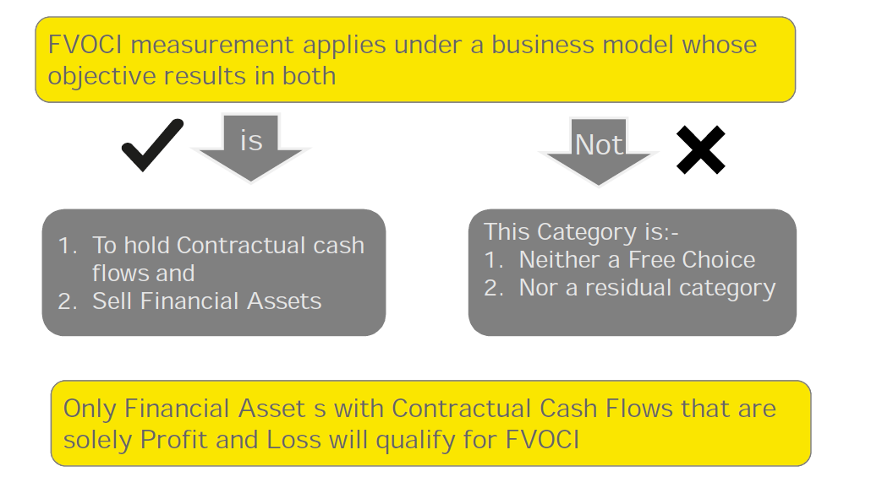

Example:
► A bank holds financial assets to meet its everyday liquidity needs.
► The bank seeks to minimise the costs of managing its liquidity needs and therefore actively manages the return on the portfolio.
► The bank typically holds some financial assets to collect contractual cash flows and sells others to reinvest in higher yielding assets or to better match the duration of liabilities.
► This strategy has resulted in significant and recurring sales activity in the past, which is expected to continue.

Response: Bank will classify the financial asset as FVOCI.

FVTPL Business Model
► FVTPL is the residual measurement category applicable to all instruments failing either the contractual cash flow or the business model test (this includes instruments held for trading, derivatives and equity instruments)
► FVO also applicable for financial instruments under a FVOCI business model if accounting mismatch is present.

Contractual cash flow characteristic test

► Contractual terms of the financial asset give rise, on specified dates, to cash flows that solely represent principal and interest payments.

► ‘Interest’ is consideration for the time value of money and the credit risk associated with the principal amount outstanding during a particular period of time.

► Meaning of interest
De minimisand non-genuine features to be disregarded
Conceptual basis for P&I is a basic lending-type relationship
Time value of money and credit risk as the most significant, but not the only, components of a basic lending-type return.
Liquidity risk and profit margin as other possible components.

► Contractual cash flow characteristic that introduces leverage do not have the characteristics of interest e.g. option, forward and swap contracts.
► An instrument that is subordinated to other instruments (e.g. to general creditors) may still have contractual cash flows that are principal and interest.

Contractual Cash Flow Characteristics’ test- Examples

Instruments that will qualify | Instruments that will NOT qualify
A bond with a stated maturity date. Principal and interest are linked to an inflation index that is not leveraged. | A convertible bond that is convertible into equity instruments of the issuer.
A variable interest rate loan with a stated maturity date that permits the borrower to change the period of the market interest rate at each interest reset date on an ongoing basis. | A loan that pays an inverse floating rate, i.e. the interest rate has an inverse relationship to the market interest rates.
A bond with a stated maturity date and pays a variable market interest rate which is capped. | A constant maturity bond with a five-year term that pays a variable rate that is reset periodically but always reflects a five-year maturity.
A full recourse loan secured by collateral.

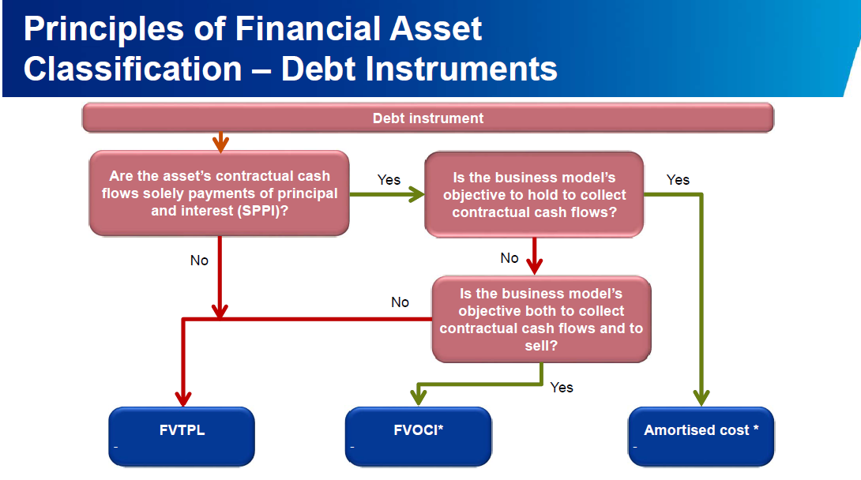

Classification of financial liabilities
Financial liabilities have been classified into two categories:
Category | Main Use
Fair value through profit or loss | ► Financial liabilities that are held for trading (including  derivatives)  ► Financial liabilities that are designated as FVTPL on  initial recognition  ► Contingent consideration recognised by an acquirer in a  business combination
Amortised Cost | ► All liabilities not in the above category

Initial Measurement
“The fair value of a financial instrument on initial recognition is normally the transaction price.”
However, if part of the consideration given or received is for something other than the financial instrument or the transaction was not transacted at arm’s length, the fair value is estimated using a valuation technique.

Please advice on initial measurement of following transactions
a) A Ltd Bank lends to B Ltd Bank loan of 10 million for 5 years and classify as asset under loans and advances. The Loan carries no interest. Market rate of interest is 10%.
b) A ltd grants interest free loan of 10 Lac to a employees for a period of two years. Market rate of interest is 10%
Solution:
a) Initial recognition at 6.21 million and this will accrete to 10 million over the term of the loan using effective interest rate method.
b) Fair value of the loan 10,00,000/(1.10)2 = 8,26,000. Difference of 1,74,000 is accounted for as employee compensation as per Ind AS 19.

Subsequent Measurements
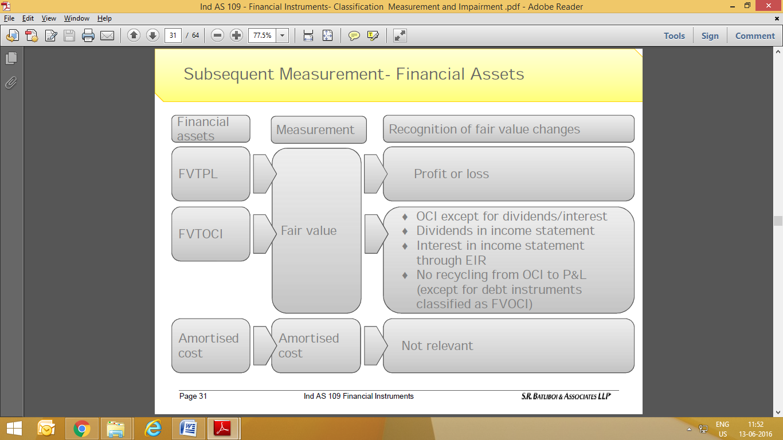

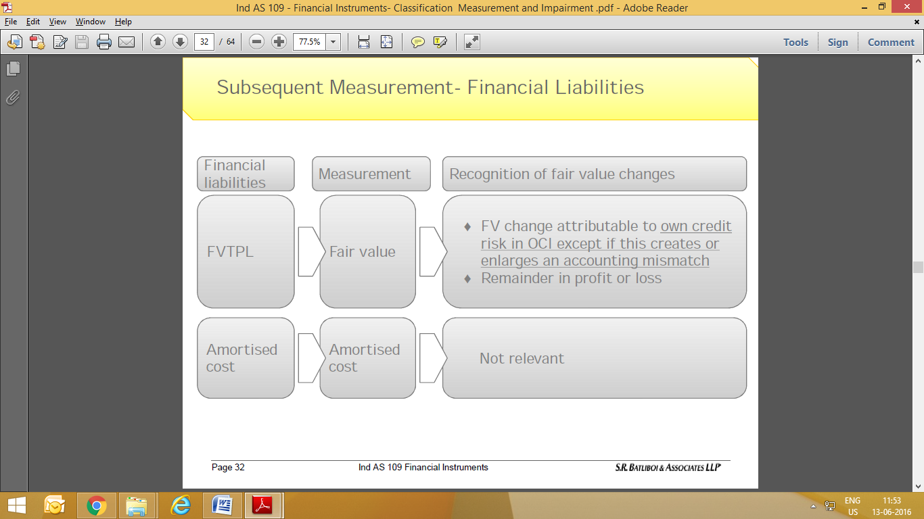
Impairment:
• The measurement of ECLs reflects a probability-weighted outcome, the time value of money and the best available forward-looking information.
• The need to incorporate forward-looking information means that application of the standard will require considerable judgement as to how changes in macroeconomic factors will affect ECLs. The increased level of judgement required in making the expected credit loss calculation may also mean that it will be more difficult to compare the reported results of different entities. However, entities are required to explain their inputs, assumptions and techniques used in estimating the ECL requirements, which should provide greater transparency over entities’ credit risk and provisioning processes.
• The need to assess whether there has been a significant increase in credit risk will also require new data and processes and the exercise of judgement.
• The effect of the new requirements will be to require larger loss allowances for banks and similar financial institutions and for investors in debt securities. On transition, this will reduce equity and have an impact on regulatory capital. The level of allowances will also be more volatile in future, as forecasts change.
• Adopting the expected credit losses requirements will require many entities to make significant changes to their current systems and processes; early impact assessment and planning will be key to managing successful implementation.

Scope and Variation of Expected Credit Loss Model

The impairment requirements would apply to:
► Debt instruments measured at amortised cost
► Debt instruments measured at fair value through other comprehensive income
► Loan commitments and financial guarantee contracts not measured at fair value through profit or loss.
► Trade receivables and contract assets
► Lease receivables

Expected Credit Loss Model: the basic General Approach

IFRS 9 introduces so-called “general model” of recognizing impairment loss. This model requires recognizing impairment losses in line with the stage in which the financial asset currently is. There are 3 stages:
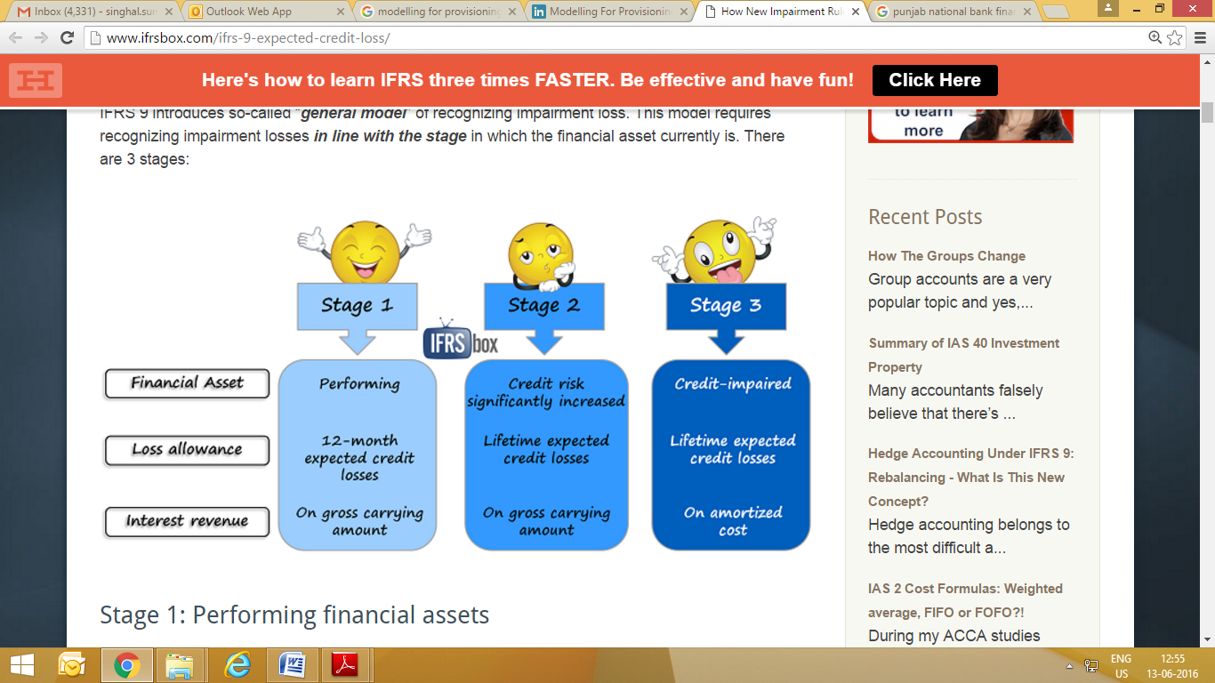

Stage 1: Performing financial assets

Here, we have financially healthy financial assets that are expected to perform normally in line with their contractual terms and there are no signs of increased credit risk.
IFRS 9 requires recognizing impairment loss amounting to 12-month expected credit losses immediately at initial recognition of these assets.

Stage 2: Financial assets with significantly increased credit risk
When the credit risk of certain financial asset significantly increased and the resulting credit quality is NOT low risk, then an entity needs to recognize full lifetime expected credit losses.
What are they?
They are present value of losses that arise if a borrower defaults on their obligations throughout the life of the financial instrument.
In fact, 12-month expected credit losses are just the portion of the life time expected credit losses.
Now, please be careful, because expected credit losses are in fact a difference between:
- The present value of cash flows based on the contract of a financial instrument; and
- The present value of cash flows that an entity really expects to obtain from the financial instrument.
As a result, the timing of payments from the financial instrument directly affects their present value and thus the amount of an impairment loss.
In practice, if you expect that debtor will pay you in full, but later than in line with the contract, there IS an impairment loss!

Stage 3: Credit-impaired financial assets

When your financial asset has already become credit impaired (meaning that certain default events have occurred), then an entity still recognizes lifetime expected credit losses.
However, this time, interest revenue is calculated and recognized based on the amortized cost(that is gross carrying amount less loss allowance).
In this stage, financial assets might need to be individually assessed.

- The new IFRS 9 impairment requirements requires threshold for the recognition of credit losses, i.e., it is no longer necessary for a credit event to have occurred before credit losses are recognised. Instead, an entity always accounts for ECLs, and updates the loss allowance for changes in these ECLs at each reporting date to reflect changes in credit risk since initial recognition. Consequently, the holder of the financial asset needs to take into account more timely and forward-looking information in order to provide users of financial statements with useful information about the ECLs on financial instruments that are in the scope of these impairment requirements.

IFRS 9 provides the following operational simplifications:

• A ‘low credit risk’ threshold equivalent to ‘investment grade’
• A more than 30 days past due rebuttable presumption.
• Use of a change in the 12-month risk of a default as an approximation for change in lifetime risk.

In Stages 1 and 2, there is a complete decoupling of interest recognition and impairment. Therefore, interest revenue is calculated on the gross carrying amount (without deducting the loss allowance). If a financial asset subsequently becomes credit-impaired (Stage 3 in the diagram at section 1.2 above), an entity is required to calculate the interest revenue by applying the EIR in subsequent reporting periods to the amortised cost of the financial asset (i.e., the gross carrying amount net of loss allowance) rather than the gross carrying amount.

In subsequent reporting periods, if the credit quality of the financial asset improves so that the financial asset is no longer credit-impaired and the improvement can be related objectively to the occurrence of an event (such as an improvement in the borrower’s credit rating), then the entity should once again calculate the interest revenue by applying the EIR to the gross carrying amount of the financial asset. When the entity has no reasonable expectations of recovering the financial asset, then the gross carrying amount of the financial asset should be directly reduced in its entirety. A write-off constitutes a derecognition event

12 month and life time expected credit loss
This is a component of life time expected credit loss which may be incurred because of defaults events on the financial instruments materializing within 12 months from the reporting date.
Major challenge:
- Differentiating between default event and significant increase in credit risk
- Segregate loss caused by a default event taking place within next 12 months from those taking place after 12 months.
Provisioning for bad debts is to be computed based on rigorous analysis of past data.
There will be a tough balancing act between the measurement requirement and corresponding cost.
Reporting entities, particularly those with regulatory capital requirement may face a negative impact since now the expected loss will also have to be provided as against the current practice of providing only incurred credit losses.
Transition from 12 month to life time provision is likely to cause an enhanced provision which will have an adverse impact on the capital adequacy.
Loss Allowance Recognition: Illustration
On 31 December 20X1 Bank B grants a loan to a borrower with lowcredit standing, but still at an acceptable level for B.The price of the loan does not reflect incurred credit losses.
Q: What loss allowance should B recognise in the statement offinancial position at 31 December 20X1?
A. None.
B. 12-month expected credit losses.
C. Lifetime expected credit losses.

Its B 12 month Expected Credit loss

Under the general model of IND AS 109, all assets need to have a lossallowance.
Allowance covers either 12-month or lifetime expected credit lossesdepending on whether the asset’s credit risk has increasedsignificantly.
Since the loan has just been granted and there has not been asignificant increase in credit risk, an allowance equal to 12-monthexpected credit losses is appropriate.

An example of a low credit risk instrument is one that has an investment grade rating (although an external rating grade is not a prerequisite for a financial instrument to be considered low credit risk)
Significant increase in credit risk:
- The term has not been defined in the standard leaving it to the judgment of reporting agency.
- It is however clear that this cannot be aligned with the date when assets become credit impaired or with the internal definition of default being used by the reporting entity.
- Focus is not on the Magnitude of the Loss (LGD) but on increase in the risk of Default (PD), LGD is useful to measure the expected credit loss.

Some of the indicators indicating Significant increase in credit risk

Credit Impaired Financial Assets
A financial asset is credit-impaired when one or more events that have detrimental impact on estimated future cash flows of that financial asset have occurred like:
(a) Significant financial difficulty of issuer or borrower;
(b) Breach of contract, such as a default or past due event;
(c) lender(s) of the borrower, for economic or contractual reasons relating to borrower's financial difficulty, having granted to borrower a concession(s) that the lender(s) would not otherwise consider;
(d) It is becoming probable that borrower will enter bankruptcy or other financial reorganisation;
(e) Disappearance of an active market for that financial asset because of financial difficulties; or
(f) Purchase or origination of financial asset at a deep discount that reflects the incurred credit losses.

Note : It may not be possible to identify a single discrete event—instead, combined effect of several events may have caused financial assets to become credit-impaired.

Measurement of Expected Credit Loss
The standard defines credit loss as the difference between all contractual cash flows that are due to an entity in accordance with the contract and all the cash flows that the entity expects to receive (i.e., all cash shortfalls), discounted at the original EIR. When estimating the cash flows, an entity is required to consider:
• All contractual terms of the financial instrument (including prepayment, extension, call and similar options) over the expected life of the financial instrument. However, in rare cases when the expected life of the financial instrument cannot be estimated reliably, then the entity is required to use the remaining contractual term of the financial instrument.
• Cash flows from the sale of collateral held or other credit enhancements that are integral to the contractual terms.

Expected credit losses are an estimate of credit losses over the life of the financial instrument. Accordingly, an entity should consider the following for measuring expected credit losses,:
(a) the probability-weighted outcome: expected credit losses should represent neither a best or worst-case scenario. Rather, the estimate should reflect the possibility that a credit loss occurs and the possibility that no credit loss occurs;
(b) the time value of money: expected credit losses should be discounted to the reporting date; and
(c) reasonable and supportable information that is available without undue cost or effort.
An entity is required to use reasonable and supportable information that is available at the reporting date without undue cost or effort, and that includes information about past events, current conditions and forecasts of future conditions.
Although the model is forward-looking, historical information is always considered to be an important anchor or base from which to measure expected credit losses. However, historical data should be adjusted on the basis of current observable data to reflect the effects of current conditions and forecasts of future conditions.

IND-AS 109 does not mandate the use of an explicit probability of default to make this assessment. An entity may apply various approaches when assessing whether the credit risk on a financial instrument has increased significantly. An entity should consider reasonable and supportable information that is available without undue cost or effort when determining whether the recognition of lifetime expected credit losses is required.
Lifetime expected credit losses are expected to be recognised before a financial instrument becomes delinquent. Typically, credit risk increases significantly before a financial instrument becomes past-due or other lagging borrower-specific factors (for example, a modification or restructuring) are observed.

Basel Vs Ind AS 109

Compatibility between Basel Expected Loss Model and IFRS 9

The expected loss model of impairment accounting proposed by the IASB has increased convergence between accounting and regulatory standards. Under both accounting impairment and regulatory capital standards, the key input parameters for the computation of expected loss are Probability of Default (PD) and Loss Given Default (LGD). However, due to differences in the objectivity between regulatory capital and financial reporting, Basel PD and LGD estimates can be used in the IFRS impairment model only after making significant adjustments.
Under the existing Basel regulatory capital framework, the treatment of impairment provisions is primarily dependent on the approach that a financial institution adopts for computing its regulatory capital for credit risk. Table 1 summarizes impairment provisions under different Basel credit risk measurement techniques, and analyzes whether or not the data used for modelling regulatory expected loss can be used to model expected loss under IFRS 9.
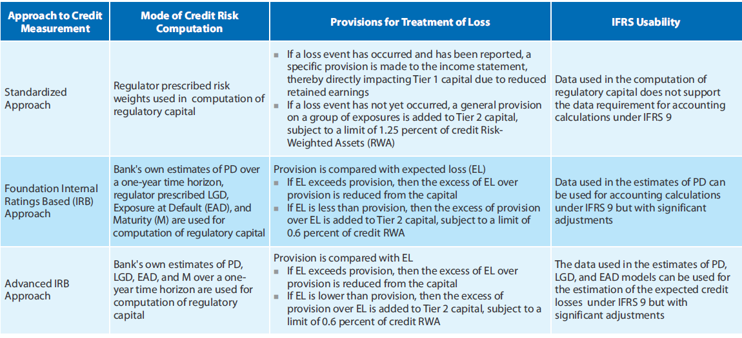

List of some key differences between Basel and IFRS 9 with respect to data usability, and outline the factors that require notable adjustments.
.
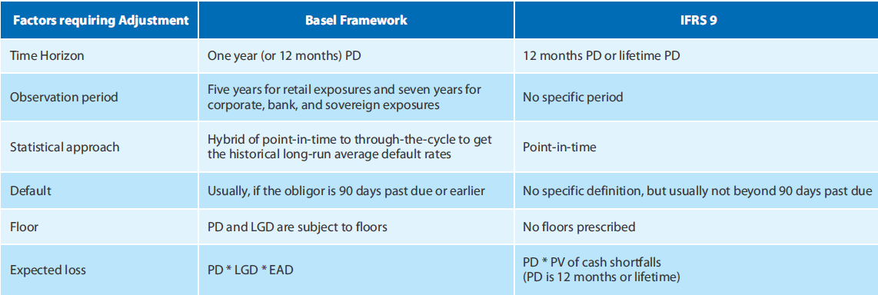

Impact of IFRS 9 Expected Loss Model on Regulatory Capital
The expected loss impairment model of IFRS 9 has a considerable impact on capital resource planning. The regulation requires financial institutions to recognize the credit loss from a financial asset at the first reporting date immediately after origination, and create an allowance to cover such future expected loss. This will significantly increase the provisions for loss, which will in turn reduce the Tier 1 capital ratio – ratio of core equity capital to RWA under Basel III. This would be of serious concern to the senior management of financial institutions, regulators, and investors.

Implementation Challenges Posed by the IFRS 9 Expected Loss Model

The new approach for impairment accounting reflects the convergence between regulatory and accounting standards. However, financial institutions still face challenges in the implementation of this new approach. In addition to the data usability adjustments that need to be made to leverage the Basel expected loss model, implementing the IFRS 9 expected loss model calls for significant work on the part of financial organizations.
The modelling of expected loss based on the 12-months or the lifetime horizon primarily entails extended data requirements. To exercise discretion while labelling a certain case as 'default' or 'significant increase in credit risk', on the basis of data interpretation brings in a great deal of subjectivity and inconsistency in the process, which ultimately defeats the purpose of enforcing these regulations in the first place.
Immediate problems range from a possible overstatement of expected loss due to the concept of initial recognition, leading to a drag on earnings, thereby impacting capital. The new standards of impairment accounting would adversely affect Common Equity Tier 1 (CET1) capital ratio, capital planning, and regulatory capital. Increased volatility of the P&L account, with financial assets moving from a 12-months EL to a lifetime EL, and the reverse, is another concern. Furthermore, the approach is not entirely consistent with the fair value (FV) concept because the initial recognition of expected loss leads to initial carrying amount of a financial asset lower than the fair value.

Benefits of the Proposed Expected Loss Model
IAS 39's Incurred loss (IL) approach to impairment accounting was reactive in recognizing credit losses. Though IASB's expected loss model has its share of implementation challenges, this is certainly a step toward a more proactive and effective method. Merits include:
- Early recognition of expected credit losses
- Consistency with standardized pricing or valuation of financial instruments
- Forward-looking approach that is loser to the future value concept, to determine the initial carrying value of a financial asset, and hence, economically more relevant
- Increased transparency and reduced uncertainty over loan valuations, thereby enabling financial institutions to acquire easy and economical funding
- Greater convergence with the regulatory capital models, though, with some adjustments.

Impact on the Banking Companies- Summary
- Banking sector have additional regulatory requirement of providing for credit risk under various versions of Basel accord.
- The major points to be considered are as under:
- In case of Basel, Credit Risk can be seen at any “point of time” or “through the cycle”, whereas under IFRS 9 it is “a point of time” view.
- IFRS 89 does not mandate any minimum data requirement for LGD and EAD computation unlike basel where minimum data requirement is 5 years for retail and 7 years for corporate, sovereign, and others.
- Default is defined under Basel but not under IFRS 9.
- There is no minimum floor for expected credit loss in IFRS unlike Basel.
- Discounting rate is essentially EIR under IFRS 9 and WACC under Basel 2.
- IFRS 9 uses cash shortfall to compute expected loss, basel uses PDxEADxLGD.

