)Use the following information to determine the margin of safety in dollars:
Unit sales - 50,000 units
Dollar sales - $500,000
Fixed costs - $204,000
Variable costs - $187,500
$88,500
$108,500
$173,600
$326,400

2) 2)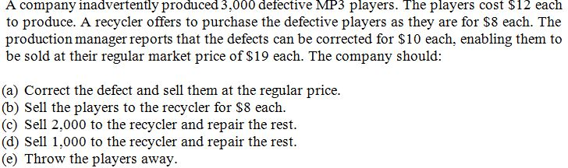

A
B
C
D

3)Craft Company produces a single product. Last year, the company had a net operating income of $80,000 using absorption costing and $74,500 using variable costing. The fixed manufacturing overhead cost was $5 per unit. There were no beginning inventories. If 21,500 units were produced last year, then sales last year were:
22,600 units
27,000 units
20,400 units
16,000 units

4) 4)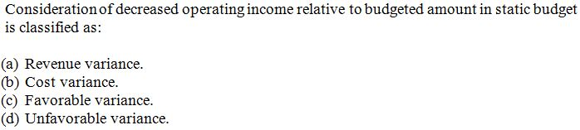
A
B
C
D
5) 5)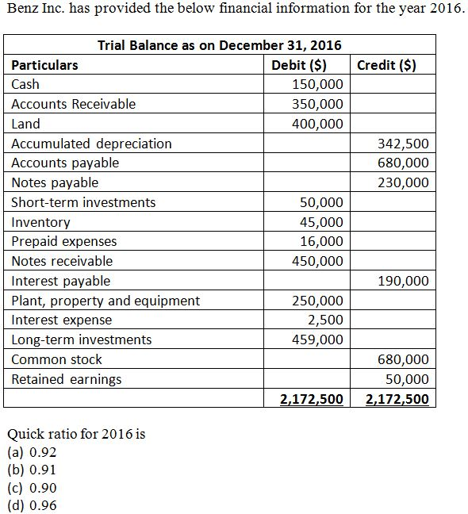

A
B
C
D

6)You placed a bet on Chicago for this year’s Super Bowl. To cover your loss, you agree to pay your bookie $612.52 in three years. Assuming 7% interest, how much was your total bet? (Round you answer to zero decimal places)
$500
$600
$650
$550

7)Clarence Weatherspoon, a super salesman contemplating retirement on his fifty-fifth birthday, decides to create a fund on an 8% basis that will enable him to withdraw $34,100 per year on June 30, beginning in 2018 and continuing through 2021. To develop this fund, Clarence intends to make equal contributions on June 30 of each of the years 2014-2017.
How much must the balance of the fund equal on June 30, 2017, in order for Clarence Weatherspoon to satisfy his objective? (Round factor values to 5 decimal places, e.g. 1.25124 and final answer to 0 decimal places, e.g. 458,581.)
What is each of Clarence’s contributions to the fund? (Round factor values to 5 decimal places, e.g. 1.25124 and final answer to 0 decimal places, e.g. 458,581.)
$105,222 and $21,448
$115,154 and $20,408
$117,254 and $20,408
$112,944 and $23,208

8) 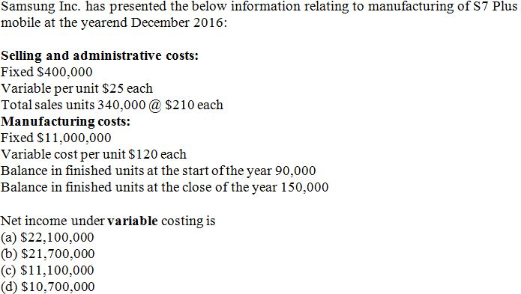
A
B
C
D

9)In January 2014, Domingo, Inc., acquired 20 percent of the outstanding common stock of Martes, Inc., for $811,000. This investment gave Domingo the ability to exercise significant influence over Martes. Martes assets on that date were recorded at $4,171,000 with liabilities of $971,000. Any excess of cost over book value of the investment was attributed to a patent having a remaining useful life of 10 years.
In 2014, Martes reported net income of $188,000. In 2015, Martes reported net income of $252,250. Dividends of $82,000 were declared in each of these two years. What is the equity method balance of Domingos Investment in Martes, Inc., at December 31, 2015?
$866,250
$930,450
$832,050
$947,550

10)Beyoncé Corporation factors $175,000 of accounts receivable with Kathleen Battle Financing, Inc. on a with recourse basis. Kathleen Battle Financing will collect the receivables. The receivables records are transferred to Kathleen Battle Financing on August 15, 2014.
Kathleen Battle Financing assesses a finance charge of 2% of the amount of accounts receivable and also reserves an amount equal to 4% of accounts receivable to cover probable adjustments.
Assume that the conditions are met for the transfer of receivables with recourse to be accounted for as a sale. The journal entry on August 15, 2014, for Beyoncé to record the sale of receivables, assuming the recourse liability has a fair value of $2,000 would include which of the following:
Debit cash $164,500, Debit due from factor $18,000, Credit gain on sale of receivables $5,500, Credit recourse liability $2,000, and Credit accounts receivable $175,000
Debit cash $164,500, Debit due from factor $7,000, Debit loss on sale of receivables $5,500, Credit recourse liability $2,000, and Credit accounts receivable $175,000
Debit cash $164,500, Debit due from factor 7,000, Debit loss on sale of receivables $3,500, Credit recourse liability $2,000, and Credit accounts receivable $173,000
Debit cash $164,500, Debit due from factor 5,000, Debit loss on sale of receivables $7,500, Credit recourse liability $2,000, and Credit accounts receivable $175,000

