DISCLAIMER : This notes is NOT a substitute for the ICAI Study Material at any means. This notes can be supplemented alongwith the Study Material. Students are advised to first read the Study Material thoroughly and then refer this notes for subsequent revisions. Flowcharts and diagrams are included for better understanding of the concepts. The objective of this notes is NOT to replace the Study Material at any means.In case of discrepancies or errors, students are advised to refer the Study Material.

Chapter 2 : Audit Strategy, Planning and Programming
Points to be discussed:
- Commencing an Audit
- Benefits/Advantages of Planning in an audit of Financial Statements
- Nature and extent of planning
- Planning – A Continuous process
- Overall Audit Strategy and Audit Plan – Responsibility of the Auditor
- Preliminary Engagement Activities
- Contents of an Audit Plan
- Changes to Planning decisions
- Overall Audit Strategy
- Factors while establishing Overall Audit Strategy
- Benefits of Overall Audit Strategy
- Considerations in Establishing the Overall Audit Strategy
- Documenting the Audit Plan
- Relationship between the Overall Audit Strategy and the Audit Plan
- Audit Programme
- Formulating an Audit Programme
- Drawing up the Audit Programme

- Commencing an Audit:
Applicable Standard on Auditing and its relevance:
SA 200 : Overall objectives of the Independent Auditor and the Conduct of an Audit in accordance with Standards on Auditing” which states that to achieve the overall objectives of the auditor, the auditor shall use the objectives stated in relevant SAs in planning and performing the audit.
- Benefits/Advantages of Planning in an audit of Financial Statements:
Planning an audit involves establishing the overall audit strategy for the engagement and development of an audit plan. Few of the benefits are listed below:
- Attention to important areas
- Timely resolution of potential problems
- Proper organization and management of audit engagement
- Proper selection of engagement team
- Direction and supervision of engagement team
- Easy coordination

- Nature and extent of planning:

The nature of planning depends on the:

- Size and complexity of the auditee
- Past experience
- Changes in circumstances

- Planning – A Continuous process:
Planning is not a discrete phase of an audit but rather a continual and iterative process.Planning includes consideration of the timing of certain activities and audit procedures.
For example, planning includes the need to consider :

- The analytical procedures to be applied as Risk Assessment Procedures (RAP)
- Obtaining a general understanding of the legal and the regulatory framework applicable to the entity and how the entity is complying with that framework.
- The determination of materiality
- The involvement of experts
- The performance of other Risk Assessment Procedures (RAP)

- Overall Audit Strategy and Audit Plan – Responsibility of the Auditor:
The auditor may decide to discuss elements of planning with the entity’s management to facilitate the conduct and management of the audit engagement. When discussing matters about the overall audit strategy or audit plan, care has to be taken not to compromise the effectiveness of the audit. The engagement partner and other key members of the engagement team shall be involved in planning the audit. The involvement of the engagement partner and other key members of the engagement team in planning the audit draws on their experience thereby enhancing the effectiveness and efficiency of the planning process.
- Preliminary Engagement Activities:
The auditor should undertake the following activities at the beginning of the current audit engagement:
- Performing procedures as required by SA 220: “Quality control for an Audit of Financial Statements” regarding continuance of the client relationship and the specific audit engagement.
- As per SA 220 and SQC 1 combined, information and procedures such as :
- The integrity of the principal owners, key management and those charged with governance of the entity;
- Whether the engagement team is competent to perform the audit engagement and has the necessary capabilities, including time and resources;
- Whether the firm and the engagement team can comply with relevant ethical requirements;
- Significant matters that have arisen during the current or previous audit engagement, and their implications for continuing the relationship;
which assist the auditor in determining whether the conclusions reached are appropriate with regard to the acceptance of audit, client relationship and audit engagement.

- Evaluating compliance with ethical requirements, including independence, as per SA 220.
- Establishing an understanding of the terms of the engagement as per SA 210.

- Content of the Audit Plan:
The auditor shall develop an audit plan that shall include the following:
- The nature, timing and extent of planned risk assessment procedures, as per SA 315 : “Identifying and Assessing the Risks of Material Misstatement through Understanding the Entity and its Environment”;
- The nature, timing and extent of planned further audit procedures at the assertion level, as per SA 330 : “The Auditor’s Responses to Assessed Risks”;
- Other planned audit procedures that are required to be carried out so that the engagement complies with SAs.
The audit plan is more detailed than the overall audit strategy that includes the nature, timing and extent of audit procedures to be performed by engagement team members. Planning for these audit procedures takes place over the course of the audit as the audit plan for the engagement develops.
- Changes to Planning decisions:
The auditor shall update and change the overall audit strategy and audit plan as necessary during the course of the audit due to factors such as result of unexpected events, changes in conditions or the audit evidence obtained from the results of audit procedures and also based on the revised consideration of assessed risks.
- Overall Audit Strategy

The auditor shall establish an overall audit strategy that sets the scope, timing and direction of the audit, and that guides the development of the audit plan.

- Factors while establishing Overall Audit Strategy:
Overall audit strategy would involve –
- Determination of Characteristics of Audit
- Reporting Objectives
- Team’s Efforts
- Preliminary Work
- Nature, timing and resources

- Benefits of Overall Audit Strategy:
The process of establising the overall audit strategy assists the auditor to determine matters such as:
- Employment of qualitative resources
- Allocation of quantity of resources
- Timing of deployment of resources
- Management of resources

- Considerations in Establishing the Overall Audit Strategy:
Some of the examples of matters that the auditor may consider in establishing the overall audit strategy are given hereunder.
- Characteristics of the engagement :
- The financial reporting framework
- Industry –specific reporting requirements such as reports mandated by industry regulators.
- The expected audit coverage, including the number and locations of components to be included.
- The nature of the control relationships between a parent and its components that determine how the group is to be consolidated.
- Reporting objectives, Timing of the audit and Nature of the communications.

- Significant Factors, Preliminary Engagement Activities, and Knowledge Gained on Other Engagements :
- The determination of materiality in accordance with SA 320.
- Preliminary identification of areas where there may be a high risk of misstatement.
- Volume of transactions which may determine reliance on internal control.
- Significant business developments affecting the entity.
- Significant industry developments.
- Significant changes in the financial reporting framework.

- Nature ,Timing and Extent of resources :
- The selection of the engagement team and the assignment of audit work to the team members.
- Engagement budgeting.

- Documenting the Audit Plan:
The auditor shall document –
- The overall audit strategy;
- The audit plan ; and
- Any significant changes made during the audit engagement to the overall audit strategy or the audit plan, and the reasons for such changes as under :

- Record of Key Decisions
- Record of Nature, Timing and Extent of Risk Assessment Procedures
- Record of reasons for Change in Audit Plans
- Relationship between the Overall Audit Strategy and the Audit Plan:
Audit Strategy and the Audit Plan are inter-related because change in one would result into change in the other. The audit strategy is prepared before the audit plan. The audit plan contains more details than the overall audit strategy .The audit strategy provides the guidelines for developing the audit plan.It establishes the scope and conduct of the audit procedures and thereby works as basis for developing a detailed audit plan.
- Audit Programme

An audit programme is prepared to allocate work to team members which may include the list of audit procedures and instructions to be followed by the member.It also estimates the duration for completing an audit task.

- Formulating an Audit Programme:
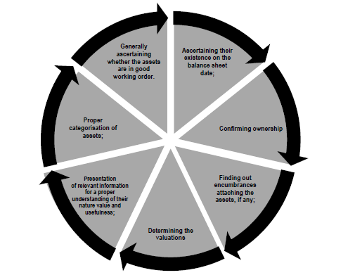

The audit programme may contain audit objectives for each area and should have sufficient detail to serve a lot of instructions to the assistants involved in the audit and as a means to control the proper execution of work. It may be emphasized that a clear spelling out of audit objectives for each area is important to link up the procedures with audit objectives and to ensure a purposeful audit.
The important matters which needs to be considered are:
  - Nature of business in which the organization is engaged
  - Overall plan
  - System of Internal Control and accounting procedures
    - Review and Preliminary Evaluation
    - Test of compliance
    - Evaluation
  - Size of the organization and structure of its management
  - Information as regards organization of the business
  - Accounting and management policies
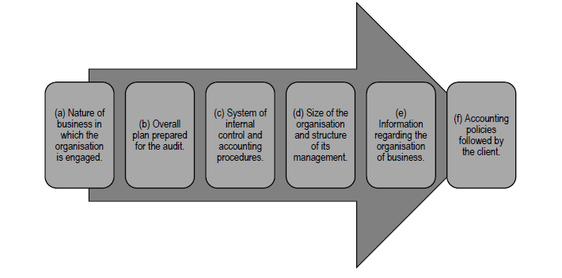

- Drawing up the Audit Programme:
When an auditor is appointed to audit the accounts of the entity for the first time , the audit programme should be developed in three stages :
    - Firstly,a broad outline of the audit programme should be drawn up.
    - After the internal and accounting procedures have been reviewed, the details should be filled up on a consideration of the deficiencies in the system of internal control.
    - After the detailed checking formality is over, the extent to which the special procedures need to be applied should be determined.
At each subsequent engagement the programme should be reviewed and, if necessary, modified on account of:
- experience gained during the previous audits;
- important changes that have taken place in the business specially in the system of internal controls, accounting procedures or in the structure of management or of the scope of business ; and
- evaluation of internal control made for the current year.
The audit plan and related programme should be reconsidered as the audit progresses. Such re-consideration is based on the auditor’s review of internal control, his preliminary evaluation thereof and the result of his compliance and substantive procedures.

