How I revised a major chunk of Directors in just 30 minutes with the help of mnemonics?
All those who have covered ‘Directors’ in CA-FINAL Law know how important the topic is in terms of its coverage in exams, how in depth you need to go to understand some transactions and its related approvals and process a company needs to follow, and how it can take a lot of time to revise to get a grip on the topic.
This article will be helpful for revision within 30 minutes of the chapter Meetings of Board and its Powers but first you need to go through the chapter from Study material or any main textbook you use at least once for maximum benefit; Still I have covered all the important aspects as well the tricky ones.
First let’s get the headings of rules covered, one needs to just learn the heading and apply as Companies (Relevant Heading) Rules,2014 in examination, for example for Chapter 1-Appointment of qualification of Directors, it shall be Companies(AQD) Rules, 2014 and always remember in exams you need to quote rules with sections using ‘As per Section 188 of the Companies act,2013 read with Rule 15 of Companies (Meetings of Board and its Powers) Rules, 2014’ to score good marks.
 |  | Learn by
Chapter 1 | Appointment of qualification of Directors | AQD
Chapter 2 | Meetings of Board and its Powers | MBP
Chapter 3 | Appointment and Remuneration of Managerial Personnel | ARM

Chapter 2: Meetings of Board and its Powers (Section 176 to 195)
Section 179-Decisions to be taken only in a Board meeting
Objective | Mnemonics |  |  | Key points | Caution pointers
Board has all the powers of the company except those which are given to shareholders (from AOA/MOA/Law) to be availed at a GM, so all the decisions will be taken by the board however some decisions needs to be taken in a BM and some powers to take decisions can be delegated further. | ABCD2  FILS  (As in movie ABCD2  & FILS) | A | Amalgamation, Reconstruction & Takeover | - Board= Supreme governing authority/ Absolute power of management  - Shareholders can limit/restrict powers of Board and also file an injunction but in no case it can invalidate prior acts of Board.  - Doctrine of Indoor management: Applicable*  - BOD can delegate powers related to cash inflow/outflow (B I L) to MD/Manager/Committee of Directors/Principal Officer of Company/Principal Officer of Branch.  - Borrowings don’t include Temporary Loans. ** | - Board may put restrictions for:  - In section 186 no delegation can be done as unanimous Board approval is required.  - Borrowing don’t include Temporary loans.
   | Borrowing | Investment | Loans
  How much amount can be borrowed/Invested or given as Loan
  Of which nature | -  (As no restriction is there on nature of borrowings thus Principal officer of Branch can borrow for Company.)
 | ABCD2  FILS  (As in movie ABCD2  & FILS) | B | Borrowing Money
 | ABCD2  FILS  (As in movie ABCD2  & FILS) | B | Buyback u/s 68
 | ABCD2  FILS  (As in movie ABCD2  & FILS) | C | Calls require
 | ABCD2  FILS  (As in movie ABCD2  & FILS) | D | Diversification
 | ABCD2  FILS  (As in movie ABCD2  & FILS) | F | Financial statements approve including Board report
 | ABCD2  FILS  (As in movie ABCD2  & FILS) | I | Invest the Funds
 | ABCD2  FILS  (As in movie ABCD2  & FILS) | L | Loans require
 | ABCD2  FILS  (As in movie ABCD2  & FILS) | S | Securities including Debentures issue

Contributions by a Company: Section 181-183
Section | 181 | 182 | 183
Example: | Being Human | BJP | National Defense Fund
Amount cap | 5%* | 7.5%* with BR in BM (Rule 8) | No Limit with BR in BM/RBC
Authority if Cap is breached | 1st OR Then BR in BM | Not allowed | -
Disclosures | No disclosures | SPL: Amount and Name of Party | SPL: Amount
- * % is calculated on Average net profits of past three years’ data if available. It is immaterial if Company has incurred losses in Previous year as average is considered here.
- If Donations is made only towards employees, then they are staff welfare expenses and not donations to charitable institutions thus not included in limit.
- Political Contribution includes directly or indirectly towards benefit of Parties and includes
- Directly/indirectly paid to an agency
- Advertisement of Party
- Advertisement through Party
- Political contributions not allowed to Government companies and other companies incorporated for less than 3 years.
- Exemption: Disclosure of name of Political party not required in case of donation to Electoral Trust company.
- If AOA/MOA restricts/prohibits company to donate u/s 183 then it is ultravirus the act and not valid

Now the major ones:
Section 185-Loan to directors and specified persons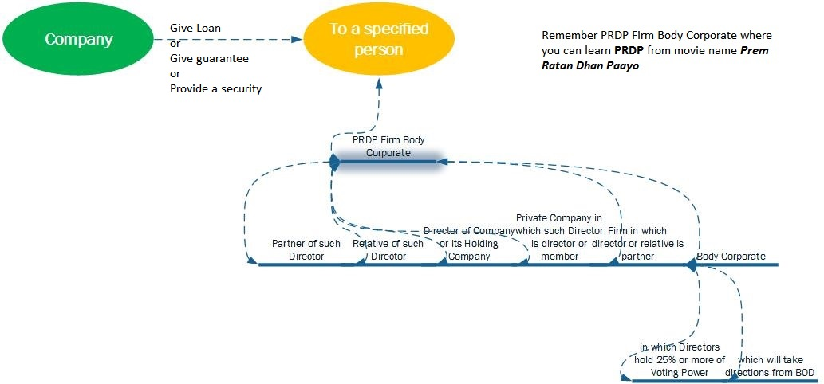
Caution pointers
Following do not amount to loan to directors:
- Loan means advance of money with a condition that amount will be given back bearing or not interest. Thus flat purchased and then sold by company to MD/WTD for 50% of it cost price upfront and rest on installments is not covered.
- Security deposit given by company to landlord for flat allotted to MD/WTD is also not covered as it is MD/WTD was not a party between the transaction and such transaction is bonfire b/s transaction.
- Salary advance to wife of MD/WTD who is also an employee of the company cannot be termed as Loan to director right away. It needs to be checked that
  - Amt. of advance and repayment capacity (Salary of wife)
  - Interest rate and repayment schedule
  - Beneficiary is a bonafide employee
  - Advance are according to policy
- Normal cash balance given to director is as an agent of a company.
Exemptions
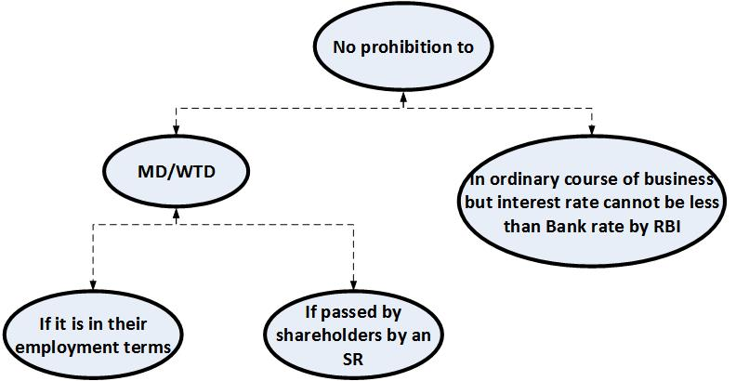
Non Applicability
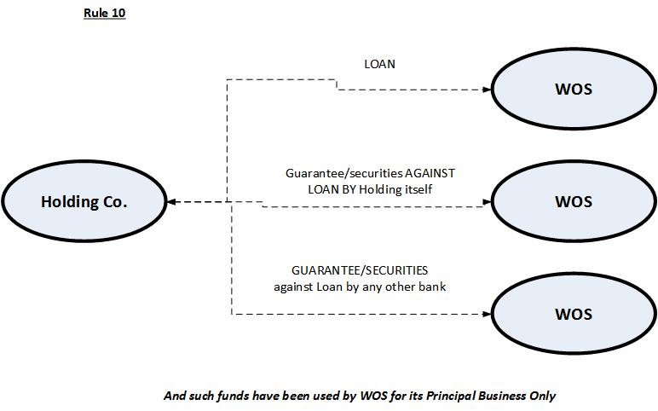
Please note that now Rule 10 has been merged with section 185.

Section 184-Disclosure of Interest
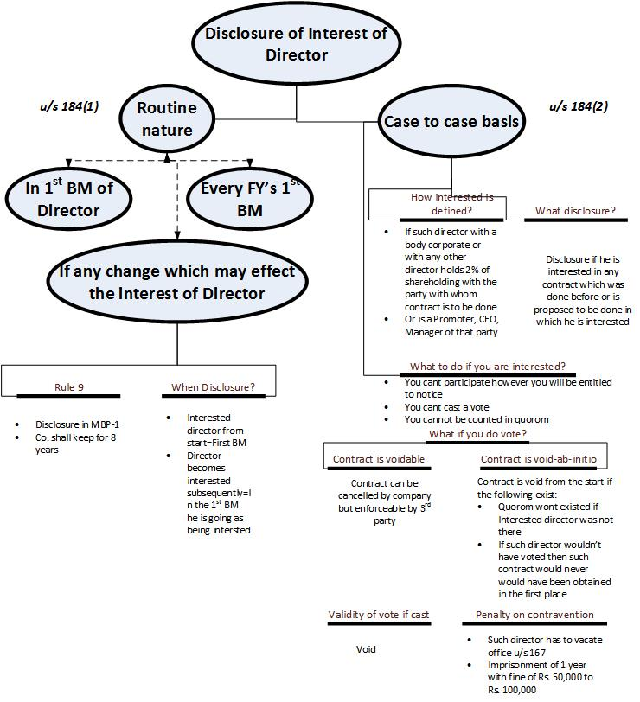
Section 186- Loan, Investment etc

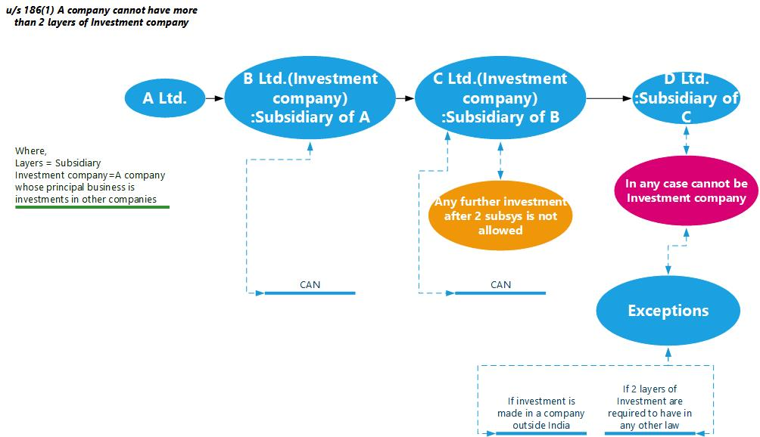

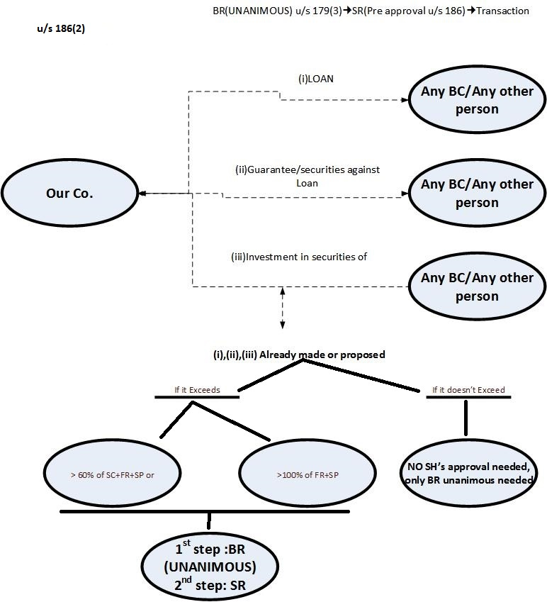
Exemption from section 186
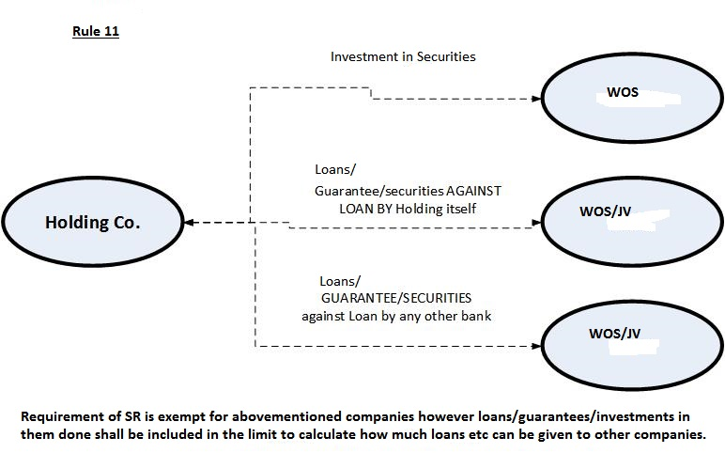
Non applicability of section 186(2) to 186(11)
Mnemonic: BHIN (as in Bhin-bhin tarah ke log hote hain)
- Banking company/Housing Finance company/Insurance company/NBFC gives Loans/Guarantee/Securities/Investment purchase Any person in ordinary course of Business
- Right shares acquired by any shareholder from a company
- A company whose Principal business is acquisition of shares
Caution pointers
- Approval shall be required from PFI from whom company has taken loans and now wants to disburse that amount u/s 186 even if the loan agreement with PFI doesn’t bear such condition however approval will not be required if prior no default was done by company against such loan and Limits u/s186 have not been crossed.
- PFI is defined u/s 2(72) and do learn the list as in examination there could be any other lender other than LIC, IDFC, UTI which are the only parties covered u/s 2(72).
- BOD cannot delegate powers on which section 186 also applies thus it can be said that 186 overrules 179(3) further unanimous BR is required in a BM.
- Whether or not the concerned company crosses the limits specifies under this section, it needs to disclose in FS where and purpose of such loans/ guarantees/ securities/ investments.
- In practical questions having entries ‘Business Advances’ and ‘Advances for deposits’, take ‘Advances for deposits’ as loans thus covered under already existed loans, rest are not to be included.
- BC taking loans if covered u/s 12 of SEBI Act,2002 then upper limit of how much loan it can take shall be defined as per SEBI Act
- ROI at which loan is given should be comparable with 1/3/5/10 years GOI Bond thus 0% loans cannot be given
- Similar to section 180/179 even if SR is passed at GM, the shareholders need to specify the upper limit of loan which can be given.
Section 180-Decisions first to be approved by Shareholders by SR
Shareholders pass an SRBOD pass BRTransaction
In four cases prior approval in form of SR is required from Shareholders before a BR is passed
(a)Selling/Leasing/Disposing whole or substantially the whole of undertaking. *** | (b) Invest compensation received from merger/amalgamation | (c)Borrowings made+ proposed >SC+FR | (d)Remit or Reschedule loan due by a director
- At GM, where SR is required the shareholders can first impose conditions on (a) which is valid  - Exemption: (a) in ordinary course of business doesn’t require SR.  - If any Buyer or lessee on good faith buys or takes on lease after performing due diligence of undertaking and sale was defective (SR not passed) still buyer shall get a valid title. | - Exemption: If Board wants to invest in Trust Securities then no SR is required and just BR will do.  - Investment of proceeds of compensation covered here, rest all investments are covered u/s 179. | - Borrowings above the specified limit are covered here, rest all borrowings are covered u/s 179.  - Borrowings don’t include Temporary loans. **  - Shareholders need to specify the upper limit of borrowings which can be taken even after passing an SR.  - If BOD has exceeded the limit of borrowings approved via SR, then the shareholders can ratify it in the next meeting. However, if they don’t then company shall be only liable if Doctrine of Indoor management applicable. *  - Directors are agents of the company and not the shareholders, thus BOD can wish not to pass a BR and do the transaction even after SR is passed. | Remit means to waive off

Where
**Temporary loans=Demand Loans (Loans which are repayable on demand)/ Loans which are repayable within 6 months but doesn’t include Loans for CAPEX, Thus Loans for CAPEX are to be considered in the specified limit.
*Doctrine of indoor management: If lender proves that he has advanced the loan in good faith and he wasn’t aware of non-compliance and If the company has used the funds for themselves then the company is liable.
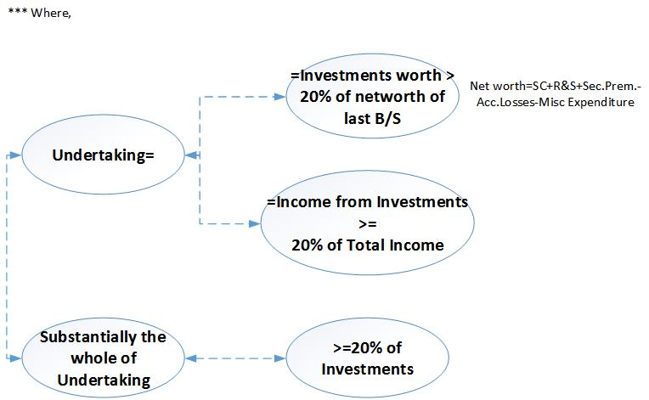
Section 188-Related Party Approvals
Remember that Related party as per 2(76) i.e. Definition of Related party is a mixture of Definitions under section 184 and section 185, So Mnemonic is also same as in section 185 with the exclusion of ‘P’ as given below:

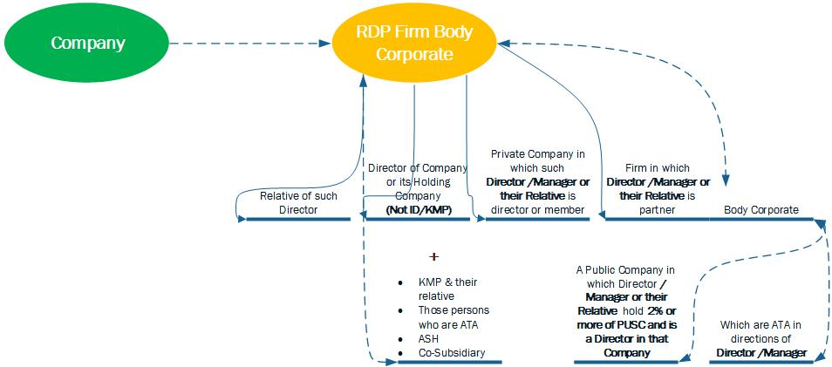
Further as per section 188 read with Rule 15, specific related party transactions are given and limit is also defined above which OR is required from shareholders as mentioned below:


S.no. | 7 types of contracts or arrangement has been defined: | Arrangement limits: |  | How to memorize?
1 | Sale, purchase or supply of goods/material | 1 & 5 | Transaction exceeds 10% of Turnover or 100 crores | - Ek hi main hai 50 Crore hai, Ek hi main hai Turnover hai, Ek hi transaction main Agent kaam nahi karta, baaki sab main hai 100 crores/Net worth/Agency services hain.  - Transactions shall be seen for during the year, and all limits will be checked from actuals from last audited balance sheet.
2 | Buying, selling, Disposing of Property | 2 & 5 | Transaction exceeds 10% of Net worth or 100 crores
3 | Leasing of Property | 3 | Transaction exceeds 10% of Net worth or 100 crores
4 | Availing or rendering services | 4 & 5 | Transaction exceeds 10% of Net worth or 50 crores
5 | Agent services for above except (3) | Covered above
6 | Appointment of RP in OOPOPOC in CAS | 6 | If RP is to be appointed as a  - Director: If that person receives any amount in excess remuneration in comparison to capacity of Director.  - Any other post: If remuneration for that post is> ₹2,50,000 p.m. | Memorize by:  If one is demoted in OOPOPOC then he is a RP, if one is promoted then he is not a RP.
  Company,  Associate,  Subsidiary | Demoted
  Holding | Promoted
7 | Underwriting/subscription of securities/derivatives of company | 7 | Transaction exceeds 1% of Net worth | -

Where ATA = Accustomed to Act
OOPOPOC= Office or place of profit of Company
CAS=Concerned Company, Its Associate as well its Subsidiary
Non applicability and Exemption
If arrangement has been made under following, then section 188 is not applicable
- Ordinary course of business
- Arm’s length price
- Between Holding & WOS does not require BR/OR
Ratification
- Ratification is allowed within 3 months of such arrangement, if such is not taken then such agreement is voidable by the company and compensation paid to shall be recovered by defaulting directors.
Disclosures and Caution pointers
- Special notice shall be given and RPT shall be mentioned in the explanatory notes attached with the notice as well.
- Interested director u/s 184 cannot vote in a BM however he can vote in GM where OR is required.

Section 177 -Audit committee
- Whom to constitute?
It is mandatory to constitute by evert listed company and any other class of company as may be prescribed. The limit and classes of company is prescribed under Rule 6. (Remember Rule 6: Same as limits of Independent director)
- Constitution?
At least 3 directors and majority should be Independent directors. Further all must be Persons having knowledge to understand and interpret Financial statements.
- Functions?
Mnemonic: Auditor LUV to FIR
  - Auditor’s Appointment and Independence Review
  - Scrutiny of Intercorporate Loans
  - Utilization/Use of funds by public offer
  - Valuation of assets & undertakings of company
  - Approval of Financial statements and Auditors Report
  - Internal Financial Controls
  - Omnibus approval of Related Party Transactions u/s 188
- Powers of AC: No mnemonic
  - Financial statements before going for Board approval (u/s 179)
  - Vigil Mechanism
  - Investigate about: Internal controls and Issues in Financial statements with internal and external auditors.
  - For investigation: External sources and Unrestricted access to records of Company.

- Omnibus Approval to be read in Rule 6A (For students completed TP in Direct tax this concept is just like Advance Pricing agreement)
Criteria | - Maximum value in a year  - Maximum value per transaction  - Review by AC at such intervals as may be deem fit of Omnibus approval  - Transactions which cannot be set for omnibus approval
While deciding criteria what to consider | - Repetitions  - & Justification of Omnibus approval
Maximum period | Maximum 1 Financial year then fresh approval shall be required.
Not applicable on | It shall not be given for selling/disposing undertaking/property of company
What shall be mentioned? | - Name of RP  - Nature of RPT  - Maximum amount per Transaction  - Duration  - Base Price & Variation allowed
What shall be mentioned? | However, nothing is required to be mentioned when RPT cannot be foreseen and amount is less than 1 crore per transaction.

Please cover the following sections from study material or any main text book which you use as no mnemonic is needed in these sections however some important tricky points is mentioned below
Section | Caution pointers
Section 173 on Board meetings | Meeting  - There should be intention to meet and accidental meeting or meeting against will does not count. However, a mere informality in conduction of meeting does not invalidate the decisions approved.  - For 120 days’ condition one needs to see days between 2 meetings and that not need to be in a calendar year only, that means if the last meeting was held on 09.08.2017 then automatically company is in default as next meeting for 2018 shall be on or after 01.01.2018 and period shall be more than 120 days.  - A director has to attend all the meetings but he is not duty bound, however do note that if a director does not attend BMs for more than 12 months then Casual vacancy u/s167 shall be applicable.  - Unlike section 96 which is on AGM, there’s no requirement to place, time and day of a BM, thus a BM can be held at any place not restricted to registered office or the city where the registered office is situated, can be held after business hours, and can be held even on a public holiday.  - Adjourned meeting:  - It is a continuation of original meeting thus if 4th is adjourned then that adjourned meeting shall also be considered to be started on the date of original meeting and no non-compliance of section 173 will be there.  - Separate notice not required however it is required when mentioned in AOA or meeting has been adjourned indefinitely.  Notice of BM  - Contravention to send Notice of BM has no penal effect on company as per new companies act, however as per past decided cases resolution in that BM shall be invalid/void. Do note that ratification of invalid BM is allowed.  - No format is given in companies act for notice which proves that notice can be given casually provided all conditions of section 173 are complied with.  - Agenda may or may not be provided however in purview of good corporate governance and unless required as a special notice agenda must be given, Cases of special notice are u/s 203/188.  - No waiver of notice and every director whether interested, alternate director should be presented with a notice  Voting  - As per Regulation 68 Table F unless required by act for want of a unanimous resolution (section 186/203) consent of board shall be seen by majority of votes seen by ‘Show of hands’ and majority shall be counted by votes in favor to votes of directors present & voting
Section 174 on Quorum | - Directors opting for video conferencing shall be counted in quorum.  - There is a dispute regarding requirement of quorum in the adjourned meeting, in my view if quorum not present in the adjourned meeting also then the meeting shall stand cancelled and if it a case of the 4th meeting of the year then there shall be non-compliance of section 173 (as Adjourned meeting is a mere continuation of the original meeting)  - Quorum needs to present throughout a BM unlike quorum in a GM.
Section 175 on Resolution by Circulation | - No requirement of quorum in RBC however approval is required from majority of directors excluding Interested directors  - Holding a RBC does not relieve company to its responsibility of holding a BM u/s 173
Section 176 which is on Defects in appointment shall not invalidate the actions of Directors | - Section 176: When a Director is appointed and it is subsequently noticed that hi appointment has disqualification/was terminated, all his prior acts shall be valid; However, this protection is not given to MD& Chairperson  - Section 196: If BOD has appointed a Managerial Person but his appointment was not approved by Shareholders/CG, his prior acts shall be valid.  See figure below

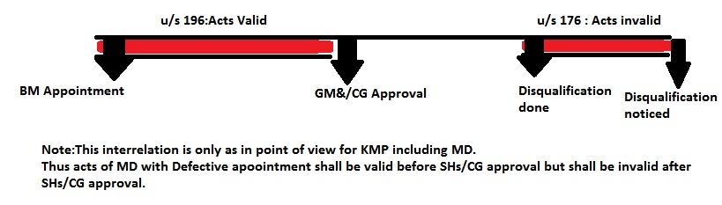

Section 177 on Vigil Mechanism | It is in nature of Whistle blowing policy
Section 178 on Stakeholders relationship committee & Nomination and Remuneration committee | Mnemonic for Functions of N&R Committee: PPI as in Prior Period Item  - It shall evaluate Performance of Directors  - It shall recommend a Policy to Board relating to remuneration of directors  - It shall Identify persons who are qualified to be directors.
Section 187 on Investment should be in name of the company | Remember the Cases where Investment can be held in name other than the concerned company
Section 189 to Section 194 | Read yourself as nothing complicated is there

Important Rules to learn in this chapter
Rule no. | Section no. | Summary
6 | 177 | AC needs to be constituted for which companies.
6A | 177 | Omnibus approval
7 | 177 | Vigil mechanism
8 | 176 | Political contribution needs BR in BM
9 | 184 | Disclosure of interest in MBP-1
10 | 185 | Exemption
11 | 186 | Non applicability
15 | 188 | RPTs which need OR

Similar concepts in all chapters of Directors
Adjournment of meeting | Section 152(7) | Section 173
Declaration | Section 149(5) | Section 184
Limits of Audit committee, Nomination & Remuneration Committee and Independent director | Rule 4 of Companies(AQD) Rules,2014 | Rule 6 of Companies(MBP) Rules,2014
Majority shall be seen by present & voting directors | Section 173 | -
Where Board does not accept any recommendation of AC it should disclose the same along with reasons | Section 177 | Rule 3 of Companies (Audit and auditors) Rules,2014

Exemptions mentioned in Rules or act itself other than of private companies, government companies etc
Section 173 & 174 | OPC with 1 director are fully exempted while other OPCs, dormant company needs to conduct atleast 1 BM in half a year and not less than 90 days’ gap should be between 2 meetings
Section 179(3) | Banking companies does not need BR in BM for Borrowings
Section 180 | Selling/Leasing/Disposing in ordinary course of Business does not require SR
Section 185 | Rule 10 and Exemptions
Section 186 | Section 186(11) i.e. BHIN in ordinary course of business
Section 188 | In ordinary course of business/arm’s length basis/Transactions between Holding and WOS

List of major penalties in this chapter are
Section |  | Officer in Default(OID) |  | Company
173 | Notice | ₹ 25000 |  | -
182 | Political contribution | 5*Amount Contributed | 6 m | 5*Amount Contributed
184 | Disclosure of Interest | ₹ 50000 | 1 y
188 | RPT | Listed company: ₹ 25000 to 5lakhs | 1 y
188 | RPT | Others: ₹ 25000 to 5lakhs | -
189 | Register maintain | ₹ 25000
191 | Loss of office on transfer of undertakings | ₹ 25000 to 1 lakh
194 | Trading in Derivatives of own company | ₹ 1 lakh to 5 lakhs | 2 y
195 | Insider trading | ₹ 5 lakhs to 25 crores or  3 times the profit made whichever is higher | 5 y

Note: Short forms used in this article just for quick revision and to be reproduced only in its original full form in examination.
AC | Audit Committee
RPT | Related party transactions
RBC | Resolution by Circulation
BM/BR | Board meeting/Resolution
BOD/Board | Board of directors
GM | General meeting
MD/WTD | Managing Director/Whole time Director
OR/SR | Ordinary Resolution/Special resolution
WOS | Wholly owned subsidiary
ID/KMP | Independent Director/Key managerial Person

I hope this article would be helpful to students and I have made sufficient efforts to remove any errors/omission still I am sorry if any mistake has made its way above. For similar articles on revision of other topics of CA-FINAL LAW & AUDIT please provide your feedback below.

