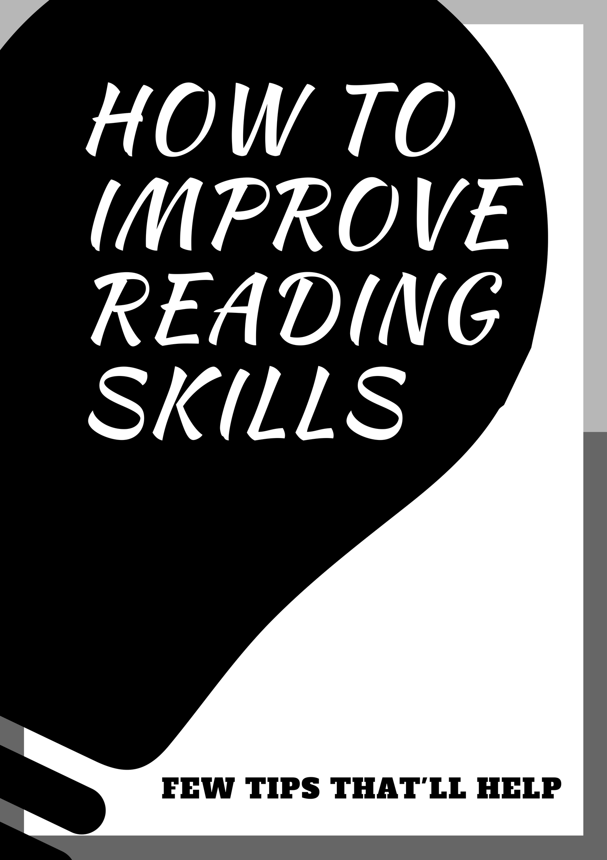

Hello Everyone,
We all love to read right? But why is that we never have time enough time for the same. It doesn’t matter whether its related to your academics or just a self-help book for casual reading.
Many people write READING as one of their hobbies in their resume. But when you ask them which is the latest you have read, they start scratching their head.
Why this happen? I’m not saying all of them lie on their resume it’s just that many people love to read but not able spend time on them. This is just not for reading, take any hobbies, in today’s fast moving era people don’t have time to do things they love, everyone just wants to grow and make more money. I’m not against it, but all I am saying is that you should always make time to do things you love.
“You should definitely read this!” says someone and you go ahead and buy it but never make any time for reading them, even when we do, we have many other things in our mind. I love to read it’s one my favorite things to do and I’m going to share some tips that’ll help you to improve your skills as a reader.

- Start reading with something simple
You can read short stories book, articles, or children’s book too. Just any easy to read book will do.

- Find a place to read
It need not to be a library, but make sure it’s quiet. This helps in concentrating.

- Schedule a time to read.
Any time is a good time to read. But if you can set aside some time every day, that will help in developing a reading habit. It can be when you are traveling on bus or train

- Start reading for 10-15 minutes. Do this for at least 10-12 days.
Just 2-3 pages, keep your mobile aside and avoid any distraction for these 10-15 minutes in these days.

- Increase reading time from 15 to 30 minutes
After 10-12 days your brain gets used to daily reading and concentration. Now you just have to increase the time from 15 to 30 minutes.

- Ask yourself the five Ws- Why, What, Who, When, and Where. This will guide your reading. If you don’t understand something reread it. If you get irritated skip it for now and come back at it later. When you get start getting bored and need a break, take one. But on return continue from wherever you were.

- Before closing the book do a quick eye review of what you have read. This will help in assessing and reinforcing your understanding

- Do this exercise for at least 21 days
Because when you do something for more than 21 days regularly it becomes part of your long term memory and eventually a habit. Once it become a habit, you won’t need much effort as it will come naturally.

Some bonus tips for reading
- When you read a book or anything else, read out loud to yourself so that you get used to speaking the language. With time, this will help you to improve your pronunciation.

- When reading a big paragraph after completing it try to summarize it in short.

- Try to take notes every now and then this will help you concentrate.

- Don’t take breaks in between any paragraph or article. Complete it and reward yourself with a break.

- Be curious, ask yourself questions about idea presented in the text.

- While reading for academics always set a goal before starting. The goal should be realistic. Don’t go too hard on yourself.

Remember this reading will give you upper hand over those who don’t. It’s always good to be the most well-informed person in the room
I hope the above few tips compiled by me helps you to improve your reading skills. Do comment with your remarks. If you find this helpful you can always connect with me on https://therightguru.blogspot.in/

