Preface

It is perhaps the growing significance of Cost Accounting in today’s Global Business that our institute has emphasized this subject at CA-IPC level.

This present book is humble attempt to expose the basics of Cost Accounting and to ignite the passion for continuous study and revision from the examination point of view.

This book fully covers the syllabus of Cost Accounting at CA-IPC level. Although this book is primarily meant for examination of CA-IPC but still it covers most of the syllabus of ICWA Inter & CS Inter.

It has been advised that this book gives the students all material required for examination. This book is purely based on examination.

It is suggested that student should adopt the following procedure to get maximum benefit from this book:-
Step 1:-Understand all the concepts deeply with the help of examples as taught in classes.
Step 2:-Understand practical questions and solve them thoroughly in the classes.
Step 3:- After step-2, You have solutions of all the questions in your register. Now is the time to solve all the questions yourself at home by hiding its solution.
Step 4:-Write down typical points you came across while solving question under Step-3.
Step 5:-Now verify solutions to questions point-by-point with the help of pencil and revise all typical points as noted down under step 4.
Step 6:-Repeat step 5 continously after a certain time to to fix them in your permanent memory.

In a discipline like Cost Accounting which is multi-dimensional, no one claim perfection in writing a book. Hence imperfection could be noticed in this book also, by esteemed readers. So suggestions and criticisms for improvement from all readers are welcome.

CA Purushottam Aggarwal
About the Author….

Purushottam Aggarwal is a through out first class graduate in B.Com (H) in the year 2005. He is a fellow member of The Institute of Chartered Accountants of India.

He pursued Both B.Com(H), regular from Maharaja Agrsen College (Delhi University) and CA-course simultaneously. He qualified all levels of CA in just one attempt by appearing for both groups in CA-Inter (at that time) and CA- Final.

After professional education, he worked in a reputed CA firm and later on, worked in “Bharat Heavy Electricals Limited” (A Mahanavratna Company) in managerial capacity.

After getting professional practical experience of Business Environment. He started his academic career. He has been faculty of Cost Accounting, Financial Management and Advanced Management Accounting in various Management and Professional Institutes. His technique of approaching the subject matter, strategy for preparation of examination and scientific method of teaching are quite popular among the students.

His arrears of specialization include Cost Accounting, Financial Management and Advanced management Accounting.

At Present he is a professional financial consultant and faculty of Cost Accounting, Financial Management and Advanced management Accounting at:

Aaditya Jain Classes
Laxmi nagar
9582808296

You Can Also View Complete Marginal Costing Lecture On Youtube Directly
Click on The Following Link
https://www.youtube.com/watch?v=jMjiDUUr9Zs&t=5s
Channel Name – Purushottam Aggarwal
If you Have Any Query
Plz Contact at 7532 85 35 16
View Complete Marginal Costing Lecture On Youtube


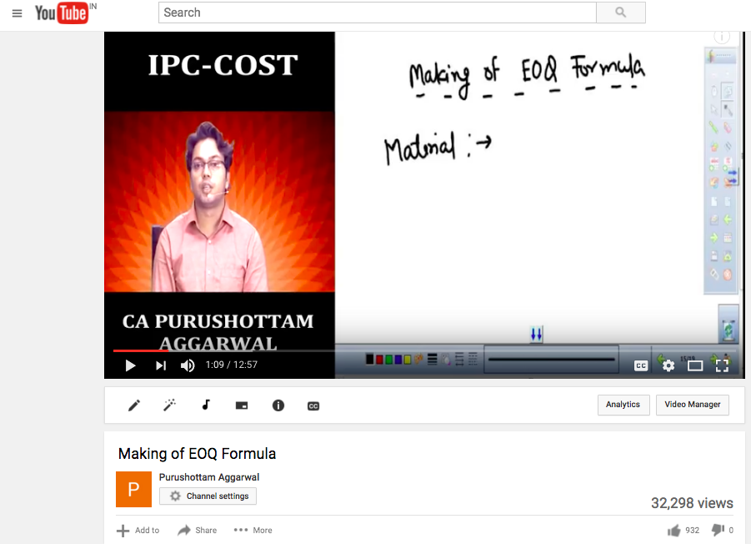

Stay Connected For Revision lecture for May 2017 Exam
Whatsapp your details for future notification at 7532853516

Next Update – Video on confusing topics in ipc costing
So don’t forget to subscribe

Material
Maximum Stock Level= Re-order level + Re-order quantity – (Minimum consumption × Minimum re-order period)

Minimum Stock Level= Re-order level – (Average lead time × Average consumption)

Average Stock Level = $\frac{Maximum Stock Level + Minimum Stock Level}{2}$

Or,
Minimum Stock Level + ½ Re-order Quantity

Re-order Level = Maximum Re-order period × Maximum consumption

Or

(Normal Usage × Average Delivery Time) + Minimum Stock Level

Or
Safety Stock + Lead Time Consumption

Danger Level = Minimum Consumption × Emergency Delivery Time

(EOQ) Economic Order Quantity = $\sqrt{\frac{2×Annual Consumption × Cost of placing an order}{ Cost of carrying per unit per annum}}$

Inventory Turnover Ratio ₌ $\frac{Material Consumed}{Average Inventory}$

Inventory Turnover Period = 365 ÷ Inventory Turnover Ratio

Safety Stock = $\frac{ Annual Demand }{365}$× (Maximum lead time – Average lead time)

Total Inventory Cost= Ordering Cost + Carrying Cost + Purchase Cost

Ordering Cost = $\frac{Annual consumption ×Cost of placing an order}{Quantity Ordered}$

Carrying Cost = $\frac{Quantity ordered}{2}$× Price per unit × Carrying Cost expressed as % of average inventory

Note: For calculation of total inventory carrying cost, average inventory should be taken as half of EOQ. Average inventory cost is normally given as a percentage of cost per unit.

Note: To decide whether discount on purchase of material should be availed or not, compare total inventory cost before discount and after discount. Total inventory cost will include ordering cost, carrying cost and purchase cost.

Labour
Time Rate System:- Earnings = Hours worked × Rate per hour

Straight Piece Rate System:- Earnings = Number of units × Piece rate per unit

Merrick Differential Piece Rate System:-

Efficiency | Payment
Up to 83 % | Ordinary piece rate
83% to 100% | 110% of ordinary piece rate (10% above the ordinary piece rate)
Above 100% | 120% or 130% of ordinary piece rate (20% to 30% above ordinary piece rate)

Combination of Time and Piece Rate

Gantt Task And Bonus System

Output | Payment
Output below standard | Guaranteed time rate
Output at standard | 120% of time rate
Output above standard | 120% of piece rate

Emerson Efficiency System
Earning is calculated as follows :

Efficiency | Payment
Below 66-2/3% | No bonus, only guaranteed time rate is paid.
66-2/3% to 100% | Worker is paid by hourly rate for the time he actually worked plus in increase in bonus according to degree of efficiency on the basis of step bonus rates. Bonus rate can be up to 20%.
Above 100% | 120% of time wage rate plus additional bonus of 1% for each of 1% increase in efficiency.

Bedeaux Point System

Earning= Hours Worked X Rate per hour + ( $\frac{75}{100}$ X $\frac{Bedeaux Points saved}{60}$ X Rate per hour)

Haynes Manit System
This system is similar to Bedeaux Point system. Instead of Bedeaux points saved, ‘MANIT’(Man-minutes) saved are measured for payment of bonus. Bonus is distributed as follows :

- 50% bonus to the workers
- 10% bonus to the supervisors
- 40% bonus to the employer

Accelerated Premium System
In this system individual employer makes his own formula. The following formula may be used for a general idea of the scheme:
y = 0.8 × x²
Where y = wages
x = efficiency

Premium Bonus Plan

Halsey Premium Plan
Earnings = Hours worked × Rate per hour +( $\frac{50}{100}$ X Time Saved X Rate per Hour)

Halsey-Weir Premium Plan
Earnings = Hours worked × Rate per hour + $( \frac{30}{100}$ X Time Saved X Rate per Hour)

Rowan System
Earnings = Hours worked × Rate per hour +$( \frac{Time Saved}{Time allowed}$X Hours Worked X Rate per hour)

Labour Turnover Rate
Separation Method

Separation Method = $\frac{Number of separations during the period }{Average number of Workers on Roll}$ X 100

Replacement Method
Replacement Method = $\frac{Number of workers replaced in a period}{Average number of Workers on roll}$ X 100

Flux Method
Flux Method = $\frac{No. of separations + No. of replacements}{Average number of Workers on roll}$ X 100
OR
= $\frac{No. of separations + No. of replacements+No. of New Recruitments}{Average number of Workers on roll}$ X100

Overhead
Overhead Recovery Rate or Overhead Absorption Rate

Overhead Absorption Rate = $\frac{Amount of overhead incurred}{Basis for Absorption}$

Predetermined Overhead Rate

Predetermined Overhead Rate = $\frac{Budgeted overhead for the period}{Budgeted basis for the Period }$

Blanket Overhead Rate

Blanket Overhead Rate = $\frac{Overhead cost for the entire factory for the period}{Base for the period ( total labour hours, total machine hours, etc)}$

Multiple Overhead Rate

Multiple Overhead Rate = $\frac{Overheads allocated / apportioned to each Deptt.}{Corresponding base}$

Variable Overhead in Semi-Variable Overhead

Variable Overhead Rate = $\frac{Change in amount of expense}{Change in Activity Level or Quantity}$

Non Integrated Accounts

RECONCILIATION STATEMENT

(When Profit as per Cost Accounts is taken as a starting point)

Format of Reconciliation Statement

Particulars | (`) | (`)
A. Profit as per Cost Accounts |  | …….
- Add. Items having the effect of higher profit in financial accounts:
- Over-absorption of Factory Overhead/ Office & Adm. Overheads / Selling & Distribution Overheads in Cost Accounts | ……..
- Over-valuation of Opening Stock of Raw Material / Work-in-progress / Finished goods in Cost Accounts | ……..
(c ) Under-valuation of Closing Stock of Raw Material / Work-in-progress / Finished Goods in Cost Accounts | ……..
(d) Income excluded from Cost Accounts : (e.g.)  Interest & Dividend on Investments  Rent received  Transfer Fees received etc | ……..  ……..  …….. | ……..
- Less: Items having the effect of lower profit in financial accounts:
- Under-absorption of Factory Overheads/ Office & Adm. Overheads / Selling & Distribution Overheads in Cost Accounts | ……..
- Under-valuation of Opening Stock of Raw Material / Work-in-progress/ Finished goods in Cost Accounts | ……..
(c ) Over-valuation of Closing Stock of Raw Material / Work-in-progress / Finished Goods in Cost Accounts | ……..
- Expenses excluded from Cost Accounts : (e.g.)  Bad Debts written off  Preliminary Expenses/ Discount on Issue/ Write-off  Legal Charges | ……..  ……..  …….. | (……..)
D. Profit as per Financial Accounts (A + B – C) |  | ……..
Note: In case of ‘Loss’, the amount shall appear as a minus item.

Note: When profit as per Cost account is calculated from profit as per financial accounts, then items which are added above will be deducted and vice-versa.

Journal Entries under Non-integrated Accounting System

Material Purchased and Material Issued:-
At the time of purchase
Dr. Stores Ledger Control A/c xxxx
Cr. Cost Ledger Control A/c xxxx

If purchased on special requirement for a job
Dr. Work-in-Progress Control A/c |  |  |  | xxxx
Cr. Cost Ledger Control A/c |  |  |  | xxxx

When Materials returned to vendor (Return outwards)
Dr. Cost Ledger Control A/c |  |  | xxxx
Cr. Store Ledger Control A/c |  |  | xxxx

When direct material issued to production
Dr. Work-in-Progress Control A/c |  |  | xxxx
Cr. Store Ledger Control A/c |  |  | xxxx

When indirect material issued to production
Dr. Production Overhead Control A/c |  |  | xxxx
Cr. Store Ledger Control A/c |  |  | xxxx

When Materials returned to Store (Return inwards)
Dr. Store Ledger Control A/c |  |  | xxxx
Cr. Work-in-Progress Control A/c |  |  | xxxx

Wages Paid
When wages paid to workers
Dr. Wages Control A/c |  |  | xxxx
Cr. Cost Ledger Control A/c |  |  | xxxx

When wages (for direct labour) charged to the production
Dr. Work-in-Progress Control A/c |  |  | xxxx
Cr. Wages Control A/c |  |  | xxxx

When wages (for indirect labour) charged to the production
Dr. Production Overhead Control A/c |  |  | xxxx
Cr. Wages Control A/c |  |  | xxxx

Production Overheads
When production overheads incurred
Dr. Production Overhead Control A/c xxxx
Cr. Cost Ledger Control A/c xxxx

When production overheads recovered (absorbed)
Dr. Work-in-Progress Control A/c xxxx
Cr. Production Overhead Control A/c xxxx

Administrative Overheads
When administration overheads incurred
Dr. Administrative Overhead Control A/c xxxx
Cr. Cost Ledger Control A/c xxxx

When administration overheads recovered (absorbed)
Dr. Finished Goods Ledger Control A/c xxxx
Cr. Administration Overhead Control A/c xxxx

Selling and Distribution Overheads
When selling and distribution overheads incurred
Dr. Selling and Distribution Overhead Control A/c xxxx
Cr. Cost Ledger Control A/c xxxx

When selling and distribution overheads recovered (absorbed)
Dr. Cost of Sales A/c xxxx
Cr. Selling and Distribution Overhead Control A/c xxxx

Transfer of under/ over absorbed Overheads
In case of over absorption of overheads
Dr. Production/Administration/Selling & Distribution Overhead Control A/c xxxx
Cr. Cost Ledger Control A/c xxxx

In case of under absorption of overheads
Dr. Cost Ledger Control A/c xxxx
Cr. Production/ Administration/ Selling & Distribution Overhead Control A/c xxxx

Sales
Dr. Cost Ledger Control A/c xxxx
Cr. Costing Profit & Loss A/c xxxx

Profit/ Loss
In case of Profit
Dr. Costing Profit & Loss A/c xxxx
Cr. Cost Ledger Control A/c xxxx

In case of Loss

Dr. Cost Ledger Control A/c xxxx
Cr. Costing Profit & Loss A/c xxxx

Job Costing & Batch Costing

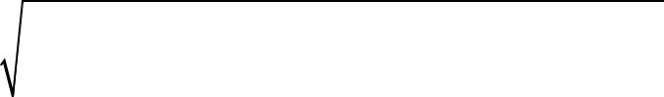
E.B.Q = $\sqrt{\frac{2×Annual Demand×Setting - upCost per batch}{Cost of carrying per unit of production per annum}}$

Stay Connected For Revision lecture for May 2017 Exam
Whatsapp your details for future notification at 7532853516

Next Update – Video on confusing topics in ipc costing
So don’t forget to subscribe

Contract Costing

Value of work certified = Value of Contract × Percentage of work certified.

Cost of work certified =
Cost of work to date - (Cost of work uncertified + Materials at site + Plant at site)

Cost of work uncertified = Cost of work to date – Cost of work certified

Estimated Profit = Value of Contract – Total estimated cost of contract completion.

Percentage of work completed = Value of Work Certified _{×100 ÷} Contract Value

Profits on Incomplete Contracts

When work on contract has not reasonably advanced =
No profit is calculated when work certified is less than 25% of the value of the contract.
No Profit is taken

When work certified is 25% or more but less than 50% of the contract price =

1 X Notional Profit X Cash Received
3 Work Certified

When work certified is 50% or more but less than90% of the contract price=

2 X Notional Profit X Cash Received
3 Work Certified

When the contract is almost complete i.e. 90% or more of the contract price.
An estimated total profit is determined by deducting aggregate of cost to date and estimated additional expenditure from contract price. A portion of this estimated total profit is credited to profit and loss account. The figure to be credited to profit and loss account is ascertained by adopting any of the following formulae:

Estimated Total Profit X Work Certified
Contract Price

Or, Estimated Total Profit X Cash Received
Contract Price

Or, Estimated Total Profit X Cost of Work to date
Estimated Total cost

Or, Estimated Total Profit X Cost of Work to date X Cash Received
Estimated Total cost Work Certified

Joint Products & By-Products

Methods of Apportioning joint costs over Joint Products

Physical Unit Method
Joint Costs are apportioned on the basis of some physical base, such as weight or measure expressed in gallon, tonnes, etc.

Average unit cost method
Under this method process cost (upto the point of separation) is divided by total units of joint products produced.

Survey Method
It is based on the technical survey of all factors involved in the production and distribution of products. Under this method joint costs are apportioned over the joint products on the basis of percentage/ point value assigned to the products according to their relative importance.

Contribution Margin Method
According to this method, joint costs are segregated into two parts-variable and fixed. The variable costs are apportioned over the joint products on the basis of units produced (average method) or physical quantities. In case the products are further processed after the point of separation, then all variable cost incurred be added to the variable costs determined earlier. In this way total variable cost is arrived which is deducted from their respective sales values to ascertain their contribution. The fixed costs are then apportioned over the joint products on the basis of the contribution ratios.

Market Value Method
Under this method joint costs upto the point of separation is apportioned on the basis of market value of the joint products at the point of separation.

Methods of Apportioning joint costs over By- Products

Market Value or realization value method
The realisation on the disposal of the by-product may be deducted from the total cost of production so as to arrive at the cost of the main product.

Standard Cost in technical estimates
The standard may be determined by averaging costs recorded in the past and making technical estimates of the number of units of original raw material going into the main product and the number forming the by-product or by adopting some other consistent basis. This method may be adopted where the by-product is not saleable in the condition in which it emerges or comparative prices of similar products are not available.

Comparative price Method
Value of the by-product is ascertained with reference to the price of a similar or an alternative material.

Re-use basis
The value put on the by-product should be same as that of the materials introduced into the process.

Standard Costing

Sales Variances (Turnover or Value)

Sales Variance
(Actual Sales) Less (Budgeted Sales)
[(AP × AQ) – (BP × BQ)]
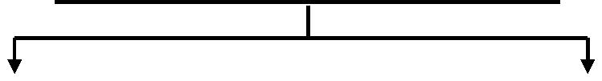

 | Sales Price Variance |  |  |  |  | Sales Volume Variance
 | (Actual Sales) |  |  |  |  | (Standard Sales)
 | Less |  |  |  |  | Less
 | (Standard Sales) |  |  |  |  | (Budgeted Sales)
 | [(AP × AQ) – (BP × AQ)] |  |  |  |  | [(BP × AQ) – (BP × BQ)]
 | Or |  |  |  |  | Or
 | [AQ × (AP – BP)] |  |  |  |  | [BP × (AQ – BQ)]
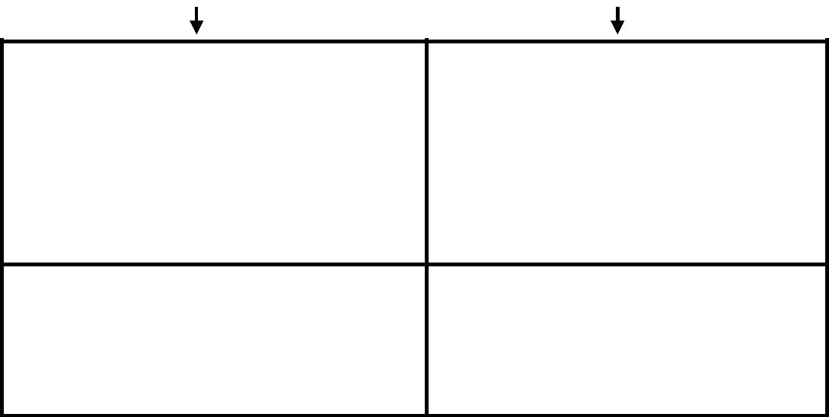
Sales Mix Variance |  | Sales Quantity Variance
(Standard Sales) |  | (Revised Standard Sales)
Less |  | Less
(Revised Standard Sales) |  | (Budgeted Sales)
[(BP × AQ) – (BP × RSQ)] |  | [(BP × RSQ) – (BP × BQ)]
Or |  | Or
[BP × (AQ – RSQ)] |  | [BP × (RSQ – BQ)]

Alternative Formula | Alternative Formula
[Total Actual Quantity (units) × {Average | [Average Budgeted Price per unit of

Marginal Costing

P/V ratio = $\frac{Sales-Variable Cost}{Sales}$ = $\frac{Contribution}{Sales}$ = $\frac{Fixed Cost+Profit}{Sales}$

Break-Even Point Sales X P/V ratio = Fixed Cost (Profit is zero at BEP)

Contribution = Sales X P/V ratio

P/V ratio = $\frac{Change in Profit}{Change in Sales}$ = $\frac{Change in Contribution}{Change in Sales}$ = $\frac{Fixed Cost}{BEP Sales}$

BEP Sales (₹) = $\frac{Fixed Cost}{Profit-Volume Ratio}$

BEP Sales (Units) = $\frac{Fixed Cost}{Contribution per unit}$

(Break-even Sales + Margin of Safety Sales) X P/V Ratio = Contribution

Total Sales = Brea-even Sales + Margin of Safety Sales

Margin of Safety Sales X P/V ratio = Profit

Margin of Safety Ratio = $\frac{Margin of Safety Sales}{Total Sales}$

Cash BEP = $\frac{Cash Fixed Cost}{Contribution per unit}$

Profit = Sales – Variable Cost – Fixed Cost

Contribution = Sales – Variable Cost = Fixed Cost + Profit = Fixed Cost –Loss

Stay Connected For Revision lecture for May 2017 Exam
Whatsapp your details for future notification at 7532853516

Next Update – Video on confusing topics in ipc costing
So don’t forget to subscribe

Youtube Channel Name – Purushottam Aggarwal

