Analysis of May 2016 CA Final Exam Paper of AMA

Question | Chapter |  | Level of Question
1(a) | Target Costing | 5 | A
1(b) | Total Quality Management | 5 | B
1(c) | Service Sector Costing | 5 | B
1(d) | Transportation | 5 | B
2(a) | Total Quality Management | 8 | C
2(b) | Pricing | 8 | A
3(a) | Transfer Pricing | 8 | A
3(b) | Budgeting | 8 | B
4(a) | Standard Costing | 8 | B
4(b) | Network Analysis | 8 | B
5(a) | Learning Curve + Life Cycle + Pricing | 8 | B
5(b) | Relevant Cost | 8 | A
6(a) | Marginal Costing | 8 | B
6(b) | LPP – Graphical Method | 8 | B
7(a) | Assignment | 8 | C
7(b) | Performance Measurement | 4 | C
7(c) | Simulation | 4 | B
7(d) | ABC Costing | 4 | B
7(e) | Pricing | 4 | C

A denotes innovative question
B denotes concept based question
C denotes average question

Allocation of Marks
CA FINAL, ADVANCED MANAGEMENT ACCOUNTING
Suggested Answers for
May, 2016 Exam

 | Q 1(a): | 5 Marks
 | UK Ltd prepared a Draft Budget for the next year as follows:
 | Quantity | 10,000 units
 |  | ₹
 | Selling Price per Unit | 60
 | Variable Cost per Unit
 | – Direct Materials | 16
 | – Direct Labour (2 hours ×₹6) | 12
 | – Variable Overheads (2 hrs₹1) | 2
 | Contribution per Unit | 30
 | Total Budgeted Contribution | 3,00,000
 | Less: Total Budgeted Fixed Overheads | 2,80,000
 | Total Budgeted Profit | 20,000

The Board of Directors are not satisfied with this Draft Budget and suggested the following changes for the better profit:

- The Budgeted Profit is ₹ 50,000,

- The Company should spend ₹ 57,000 on advertisement and the Target Sales Price up to ₹ 64 per unit.

- It is expected that the Sales Volume will also rise, inspite of the price rise, to 12,000 units.

In order to achieve the extra Production Capacity, however, the work force must be able to reduce the time taken to make each unit of the product. It is proposed to offer a pay and productivity deal in which the wages rate per hour is increased to ₹ 8. The hourly rate for Variable Overheads will be unaffected.

You are required to calculate the target labour time require to achieve the Target Profit.

Ans. 1(a)
1. Target Contribution Per Unit = | Fixed Cost + Target Profit | = | (2,80,000 + 57,000) + 50,000 | =₹32.25 PerUnit
 | Sale Quantity |  | 12,000 Units

- Target Variable Cost Per Unit = New sale Price – Target Contribution pu = ₹ 64 – ₹ 32.25 = ₹31.75 Per Unit

- Direct Materials + Direct Labour + VOH = ₹ 16+ (H × ₹ 8) + (H × ₹ 1) = ₹ 31.75

Solving, we have 9H = 15.75. So, H = ^{15.75} = 1.75 Hours
9

Q 1(b): 5 Marks Supreme Prakashan Ltd is in the business of publishing a leading newspaper which has a wide customer base. It measures quality of service in terms of –

- Print Quantity

- On time Delivery

- Number of Damaged and Unsold Paper

To improve its business prospects and performance, the Company is considering installing a scheduling and tracking system which involve an annual additional cost of ₹ 3,00,000, beside Equipments costing ₹ 4,00,000 needed for the installation of System.

To purchase the Equipment, the Company is planning to utilize the proceeds of an Investment fetching an Annual Income of 9%. Details, regarding the present and future performance are given as under:–
 | Present | Expected
On–Time Delivery | 85% | 97%
Variable Cost per lot of Newspaper Damaged and Unsold | ₹ 40 | ₹ 40
Fixed Cost | ₹ 50,000 | ₹ 50,000
No. of lots of Newspaper Damaged and Unsold | 6,000 | 1,000

It is expected that each percentage increase in on time performance will result in Revenue Increase of ₹ 36,000 per annum. Required Contribution Margin is 40%.Should Supreme Prakashan Ltd install the New System?
Ans. 1(b)Statement of Decision For New System
Relevant Costs |  | ₹ | Relevant Benefits | ₹
Annual Costs of new system (given) |  | 3,00,000 | Contribution Earned (₹ 36,000 × 12 times × 40%) | 1,72,800
Income lost on Capital Investment (₹ 4,00,0009%) |  | 36,000 | Savings in Variable Costs:
Fixed Costs (Apportionment, and not relevant) |  | Nil | (6,000 – 1,000) × ₹ 40 | 2,00,000
Net Benefit (balancing figure) |  | 36,800
Total |  | 3,72,800 | Total | 3,72,800
Decision: The new system may be implemented.

Q 1(c): 5 Marks
A Company is considering three alternative proposals for conveyance facilities for its Sales Personnel who, have to do considerable travelling, approximately 20,000 kilometres every year. The proposals are as follows:

- Purchase and maintain its own fleet of Cars. The average cost of a Car is ₹ 1,00,000.

- Allow the Executive to use his own Car and reimburse expenses at the rate of ₹ 1.60 per kilometer, and also bear Insurance Costs.
- Hire Cars from an Agency at ₹ 20,000 per year per Car. The Company will have to bear costs of Petrol, Taxes and Tyres.

The following further details are available:

- Petrol ₹ 0.60 per km

- Repairs and Maintenance ₹ 0.20 per km

- Tyres ₹ 0.12 per km

- Insurance ₹ 1,200 per Car per annum

- Taxes ₹ 800 per Car per annum

- Life of the car: 5 years with Annual Mileage of 20,000 kms

- Resale Value: ₹ 20,000 at the end of the fifth year.

Work out the relevant costs of three proposals and rank them.

Ans 1(c) Statement of Comparison & Ranking of Proposals
 |  |  |  | Computation of Operating Cost per Km
 | Particulars |  |  | Computations |  |  |  | Option (i) |  | Option (ii) | Option (iii)
(i) | Petrol |  |  | Given |  |  |  | ₹0.60 |  | – | ₹0.60
(ii) | Depreciation |  |  | ₹1,00,000 -₹20,000 |  |  |  | ₹0.80 |  | – | –
(ii) |  |  |  | 5 Years × 20,000 Km |  |  |  | ₹0.80 |  | – | –
 |  | Particulars |  | Computations |  |  | Option (i) |  | Option (ii) |  | Option (iii)
(iii) |  | Reimbursement |  |  | Given |  | – |  | ₹1.60 |  | –
(iv) |  | Hire Charges |  | ₹20,000 |  |  | – |  | – |  | ₹1.00
 |  |  |  |  | 20,000 Km |  |  |  |  |  | ₹1.00
(v) |  | Repairs and Maintenance |  |  | Given |  | ₹0.20 |  | – |  | –
(vi) Tyres |  |  |  |  | Given |  | ₹0.12 |  | – |  | ₹0.12
(vii) Insurance |  |  |  | ₹1,200 |  |  | ₹0.06 |  | ₹0.06 |  | –
 |  |  |  |  | 20,000 Km |  |  |  |  |  | –
(viii) Taxes |  |  |  | ₹800 |  |  | ₹0.04 |  | – |  | ₹0.04
 |  |  |  |  | 20,000 Km |  |  |  |  |  | ₹0.04
 |  | Total |  |  |  |  | ₹1.82 |  | ₹1.66 |  | ₹1.76
 |  | Rank |  |  |  |  | III |  | I |  | II
Q1(d): |  |  |  |  |  |  |  |  |  |  | 5 Marks
The Cost per unit of transporting goods from the Factories X, Y and Z to Destinations A, B, C and D, and the quantities demanded and supplied are given:
Factories |  |  | Destinations |  | Supply
 | A | B | C | D
X | 25 | 50 | 20 | 24 | 100
Y | 30 | 40 | 35 | 10 | 250
Z | 20 | 10 | 25 | 35 | 200
Demand | 250 | 100 | 150 | 50 | 550
Answer the following question with reasons, taking u3 as zero while calculating ui&vj :

- Is this solution is optimum?
- If yes, can there be any alternate optimum solution?

Ans 1(d)
 |  |  |  |  |  |  |  |  |  |  |  |  |  |  |  |  |  |  |  |  |  |  |  |  |  |  | Cost Differences
Particulars |  | A |  |  | B |  |  |  |  |  |  | C |  |  |  |  | D |  |  |  |  | Amount
Particulars |  |  |  |  |  |  |  |  |  |  |  |  |  |  |  |  | D |  |  |  |  |  |  |  |  |  | I | II |  | III |  |  | IV
X |  |  |  |  |  |  |  |  |  |  |  |  |  | 100
X | 25 |  |  |  | 50 |  |  |  |  |  |  | 20 |  |  |  |  | 25 |  |  | 100/0 |  |  |  |  |  |  | 5 | 5 |  | 5 |  |  | –
 |  |  |  |  |  |  |  |  |  |  |  | 50 |  |  |  |  |  | 50
Y |  |  | 150
Y | 30 |  |  |  | 40 |  |  |  |  |  |  | 35 |  |  |  |  | 10 |  |  | 250/200/0 |  |  |  |  |  |  | 20 | 20 |  | 5 |  |  | 5
Z |  |  | 100 |  |  |  | 100
Z | 20 |  |  |  | 10 |  |  |  |  |  |  | 25 |  |  |  |  | 35 |  |  | 200/100/0 |  |  |  |  |  |  | 10 | 5 |  | 5 |  |  | 5
Required | 200/150/0 |  |  |  | 100/0 |  |  |  |  |  |  | 150/50/0 |  |  |  |  | 50/0 |  |  | 550
Cost Diff:
I | 5 |  |  | 30 |  |  |  | 5 |  |  |  |  |  |  |  | 15 |  |  | In the above IBFS, Number of allocated cells is 6.
II | 5 |  |  |  | – |  |  | 5 |  |  |  |  |  |  |  | 15 |  |  | m + n – 1 (i.e. Rows + Columns – 1)
III | 5 |  |  |  | – |  |  | 5 |  |  |  |  |  |  |  |  | – |  | = 3 + 4 – 1 = 6. Hence, there is no degeneracy.
III | 5 |  |  |  |  |  |  |  |  |  |  |  |  |  |  |  | – |  | This can be tested for optimality.
IV | 10 |  |  |  | – |  |  | 10 |  |  |  |  |  |  |  |  | –
OPTIMALITY TEST: |  |  |  | Table 1 = U + V for allocated cells computed as below:
 |  |  | U & V |  |  |  |  |  |  |  | 20 – 0 = 20 |  |  |  |  |  | 10 – 0 = 10 |  |  |  |  | 35 – 10 = 25 |  |  |  |  | 10 – 10 = 0
 |  |  | 20 – 25 = –5 |  |  |  |  |  |  |  |  |  |  |  |  |  |  |  |  |  |  |  | 100
 |  |  |  |  |  |  |  | 25 |  |  |  |  |  |  |  | 50 |  |  |  |  |  | 20 |  |  |  | 25
 |  |  | 30 – 20 = 10 |  |  |  |  |  |  |  |  |  | 150 |  |  |  |  |  |  |  |  |  |  | 50 |  |  |  |  | 50
 |  |  |  |  |  |  |  | 30 |  |  |  |  |  |  |  | 40 |  |  |  |  |  | 35 |  |  |  | 10
 |  |  |  |  | (Base) 0 |  |  |  |  |  |  |  | 100 |  |  |  |  |  | 100
 |  |  |  |  |  |  |  | 20 |  |  |  |  |  |  |  | 10 |  |  |  |  |  | 25 |  |  |  | 35

Table 2 = U + V for Unallocated Cells

20+(–5) = 15 | 10+(–5) = 5 |  | 0+(–5) = –5
 | 10+10 = 20
 |  | 25 –0 = 25 | 0 – 0 = 0

Table 3 = Net Evaluation Table (NET)

= Table 1 – Table 2 for Unallocated Cells

25 – 15 = 10 | 50 – 5 = 45 |  | 25–(–5)=30
 | 40–20 = 20
 | 6 – 5 = 1 | 25–25=0 | 35–0 = 35

Conclusion: Since, all NET Entries are≥0, the solution is Optimal, but not unique. As many Zeroes, that manyAlternative Optimal Solutions are possible. Hence, in this case there is 1 alternative Optimal Solution (1 Zero in ZC cell).

Q 2(a): |  |  | 8 Marks
A Company produces and sells a single product. The Cost Data per unit for the year 2017 is predicted as below:
 | ₹ per unit |  | ₹ per unit
Direct Material | 35 | Variable Overheads | 15
Direct Labour | 25 | Selling Price | 90

The Company has forecast that demand for the product during the year 2017 will be 28,000 units. However, to satisfy this level of demand, Production Quantity will be increased.

There are no Opening Stock and Closing Stock of the Product.

The Stock Level of Material remains unchanged throughout the Period.

The following additional information regarding Costs and Revenue are given:

- 12.5% of the items delivered to Customers will be rejected due to Specification Failure, and will require free replacement. The Cost of delivering the replacement item is ₹ 5 per unit.

- 20% of the items produced will be discovered faulty at the Inspection Stage before they are delivered to customers.

- 10% of the Direct Material will be scrapped due to damage while in storage.

Due to above, Total Quality Costs for the year is expected to be ₹ 10,75,556.

The Company is now considering the following proposal:

- To introduce Training Programmes for the workers which, the Management of the Company believes, will reduce the level of faulty production to 10%. This Training Programme will cost ₹ 4,50,000 per annum.
- To avail the services of Quality Control Consultant, at an annual charges of ₹ 50,000, which would reduce the percentage of faulty items delivered to customers to 9.5%.

You are required to:

- Prepare a statement of expected Quality Costs the Company would incur if it accepts the proposal. Costs are to be calculated using the four recognized Quality Costs Heads.

- Would you recommend the proposal? Give Financial and Non–Financial Reasons.

Ans. 2(a)

- Computation of Finished Goods Production Quantity (in units)

 |  |  |  | Before TQM |  |  |  |  | After TQM
Sales Quantity |  |  |  |  | 28,000 |  |  |  |  | 28,000
Add: Additional Quantity towards Specification Failure |  |  | 28,000 × | 12.5% | = 4,000 |  | 28,000 × |  | 9.5% | = 2,939
 |  |  | 28,000 × | 87.5% |  |  | 28,000 × | 90.5% |  | = 2,939
Total of the above |  |  |  |  | 32,000 |  |  |  |  | 30,939
Add: Additional Quantity towards Faulty Inspection |  |  | 32,000 × ²⁰ |  | = 8,000 |  | 30,939 × ¹⁰ |  |  | = 3,438
 |  |  |  | 80 |  |  |  |  | 90
Total FG Quantity to be produced before Inspection |  |  |  |  | 40,000 |  |  |  |  | 34,377
2. Material Costs (in ₹)
 |  |  |  | Before TQM |  |  |  |  | After TQM
Raw Material Costs for producing Pre–Inspection FG Quantity |  | 40,000 × ₹ 35 = 14,00,000 |  |  |  |  | 34,377 × ₹ 35 = 12,03,195
Add: Scrapping at Storage Stage |  | 14,00,000 × |  | ¹⁰ = 1,55,556 |  |  | 12,03,195 × |  | ¹⁰ =1,33,688
 |  |  |  | 90 |  |  |  |  | 90
Total |  |  |  | 15,55,556 |  |  |  |  | 13,36,883

- Cost Comparison (Note: VC pu = 35+25+15 =₹75) (in ₹)

 | COQ Category | Before TQM | After TQM | Savings/(Addl)
A. Quality Compliance Costs
1. | Prevention
 | (a) Consultant to reduce Spec.Failure | – | 50,000 | (50,000)
 | (b) Training to reduce Faulty Prodn | – | 4,50,000 | (4,50,000)
2. | Appraisal | – | – | –
B. Quality Non – Compliance Costs
1. | Internal Failure:
 | (a) Material Scrap at Storage | 1,55,556 | 1,33,688 | 21,868
 | (b) Faulty Production (Pre–delivery) | 8,000 × ₹ 75 = 6,00,000 | 3,438 × ₹ 75 = 2,57,850 | 3,42,150
2. | External Failure: Specification Failure
 | (a) Production Cost of Extra Units | 4,000 × ₹ 75 = 3,00,000 | 2,939 × ₹ 75 = 2,20,425 | 79,575
 | (b) Delivery Costs | 4,000 × ₹ 5 = 20,000 | 2,939 × ₹ 5 = 14,695 | 5,305
 | Total | 10,75,556 | 11,26,658 | (51,102)

Conclusion:
- There is an Additional COQ of ₹51,102. Hence, considering financial reasons alone, TQM proposal is not worthwhile.
- Proposed Sale Revenue = ₹ 90 × 28,000 = ₹ 25,20,000. Additional COQ = _{25,20,000}^{51,102} = only 2.03% of Sale Revenue.

- Hence, considering Materiality, and Non–Financial Factors (viz. long run impact on Profits, better market image due to the quality of supply, future increase in Sales, etc.), the TQM Proposal may be implemented.

Non-financial Reason: The Company may also identify measures to reduce Material Scrapping Costs, to implement better cost management.

Q 2(b): 8 Marks A Company manufactures a product Y in addition to other products, by using the same machines in Department A and Department B.

The usage details are:–

Per unit of Product Y |  | Department A |  |  | Department B
 | Usage |  | Rate | Usage |  | Rate
Direct Material | 8 kg |  | ₹ 4 | 4 kg |  | ₹ 6
Direct Labour | 2 hours |  | ₹ 14 | 3 hours |  | ₹ 12

Basis of Overhead recovery are given below:

Per unit of Product Y | Department A per rupee of Direct Material | Department B per Direct Labour Hour
Variable Overheads | ₹ 0.80 | ₹ 2.00
Fixed Overheads | ₹ 2.20 | ₹ 3.00

Other details are:

- Value of Plant & Machinery in Department A is ₹ 22 Lakhs and in Department B is ₹ 18 Lakhs.

- The Working Capital Requirement of Product Y based on a Target Volume of output of 2,000 units per month is estimated at ₹ 2,72,800 per annum which is 40% of the potential capacity.

Required:

- Calculate the Selling Price of Product Y, to ensure contribution equivalent to 25% of Investment made.

- If Product Y is a new product about to be launched in the market, on what basis should the price be Fixed and what would be the minimum price?
- If product Y is a well-established product, what should be the basis for price fixing and what would be the minimum price?

Ans. 2(b)
 |  | 1. Computation of Required Sale Price per unit
 | Particulars |  |  | Computation | ₹
(a) | Share of Investment in Plant and Machinery |  |  | 40% of (₹ 22 Lakhs + ₹ 18 Lakhs) | 16,00,000
(b) | Investment in Working Capital |  |  |  | 2,72,800
(c) | Total Investment |  |  | Assumed 40% of FA Capacity is for this Product | 18,72,800
(d) | Required ROI= 25%. So, Required EBT |  |  | 25% on ₹ 18,72,800 | 4,68,200
(e) | Required EBT per unit per month |  |  | (₹ 4,68,200 ÷ 12 months) ÷ 2,000 units | 19.51
(f) | Material Cost p.u. |  |  | Dept A: 8 Kg × ₹ 4 + Dept. B: 4 Kg × ₹ 6 | 56.00
(g) | Labour Cost p.u. |  |  | Dept A: 2 hrs × ₹ 14 + Dept. B: 3 hrs × ₹ 12 | 64.00
(h) | VOH p.u. |  |  | (Dept A: 8 kg × ₹4 × ₹ 0.80) + (Dept. B: ₹ 2 ph × 3 hrs) | 31.60
(i) | FOH p.u. |  |  | (Dept A: 8 kg × ₹4 × ₹ 2.20) + (Dept. B: ₹ 3 ph × 3 hrs) | 79.40
(j) | Required Sale Price p.u. (Total of e to i) |  |  |  | 250.51
Note: Alternatively, FOH of₹79.40 p.u. can also be excluded, since other products are also produced using same Plant & Machinery.

2. Computation of Sale Price

 | (a) If the product is well established in the market, the |  | (b) If product is launched for the first time in the
 | minimum sale price can range from – |  | market, the minimum sale price can range from –
 | Total Cost (Total of f to i) | = ₹ 231.00 | Variable Cost (Total of f to h) | = ₹ 151.60
 | Total Cost + Profit Margin (Total of e to i) | = ₹ 250.51 | Total Cost (Total of f to i) | = ₹ 231.00
 | So, Price Range =₹231.00 to₹250.51 |  | So, Price Range = ₹151.60 to₹231.00
 | Q 3(a): |  |  | 8 Marks
Division X and Y are two divisions of XY Ltd, which operate as Profit Centres. Division X makes and sells Product X. The Budgeted Income Statement of Division X, based on a sales volume of 30,000 units, is given below:
Particulars | ₹ in ‘000
Sales Revenue | 6,000
Component Purchases Costs | 1,050
Other Variable Costs | 1,680
Fixed Costs | 480
Variable Marketing Costs | 270
Fixed Marketing Overheads | 855
Operating Profit | 1,665

The Manager of Division X suggests that sales can be increased by 9,600 units, if the Selling Price is reduced by ₹ 20 per unit from the present price of ₹ 200 per unit, and that for this additional volume, no additional Fixed Costs will be incurred.

Division Y makes a Component Y, which is sold outside at a price of ₹ 50 per unit.

Division X presently uses a component which is purchased from outside at ₹ 35 per unit. This component is similar to the component made by Division Y. Division Y can make this component for Division X with a minor modification in specification which would cause reduction in Direct Material Cost for the Division Y by ₹ 1.5 per unit, and would require extra labour hour of 1 per unit at the rate of ₹ 1.5 per hour.

Further, Division Y will not incur Variable Selling Marketing Cost on units transferred to the Division X. Division X’s Manager has offered to buy the component from Division Y at ₹ 25.00 per unit.

Division Y has the Capacity to produce 85,000 units.

The Current budgeted Information of Division Y are as follows:

Number of units sold outside 60,000 units @ ₹ 50 per unit, Variable Cost including Material and Labour ₹ 15 per unit, Variable Marketing Cost ₹ 3 per unit, Operating Profit ₹ 12,00,000 and Fixed Overheads ₹ 7,20,000.

Advise:

- Should the Division X reduce the Selling Price by ₹ 20 per unit, even if it is not able to procure the component from Division Y at ₹ 25 per unit?

- Should the Division Y be willing to supply 39,600 units to Division X at ₹ 25 per unit?

Support each of your conclusions with appropriate calculations.

Ans. 3(a)

- Cost Analysis

 | A. Division X |  |  |  |  |  | B. | Division Y
• Variable Cost Per Unit |  |  |  |  | • | Variable Cost Per Unit |  |  | Production | Marketing
(a) | Component | 1,050 | =₹ 35 |  |  | (a) | For External Sales |  | ₹15 | ₹3
 |  | 30
(b) | Other Production Costs | 1,680 | =₹ 56 |  |  | (b) | For Int. Transfer |  | ₹15 | Nil
 |  | 30 |  |  |  |  | [15+1.5–1.5]
(c) | Marketing | 270 | =₹ 09
 |  | 30
 | Total Variable Cost p.u. |  | ₹100
• Fixed Costs [4,80,000+8,55,000] |  | ₹13,35,000 |  |  | • | Fixed Costs (Given) |  |  | ₹7,20,000

- Effect of Price reduction by X

Additional Contribution from Price Reduction by Division X

= | Proposed Contribution | (–) | Present Contribution
= [39,600 Units×₹ (SP 200– Reduction 20–VC 100)] |  | (–) | [30,000 Units × ₹ (SP 200– VC 100)]
= ₹ 31,68,000 – ₹ 30,00,000 = ₹1,68,000

Hence, the Price Reduction proposal is worthwhile, even if component is bought from outside.

AssumptionThe Reduced Price applies to all 39,600 Units, and not only the additional 9,600 Units.

- Effect of Internal Transfer at ₹ 25 by Division Y

Particulars | Present | Proposed
Output | 60,000 units (Capacity: 85,000 Units) | 85,000 Units
 | External Sale | Sale | Transfer
Revenue Per Unit | ₹50 | ₹50 | ₹25
Less: Variable Cost Per Unit [WN 1B] | 15+3 = ₹ 18 | ₹18 | ₹15
Contribution Per Unit | ₹32 | ₹32 | ₹10
 |  | ₹14,52,800 | ₹3,96,000
Total Contribution (Qtty × Cnpu) | ₹19,20,000 | ₹18,48,800
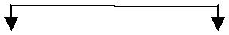

Conclusion: Division Y may not be interested in supplying 39,600 Units to X at₹25 p.u. due to reduction in Contribution.

Q3(b): 8 Marks
A Company is engaged in manufacturing two products M and N. Product M uses one unit of Component P and two units of Component Q. Product N uses two units of Component P, one unit of Component Q and two units of Component R. Component R, which is assembled in the Factory, uses one unit of Component Q. Components P and Q are purchased from the market. The Company has prepared the following forecast of Sales and Inventory for the next year:
 |  | Product M | Product N
Sales (in units) |  | 80,000 | 1,50,000
At the end of the year |  | 10,000 | 20,000
At the beginning of the year |  | 30,000 | 50,000

The production of both the products and the assembling of the Component R will be spread out uniformly throughout the year. The Company at present orders its inventory of P and Q in quantities equivalent to 3 months production. The Company has compiled the following data related to two components:

 | P | Q
Price per unit (₹) | 20 | 8
Order Placing Cost per order (₹) | 1,500 | 1,500
Carrying Cost per annum | 20% | 20%

Required:

- Prepare a Budget of Production and Requirements of Components for next year.
- Suggest the Optimal Order Quantity of Components P and Q.

Ans. 3(b)
 |  |  |  | 1. Computation of Budgeted Production Quantities
 |  |  |  | Particulars |  | Product M |  | Product N
 | Budgeted Sales |  |  |  |  | 80,000 |  | 1,50,000
Add: Stock at the end of the year |  |  |  |  |  | 10,000 |  | 20,000
 | Sub – Total |  |  |  |  | 90,000 |  | 1,70,000
Less: Stock at the beginning of the year |  |  |  |  |  | 30,000 |  | 50,000
 | Budgeted Production Quantity |  |  |  |  | 60,000 |  | 1,20,000
 | 2. Computation of Budgeted Component Requirements and EOQ
Particulars |  |  |  | Material P |  | Material Q |  | Material R
Product M: 60,000 units |  |  |  | 1 × 60,000 = 60,000 | 2 × 60,000 = 1,20,000 |  |  | NA
Product N: 1,20,000 units |  |  |  | 2 × 1,20,000 = 2,40,000 | 1 × 1,20,000 = 1,20,000 |  | 2 × 1,20,000 = 2,40,000
 |  |  |  |  |  | +(for making R) |  | (to be made internally)
 |  |  |  |  | 2,40,000 × 1=2,40,000
Total Requirement p.a. |  |  |  | 3,00,000 units |  | 4,80,000 units | (already considered in Q)
Buying Cost per Order |  |  |  | ₹1,500 | ₹1,500
Carrying Cost p.u. p.a. |  |  |  | 20% of ₹ 20 = ₹ 4.00 | 20% of ₹8 = ₹1.6
EOQ = | 2AB |  |  | 15,000 units |  | 30,000 units
EOQ = | C |  |  | 15,000 units |  | 30,000 units
Q 4(a): |  |  |  |  |  |  |  | 8 Marks
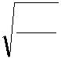
A Company operates a Standard Cost System to control the Variable Works Cost of its only product. The following are the details of actual production, Costs and Variances for November 2015.

Production Costs – Actuals – for 10,000 units: |  |  | Cost Variances:
1. | Direct Materials: | 1,05,000 kgs at a cost of ₹ 5,20,000 | 1. | Materials | Price: ₹ 5,000F, Usage: ₹ 25,000A
2. | Direct Labour: | 19,500 hours at a cost of ₹ 3,08,000 | 2. | Labour | Rate: ₹ 15,500A, Efficiency: ₹7,500F
3. | Variable Overheads: | ₹ 4,10,000 | 3. | Variable Overheads: ₹ 10,000A

The Cost Accountant finds that the Original Standard Cost Data for the product is missing from the Cost Department Files. The Variance analysis for December, 2015 is held up for want of this data.

Calculate – (i) Standard Price per kg of Direct Material; (ii) Standard Quantity for each Unit of Output; (iii) Standard Rate of Direct Labour hour; (iv) Standard Time for Actual Production; (v) Standard Variable Overhead Rate.

Ans. 4(a)
 |  |  |  | 1. Materials Variances
 | Col. (1): Std Cost = SQ × SP |  |  | Col. (2): AQ × SP | Col. (3): AQ × AP
 |  | SQ = bal.fig, SP from Col.2 |  | AQ = given, SP = bal. fig. | AQ = given, AP = bal.fig
 |  |  | × ₹ 5 = ₹ 5,00,000 | 1,05,000 kg × ₹5 = ₹ 5,25,000 | 1,05,000 kg × ₹ |  | =
 | 1,00,000 kg |  | × ₹ 5 = ₹ 5,00,000 | 1,05,000 kg × ₹5 = ₹ 5,25,000 | 1,05,000 kg × ₹ | 4.95 | =
(i.e. Col.2 ₹ 5,25,000 less MUV ₹ 25,000 A) |  |  |  | (i.e. Actual Cost ₹ 5,20,000 + MPV ₹ 5,000 F) | ₹5,20,000 (Given)
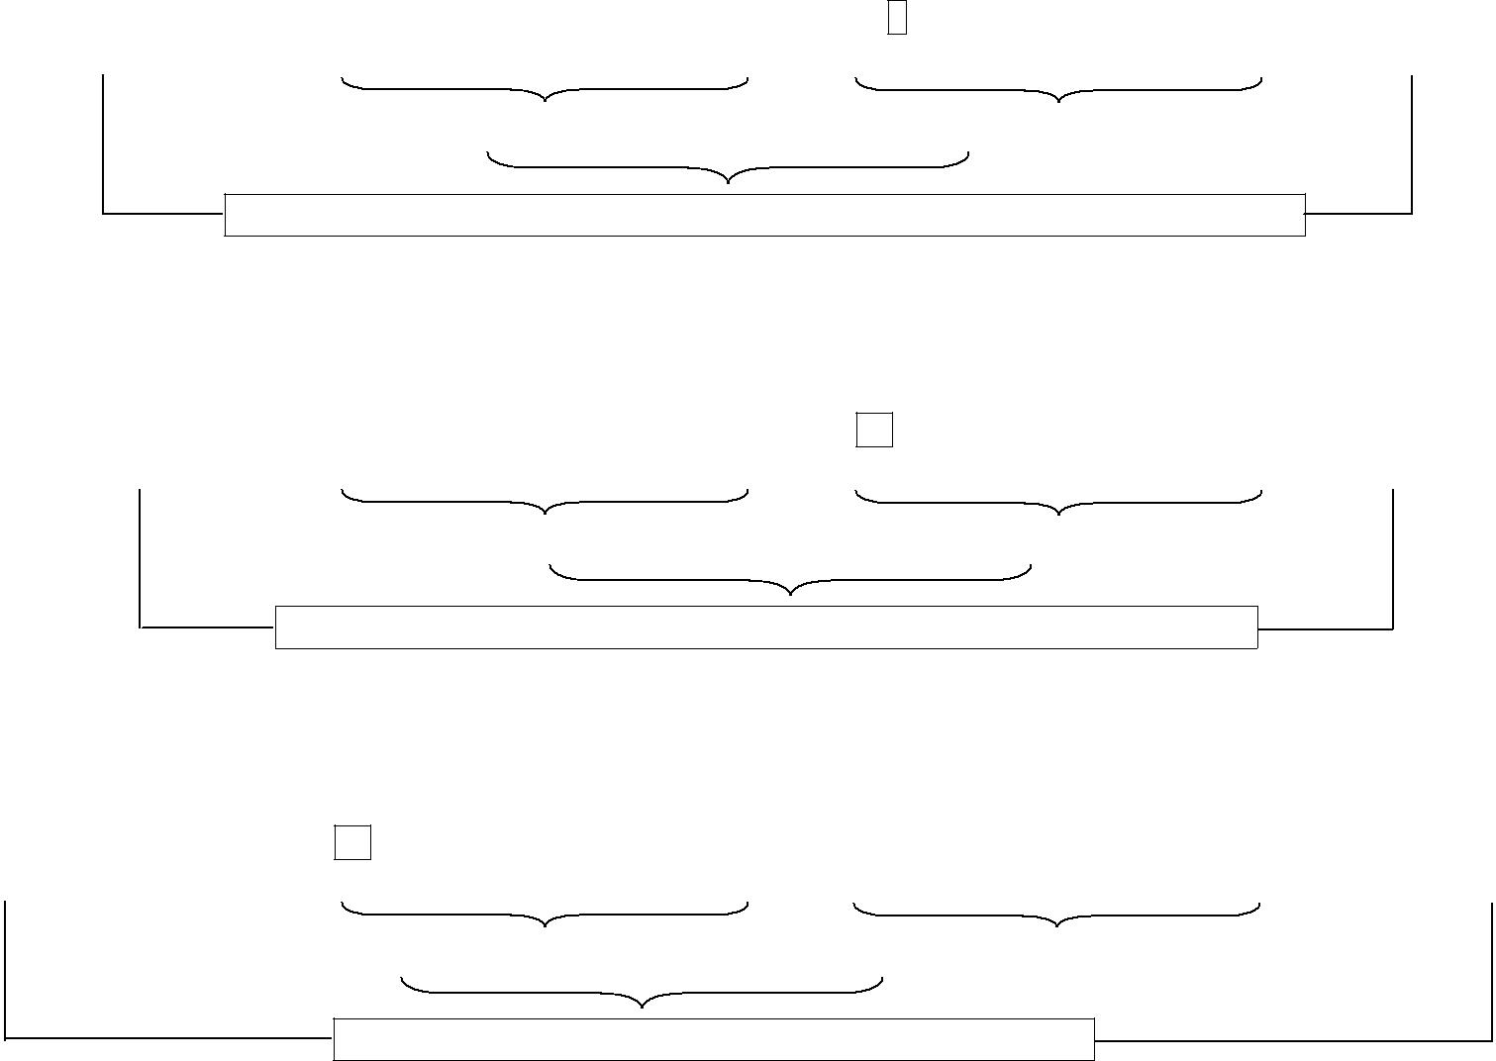
Material Usage Variance = ₹ 25,000 A (given) + Material Price Variance = ₹ 5,000 F (given)

Total Material Cost Variance (given) =₹25,000 A +₹5,000 F =₹20,000 A

Note: Since SQ of RM for 10,000 units of FG = 1,00,000 kg, it means that 1 unit of FG requires 10 kg of RM.

2. Labour Variances

 | Col. (1): Std Cost = SH × SR |  | Col. (2): AH × SR | Col. (3): AH × AR
 | SH = bal. fig, SR from Col.2 |  | AH = given, SR = bal. fig. | AH = given, AR = bal. fig.
 |  | × ₹ 15 = ₹ 3,00,000 | 19,500 hours × ₹15 = ₹ 2,92,500 | 19,500 hours× ₹ |  | =
 | 20,000 hrs | × ₹ 15 = ₹ 3,00,000 | 19,500 hours × ₹15 = ₹ 2,92,500 | 19,500 hours× ₹ | 15.79 | =
(i.e. Col.2 ₹ 2,92,500 + LEV ₹ 7,500 F) |  |  | (i.e. Actual Cost ₹ 3,08,000 less LRV ₹ 15,500 A) | ₹3,08,000 (Given)

Labour Efficiency Variance = ₹ 7,500 F (given) + Labour Rate Variance = ₹ 15,500 A (given)

Total Labour Cost Variance (given) =₹7,500 F +₹15,500 A =₹8,000 A

Note: Since SH of Labour for 10,000 units of FG = 20,000 hours, it means that 1 unit of FG requires 2 Direct Labour Hours.

3. VOH Variances

Col. (1): Std Cost = SH × SR |  | Col. (2): AH × SR | Col. (3): AH × AR
SH from Labour, SR = bal. fig. |  | AH from Labour, SR from Col.1 | (given)
20,000 hours × ₹20 = ₹ 4,00,000 |  | 19,500 hours × ₹ 20 = ₹ 3,90,000 | ₹4,10,000
(i.e. Col.3 ₹ 4,10,000 – Cost Var. ₹ 10,000 A)
Efficiency Variance =₹4,00,000–₹3,90,000 =₹10,000 F |  | + Expenditure Variance =₹ 3,90,000–₹ 4,10,000 =₹ 20,000 A

Total VOH Cost Variance (given) =₹10,000 A

4. Answer – (i) Std Price of RM =₹5 per kg, (ii) StdQttyp.u. of Output = 10 Kg, (iii) Std Rate of Labour =₹15 ph, (iv)Std Time for Actual Production = 2 hrspu and 20,000 hours for 10,000 units, (v) Std VOH Rate = ₹ 20 ph.

Q 4(b): |  |  | 8 Marks
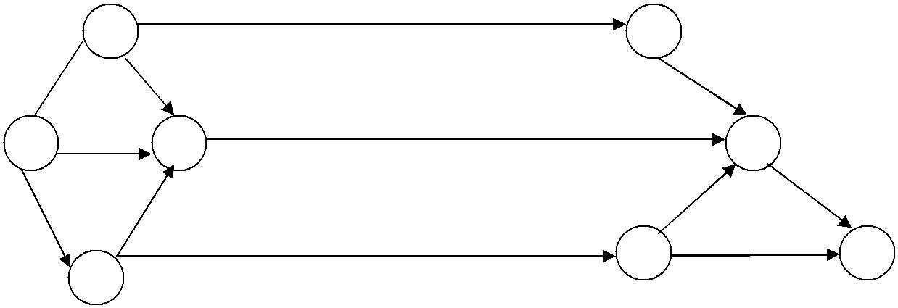 | 18
2 |  | 5
9 | 7 |  | 8
6 | 20
1 | 4 |  | 7
 | 5 | 7 | 6
10 | 5 |  | 7
 | 12 |  | 7
 | 12 | 6 | 8
3

After 15 days of working the following progress is noted for the Network of an Erection Job:

- Activity 1–2, 1–3, and 1–4 completed as per original schedule.

- Activity 2–4 is in progress and will be completed in 3 more days.

- Activity 3–6 is in progress and will need 18 days more for completion.

- Activity 6–7 appears to present some problem and its new estimated time of completion is 12 days.

- Activity 6–8 can be completed in 5 days instead of originally planned for 7 days.

You are required to:

- Update the above diagram after 15 days of the start of work based on the assumption given above.

- Write down the Critical Path with Total Project Duration.

Ans. 4(b)
 | 1. Revised Duration of Activities after 15 days for Updation
Activity | Preceding Activity | Date of Completion |  |  | Revised Duration
2–4 | 1–2 | 15 + 3 |  | = 18 days | 18 – 9 (for Activity 1 – 2) = 9 days
3–6 | 1–3 | 15 + 18 |  | = 33 days | 33 – 10 (for Activity 1 – 3) = 23 days
6–7 | 1–3 & 3–6 |  |  |  | Given = 12 days
6–8 | 1–3 & 3–6 |  |  |  | Given = 5 days

Note: Assumed no Change in duration of other activities, viz. 3–4, 2–5, etc.

2. Network and CP as per Revised Schedule

 |  | 2 | 18 | 5 | 8 |  |  | Paths | Duration (In Days)
 |  | 2 |  | 5 | 8 |  |  | 1–2–5–7–8 | 9+18+8+6 = 41
9
 |  | 6 | 9 |  |  |  |  | 1–2–4–7–8 | 9+9+20+6 = 44
1 |  | 6 | 4 | 20 | 7 |  |  | 1–4–7–8 | 6+20+6 = 32
 |  |  |  | 20 | 12 | 6 |  | 1–3–4–7–8 | 10+5+20+6 = 41
 |  |  | 5 |  | 12 | 6
10 |  |  | 5 |  | 12 | 6 |  | 1–3–6–7–8 | 10+23+12+6 = 51(max)
 |  | 3 |  | 6 |  |  | 8 | 1–3–6–8 | 10+23+5 = 38
 |  | 3 | 23 | 6 | 5 |  | 8 | Revised Critical Path, i.e. Longest Path
 |  |  | 23 |  | 5 |  |  | = 1–3–6–7–8 = 51 days.
 | Q 5(a): |  |  |  |  |  |  |  | 8 Marks
 | MP Ltd has developed a special product. Details are as follows:
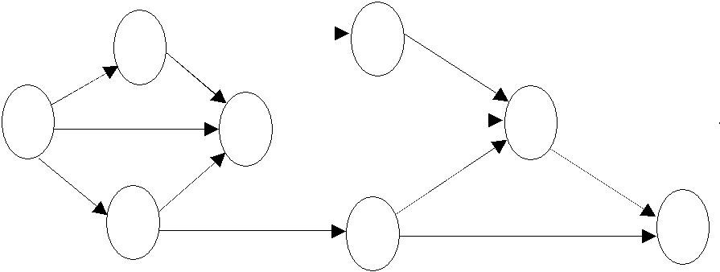
• The product will have a life cycle of 5,000 units. It is estimated that the market can absorb first 4,500 units at ₹ 64 per unit, and then the product will enter the “decline” stage of its life cycle.

• The Company estimated the following cost structure:

Direct Labour | ₹ 6 per hour
Other Variable Costs | ₹ 19 per unit

• Fixed Costs will be ₹ 40,000 over the life cycle of the product. The Labour Rate and both of these costs will not change throughout the product’s life cycle.

• The first batch of 100 units will take 1,000 Labour Hours to produce. There will be an 80% Learning Curve that will continue until 2,500 units have been produced. Batches after this level will each take the same amount of time as the 25th Batch. The Batch Size will always be 100 units.

Calculate:

- Cumulative Average Time per Batch for the first 25 Batches.

- Time taken for the 25th Batch if Average Time for 24 Batches is 359.40 hours.

- Average Selling Price of the final 500 units, that will allow the Company to earn a Total Profit of ₹ 80,000 from the product. (Note: Learning Coefficient is –0.322 for Learning Rate of 80%)

The values of Logs have been given for calculation purpose: log2 = 0.30103, log3 = 0.47712, log5 = 069897

antilog of 2.534678 = 342.51 antilog of 2.549863 = 354.70 antilog of 2.555572 = 359.40 antilog of 2.567698 = 369.57

Ans. 5(a)

1. y = ax^{b} a= Labour Time of 1st Batch = 1,000 Hours
b = Learning Coefficient for 80% = given = –0.322
x = 25 [Note: 25 = 5². In Log Form, log 25 = 2 × log 5]
log y = log a + b log x

= log 1,000 + (– 0.322) × log 25 = log 1,000 + (– 0.322) × 2 log 5
= 3.0000 + (– 0.322) × 2 × (0.69897) = 3 + (–0.45014) = 2.54986

Hence y = Antilog of 2.54986 = given = 354.70. So, Average Time Per Batch for 25 Batches = 354.70 hours

2. | Time taken for 25th Batch | = (354.70 × 25 Batches) – (359.40 × 24 Batches) | = 8,867.5–8,625.6=241.9 hours
3. | Labour Cost of 50 Batches | = Cost of 1 to 24 Batches + Cost of 25 to 50 Batches

  - (359.4 hrs × 24 batches × ₹ 6) + (241.9 hrs × 26 batches × ₹ 6)

  - ₹51,753.60 +₹37,736.40 =₹89,490

- Required Sale Value of 50 Batches = 5,000 Units = (Material + Labour + FOH + Required Profit)

    - (₹ 19 × 5,000 Units + ₹ 89,490 + ₹ 40,000 + ₹ 80,000) = ₹3,04,490

- Of the above, Sale Value of 1st 4,500 Units at ₹ 64 Per Unit = ₹ 2,88,000

6. So, Sale Price of the ‘Decline’ stage 500 Units = | ₹3,04,490 -₹2,88,000 | = ₹32.98 pu.
6. So, Sale Price of the ‘Decline’ stage 500 Units = | 500 Units | = ₹32.98 pu.
Q 5(b): |  | 8 Marks
XY Ltd is manufacturing a consumer product and doing marketing through 200 Depots all over the country. The Company is considering closing down the Depots and resorting to Dealership arrangements. The Total Turnover of the Company is ₹ 160
Crores per annum. The following information is given for each depot. | ₹ in Lakhs
Annual Turnover | 80.00
Average Inventory | 16.00
Administrative Expenses per annum | 1.60
Staff Salary per annum | 2.88
The Inventory Carrying Cost is 16% p.a. which is also the interest rate prevailing in the market for Working Capital Finance. The Other Fixed Cost per annum is ₹ 16 Crores. Marketing through Dealers would involve engaging Dealers for each area. The Dealers will assure minimum sales of each area. This would result in increasing the capacity utilization from 80% to 100%. At present, the Company’s PV Ratio is 20%. Marketing through dealers would involve payment of Commission of 8% on sales. Half of the existing Depot Staff will have to be absorbed in the Company. The Dealer will deposit ₹ 3.20 Crores with the Company on which interest at 12% p.a. will be paid.

You are required to work out the impact on profitability of the company by accepting the proposal.

Ans. 5(b) Notes

- Present Sales of ₹ 160 Crores = 80%. So, Sales at 100% Capacity = ₹ 200 Crores. Hence, Additional Sales = ₹ 40 Crores. (i.e. ₹ 4,000 Lakhs).

- Assumed that other Fixed Cost ₹ 16 Crores will be incurred irrespective of the decision i.e. Depot or Dealer.
Statement of Decision on the Proposal

Relevant Costs | ₹Lakhs | Relevant Benefits |  |  | ₹Lakhs
Commission = 8% of 4,000 | 320 | Additional Contribution = 4,000 × 20% (WN 1) |  |  | 800.00
Int paid on Dealer Deposits = 320 Lakhs × 12% | 38.4 | Savings in Staff Salary [50% of 2.88] |  |  | 1.44
 |  | Savings on Depot Administration Expense |  |  | 1.60
 |  | Savings on Inventory Carrying Cost |  |  | 512.00
 |  | [16 × 200 Depots = 3,200 Lakhs × 16%] |  |  | 512.00
Additional Net Benefit | 1,007.84 | Interest on Additional Funds available by way of |  |  | 51.20
 |  | Dealer Deposits [320 Lakhs × 16%]
 | 1,366.24 |  |  |  | 1,366.24

 | Q6(a): | 8 | Marks
 | A manufacturing unit of ABC Co. Ltd has presented the following details:
 | Average Units produced and sold per month | 2,40,000
 | No. of Workers |  | 80
 | sales Value | ₹ 60 | Lakhs
 | Contribution | ₹ 24 | Lakhs
 | Wage Rate | ₹ 5 per unit
The Production Manager proposes to introduce a new automated machine due to which following changes will take place:

- No. of units produced and sold are expected to increase by 20%.

- No. of workers will be reduced to 60.

- With a view to provide incentive for increased production, Production Manager intends to offer 1% increase in Wage Rate for every 3% increase in average individual output achieved.
- Decrease in Selling Price by 2%.

Required: Calculate amount of extra contribution after introduction of new automated machine, and give your recommendations.

Ans. 6(a)
 |  | Particulars |  |  |  |  | Before Automation |  |  | After Automation
1. |  | Total Output |  |  | (Given) = 2,40,000 units |  |  |  | 2,40,000 + 20% = 2,88,000 units
2. |  | No. of Employees |  |  |  |  | 80 |  |  | 60
3. |  | Output per Employee (1÷2) |  |  |  |  | 3,000 units |  |  | 4,800
 |  |  | Per Unit |  |  |  | Total |  | Per Unit |  | Total
4. |  | Selling Price / Sales | ₹60,00,000 ÷ 2,40,000 |  |  |  |  |  | ₹25.00 – 2% |  | 2,88,000×24.50=
 |  |  | = ₹ 25.00 |  |  |  | (Given) ₹ 60,00,000 |  | = ₹ 24.50 |  | ₹70,56,000
5. |  | Variable Costs:
 |  | (a) Labour | (given) ₹ 5.00 |  |  |  |  |  | ₹5+20%=₹6.00
 |  | (b) Others (bal. fig) |  |  |  |  |  |  | (same) ₹ 10.00
 |  | (b) Others (bal. fig) | (bal. fig) |  | ₹10.00 |  |  |  | (same) ₹ 10.00
 |  |  | ₹24,00,000 ÷ 2,40,000 |  |  |  |  |  |  |  | 2,88,000×8.50=
6. |  | Contribution (4 – 5) | = ₹ 10.00 |  |  |  | (Given) ₹ 24,00,000 |  | ₹8.50 |  | ₹24,48,000
 | Note: Average Individual Output increase = |  |  | ₹4,800 (-)₹3,000 |  |  |  | = 60%.
 |  |  |  | 3,000 Units
 | Since Average Individual Output has increased by 60%, Bonus entitlement will be 20%.
 | Decision: Increase in Monthly Contribution =₹24,48,000 –₹24,00,000 =₹ 48,000. Hence the Project is acceptable.
 | Q 6(b): |  |  |  |  |  |  | 8 Marks
A Manufacturer produces two types of products, i.e. X and Y. Each of these products requires three types of processing. The processing time for each unit and the profit per unit are given in the following table:

 | Product X (hours/unit) | Product Y (hours/unit) | Available Capacity per day (hours)
Process I | 12 | 12 | 840
Process II | 3 | 6 | 300
Process III | 8 | 4 | 480
Profit per unit (₹) | 5 | 7
Using Graphical Method, how many units of each product should the Company manufacture per day in order to maximize profit?

Ans. 6(b)

Let the number of units of the 2 Products be x & y respectively. The LPP is framed as under –

 | Objective Function: | Maximize Profit Z = 5x + 7y
 | Subject to Constraints: | 12x + 12y ≤ 840 |  | i.e x + y ≤ 70
 |  | 3x + 6y ≤ 300 |  | i.e x + 2y ≤ 100
 |  | 8x + 4y ≤ 480 |  | i.e 2x + y ≤ 120
 | Non–Negativity Assumption: x, y ≥ 0
Constraint |  | When x = 0 | When y = 0 |  |  | Co–ordinates
x + y = 70 |  | y = 70 | x = 70 |  |  | (0,70); (70,0)
x + 2y = 100 |  | y = 50 | x = 100 |  |  | (0,50); (100,0)
2x + y = 120 |  | y = 120 | x = 60 |  |  | (0,120); (60,0)

B
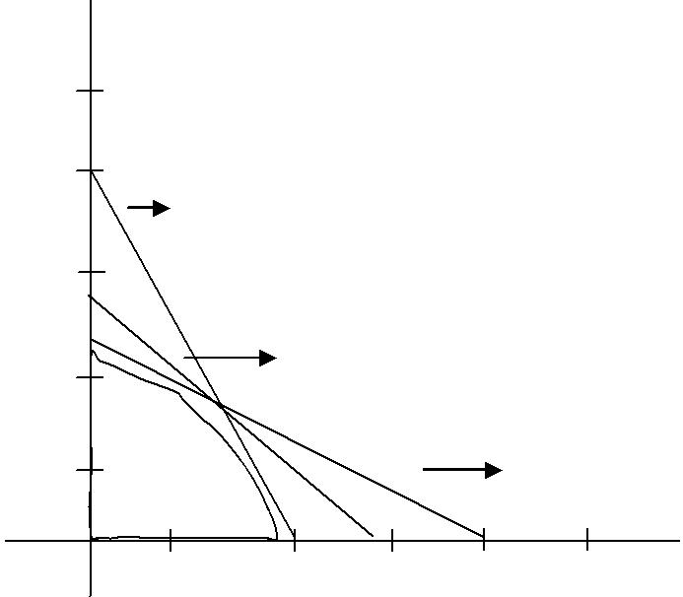
150

120
 | 2x + y = 120
90
. |  | x + y = 70
60
30 |  |  |  | x + 2y = 100
30 | 60 | 90 | 100 | 120 | A

The above co–ordinates are depicted and the Feasible Region is identified on the Graph as under:

Solving (1) & (2), x + y = 70 and x + 2y = 100; we have x= 40, y = 30

Solving (1) & (3), 2x + y = 120 and x + y = 70; we have x= 50, y = 20

Value of Z at different corners of feasible region

Point |  | Value of Z = 5x + 7y
(0, | 50) | 350
(40, 30) |  | 410 (maximum)
(50, | 20) | 390
(60, | 0) | 300

Answer: x = 40 units and y = 30 units

Q 7(a): | 8 Marks
Answer the following independent situation relating to an assignment problem with a minimization objective:
- Just after row and column minimization operations, we find that a particular row has two zeros. Does this implies that the 2 corresponding numbers in original matrix before any operation were equal? Why?
- Under the usual notation, where A32 means the element at the intersection of the 3rd Row and 2nd Column, we have, in a 4×4 Assignment Problem, A24 and A32 figuring in the optimal solution. What can you conclude about the remaining assignment? Why?

Ans. 7(a)
Case (i)

• It is not necessary that the two corresponding numbers in the original matrix, before any operation should be equal.

• Any one of the two zeroes in that Row may have been derived out of Column minimum operations also.

• Example:

 | 1. Original Matrix |  |  |  |  | 2. Row Operations |  |  |  |  | 3. Column Operations
7 |  | 6 |  | 4 | 3 |  | 2 |  | 0 | 3 |  | 1 |  | 0
8 |  | 9 |  | 11 | 0 |  | 1 |  | 3 | 0 |  | 0 |  | 3
4 |  | 6 |  | 8 | 0 |  | 2 |  | 4 | 0 |  | 1 |  | 4
Note: R₂₁& R₂₂are zero after Row and Column Minimum Operations, but the numbers in the original matrix are ‘8’ and‘9’ respectively.

 |  |  |  |  | Case (ii)
The given information is |  |  |  |  | Inference:
a | a | a | a |  | • The remaining assignments shall be – (i) a₁₁ and a₄₃ (or) (ii) a₁₃ and a₄₁.
a | a | a | 0 |  | • In these elements, the value of ‘a’ will be zero.
a | 0 | a | a |  | • This is due to the one–for–one assignment Rule, i.e.
a | a | a | a |  | • This is due to the one–for–one assignment Rule, i.e.
 |  |  |  |  | (i) two jobs cannot be assigned to the same person,
Where ‘a’ represents numbers ≥ 0, and all |  |  |  |  | (i) two jobs cannot be assigned to the same person,
 |  |  |  |  | (ii) two persons cannot be assigned the same job.
‘a’ are not equal. |  |  |  |  | (ii) two persons cannot be assigned the same job.

 | Q 7(b): |  |  |  |  |  |  |  |  |  | 4 Marks
 | Classify the following under appropriate categories in Balanced Score Card
 | Ans. 7(b)
 |  |  |  |  |  | Question |  |  |  | Perspective
 | (i) | Research & Development |  |  |  |  |  |  |  | Innovation & Learning Perspective
 | (ii) | New Product introduction |  |  |  |  |  |  |  | Internal Business Perspective
 | (iii) | Price |  |  |  |  |  |  |  | Customer Perspective
 | (iv) | Cost Leadership |  |  |  |  |  |  |  | Innovation & Learning Perspective
 | (v) | Sales Penetration |  |  |  |  |  |  |  | Internal Business Perspective
 | (vi) | Profitability |  |  |  |  |  |  |  | Financial Perspective
 | (vii) Sales |  |  |  |  |  |  |  |  | Financial Perspective
 | (viii) Quality |  |  |  |  |  |  |  |  | Customer Perspective
 | Q7(c): |  |  |  |  |  |  |  |  |  | 4 Marks
 | How would you use the Monte Carlo Simulation Method in Inventory Control?
Ans. 7(c)
Inventory management is a critical component of organizational success because every organization must determine the optimal amount of inventory to have on hand. If an organization does not have enough inventory, it risks losing its customers to competitors. Conversely, if an organization stores too much inventory, then it requires greater working capital. Therefore, it is important to be able to analyze inventory requirements and identify a strategy to minimize inventory costs. This makes Monte Carlo simulation an effective and an easy-to-apply tool that can help simulate the potential costs of numerous inventory management strategies. It can provide several useful insights about the risks underlying inventory management strategies and determine the ideal strategy to minimize costs.

 | Q 7(d): |  |  |  |  |  |  |  |  |  | 4 Marks
 | Indicate 2 Activity Drivers in respect of each of the following Activity Cost Pools:
 |  | Question |  |  |  |  |  |  |  | Ans. 7(d)
 | (i) | Manufacturing Cost |  |  |  |  |  | (a) No. of Units of Products
 | (i) |  |  |  |  |  |  | (b) | Time taken for Products
 |  |  |  |  |  |  |  | (c) | No. of Processes/Stages in Production
 | (ii) | Human Resources Cost |  |  |  |  |  | (a) | No. of Employees
 | (ii) |  |  |  |  |  |  | (b) | Rate of Labour Turnover
 |  |  |  |  |  |  |  | (c) No. of Training Programmes
 | (iii) | Marketing & Sales Costs |  |  |  |  |  | (a) No. of Advertisements/ Insertions
 | (iii) |  |  |  |  |  |  | (b) | No. of Sales Personnel
 |  |  |  |  |  |  |  | (c) | Sales Revenue
 | (iv) | Accounting Costs |  |  |  |  |  | (a) | No. of Transactions
 | (iv) |  |  |  |  |  |  | (b) | No. of Divisions/ Branches
 |  |  |  |  |  |  |  | (c) No. of Reports to be generated under MIS or applicable Reporting Framework
 | Question 7(e): Pricing – Theory |  |  |  |  |  |  |  |  |  | 4 Marks
 | What is Penetration Pricing? What are the circumstances in which this policy can be adopted?

Ans. 7(e)
Penetration pricing is a policy of using a low price as the principal instrument for penetrating mass markets early This method is used for pricing a new product and to popularize it initially. Profits may not be earned in the initial stages .However, prices may be increased as and when the the product is established and its demand picks up. The low price policy is introduced for the purpose of long -term survival and profitability .Hence ,careful analysis of the scope for price policy is introduced for the purpose of long - term survival and profitability .Hence ,careful analysis of the scope for market expansion and considerable amount of research and forecasting are necessary before determining the price under this Strategy.
- The circumstances in which penetrating pricing can be adopted are-
(a) Elastic demand: The demand of the product is high when price is low. Hence, lower prices mean large volumes and so more profits.
(b) Mass Production: When there are substantial savings in large - scale production, increase in demand is sustained by the adoption of low pricing policy.
(c) Frighten off competition : The prices fixed at a low - level act as an entry barrier to the prospective Competitors .The use this policy by existing Firms will discourage the new Firms to enter the market .This pricing policy is also known as Stay -Out-Pricing'.

