Date – 09th August, 2015
TIPS TO SCORE AT LEAST 60+ IN IPCC ACCOUNTS & ADVANCED ACCOUNTS

My dear friends,
This article (A compilation of tips) is written to help students who are week in CA IPCC Accounts & Advanced Accounts to score good marks.
However the relavent part of this article is also applicable for all PRACTICAL SUBJECTS like Costing & Financial Management & Taxation.
The purpose of this article is to help the students in CA IPCC Accounts & Advanced Accounts subjects & other practical subjects & not to take any credit in any manner.
I have got 62 Marks in PCC Advanced Accounts & 63 Marks in PCC Costing & Financial Management following some of these tips.
It has been prepared in 15 pages.
Thus I would require that the students should read it in free time & with free mind.
The subjects Accounts & Advanced Accounts are the key things to the Chartered Accounts.
Thus I would require that IPCC students should prepare it in a perfect manner.
These 2 subjects are scoring.
Students only needs are the good strategy to Study, Writing Practice, Revision & Presentation Skills.
This article has been prepared in 7 parts.
These are as follows:
Part I – The Mind Set ;
Part II – The Motivation ;
Part III – The Concept Clarity (Study Plan) ;
Part IV – Solving, not just readind ;
Part V – The Question Paper solving (Mock Tests) ;
Part VI – The Presentation ; &
Part VII – The Feedback.
Part I – The Mind Set

There are two types of subjects in CA IPCC & Final as well.
- Practical (Calculation wale subjects) ; &
- Theory Subjects (Including IT – SM).

Every students is not same.
Every students has different likes, dislikes & Interest as well.
For some students Practical subjects is strong point.
While for others Theory is easy.
You decide your strong & week point.
Level of knowledge required in this subject is “WORKING KNOWLEDGE”
I personally believe that when you are studying something, if you understand its objectives & purposes behind introducing the subjects & concepts, you have done half study.
Thus students should understand the objectives first.
The Learning Objectives of the Accounts Subjects are as follows
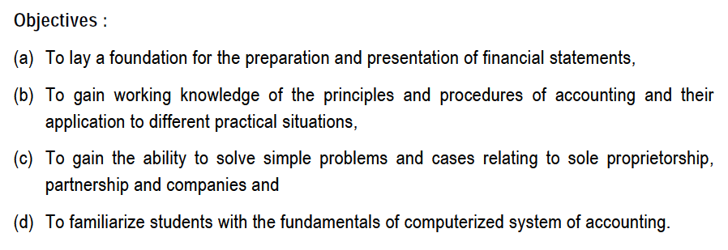
The Learning Objectives of the Advanced Accounts Subjects are as follows
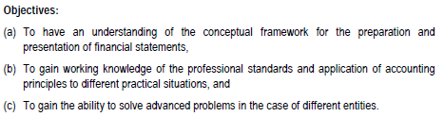
Note : - These objectives are copied from ICAI study Material.

Part II – The Motivation

Meaning – If you think only & only Positive, the Negativity can NOT at all look at you.

Part III – The Concept Clarity (Study Plan)

All of us know that the Accounts & Advanced Accounts subjects are practical based question.
Thus there is a misunderstanding among students that students should only solve the problems.
Yes it is true that solving is necessary, in order to solve the problems the reading of theory is MUST.
Thus before start solving problems, you should understand the concept by reading theory.
Prepare theory notes regarding steps to solve, logics etc.
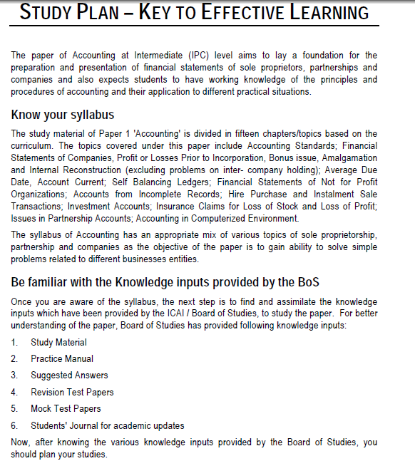
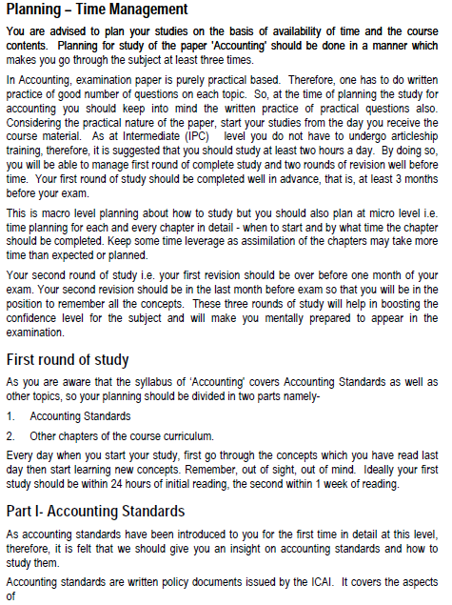
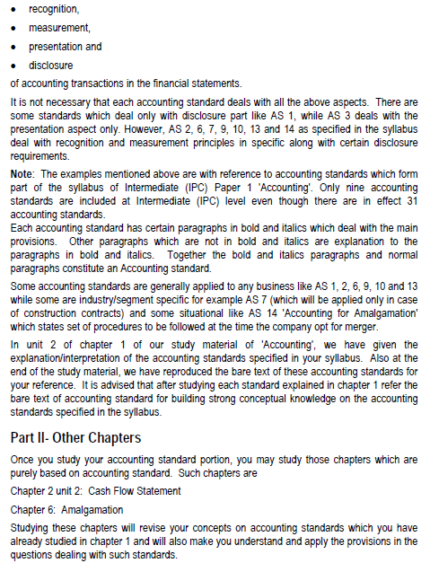
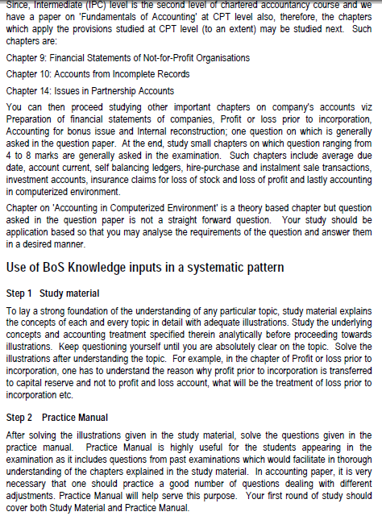
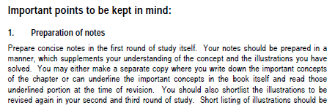
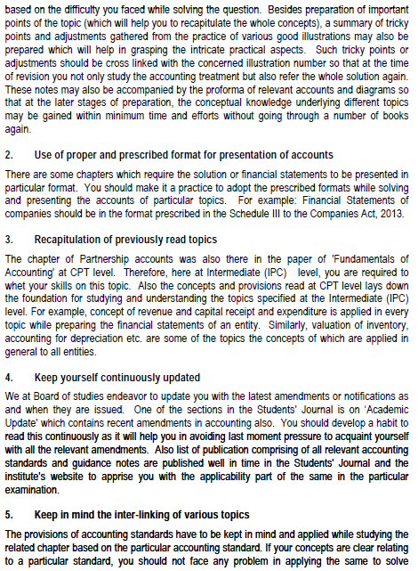
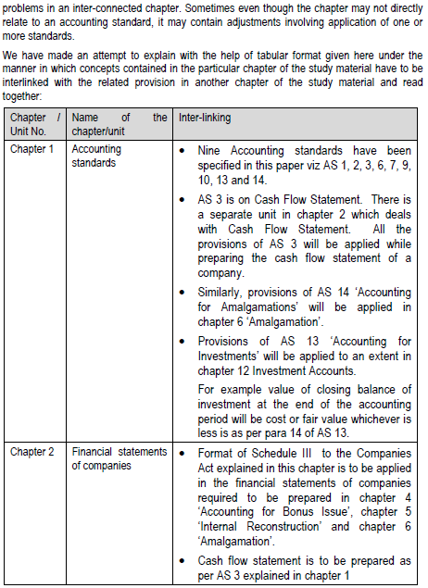
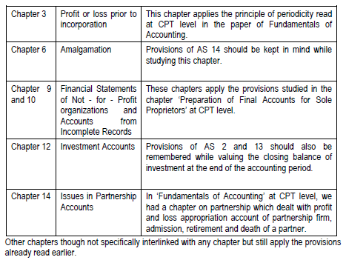

Part IV - SOLVING, not just reading
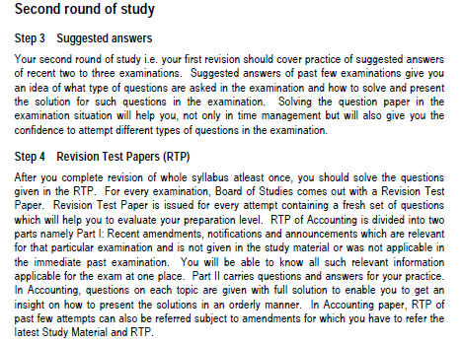

Part V – The Question Paper Solving (Mock Tests)

Every faculty in practical subjects says to solve the problems & not just to read it.
I have already mentioned that the subjects Accounts & Advanced Accounts are practical based question.
After you finish your reading, close down your books & try to write solve the problems.
It may happen that your answer in first time is not correct.
It has happen to me also.
But if you have finished your class seriously or reading seriously, you will surely remember how to solve it.
The Chanakya said “Unless & Untill you dare to run in the competition, you can’t win”.
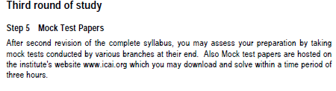
The While solving, your objectives should be
On first solving – Accurate Answers with all the steps,
On second solving – Accurate answers with all the steps ;
- Within time ; &
- Good presentation & Handwriting.
VERY IMPORTANT TO NOTE THAT the first solving may be after reading theory without setting time & without sitting in examination condition.
While during second solving – it should be under examination condition.

The question may arise in your mind that why problem solving practice.
The answer is the problem solving practice suggest you
- Writing speed;
- Handwriting; &
- Presentation skills.
Note that the handwriting needs not to be beautiful but at least it should be readable.
Conclusion – Problem solving teaches you to have a balance between Handwriting & writing speed.

Most Important –
- Practice more & more problem solving.
- Even if your final answer is wrong, but you have solved all the steps or mentioned all the steps, you will get proportionate marks for it.

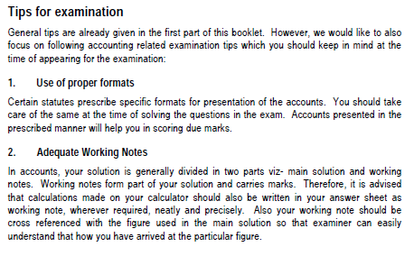
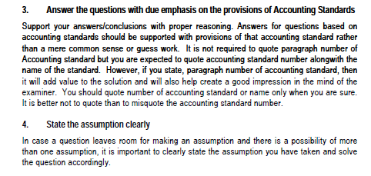
Part VI – The Presentation

Note down some tips –
It is NOT necessary to draw the ledger accounts by drawing lines.
You can write down in particulars column imaging one below another.
You can write down in amount column imagining one below another.
When you write a heading like Revaluation Account or anything, DON NOT use short cut words like A/c., if you don’t have time to write, the examiner don’t have time to evaluate your paper.
It is not possible that the practical papers covers full 120 marks of practicals.
ICAI know that for some students theory is easy while for some students practical is easy, thus few marks are allotted for theory questions.
Thus do not avoid theory in practical papers.
Some expert students & Famous faculties have given following tips that will help you.
- Write answer pointwise & avoid Paragraph writing answers.
- Avoid short cut words.
- Leave a seprate line between two points.
- Each seprate sentence should start in a seprate line.
- Underline with a pencil the main body of the answer & also the conclusion.
- Each sub – question should begin on a seprate page,
- There should be Heading to the answer & that heading of the answer should be BOLD & UNDERLINED.
- The vertical line on the Right hand of the page needs not to be drawn.
It may be Imaginary. So you leave some space before your line comes to an end.

Moral – The presentation has good Marks.

Note - Part V of the article is also useful for all theory papers.

Part VII - The Feedback

I request you to kindly respond whether you like the above mentioned tips or not on the below mentioned e mail id.
It is ultimately beneficial for the students.

Also if you require any explanations on any of the above tips, you can feel free to ask me on my below mentioned e mail id.

You might have observed the presentation in this article.

Best of Luck for your EXAMINATIONS & FUTURE.

Note :- Some part of this article has been followed by me while some other is copied from ICAI study material (Initial Pages).

Thanks & Regards,

Ashwin Gyanchandani

E mail id – Ashwin.gyanchandani@gmail.com

