THE INSTITUTE OF CHARTERED ACCONTANTS OF INDIA
(DECENTRALIZED OFFICE)
XXXXXXXXXXXXXXXXXXXXXXXX
CITY-ZIP CODE
PH.NO: XXXXXXXXXXX, E-MAIL: XXXXXXXXXXXXX@icai.org
A PROJECT SUBMITTED
By

BATCH NO: ROLL NO:
Submitted in part of fulfillment of the requirements
for information technology training department ITT
THE INSTITUTE OF CHARTERED ACCONTANTS OF INDIA
CITY

THE INSTITUTE OF CHARTERED ACCONTANTS OF INDIA
(DECENTRALIZED OFFICE)
XXXXXXXXXXXXXXXXXXXXXXXX,
CITY-ZIP CODE
PH.NO: XXXXXXXXXXX, E-MAIL: XXXXXXXXXXXXX@icai.org
DEPARTMENT OF INFORMATION TECHNOLOGY TRAINING
BONAFIDE CERTIFICATE
This is to certify that the project work is comfortably carried out by:

BATCH NO: ROLL NO:
under my supervision and guidance during ITT Course
Department of ITT

Acknowledgment
At the outset, I would like to thank the INSTITUTE OF CHARTERED ACCOUNTANTS OF INDIA for organizing this course which served as a vibrant platform for learning the dynamic areas of computers relevant to us as future chartered accountants.
I would record my gratitude and respect to the chairman and course coordinator of this chapter for their guidance throughout the training session.
I would also acknowledge my gratitude to my faculty for their lectures and guidance throughout the course and their valuable advice in my practical sessions.
Also I would record my gratitude to my parents, friends and fellow trainees who are with me during all successes and failures.

INDEX
UNIT-1 : DATABASE APPLICATION USING MS-ACCESS 5

CHAPTER 1. ADVANCED SQL QUERIES 6
CHAPTER 2. DESIGNING FORMS AND REPORTS 10
CHAPTER 3. BUILDING CRITERIA EXPRESSIONS 14
CHAPTER 4. MACROS AND SWITCHBOARDS 19

UNIT-2 : ADVANCE MS-EXCEL 33
CHAPTER 1. | WORKINGWITHXML...................................................................................................... | 34
CHAPTER2. | IMPORTING/EXPORTINGDATA...................................................................................... | 39
CHAPTER3. | ADVANCESINMACROS.................................................................................................. | 42

UNIT-3 : COMPUTER ASSISTED AUDIT TECHNIQUES 46

CHAPTER 1. INTRODUCTION TO CAAT 47
CHAPTER 2. DATA ANALYSIS AND AUDIT TECHNIQUES 50
CHAPTER 3. DATA ANALYSIS USING IDEA 53

UNIT-4 : CORE BANKING SOLUTION 58
CHAPTER 1. CBS BASICS AND ITS WORKING METHODOLOGY 59
CHAPTER 2. CBS INTERFACES-THEIR FUNCTIONALITY AND CONTROLS 63
CHAPTER 3. SYSTEMS AUDIT OF CBS AND ITS INTERFACES 66

UNIT-5 : ENTERPRISE RESOURCE PLANNING 68

UNIT-6 : OFFICE AUTOMATION APPLICATION AND IT APPLICATION IN CA’sOFFICE 77

UNIT-1
DATABASE APPLICATION USING MS-ACCESS

ADVANCED SQL QUERIES
Introduction:
Queries are essential part of database. They are used to extract required data from one or more tables and present the result in a Database or a Form or Report. They can be considered as questions asked to a table in a database. There are few advanced queries in Access such as Sub-Queries, Crosstab Queries, Creating Unmatched and Duplicate Queries, and also creating Pivot Table and Pivot Chart through Queries.
Creating Sub-queries:
A Sub-query is a query nested inside another query.
Creating a Sub-Query in Design View:
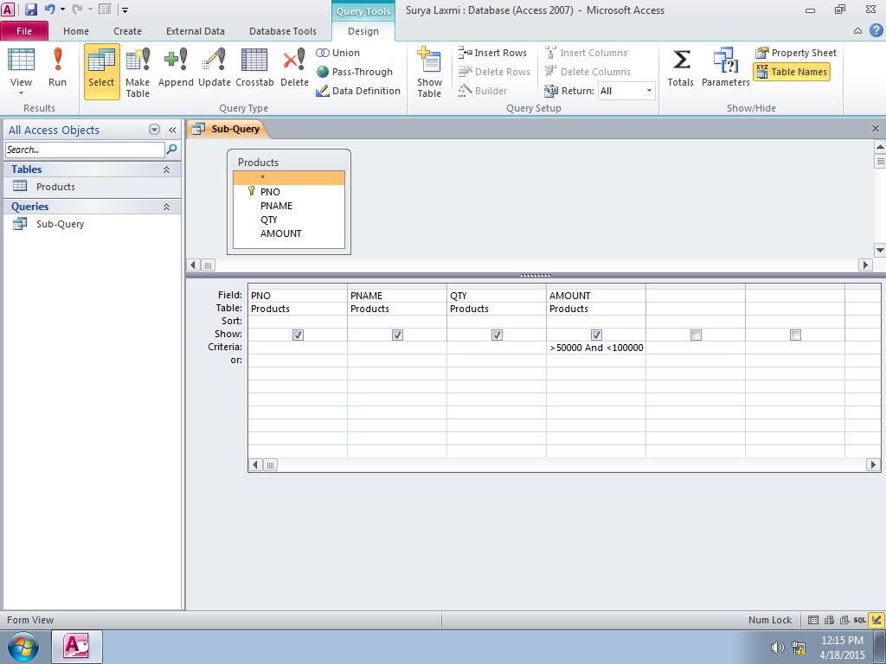
Sub- Query is displayed as below in Datasheet View:
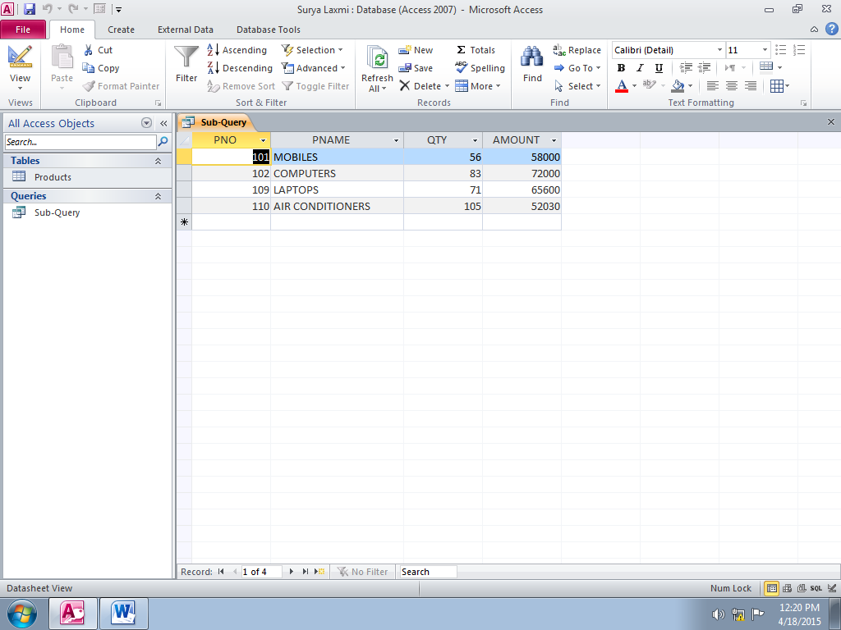
Creating Unmatched And Duplicate Queries:
Query Wizard in Access can be used to create different types of queries. Along with several different queries, it also provides queries to find duplicate records in a table on the basis of one or more fields in a table. Unmatched Query will examine the data found in two different tables/queries and compare the values in second table.
Steps in Creating Unmatched Query Wizard using Query Wizard:
- Open the Query Wizard by selecting Query Wizard from Create-> Queries, as indicated below:

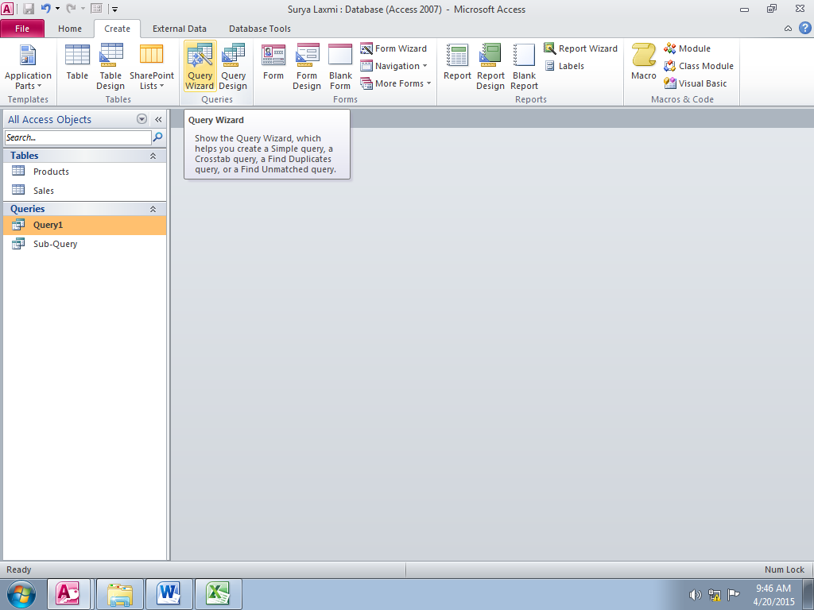

- The new Query window appears then Select Find Unmatched Query Wizard from the New Query window and click OK, as shown below:
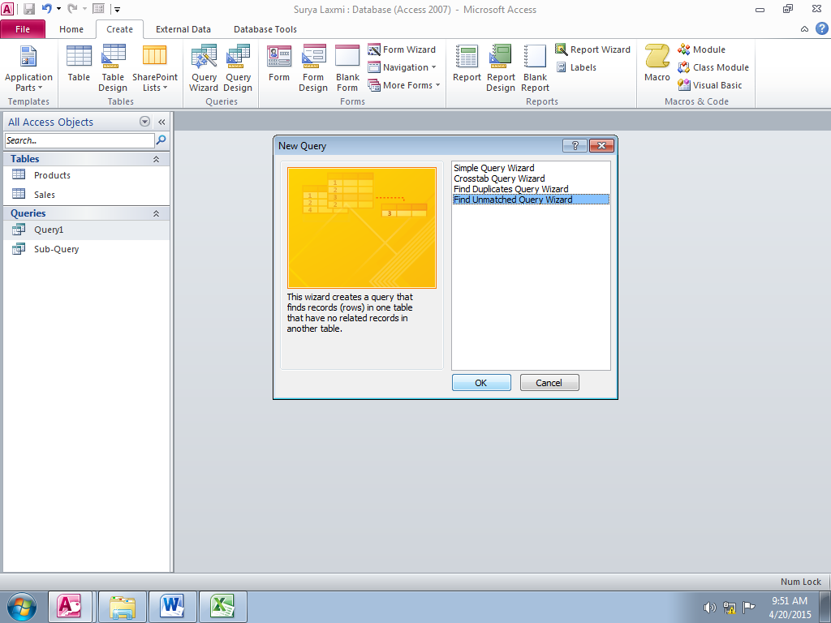
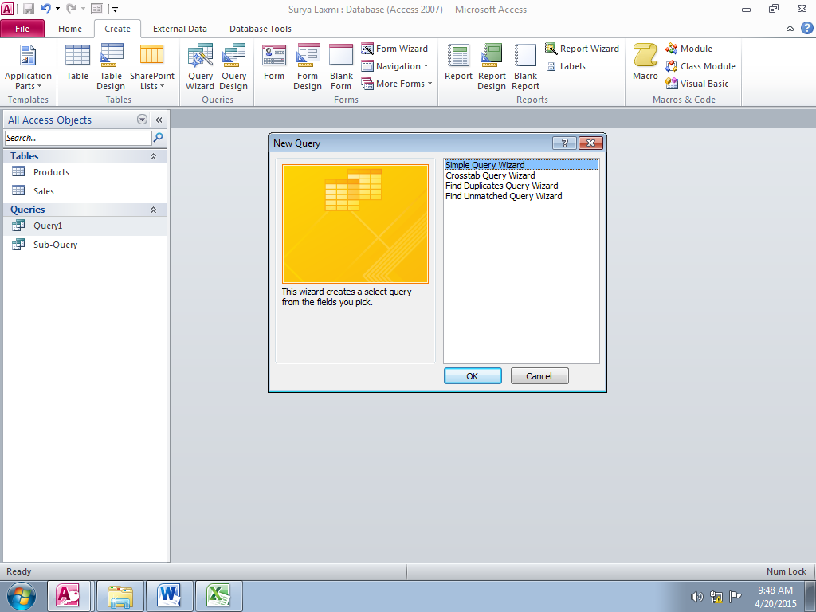

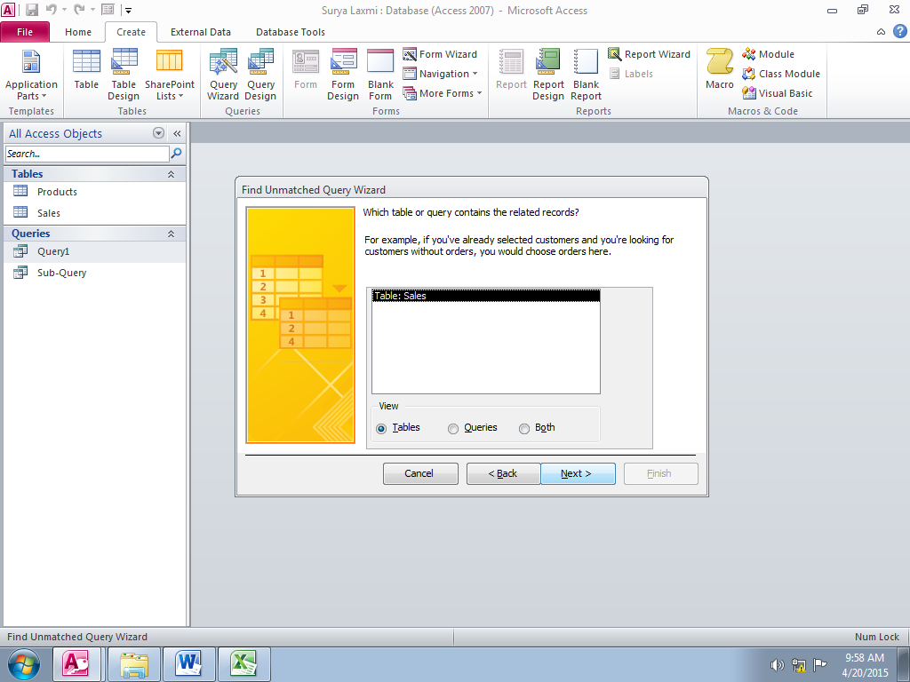
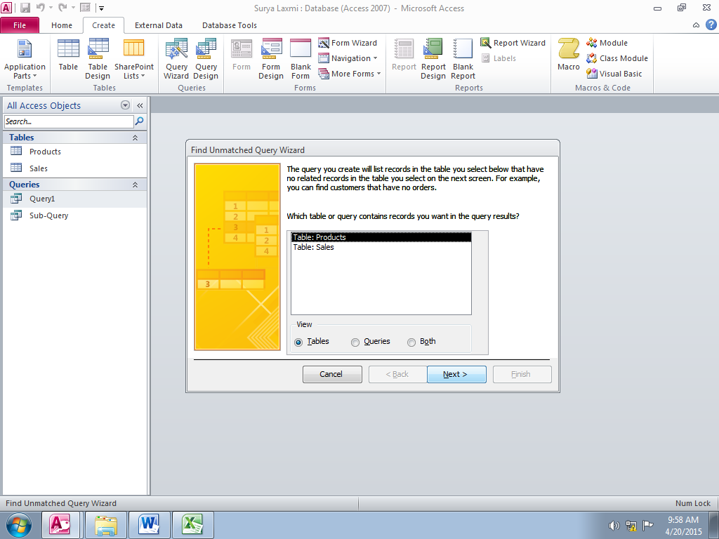
- The Find Unmatched Query Wizard appears. Select the table Product and click Next, and then select table Sales and click Next as shown below:
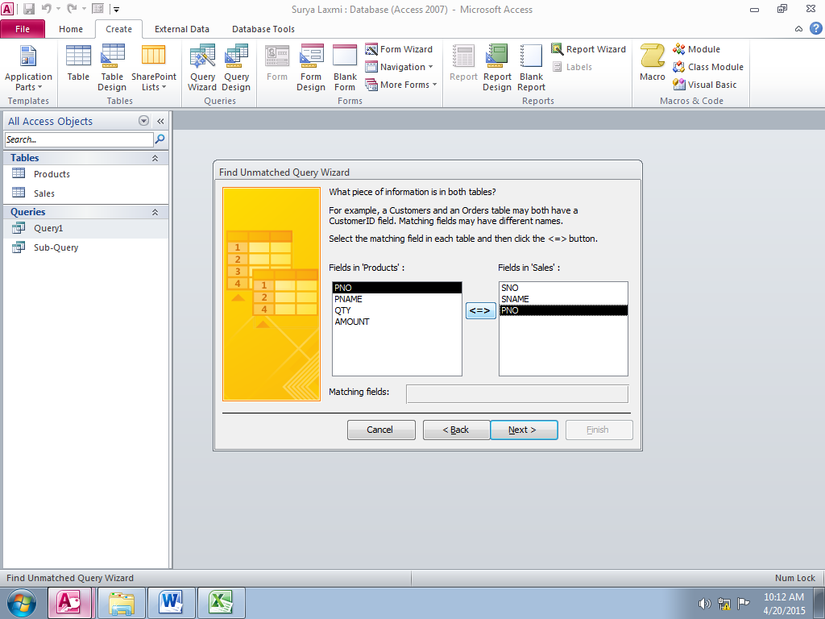
- Now we need to mark the common field in the tables to be compared. For this example, select the PNo in both Product and Sales table and click Button

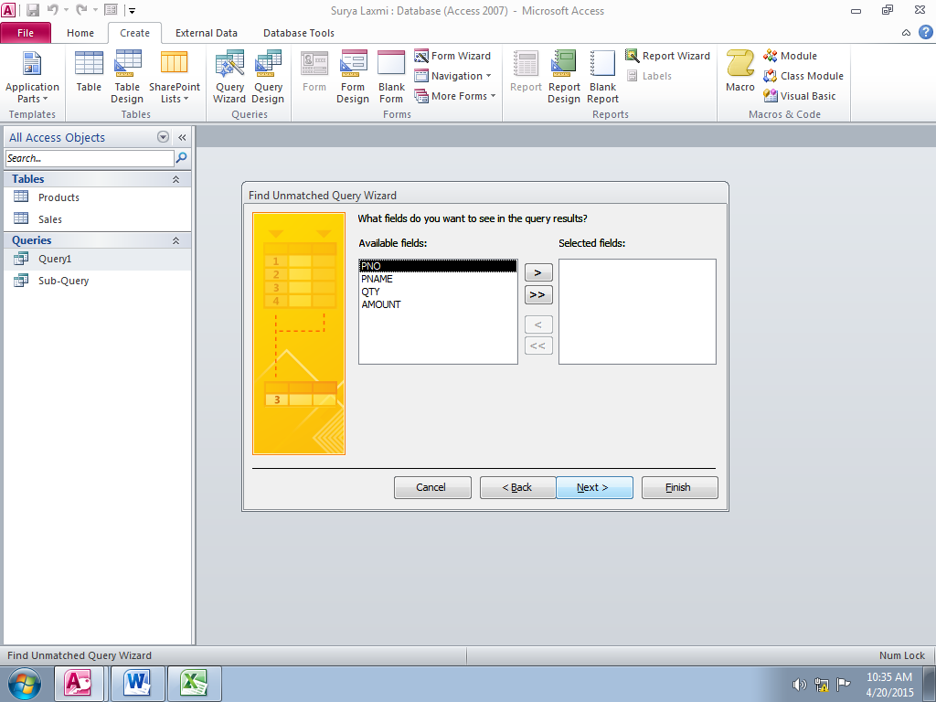
- On the next page in Wizard, select the columns that should be part of query result and click Next. In this page, select all the fields as shown below:

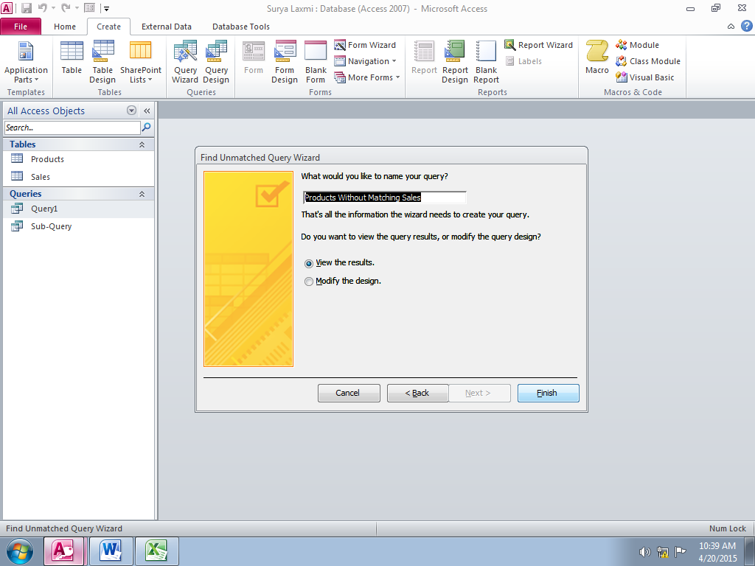
- Name the query as Products without Matching Sales in the final window that appears and click Finish as shown below:

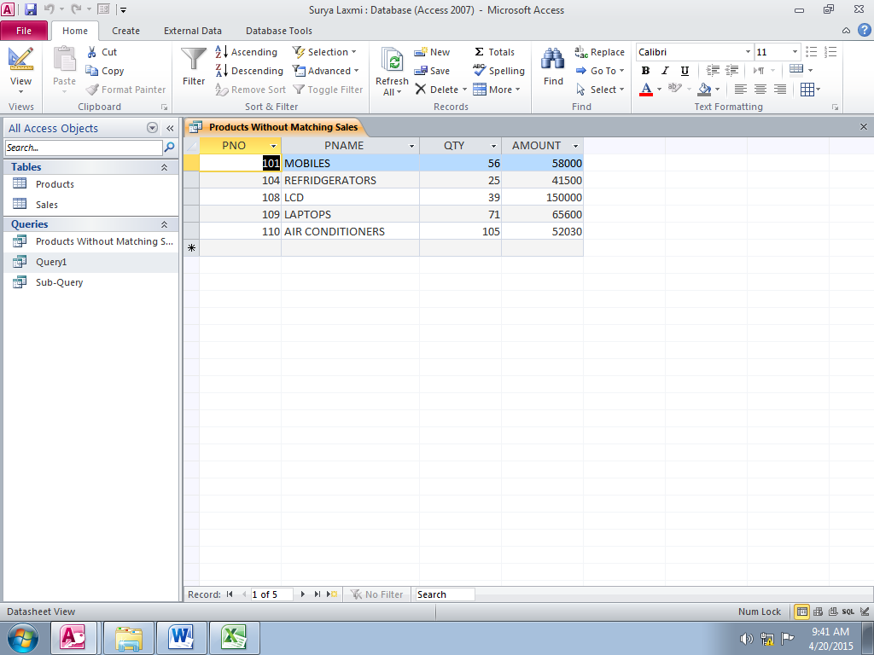
- The result of the query appears as in Datasheet form, indicating the products that don’t have an sales associated with them as shown below:
Pivot Table And Pivot Chart:
Pivot Table:
A pivot table is a view in Access Queries that allows summarizing and examining data in a database form. It is used to group values as rows and columns with a calculated value at the intersection of each row and column.
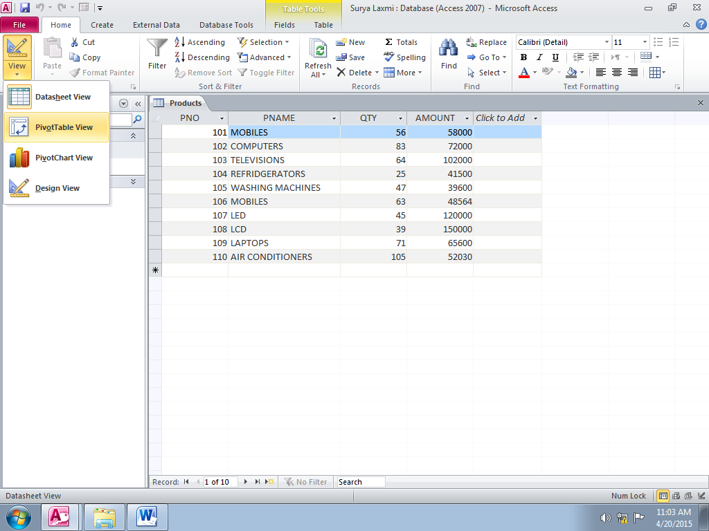
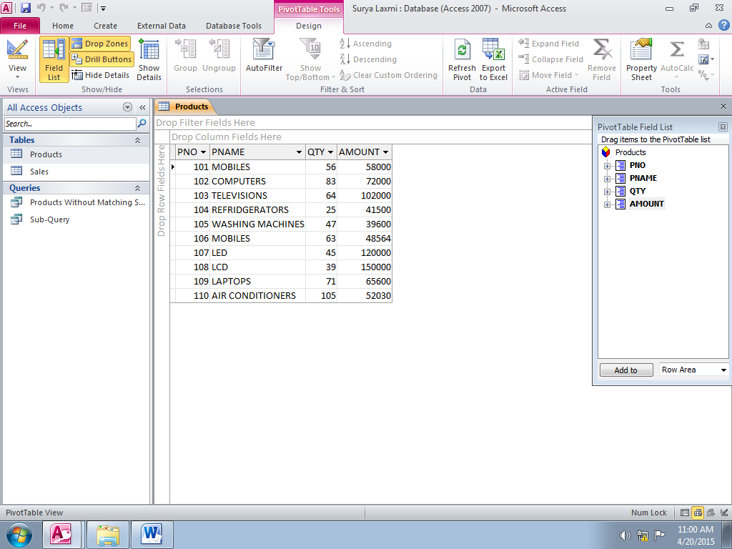
The Pivot Table view can be obtained by selecting the PivotTable View from Home->Views as below:

Pivot Chart:
A pivot chart is a tool for graphical analysis of data. In simple terms, PivotChart helps visualize a Pivot table, Query or Form. It can display summarized data in different chart formats and enables data analysis. Data can be presented by using different chart formats as required, unwanted items can be hidden from being viewed.
The Pivot Chart view can be obtained by selecting the PivotChart View from Home->Views as below:
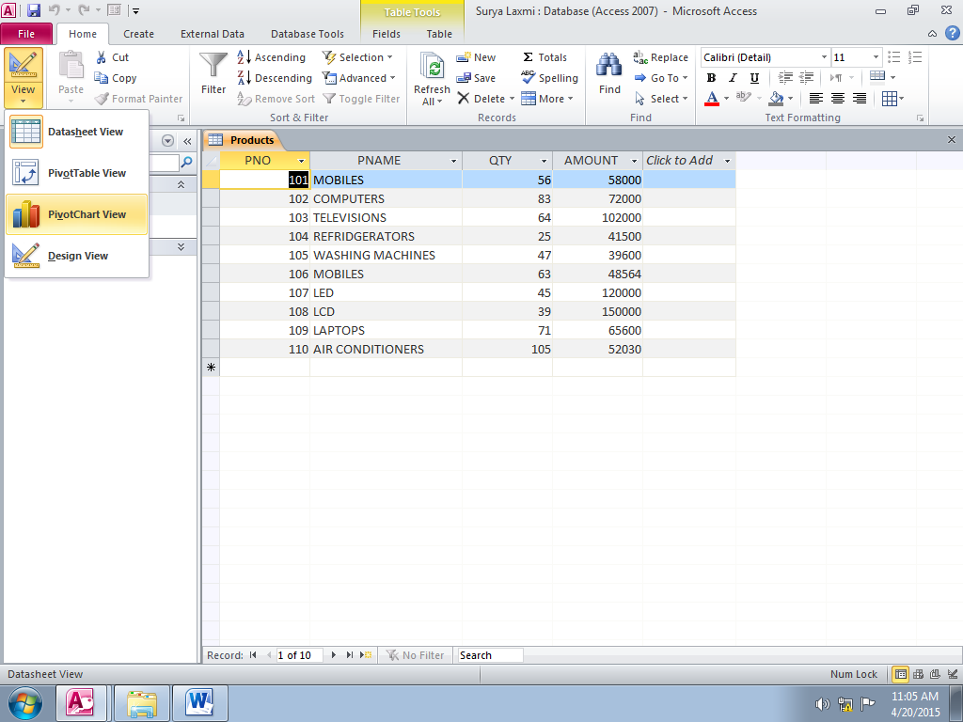
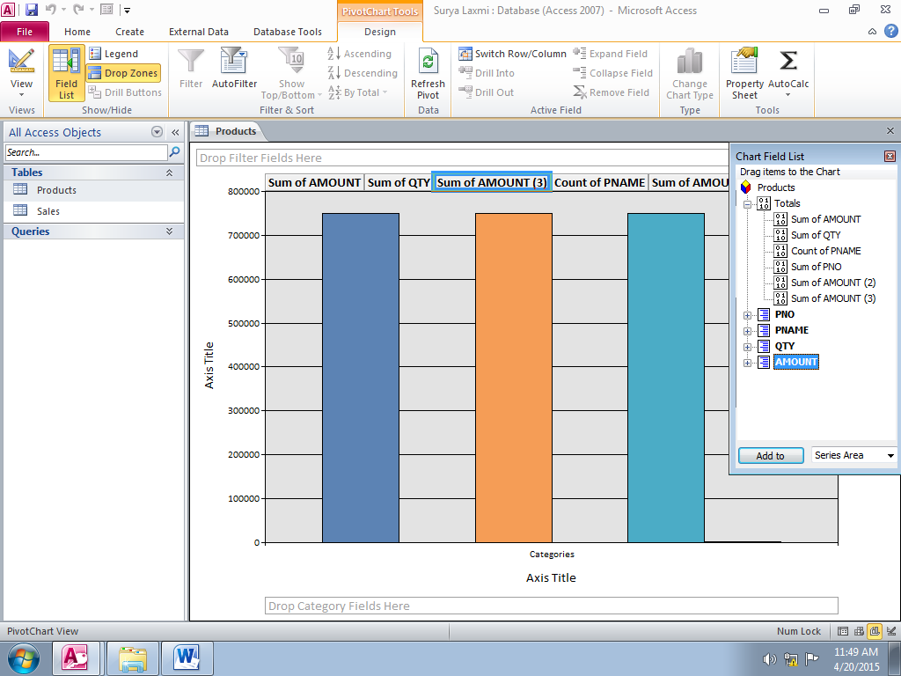

DESIGNING FORMS AND REPORTS
FORMS
Introduction:
Forms help to display, add, modify, and delete data. Different features available in Access enable to create forms such that it becomes easier for the users to handle data. A form can be divided into pages to increase the readability or can include a summary section to display grouped data.
- Creating Form:
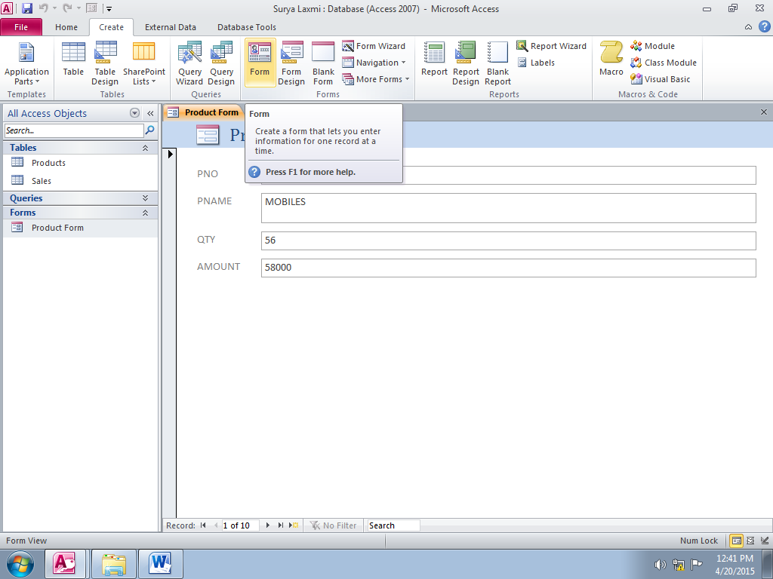
- Form is Created using Form wizard by selecting Create -> Form as shown below:

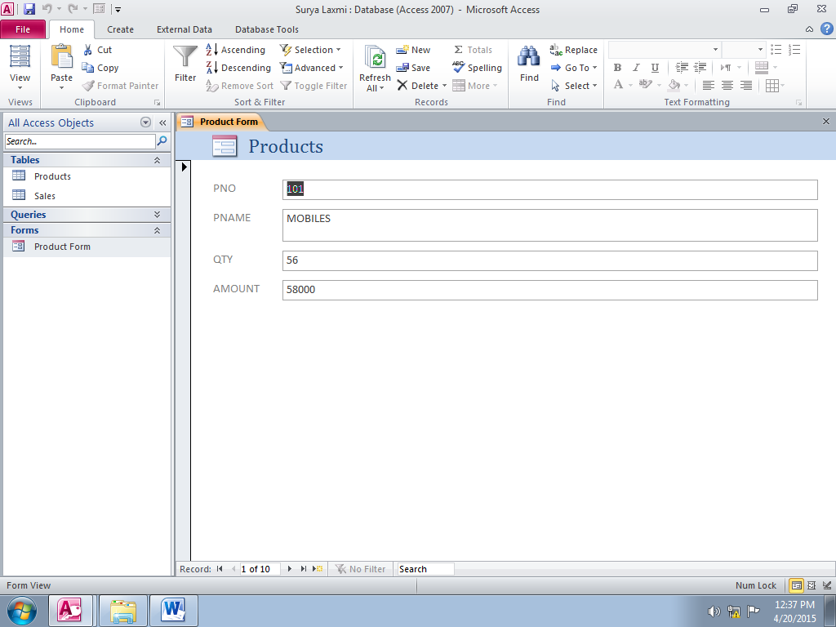
- Form is displayed as shown below:
- Inserting Date and Time:
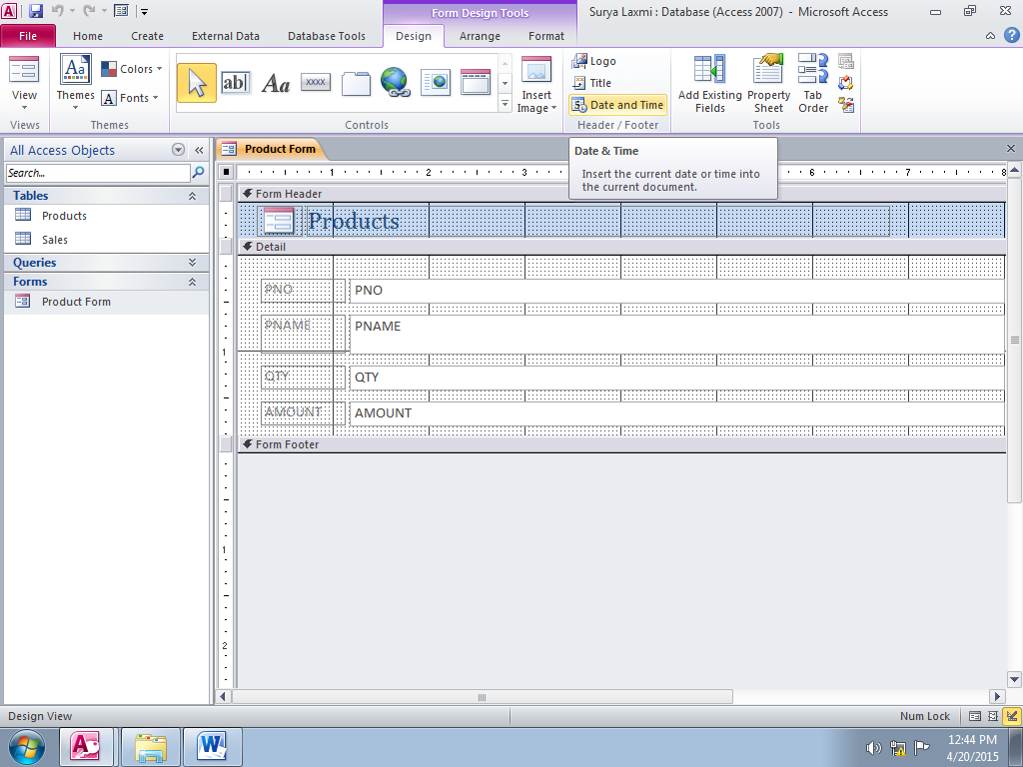
- Inserting Image:
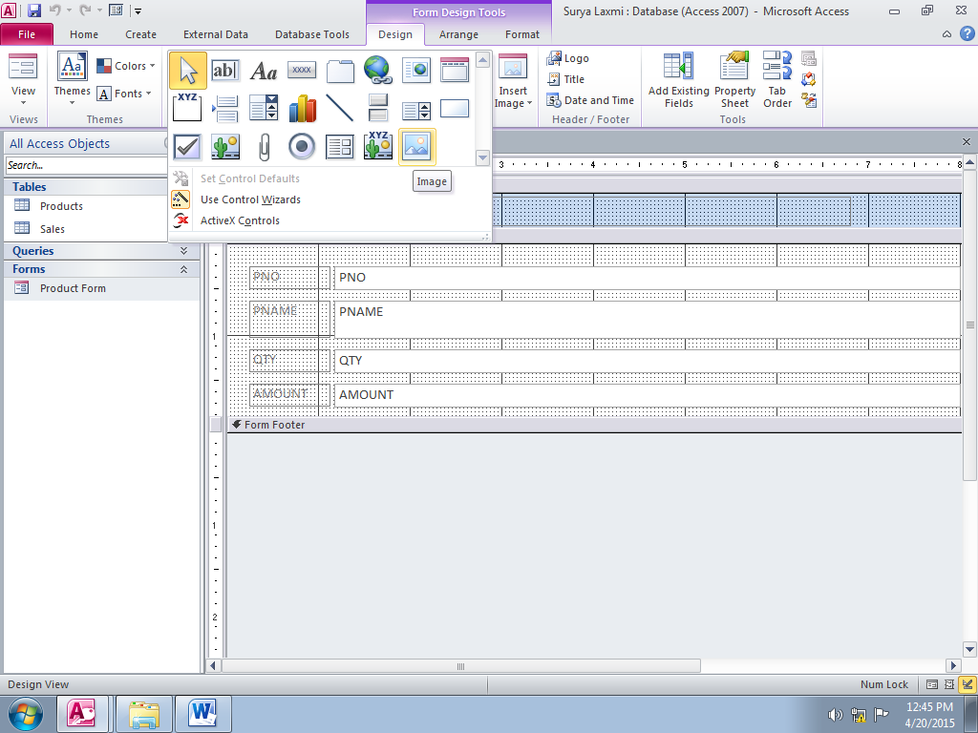
- Inserting Combo Box:
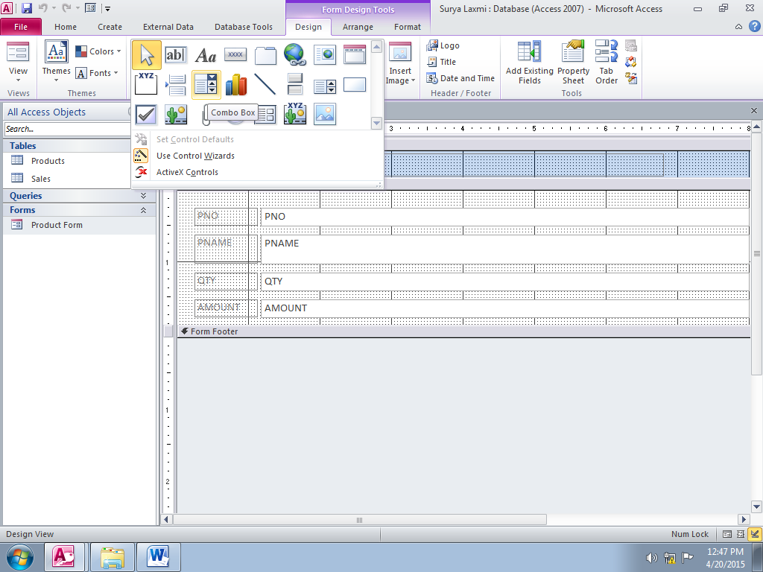
- Inserting Text Box:
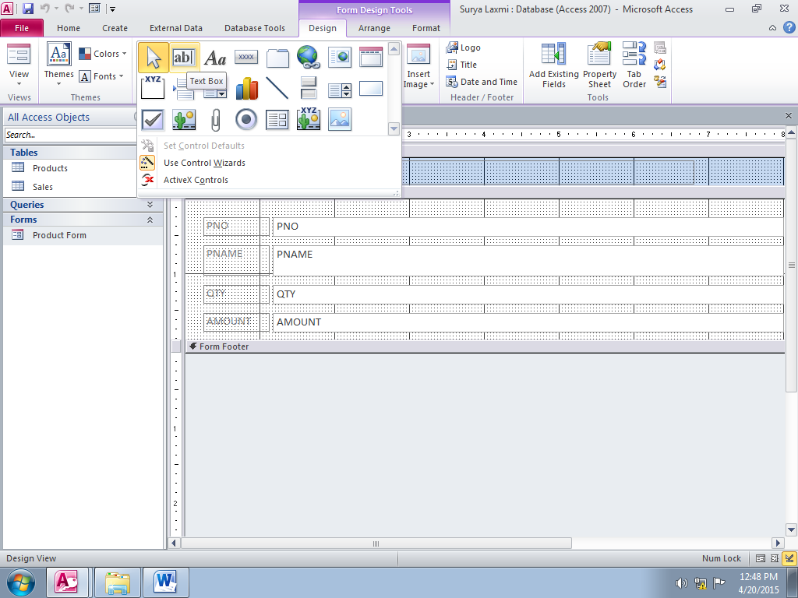
REPORTS
Introduction:
Reports can be considered as the static versions of forms. Reports are the best way to present data to higher authority and communicate the information to the people. Since reports are used for business communication, it must be available for everyone. Reports can be made more advanced and more user friendly to represent the data in amore organized form.
Creating Customized Headers and Footers:
The Database Developer adds a Page Header & Footer to the report and customizes the Page Header to hold a label with Report Title, and Page Footer to contain the Date & Time using Date Time Control.
Steps to Customize Page Header & Footer of the Report:
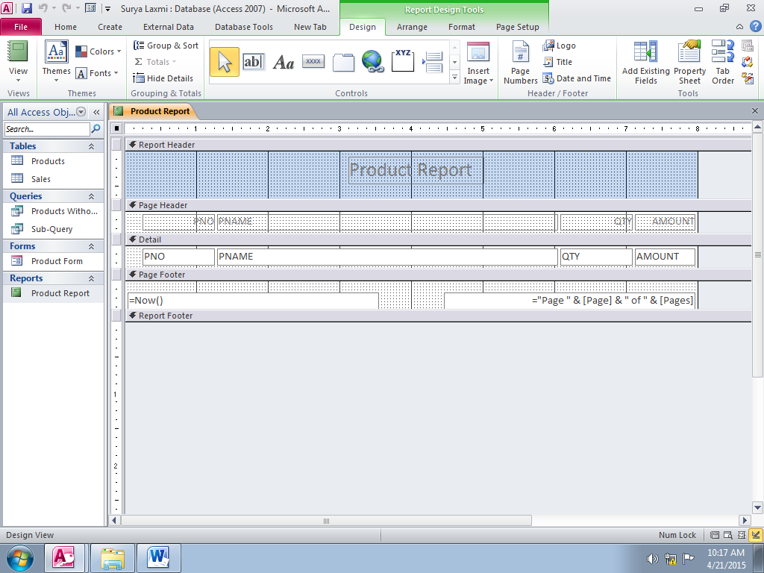
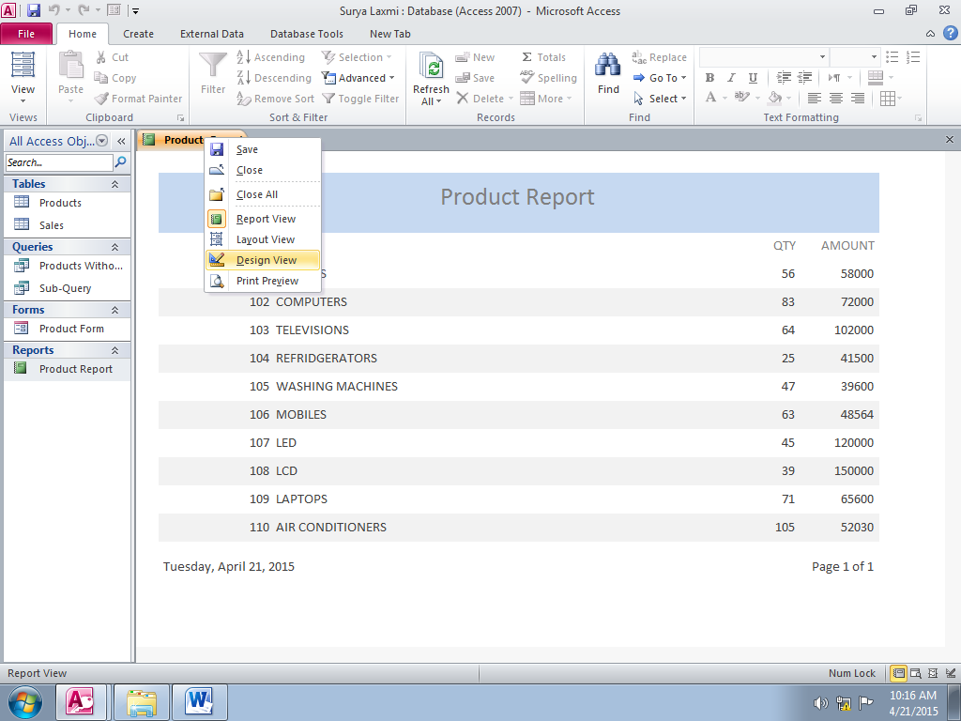
- Right-click the Report Product Report under AllAccess Object-> Reports tab and select Design View from the dropdown to open the report in Design View. The report Design View should appear as shown below:

- Expand the Page Header section. Select a label control Aa from Design Ribbon-> Controls tab and draw it on the Page Header section and type the Text Products into the label and format it according to the requirement, as indicated below:
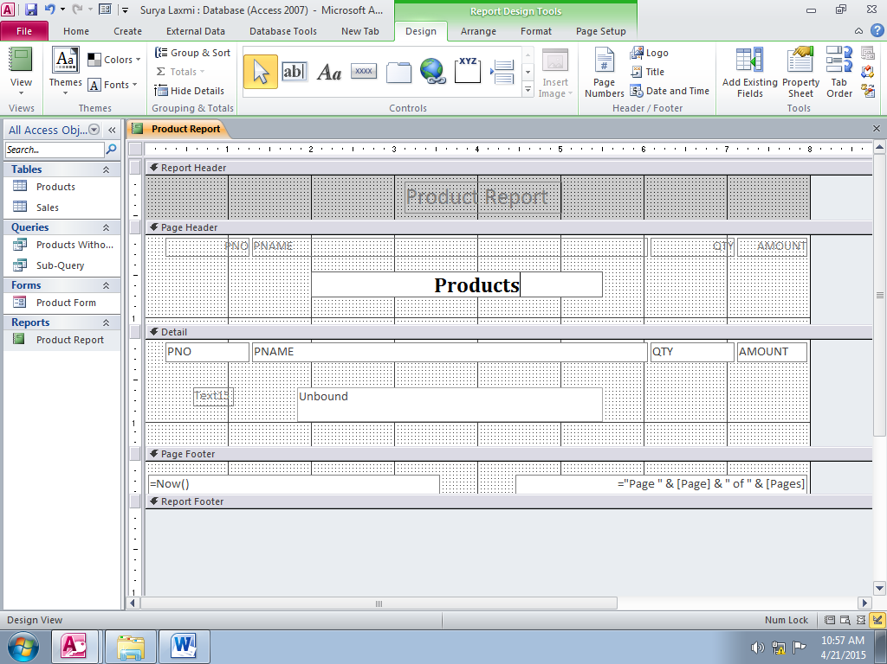

- In a similar manner, add a textbox control ab| to the Page Footer of the Report from Design Ribbon-> Controls tab. The Resultant report appears as shown below:
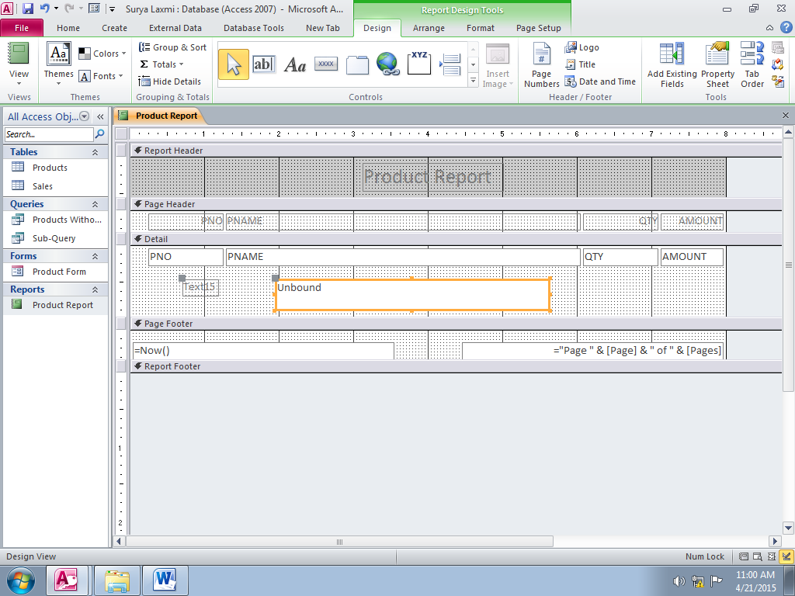
Label associated with TextBox

Unbounded TextBox
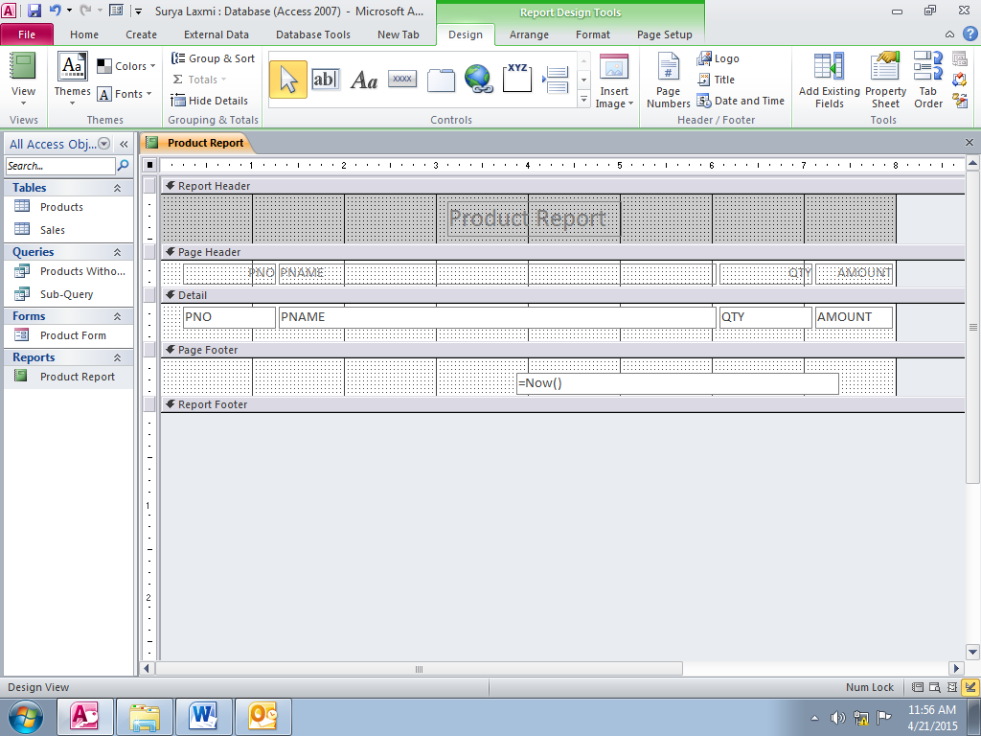
- Delete the Label of the TextBox and type = Now() in the textbox. The report appears, as shown below:

- Right-click the report and deselect Report Header/Footer to remove the Report header and footer. This is optional. The report header can contain some different text and can be displayed.

- Open the report in Report View format by selecting Report View from Home
Report Title at every Page
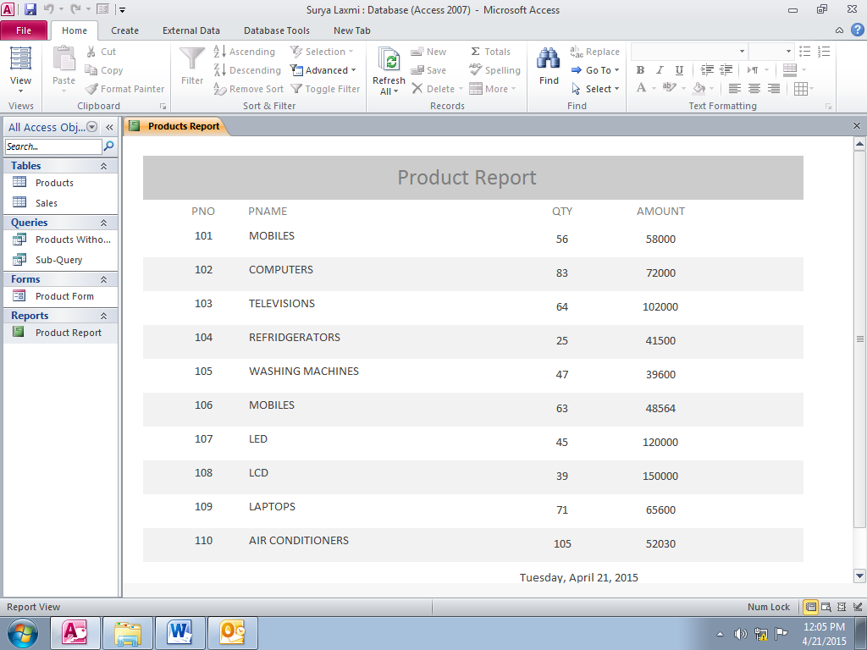
Ribbon -> Views tab to verify the data. The Report should appear as shown below:
Date & Time

21/04/2015 12.10.50PM

BUILDING CRITERIA EXPRESSIONS
Introduction:
Expressions in Microsoft Access can be considered similar to formulae in Microsoft Excel. Expressions are a combination of operands, operators, functions, values that are evaluated according to their order of precedence. Expressions can be used with tables, queries, forms, reports, and macros. In Access, expressions are used to obtain calculated values, provide criteria, and query or supply constraint to table columns. Access also provides a powerful user interactive graphical tool to create expressions know as Expression Builder.
Using Operands In Criteria Expressions:
Anoperandisavalueonwhichacalculationisperformed.Inotherwords,anoperandis adata valuethatgetsmanipulatedinthequeryexpression.Operandscanbe literals,identifiers,orfunctions.
1) Literals:
Aliteralisvaluethatisnotaddressedbyanyname.Itcanbetypeddirectlyintothecriteriaexpression.In Access,literalcanbeoftypenumber,text,date,orlogicalvalue(i.e.TrueorFalse).Literalsarealsoreferred asconstantsastheirvaluesremainstatic throughouttheevaluation ofexpression.
Examplesofliteral:
“Hello”+““+“Everyone”,Here Hello andEveryoneareTextliterals
[Date]>#1/1/2011#,Here 1/1/2011 (1-Jan-2011)isaDate literal
2) Identifiers:
Identifiersarevariables.InAccess, identifiersrepresentfieldname,tablename,orcontrolname. Identifiersare acrucialpartofexpressionbuildingastheyspecifythecolumntowhichanexpressionrepresents. While creatinganexpressioninAccess, identifiersarealwaysrepresentedinsquarebrackets[].
Examplesofidentifiers usedinanexpression:
[BasicSalary]+[Tax]:Where BasicSalaryandTaxare identifiers
3) Functions:
Functionsprovidespecialised operationstoenhancetheworking ofAccess.Functionsarebuilt-in expressions thattakeaninput,performnecessarycalculationsonit,andreturntheoutput. Accessprovidesus differentfunctions towork with differenttypeofdata,suchasTextfunctions, Date andTimefunctions,Numeric functions,andMathematicalfunctions.
Comparison Operators:
Comparisonoperators,alsoknownasrelationaloperators,definerelationbetweentwoidentifiersortwovalues bycomparingthem.Theseoperatorscanbeused with Numericor Datedatatype.
OPERATOR | NAME | EXPLAINATION
> | GreaterThan | Num1>Num2returnstrueif Num1isgreaterthan Num2
< | Less Than | Num1<Num2returnstrueif Num1islessthan Num2
>= | Greater Than Equal to | Num1>=Num2returnstrueif Num1isgreaterthanorEqualtoNum2
<= | Less Than EqualTo | Num1<= Num2returnstrueif Num1islessthan orequal toNum2
<> | NotEqualTo | Num1<>Num2returnstrueif Num1isnotequal toNum2
= | EqualTo | Num1= Num2returnstrueif Num1isequal toNum2

Arithematic Operators:
Arithmeticoperators,commonlyknownasmathematicaloperators,areusedwithnumericdatatoperform calculations.
OPERATOR | NAME | EXPLAINATION
+ | Addition
- | Subtraction
* | Multiplication
/ | Divide | Returnsintegerasaresult ofdivisionofintegernumbers and decimalasaresultofdivision ofdecimalnumbers, thatis,5\2 will return 2.5 and5\2.5will return2.
\ | IntegerDivide | Returnsintegerasaresultofdivision,thatis,5\2willreturn2and  5\2.5will return 2.
^ | Exponentiation | Computespower,thatis,the resultof5^3is125.
Mod | Modulo | Returnstheremainderofthedivisionoftwointegers,thatis,5/2 willreturn 1.

Miscellaneous Operators:
InAccess,aspecialsetofoperatorsisusedwithmultipledatatypes.Theseoperatorsprovideanadditional functionalitytocreateexpressions.Someofthemiscellaneousoperatorsare–LIKE,Between, IN,IsNulletc.
1) The LIKE Operator:
TheLIKEoperatorworkswithtextordatedatatype.LIKEisusedtomatchtextpatternsinthequerycriteria. Thisoperatorusesvariouswildcardstoformdifferentpatterns.Thevariouswildcardsthatcanbeusedwith LIKEarementioned inTable
Wildcard | Explanation | Example
* | Denotes any number of characters(0ormore) | LIKE‘A*’willmatchallthecharacters startingfromA  Forexample,Accounts,Audit
? | Denotesasinglecharacter | LIKE‘B??K’willmatchallthetextwith Basfirstletter, kaslastletter and2 letters inbetween.  Forexample-Book, Back
# | Denotesasingle digit | LIKE ‘#ABC’ willmatch text which startsfromadigitfollowedby ABC.
[xyz] | Denotesasetofcharacters | LIKE[ABC]*willmatchalltextstarting from either A,B,orC.

2) TheBetween…AndOperator:
TheBetweenoperatorisusedwithNumericandDatedatatypetoobtainasetofvalueswithinaspecified range ofvalues.
ForExample:
Between10and20willgiveallthe valueswithintherange of10and20including10and20. Between #1/1/2011# And#8/1/2011# willreturnallthedatesbetween1-Jan-2011And1-Aug-2011. (Notethatdatesareincludedbetween #andarewritten in“mm/dd/yyyy”format).
The Logical Operators:
AlogicaloperatorresultsinexpressionthatreturnsTrueorFalse.Theseoperatorsareusedtocombine multipleexpressions.Theyarealso known as Booleanoperators.
Thelogicaloperatorsarelisted below:
OPERATOR | NAME | EXPLAINATION
And | LogicalAnd | ReturnsTrue ifboththeexpressions comparedare True
Or | LogicalOr | ReturnsTrue ifeitheroftheexpressionscomparedisTrue
Eqv | LogicalExclusive Nor | ReturnTrueifeitherboththeexpressionsareTrueorboth theexpressions areFalse
Xor | LogicalExclusive Or | ReturnTrue ifeitheroftheexpressionsisTrue
Not | LogicalNot | Works with a single expression and returns True if the expressionisFalse
USING THE BUILT-IN FUNCTIONS:
Built-In Functions provide specialized operations to enhance the working of Access. We canperformmathematical,financial,comparative,andotheroperationsusingfunctions.
Someusefultypesoffunctions availableinAccess are:
- Mathematical
- Date/Time
- Financial
- SQLAggregate
- Text
1) UsingTextFunctions:
Textfunctionsareusedtoperformvariousoperations onstrings,suchasmanipulatingstrings,concatenatethe string, extracting aportionofstring.
Someusefulstringfunctionsare listedinTable:
FUNCTION NAME | EXPLANATION | EXAMPLE
Left() | Returns specified number of charactersfromleftofthestring | Left(“Access”,3)will returnAcc
Right() | Returns specified number of characters from rightofthestring | Right(“Access”,3)willreturn ess
Mid() | Returnsspecified numberof characters from thegivenpositionin string | Mid(“Access”,2,3)willreturn3charactersfrom2 positions, thatis,cce
Len() | Returns the length of the given string | Len(“Access”)will return6
Lcase() | Converts thetext tolowercase | Lcase(“ACCESS”)willreturnaccess
Ucase() | Converts the text to capitalcase | Ucase(“access”)will returnACCESS
Instr() | Returns theposition of first occurrence ofastringinanother string | Instr(“Operations”,”ra”)willreturn4
Trim() | Removesleadingortrailingspaces inatext | Trim(“ Access “)willreturn“Access”
Replace() | Convertsasubstringfromthegiven stringinto specifiedstring | Replace(“AccountTransactions”,”Account”,”Daily”)  returnsDailyTransactions
Strcomp() | Comparestwostrings  Returns  0ifstrings are same.  1iffirststringisgreaterthesecond.  -1 Iffirst string is less than the second. | Strcomp(“Access”,”Access”)returns0  Strcomp(“Access”,”Training”) returns -1 as  “Training” isgreaterthan“Access”
2) UsingDateandTimeFunctions:
Thesefunctionsare usedto handleDate and Time data. This groupcontainsvarious functionssuch as extracting apartofdateoraddingtwodates.
Fewof theimportantDate/Timefunctions, are showninTable below:
FUNCTIONNAME | EXPLANATION | EXAMPLE
Now() | Returnscurrentdate and time | Now()  Returns07/18/201212:20:55
Date() | Returnscurrentdate | Date()_  Returns07/18/2012
Time() | Returnscurrenttime | Time()_  Returns12:30:15
DateDiff() | Returns difference twodates.The intervalfordifference canbeinterms of Days (“d”), months(“m”), Quarter (“q”),years(“yyyy”), weeks(“ww”) | DateDiff (“m”,#7/18/2011#,#12/3/2011#) Returns5asthedifferencebetween two datesintermsofmonthsis5.
DateAdd() | Addsaspecified interval tothegiven Date.Intervals inthiscanbeusedas sameinDateDiff | DateAdd(“q”,1,#1/11/2012#) will return  4/11/2012  AsaQuarteraddedtoJanuaryreturns  April.
DatePart() | Extractsaportionofadatefromthe given date | DatePart(“ww”,#2/3/2012#)returns6
Month() | Returns month in integer from the given date | Month(#12/1/2011#)returns12
MonthName() | Returns name of the month, that is, given asaninteger | MonthName(12)returnsDecember
Year() | Returnsyear fromagivendate | Year(#2/2/2012#)returns2012

UsingMathFunctions:
Math functions are used for performing calculations on Numeric data. These functions provide us the property of performing various mathematical operations.
Some important mathematicalfunctionsarelisted inTable below:
FUNCTION NAME | EXPLANATION | EXAMPLE
Abs() | Returnsthe absolutevalueofanumber | Abs(14) returns14  Abs(-14)returns14
Fix() | Returnsthe nearestintegerforanegativenumber | Fix(-125.64)returns-125
Int() | Returnsanintegerforaspecificvalue | Int(23.64) returns23
Round() | Returnsanumberroundedtospecifiednumberof digits | Round(18.234,2)returns18.23  Round(18.246)return18.25
Rnd() | Returnsanygenerated randomnumber | Rnd()returnsany Randomno.
Sgn() | Returnsanintegerrepresentingsignofanumber-  1for–venumber  1 for+ve number  0 for Zero | Sgn(-14)returns-1
Sqr() | Returnssquarerootofanumber | Sqr(16)returns4
Log() | Returnslogarithmofanumber

MACROS AND SWITCHBOARDS
A macro allows you to automate tasks and add functionality to your forms, reports, and controls. Access macros let you perform defined actions and add functionality to your forms and reports. Macros in Access can be thought of a graphical and a simpler way to do programming. Every macro has a list of actions and arguments defined for each action. Macros can be used independently or attached to a form, report, or control events. Arguments provided in a macro can restrict, validate, or automate data entry. Microsoft Access 2010 has added new features to macros to eliminate the need to writing VBA code.
Switchboards are forms available in Access 2010 to present data in the form so that users can focus on using the database as intended. A switchboard form presents the user with a limited number of choices for working with the application and makes the application easier to use. For example, a switchboard may give choice to open the tables, forms, and open or print reports.
Creating a Macro
In Access, macros can be created using the Macro Design window. This window can be opened by clicking
CreateOtherMacro, as shown below:
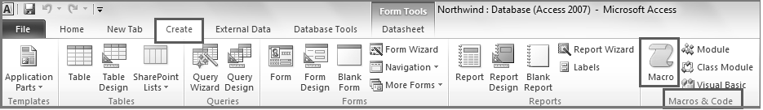

Create New Macro:
The Macro Design window is displayed as shown below
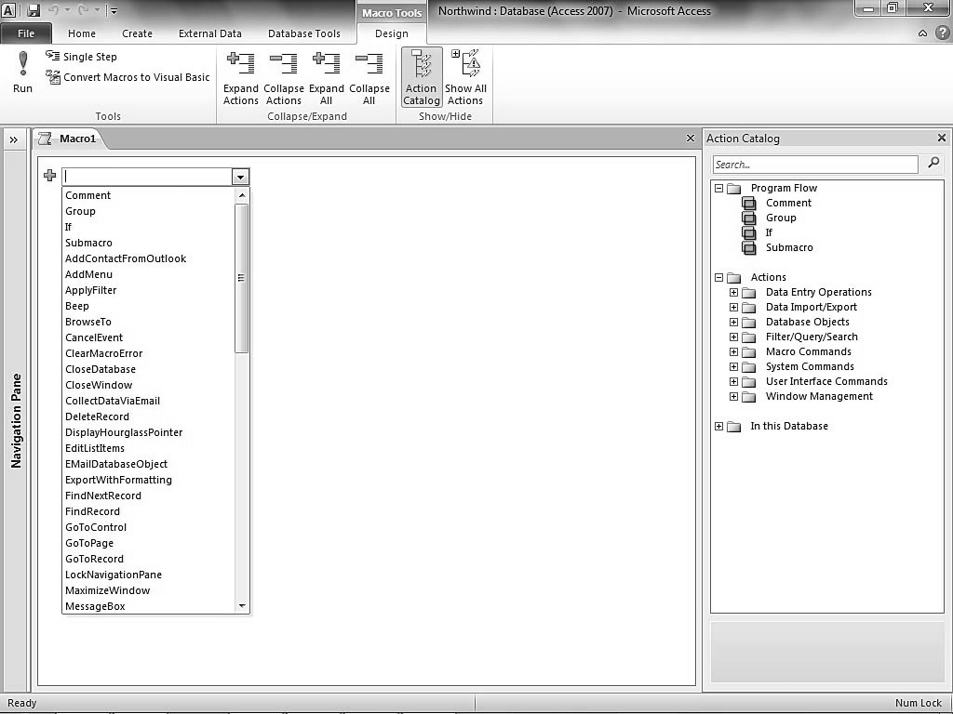
Steps for creating the macro
1. Open Macro Designer. Click CreateMacro & CodeMacro.
2. Click AddNew Action drop-down box. Select ExportWithFormatting. Note that the ExportWithFormatting option will also be available in Action Catalog. The Macro Designer window appears, as shown below:
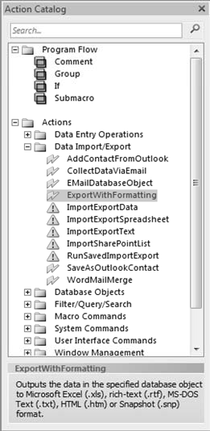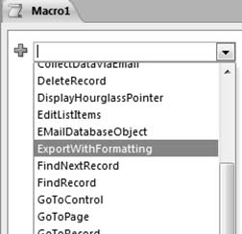

3. When we select an action that needs more than one argument, it would appear, followed by a box for each argument as shown below:
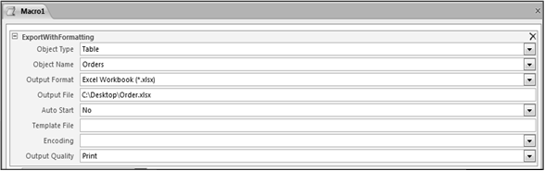
Object Type: Table
Object Name: Orders
Output Format: Excel Workbook (*.xlsx)
Output File: C:\Desktop\Order.xlsx
Note: Output File Name should include the complete absolute path of the shared folder. Macro Designer appears.
4. Select the next action in the Query Designer window as EmailDatabaseObject and specify ActionArguments, as shown.
5. Action SendObject
Object Type: Table
Object Name: Orders
Output Format: Excel Workbook (*.xlsx)
To: SalesHead@Apex.com<email of Sales Head> Cc :
Bcc:
Subject: <Subject line for the mail>
Message Text: <Message to be sent along with attachment>
Edit Message: No (Select Yes to edit message before sending>
Template File: <template file for output to be generated>
Note: The EmailDatabaseObject action can only be used if the Outlook is configured and is open. The To, Cc, Bcc, Subject, Message Text options can be set according to the requirement.
6. Click Quick Access. The window prompts for the name of the macro, write the name of macros as MailCurrentOrders and click OK. Close the Macro Design window.
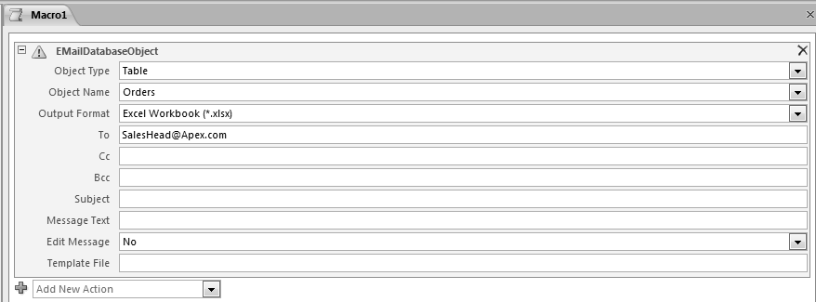7. Double-click the Macro Name under the Macro option in the All Access Objects tab to execute it.

All Macros are saved automatically in default name.
Macro Builder can use many actions in a single macro or create multiple macros in one macro designer by using macro names. Macro can also be assigned shortcut keys using the AutoKeys macro.

Managing Switch Boards:
A switchboard is a Microsoft Office Access 2010 form that facilitates navigation in Access and access to different parts of an application. It functions as an interface between the user and the application. A switchboard is similar to the Ribbon of the Access application. It provides users with direct access to the specific functions of the application and acts as an interface between the user and the application.
Switchboard contains command buttons that execute specified actions. These buttons can be programmed to open forms, reports, queries. Each button on the switchboard triggers some action within the database or leads to another switchboard form. Switchboard forms are an invaluable way to keep users focused on using the database as intended.
A switchboard form presents the user with a limited number of choices for working with the application and makes the application easier and user specific to use. The user’s login information can determine which of a number of switchboard forms to use.
Steps for creating Switchboard in Access 2010:
On the New tab, in the Ribbon, click Switchboard Manager, as shown below:
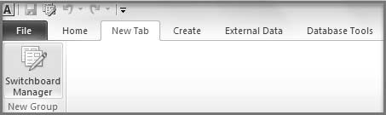
Note: If the database does not contain any switchboard, a message box as indicated below appears confirming to create a new Switchboard.

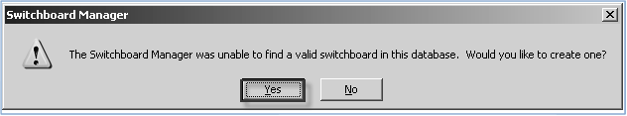
1. The Switchboard Manager Dialog box appears. Click New to create a Switchboard. Switchboard Manager is displayed as shown above
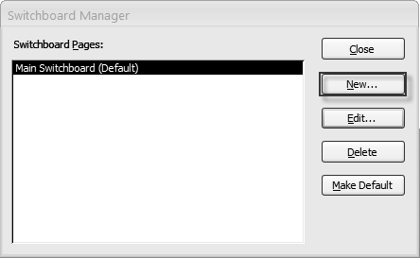

Note: Instead of creating a new Switchboard, the default created switchboard can also be used.
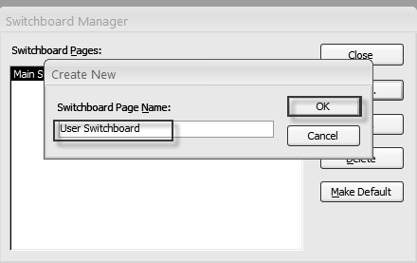2. In the Create New dialog box, in the Switchboard Page Name text box, enter User Switchboard and then click OK to create a sub-switchboard with that name, as shown below

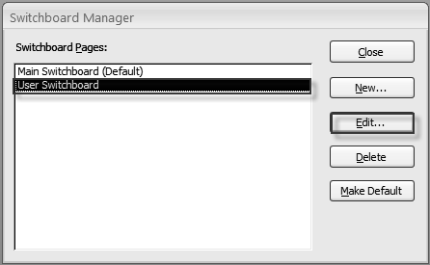
3. In the Switchboard Manager Dialog box, in the Switchboard Pages section, verify that User Switchboard is selected and click Edit, as displayed as follows
4. In the Edit Switchboard Page dialog box, click New to add buttons to Switchboard. The Edit Switchboard Item dialog box appears, as shown below
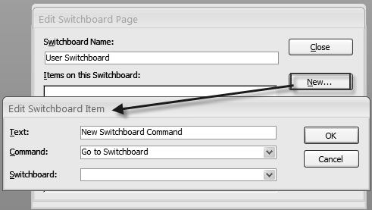

5. In the Edit Switchboard Item dialog box, in the Text field, type Customers as name of the button.
6. From the Command list, select Run Macro.
7. From the Form list, select MacroOpenTable.MacroCust and click OK. The Edit Switchboard window appears, as shown follows
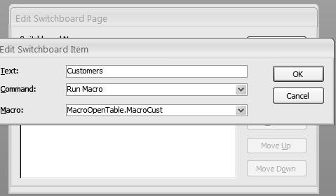

8. Click OK to close the Edit Switchboard window, the created button appears in Items on the Switchboard tab, as shown below
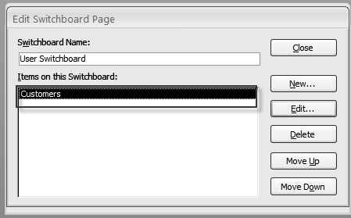

9. Repeat steps 4 - 8 to add another button to the form which opens the Inventory table. The final Edit Switchboard window appears, shown as follows
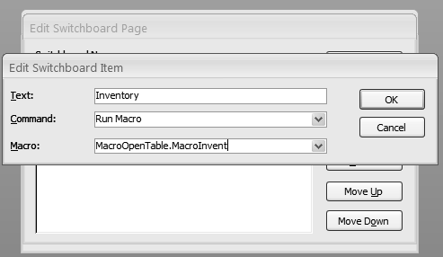

HYPERLINK FIELDS
MicrosoftAccessprovides Hyperlink data typetocreateaclickablelinktoaWebpage,file,oremailaddress.A HyperlinkcanbeaUNC(universalnamingconvention:\\server\share\path\filename)pathoraURL (Uniform ResourceLocator:http://www.microsoft.com/.).Itcanstore upto2048characters.The Hyperlink data type field holds combinations of text and numbers stored as text and used as a Hyperlinkaddress.Itcanhave uptothree parts:
•The textthatappearsinafield.
•The destination you go to when you click the cell (the URL or file path)
•Anysub-addresswithinthefileorpage.Eachpartisseparatedbythehashsymbol(#).Forexample, MicrosoftNetHomePagehttp://www.msn.com.
TheHyperlinkvaluecan be insertedintwo ways:
•By typingtheURL directly
•Throughthe Insert Hyperlinkwindow
ThereferencetoawebsiteorawebpagemaybedirectlyenteredintheHyperlinkcolumn,whileareferenceto afolderwill bemoreeasily donebytheInsertHyperlinkwindow.
Steps foraddingaHyperlinkfieldinatable
. 1Right-clicktheCustomerstableunderAllAccessObjects->Tables.SelecttheDesignView,asshownin
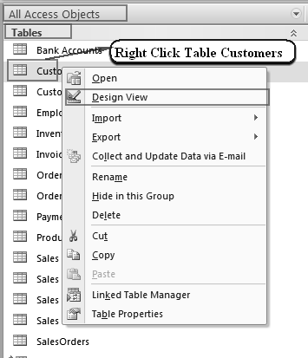

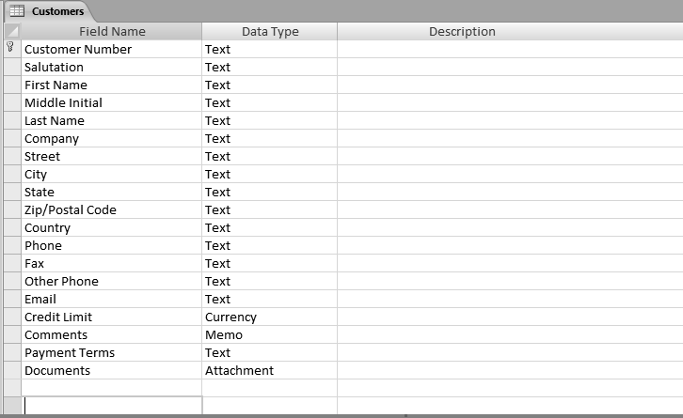2. TheDesignwindowoftable appearsasdisplayed

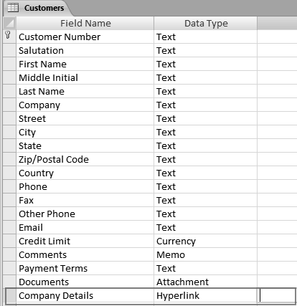3. Add a new column Company Details to the table and select the Hyperlink DataType, as shown

- Savethe changesmadeto thetableandcloseit.

Steps toenterdata intheHyperlinkfield
1.Double-clicktheCustomers tabletoopenitinthe Datasheetview.
2. Right-click theCompanyDetailscolumnfor the customer no. “BAN-0009” andselect Hyperlink ->Edit
Hyperlink,asshown
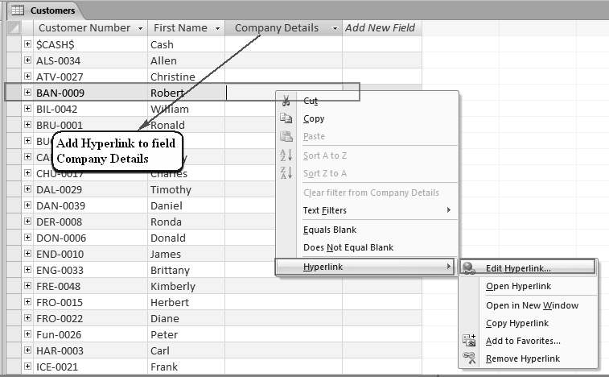

3. The InsertHyperlinkdialog boxappearsasdescribed
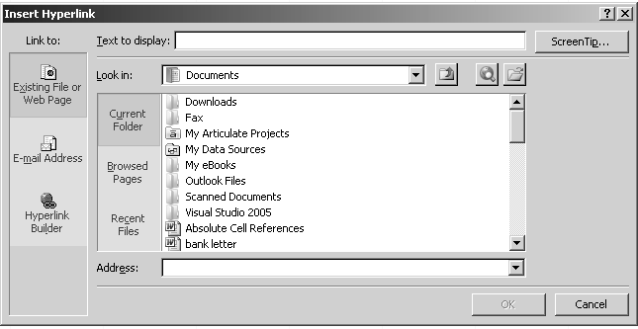
4. SelectthepagetobeattachedasHyperlinkfromthedesiredlocation.Specifythetexttobedisplayedin theCompany Details columnandthe URLfor thefileto beattached andclickOK.The Insert Hyperlink dialogboxisshown
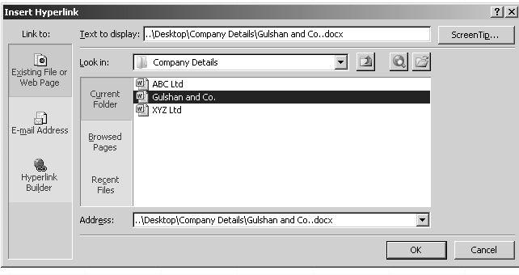

5 TheHyperlinkfieldcanalsobeinsertedusingtheDatasheetview.ThefieldmaycontainlinktoanE-Mail, WebPage, oradocument onsameordifferentmachine.
SPLITTING A DATABASE
Whenan Accessdatabase issplit,itcreatestwofiles—aback-end databaseanda front-end database.A backenddatabaseholdsallthetables,andafrontenddatabaseholdsalltheforms,queries,reports,macros, andthemodules.Inamulti-userconfiguration,theback-enddatabaseisstoredonafileserverandacopyof the front-end isprovided toeveryuser thatneeds accesstothedatabase. Thefront-end linksto the backenddatabasethusprovidingmulti-useraccesstothemainsetoftables.Whendeployed,theformsarenot sentfromthedatabasebutopenfromthefront-endlocallyandonlythedataactuallyenteredmovestothe back-end tables.Thisreducesthe datatrafficover the network.
WhentosplitanAccessDatabase
•To restrict the access of many users on the tables to avoid any changes to it
•Toreducenetworktrafficinamultiuserapplication
•Tomaintaindatabasebecausemaintenanceofdatabecomeseasierasthedataandapplicationfileare separate file
StepstocreateaSplitDatabase
1. Click Access Database from Database Tools ->Move Data -> Access Database button, as shown. The Database Splitter window appear
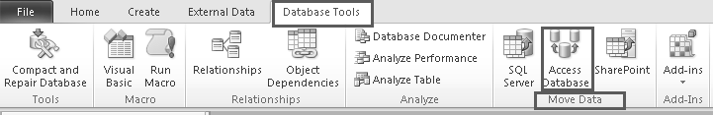

2. Clickthe SplitDatabasebutton,asshown inFig.5.4.2.Create the Back-endDatabasedialog box appears.

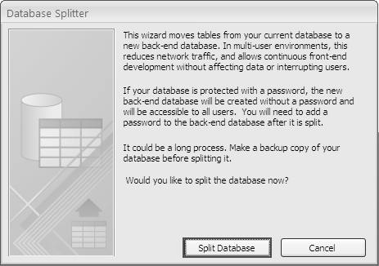

3. Specifyaname,afiletype,andalocationfortheback-enddatabasefile,
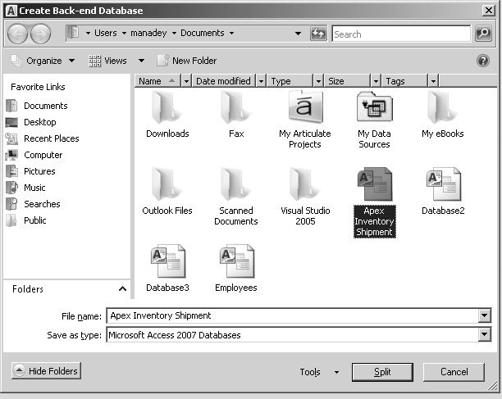

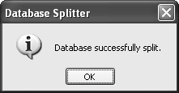4. ClicktheSplitbutton,thesplitdatabaseiscreatedandaconfirmationpromptappears,asshown

ENCRYPTION IN DATABASE
Encryption helpsto protect the database from prying eyes. Security professionalsrecommend the use of encryptionto protect sensitive information.Encryptionscrambles andcompact the databaseso that it is completely unreadablebyaword processor oranyotherutilityprogram.
Encryptingadatabasedoesnotrestrictaccesstodatabaseobjects,buttoopenthedatabase;theusermust firstenterapassword.Decryptingthedatabasereversestheprocessand restoresittoitsoriginalform.Stepsforencryptingadatabase
1. OpentheApex InventoryShipmentdatabaseintheOpenExclusive mode asshown

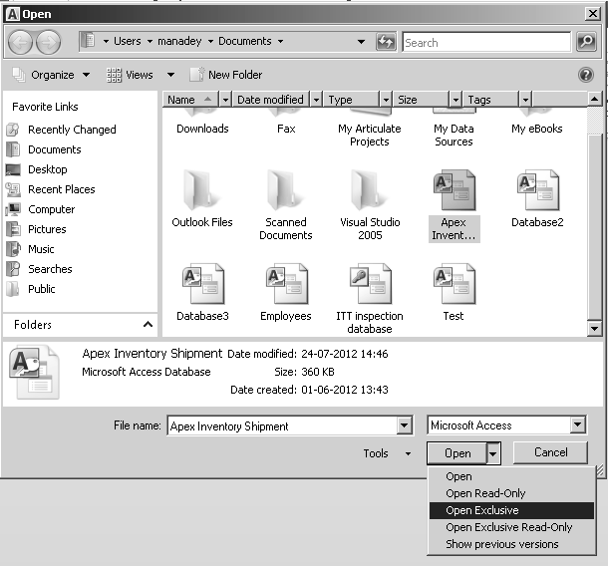

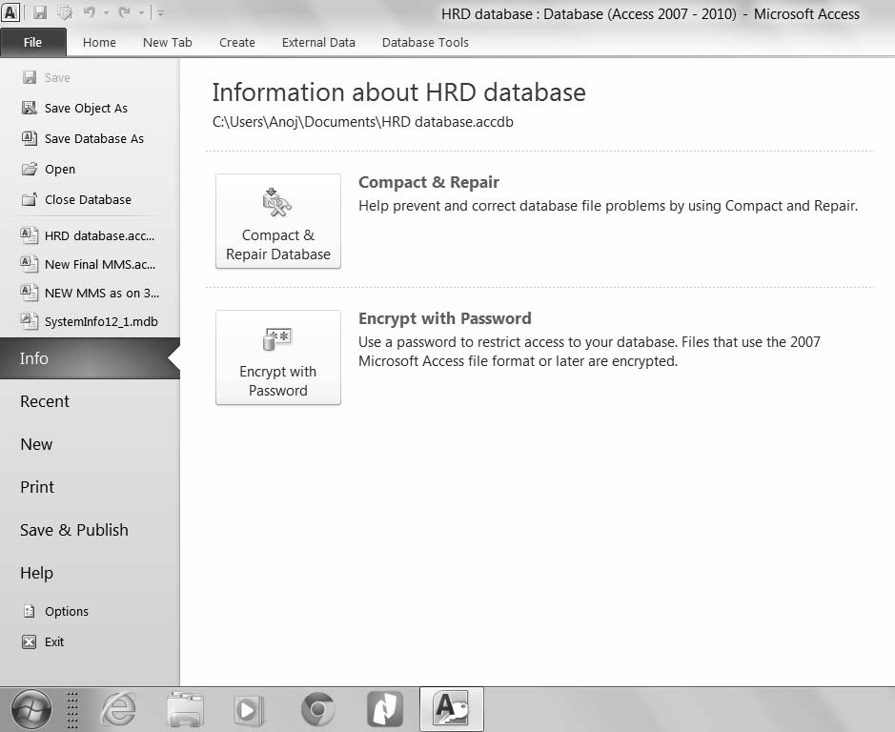
2. SelectEncryptwithPasswordfromFiletab->Info,asshown.TheSetDatabasePassword dialogboxappears.

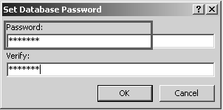3. TypeapasswordinthePasswordbox,andthen typethesamepasswordintheVerifybox,

The database is now encrypted with a password. If any user tries to open the database, Access will prompt for password. The password set for the database can be decrypted by entering database password in password required dialog box

UNIT 2
ADVANCE EXCEL

WORKING WITH XML
Introduction:
XMLisatechnologythatisdesignedformanagingandsharingstructureddatainahuman-readabletextfile. XMLfollowsindustry-standardguidelinesandcanbeprocessedbyavarietyofdatabasesandapplications. UsingXML,applicationdesignerscancreatetheirowncustomizedtags,datastructures,andschemas.In short,XMLgreatlyeasesthedefinition,transmission, validation, andinterpretation ofdatabetween databases, applications,andorganizations.
XMLwasdesigned to transport and storedata.
- XMLstands for EXtensible MarkupLanguage
- XMLisamarkuplanguage muchlikeHTML
- XML wasdesigned tocarry data,nottodisplaydata
- XMLtagsarenot predefined,wemustdefineourowntags
- XMLisdesigned tobeself-descriptive
- XMLisaW3CRecommendation
XML IN EXCEL:
MicrosoftOfficeExcelmakesiteasytoimport ExtensibleMarkupLanguage(XML) datathatiscreatedfrom otherdatabasesandapplications, tomap XMLelementsfromanXMLschematoworksheetcells,and toexport revisedXML data forinteraction with otherdatabasesand applications. ThinkoftheseXML featuresasturning OfficeExcelinto anXMLdatafilegenerator withafamiliaruser interface.
ExcelworksprimarilywithtwotypesofXMLfiles:
- XMLdatafiles(.xml), whichcontainthe customtagsand structured data.
- Schemafiles(.xsd),whichcontainschematagsthatenforcerules,suchasdatatype and validation.
The following are key scenariosthat the XMLfeaturesaredesigned toaddress:
- ExtendthefunctionalityofexistingExceltemplatesbymappingXMLelementsontoexistingcells.This makes iteasiertoget XMLdatainto and outofour templates withouthavingtoredesign them.
- Use XML data as input to existing calculation models by mapping XML elements onto existing worksheets.
- Import XMLdatafilesintoanewworkbook.
- ImportXMLdatafromaWeb serviceintoExcel worksheet.

XML MAPS:
XMLschemasinExcelarecalledXMLmaps.XMLmapslinkthecellsinaworksheettotheelements(items)in anXMLschema.WemustbuildourmapsfromXMLschemas.Becauseschemasdon'tcontaindata,our mappedcellsremain blankuntilweimportorotherwise loaddata into them.
InferredSchemas
If there isno schema,Excel hasagreatfacilitywhereitinfers one from thestructure ofthetags inan XML data file.
XmlDataFileFormatvs.XMLSpreadsheetFormat
TheXMLData formatallowsustosaveourdatatostandardXMLdatafiles.TheXMLSpreadsheet format is proprietary, and requiresExcel2002orlater.
CREATE AN XSD SCHEMA FILE:
TocreateaXSD Schema file,
- SelecttheXML toolsinthe Add-InsTab.
- Select “CreateXSDfiles for theXMLSchemaat theactivecell”
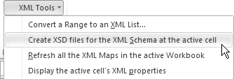

- 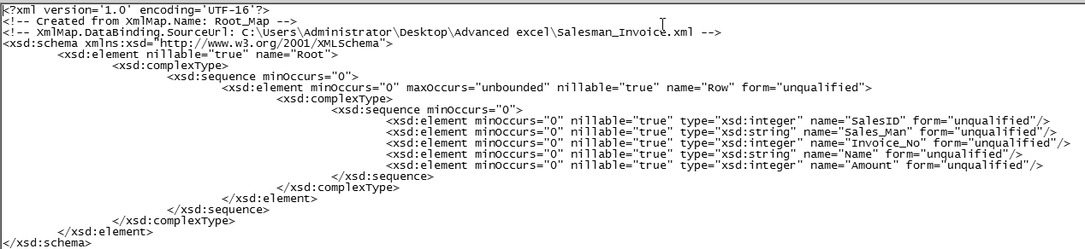An XSDSchema fileiscreated asshownbelow:

Delete An Xml Map:
IfwewanttodeletetheXMLMapcreatedabovewegotoXML>SourcePane>XMLMapsandadialogbox willappear asshowninFig.1.7.1. Wehavetosimply selectthe map wewant todeleteandClick“Delete”
Working With Xml Tables:
ByusingXMLmaps,we caneasilyadd,identify,andextract specificpiecesofbusiness datafromExcel documents.Forexample,aninvoicethatcontainsthenameandaddressofacustomer.Wecaneasilyimport thisinformation fromdatabases andapplications, revise it,andexportittothesameorotherdatabasesand applications.
Excelcreatesamapforusautomatically whenweopentheXMLdatafileasaTable. Exceluseseveryelement intheschema,and wehavenocontrol over the maporthe amountofdatathatExcelloadsintothe worksheet.
Themapbecomespartoftheworkbook,andExcelsavesanychangesornewdatatotheworkbookinthe standard Excelfileformat(.xlsx).We canonlysave theworkbookasanxlsxfile.
We can'texportthe datafromtheTable,butwecanimportneworchangeddatainto the list.
Strategy:
- We openExceland on theFilemenu, clickOpen.
- IntheFilesoftypelist,selectXML files(*.xml).
- IntheLookinlist,navigatetothe fileSalesmanInvoice.xml.
- ClickOpen.
- Open XML dialogboxappears.
- 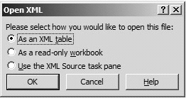Select“AsanXML Table”asshownbelowandclick OK.

- Analertmessageisseen asshown inFigclickOK.
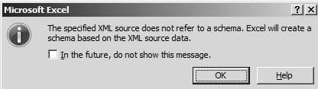

- Excelcreatesanew, blank workbook andloads thedata intoanXML listinthatworkbook.
- WecannowClickacolumnheader anduse theAutoFilter buttonstosortorfilterthedata.
- Wecanalsousethe TableTools tabtoturnonthe Totalrowunder TableStyle options.
- We canusethetable optionswiththisTableasshownbelow:
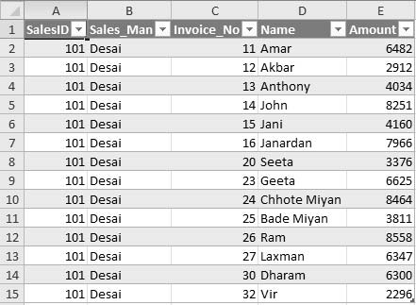

Creating A Map:
XMLMapsarecreatedfromXMLSchema.IfthereisnoschemaExcelinfersonefromthestructureofthe dataintheXMLfile.Schemasdon'tcontaindata;themappedworksheetcellsremainemptyuntildataisputintothem.
Strategy:
- OpenanewWorkbook
- OntheDeveloperTabgotoXML,and then clickSource.
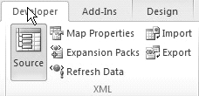

- Atthebottom oftheXML Sourcetaskdialogbox,click XMLmaps.
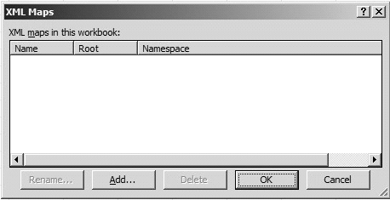

- IntheXML mapsdialogbox,clickAdd. FindtheSalesman Invoice.xmlfile
- ClickOpen.
- We getanalertthatExcelwill createaschema,clickOK.
- ExcelinfersaschemafortheXMLdatafile,andtheXMLSourcetaskpanedisplaysthatschemafor ustouseincreatingXMLmap.

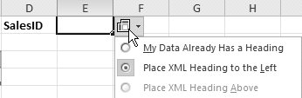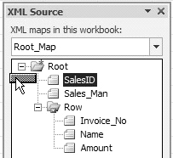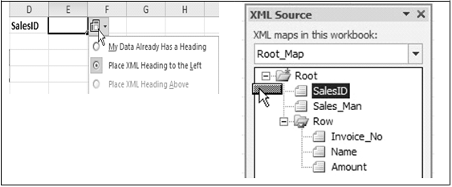
- Ontheworksheetwestartbymappingitemsthatoccuronlyonceinthedatafile.UnderSalesIDwe drag SalesIDfrom the taskpanetocellE1.Excelsurrounds the mapped cellwithaBlack border, andit displaystheHeader Optionssmarttag.Select “PlaceXML Headingtotheleft”

- Whenweclick anothercell,theborder becomesthinner and turnsblue .
- Nowdrag Sales_mantocell B1.
- Weneedtoalsomapthedatathatwilloccurseveraltimesintheworksheet.DragRowfromthe XMLSourcetaskpanetocellA3.ExcelfillscellsA3throughC3withtheschemaelementslocated beneath Row.
- Save the workbook.
IMPORTING/EXPORTING DATA
Introduction:
As Bank auditors, we find that many Banking applications generate text files in txt or csv format, these files we would need for our data analysis, but Text files do not provide us with data analysis capabilities. Whereas if the same could be converted to Excel File, we could get lot of data analysis capabilities.
Excel provides us with these capabilities to import and export data.
Importing Data from text files:
We often get external data that we can import into Excel and analyze. Like data from accounting software, ERP Systems, Banking Applications, databases. At many of these places client would not like to give direct access to databases but he would be comfortable giving us output in text formats.
However if we can import these text files, we don't have to type it into Excel saving time and avoiding transcription errors.
Text files contain plain text, that is, text without formatting. In text files, data is split by delimiters, characters that separate each field of text. There could be following delimiters:
- Tab or some other special character delimited files. A tab usually separates each column.
- Comma separated value csv files. A comma (,) usually separates each column. A csv file is a native form to Excel. We notice this by looking at the file icon. It is like a normal one but with a letter 'a' and a comma. If we double-click directly on a csv file, excel will open it
- Fixed-length or space delimited files could be in prn file format. Several spaces usually separate each column.
We can use Microsoft Office Excel to import data from a text file into a worksheet. The Text Import Wizard examines the text file that we are importing and helps us ensure that the data is imported in the way that we want
Data can be imported in two different ways, will depend on
- Whether data is static i.e., we don’t have to change it in future or
- Whether data will change/revise in future depending upon external data source.
Both the methods start in different ways but the last steps are same.
The trick to importing data from a Word or text file into Excel is to use the Excel Text Import Wizard which imports the text file in 3 easy steps.
Step 1- Wizard determines whether data is Delimited or Fixed width, the other usual option allows us to start the import at a certain row.
Step 2-We can define Delimiters or in case of fixed width this step allows us to click at the fixed widths of your data to set the delimiting 'bars'.
Step 3- We can set the columns as certain data types i.e., text or Date etc. or not import at all. We can import or export up to 1,048,576 rows and 16,384 columns in Excel.
Exporting Data to a Text File:
We can convert any Excel worksheet to a text file by using the Save As command.
- Click the File Tab, and then click Save As.
- The Save As dialog box appears.
- In the Save as type box, choose the text file format for the worksheet.
Different formats will give different results
.txt - Text (Tab delimited)
This file format (.txt) saves only the text and values as they are displayed in cells of the active worksheet. Columns of data are separated by tab characters, and each row of data ends in a carriage return. If a cell contains a comma, the cell contents are enclosed in double quotation marks. If the data contains a quotation mark, double quotation marks will replace the quotation mark, and the cell contents are also enclosed in double quotation marks.
.csv- CSV (Comma delimited)
This file format (.csv) saves only the text and values as they are displayed in cells of the active worksheet. All rows and all characters in each cell are saved. Columns of data are separated by commas, and each row of data ends in a carriage return .prn- Fixed Width Text
This file format (.prn) saves only the text and values as they are displayed in cells of the active worksheet. For best results first format the worksheet in Courier New font and save as .prn file
- A dialog box appears, reminding us that only the current worksheet will be saved to the new file
- A second dialog box appears, reminding us that our worksheet may contain features that are not supported by text file formats.
- If we are interested only in saving the worksheet data into the new text file, click Yes.
- The file is now exported or converted as text file.
Create a Web Query
Web queries allow us to query data from a specific World Wide Web, Internet, or intranet site and retrieve the information directly into a Microsoft Excel worksheet. We now want to create a web query from the web page we have in Fig.
- Open the web page expired limits
- Select the data and press the Ctrl + C combination.
- Open a new Excel workbook and activate the cell where we wish to insert the data.
- Click the Paste dropdown button on the Home Ribbon as shown
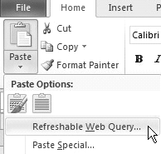

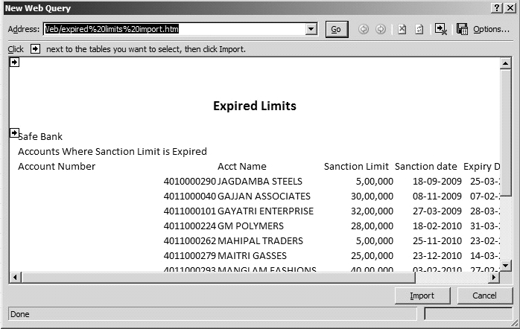Click Refreshable Web Query. A New Web Query dialog box appears as shown below

-Click the Yellow Arrow next to the information we want to import.
-Click Import.
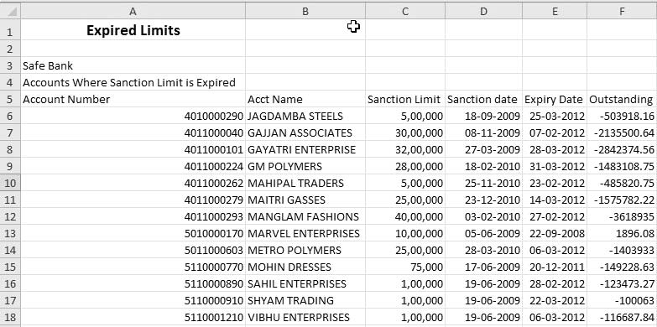-The web query is created in Excel.

•Savethe workbook.
ADVANCES IN MACROS
Introduction:
Programming ofMacrosisdoneinprogrammingLanguage VBA(VisualBasicforApplications)butwecanuse MacrosevenifwedonotknowVBAsinceExcelgivesusawonderfultoolintheformofMacroRecorder.A macrorecordsourmouseclicksandkeystrokes while weworkandplaythembacklater
Macroscanbewrittenintwoways
•WritingaMacrousing VBACode
•Recording amacrousingExcelMacrorecorder
IfwehavetostoreMacrositisnotpossible in.xlsxfiles. Fortunately excel hasafileextension .xlsmwhich are macroenabled workbooks.Excelgivesmacro-enabled workbooksadifferenticon,withasuperimposed exclamationmark.Thisiconenablesustorecognize amacro-enabledworkbook.
Sometipsto recordamacro:
•Excelrecords everykeystroke &everycommandwerun,sosomething wedon’twantshould notbedone whilerecording Macro.
•Wedon’tneedtoworkfast,i.e.,Macrojustrecordsouractions,soifwearejustbrowsing,thatisnot recordeditisonly specific actionswhichgetrecorded.
•Trytobegeneric,sincewe’d want thatmacrotorun invarioussituations&scenarios.
We canrecordaMacroin3differentways
•InExcel2010Macrosare inDeveloperTab,whichisnottherebydefault.
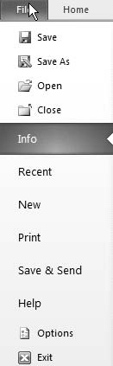•Toactivateitwehave togotoFile> Optionsasshown

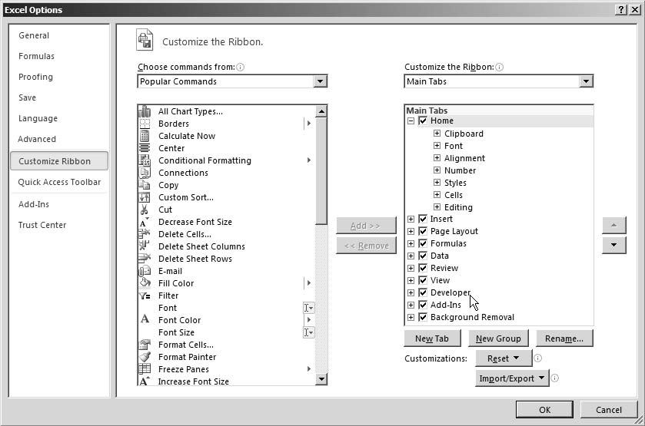•UnderOptions>CustomizetheRibbon>Ontherightofthewindow,alargeboxlistsallthetabsthat arecurrentlyshownintheribbon.Near thebottom,weseeanunchecked item named Developeras shown.Toshow theDevelopertab,checkthisbox,and thenclick OK.

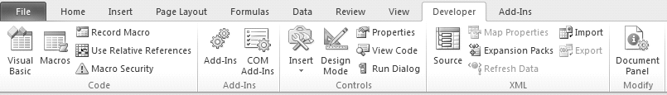•Macros areunderDevelopertabas shown

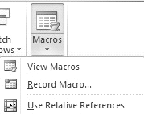•Recording aMacrosisalsoavailableinView>Macrosasshown

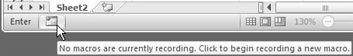•There isonemore optionto recordmacroinstatusbarasshowninFig.3.3.6

•UsinganyoftheabovemethodswestartrecodingaMacro,amacrodialogboxappears
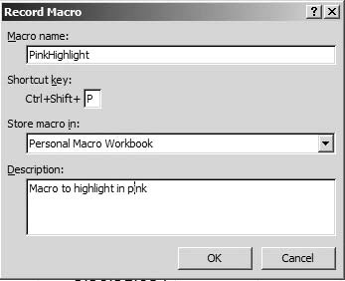

FurtherMacrocanbestored in:
•This Workbook.
Ifwechoosethisoption,Excelstoresourmacrointhecurrentworkbook.Remember,weneedtosave thisworkbookasamacro-enabled.xlsm fileorabinary.xlsbfile,orwe’lllose ourmacros.
•NewWorkbook.
Ifwechoosethisoption,Excelautomaticallycreatesanewworkbook(whichitopensinaseparate window)and storesourmacrothere.
•Personal Macro Workbook.
Ifwechoosethisoption,ExcelstoresourmacroinaspecialhiddenworkbooknamedPersonal.xlsb.ThePersonal.xlsbworkbookopensautomaticallywheneverwestartExcel(althoughitremainshidden),so macrosinthisworkbookarealways availablenomatterwhatworkbook we’reusing.
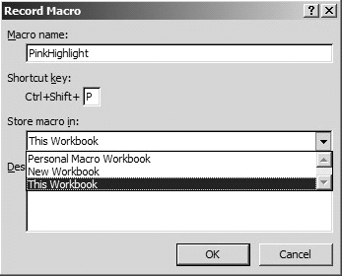

•Westore themacroinpersonalworkbooksincewewantittobeavailable forallworkbooks.
•We also givethe macroadescription“Macrotohighlight inpink”.

•Aswebeginrecordingweseethatrecordmacrobuttonhaschangedto“stoprecording”inbothheader&status barasshown

Nowweperform therecordingofaction
- we selectB10 whichweneedtohighlightinpinkand
- go throughthe desiredstepsonHomeTab firstwemakethefontBold,
- next wechangethefontcolourto Blue,
- ChangethefilltoPink&
- Insertaborderforthecell.
·Wenowclickthestop recordingButton
·Ourmacroisnowready,toexecuteonanycellpressCtrl+Shift+Pandwefindthatthecellgetsthe desiredformatting
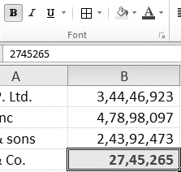

Gist:WehaverecordedamacrotogivethedesiredpinkhighlightingtoacelltoExcelbothinstaticformatas wellasdynamicformat

UNIT-3
COMPUTER ASSISTED AUDIT TECHNIQUES

INTRODUCTION TO CAAT
Introduction:
Auditorsdealwithinformationinmyriadwaysencompassingtheareasofaccounting,assurance,consulting andcompliance andmostofthisinformation isnowavailableinelectronicform.Thisistruenotonlyincaseof largeand mediumenterprisesbuteven insmallenterprises. Incase thereareenterpriseswhohavestillnot adaptedthedigitalway,thenitisanopportunity forAuditorstohelpsuch enterprisestoridethedigital wave. Hence,ithasbecomecriticalforAuditors tounderstandanduseinformation technologyasrelevantforthe servicesweprovide.
Auditors & CAATs:
Asauditors,wecomeacrosscomputersandcommunication technologyasthemostcommondenominator among our clients, both large and small. Further, we use computers and communicationtechnology for providing services to our clients. CAATsempowerAuditors withthekeysurvival techniques whicheffective usedinanyITenvironment. CAATsarenotspecialisttoolsdesignedforusebyspecialistIT auditors but these are common techniques which can be easily mastered to audit in a computerized environmentforstatutoryaudit, taxauditandinternalauditasalso forprovidingconsulting services.
Need for CAATs:
Inadiverse digitalworldofclients’ enterprises, thegreatestchallengesforanAuditoristousetechnologyto access,analyzeandaudit thismazeofelectronic data. CAATsenableauditors to movefromtheeraof ticks of usingpencilor pentotheeraofclicksbyusinga mouse.CAATswillhelpauditors tochange focusfromtime- consumingmanualauditprocedurestointelligentanalysisofdatasoastoprovidebetterassurancetoclients and also mangeaudit risks.Some ofthekeyreasonsforusing CAATs are:
1. Absenceof input documentsor lack of a visible paper trail may requirethe use of CAATs in the application ofcomplianceandsubstantiveprocedures.

2. Needforobtainingsufficient,relevantandusefulevidencefromtheITapplicationsordatabaseasper auditobjectives.

3. Ensuringauditfindingsandconclusionsaresupportedbyappropriateanalysisandinterpretationofthe evidence

4. Needtoaccessinformationfromsystemshavingdifferenthardware andsoftwareenvironments,different datastructure,recordformats,processingfunctionsinacommonly usableformat.
5. Need to increased audit quality and comply with auditing standards.

6. Need to identify materiality, risk and significance in an IT environment.

7. Improving the efficiency and effectiveness of the audit process.

8. Ensuring better audit planning and management of audit resources.

Key Capabilities Of CAATs:
CAATsrefertousingcomputerforauditingdataasperauditobjectives.Thisrequiresunderstanding oftheIT environmentandmostcriticallythecoreapplications andtherelevant databaseanddatabasestructure.CAATs couldbeusedbyusingtherelevantfunctionalitiesavailableingeneralauditsoftware,spreadsheetsoftwareor thebusinessapplication software.However,broadlythekeycapabilitiesofCAATscouldbecategorized as follows:

1. Fileaccess:Thisreferstothecapabilityofreadingofdifferentrecordformatsandfilestructures.These includecommon formatsofdatasuchasdatabase, textformats,excelfiles. Thisisgenerallydone using theimport/ODBCfunction.

2. Filereorganization:Thisreferstothefeaturesofindexing,sorting,merging,linkingwithotheridentified files.Thesefunctions provideauditorwith aninstant viewofthe datafromdifferentperspectives.

3. Dataselection:Thisinvolvesusingofglobalfilterconditionstoselectrequireddatabasedonspecified criteria.

4. Statistical functions: This refers to the features of sampling, stratification and frequency analysis. These functions enable intelligent analysis of data.

5. Arithmetical functions: This refers to the functions involving use of arithmetic operators. These functions enable performing re-computations and re-performance of results.
Precautions in using CAATs:

CAATshavedistinctadvantages forAuditors andenable them toperformvarioustypesoftests.However, itis importanttoensurethatadequateprecautionsareintakeninusingthem. Someoftheimportantprecautions to be takenbyAuditors are:

1. Identify correctly data to be audited

2. Collect the relevant and correct data files

3. Identify all the important fields that need to be accessed from the system

4. State in advance the format the data can be downloaded and define the fields correctly

5. Ensure the data represent the audit universe correctly and completely.

6. Ensure the data analysis is relevant and complete.

7. Perform substantive testing as required.

8. Information provided by CAATs could be only indicators of problems as relevant and perform detailed testing as required.

Step by Step Methodology for using CAATs:
CAATsareverycriticaltoolsforAuditors.Hence,itisimportanttoformulateappropriatestrategiestoensure theireffectiveuse. Someof thekeystrategiesforusing CAATsare:

1. Identifythescopeandobjectivesoftheaudit.Basedonthis,auditorcandecidedabouttheneedandthe extenttowhichCAATcouldbeused.

2. Identify the critical data which is being audited as per audit scope and objectives.

3. Identify the sources of data from the enterprise information system/application software. These could be relating to general ledger, inventory, payroll, sundry debtors, sundry creditors.

4. Identify the relevant personnel responsible for the data and information system. These personnel could be from the IT department, vendors, managers, etc.

5. Obtain and review documents relating to data/information systems. This should provide information about data types/data structures and data flow of the system.

6. Understand the software by having a walk-through right from user creation, grant of user access, configuration settings, data entry, query and reporting features.

7. Decide what techniques of CAATs could be used as relevant to the environment by using relevant CAAT software as required.

8. Prepare a detailed plan for analyzing the data. This includes all the above steps.

- Perform relevant tests on audit data as required and prepare audit findings which will be used for forming audit report/opinion as required.

DATA ANALYSIS AND AUDIT TECHNIQUES

Key Factors to be considered in Using CAATs:
Whenplanningtheaudit,theISauditorshouldconsideranappropriatecombinationofmanualtechniquesandCAATs. In determining whether to use CAATs, the factors to be considered include:
- Computer knowledge, expertise, and experience of the IS auditor

- Availability of suitable CAATs and IS facilities

- Efficiency and effectiveness of using CAATs over manual techniques

- Time constraints

- Integrity of the information system and IT environment

- Level of audit risk

Audit Evidence and CAATs:
Audit is primarily said to be the process of collecting and evaluating audit evidence as per audit objectives. Based on the scope and objectives of audit, auditor can obtain the audit evidence by:
- Inspection

- Observation

- Inquiry and confirmation

- Re-performance

- Recalculation

- Computation

- Analytical procedures

- Other generally accepted methods
Audit Test Using CAATs:
If the data to be audited is available in electronic form, then CAATs could be used for:
- Inquiryandconfirmation–identifyingaccounts forwhichexternal confirmationistobeobtained.Request lettersforconfirmationofbalancescan beprintedusingCAAT software.

- Re-performance:The processing of transactions done by the application software can be re-performed and the resultant data can be compared to verify correctness and completeness. For example: Postings of transactions to personal ledger can be re-performed using the original transaction data base and compared with classified transactions as per ledgers.

- Re-calculation:Allthecomputationswhichweredoneelectronicallybytheapplicationsoftwareusedin theenterprisecanbeindependentlyvalidatedbyre-performing thecomputations.

- Computation:usingCAATsoftware,itispossibletocomputetotalstoconfirmcorrectness.Forexample, theVATpaymentsmadefortheyearcanbetotalinCAATsoftwaretocomparewiththetotalpayments asperVATreturns.Theinterestdebitedcanbecomputedandcomparedwithactualdebittointeresta/c fortheyear.

- Analyticalprocedures:Basedonthedataavailableinelectronicformat,variousanalyticalprocedures canbeperformedbycomparing and relatingvariousaspects offinancialandon-financial information.

Audit Sampling:

Auditorhastodesignandselectanauditsample andevaluatesampleresults.Appropriate samplingand evaluation willmeettherequirements of‘sufficient,reliable,relevant anduseful evidence’and‘supported by appropriateanalysis.Auditor shouldconsider selection techniques thatresultinastatisticallybased representativesampleforperforming complianceorsubstantivetesting.
Whenusingeitherstatisticalornon-statistical samplingmethods, auditorshoulddesignandselectanaudit sample,perform auditprocedures,andevaluate sampleresultstoobtainsufficient,reliable,relevantanduseful auditevidence.
Auditsampling isdefinedastheapplication ofauditprocedures tolessthan100percent ofthe populationtoenablethe ISauditortoevaluateauditevidenceaboutsome characteristicoftheitemsselected to formorassist informingaconclusionconcerningthepopulation. Statistical sampling involves the use of techniques from which mathematically constructed conclusions regarding thepopulation canbedrawn.
Design of the Sample:
When designing the size and structure of an audit sample, IS auditors should consider the specific audit objectives, the nature of the population, and the sampling and selection methods. Auditor should consider the need to involve appropriate specialists in the design and analysis of samples.
Selection of the Sample:
There are four commonly used sampling methods. Statistical Samplings methods are:
- Random sampling—Ensures that all combinations of sampling units in the population have an equal chance of selection

- Systematicsampling—Involvesselectingsamplingunitsusingafixedintervalbetweenselections,the firstintervalhavingarandomstart.This method systematically weights the selection in favour of the larger amounts but still gives every monetary value an equal opportunity for selection. Another example includes selecting every ‘nth sampling unit.
Non-statisticalsamplingmethods are:
- Haphazard sampling—The IS auditor selects the sample without following a structured technique, while avoiding any conscious bias or predictability. However, analysis of a haphazard sample should not be relied upon to form a conclusion on the population

- Judgmental sampling—The IS auditor places a bias on the sample (e.g., all sampling units over a certain value, all for a specific type of exception, all negatives, all new users). It should be noted that a judgmental sample is not statistically based and results should not be extrapolated over the population as the sample is unlikely to be representative of the population.

Auditorshouldselectsampleitemsinsuchawaythatthesampleisexpectedtoberepresentative ofthe populationregardingthecharacteristics beingtested,i.e.,using statisticalsamplingmethods.Tomaintainaudit independence, theISauditorshouldensure thatthepopulation iscomplete andcontrol theselectionofthe sample.Forasampletoberepresentativeofthepopulation,allsamplingunitsinthepopulationshouldhave an equalorknown probabilityofbeingselected, i.e.,statistical samplingmethods.

DATA ANALYSIS USING IDEA

Importing Data:

ImportantAssistantbringstheselectedfileorfilesintoIDEAdatabasemanagementsystem.User-friendly ImportassistantguidesuserthroughaseriesofstepsandinstructionsforimportingthefileintotheSoftware. Allthefunctionalities ofIDEAcanbeperformedonlywhen thefileisavailable withinIDEA.Hence,thefirststep indataanalysisisensuringthatthefilestobeauditedareinselectedformatacceptableinIDEAandare imported intoIDEA.
LetusassumeyouhaveanExcelorAccessfileandyouwanttoperformcertainideafunctionalitiesonit,then itisimportanttoimportthesefilesintoIDEA.IDEA facilitates usertoimportexternalfilesindifferent formatslike Access,Excel,dbase orotherODBC/DSNformatsinto IDEAdatabase.
Step by Step Procedure for Importing Data into IDEA:
Location

·File>ImportAssistant>ImporttoIDEA
·Alternatively,ontheOperationstoolbar,clicktheImporttoIDEAbutton.ImportAssistantdialogbox appears asshown below:

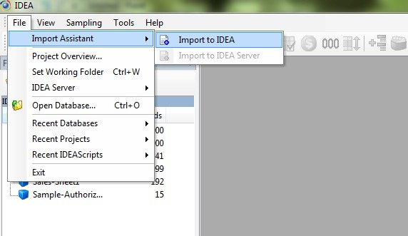

Step1:Selectthe Format:
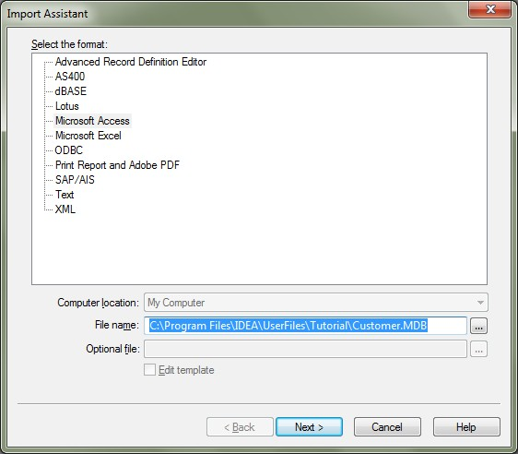

- In theImportAssistantDialogBox, select MicrosoftAccessfrom thelist.
- Click the Browse button next to the File name box to select the Microsoft Access database you want to Import.
- Navigate to and select C:\Program Files\IDEA\User Files\Tutorial\Customer.MDB.
- Click Open.
- The Select File dialog box closes and the selected file name and path appear in the File name box in the Import Assistant dialog box.
- Click Next.
TheMicrosoftAccessdialogboxappears.
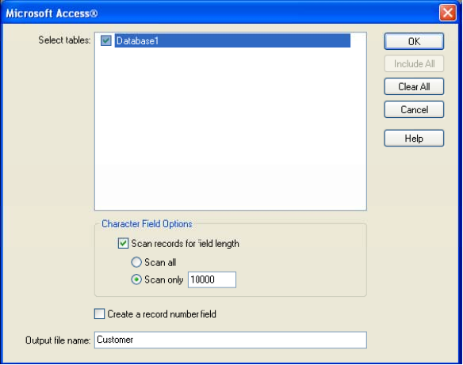

Step 2: Select Tables as shown below:

- In the Select tables box, select Database1.
- Accept the default output file name (Customer), and then click OK. When the file is imported, the database name becomes filename-tablename. In this case, the file you imported becomes an IDEA database called Customer-Database.
Step 3: Result - Customer-Database
On clicking Ok, the Customer Database is imported into IDEA. The imported database is opened in the Database Window. In the File Explorer Window the imported database is highlighted as shown below:
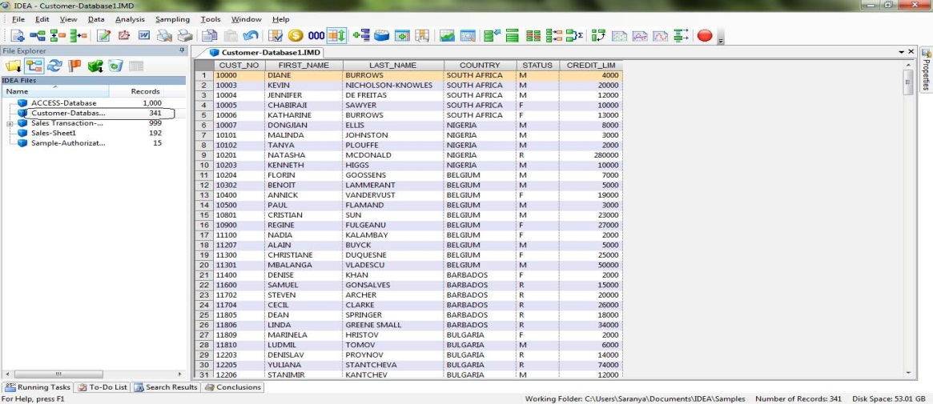

Importing Data:
Clickonfieldstatisticsafterimporting the filesandunderstandthenatureofdata whichisimported.
Function Description
You canusetheExport Database taskto createan external filefroman IDEAdatabase sothat you canusethe datainotherapplications, suchasaspreadsheetpackage.IDEAexportsdatainanumberoftext,database, spreadsheet,andmailmergeformats.
You canusetheExport Database taskto createan external filefroman IDEAdatabase sothat you canusethe datainotherapplications, suchasaspreadsheetpackage.YoucanalsouseCopyandPaste toincorporate portionsoftextorsectionsofdatabaseintootherWindows applications. IDEAalsosupportsdraganddropinto any other OLE2 container application, such as Microsoft Excel. IDEA exports data in a number of text, database, spreadsheet, and mailmergeformats.
StepbystepprocessforexportingfilesfromIDEA.
Location
- File>Export Database
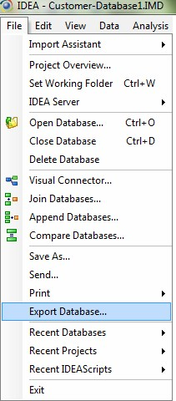

Database Used
- Customer-Database1
ExportDialogBox
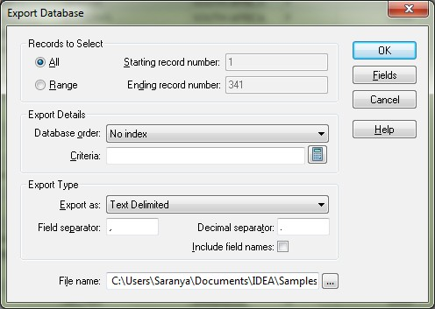

- InRecordstoSelect,onselectingAllwillselecttheentirerecords.OnselectingRangeallowstheuser to selecttheStartingandEndingrecordnumber.

- By default the path is set to C:\Users\Saranya\Documents\IDEA\Samples\Customer-Database1.

- In Export Type, user can select the format in which the current file has to be exported and also name the resultant exported file.

- In Filename allows the user to select the path to which the file has to be exported.

- On clicking Fields, we can select or unselect the fields that have to be exported.

- During Exporting process, condition or criteria can be applied using the criteria button. On clicking this button, Equation Editor Dialog box is opened which facilitates the user to write in query or condition.

- Clicking Ok, exports the active file into given desired format.

UNIT-4
CORE BANKING SOLUTION

CBS BASIS AND ITS WORKING METHODOLOGY

What is Core Banking Solution?
CoreBankingSolution(CBS)iscentralizedBankingApplicationsoftware.Ithasseveralcomponentswhich havebeendesignedtomeetthedemandsofthebanking industry.Core BankingSolutionissupported by advancedtechnologyinfrastructure. Ithashighstandardsofbusiness functionality.Thesefactorsprovidethe banksacompetitiveedge.

There are different vendors in the market providingCBS. The software,(CBS) is developedby different softwaredevelopmentcompanieslikeInfosys,TCS,IflexSolutionsetc.,Eachofthesoftwarehasdifferent names:

Apart fromtheabove,some institutions havedevelopedthesoftwareinhouse.

Thesoftwareresides inaCentral application serverwhich islocatedintheCentralOffice DataCentre.The applicationsoftwareisnotavailableatthebranchbutcanbeaccessedfromthebranches.AlongwithData base servers andotherservers,applicationserver islocatedattheCentralData Centre.

Comparison of TBA with CBS:
Total Branch Automation System (TBA) was in existence before Core Banking Solution (CBS) was implemented. TBA itself was deemed a technology development compared to its predecessor ALPMS (AdvancedLedger PrintingMachines).

IntheTotalBranchAutomation system eachbranchwasperformingthebranchoperationsintotalityatthe respectivebranch.Thefinaloutputwastransmittedtotheheadoffice.ThedatawastransmittedeitheronaCD oraFloppy.TheinformationonthismediawasprocessedattheCentralOfficeforconsolidationofaccounts andpreparationofreports.

Aseachbranch wasselfreliantinasmuchasalltheinformation regardingthebranchoperations wasavailable at the server locatedatthebranch.
Theapplication softwarewhichisalso residing intheserveratthebranchactuallydoes the bankingoperations.The customer mighthave come to withdraw Rs.10,000/-. TheoperatoraccessesthemachinewhenheispromptedtogivetheuserIDandpassword.Once hegivesitcorrectly,ascreenwouldpopupbywhichhewouldclicktheSBA/candintheSBmenuhewould typethenameofthecustomerasalsotheaccountnumber.Hehasnowaccessed tothespecificaccountofthe customer.

Disadvantages:
- Asmentionedintheearlierparagraphsacopyofthesoftwarehadtobeloadedintoeachoftheservers at variousbranches

- Asweallknow,theprogramrequireconstantchangeseitherduetobugsintheprogramordueto changesinthebusinessprocess orforanyotherjustifiablereasons.

- Thesechangesare madeat the centraloffice(ComputerPlanningand PolicyDepartment-CPPD). Copies ofthisprogramwouldhave to bemadeeffectiveatthebranches.

- ThemethodologyadoptedforupdatingisthatacopyoftheprogrammewouldbetakenonaCDor FloppyandpassedovertoabranchorpersonallycarriedbyamemberofthestaffoftheCCPDfor updatingthecopyoftheprogramme residingintheserverofthebranch.Sometimesitwasalso communicatedthroughe-mail.

- Whiletheoreticallyitseemssimple,theproblemsthathavebeenfacedarewiththeneedtochange program often. There were different versions of the program available and operational at different branchesofthebank. Versioncontrolmechanism wasnoteffective.

Functions of IT Department in CBS Environment:
Asexplainedearlier,incorebankingsolutionenvironmentofInformationTechnologyfunctions(ITfunctions) arecentralisedatthedatacentre.Therearespecificrolesandresponsibilitiesfordifferentindividualslikeinall ITDepartments.Therearecertainfunctionswhichareincompatible,whichmeansthatundernocircumstance canoneindividualperformtwodifferentfunctionsasthosespecificfunctionsaresensitive.Thesefunctions have tobeperformed bytwodifferentindividuals.Thisconcept issimilartowhatweareaware ofinapurchase function.. The rationale for theseparationisthatcontrolwillbecompromised.Thisisknownassegregationofdutiesandisveryimportant inanycomputerizedfunction.AbriefdescriptionoftherolesofdifferentindividualsinanITDepartment isgiven below:

➢ SecurityAdministration:Itisadvisableandnecessaryforallorganizationsincludingbankingtohavea security policywhichisapprovedattheBoardlevel.Theofficerinchargeofthesecurity administration is expectedtounderstandthepoliciesandproceduresmentionedinthesecuritypolicy.Heshouldbeable toassesstherisksfornoncompliance.Hisdutieswouldincludedecidingonaccessrulestodataand otherITresources.

➢ TherewillbeseparatesetofpeoplewhowillbeIssuingofuserIDpasswordsandmanageit.Monitoring thesecurityarchitecture constantlywithaview toensuringthattherearenoweakpointswhichcanbe exploitedisthedutyofsecurityadministrator. Security administrator shouldnothaveanyaccessto transactionleveldata
➢Be responsibleforprocessingofendofdayoperationsand beginning ofdayoperations.

➢Be responsibleforintroducinglatestapplicationofthe program.

➢ Databaseadministration:Astheverynameindicates,theDataBaseAdministratoristhecustodianof thebank’sdata.Heisresponsible forensuringthataccess isgiven totheCentralData Base inasecure mannerinline with businessrequirements.Hisresponsibilitieswouldinclude

- Ensuringdataintegrity

- Ensuringdataavailability

- Ensuing securityto accessdata

- Importantlyensurerecoverabilityofdataincaseofsystemfailure

- Maintainingsizeand volumeofdatabaseand correspondingprocesses

➢ NetworkAdministration:Networking,generallyandmorespecificallyinacorebankingenvironment playsaverysignificantrole.TheNetworkAdministratorhasthe followingimportant responsibilities:

- To placerouters,switchesand hubs at the appropriateplacesand ensurea securenetwork configuration.

- Sensitive deviseslikefirewallsandintrusiondetectionsystems/ IPSneedtobestrategicallyplaced toensuresecurityforthenetwork.

- Atperiodicalintervalsarrangeforvulnerabilityassessmentandpenetration teststotakecorrective actionwhenevertheseteststhrowupweak points.

➢ Librarian:NormallyweunderstandthattheLibrarianisinchargeofmaintainingtheLibrary,issuing booksandreceivingthemback.Inacomputerisedenvironment, theLibrarianhasgotsimilar functions excepting thatinsteadofdealingwithbooks, hewillbedealingwithsoftware.Asweareaware,the software,whichisbeingdevelopedandtested,wouldbeclearasacompleteproductreadyforuseby the ProjectLeader. The Librarian maintain recordsofthe variousversions oftheprogramrecords all thevariousversionsoftheprogramjustaswehavedifferenteditionsofabookandgenerallyalater editionisexpectedtobeimportantovertheearlierone.Similarly,softwaremayhavedifferentversions anditisextremelyimportanttorememberthemandthisnumberisreferredtoastheversionnumber.

The Librarianhas thefollowing responsibilities:

- Movingthe correctversionofthesoftwareintoproduction environment.

- Maintaindetaileddocumentationofallreceiptsandissuesofsoftware.

- Keeparecord ofalllicensesobtained fortheusageofsoftware.

- Beinchargeofusermanualand systemmanual

Noneofthesegroupsofadministrators should haveaccesstothedatabasehaving transactiondata. Implementationofmakercheckerconceptwillensure propersegregationofduties.

ChangedManagementProcedures:

Inthenormalcourse,duetoanychangeinthebusinessprocessorupgradationoftechnologyordueto programbugsdiscovered subsequent implementation changesarewarrantedinhardware,softwareand communicationsystems.

There needstobeawelldocumentedprocedure inplace andastrictadherencetosuchprocedure.

Changes tohardwareandcommunication systemsneedtobeenteredinaregisterapartfromasoftcopyofthe registerbeingavailableonthesystem.Thelatestcopyofthenetworkprogramshouldalwaysbeavailable. Thesedocumentsshouldalwaysbemaintaineduptodateincorporatingallthechangesandthedateswhen such changeshave been incorporated.
ApplicationSoftware:

Thereneedstobeacontrolonthevariousversionsofsoftware.Atthestageofinitialimplementation ofthe software(forthefirsttimesoftwarewhichhasbeendebuggedthoroughlymovedfromthetestenvironmentto theproductionenvironment)aspecificversionnumbershouldbeprovidede.g.CBSVersionNo:1.1.There needs tobeadocumentwhichcontainsdetails regarding theVersionNo.anddateofimplementation.

Thereafter for all subsequent procedures, there needs to be a strict procedure to be adhered to. The procedures wouldbeasfollows:

- ThereshouldbeaspecificrequestfromanauthorisedpersonliketheManageroftheuserdepartment.
- Therequestshouldbeapproved bythepersonincharge oftheSystemsDepartment.

CBS Interfaces- Their Functionality and Controls
Automated Teller machine:
AutomatedTellerMachine(ATM)isacomputerizedtelecommunication devise.Usageofthisfacilitydispenses withtheneedforabankteller.Thisfacilityprovidesacustomertoaccessfinancialtransactionsinapublic place. ATMs maybeinstalledwithinthebranches,away fromthebranchesandatshoppingmallsalso.

ATM Card:
TheATMcard hasamagnetic strip.Thecardcontainsanuniquenumberandsome other securityinformation apartfromdateofexpiryofthecard.TheATMcardisissuedonlytoexistingcustomersofthebank.The concerned Branch Manager recommends and authorizes the issue of an ATM card by forwarding the applicationtotheCentralOfficewhich deals withtheissueofATM cards.Inviewoftheseverecompetition nowalmostallthebanksprovide totheircustomerssoonaftertheyopenan accountwith the facilitytoperforminternetbankingandpossessanATMCard.
ATM Operations:
TheATMgenerallyperformsthe followingfunctions:
(a) CashWithdrawal
(b) Balance Inquiry

(c) Registeringrequestsforchequebook

(d) Changing ofPINnumber
ATM Switch Operations:
AsalreadymentionedATMswitchconsistsofacomputerwithaserverattachedtothesame.Detailsofthe ATMcard holdersisavailableatthedata base,Thedetails wouldinclude

(a) Card No.andcorrespondingoffsetvalue
(b) Detailsofhotlisted cards
(c) Details ofsurrenderedcards and

(d) Accountbalanceofcustomers.(Thisaccountbalanceisalsocalledpositivebalancefile-PBF.Thisis made availableat the ATM switch. Even whenthe ATM is offline, the balanceof the customeris available.

Internet Banking:
InternetBankingreferstobankingtransactions routedthroughtheInternet.This facility permitsregistered customersofthebanktoperformbankingoperationsatanytimeofthedayfromanycomputer-nowitmay also bepossible todoitfromacell phone.

No doubt, Internet Banking facilitates banking through the medium of internet. However, italso needs specialized softwareand hardware.The internet asyou allknowisapublic network.Henceproper security features arebuiltinto the systemtomaintainconfidentiality andintegrityofthedata thatisbeing transferred throughthe internet.

SomeBanksprovide thisfacilityautomatically soonafteracustomeropensanaccount withthem.Someothers requireaspecialrequestfromthecustomertoprovidethisfacility.

Real Time Gross Payment:
TheacronymRTGSstandsfor“RealTimeGrossSettlement”.RTGSsystemenablestransferofmoneyfrom onebanktoanotherona“RealTime”andon“Gross”basis.Realtimemeansthatthetransactionsaresettled assoonastheyareprocessed.Thereisnowaitingperiod.Grosssettlementmeansthatthistransactionis settledonaonetoonebasis.There isnobunchingwithanothertransaction. Themoneytransfer takesplacein thebooksoftheCentralBankofthecountry-ReserveBankofIndiainourcountry.Asthemoneytransfer takesplace inthebooksoftheRBI, thepaymentisfinalandirrevocable.

DifferencebetweenElectronicFundTransferSystem(EFT)orNationalElectronicsFundTransferSystem(NEFT)and RTGS:

EFTandNEFTarealso electronic fund transfermodes.However, they operateonaDeferredNet Settlement (DNS)basis.InDNSbasistransactionsaresettled inbatches.Transactions whichtakeplaceafteraparticular settlement time wouldhavetowait till the nextdesignatedsettlement time.

InRTGS,transactionsareprocessedcontinuouslythroughouttheRTGS businesstime.

RTGS system isprimarilyforlargevalue transactions. Asofnow,theminimumamounttoberemittedthrough RTGSisRs.1.00lakh and thereisnoupper ceiling.In EFTandNEFTsystems,thereisnostipulation regarding theminimumandmaximumamount.Thetimetakenforthetransactiontobeeffectedwouldbewithintwo hours.Thebeneficiarybank(Bankwhichisreceivingtheamount)hastocredittothebeneficiary’saccount withintwohoursofreceivingthefundtransfermessage.The remitting customerwouldreceivean acknowledgment forthemoneycreditedtothebeneficiary’saccountastheremittingbankreceivesamessage from theRBIthatthemoneyhasbeen creditedtothereceivingbank.

Cash Management System:
CashManagementSystem(CMS)isanewproduct developedbybanks. Theobjectiveoftheproductistomeet theneedsofthecustomerswhohave operationsalloverthecountry. Suchorganizations wouldnaturally have collection andpayments invariouslocations.
Inthenormalcourse, chequeswould becollectedinonesinglelocationand thendeposited inthe mainbranch. Thiscausescashflowproblemsasthereis uncertaintyregardingthedateswhenthechequeswouldbe realised.Inviewofthisuncertaintybothscenariosofexcesscashanddeficitcashwerearising.Asinreceipts bywayofchequesasimilarsituationariseswhenahighvolumeofdisbursementhastobemade e.g.,

(a) Salariesforthedifferentbranches

(b) Dividendpayments.

EvaluationofControlsofCMS:

Parameter settings (Master Settings):There needs to be adequate controls over parameter settings, authorizationasalso modificationofsuchsettings.E.g.,Parameterswouldinclude:

- Clearingcycle

- Credit limit

- Charges(variousslabs)
- Interest(“ )
ProcessingCharges:When the bank offers CMS productto the customer,naturallythere are associated chargesfor the samewhichwouldinclude:

- DD/PayOrderissue charges

- CourierCharges

- Chequereturncharges

- Interestchargesforcreditoffered.

Thereneedstobeaprocesslogicforcomputingthevariouscharges.Anydefectinthelogicwouldleadto incomeleakage.Whileevaluatingthecontrols,itisnecessarytoverifythecorrectnessoftheparametersand also testthe programlogic. It is importantto verify the authorizationprocessfor creatingand modifying parameters.

SYSTEMS AUDIT OF CBS AND ITS INTERFACES
Introduction to Information System Audit:
Systemsauditingis animportantaspectin the presentcontextof extensivecomputerisation.The control objectives and audit objectives always remain the same. However, auditmethodologyin a computerised environmentisdistinctlydifferentfromthatinamanualenvironment.

In1967,intheUnitedStates,asignificanteventtookplaceinhistoryofsystemsaudit.Itiscommonly and popularlyreferredtoasthe“EquityFundingCase”.TheManagersandDirectorsofEquityFundingCorporation ofAmerica,withtheideaofincreasing thesharevalueoftheircompanyprofitswerefalsified bycreating bogus insurancepolicies.

Thesematterswerefurthercomplicatedbytheexternalauditorsconfirmingtheexistenceoftheinsurance policies(thefakedones)!Theconfirmation wasobtained onthetelephone.Itwasreportedthatthecallswent throughthe equity fund switch board to the employeeswho were colludingwith the managersand they confirmed theexistence ofthepolicies.

Audit of Core Banking Solutions:
Auditistheprocessofevaluating theadequacy ofcontrolsandalsoensuringrelevant applicationmodulesdeal comprehensivelywithbusinessprocess.Thevariousaspectstobeverifiedwhileperformingtheauditinthe CoreBankingSolutionenvironmentwouldbe:

- ReviewofSecurityPolicy

- Review ofBusinessContinuity Planning &BCPpolicy

- Review ofSystemsDevelopmentandChangeManagementProcedures&process
- NetworkvulnerabilityAssessmentofEffectivenessofIntrusionDetection Systems.
- Evaluation ofcontrolsinoperating systems.
- Controlindatabases

- Whenanyoftheserviceslikesoftware development,databasemanagement,network management are outsourced,reviewoftheservicelevelagreementtoensurethatconfidentialityintegrityandavailability are taken care of is extremely important. Service levelagreements should provide for a systems auditabilityclause.SothatBanks willhave theright tohavesystemsauditconductedofthethirdparty services.

- Testingofapplicationmodules oftheCore Banking Solution.
- ReviewofSystemslogs.

Review of System Logs:
Logsasalreadymentioned arereportsgeneratedbythesystem automatically. However,itneedstobementionedthattheygenerate automaticallyonceitisprogrammed todoso.Auditors shouldreview thesystemslogs. The systemslogscould beclassifiedas:

(a) Operating SystemLogs

(b) ApplicationLogsand

(c) DataBaseLogs

OperatingSystemLogs:
Depending upon the operating systems (Windows-2000, Windows 2003, Unix etc.) logs aregenerated containingauthenticinformationrelatedtosecurity.Theconcernedadministrationmanualoftheoperating systemwould provideenoughguidance toevaluatesecurityconcerns,ifany.

ApplicationLogs:

Applicationlogsarelogsgenerated bytheapplicationprograms.Whiledeveloping theprograms,decisionsare taken regardingtheaspectstobereviewedandlogs tobeprepared.

Thesystemcouldalso beprogrammedtoprovidetogenerateexceptionreports.Anauditorshouldcollectdetailsaboutexception reportswhichhave been generated. Theexceptionreportscould include:

(a) Accountopenedand closedduringthemonthand

(b) LoanArrears and

(c) TemporaryOverDraftsgranted etc.,

DateBaseLogs:
Theselogsareavailableonlyforthecomputersystems department and could beviewedonlybyanauthorised userlikedatabaseadministrator. Therecouldbeothersignificant databaselogstoreviewchangesatthedata base levelbutnotthroughtheapplication. Thisisamatter ofseriousdata concern,
Thelogmanagement isessentialtoensurethatcomputersecurity recordsarestoredinsufficientdetailfor appropriateperiod oftime.

UNIT-5
ENTERPRISE RESOURCE PLANNING

ERP OVERVIEW
Introduction:
Anenterprise isagroupofpeoplewithacommongoal, havingcertainresources atitsdisposaltoachievethis goal.Inanenterpriseway,theentireorganization isconsidered asonesystemandallthedepartmentsareits sub-systems.Informationregardingallaspectsoftheorganizationisstoredcentrallyandisavailabletoalldepartments.Resourcesincludemoney,manpower, materials, machines, technologiesetc.
Production Planning

Finance

Marketing
Research & development
Production
Logistic Management

Human Resources
Quality Management

Sales & Distribution

AsshowninFigure aboveeachdepartmentwillmaintainseparatedatabasesanddesignapplicationsaspertheir functionalities. ERPcombinesallthebusinessrequirementsofthecompany together intoasingle,integratedsoftware program thatrunsoffasingledatabasesothatthevarious departments can moreeasilyshareinformationandcommunicate witheachother.Thistransparencyandinformationaccess ensuresthatthedepartmentsnolongerworkinisolationpursuingtheirownindependentgoals.
Eachsub-system knowswhatothersaredoing, whytheyaredoingitandwhat shouldbedonetomovethe company towardsthe common goal. The ERP systems help to make this task easier by integratingthe information systems, enabling smooth and seamless flow of information across departmental barriers, automatingbusinessprocessesand functions,and thushelpingtheorganizationtoworkand moveforwardasa singleentity.

DataMining:
Data Mining is the process of identifying valid, novel, potentially useful and ultimately comprehensible knowledge fromdatabasesthatisusedtomakecrucialbusinessdecisions.Dataminingistheprocessof extractingpatternsfromdata.Asmoredataaregathered,dataminingisbecominganincreasinglyimportant tooltotransformthese dataintoinformation. Itiscommonlyusedinawiderangeofprofilingpractices,such as marketing,surveillance,fraud detectionandscientificdiscovery.
Data mininginrelationtoEnterprise Resource Planningisthestatisticaland logical analysisoflarge setsof transactiondata,lookingforpatternsthatcanaiddecisionmaking.
Themainreasonforthenecessity ofautomated computersystems forintelligentdataanalysis istheenormous volumeofexistingandnewlyappearingdata,accumulated eachdaybyvariousbusinesses,scientific and governmentalorganizationsaroundthe worldthatrequiresprocessing.
Further,automated datamining systemshasamuchlowercostthanhiringanarmyofhighlytrained and professional statisticians. While data mining does not eliminate human participation in solving the task completely, itsignificantly simplifiesthejobandallowsananalystwhoisnotaprofessionalinstatisticsand programmingtomanagetheprocess ofextractingknowledgefromdata.
OnlineAnalyticalProcessing(OLAP):
OnlineAnalyticalProcessing,orOLAP,isanapproachtoquicklyanswermulti-dimensional analyticalqueries. OLAPispartofthebroadercategoryofbusinessintelligence,whichalsoencompasses relational reporting and datamining.Thetypicalapplications ofOLAPareinbusinessreportingforsales,marketing,management reporting,BusinessProcessManagement(BPM),budgetingandforecasting,financialreportingandsimilar areas.
Databases configured forOLAPuseamultidimensional datamodel,allowingforcomplexanalyticalandad-hoc querieswitharapidexecutiontime.OLAPsystemsuseconceptofOLAPcubecalledamultidimensional cubeorahypercubeconsisting ofnumericfactscalledmeasures whicharecategorizedbydimensions.The cubemetadataistypicallycreatedfromasetoftables(FactsandDimensional)inarelationaldatabase.Measuresarederivedfrom the recordsinthe facttable anddimensionsarederivedfrom thedimensiontables.
TheoutputofanOLAPqueryistypicallydisplayedinamatrix(orpivot)format.Thedimensionsformtherows andcolumnsofthematrix;the measuresformthe values.

CharacteristicsofOLAP:
1. Fast:Meansthatthesystemistargetedtodeliver most responses touserswithinnotime.
2. Analysis: Meansthat thesystemcan cope with any businesslogic and statisticalanalysisthat is relevantfortheapplicationand theuser,andkeep iteasyenoughforthe targetuser.
3. Shared:Means thatthesystemimplements allthesecurityrequirementsforconfidentiality andifmultiple write accessisneeded,concurrent updatelocking atanappropriatelevel.
4. Multi-Dimensional:Meansthatthesystemmustprovideamulti-dimensionalconceptualviewofthe data,includingfullsupportforhierarchiesandmultiplehierarchies.
5. Information:Isallofthedataandderivedinformationneeded,whereveritisandhowevermuchis relevantfortheapplication.
OLAPtechnology ismost commonlyappliedforsales andmarketing analysis,financialreportingand consolidation, budgeting and planning, product profitability and pricing analysis, activity based costing, manpowerplanningandquality analysis.
ProductLifecycleManagement(PLM):
The conditionsunder whicha productis sold will changeover time. The productlife cycle refers to the successionofstagesaproductgoesthrough.ProductLifecycleManagementisthesuccessionofstrategies used bymanagementasaproductgoesthroughitslifecycle.
Inotherwords, PLMistheprocess ofmanaging theentire lifecycleofaproductfromitsconception, through design andmanufacture, to service and disposal. PLM integratespeople, data, processes and business systemsandprovidesaproductinformationbackboneforcompanies and theirextendedenterprise.
PLMhelpsorganizationsinthe followingareas:
- Reducetime-to-marketthroughfasterdesignand validation.
- OptimallydeployCADandprototypingresourcestocomplete critical projects.
- Reduceproductdevelopmentandmanufacturingcosts.
- Reducelevels ofobsoletecomponent inventoryatmultiplelocations.
- Getproductdesignchangesintoproductivity quickly.
Supply Chain Management:
Asupplychainisanetwork offacilitiesanddistributionoptionsthatperformsthefunctionsofprocurement of materials,transformationsofthesematerialsintointermediateandfinishedproductsandthedistributionof these finished productstocustomers.Supplychainmanagement (SCM) isthemanagement ofanetworkof interconnectedbusinessesinvolvedintheultimateprovisionofproductandservicepackagesrequiredbyend customers.Itisdefinedastheprocessofplanning,implementingandcontrollingtheoperationsoftheSupplychainas efficientlyas possible. SCM includes movement and storage of raw materials, work-in-process inventory,andfinishedgoodsfrompoint-of-origintopoint-of-consumption.Inessence,SCMintegratessupply anddemandmanagementwithinandacross companies.
SCMcanbegroupedintostrategic,tacticalandoperational levelsofactivities.
Strategic
- Strategicnetworkoptimization,includingthenumber,location,andsize ofwarehousing,distribution centers,andfacilities.
- Strategicpartnershipswithsuppliers,distributors,andcustomers,creatingcommunicationchannelsfor criticalinformationandoperationalimprovements suchascrossdocking,directshipping, andthird-party logistics.
- Productlifecyclemanagement,sothatnewandexistingproductscanbeoptimallyintegratedintothe supplychain andcapacitymanagementactivities.
- Informationtechnologyinfrastructuretosupport supply chain operations.
- Where-to-makeandwhat-to-make-or-buydecisions.
- Aligningoverallorganizationalstrategywithsupplystrategy.
Tactical
- Sourcingcontractsandother purchasingdecisions.
- Productiondecisions,includingcontracting,scheduling, andplanningprocess definition.
- Inventorydecisions,includingquantity,location,andqualityofinventory.
- Transportationstrategy,including frequency,routes,andcontracting.
- Benchmarkingofalloperationsagainstcompetitorsandimplementationofbestpracticesthroughoutthe enterprise.
- Milestone payments.
- Focus oncustomerdemand.

Operational
- Dailyproduction anddistributionplanning,includingallnodes inthesupply chain.
- Productionschedulingforeach manufacturingfacilityinthesupply chain(minutebyminute).
- Demandplanningandforecasting,coordinatingthedemandforecastofallcustomersandsharingthe forecastwithallsuppliers.
- Sourcingplanning,includingcurrentinventoryand forecastdemand,incollaborationwithallsuppliers.
- Inboundoperations,including transportationfromsuppliersand receivinginventory.
- Productionoperations, including the consumptionofmaterialsandflowoffinishedgoods.

- Outbound operations, includingallfulfillmentactivities,warehousingand transportationtocustomers.
- Orderpromising,accountingforallconstraintsinthesupplychain,includingallsuppliers,manufacturing facilities,distributioncenters,andother customers.
SCMaddressesourclients' challengesthroughsevenserviceareas:
- SupplyChainStrategy
- SupplyChainPlanning
- Logistics
- Procurement
- Product LifecycleManagement
- SupplyChainEnterprise Applications
- Assetmanagement

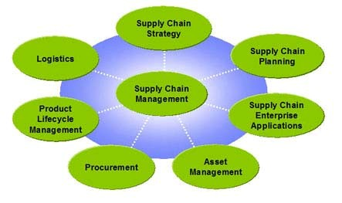

CustomerRelationshipManagement(CRM):
Customer Relationship Management isacorporatelevelstrategy,focusingoncreatingandmaintaining relationshipswithcustomers.Itcoversmethods andtechnologies usedbycompaniestomanagetheir relationshipswith clients.
There are severaldifferentapproachestoCRM,with differentsoftwarepackages focusingondifferentaspects:
1. OperationalCRM
OperationalCRMprovidessupportto"frontoffice"businessprocesses,e.g.tosales,marketingandservice staff.Interactionswithcustomersaregenerallystored incustomers' contacthistories,andstaffcanretrieve customerinformationasrequired.
Thecontacthistory providesstaff memberswithimmediateaccesstoimportantinformation onthecustomer (productsowned,priorsupportcallsetc.),eliminatingtheneedtoindividuallyobtainthisinformationdirectly fromthe customer. Reaching to the customeratrighttimeatrightplaceispreferable.
Operational CRM processes customerdataforavarietyofpurposes:
- Managing campaigns
- Enterprise MarketingAutomation
- SalesForceAutomation
- SalesManagementSystem
2. AnalyticalCRM
- AnalyticalCRManalyzescustomer dataforavarietyofpurposes:
- Designingandexecutingtargetedmarketing campaigns
- Designingandexecutingcampaigns, e.g.customeracquisition,cross-selling,up-selling,addon-selling
- Analyzingcustomerbehaviorinordertomakedecisionsrelatingtoproductsandservices(e.g.pricing, product development)
- Managementinformationsystem (e.g. financialforecastingand customerprofitabilityanalysis)
AnalyticalCRMgenerallymakesheavy useofdata miningandothertechniques toproduceusefulresultsfor decision-making.ItisattheanalyticalstagethattheimportanceoffullyintegratedCRMsoftwarebecomes mostapparent-themoreinformation availabletoanalyticalsoftware,thebetteritspredictionsand recommendationswillbe.

3. SalesIntelligenceCRM
SalesIntelligenceCRMissimilartoAnalyticalCRM,butisintendedasamoredirectsalestool.Features includealertssenttosales staffregarding:
- Cross-selling/Up-selling/Switch-sellingopportunities
- Customerdrift
- Sales performance
- Customertrends
- Customermargins
- Customeralignment
4. CampaignManagement
Campaign managementcombines elements of Operational and Analytical CRM. Campaign management functionsinclude:
- Targeting groupsformedfrom the clientbase according toselectedcriteria
- Sendingcampaign-relatedmaterial(e.g.onspecialoffers)toselectedrecipientsusingvariouschannels
- (e.g.e-mail,telephone, SMS, post)

- Tracking,storing, andanalyzing campaign statistics,includingtrackingresponsesandanalyzing trends
5. CollaborativeCRM
Collaborative CRM covers aspects of a company's dealings with customers that are handled by various departmentswithinacompany,suchassales,technicalsupportandmarketing.Staffmembersfromdifferent departmentscanshareinformationcollectedwheninteractingwithcustomers.Forexample,feedbackreceived bycustomersupport agentscanprovideotherstaffmemberswithinformation ontheservicesandfeatures requestedbycustomers.CollaborativeCRM'sultimategoalistouseinformation collected byalldepartmentsto improvethequalityofservicesprovidedbythecompany.ProducerscanuseCRMinformationtodevelop productsorfindnewmarket.CRMfacilitatescommunicationbetween customers,suppliersandpartner.
6. Consumer Relationship CRM
ConsumerRelationship System(CRS)coversaspectsofacompany's dealingwithcustomershandledbythe ConsumerAffairsandCustomer Relationscontactcenterswithinacompany.Representatives handlein-bound contactfromanonymousconsumersandcustomers.Earlywarningscanbeissuedregardingproductissues (e.g. itemrecalls)andcurrentconsumersentiment canbetracked(voiceofthe customer).
7. SimpleCRM
ItisarelativelynewspinoffofthetraditionalCRMmodel firstappearing in2006. Attheircore,CRMtoolsare designedtomanagecustomerrelationships.Asdescribedabovetherearecountlesssupplementalfeatures andcapabilities. SimpleCRMsystemsbreakdown thetraditional CRMsystem tofocusonthecorevalues,i.e managingcontactsandactivitieswithcustomersandprospects.Thesesystemsaredesignedtocreatethe mostvaluefortheimmediateenduserratherthantheorganizationasawhole.Theyoftenfocusonsatisfying the needs of a particular marketplace niche, organizational unit, or type of user rather than an entire organization.

8. SocialCRM
Beginning in2007,therapidgrowth insocialmedia andsocialnetworking forced CRMproduct companiesto integrate"social"featuresintotheirtraditionalCRMsystems.Someofthefirstfeaturesaddedweresocial network monitoringfeeds (e.g. Twitter timeline). Other emergingfeatures include messaging, sentiment analysis,and other analytics.CRM expertsagreethat online social communitiesand conversationshave significantconsequencesforcompanies, andmustbemonitoredforreal-timemarketplacefeedbackandtrends.

UNIT-6
OFFICE AUTOMATION APPLICATION AND IT SECURITY IN CA’s OFFICE

IT APPLICATIONS IN CA’s OFFICE
Nature of services provided by a CA Firm:
A CA firm is a firm of CAs who render their professional services to the client for a fee. It is important to understand the nature of services provided as the IT applications will depend on the same. Following are the key services provided by a CA firm:
-Auditing
-Statutory audit
-Internal / Management audit
-Tax Audit
-Taxation related services
-Advisory / consulting services in:
-Corporate finance and Merchant Banking
-Information Technology:
-Identification of suitable ERP
-Identification of ERP implementation partner
-ERP implementation
-ERP – Post implementation review
-Information Systems (IS) Audit
-Company Law matters
-Others
-Investigation or forensic services
Meaning of Office automation:
There is no prescribed definition of office automation. It refers to use of various applications in office to create and store the documentation / information in soft copy format, use software / applications to automatically perform tasks (accounting, preparing trial balance, financial statements etc.) and electrically transmit the data or information to others through use of internet / telecommunications technology like use of email, fax machine etc. It should be noted that the degree of automation in office automated equipment may vary from organization to organizationToday, even a small firm uses Personal Computer (PC) and printer with certain basic software / application like Microsoft Word, MS Excel, and MS Power Point etc. for day to day routine work. With this, the typewriters used in the past are done away with.
Evolution of Office automation:
Office automation has evolved over a period of time. It started with the use of certain basic applications like typewriters for typing official letters, copy machines for coping the documents and fax machines to send the written message to business partners. Slowly and slowly, with advancement of technology and internet, sophisticated applications evolved which helped the management to efficiently manage the business. There are various types of office automation and purpose of each of the machines is different.
Today’s business environment is much different from earlier times. For example, till around 2007, CAs used to file manual tax returns. They used to perform lot of calculations manually or with the help of some applications but tax returns were filled and submitted manually in the respective department. Today, there are sophisticated applications where they input the required details. System computes the taxable income, calculate the liability and also electronically submit the income tax return. CA or his staff need not visit the income tax department to submit the return. Further, for transmitting the information or document, it is not necessary to take print out and send the same by courier or send the same over fax. Data / documents in electronic form can be sent with the help of email. This saves lot of time of the staff and brings efficiency. Considering the today’s business environment, office automation is not limited just limited to typing or coping documents electrically but also include the following:
- Capture the data in the applications by way of scanning or manually punching the data
- Perform calculations and handling numerical data in database or in excel sheets
- Word processing
- Task management
- Electronic approval of transactions
- Storing the data in electronic / digital form
- Electronically transmit the information or documents
Important aspects to be considered for office automation
(a) Common network
Various applications deployed should be on the same network as employees in the office can access the entire automated applications provided they are on the same network. If not, employees on different network will have to login and process data. This will be complicated both for the employees and for the IT to maintain the IT.
(b) Integration
Office equipment may not be effective if they are stand alone. Integration is the key to achieve efficiency so that various tasks can be performed with minimum intervention of the staff. However, it may not always be possible that all the office equipment / applications are integrated as they are made by different manufacturers and may also be using different technology. In such cases, there should be some interface between various applications so that data can be transmitted between various applications automatically or with minimum intervention of the employees. Else, employees will have feed data manually which is onerous and prone to humane errors.
(c) Training
As the applications are made by different manufacturers and may be using different technology, it is important that employees are trained to use the equipment / applications. Else, organization may not be able to realize the benefits of automation and investment in office automation equipment would be waste. This is commonly seen in various organizations. For example, management has invested in a sophisticated printer cum copying machine which can scan the document and automatically send the email to concerned person, print the document and automatically staple the documents etc. However, employees normally rely on the help being provided by person standing at the copy machine rather than taking interest to learn the features of machine and how to use the machine. In such situations, it is observed that employees scan the document and take the file on pen drive and then send the mail with scanned copy of the document as an attachment. Further, employees print the document and then look around for stapler to staple the document.
Considering the above, Training the employees on the office applications is important.
(d) Security
Security of the office applications and data / information contained therein is of utmost importance. Else, data may get in the hands of wrong persons and may be utilized by them for their personal benefit. Hence, security of the applications should be ensured. We will discuss this later in detail.
(e) Automation of all / key services
All services offered by the firm should be covered in automation or at least the key services. For example, the resource allocation and scheduling is automated for audit but not for tax services team. With this, it will be difficult to track the time availability of employees, especially those who are involved in both the services.
(f) Access rights
Access to the automated office equipment / application should be defined on the basis of need to know and need to do.

Applications used in CA’s Office
Considering the nature of services provided by a CA firm, following software and hardware equipment are required in a CA’s office:
Software
(a) Client Management
(b) Resource allocation and scheduling
(c) Financial Accounting
(i) Sales module
(ii) Purchasing module
(iii) Accounts Receivable (AR) module
(iv) Accounts Payable (AP) module
(v) General Ledger (GL) module
(vi) Fixed Assets (FA) module
(vii) Cash Management / Bank Reconciliation
(viii) Expense Management
(d) Human Resource (HR) and Payroll
(i) HR Management System
Hiring and recruitment
Induction
Training
(ii) Timesheets
(iii) Payroll
(iv) Performance Management System
(e) Document Management System
(f) Knowledge Management
(g) E-filing

Hardware / infrastructure
- Copy, scanning and printing machine
- Fax machine
- Pbx
- Personal Computers (PC) / laptops
- Application server
- Email server
- Network (wired / wireless)
-Local Area Network (LAN)
-Wide Area Network (WAN)
-Metropolitan Area Network

Applications arranged by ICAI
The above stated applications are generally required for any service rendering organization including a CA firm. However, the cost of such applications is high and small and medium sized firms may not be able to afford such cost. Hence, ICAI has made certain arrangement with external vendors and arranged to provide the following applications for its members:
- ICAI-XBRL software
- Payroll
- Billing and Accounting
- K-DOC
- E-Secretary
- ICAI-ROC
- ICAI Tax Suite
Brief explanation of each of the above said applications / IT components are as follows:

Software:
Client Management
Survival of the firm depends on the services. To be competitive, it is critical for the CA firm to understand the client needs, identify them and track the responses. This is important to gain client confidence and improve their confidence level. It is very difficult to manage this manually, especially in case where the client is big and has multi location presence. Technology plays an important role. Let us understand this in detail.
Client Needs management
While the client needs can be managed and tracked manually on excel sheets but this is time consuming and subject to human errors. Seamless automation is the need of almost every professional firm to be competitive in the market. There are 3 stages of the sales cycle:
(a) Get needs
(b) Determine solution to client needs
(c) Communicate to client.
Changes would need to be made by the person working on the solution as per need of the client. Following information may be stored at one place which helps to fasten the solution process:
- History of the organization, office locations etc.
- Key processes in various industries and associated risks
- Approach and methodology
- Thought leadership document samples
- Brief note on various tools and technologies to be deployed in various types of assignments
- Contact details of employees worked on same or similar areas in the past
Following are some of the advantages offered by the Client Management application:
Avoid duplication: Client management application helps management in avoiding duplication of efforts. i.e., if an employee is already in touch with a new client, other manager / director will be able to see details online. In its absence it may be possible that various manager / directors may work on the same client need due to lack of communication between employees.
Easy monitoring and tracking: the details of the client needs and respective solution are available in the application. Various reports can be generated to review the client needs / opportunities client wise, city wise, amount wise etc.
Compliance to the risk management policy: various parameters of the risk management policy of the firm may be incorporated in the application whereby each manager / director is responsible to answer the relevant questions as per the risk management policy. The opportunity / solution are submitted to the relevant person as per the final risk rating and reviewer would be able to see the complete details online.
Online approval workflow: The application provides the mechanism to approve the solution as per the approval workflow of the organization (depending on the risk perceived in the opportunity). The application also captures the complete audit trail of the solution submitted and approved with the date and time stamp.
Sharing of revenue between employees: This application also helps the management to allocate the revenue to the credit of the right employee as the application captures the person who identified the opportunity, who worked on the solution and how the revenue share should be done between teams/offices working on the client engagement.
This application is operational in nature but is important from the management point of view as it contain details of all the client needs and opportunities pursued by the firm.
Resource allocation and scheduling
Employees are assets for the firm and their effective utilization determines the profitability of the firm. It is generally observed that employees in professional firms are overloaded as they work on multiple assignments at the same time. Further, many assignments are delayed due to non-availability of right resources. This is primarily due to shortage of manpower and ineffective manpower planning and allocation of resources.
We have seen certain firms performing the resource allocation on excel sheets. This is convenient but it leads to lot of chaos as multiple versions of the excel sheet float in the organization. It is difficult to have effective change management of the excel sheets because multiple people have access to make modifications. As a result, managers assign resources to some of their projects while the engagement may not have started. Further, some other assignment which is in need of right person may suffer due to absence of staff. This affects the profitability and client satisfaction.
Resource planning and scheduling application helps the management in following ways:
- Map the employees against their skill set.
- With role based access, one or limited persons may be made responsible for the resource allocation. Based on the deadline of the engagements, manager / director submit request to the resource allocation manager who in turn update the request in application and assign resources subject to availability and as per the skill set requirement.
- Employees may be linked with the HR database. As a result, the employees who have left the company will not be allowed to be allocated to assignments after their release date. Further, application does not allow the allocation of resource beyond the expected release date of the employee in case he is serving the notice period.
- Application provides the visibility of time allocation of employees and their availability.
The advantage of this application is that it makes the resource allocation a structured process and avoids confusion / duplicate allocate of some person against multiple assignments. Following is a sample report of the application which provide clear visibility on the allocation and availability of employees:
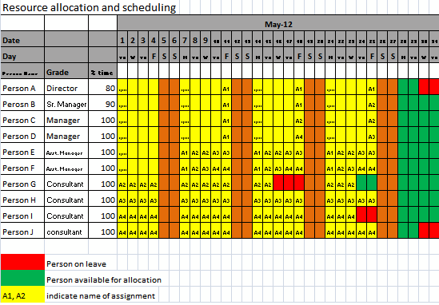
This application is also operational in nature but has great impact on the profitability of the firm.

Financial Accounting application
The main purpose of finance and accounts application is to help management to record various transactions like sales, purchases, expenses, revenue, accruals, assets, liabilities and provide timely information to management for decision making. Routine transactions are recorded on day to day basis and financial reports like Profit and Loss account, balance sheets, and Cash Flow statements are prepared as per need of the management. This application is critical from the internal management and statutory reporting as the key reports are prepared based on the output from the financial accounting application. Following diagram demonstrates the relation between various modules of financial application and HRMS.

Cash Management
Purchasing
Accounts Payable

General Ledger
Expense Management
Sales

Receivable
Assets
Payroll

CHAPTER2 | INFORMATIONSECURITYINCA’SOFFICE  ...................................................................

Introduction:
AfterhavingunderstoodtheITapplicationsbeingusedinaCA’soffice,letusunderstandtheinformation security concerns associated with these applications / infrastructure. Before we proceed to information security,letusfirstunderstandwhat informationisandwhat thedifferencebetweendataand informationis.
Data may be anything but which is raw and is without processing. Example ofdata may include sales, transactionsdatabutthedatashouldbefactual. Oncethedataisprocessed,itprovidedsomemeaningful resultstotheuser. Thisprocessed data isinformation.
Thedataorinformationmayresideonserverornetworkoftheorganization.Informationsecurityisprotection ofinformation assets fromthreatstopreservetheirvalue.Intoday’slife, almost everybody work on the network.
Itcanbeeithertheorganization’snetworkorinternet(publicnetwork). Internetisveryconvenientbutthis conveniencemaybeatthecostofsecurityofthedataorinformation. Sincethedataisinsoftcopyformat, thereisriskofsomeonestealingthe confidentialinformation.
Evenifthedataisinhardcopyformat,thedatamaymiss-utilizedbysomeoneagainsttheinterestofthefirm. Itiscriticalthatthedata shouldbekeptinlockandkey.
Whichinformationassetsneedtobesecured?
Therearetwo typesofdatawhich isavailable inaChartered Accountant (CA)office:
•Clientdata/documents
•Owndata/documents
Anydataorinformationthat is confidential in natureshouldbesecured. Further,anydataorinformation that may be modified, destroyed or misused by othersneedstobesecured. Forthis,itisessentialto considerallsourcesfromwherethedataorinformationcanberetrieved. Oncethesourcesare identified,first thephysicalsecurityofthecomputerhardwarelikeserversneedstobeensured. Physicalsecurityinvolves useoflockandkeyforcriticalcomputerhardware.I.e.useoflockandkeyonthecabininwhichcomputer serverisstored.
Asregards which information needs tobesecured,itwilldepend onthecriticalityoftheinformation. Forthis, management needstodotheriskassessmentanddefinethecriticalitylevelforeachinformationassets sothat appropriatesecuritymechanismsmaybeadopted.
GoalsofInformationSecurity
Purposeofinformationsecurityistoretainsecurityoftheinformation. Themaingoalsofinformationsecurity are:
•Confidentiality(C),
•Integrity(I)
•Availability (A)
ThesearecommonlyreferredtoasCIAininformationsecurityparlance. Inaddition,authenticityandnon- repudiationarealsorelevantfromtheinformation security pointofview. Thegoalsofinformationsecurityare explained asunder:

•Confidentiality–Itmeanstheinformationavailableintheorganizationalapplicationsshouldbesafe fromunauthorizedaccess. i.e.informationshouldnotbeavailabletounauthorizedusers. Theextentandlevel ofconfidentialitywoulddependonthenatureofinformation. Thelevelofconfidentialitywouldbemoreincase ofcriticalinformation andlesserinothercases

•Integrity–it meansinformationavailablein the organizationshouldnot be alteredor modifiedby unauthorizedpersonnel. Anyunauthorized modification oralteration totheinformationmayhavefinancialand reputationalloss. Incasethedataismodifiedbyanyauthorizedpersonandisdetectedbymanagement,the only options are either to restore the data from backups or re-createthe whole data which will be time consumingandwillhavefinancialcost forsucheffort.

•Availability –informationshouldbeavailableforusewhenneeded. Availabilityofinformationmightbe affectedduetodenialofserviceattackorsomeotherreasons. Letusassumethatacompanyishitbyfireor floodand haslostitscomputersand data. Insuchcase,thecompany has theoptiontorestorethedatafrom backup ifstoredatsomesafeplace. Else,thedatawillnotbeavailableandwouldadverselyaffectbusinessof thecompany.

•Authentication–Information maybeavailabletomultipleusers. Thecomputersystemsshouldbeable toidentifytheuser makingthe requestthroughuseridandpassword.
•Nonrepudiation –itmeans someonecannotdenysomething. Forexample,incaseofemailsentover internet,thesender cannotdenyhavingsentamessageand receivercannotdenyreceivingthemessage

APPLICATIONS USING MIS AND DSS
Introduction:
Riskmeanswhatwillhappen ifsomethinggoeswrong. Riskmaybefinancial,operational orreputational in nature. Risk is the possibility or probability of a threat, damage or loss due to internal or external vulnerabilities. Riskcannot beavoided. Itcanatthe mostbe minimized.
Vulnerabilityisanyweaknessorflawinthe hardware,softwarewhichleavesthe systemopenforexploitationor susceptible toattack. Itwouldbedifficult tosaythatanapplicationisabsolutelyfoolproof. Therearesome loopholesorweaknesseswhichmaybeexploitedbysomebodytogainunauthorized access. Thisexposureto attack isvulnerability.
Attackistheactiontaken byattackeragainstthetargetwith intention ofdoing harm. Itisanattempttogainor makeunauthorizedaccesstoinformationordestroyit.
Threat ispotentialforoccurrence ofaharmful attackontheinformation assetswhichmayimpacttheir confidentiality, integrityandavailability. Threatmaybefrominternalorexternal persons. Internal personsmay beemployees ofthecompanyandexternalpersonsmaybeterrorists,hackers etc. Thethreats canbebroadly classifiedasNaturaland Man-made.
Naturalthreats
Threatstofacilitiesand environmentfromnaturalcausesinclude:
•Naturaldisasterssuchasearthquakes, foods,volcanoes,hurricanesandtornadoes.
•Extremevariationsintemperaturesuch asheatorcold,snow,sunlightetc.
•Humidity, vapors,smokeand suspendedparticles
•Insects andorganismssuchasrodents,termites and fungi
Manmadethreats
Thesecan beintentional orunintentional. Someexamplesare:
•Fire tonegligenceandhumanaction
•Warandbombthreats
•Equipmentfailure
•Failureofair-conditioningHumidifiers, Heaters
•Foodparticlesandresidues,undesiredactivitieslikesmokingincomputerfacilities,structuraldamage due tohuman action/inactionandnegligence.
•ElectricalandElectromagneticInterface(EMI) fromgenerators andmotors
•Radiation
•Chemical /liquidspillsorgasleaksdue tohumancarelessnessornegligence.
Exposures
Some examplesofexposuresfromviolationofenvironmentalcontrols:
- Afirecoulddestroyvaluablecomputerequipmentandsupportinginfrastructureandorganizationaldata.Usuallytheuse/storageofthermocolorStyrofoammaterial,inflammablematerialusedforconstruction ofthe server cabin,falseceilingaggravatetheprobability offire and lossdue to fire.
- Waterleakagescaninduceshocks andshort circuits.
- EMI(ElectromagneticInterface) fromgenerators candamageintegrityofcontentsonmagneticmedia.
- Fungiformation ontapes canlead totapesanddisksnotbeingreadable.
- Suddensurgeinpowerorothervoltagefluctuationscandamagecomputerequipment
- ChemicalorliquidspillsfromanearbyunitmayseepintotheIPF(InformationProcessingFacility)thereby damaging equipment.
- Damageofkeyboardsorothercomputerequipmentcanbecausedbyaccidentaldroppingofbeverage, liquidetc.
- Continuous process systems bear the risk of internal component damage due to improper air conditioningorhighhumidity.
- Lighteningmay burncommunicationdevicesandcomputingequipmentdueto improperearthingor grounding.

RISKS APPLICABLE TO SOFTWARE APPLICATIONS USED IN CA’S OFFICE:
Risks toapplicationsmaybeviewedfromthe followingaspects:
- Configurations/setups
- Input
- Processing
- Output
- Accessrights
- SegregationofDuties (SoD)
ClientManagement
Thisapplicationprimarilymanagesclientrelations,opportunitiesandassignments. Therisksassociatedwith thisapplicationmoreofoperational ratherthan financial. Thebiggest riskduetoanyprobleminthisapplication istheriskoflossofclientand/or business. Thekeyrisksareasfollows:
•Unauthorizedaccess–accessrightsmaynothavebeenprovidedonaneedtoknowandneed to do basis. As a result, the access to the application may not be restricted to authorizedusers. Withthis,the user maymake unauthorizedchangestoleads,opportunities,proposalsetc. Due tothis,there isriskof:
- Compromisingconfidentialityoftheopportunitiesrelatedinformation.
- Further,iftheuserhaswriteaccess,suchusermaymakeunauthorizedchangestoproposalmay beacceptedagainsttheriskmanagementpolicyofthe firm
- Salescreditoftheemployeesmaybechangedimpactbehavioroftheapplication.Forexample, proposalsmaybe approvedwithout
- Changestotheconfigurations/ setupwhichmaygoingthroughtheriskmanagementsteps.

Theabovemayleadtodataintegrityissues. Thismayresultinmisleadingreportingoftheopportunitiesand hencethemonitoringofopportunitiesmaybemisleading.

The approval workflow may not be mapped as per the authorization matrix. This maylead to unauthorizedapprovalofopportunities.
There may be absence of Segregation of Duties as the user may identify, enter and approve opportunities.

