

THE INSTITUTE OF CHARTERED ACCOUNTANTS OF INDIA
(DECENTRALIZED OFFICE)
D.NO.XXXXXXXXXXXXXXXX,
XXXXXXXXXXXXXXX
PH NO:XXXXXXXXX,E-MAIL:XXXXXXXXXXXXXXX
A project submitted
By
XXXXXXXXXX (SRO XXXXXXX)
1st BATCH
(Roll no: XX)
Submitted in part of fulfillment of the requirements
For Advanced Information Technology Training
Department AITT
THE INSTITUTE OF CHARTERED ACCOUNTANTS OF INDIA
XXXXXXXXXXXX (APRIL - MAY 2015)

THE INSTITUTE OF CHARTERED ACCOUNTANTS OF INDIA
(DECENTRALIZED OFFICE)
D.NO:XXXXXXXXXXXXXXXXXXX,
XXXXXXXXXXXXXXXX
PH NO: XXXXXXXXXX, E-MAIL:XXXXXXXXXXXXXXXXXXX
DEPARTMENT OF ADVANCED INFORMATION TECHNOLOGY TRAINING
BONAFIDE CERTIFICATE
This is certified that the project work is comfortably carried out by
XXXXXXXXXXXXX (SRO XXXXXXX) under my supervision
And guidance during AITT course
Department of AITT

ACKNOWLEDGEMENT

At the outset, I would like to thank the INSTITUTE OF CHARTERED ACCOUNTANTS OF INDIA for organizing this course which served as a vibrant platform for learning the dynamic area of computers relevant to us as future Chartered Accountants.

I would record my gratitude and respect to the chairman and course coordinator of this chapter for their guidance throughout the training Sessions.

I would also acknowledge my gratitude to my faculty for their lectures and guidance throughout the course and their valuable advice in my practical sessions.

Also I would record my gratitude to my parents, friends and fellow trainees who are with me during all successes and failures.

- XXXXXXXXXXXX

TOPICS
- DATABASE APPLICATION USING MS-ACCESS
CHAPTERS:
1. ADVANCED SQL QUERIES
2. DESIGNING FORMS AND REPORTS
3. BUILDING CRITERIA EXPRESSIONS
4. MACROS AND SWITCHBOARDS
5. DATA PAGES AND PROTECTION
6. IMPORTING/EXPORTING DATA

- ADVANCE MS-EXCEL
- WORKING WITH XML
- IMPORTING/EXPORTING DATA
- ADVANCES IN MACROS
- APPLIED FINANCIAL ANALYSIS AND FORECASTING FINANCIAL STATEMENTS
- MATHEMATICAL AND STATISTICAL TOOLS FOR FINANCIAL ANALYSIS
- APPLICATION OF MS-EXCEL

- COMPUTER AIDED AUDIT TECHNIQUES (CAAT)
1. INTRODUCTION TO CAAT
2. DATA ANALYSIS AND AUDIT TECHNIQUES
3. DATA ANALYSIS USING IDEA
- CORE BANKING SOLUTIONS (CBS)
- CBS BASICS AND ITS WORKING METHODOLOGY
- CBS INTERFACES-THEIR FUNCTIONALITY AND CONTROLS
- SYSTEMS AUDIT OF CBS AND ITS INTERFACES
- ENTERPRISE RESOURCE PLANNING (ERP)
- ERP INTERVIEW
- ERP IMPLEMENTATION
- ERP CONTROL AND AUDIT
- E-FILING

- OFFICE AUTOMATION APPLICATION AND IT SECURITY IN A CA’S OFFICE
- IT APPLICATION IN CA’S OFFICE
- INFORMATION SECURITY IN A CA’S OFFICE
- APPLICATION USING MIS AND DSS

DATABASE APPLICATION USING MS-ACCESS

ADVANCED SQL QUERIES

INTRODUCTION
- Writing Advanced Queries:
QUERY: They are used to extract required data from one or more tables and present the result in a datasheet or on a Form or Report. They can be considered as questions asked to a table in a database.
MS access 2010 discusses advanced queries:
- Sub queries
- Cross tab queries
- Creating Unmatched and duplicate Queries and
- Creating pivot table & pivot charts.
(i) Creating Sub queries: Query inside query
Points to be noted while writing a sub query:
- The sub query must always be written as an SQL statement.
- The sub query is always written in brackets ( ).
- If we are using the same table for the main query and sub query, we need to provide aliases (alternate names) to the tables.
- If a sub query is returning more than one row, the IN, ANY, ALL or EXISTS clause should be used in the WHERE statement.

- Steps to add sub query to existing table:
- In criteria tab , the query window appears as shown the fig,
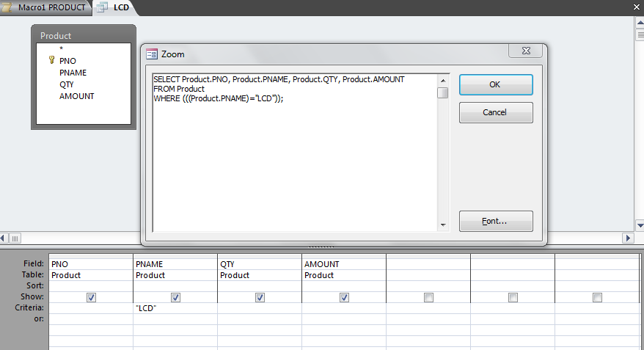
(ii) Creating Cross tab queries: It is an analytical tool which creates to describe one numerical quantity in terms of two other fields. Cross tab queries are useful to summarize the information, and are somewhat similar to pivot tables in MS-excel.
- Go to create tab in ribbon >> select query wizard >> select cross tab query wizard as shown in the dialog box.
- Then select the required table (ex:-product) >> click next > the next page confirms the columns to be taken as Row heading & column heading as required (i.e., PNO, PName, Amount, Qty) >> click next > next dialog box specifies the values that should appear on the intersection of rows & columns. select the field & functions as required (ex: QTY as field, function: Sum)
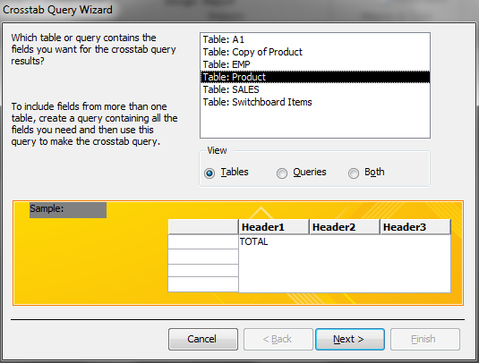
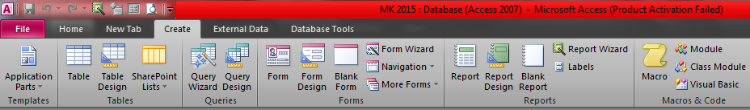

The result of the query appears in datasheet form as shown in the fig,

(iii) Creating Unmatched and duplicate Queries:
Unmatched Queries:
It will examine the data found in two different tables/queries and compare the records based on a common field. It will return the records from the first table which do not have matching values in second table.
- Go to create tab in ribbon >> select query wizard >> select Find Unmatched Query Wizard as shown in the dialog box.
- Then select the required table (ex:-product) >> click next > select the required compare table (ex:- sales) >> click on button < = > which we need to mark the common field in the both the tables to be compared >> click next
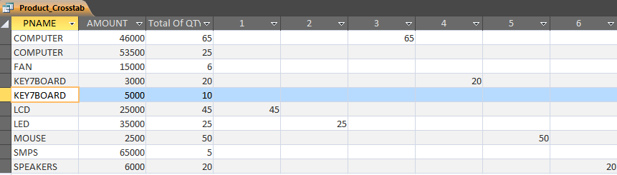
- Select the Fields which are available fields into selected fields by clicking on the button = > (ex: PNO, PName, QTY, AMOUNT) >> click next & name the query wizard.
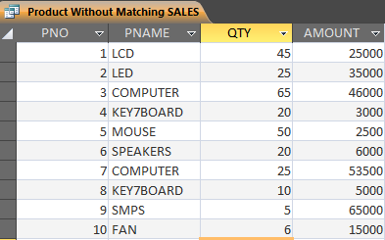
The result of the query appears in datasheet form as shown in the fig,
Duplicate Queries:
It creates a query that reports which records in a table are duplicated by matching one or more fields in the table. The Query wizard first confirms which fields have to be used to check fir duplication and then prompts to enter some other fields that may be a part of query result.
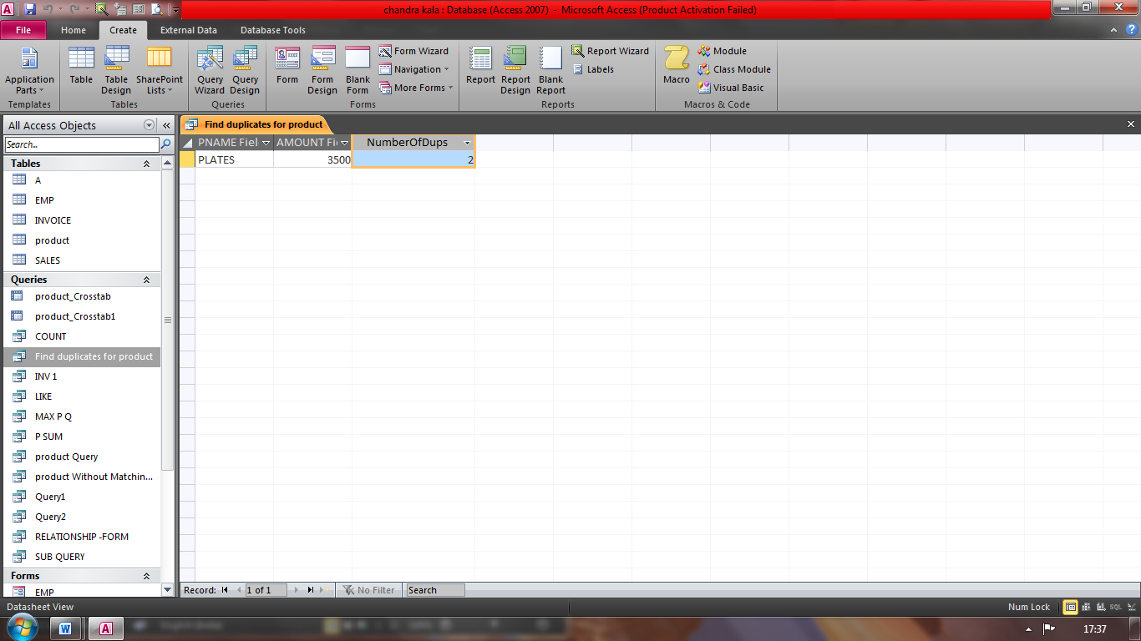
(iv) CREATING PIVOT TABLE AND PIVOT CHART:
Pivot Table:
A pivot table is a view in access queries that allows summarising and examining data in a datasheet form. It is used to group values as rows and columns with a calculated value at the intersection of each row and column. A Pivot table is created by dragging fields to the appropriate area on the design screen. Data can also be broken down to different levels of detail, such as showing by year, quarter or month.
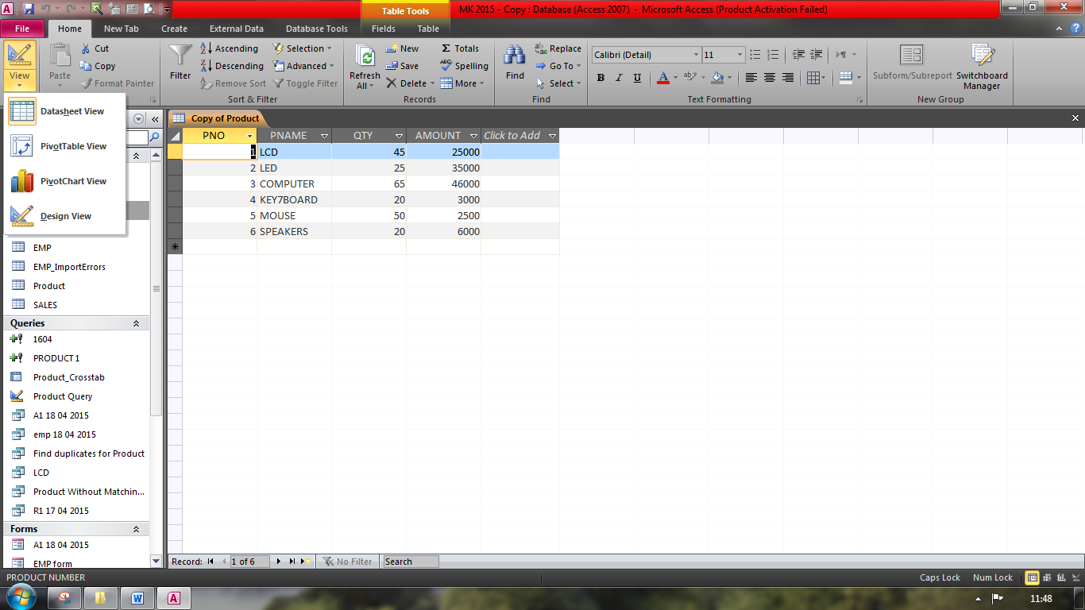
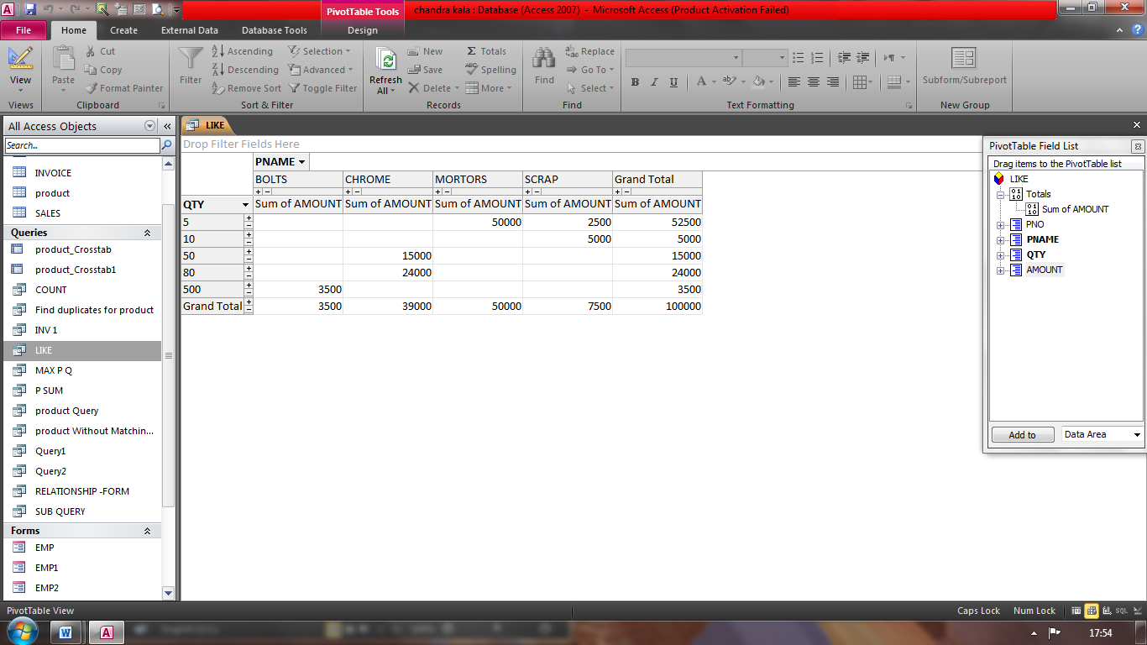
Pivot chart:
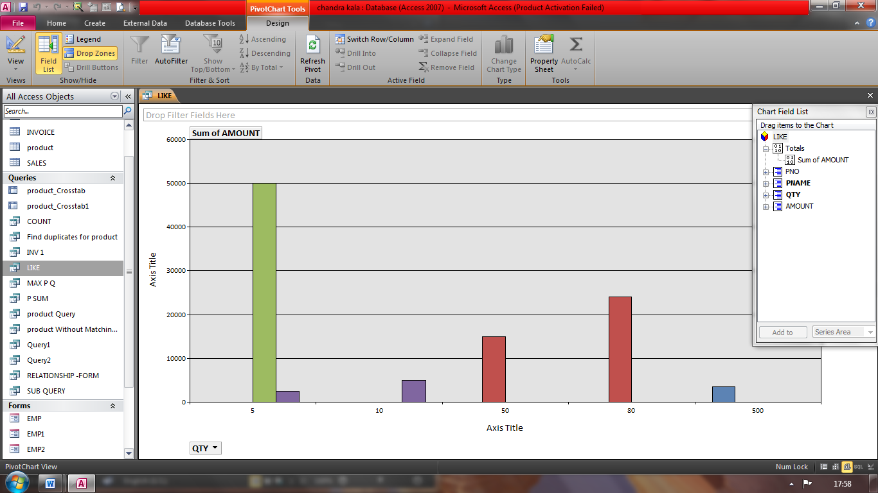
A Pivot chart is a tool used for graphical analysis of data. In simple terms, Pivot chart helps visualise a pivot table, query or a form. Data can be presented by using different chart formats as required, and unwanted items can be hidden from being viewed.

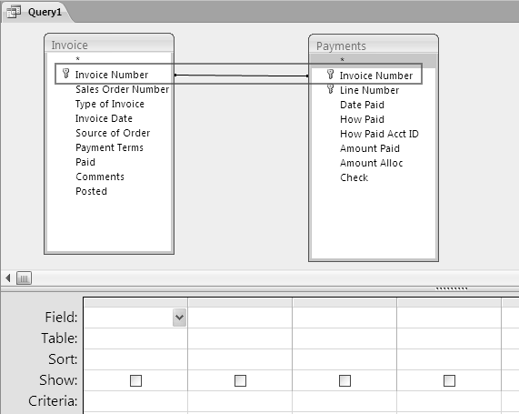

DESIGNING FORMS & REPORTS
Advanced Form Design: - Effective Use of Form
- Adding Unbound Controls (1).Displaying a calendar control
- Adding Graphics (2).DisplayingaSummaryofDatainaForm
- Adding Calculated values (3).Organisinginformationwithtabpages
- Adding combo boxes
Controls
- Ingeneral,allthecontrolsareboundedtoonefieldofthetableor querytheformisbasedon.
- However,therearefewcontrolswhichretaintheenteredvalue,butarenotlinked with anytablefields.
- These controls can be used for text label display, for controls such as lines and rectangles,orforholdingunboundOLEobjects(suchasbitmappicturesorlogo)thatarenotstoredinatable, butintheformitself.

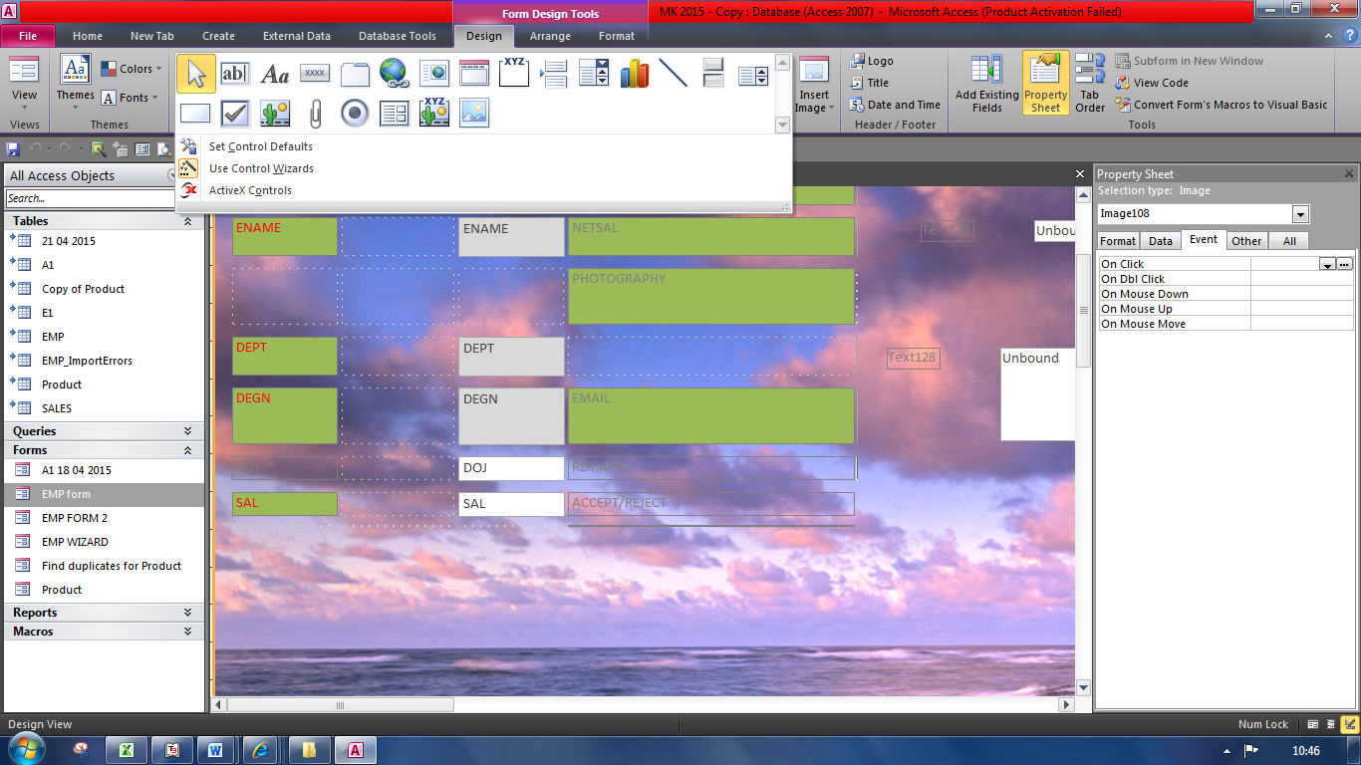
- Unboundcontrolsare also knownasvariables ormemoryvariables.
- Right-click the form frmOrders under All Access Objects ->Forms tab. Select Design View from the dropdowntoopenthetableinDesignView,
- ClickOKtoclosethewindow anddrawthecontrolontheFormHeaderportion ontheform.
- Adding graphics
- Attractive formsarealwaysavaluableaddition.Access2010makesiteasytoaddagraphictothebackground ofaform, such asa“watermark” whichappear onexpensive bondpaper.
- Thepicturecan containacompany logo,text, oranyother graphicelement. Thepictureisspecifiedbythe form’spictureproperty and canbe embedded intheformorlinked toanexternalfile.
- Ifthepictureislinked,thegraphicdisplayedontheform changesanytime theexternalfileisedited.
- Thegraphiccan beinsertedintotheforminthefollowingways:
  - Importagraphicfile(clipart,gif,jpeg,bmp,etc.)directlyintothe form.
  - Attachalink to the graphicthatopensawebsiteorotherdatabase object.
  - Associatethegraphicwith anexistingmacrointhe database.
- Steps:-
- Right-click the form frmOrders under All Access Objects ->Forms tab. Select Design Viewfromthedropdown toopenthe table inDesignView.
- SelecttheinsertimagebuttonfromDesignribbon->ControlstabanddragittocovertheDetailssectionof theform.
- TheInsertPicturewindowappears.BrowseforthepicturetobeinsertedandclickOKtoclosethewindow.

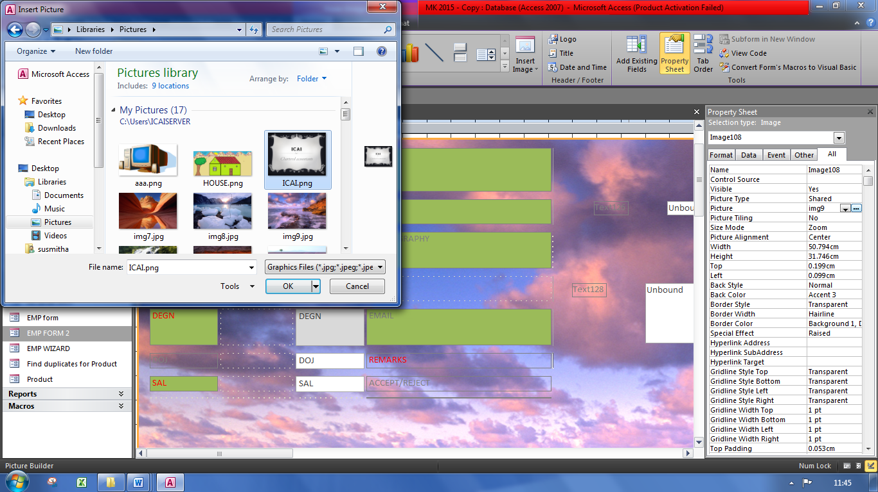
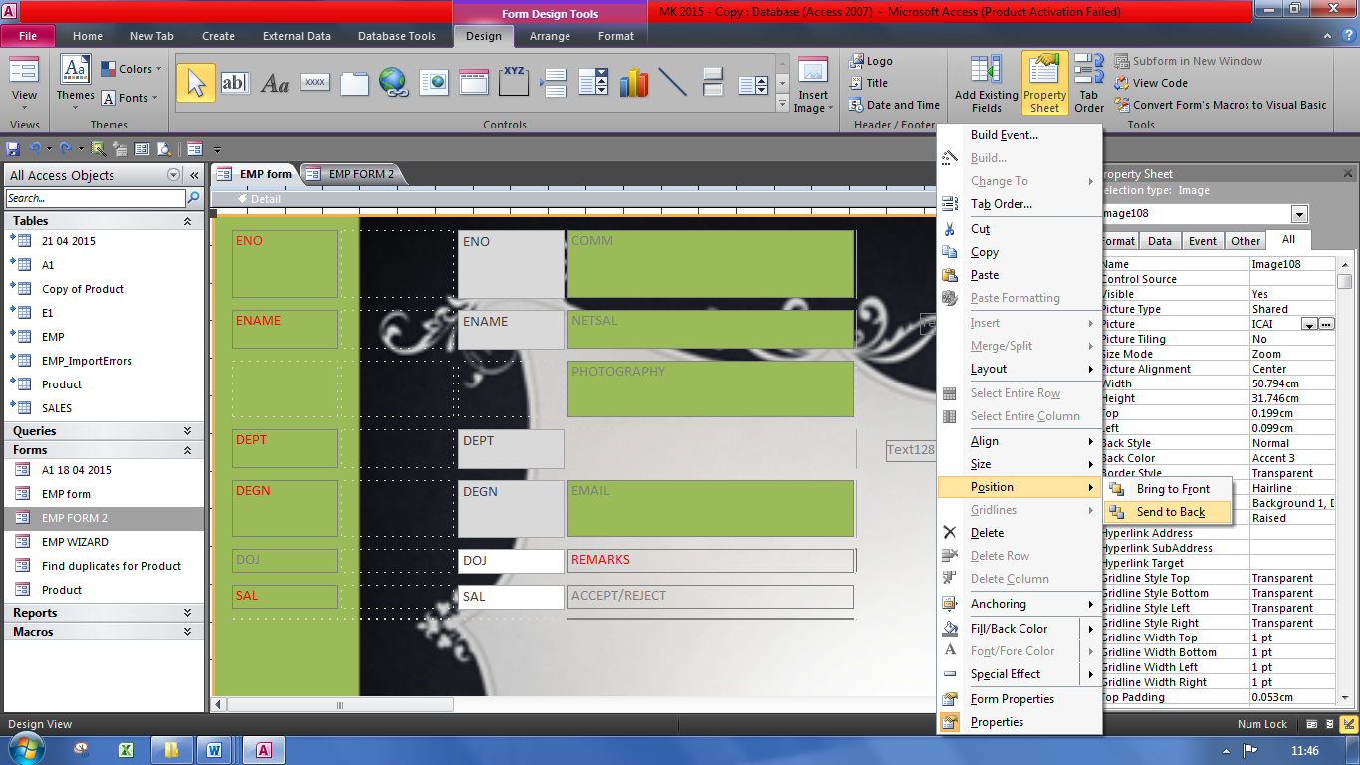
- Thepictureisrequiredtomovetothebackofcontrols.Right-click thepictureandselectPosition->Sendto backfromthedropdown,asindicated

- The final the formappears:
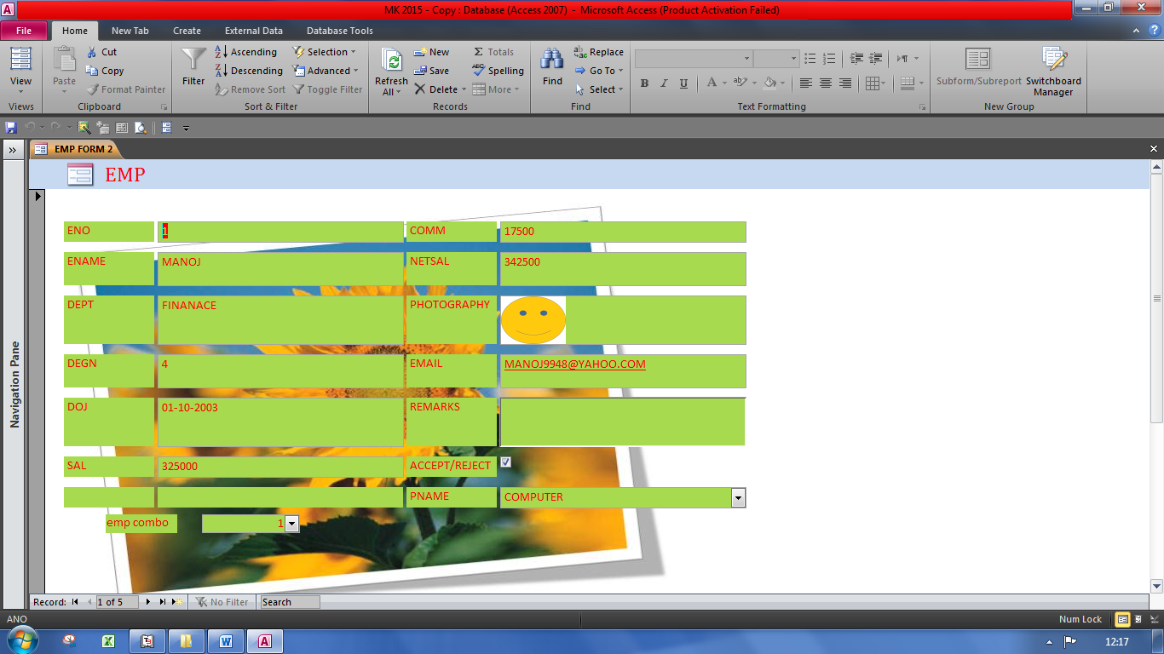

- Adding combo Boxes:-
- ComboboxesinAccess2010provideawayofselecting avaluefromalist.
- A comboboxis a compact methodof presenting alistofchoicesandallowsuser toenteravaluethatisnotinthelist.
- Thevaluesinacomboboxaredisplayedbyclickingthearrowattheend.Incomboboxvalues canbeselected byclickingitorbytypingthefirstfewcharactersofthevalueintothetextboxareaofthecombobox
- Steps:-
- Right-clicktheformandselectDesignViewfromthedropdowntoopentheforminDesignView.
- SelecttheComboBoxcontrolfromDesignribbon->Controlstabanddrawit
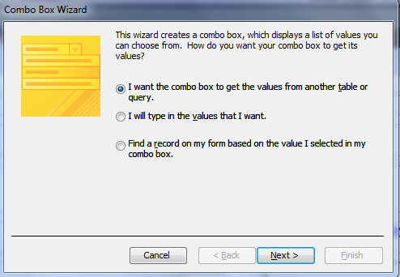

- Selectthefirstoption i.e.Iwantthe combobox tolookup the valuesinatableorqueryandclickNext.
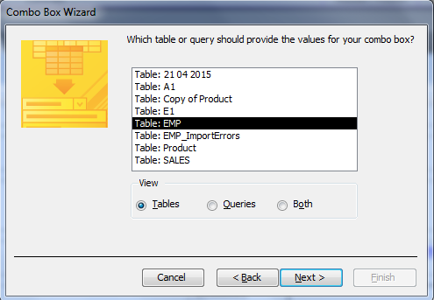
- IntheSelectTableorQuerywindow,selectthetableoptionfromViewtabandchoosetable
- IntheSelectFieldwindow,selectfieldCustomerNumberfromAvailablefieldandclickonsigntoputitintoselectedfields. Similarly,addFirstNameandLastNametoselectedfield.
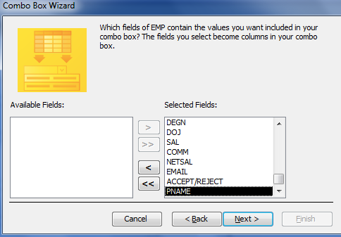

- ClickNexttocontinue.IntheSortOrderwindowselect
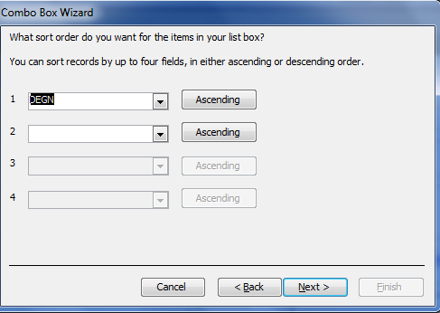

- IntheHideKeyColumnwindow,unchecktheHideKeyColumncheckbox,Click next proceed
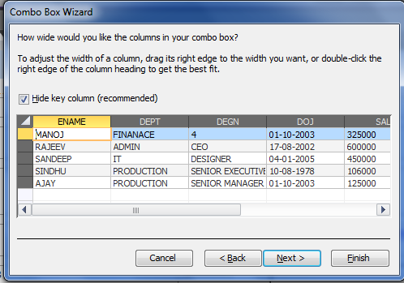

- Thenextwindowconfirmsauniquevaluetobestoredintable.SelectCustomerNumberandclickNext,as indicated
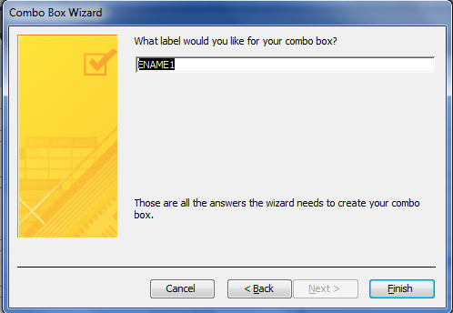

- Inthenextwindowthatappears,selecttheoptionStorethevalueinthisfieldandselectthevalueSaletoCustomerfromthedropdown,

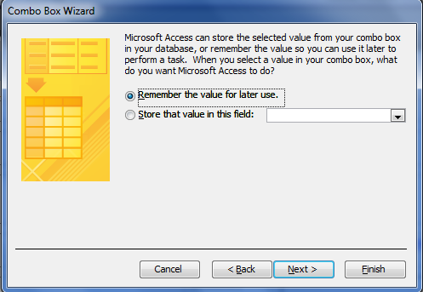

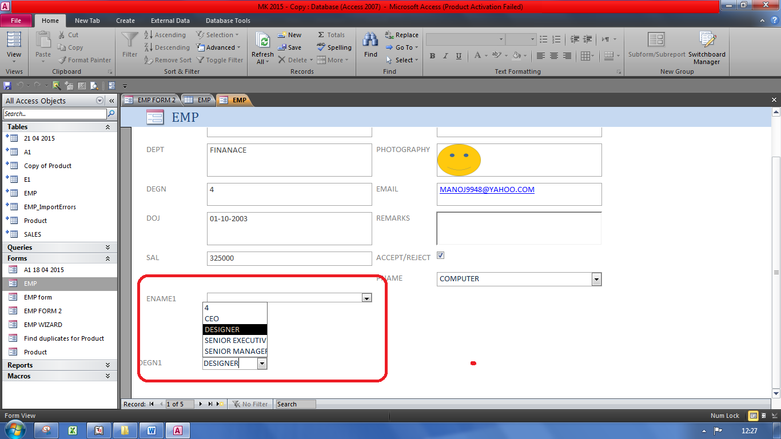
- Finally it appears

DATA PAGES AND PROTECTION

Hyperlink Fields:-
- MicrosoftAccessprovides Hyperlink data typetocreateaclickablelinktoaWebpage,file,oremailaddress.
- A HyperlinkcanbeaUNC(universalnamingconvention:\\server\share\path\filename)pathoraURL (Uniform ResourceLocator:http://www.microsoft.com/.).Itcanstore upto2048characters.
- The Hyperlinkdata type field holds combinations of text and numbers stored as text and used as a Hyperlink address.
- Itcanhave uptothree parts:
- The textthatappearsinafield.
- Thedestinationyougotowhenyouclick thecell(theURLorfilepath)
- Anysub-addresswithinthefileorpage.Eachpartisseparatedbythehashsymbol(#).Forexample, MicrosoftNetHomePagehttp://www.msn.com.
- TheHyperlinkvaluecan be insertedintwo ways:
- By typingtheURL directly
- ThroughtheInsert Hyperlinkwindow
ThereferencetoawebsiteorawebpagemaybedirectlyenteredintheHyperlinkcolumn,whileareferenceto afolderwill bemoreeasily donebytheInsertHyperlinkwindow.
Steps foraddingaHyperlinkfieldinatable:-
- Open the required table in DesignView,>>Add a new column & specify the details required (like Company; email address of employee) Details to the table >>and select the Hyperlink DataType. Savethe changesmadeto thetableandcloseit.
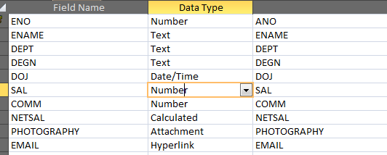
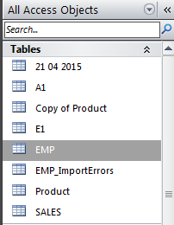

- Steps to enter data in the hyperlink field:
Open the table in datasheet view >> right click on the field and select hyperlink >> Edit Hyperlink >> and select the page to be attached as hyperlink
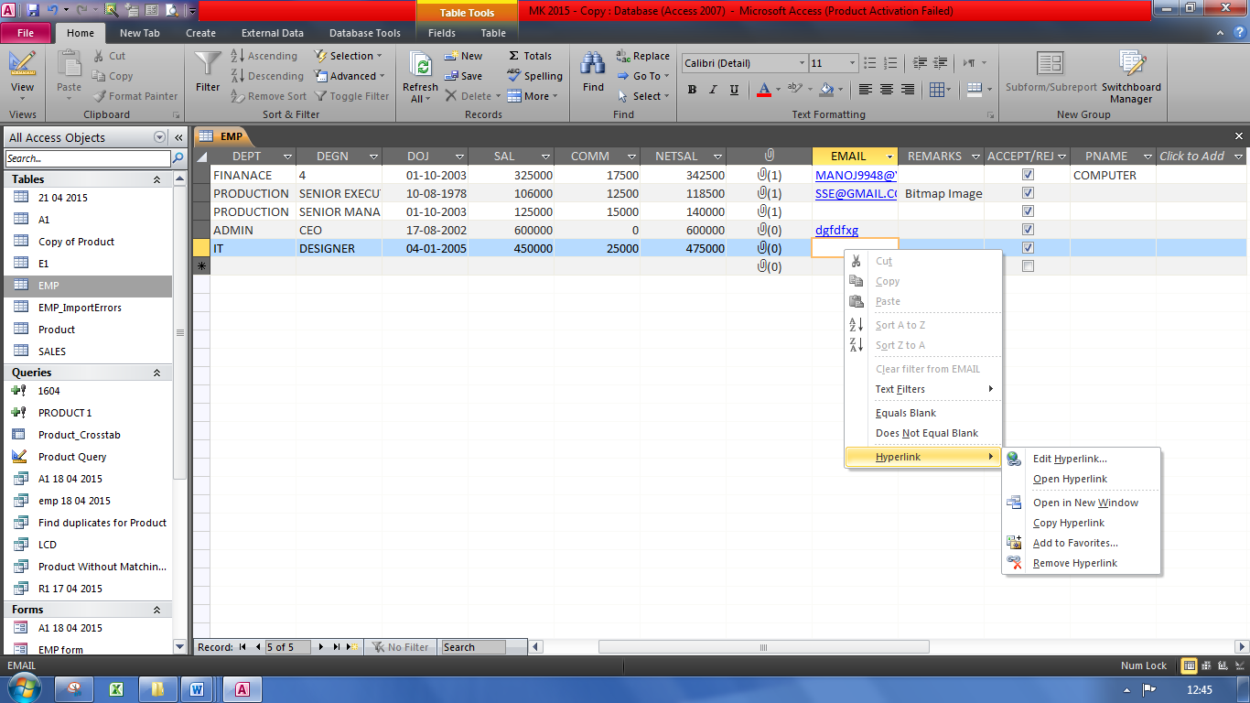

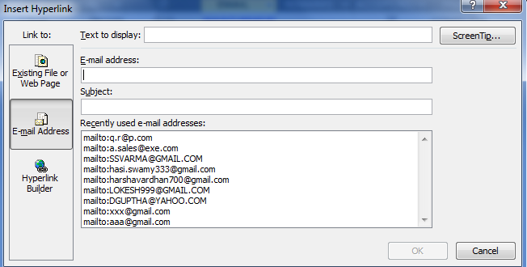
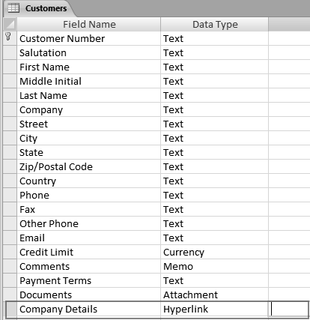

Splitting Database
- Splittingashareddatabasecanhelpimproveits performanceandreducethe chanceofdatabasefilecorruption.
- Whenan Accessdatabase issplit,itcreatestwofiles
- aback-end databaseanda
- Front-enddatabase.
- A backenddatabaseholdsallthetables and it isstoredonafileserverandacopyof the front-end isprovided toeveryuser thatneeds accesstothedatabase.
- A frontenddatabaseholdsalltheforms,queries,reports,macros, andthemodules.Thefront-end linksto the backend databasethusprovidingmulti-useraccesstothemainsetoftables.
- Whendeployed,theformsarenot sentfromthedatabasebutopenfromthefront-endlocallyandonlythedataactuallyenteredmovestothe back-end tables.Thisreducesthe datatrafficover the network.
- WhentosplitanAccessDatabase
- Torestricttheaccessofmanyuserson the tablestoavoidany changestoit
- Toreducenetworktrafficinamultiuserapplication
- Tomaintaindatabasebecausemaintenanceofdatabecomeseasierasthedataandapplicationfileare separate file
- Steps to create:-
Open the table in datasheet view >>ClickAccessDatabasefromDatabaseTools>MoveData-> AccessDatabasebutton >>ClicktheSplitDatabasebutton,>>Create the Back-endDatabasedialog box appears. Specifyaname,afiletype,andalocationfortheback-enddatabasefile>>ClicktheSplitbutton,thesplitdatabaseiscreatedandaconfirmationpromptappears
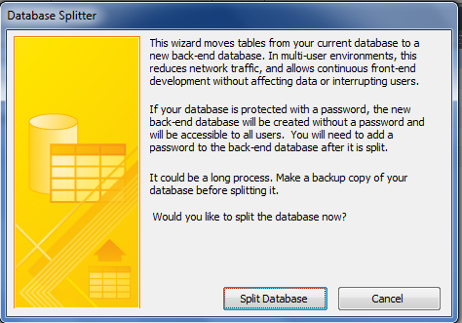

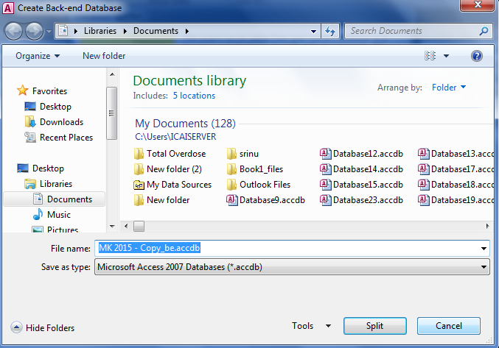

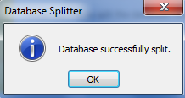

Converting an access database to an accde file:
An accde file contains complied versions of all the code in the database with none of the source code. It helps to secure database by protecting development investment by securing the design of the application’s objects and code.
Open File & click on the file tab, select save & publish, and then under save database as >> click on Access database >> and under advanced click on Make ACCDE >> click save as and save file at the required path
Benefits of .ACCDE File:
- Reduces the sizes of the database.
- Optimizes memory Usage & improves performance.
- Protects the VBA code from being viewed or edited while still allowing it to run.
- Allows users to update data and run reports without providing the entire database.

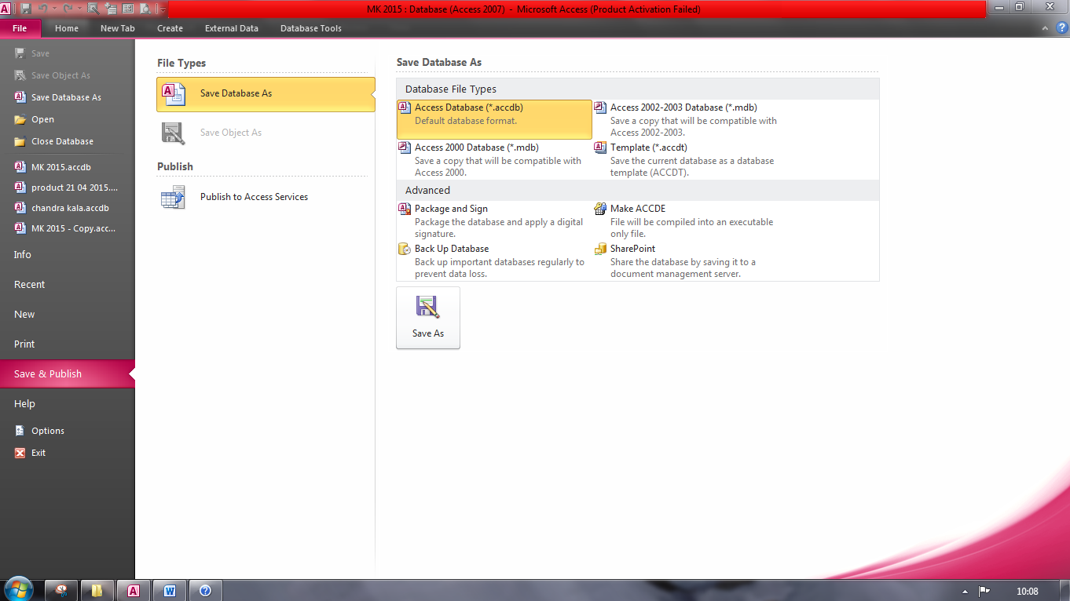

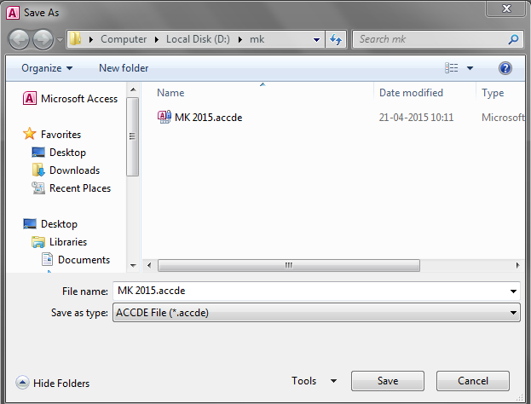

Convert Your Excel File to An XML Data File
You can convert your Excel file to an XML data file, or vice versa. This enables you to exchange data between different applications. First, turn on the Developer tab.
Here's the data we want to convert to an XML data file.
First, we will create a schema based on XML source data. The schema defines the structure of the XML file. We have to do this outside Excel.
1. For example, open Notepad and add the following lines.
<?xml version="1.0" encoding="UTF-8" standalone="yes"?>
<data-set xmlns:xsi="http://www.w3.org/2001/XMLSchema-instance">
<record>
<LastName>Smith</LastName>
<Sales>16753</Sales>
<Country>UK</Country>
<Quarter>Qtr 3</Quarter>
</record>
<record>
<LastName>Johnson</LastName>
<Sales>14808</Sales>
<Country>USA</Country>
<Quarter>Qtr 4</Quarter>
</record>
</data-set>
Note: the tags refer to the column names, but you can give them any name you want! For example, instead of LastName use Name.
2. Save the file as schema.xml.
3. Open data-set.xls.
4. On the Developer tab, open the XML Source task pane.

5. To add an XML map, click XML Maps..
The XML Maps dialog box appears.
6. Click Add...
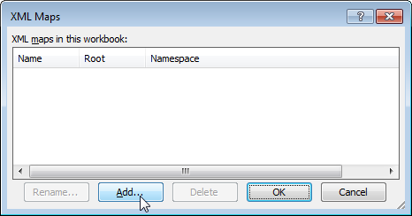
7. Select schema.xml and click OK twice.
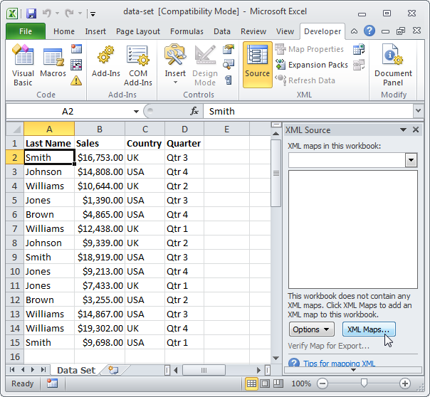
8. Now simply drag (map) the 4 elements from the tree onto the worksheet (row 1). 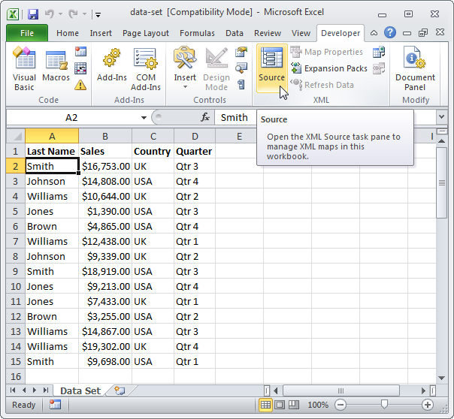
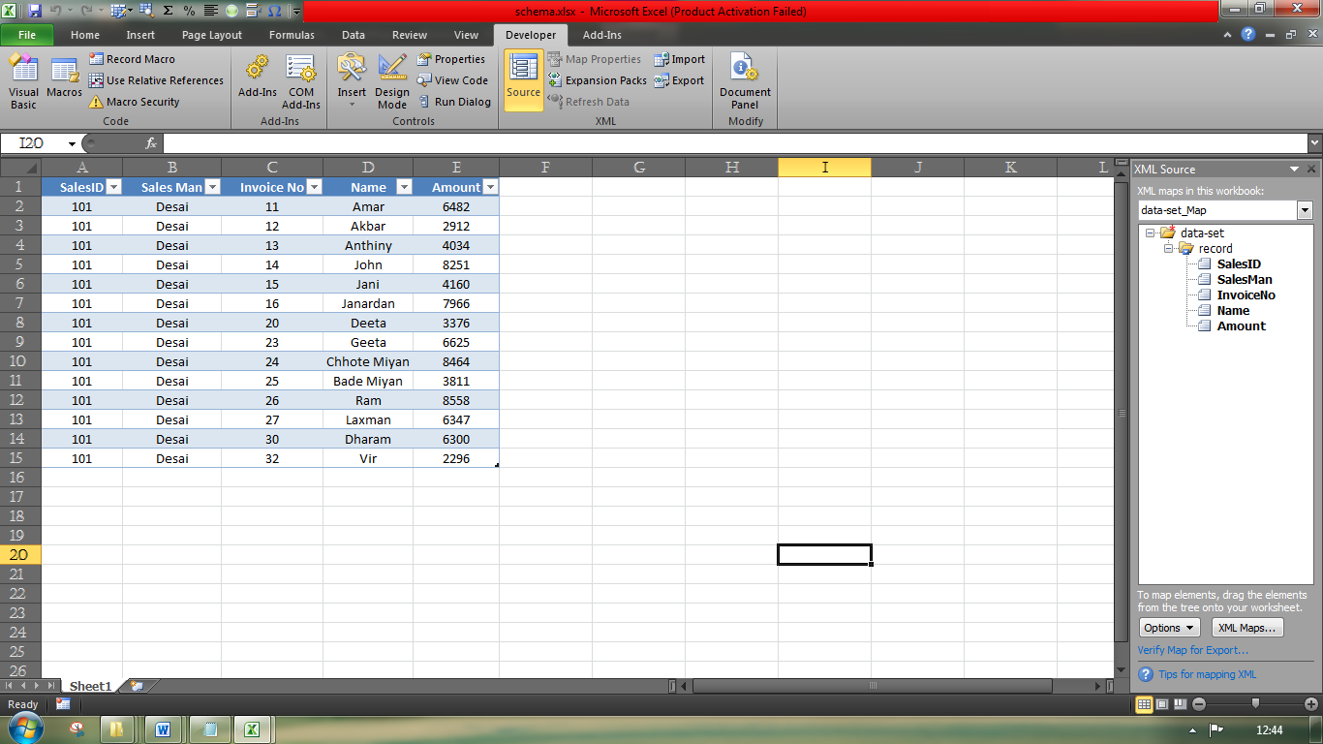
9. On the Developer tab, under the XML group, click Export.
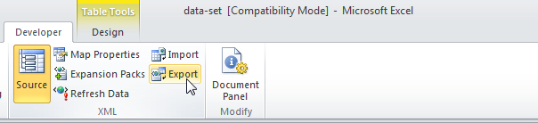
10. Save your file as data-set.xml and press Enter.
Result: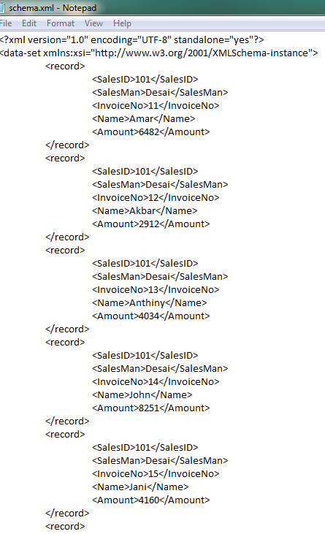

That saves quite a lot of time!
Note: to import an XML file, open a blank workbook, on the Developer tab click Import, and select the XML file.

Macro
A macro is an action or a set of actions that you can run as many times as you want. When you create a macro, you are recording your mouse clicks and keystrokes. After you create a macro, you can edit it to make minor changes to the way it works.
Make sure the Developer tab is visible on the ribbon. By default, the Developer tab is not visible, so do the following:
- Click the File tab, click Options and then click the Customize Ribbon category.
- Under Customize the Ribbon, in the Main Tabs list, click Developer, and then click OK.
Record a macro
- In the Code group on the Developer tab, click Record Macro, and then click OK to start recording.
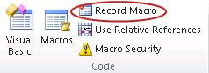
- Perform some actions in your worksheet, such as typing some text, selecting some columns or rows, or filling down some data.
- In the Code group on the Developer tab, click Stop Recording
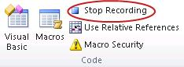

LEASING DECISIONS:

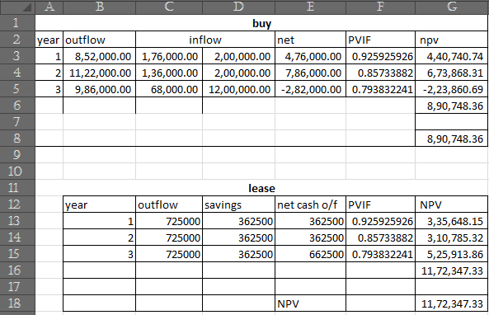

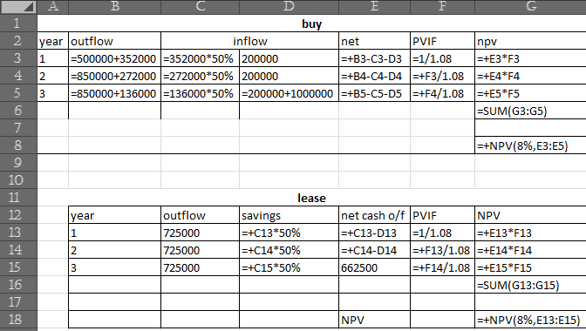

ENRON CASE:
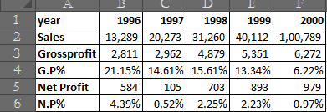
- Select Range A2:F2
- GotoInsertTab>ChartsSection>Line Chart>2DLine Chart>Firstoption

- On the Layout tab, you can also find options to add pictures, shapes, or text boxes (Insert group), and you can change the name of your chart (Properties group).
- To change the format of a specific chart element, you can right-click that chart element, and then click Format <Chart element>.
Change the formatting style of chart elements manually
- Click the chart element that you want to change or do the following to select it from a list of chart elements:
  - Click the chart.
This displays the Chart Tools, adding the Design, Layout, and Format tabs.
  - On the Format tab, in the Current Selection group, click the arrow in the Chart Elements box, and then click the chart element for which you want to change the formatting style.
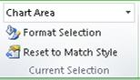
- On the Format tab, do one of the following:
  - In the Current Selection group, click Format Selection, and then in the Format <Chart element> dialog box, select the formatting options that you want.

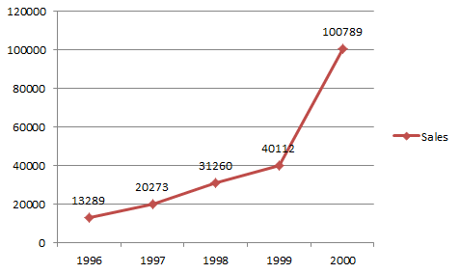

Dividend
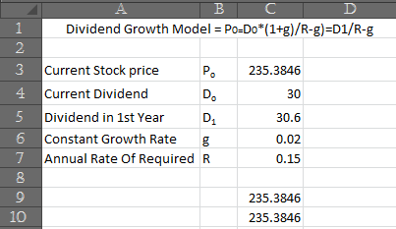
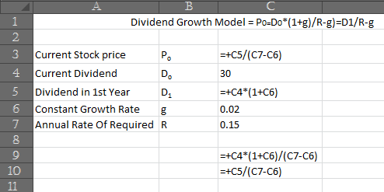
Stock Price Sensitivity Analysis- growth percentage:
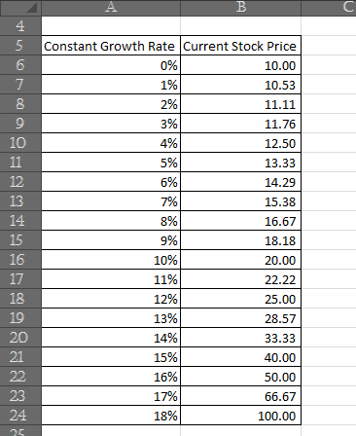
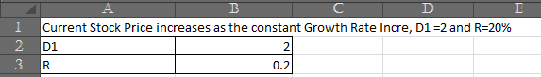

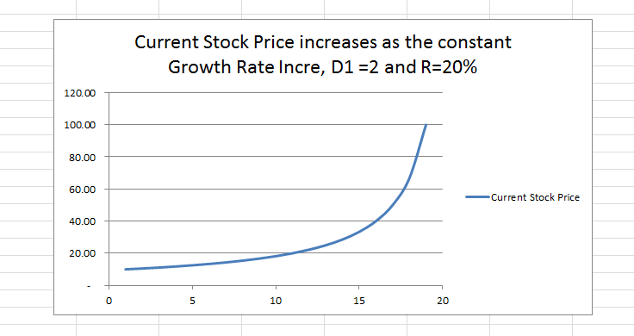

Stock Price Sensitivity Analysis-expected return:
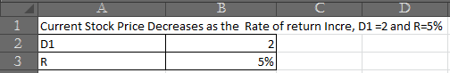
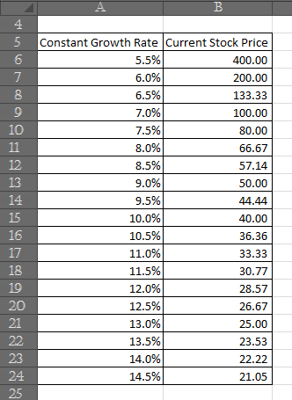

OFFICE AUTOMATION
O
ffice automation refers to the varied computer machinery and software used to digitally create, collect, store, manipulate, and relay office information needed for accomplishing basic tasks. Raw data storage, electronic transfer, and the management of electronic business information comprise the basic activities of an office automation system. Office automation helps in optimizing or automating existing office procedures. The modern history of office automation began with the typewriter and the copy machine, which mechanized previously manual tasks. Today, however, office automation is increasingly understood as a term that refers not just to the mechanization of tasks but to the conversion of information to electronic form as well. The advent of the personal computer revolutionized office automation, and today, popular operating systems and user interfaces dominate office computer systems. This revolution has been so complete, and has infiltrated so many areas of business, that almost all businesses use at least one commercial computer business application in the course of daily activity. Even the smallest companies commonly utilize computer technology to maintain financial records, inventory information, payroll records, and other pertinent business information.
The backbone of office automation is a LAN, which allows users to transfer data, mail and even voice across the network. All office functions, including dictation, typing, filing, copying, fax, Telex, microfilm and records management, telephone and telephone switchboard operations, fall into this category. Office automation was a popular term in the 1970s and 1980s as the desktop computer exploded onto the scene.

IMPORTANT ASPECTS TO BE CONSIDERED FOR OFFICE AUTOMATION

- Network Connectivity:
All Application Software used should be on the same network to enable employees in different locations to access and process data. A LAN/WAN should be setup so as to keep all the branches permanently connected and ensure speedy transmission of data. Routers should be used to connect LAN and WAN.
- Integration:
In order to achieve efficiency, office equipment and Application Software should be integrated. We should use Software Applications developed by a single manufacturer so that there will be an interface between the different applications used in the system. Else, employees will have to feed data manually which may lead to errors.
- Cost of the System:
One of the most important aspects to be considered is the cost effectiveness of the Office Automation System. The benefit should exceed the costs. Costs like up-front cost, maintenance costs, Upgradation costs, Availability of funds with the Management, etc. should be taken into account.
- Training:
A wide range of people—including software and hardware engineers, management information scientists, executives, mid-level workers, and secretaries—are just a few of the people that use office automation on a daily basis. As a result, training of personnel on these office automation systems has become an essential part of many companies' planning.After all, the office automation system is only as good as the people who make it and use it, and smart business owners and managers recognize that workplace resistance to these systems can dramatically lessen their benefits
- Security:
There are many possible threats to the information being stored by an Office Automation System, as well as to the system itself. The system may be stolen or destroyed. Information stored on the system may be compromised; that is, it may be exposed to a user or process that does not have proper authorization to see it. Information may also be corrupted or destroyed altogether by a malicious user. Another threat might be the interference with the system's ability to process information correctly. A security control is a step that is taken in an attempt to reduce the probability of exploitation of vulnerability.

- Automation of all/ Key Services:
Most of the business processes today are automated to various degrees and businesses continue to invest in maintaining and expanding this automation through the acquisition of computer and telecommunication technologies and various enterprise systems such as Enterprise Resource Planning (ERP), Supply Chain Management (SCM), Partnership Relationship Management (PRM), Customer Relationship Management (CRM), Data Mining etc. Such automation of business processes has led to compulsory changes in Auditing procedures, standards and Processes.

- Access Rights:
Access Rights refers to the practice of restricting entrance to a data. To includes Authorization, Authentication and Access Approval. It determines who should be given access to the different types of data on the basis of their need.

PROCESSES THAT ARE TO BE AUTOMATED

There are a variety of Processes right from a client entering helpdesk till the audit being done for the client that can be automated in an office.
- First and foremost when a client enters our helpdesk, he will be given a form containing various details to be filled in. His details are collected and entered in the central database which resides in the server and he will be registered as a client. So all the basic or contact details of our clients get updated and can be used whenever needed.
- A LAN Configuration must be given in each and every branch office so that all the client computers are inter-connected together. But LAN Configuration is suitable in case of a smaller geographical area.
- A Client-Server model can be incorporated in case of large organizations where a central server resides at the head office. All the client computers at various branches are connected to the central server through the Wide Area network (WAN). Various Software applications used in a CA firm are installed and upgraded in the central server. A Centralized Database is maintained at the server where all the data including Clients basic details, working paper files, any documentary evidences, client files and folders, details of the firm etc. gets updated. This is called Client-server architecture. This scenario is similar to a Core-Banking or Core-Insurance solutions.

- The Firm can create its own web browser so as to ensure safe transmission of data by not using the public domain. Various network devices like Routers, Hubs, Switches, Fire walls can be placed at appropriate places in the network to ensure network integrity.

- The Employee records are centralized where the application itself calculates the salary and deducts the taxes at applicable rates. Other deductions are indicated in the Employee masters.
- Salary pay-slips are auto-generated and updated in our books of accounts enabling easy remittance to employees.
- Large Businesses use large database for payroll and work orders. They keep track of employees’ working hours and their corresponding benefits. For example if staff works overtime, it gets updated and the incentive gets calculated automatically.
- Engagement Teams working in multiple locations can view the audit plan and program, progress of audit, documents gathered and critical observations online and also update the documentation from any remote location.
- Various types of Leave like sick leave, casual leave, maternity leave etc. are credited to the employees as per the leave policy of the company. This System helps the management to administer and track various benefits which the employees are entitled to like insurance, pension plan, med claim etc.
- Biometric device in the place where documents are kept. Login and log out time are noted. Segregate the files on the basis of level of confidentiality
- Back up of all Data is required to be done every week especially during the work involving due date
- All the data to be stored in a server and the server must be kept in a place which is not easily accessible. Each Person should be given required access like read access, modify access. No access for high confidential documents(Ex: Payroll details)(Ex: Pen drive)

- Present Need for Office Automation

- In the present competitive environment, Computerization is a basic need to provide better services to the clients at a minimal cost.
- Increased volume of work, scarcity of time and the slow manual processes necessitates the introduction of automation.
- Automation increases the goodwill and reputation of the firm because it adds to the prestige and status symbol of the enterprise.
- Office automation can get many tasks accomplished faster and eliminate the need for a large staff.
- To enable centralized storage and access of Data from all the branches of the firm
- To protect the data from Physical Threats and Cyber Attacks

BENEFITS OF OFFICE AUTOMATION OVER MANUAL PROCESSES

- The Staff can perform their services in an efficient and effective manner by reducing errors which are created in manual work.
- It saves a lot of time.
- Information or Documents can be electronically transmitted.
- Helps to perform calculations and handle numerical data.
- Data can be stored in an electronic/digital form.
- Self –Regulated Process (i.e.) work can be completed with minimum human efforts.
- Ensures speedy recording, processing and presenting of information. This process results in increased output.
- Multiple people can update data simultaneously in the event of changes in schedule.
- Used to aid administrative processes in an office.
- It ensures data security and integrity.
- It enhances the quality of work.

DATA SHARING AND COLLABORATIVE CAPABILITIES PROMOTED THROUGH THE USE OF CLOUD BASED DATABASE SYSTEMS:
Cloud Computing simply means the use of computing resources as a service through Internet. The Internet is commonly visualized as Clouds. Users can access database resources via the Internet from anywhere, for as long as they need. The databases in the cloud may be highly dynamic and scalable. The best example of cloud computing is Google Apps where any application can be accessed using a simple front-end interface such as a Web Browser and as a result enabling the users to access the resources from any client device including notebooks, desktops and mobile devices.
It provides the facility to access shared resources and common infrastructure offering services over the network to perform operations. Organizations who wish to get peak load capacity without incurring the higher cost of building larger data centres internally can use cloud computing.
It is the most cost efficient method to use since adding up the licensing fees for multiple users in traditional desktop software proves to be expensive. There is no need to worry about running out of storage space or increasing the current storage space availability. Since all data is stored in the cloud, backing it up and restoring the same is relatively much easier. In the cloud, software integration is usually something that occurs automatically. This convenient feature lets one move beyond time zone and geographic location issues.
The cloud computing applications are easier, because they are not to be installed on each user’s computer and can be accessed from different places. With the cloud working in a distributed and shared mode, multiple users and applications can work more efficiently with cost reductions by sharing common infrastructure.
SOFTWARE APPLICATIONS USED IN CA’S OFFICE AND THEIR BENEFITS
Considering the nature of services provided by our Firm, following software and hardware equipment are required:-
- Client Management
To gain a competitive advantage over others, it is important for a CA firm to understand and identify clients’ needs, track the responses and gain client confidence. In cases where the client is big and has multi location presence, it is difficult to manage manually without automation. It also contains details regarding History of the organization, key processes in various industries and associated risks, approach, various tools and technologies to be deployed in various assignments, contact details of employees worked on same or similar areas etc.
It helps in avoiding duplication of efforts i.e. if an employee is already in touch with a new client, other manager/ director will be able to see the details online and in his absence, and they would be able to manage the work. This application also helps the management to allocate the revenue to the credit of right employee as the application captures the person who worked on the solution.
- Resource Planning & Scheduling
Employees are the assets of any organization and hence they should be optimally utilized. Proper allocation of right persons for specific tasks depending on their skill sets leads to effective utilization. Application helps to know the time and employee allocated for each project. This Application has a great impact on the Profitability of the Firm.
- Document Management System
The computer based document management systems capture the information contained in documents, stored for future reference and make them available to the users as and when required. These systems are linked to the office automation systems such as text processors, electronic message communication systems.
There are two types of data which is available in a CA Office:
- Client Data/Documents
These are the data/documents which CA has gathered during the course of engagement. For example: Permanent Audit file and Current Audit file.
- Own data/Documents
These are the data/documents which the CA Firm has in its Database. Examples are Contact details of the client, Client and Engagement Acceptance Questionnaire, Engagement Letters with clients etc.
Working paper files and Documentary evidences can be retained in soft copy like email trail approvals, scanned copies of the documents, MS word/excel for various calculations and it is also easy, convenient and cost effective. Engagement Teams working multiple locations can view the audit plan and program, progress of audit, documents gathered and critical observations online and also update the documentation from any remote location. This application captures the complete audit trail with the details of user ID, date and time relating to any creation or modifications done to the data.

- Knowledge Management

For professional firms, Training their employees is one of the key requirements. In addition to training, there are various articles, presentations, proposals, past reports which may be kept at one common place. Employees may logon to the Knowledge management server and search for the relevant document. It is the process of capturing, developing, sharing and effectively using organizational knowledge.

- HR & Payroll Applications

This Application covers aspects such as Identification of Human Resources, Recruitment, Training and Induction, Leave Management, Time & Attendance Management and Appraisal and Performance Management, Payroll Management, etc. This Application consists of the Employee Master Data. It manages the Job Vacancies, Track Applicants and Manage Interviews and offers.

6. Billing and Accounting

The main purpose of this application is to help the management to record various transactions like Sale of services, Expenses, Bills Outstanding, Assets, Liabilities, etc and to help in Decision Making. It is considered critical from the view point of Internal Management and Statutory Reporting.

INFRASTRUCTURE REQUIREMENTS

Network Infrastructure:

Every business depends on a network infrastructure for all aspects of daily operations. One of the most important things for a company in today’s structure is engaging prospective customers through social networks. Twitter and Face book have become two staples in business advertising. Without a reliable internet network, keeping social sites updated can be frustrating. Thus we have decided to set-up a WAN for us organization as it covers a broad area using leased telecommunication lines
WANs are used to connect LANs and other types of networks together, so that users and computers in one location can communicate with users and computers in other locations.
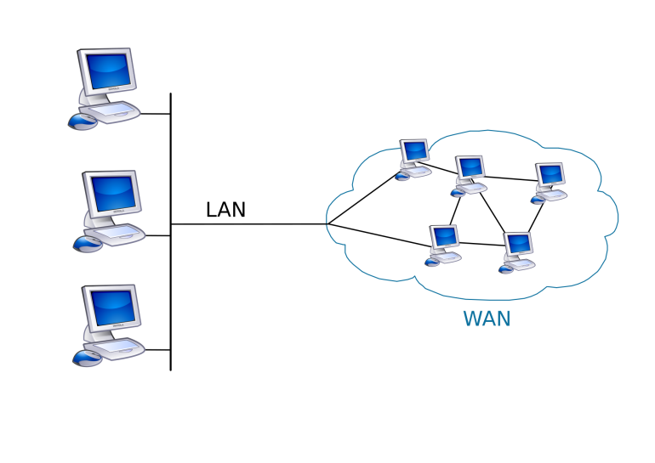

Applications provided by ICAI:
The following applications are provided by ICAI for its members:
- ICAI – XBRL Software
- Payroll
- Billing and Accounting
- K-Doc
- E-Secretary
- ICAI – ROC
- ICAI Tax Suite
ICAI – XBRL Software:
It is a solution for converting financial information of the company in XBRL format as per MCA mandate.

Purposes and Utility:
- Accurate, easy to use, import and export facility to almost all formats, Validation, XML Viewer, CIN Verification.
- Easy validation to avoid errors.
- Merging of Data from Standalone to Consolidate
- No Rekeying, Instant User Access and most efficient reports for faster information retrieval, auto calculation.
- ICAI – XBRL Software is provided at free of cost for its members for 2 financial years.
Payroll:
ICAI - Payroll is a tailor made solution for the members of ICAI. The Complete Payroll software enables the organization to record attendance, process salary, arrears, gratuity, reimbursements etc. and approval systems.
Purposes and Utility:
- Chartered Accountants can process salary not only for their firm but also for their client companies using this software.
- Enables online filing of PF and ESI Forms
- Automatic Challan and form generation
- Enables getting integrated with attendance management system like Bio-metric systems, Smart Cards etc.,
Billing and Accounting:
It is a complete package to manage the billing requirements of a CA Firm on cash/mercantile system of accounting.
Purposes and Utility:
- It facilitates generation of bills, receipts and vouchers.
- Manages the client billing activities.
- Service Tax return generation is also possible.
- It enables you to track payments and outstanding anytime live.
K-Doc:
The software is structured in such a way that it enables members have a structured file and knowledge system.

Purposes and Utility:
- Centralized management is possible as the software compels the users to save documents in secure K-Doc repository.
- Helps in the creation of systematic records of documents for easy reference and re-use.
- Data integration is possible with K-Doc.
E-Secretary:
The software is the tool kit on knowledge management solution, correspondence automation and tracking. It helps in escalating your productivity and service.

Purposes and Utility:
- Inbuilt templates are available for Email, Envelope printing etc.,
- Enables Retrieval of past correspondence
- Creates Centralized Repository of E-mails and other documents.
- Helps in archival of Mails
- Provides E-mail template management for creating and replying standard emails faster.

ICAI – ROC:
The software has been uploaded in the Committee website www.icai.org.in so that members can easily download, free of cost. The software enables the practicing members to strengthen their general and specific practices in the field of managing the compliance of MCA-21 in accordance with the Ministry of Corporate Affairs.
Purposes and Utility:
- Generates forms as per MCA 21 requirements
- Pre-drafted resolutions are available
- Facilitates auto filing of e-forms, Shares records, Annual return forms, maintenance of registers and reports etc.,

ICAI Tax Suite:
It is comprehensive software which meets the compliance requirements of Income Tax, TDS, Audit Reports, Forms manager, AIR, Service Tax and Documents management that helps the CA Firms and practitioners.
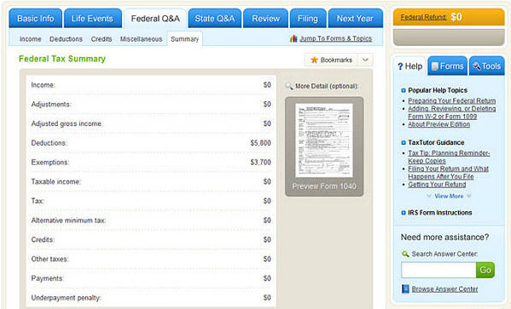

Purposes and Utility:
- Direct E-Filing facility has been provided through the software.
- Multi-purpose form generation is possible

INFORMATION SECURITY

Earlier sensitive information used to be in Hard copy format, physically secured. With the advent of digitization, and wide use of Computers and Internet, the need for information Security has increased.

Information security plays a very important role in protecting data and assets of an organization. Now -a -days, we often hear news about security incidents, such as defacement of websites, server hacking and data leakage.

Organizations need to be fully aware of the need to devote more resources to the protection of information assets and information security must become a top concern. Organizations hold sensitive information like Employee salary details, Employees Bank Account Details, Credit card Details, etc.
To address the situation, a number of organizations have set up benchmarks, standards and in some cases, legal regulations on information security to help ensure an adequate level of security is maintained, resources are used in the right way, and the best security practices are adopted.

Which Information Assets need to be secured?

- Client Data and Documents
- Own Data and Documents

GOALS OF INFORMATION SECURITY
Three primary goals of Network Security are
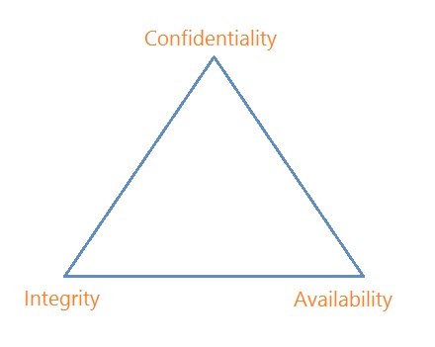
Confidentiality: The first goal of Network Security is "Confidentiality". The function of "Confidentiality" is in protecting precious business data (in storage or in motion) from unauthorized persons. Confidentiality as part of Network Security makes sure that the data is available ONLY to intended and authorized persons. Access to business data should be only for those individuals who are permitted to use that data.

Integrity: The second goal of Network Security is "Integrity". Integrity aims at maintaining and assuring the accuracy and consistency of data. Its function is to make sure that the data is accurate and reliable and is not changed by unauthorized persons or hackers. The data received by the recipient must be exactly same as the data sent from the sender, without change in even single bit of data.

Availability: The third goal of network security is "Availability". The function of "Availability" in Network Security is to make sure that the Data, Network Resources or Network Services are continuously available to the legitimate users, whenever they require it.


Apart from the above, Authentication and Non-Repudiation also form part of Goals of Information security.
Authentication:
It is a security measure designed to establish the users ID and ensures that the users are who they say they are. The computer system should be able to identify the user making the request through User ID and Password. It determines who should be given access to the different types of data on the basis of their need.
Non-Repudiation:
Non-Repudiation in general refers to not denying something. It provides proof of the integrity and origin of data. It ensures Accountability. Example, for computer accounts, the individual owner of accounts must not allow the others use his account by giving the password and later deny such usage.
Information Security Policy:
An Information Security Policy is the statement of intent by the management about how to protect a company’s information assets. It is a formal statement of the rules, which give access to people to an organization’s technology and information assets, and which they must abide.
Standards specify technologies and methodologies to be used to secure systems. Guidelines help in smooth implementation of information security policy. Procedures are more detailed steps to be followed to accomplish particular security related tasks.
An Information Security policy addresses many issues such as confidentiality, integrity and availability concerns, who may access what information and in what manner, basis on which access decision is made, maximized sharing versus least privilege, separation of duties, who controls and who owns the information, and authority issues.

Access Controls:
- Physical Access Controls

These are the controls relating to physical security of the tangible IS resources and intangible resources stored on tangible media. The number of physical access /entry points at facilities that store material data should be commensurate with the safety aspects and work functions at the site. Access points should have physical security controls such as Security doors, shutters or grills. Controls may be enhanced by Intrusion Detection Systems (IDS), closed-circuit television systems (CCTVs) or guard services. Access to Information systems resources must always be provided only on a need-to-know basis. Authentication controls such as card plus personal identification number (PIN).

- Logical Access Controls:
These are the controls relating to logical access to information resources such as operating systems controls, application software boundary controls, networking controls, access to database objects, encryption controls etc. Logical access controls are implemented to ensure that access to systems, data and programs is restricted to authorized users so as to safeguard information against unauthorized use, disclosure or modification, damage or loss.
The key factors considered in designing logical access controls include confidentiality and privacy requirements, authorization, authentication and incident handling, reporting and follow-up, virus prevention and detection, firewalls , centralized security administration, user training and tools for monitoring compliance, intrusion testing and reporting.

INFORMATION SECURITY RISKS, THREATS, ATTACKS AND VULNERABILITIES
A Threat is a person, thing, prevent that can exploit a vulnerability of the system. Examples of threats include a maintenance man who wants information to sell, a wire tapper, or a business competitor.
Vulnerability is an area in which an attack, if made, is likely to be successful. Examples of vulnerabilities include lack of identification and authentication schemes, lack of physical access controls, and lack of communications security controls.
If a threat and vulnerability coincide, then a penetrator can cause a violation of the system's security policy. For example, suppose that there is a maintenance person (the threat) who is secretly working for an unscrupulous contractor. In addition, there is vulnerability in that lack of physical access controls allows maintenance personnel to work on the Office Automation System without supervision.
In this case, information may be corrupted, causing a disruption in the normal work routine. A security control is a step that is taken in an attempt to reduce the probability of exploitation of vulnerability. This control may take one of many forms: an operational procedure, a hardware/software security feature, the use of encryption, or several others.
There are many possible threats to the information being stored by an Office Automation System, as well as to the system itself. The system may be stolen or destroyed. Information stored on the system may be compromised; that is, it may be exposed to a user or process that does not have proper authorization to see it. Information may also be corrupted or destroyed altogether by a malicious user. Another threat might be the interference with the system's ability to process information correctly.

1.1 The all-encompassing Electronic data

A great blessing in ancient times was: “May you live in exciting times”. Indeed, we are living in exciting times without even being aware of it. We are experiencing how technology innovations are making our life and living simpler by bridging global boundaries and bringing global information on our finger tips. For enterprises as well as professionals, the question is no longer what technology can do for us but what we can do with technology. The question “do I need to use technology” is no longer relevant instead the relevant decision is about “how do I use technology to remain relevant”. Information technology is all pervasive and more so as the government and regulatory agencies also are using technology platform to provide services to citizens and compelling information to be filed in electronic form. The government at all levels has drawn up ambitious plans to implement e-Governance initiatives to improve speed, access and transparency of services. The Information Technology (IT) Act 2000 with IT Amendment Act 2008 and IT rules 2011 provide the regulatory framework and mechanism for recognizing electronic records and electronic transactions thereby facilitating ecommerce and also identifying cybercrimes and providing penalties and compensation for them. Hence, we can expect IT usage to only keep growing in the near future impacting all areas of life more so in our work as professionals.

1.2 Auditors and CAATs

As auditors, we come across computers and communication technology as the most common denominator among our clients, both large and small. Further, we use computers and communication technology for providing services to our clients. In today’s complex and rapidly changing technology environment, it is important to master the right techniques which could be used across enterprises and across various technology platforms. Typical of a IT environment are the speed of processing, large capacity of storage, lack of the paper based trails, the radically different way of information processing, the ease of information access, internal controls being imbedded and the ever-present risk of failure of IT and loss of data. All these factors make it imperative for auditors to harness power of technology to audit technology environment by taking into consideration the risks, benefits and advantages. CAATs empower Auditors with the key survival techniques which effective used in any IT environment. CAATs are not specialist tools designed for use by specialist IT auditors but these are common techniques which can be easily mastered to audit in a computerized environment for statutory audit, tax audit and internal audit as also for providing consulting services.

1.3 Auditors and CAATs

CAATs are tools for drawing inferences and gathering relevant and reliable evidence as per requirements of the assignment. CAATs provide direct access to electronic information and empower auditors not only to perform their existing audits more efficiently and effectively but also facilitate them in knowing how to create and execute new type of IT related audit assignments. CAATs provide a mechanism to gain access and to analyze data as per audit objective and report the audit findings with greater emphasis on the reliability of electronic
information maintained in the computer system. There is higher reliability on the audit process as the source of
the information used provides and greater assurance on audit findings and opinion. CAATs are available in specific general audit software designed for this purpose but the techniques of CAATs can be applied even by using commonly used software such as MS Excel and by using query/reporting features of commonly used application software. CAATs can be used to perform routine functions or activities which can be done using computers, allowing the auditors to spend more time on analysis and reporting. A good understanding of CAATs and know where and when to apply them is the key to success. ICAI has published a guidance note on CAAT and publication titled: “Data Analysis for Auditors” which may be referred for more details.

1.4 Need for CAATs

In a diverse digital world of clients’ enterprises, the greatest challenges for an Auditor is to use technology to access, analyze and audit this maze of electronic data. CAATs enable auditors to move from the era of ticks of using pencil or pen to the era of clicks by using a mouse. CAATs will help auditors to change focus from time- consuming manual audit procedures to intelligent analysis of data so as to provide better assurance to clients and also mange audit risks. Some of the key reasons for using CAATs are:
1. Absence of input documents or lack of a visible paper trail may require the use of CAATs in the application of compliance and substantive procedures.

2. Need for obtaining sufficient, relevant and useful evidence from the IT applications or database as per audit objectives.

3. Ensuring audit findings and conclusions are supported by appropriate analysis and interpretation of the evidence

4. Need to access information from systems having different hardware and software environments, different data structure, record formats, processing functions in a commonly usable format.

5. Need to increased audit quality and comply with auditing standards.

6. Need to identify materiality, risk and significance in an IT environment.

7. Improving the efficiency and effectiveness of the audit process.

8. Ensuring better audit planning and management of audit resources.

1.5 Obtaining audit data

In most cases where CAATs are used, it becomes necessary to obtain copy of data in their original format for independent analysis. The data has to be obtained in commonly accepted format. It is important to understand the format in which the data is stored in the application which is being audited. If the data is a native format which is not readable by audit software, then it is necessary to use the reporting feature of application software and export this data to commonly recognizable format of audit software. For example, auditor may not be aware of the data structure/tables of a software developed through a vendor by the client. In such case, auditor may have to study the reporting features and use the export feature to get the data in the required format. It is very important to educate the client about the need to obtain copy of the data as required for audit. Based on the audit scope and relevant audit environment, auditor may have to finalize the required approach for getting the data for audit. This may include installing audit software on client system or using the application software for audit as feasible.

1.6 Key steps for obtaining data

1. Discuss with client about the requirement of raw data for audit and issue a request letter for getting the requested data in specified form as per the audit objectives.

2. Discuss with the IT personnel responsible for maintain data/application software and obtain copies of record layout and definitions of all fields and ensure that you have an overall understanding of the data. The record layout should describe each field and provide information about the starting and ending positions and the data type (numeric, alphanumeric, character, etc.).

3. Print sample list of the first 100 records in the data file and compare this to a printout of the obtained data to confirm they are correct.
4. Verify data for completeness and accuracy by checking the field types and formats, such as identifying all records with an invalid date in a date field.

5. Obtain control totals of all the key data and compare with totals from the raw data to ensure all records have been properly obtained. This can be performed by importing the data in audit software and reviewing the statistics of all the key fields.

1.7 Key capabilities of CAATs

CAATs refer to using computer for auditing data as per audit objectives. This requires understanding of the IT environment and most critically the core applications and the relevant database and database structure. CAATs could be used by using the relevant functionalities available in general audit software, spreadsheet software or the business application software. However, broadly the key capabilities of CAATs could be categorized as follows:

1. File access: This refers to the capability of reading of different record formats and file structures. These include common formats of data such as database, text formats, excel files. This is generally done using the import/ODBC function.

2. File reorganization: This refers to the features of indexing, sorting, merging, linking with other identified files. These functions provide auditor with an instant view of the data from different perspectives.

3. Data selection: This involves using of global filter conditions to select required data based on specified criteria.

4. Statistical functions: This refers to the features of sampling, stratification and frequency analysis.
These functions enable intelligent analysis of data.

5. Arithmetical functions: This refers to the functions involving use of arithmetic operators. These functions enable performing re-computations and re-performance of results.

Precautions in using CAATs

CAATs have distinct advantages for Auditors and enable them to perform various types of tests. However, it is important to ensure that adequate precautions are in taken in using them. Some of the important precautions to be taken by Auditors are:

1. Identify correctly data to be audited

2. Collect the relevant and correct data files
3.Identify all the important fields that need to be accessed from the system

4.State in advance the format the data can be downloaded and define the fields correctly

5.Ensure the data represent the audit universe correctly and completely.

6.Ensure the data analysis is relevant and complete.

7.Perform substantive testing as required.

8.Information provided by CAATs could be only indicators of problems as relevant and perform detailed testing as required.

1.8 Step by step methodology for using CAATs

CAATs are very critical tools for Auditors. Hence, it is important to formulate appropriate strategies to ensure their effective use. Some of the key strategies for using CAATs are:

1. Identify the scope and objectives of the audit. Based on this, auditor can decided about the need and the extent to which CAAT could be used.

2. Identify the critical data which is being audited as per audit scope and objectives.

3. Identify the sources of data from the enterprise information system/application software. These could be relating to general ledger, inventory, payroll, sundry debtors, sundry creditors.

4. Identify the relevant personnel responsible for the data and information system. These personnel could be from the IT department, vendors, managers, etc.

5. Obtain and review documents relating to data/information systems. This should provide information about data types/data structures and data flow of the system.

6. Understand the software by having a walk-through right from user creation, grant of user access, configuration settings, data entry, query and reporting features.

7. Decide what techniques of CAATs could be used as relevant to the environment by using relevant CAATsoftware as required.

8. Prepare a detailed plan for analyzing the data. This includes all the above steps.

9. Perform relevant tests on audit data as required and prepare audit findings which will be used for forming audit report/opinion as required.

1.9 Examples of Tests performed using CAATs

CAATs can be used for compliance or substantive tests. As per the audit plan, compliance tests are performed first as per risk assessment and based on the results of the compliance tests; detailed compliance tests could be performed. Some examples of tests which can be performed using CAATs are given below:

1. Identify exceptions: Identify exceptional transactions based on set criteria. For example, cash transactions above Rs. 20,000.

2. Analysis of Controls: Identify whether controls as set have been working as prescribed. For example, transactions are entered as per authorised limits for specified users.

3. Identify errors: Identify data, which is inconsistent or erroneous. For e.g.: account number which is not numeric.

4. Statistical sampling: Perform various types of statistical analysis to identify samples as required.

5. Detect frauds: Identify potential areas of fraud. For example, transactions entered on week-days or purchases from vendors who are not approved.
6. Verify calculations: Re-perform various computations in audit software to confirm the results from application software confirm with the audit software. For e.g.: TDS rate applied as per criteria.

7. Existence of records: Identify fields, which have null values. For example: invoices which do not have vendor name.

8. Data completeness: Identify whether all fields have valid data. For example: null values in any key field such as date, invoice number or value or name.

9. Data consistency: Identify data, which are not consistent with the regular format. For example: invoices which are not in the required sequence.

10. Duplicate payments: Establish relationship between two or more tables as required. For example duplicate payment for same invoice.

11. Inventory obsolescence: Sort inventory based on data of purchase or categories as per specified aging criteria or period and identify inventory which has become obsolete.

12. Accounts exceeding authorized limit: Identify data beyond specified limit. For example, transactions entered by user beyond their authorized limit or payment to vendor beyond amount due or overdraft allowed beyond limit.

1.10 Analytical Review Procedures

The various standards on auditing highlight need for acquiring the required skill-sets to audit in an IT environment and using relevant techniques. Many of the requirements of the auditing standards can be complied by adapting them for use in an IT environment as required. For example: Standard on Auditing (SA)
520Analytical Procedures states:

A1. Analytical procedures include the consideration of comparisons of the entity’s financial information with, for example:

• Comparable information for prior periods.

• Anticipated results of the entity, such as budgets or forecasts, or expectations of the auditor, such as an estimation of depreciation.

• Similar industry information, such as a comparison of the entity’s ratio of sales to accounts receivable with industry averages or with other entities of comparable size in the same industry.

A2. Analytical procedures also include consideration of relationships, for example: Among elements of financial information that would be expected to conform to a predictable pattern based onthe entity’s experience, such as gross margin percentages.

Most of the analytical procedures can be performed in an IT environment using CAATs which makes the audit process much more effective and efficient.

DATA ANALYSIS AND AUDIT TECHNIQUES

ICAI has issued guidelines on CAAT and the various assurance standards highlight the importance of using CAATs as relevant for audit. ISACA has also issued standards and guidelines on auditing and CAATs. Some of the key aspects from these standards and guidelines are given below.

2.0 Need for using CAATs

As entities increase the use of information systems to record, transact and process data, the need for the auditors to utilize tools to adequately assess risk becomes an integral part of audit coverage. The use of computer-assisted audit techniques (CAATs) serves as an important tool for the auditor to evaluate the control environment in an efficient and effective manner. The use of CAATs can lead to increased audit coverage, more thorough and consistent analysis of data, and reduction in risk.

CAATs include many types of tools and techniques, such as generalized audit software, customized queries or scripts, utility software, software tracing and mapping, and audit expert systems.

CAATs may be used in performing various audit procedures including:

• Tests of details of transactions and balances

• Analytical review procedures

• Compliance tests of general controls

• Compliance tests of application controls

CAATs may produce a large proportion of the audit evidence developed on audits and, as a result, the auditor should carefully plan for and exhibit due professional care in the use of CAATs.

2.1 Key Factors to be considered in Using CAATs

When planning the audit, the IS auditor should consider an appropriate combination of manual techniques and
CAATs. In determining whether to use CAATs, the factors to be considered include:

• Computer knowledge, expertise, and experience of the IS auditor

• Availability of suitable CAATs and IS facilities

• Efficiency and effectiveness of using CAATs over manual techniques

• Time constraint

• Integrity of the information system and IT environment

• Level of audit risk

2.2 CAATs Planning Steps

The major steps to be undertaken by the auditor in preparing for the application of the selected CAATs include the following:

• Set the audit objectives of the CAATs, which may be included in the terms of reference for the exercise.

• Determine the accessibility and availability of the organization’s IS facilities, programs/systems and data.

• Clearly understand composition of data to be processed including quantity, type, format and layout.

• Define the procedures to be undertaken (e.g., statistical sampling, recalculation, confirmation).

• Define output requirements.

• Determine resource requirements, i.e., personnel, CAATs, processing environment (the organization’s IS facilities or audit IS facilities).

• Obtain access to the organization’s IS facilities, programs/systems and data, including file definitions.

• Document CAATs to be used, including objectives, high-level flowcharts and run instructions.

2.3 Audit evidence and CAATs

Audit is primarily said to be the process of collecting and evaluating audit evidence as per audit objectives. Based on the scope and objectives of audit, auditor can obtain the audit evidence by:

• Inspection
• Observation

• Inquiry and confirmation

• Re-performance

• Recalculation

• Computation

• Analytical procedures

• Other generally accepted methods

2.4 CAATs Documentation

Work papers

The step-by-step CAATs process should be sufficiently documented to provide adequate audit evidence. Specifically, the audit work papers should contain sufficient documentation to describe the CAATs application, including the details set out in the following sections.
Planning

Documentation should include:

• CAATs objectives

• CAATs to be used

• Controls to be exercised

• Staffing and timing

Execution

Documentation should include:

• CAATs preparation and testing procedures and controls

• Details of the tests performed by the CAATs

• Details of inputs (e.g., data used, file layouts), testing periods, processing (e.g., CAATs high-level flowcharts, logic) and outputs (e.g., log files, reports)

• Listing of relevant parameters or source code

Audit Evidence

Documentation should include:

• Output produced

• Description of the audit analysis work performed on the output

• Audit findings

• Audit conclusions

• Audit recommendations

In audits where CAAT is used, it is advisable that the audit report includes a clear description of the CAATs used in the objectives, scope and methodology section. The description of CAATs used should also be included in the body of the report, where the specific finding relating to the use of CAATs is discussed. This description should not be overly detailed, but it should provide a good overview for the reader.

2.5 Audit Test using CAATs

If the data to be audited is available in electronic form, then CAATs could be used for:

• Inquiry and confirmation – identifying accounts for which external confirmation is to be obtained. Request letters for confirmation of balances can be printed using CAAT software.

• Re-performance: The processing of transactions done by the application software can be re-performed and the resultant data can be compared to verify correctness and completeness. For example: Postings of transactions to personal ledger can be re-performed using the original transaction data base and compared with classified transactions as per ledgers.

• Re-calculation: All the computations which were done electronically by the application software used in the enterprise can be independently validated by re-performing the computations. For example, Tax deducted at source or VAT charged on sales, interest computation, etc. can be re-computed in CAAT software and validated with the computed totals from the original application software to confirm correctness of processing of transactions.

• Computation: using CAAT software, it is possible to compute totals to confirm correctness. For example, the VAT payments made for the year can be total in CAAT software to compare with the total payments as per VAT returns. The interest debited can be computed and compared with actual debit to interest a/c for the year.

• Analytical procedures: Based on the data available in electronic format, various analytical procedures can be performed by comparing and relating various aspects of financial and on-financial information.

2.6 Audit Sampling

Auditor has to design and select an audit sample and evaluate sample results. Appropriate sampling and evaluation will meet the requirements of ‘sufficient, reliable, relevant and useful evidence’ and ‘supported by appropriate analysis. Auditor should consider selection techniques that result in a statistically based representative sample for performing compliance or substantive testing.

When using either statistical or non-statistical sampling methods, auditor should design and select an audit sample, perform audit procedures, and evaluate sample results to obtain sufficient, reliable, relevant and useful audit evidence. Audit sampling is defined as the application of audit procedures to less than 100 percent of the population to enable the IS auditor to evaluate audit evidence about some characteristic of the items selected to form or assist in forming a conclusion concerning the population.

Statistical sampling involves the use of techniques from which mathematically constructed conclusions regarding the population can be drawn. Non-statistical sampling is not statistically based, and results should not be extrapolated over the population as the sample is unlikely to be representative of the population.

Design of the Sample

When designing the size and structure of an audit sample, IS auditors should consider the specific audit objectives, the nature of the population, and the sampling and selection methods.

Auditor should consider the need to involve appropriate specialists in the design and analysis of samples.

Selection of the Sample

There are four commonly used sampling methods. Statistical sampling methods are:

• Random sampling—Ensures that all combinations of sampling units in the population have an equal chance of selection

• Systematic sampling—Involves selecting sampling units using a fixed interval between selections, the first interval having a random start. Examples include Monetary Unit Sampling or Value Weighted selection where each individual monetary value (e.g., Rs. 1) in the population is given an equal chance of selection. As
the individual monetary unit cannot ordinarily be examined separately, the item which includes that monetary unit is selected for examination. This method systematically weights the selection in favour of the larger amounts but still gives every monetary value an equal opportunity for selection. Another example includes selecting every ‘nth sampling unit

Non-statistical sampling methods are:

• Haphazard sampling—The IS auditor selects the sample without following a structured technique, while avoiding any conscious bias or predictability. However, analysis of a haphazard sample should not be relied upon to form a conclusion on the population

• Judgmental sampling—The IS auditor places a bias on the sample (e.g., all sampling units over a certain value, all for a specific type of exception, all negatives, all new users). It should be noted that a judgmental sample is not statistically based and results should not be extrapolated over the population as the sample is unlikely to be representative of the population.

Auditor should select sample items in such a way that the sample is expected to be representative of the population regarding the characteristics being tested, i.e., using statistical sampling methods. To maintain audit independence, the IS auditor should ensure that the population is complete and control the selection of the sample. For a sample to be representative of the population, all sampling units in the population should have an
equal or known probability of being selected, i.e., statistical sampling methods.

DATA ANALYSIS USING IDEA

There are many audit software available in the market. However, for the purpose of learning CAATs, we will be using IDEA software in this chapter and also for performing exercises in the lab. Students may refer to the ICAI publication titled: “Practical application of CAAT –case studies” for more examples and details of CAATs using IDEA Software.

3.0 Importing Data

Function Description

Important Assistant brings the selected file or files into IDEA database management system. User-friendly Import assistant guides user through a series of steps and instructions for importing the file into the Software. All the functionalities of IDEA can be performed only when the file is available within IDEA. Hence, the first step in data analysis is ensuring that the files to be audited are in selected format acceptable in IDEA and are imported into IDEA.

Let us assume you have an Excel or Access file and you want to perform certain idea functionalities on it, then it is important to import these files into IDEA.IDEA facilitates user to import external files in different formats like Access, Excel, dbase or other ODBC/DSN formats into IDEA database.

We are explaining below step by step how to import a file into IDEA. If you have access to IDEA Server, you can also import files to IDEA Server. For now, you will have to import a file to your Working Folder. A Working Folder is simply a folder that contains the IDEA databases that you wish to analyze. It is recommended that all the files related to each audit or investigation be stored in a separate folder or directory to simplify file management and housekeeping.

Note: The sample files which are used for explaining how to perform various functionalities of idea are available in the C:\Program Files\IDEA\UserFiles\Tutorial\ when IDEA is installed with default settings. You can perform exercises using the relevant sample data files. Please check with your lab instructor about the location of these files. We will be using tutorial/sample files for explaining different functionalities of IDEA in this booklet.

You can import files of different format into IDEA. However, for this exercise, we are giving below an example for importing an Access file into IDEA.
Step by Step Procedure for Importing Data into IDEA

Location

• File>Import Assistant >Import to IDEA

• Alternatively, on the Operations toolbar, click the Import to IDEA button. Import Assistant dialog box appears.

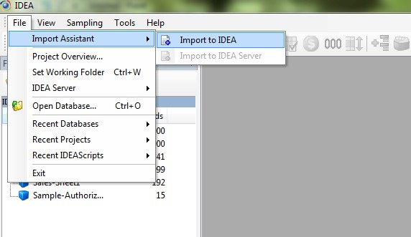

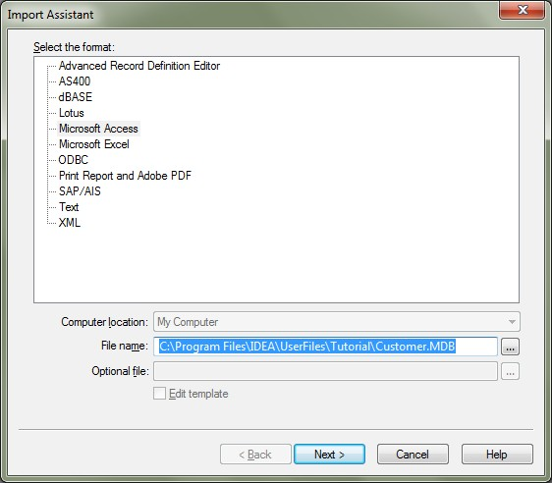Step 1: Select the Format

(a) In the Import Assistant Dialog Box, select Microsoft Access from the list.

(b) Click the Browse button next to the File namebox to select the Microsoft Access database you want to
Import.

(c) Navigate to and select C:\Program Files\IDEA\UserFiles\Tutorial\Customer.MDB. (d) Click Open.
(e) The Select File dialog box closes and the selected file name and path appear in the File namebox inthe
Import Assistant dialog box. (f) Click Next.
The Microsoft Access dialog box appears.

Step 2: Select Tables

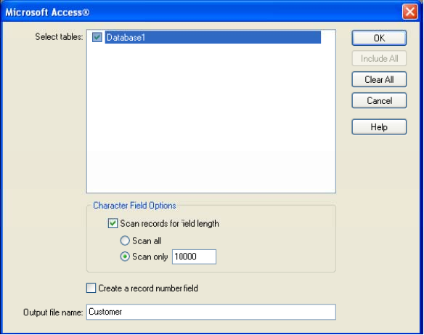

(g) In the Select tables box, select Database1.

Note: If you import a Microsoft Access file that contains more than one table, you may simultaneously import multiple tables by selecting the associated check boxes. However, any options you select will apply to all imported tables.

(h) All Character fields will be imported with a length of 255 characters unless changed. This is not likely to be the underlying Character field length. Therefore, leave the Scan records for field length check box selected. Also, accept the default value in the Scan only box in order to scan 10,000 records to determine the maximum field length.

(i) Accept the default output file name (Customer), and then click OK. When the file is imported, the database name becomes filename-tablename. In this case, the file you imported becomes an IDEA database called Customer-Database.

Step 3: Result - Customer-Database

On clicking Ok, the Customer Database is imported into IDEA. The imported database is opened in the
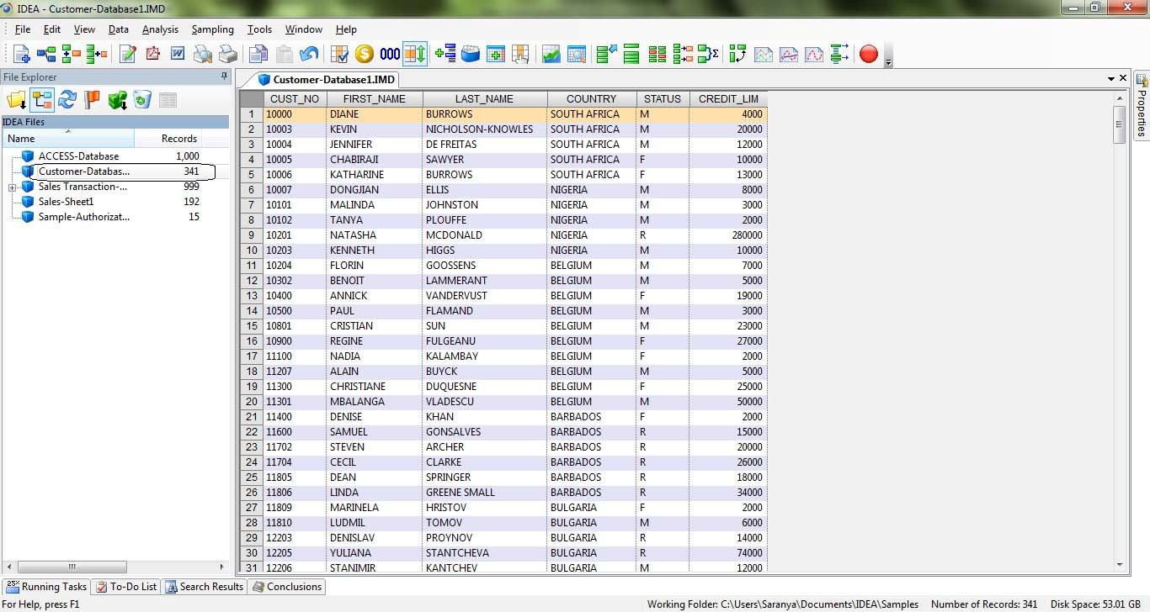Database Window. In the File Explorer Window the imported database is highlighted

Exercises:

1. Please perform the following exercises in your lab.

2. Please import excel file following the above steps.

3. Please import text delimiter file and notice the different steps.

4. Please import excel file using ODBC option.

3.1 Importing Data

Click on field statistics after importing the files and understand the nature of data which is imported.

Function Description

You can use the Export Database task to create an external file from an IDEA database so that you can use the data in other applications, such as a spreadsheet package. IDEA exports data in a number of text, database, spreadsheet, and mail merge formats.

You can use the Export Database task to create an external file from an IDEA database so that you can use the data in other applications, such as a spreadsheet package. You can also use Copy and Paste to incorporate portions of text or sections of database into other Windows applications. IDEA also supports drag and drop into any other OLE2 container application, such as Microsoft Excel. IDEA exports data in a number of text, database, spreadsheet, and mail merge formats.

Step by step process for exporting files from IDEA.

Location

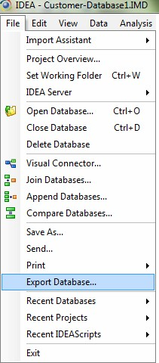• File>Export Database

Database Used

• Customer-Database1

Export Dialog Box

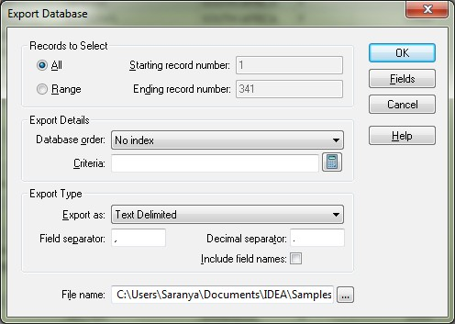

(a) In Records to Select, on selecting All will select the entire records. On selecting Range allows the user to select the Starting and Ending record number.

(b) By default the path is set to C:\Users\Saranya\Documents\IDEA\Samples\Customer-Database1.

(c) In Export Type, user can select the format in which the current file has to be exported and also name the resultant exported file.

(d) In Filename allows the user to select the path to which the file has to be exported. (e) On clicking Fields, we can select or unselect the fields that have to be exported.
(f) During Exporting process, condition or criteria can be applied using the criteria button. On clicking this button, Equation Editor Dialog box is opened which facilitates the user to write in query or condition.

(g) Clicking Ok, exports the active file into given desired format.

Exercise:

1. Export actual idea file to different formats such as: HTML, Excel, text delimited file and check the results.

3.2 Summarization

Learning Objectives:

To total the sales transaction by INVOICENO to produce a list of outstanding Sales as well as to identify the number of INVOICENO and the Sales per INVOICENO.

Function Description

Summarization accumulates the values of Numeric fields for each unique key. For example, summarizing an
Accounts Payable database by account number (the key) and totalling invoice amounts produces a database or

Results output of outstanding liabilities by supplier. The Summarization task provides:

• A list of unique items (keys) in the database

• The number of records for each key

• Totals of one or more numeric fields for each key

You may select up to eight fields to summarize by or if using one field you can use the Quick Summarization option. If using multiple fields, the Summarization task works faster and is more efficient on a database that has been sorted.

You may select any number of Numeric fields to total. The resultant database provides a list of unique key items and the number of records (NO_OF_RECS) for each key from where you can drill down to display the individual records for the key. You can select additional field data to be selected from fields from the first occurrence or the last occurrence.

The summarization result grid is limited to 4,000 rows and does not display results beyond 4,000 rows. If you expect your result will have more than 4,000 rows, you must choose to create a database.

Step by Step Procedure for summarization

Ensure that Sales Transactions is the active database and the Data property is selected in the Properties
window.

Location

• Analysis > Summarization

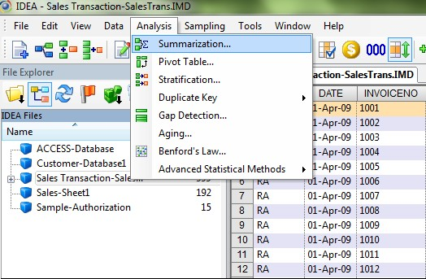

(a) In the Summarization Dialog Box, select the following:

• Fields to summarize: INVOICENO

• Numeric fields to total: SALES
(b) Click Fields. The Fields dialog box appears. Note that no fields are selected. This stops unnecessary information from being included in the summarized database.

(c) Click OK to return to the Summarization dialog box.

Select the Use Quick Summarization check box. The Use Quick Summarization check box may be selected as a faster means to summarize your database. However, Quick Summarization may only be used if the database has no more than 4,000 unique keys. In addition, Quick Summarization allows you to select only one field to summarize.

There are two types of output from the Summarization task:

• Summarization database

• Summarization result

Note that as with most tasks in IDEA, you may apply a criterion to the task, for example; only summarize transactions for a specified period. As with all other tasks where you can apply a criterion, if you apply the criterion to the database using the Criteria link in the Properties window, the criterion equation appears in the Criteria text box on the task dialog box. However, you may enter a new criterion or modify an existing one using the Equation Editor

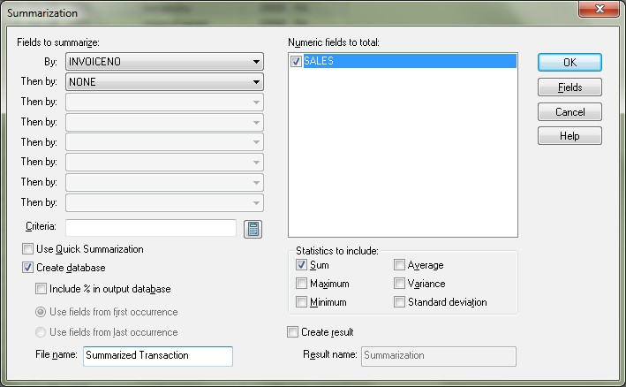

(d) In the Statistics to include area, accept the default selections of Sum. (e) Click OK.
View the resultant database and note the following fields:

• INVOICENO- List of unique INVOICENO

• NO_OF_RECS - Number of records for each INVOICENO

• Sales_SUM- Total Sales of the transactions for each INVOICENO

Also note the number of records (989) on the Status bar displayed in the below figure. Note that IDEA automatically creates an Action Field link to the parent database (Sales Transactions). It allows you to display the records from the Sales Transactions database by clicking on a value (in blue) in the NO_OF_RECS field

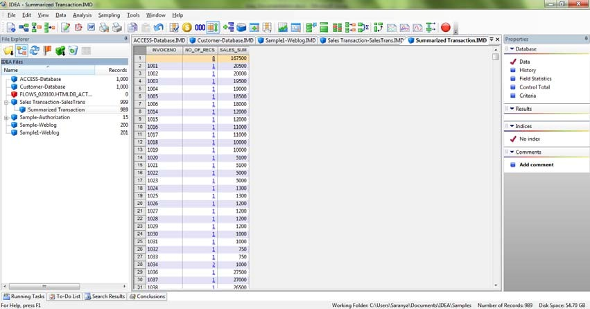

Exercises:

1. Use the sample employees file in the sample database of idea and perform summarization on branch and total on salary. Click on the hyperlink of the number of records and check the result.

2. Use the sample employees file in sample database of idea and perform summarization on country and total on salary and check the result.

3.3 Statistics

Learning Objectives

• Understanding to view the field statistics for the Numeric fields in the active database.

• The statistics is used for reconciling totals, obtaining a general understanding of the ranges of values in the database, and highlighting potential errors and the area of weakness to focus subsequent tasks.

Function Description

The Field Statistics property provides statistical information about all Numeric, Date, and Time fields within the active database. The field statistics are available and displayed for all records in the database, with any applied criteria ignored.
By default, the Field Statistics window displays the statistics for Numeric fields. Ensure that Customer- Database is the active database and the Data property is selected in the Properties window.

Step by Step Procedure for Statistics

Location

• In the Properties window, click Field Statistics.

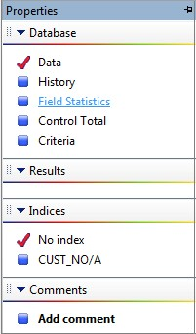

(a) On clicking Field Statistics in property window, IDEA displays below message box. (b) Click Yes to generate field statistics for all fields.

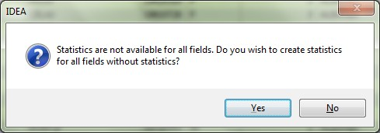

(c) By Default By default, the Field Statistics window displays the statistics for Numeric fields. In this case, field statistics appear for all the available numeric fields. To view field statistics for the Date fields and Time fields in a database, click Date and Time in the Field Type area of the Field Statistics window. In the current database, there are no Date or Time fields.

(d) If the database contained more than one Date, Numeric, or Time field, multiple date, numeric, or

Time field statistics would appear together on the same screen for easy comparison of values.

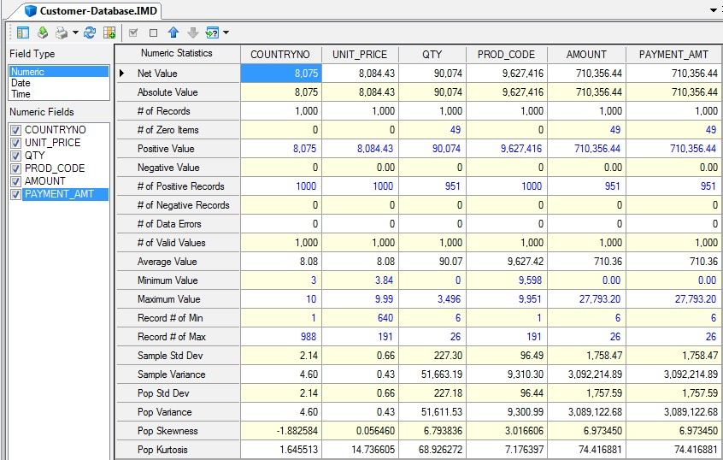Statistics for Numeric Fields

(a) As shown in the above image, active database contains six numeric fields and the statistics for all six numeric fields are displayed in Field Statistics window which allows easy comparison between them.

(b) Study the field statistics for the all Numeric fields. Note in particular:

COUNTRYNO UNIT_PRICE QTY PROD_CODE AMOUNT PAYMENT_AMT
# of Records  # of Zero | 1,000 | 1,000 | 1,000 1,000 | 1,000 | 1,000
Items | 0 | 0 | 49 0 | 49 | 49
Average  Value | 8.08 | 8.08 | 90.07 9627.42 | 710.36 | 710.36
Minimum  Value | 3 | 3.84 | 0 9598 | 0.00 | 0.00
Maximum  Value | 10 | 9.99 | 3496 9951 | 27793.20 | 27793.20

Below two Images displays statistics for Date and Time fields for current active database.

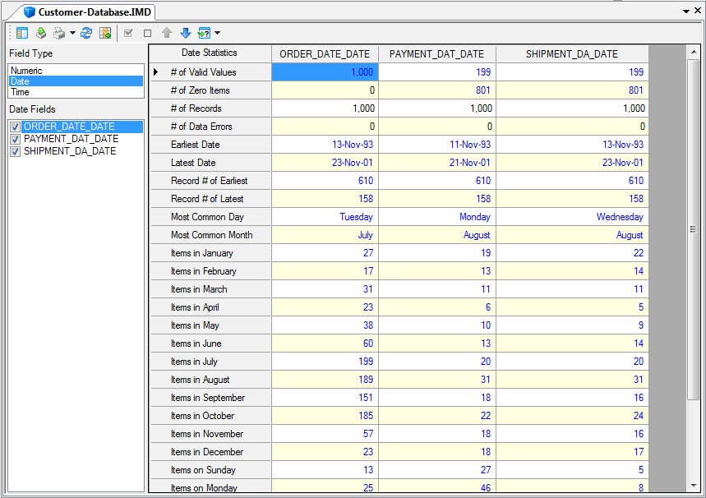Statistics for Date Fields

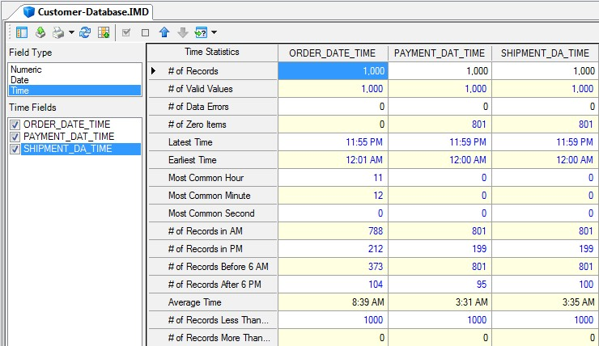Statistics for Time Fields

Exercise:
1. Click on field statistics for sample employees and understand profile of data.

2. Click on field statistics for sample-inventory and understand profile of data.

3.4 Sampling

Learning Objectives

• To draw a number of records with fixed interval for testing.

• To select a random sample of records for testing.

• To extracts a random sample with a specified number of records from each of a series of bands.

Function Description

Sampling in IDEA is broadly statistical and probability-based.

The probability-based sampling techniques are: Systematic, Random and Stratified Random

The statistical sampling techniques are: Attribute, Classical Variable and Monetary Unit sampling

We will be covering examples of systematic and random sampling only in this training. Students may try other forms of sampling in the lab exercise.

Systematic Record Sampling

Systematic Record Samplings a method to extract a number of records from a database at equal intervals to a separate database. It is often referred to as interval sampling.

There are two methods of determining the sample:

• Entering the number of records, in which case IDEA computes the interval size.

• Entering the selection interval, in which case IDEA computes the number of records.

IDEA calculates the above parameters on the number of records in the database and defaults to the first to last records. However, we can extract the sample from a range of records, if required.

Step by Step Procedure for performing Systematic Sampling

Ensure that Sales Transaction-Sales Trans is the active database and the Data property is selected in the
Properties window.

Location

• Sampling >Systematic.

• Alternatively, click the Random Record Sampling button on the Operations toolbar. The Random
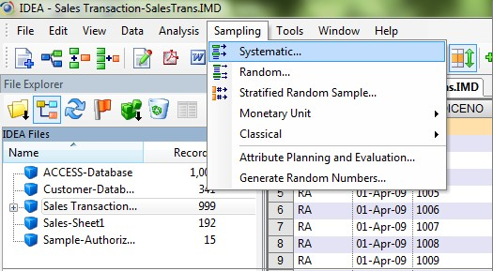Record Sampling dialog box appears

Core Banking Solution (CBS)
- Core Banking Solution (CBS) is centralized Banking Application software. It has several components which have been designed to meet the demands of the banking industry.
- There are different vendors in the market providing CBS software, (CBS) is developed by different software development companies. Some institutions have developed the software in house.
Name of the Vendor : Software
Infosys : Finacle
TCS : Quartz
Iflex Solutions : Flex Cube
HCL : Bankmate
Key Points:
- The software resides in a Central application server which is located in the Central Office Data Centre.
- The application software is not available at the branch but can be accessed from the branches.
- Along with Data base servers and other servers, application server is located at the Central Data Centre.
- All of the branches of the bank are connected to the Central Data Centre.
- Broadly speaking, the customer is no longer a customer of the branch but a customer of the bank.
Core Banking Solution brings significant benefits:-
(a) A customer is a customer of the bank and not only of the branch.
(b) The CBS is capable of being implemented in stages.

- Initially basic modules like Savings Account, Current Account, Fixed Deposits, Bills & Remittances, Loans and advances models implemented.
- Subsequently alternate delivery channels like ATM, Internet banking, RTGS/ NEFT, Mobile Banking, Treasury, Government Business etc., could be added.
Technology behind Core Banking Solutions
The various components of a core banking environment would be:
- Central Application Server that runs the core banking solutions (CBS). The application is centrally accessed by the branches. There are different core banking solutions available in the market and there are other CBS software also some developed in-house by the bankers; others developed by other vendors.

- Central Data Base Servers that store the data of the bank. The server is a sophisticated computer that accepts service requests from different machines which are called clients. The requests are processed by the server and sent back to the clients. Other infrastructure needed for internet banking and automated teller machine (ATM) operations. Necessary infrastructure to provide security for stored data and data transferred across the network.
- There are different types of servers as follows:
- Application Server,
- Data Base Server,
- Anti-Virus Server,
- Web Server,
- ATM Server,
- Internet Banking Application Server (IBAS),
- Internet Banking Data base Server,
- Proxy Server,
- Mail Server etc.,
Application Server
- Application server hosts the core banking application like Finacle, Flex cube, Quartz or Bankmate etc.
- This server has to be a powerful and robust system as it has to perform all the core banking operations.
- The branch does not have the entire application. It will have only a version which is called the “client version” of the application. The client version of the application is capable of only entering the data at the end point that is branches.
- The application server performs necessary operations and this updates the account of the customers in the data base server. The customer may do some other operation in branches.
- The process is validated at branches and the data is transmitted to the application software at the data centre. The results are updated in the data base server at the centralised data centre. Thus it would be observed that whatever operations a customer may do at any of the branches of the bank the accounting process being centralised at the centralised data centre is updated at the centralized data base.
- The application server would be placed in a trusted inside zone in a separate Virtual Local Area Network (VLAN) -.
- There is no direct access to the application server. The communication has to pass through a firewall, properly directed by a switch which is also located behind the firewall.
VLAN: Each of the servers are segregated using the concept of Virtual Local Area Network (VLAN). VLAN is a method of creating virtual networks within a physical network. Each virtual network thus created will act a separate network. This concept has got distinct advantages. Data communication between the 2 VLANs can be controlled as per business requirements.
Data Base Server
The Data Base Server of the Bank, as already observed contains the entire data of the Bank. The data would consist of various accounts of the customers, as also certain master data Application software would access the data base server. The data contained in the data base has to be very secure and no direct access would be permitted to prevent unauthorised changes. Strict discipline is followed regarding the maintenance of the data base server. There is a designated role for maintenance of the data base. This individual who performs the role is called the Data Base Administrator. His activities will also be monitored as all changes made would be recorded in a Log. Scrutiny of the log would disclose the type of activities and the effect of such activities. Security aspects of data base server are an audit concern. Apart from the normal application server, the Automated Teller Machine server (ATMS) and Internet Banking Application Server (IBAS) would also access the Data Base Server.
However, it would be only through VLAN. It must be noted that whatever be the operation that the customer has performed, etc., at the branch, through ATM, by Internet, mobile banking or any other alternate delivery channels his account at the Centralised Data Base would be updated.
Automated Teller Machines Server
- This server contains the details of ATM account holders. Soon after the facility of using the ATM is created by the Bank, the details of such customers are loaded on to the ATM server. When the Central Data Base is busy with central end-of-day activities or for any other reason, the file containing the account balance of the customer is sent to the ATM switch. Such a file is called Positive Balance File (PBF).
- Till the central data base becomes accessible, the ATM transactions are passed and the balance available in the ATM server.
- Once the central data base server becomes accessible all the transactions that took place till such time as the central data base became un-accessible would be updated in the central data base. This ensures not only continuity of ATM operations but also ensures that the Central data base is always up-to-date.
- The above process is applicable to stand alone ATM at the Branch level. As most of the ATM are attached to central network the control is through ATM SWITCH only.
Internet Banking Data Base Server
Just as in the case of ATM servers, where the details of all the account holders who have ATM facility are stored, the Internet banking data base server stores the user name, password of all the internet banking customers IBDS (Internet Banking Data Base Server) software stores the name and password of the entire internet banking customers. IBDS server also contains the details about the branch to which the customer belongs
Steps:-
- The Internet Banking customer would first have to log into the bank’s website.
- The next step would be to give the user name and password.
- The Internet Banking software which is stored in the IBAS (Internet Banking Application Server) authenticates the customer with the log in details stored in the IBDS.
The IBDS is located in a demilitarised zone. It has a separate VLAN that connects a proxy server, mail server, web server and IBAS.
The main components of Internet banking system consist of Web Server, Internet Banking Application Server (IBAS), Internet Banking Data Base Server (IBDS), Middleware, and Central Data Base Server.

Proxy Server
A Proxy server always acts in conjunction with a firewall. The Proxy Server provides network security by preventing malicious data from entering the network. Location Proxy server is placed inside the demilitarized zone wherein the mail server, web server, internet banking application server, are placed.
Comparison of TBA with CBS:-
- Total Branch Automation System (TBA) was in existence before Core Banking Solution (CBS) was implemented.
- TBA itself was deemed a technology development compared to its predecessor ALPMS (Advanced Ledger Printing Machines).
- In the TBA system each branch was performing the branch operations in totality at the respective branch.
- The final output was transmitted to the head office. The data was transmitted either on a CD or a Floppy.
- The information on this media was processed at the Central Office for consolidation of accounts and preparation of reports.
The technology infrastructure at the branch was as follows:
- There would be a server which would be either in the Branch Manager’s room or more commonly kept in a separate air conditioned enclosure with a separate entrance, so that entry to the server room can be restricted. At the most the Systems Administrator may be inside the cabin along with the server.
- There would be four or five nodes or more depending upon the need of the branch or the volume of transactions. Each of the nodes would be connected to the server. The server would have the application systems as also the data base.
- The bank as a whole would have one banking software which might have been developed in-house or purchased from an outside vendor. A copy of this software is loaded in each of the servers in all the branches of the bank. The server also hosts data base of the branch.
- The data base would have a master data, and all the details of the transactions entered into. The master data consists the data relating to standing information like the name, address of the customer interest payable on all Deposits. This would have the details of interest payable for various Deposits with different tenures eg: - 8.5% pa, 9% pa 9% for two years and so on. Additional/ concessional interest for senior citizen, staff members, educational loan for girl child, various concessional rates during festive seasons etc.
Disadvantages:-
- The program requires constant changes either due to bugs in the program or due to changes in the business process or for any other justifiable reasons. These changes are made at the central office (Computer Planning and Policy Department- CPPD). Copies of this program would have to be made effective at the branches.
- While theoretically it seems simple, the problems that have been faced are with the need to change program often. There were different versions of the program available and operational at different branches of the bank. Version control mechanism was not effective.
- In addition to changes in programme master data regarding rates of Fixed Deposits, Loans, Penalties, etc., have to take place almost immediately in the entire bank at a single point of time. This was possible only by sending e-mails to the branches and instructing the Branch Managers to get the Systems Administrators of their respective branches to update the masters.
- The Branch Managers being busy with operations were not devoting time to personally ensure that these corrections are made properly. This resulted in a situation when modifications were made differently at different branches at different points of time.
- Also intentionally some ‘mistakes’ could be committed. This situation led to a great extent of chaotic condition of branch transactions at the head office and not to speak of suspense or sundry accounts created in each branch to ensure the trial balance tallied.
Functions of I.T. Department in CBS Environment
- Security Administration: - All organizations including banking to have a security policy which is approved at the Board level.

- System Administration: - The Systems Administrator has the powers to create, modify and delete users in accessing the system. He should be responsible for processing of end of day operations and beginning of day operations. He should be responsible for introducing latest application of the program.

- Data base administration: - the Data Base Administrator is the custodian of the bank’s data. He is responsible for ensuring that access is given to the Central Data Base in a secure manner in line with business requirements

- Network Administration: To place routers, switches and hubs at the appropriate places and ensure a secure network configuration. Sensitive devises like firewalls and intrusion detection systems/ IPS need to be strategically placed to ensure security for the network. At periodical intervals arrange for vulnerability assessment and penetration tests to take corrective action whenever these tests throw up weak points.

- Librarian: - In a computerised environment, the Librarian has got similar functions excepting that instead of dealing with books, he will be dealing with software. The Librarian maintain records of the various versions of the program records all the various versions of the program just as we have different editions of a book and generally a later edition is expected to be important over the earlier one. Similarly, software may have different versions and it is extremely important to remember them and this number is referred to as the version number.
The Librarian has the following responsibilities:
- Moving the correct version of the software into production environment.
- Maintain detailed documentation of all receipts and issues of software.
- Keep a record of all licenses obtained for the usage of software.
- Be in charge of user manual and system manual.
.

CBS INTERFACES-THEIR FUNCTIONALITY AND CONTROLS
Automated Teller Machine
Cash Management System (CMS)
- The objective of the CMS is to meet the needs of the customers who have operations all over the country. Such organizations would naturally have collection and payments in various locations.
- In the normal course, cheques would be collected in one single location and then deposited in the main branch. This causes cash flow problems as there is uncertainty regarding the dates when the cheques would be realised.
- In view of this uncertainty both scenarios of excess cash and deficit cash were arising. As in receipts by way of cheques a similar situation arises when a high volume of disbursement has to be made
e.g., (a) Salaries for the different branches (b) Dividend payments.

- To get over these problems of cash management and to make the process of cash management effective, banks have introduced this new product - CMS.
- The broad features of CMS are as follows:
- Multiple collection centres have been authorised to receive the cheques / drafts of the customers.
- It is not necessary to open a separate account in each of these centres.
- At the client’s main account which is maintained at the pooling centre credit is offered on the same day for all the cheques / drafts deposited and cleared at the branches.
- The product also provides Management Information System to customers providing details location wise and also party wise.
- If necessary, information can even be provided by e-mail.

Evaluation of Controls of CMS:

Parameter settings (Master Settings): There needs to be adequate controls over parameter settings, authorization as also modification of such settings. E.g., Parameters would include:

(a) Clearing cycle

(b) Credit limit

© Charges (various slabs) (d) Interest ( “ )
Processing Charges: When the bank offers CMS product to the customer, naturally there are associated charges for the same which would include:

(a) DD / Pay Order issue charges

(b) Courier Charges

(c) Cheque return charges

(d) Interest charges for credit offered.

There needs to be a process logic for computing the various charges. Any defect in the logic would lead to income leakage. While evaluating the controls, it is necessary to verify the correctness of the parameters and also test the program logic. It is important to verify the authorization process for creating and modifying
parameters
In certain circumstances the customer may be offered a credit limit which exceeds the sanctioned limit. This can be done only under proper authorization. Aspects of this nature need to be verified at the time of performing the audit.
End of Day Processing
The various amounts collected and different amounts disbursed are all pooled in a designated account. There needs to be a control to ensure the accuracy of such pooling.

The CBS product is interfaced with the core banking solution. The charges and other items need to find a place in the general ledger. Mapping of entries need to be verified. It should also be verified whether there is a built in control to prepare an exception report in case of apparently wrong entries e.g., collection charges being credited. Normally the CMS product provides various audit trails which include listing of parameter settings, transaction authorization and waiver charges. While evaluating the trails and performing the audit, the
adequacy of audit trials need to be verified.

SYSTEMS AUDIT OF CBS AND ITS INTERFACES
System Audit:-
- Systems auditing is an important aspect in the present context of extensive computerisation. However, audit methodology in a computerised environment is distinctly different from that in a manual environment.
- The importance of performing systems audit was very much appreciated as the cause for the non-detection of the fraud.
- Systems Audit, which verifies the controls in a computerised environment evaluates the controls and provides assurance regarding adequacy.
- In a banking environment, where all of manual maintenance of accounts have been shifted to computers
- Many controls for information systems and important ones at that are built into computers. Hence as verification of internal controls are of utmost importance, systems audit as distinct from manual audit assumes importance
- With the Core Banking Solution being implemented, the computer technology has become more advanced and all of the operations at all of the branches are all networked to the Central Office. The hardware and the communication are distributed and the software is centralised.
- Audit objectives of performing audit of banks have not undergone any change. However, audit methodology has undergone a ‘sea change’. Reserve Bank of India has in these circumstances issued many circulars.
- The Institute of Chartered Accountants has issued guidelines for performing audit in an information technology environment. As of now, many of them are as guidelines and hence though not mandatory, members are expected to comply with the requirements
Security and Controls in CBS
When specific products like internet banking, ATM. RTGS/ NEFT, and CMS are introduced, there are certain additional controls specific to those systems
The main heads would be
  - Management Controls

- Formulating a security policy: -
Security Policy is a document approved at the Board level. Reserve Bank of India mandates that every bank should have a security policy

- developing a business continuity planning:-
Reserve Bank of India mandates on every bank having a Business Continuity Plan in place. From the accounting point of view, one needs to look at it from the “going concern concept”. The existence of a Business Continuity Plan, evidence of testing and evidence of updating are essential.

- laying down procedures for systems development:- Best practices for development of systems and change management should be documented. Constant monitoring of its being complied with should be in place. The procedures would include program development, program testing, and movement to library, movement from library to production, roles and responsibilities of Computer Team members, highlighting incompatible functions.

  - Organizational Controls: - Organizational Controls would include the organization structure of the IT Department, IT Strategies roles and responsibility including incompatible functions would include.

  - Operational Controls: - This would include physical access, logical access, environmental controls, evaluation controls in operation systems and evaluation controls of network.

  - Application Controls:- The controls would broadly come under the following heads:
- Input
- Process
- Output
  - Infrastructure controls.
Audit of Core Banking Solution
Audit is the process of evaluating the adequacy of controls and also ensuring relevant application modules deal comprehensively with business process. The various aspects to be verified while performing the audit in the Core Banking Solution environment would be:
- Review of Security Policy:- The broad contents of the security policy should be-
- Formulation of a security committee to manage information security within the organization.
- Asset Management
- Human Resources
- Physical Environment
- Communications and Operations Management
- Media Handling
- Access Control
- Network Access Policy
- Operating System Access Control
- System Acquisition Development and Maintenance
- Information Security Incident Management
- Review of Business Continuity Planning & BCP policy
- Review of Systems Development and Change Management Procedures & process
- Network vulnerability Assessment of Effectiveness of Intrusion Detection Systems.
- Evaluation of controls in operating systems.
- Control in databases
- Testing of application modules of the Core Banking Solution.
- Review of Systems logs.
- Operating System Logs

- Application Logs and

- Data Base Logs
- Audit of Internet Banking, Audit of ATM and RTGS/ NEFT also needs to be done and these have been considered separately under their respective heads
Modules in Core Banking Solutions
The various application modules form part of the total Core Banking Solution
- Customer ID generation | create a customer with a specific No.
- Accounts Management | - To ensure that the account opening process is in line with the bank’s laid down procedures.  - This module will deal with creating savings account, current account, cash credit account, overdraft etc.,
- Clearing Module | Which would include inward clearing as also outward clearing?
- Bank Guarantee | - This module would cover bank guarantees issued by the bank on behalf of the customers in favour of third party’s guaranteeing to fulfil the terms of the guarantee. Guarantees may be in the nature of  - Performance guarantee or  - Deferred Payment guarantee.
- Bills | Bills involve trade transactions and would include  - Clean supply of bills  - Payment Usance Bills  - Outward Bills (Cheques)  - Inward bills
- Letter of Credit | Letter of Credit refers to an arrangement wherein the issuing bank acts on the request and instructions of a customer.
- Remittances | This process involves remittances of money by way of DDs or Money Transfers etc.
- Advances | - The banks collect demand deposits and term deposits.  - Out of the funds collected they maintain Statutory Liquidity Ratio (SLR) and Cash Reserve Ratio (CRR) as per the RBI’s requirements.  - Out of the balance funds available they lend to priority and non-priority sectors.
- Master Maintenance | - The functionality of each of the modules has to be comprehensive.  - The core banking solution would need to have master data.  - Parameter setting for account type and structure settings keeping in view the General Ledger  - Parameter settings for interest rates applicable. These interest rates would vary for different parties e.g., staff, senior citizens etc.  - Rates would vary also for the tenor deposits eg. 1 year, 2 years etc.
- Savings Bank and Current Accounts
- Fixed Deposits, Recurring Deposits and other Term Deposits
- Cash Operations Module

(b) There should be a procedure in place to ensure that soon after an employee designs his user ID and password are revoked. His logical access should be denied.

4. Roles and Responsibilities of System Administrator

System administration is a sensitive function and should be allocated to a specific individual. He needs to have access only to perform system administration function. There should be built in control to report by means of a log if he performs any other function.

5. Firewall

It has to be ensured that internet banking services is only through a dedicated Firewall.

Periodically penetration tasks (tests to unauthorized enter the network) should be performed to ensure it is not possible

If vulnerabilities are highlighted it should be verified whether immediate corrective steps have been taken.

There should be approval from appropriate senior management before firewall, routers and other associated systems are changed or upgraded.

6. Segregation of Live and Test Environments

Like in all Computer Systems, test environment should be separate from live environment. No testing should be done in the live environment. Live environment is the environment where the live program is running. Such a program would have been thoroughly tested and moved under proper authority from test environment to live environment.

7. Network Security

There should be adequate control mechanism in place to ensure that access to both in and out of internal network are controlled.

Review whether there is any provision (usage of tools) to monitor suspicious activity.

8. Router Configuration

Routers should be properly configured to ensure that network is restricted to only necessary systems and none else.

