Interim Budget 2014 .
In this interim budget following were the key areas on which the finance minister has worked out:
- In Manufacturing Industry (Specially Automobile Sector)
- The excise duty on small cars, bikes, scooters and commercial vehicles excise duty reduced from 12% to 8%.
- The segment sedan segment (large and medium cars) saw a cut in exercise duty from 24-27% to 24-20%.
- Excise duty on SUVs has been decreased from 30% to 24%.
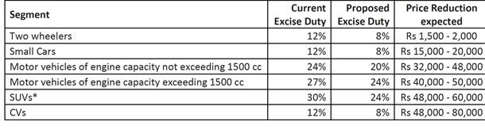
Effect on Industry: TATA motors, General motors, Audi Mercedes, Mahindra & Mahindra and other leading car manufacturing companies have announced reduction in their car prices. The Companies are taking effect of the same and working out on their new prices.
- Reduction in Excise duty on Consumer Products: The excise duty on consumer durables such as TV sets, Refrigerator, Air Conditioners has also been cut from 12% to 10% (all goods falling under chapter 84 and 85 of the schedule to the central excise tariff act).
Effect on Industry: Panasonic LG reviewing prices after excise duty Cut.
- Major Relief to ex-servicemen. The Finance Minister also promised implementation of 'One-Rank-One-Pension' from 2014-15. The Government has allocated Rs. 500 crores to the Pension scheme.
- Interest Subvention scheme for farm loans and a moratorium period for education loans taken before march 31, 2009.
- No changes made on the Income tax rates. Finance minister did not purpose to make changes in the tax laws except to continue the 10 % income tax surcharge on super- rich individual and up to 5% on corporate.
- Service Tax Rate Amendment in : Handling, storage or warehousing of rice (Service Tax rate cut from 12% to 10%)
Other Points:
- The Finance Minister appealed to all political parties to resolve and pass the GST Laws and the Direct Tax Code in 2014-15.
- Apart from a small mention about the land acquisition bill and allocating Rs 2000 crore to the Urban Housing Fund for affordable housing, not much was said on the housing sector.
- The FM has suggested creating one record for all financial assets of every individual. However, Chidambaram did not elaborate on how he plans to execute it.
- Another agenda raised by the FM is to enable smoother clearing and settlement for international investors looking to invest in Indian bonds.
- The Financial Sector Legislative Reforms Commission (FSLRC) had recommended that the Securities and Exchange Board of India, (SEBI) the Forward Markets Commission (FMC), the Insurance Regulatory and Development Authority (IRDA) and the Pension Fund Regulatory and Development Authority (PFRDA) should be merged into a new unified agency UFRA.
- GDP growth rate for Q3 & Q4 of 2013-14 will be at least 5.2%
- Current Account deficit and the Currency (CAD) : Contained at $45 billion which is significantly lower than analyst earlier projection of $50.5 billions.
- Gem and Jewellery industry disappointed with interim budget: High import duties not curtailed. (

