CLOUD COMPUTING: OPPORTUNITIES AND THREATS
HIRESH RAI KHANNA

WHAT IS CLOUD COMPUTING?

Cloud Computing is a type of computing that relies on sharing computing resources rather than having local servers or personal devices to handle applications. In cloud computing the word ‘computing’ is used as a metaphor for “Internet”, and so the meaning of the word cloud computing means a type of Internet based computing where different services such as –servers ,storage and the applications are delivered to the organization’s computers through the Internet.
Cloud Computing is a compared to GRID COMPUTING, where the unused processing cycles of all the computers in a network are harnessed together so as to solve too intensive problems of a standalone machine.

Cloud Architecture

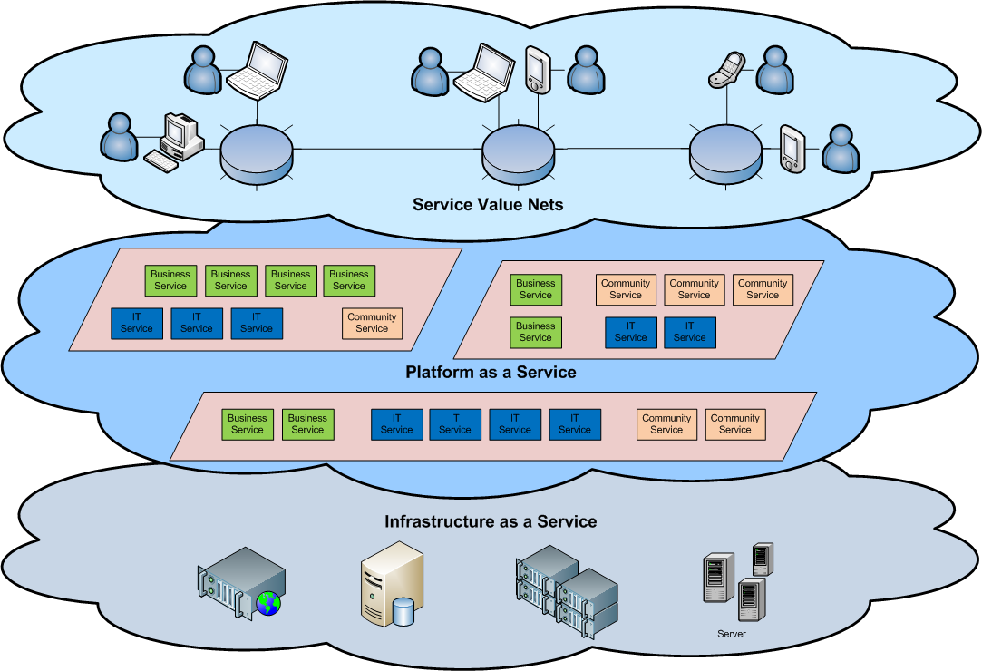

ADVANTAGES

- Cloud computing relies on sharing of resources to achieve coherence and economics of scale. At the foundation of cloud computing is the broader concept of converged infrastructure and shared services.
- It focuses on maximizing the effectiveness of the shared resources. Cloud resources are usually not only shared by multiple users but are also dynamically reallocated per demand. This can work for allocating resources to users. For example, a cloud computer facility that serves European users during European business hours with a specific application (e.g., email) may reallocate the same resources to serve North American users during North America's business hours with a different application (e.g., a web server).
- Cloud computing maximizes the use of computing powers thus reducing environmental damage as well since less power, air conditioning, rack space, etc. is required for a variety of functions.
- Lower computer costs:
- You do not need a high-powered and high-priced computer to run cloud computing's web-based applications.
- Since applications run in the cloud, not on the desktop PC, your desktop PC does not need the processing power or hard disk space demanded by traditional desktop software.
- When you are using web-based applications, your PC can be less expensive, with a smaller hard disk, less memory, more efficient processor...
- In fact, your PC in this scenario does not even need a CD or DVD drive, as no software programs have to be loaded and no document files need to be saved.

DISADVANTAGE

Though Cloud Computing has many advantages ,it also some disadvantages
- Requires constant internet connection.

- Cloud computing is impossible if you cannot connect to the Internet.
- Since you use the Internet to connect to both your applications and documents, if you do not have an Internet connection you cannot access anything, even your own documents.
- A dead Internet connection means no work and in areas where Internet connections are few or inherently unreliable, this could be a deal-breaker.

- Does not work well with low internet speeds.

- Similarly, a low-speed Internet connection, such as that found with dial-up services, makes cloud computing painful at best and often impossible.
- Web-based applications require a lot of bandwidth to download, as do large documents.
- Stored data might not be secure:
- With cloud computing, all your data is stored on the cloud.
The questions is How secure is the cloud?
- Can unauthorized users gain access to your confidential data?

- Stored data can be lost:

1. Theoretically, data stored in the cloud is safe, replicated across multiple
Machines.
2. But on the off chance that your data goes missing, you have no physical or local
Backup.

SERVICE MODELS

Cloud computing providers offer their services according to several fundamental models:^{[2][56]} infrastructure as a service (IaaS), platform as a service (PaaS), and software as a service (SaaS) where IaaS is the most basic and each higher model abstracts from the details of the lower models. Other key components in anything as a service (XaaS)

- INFRASTRUCTURE AS A SERVICE (IaaS)

In the most basic cloud-service model, providers of IaaS offer computers – physical or (more often) virtual machines – and other resources. (A hyperadvisor, such as HyperV or Xen or KVM or Vmare, runs the virtual machines as guests. Pools of hypervisors within the cloud operational support-system can support large numbers of virtual machines and the ability to scale services up and down according to customers' varying requirements.) IaaS clouds often offer additional resources such as a virtual-machine disk image library, raw (block) and file-based storage, firewalls, load balancers, IP addresses, Virtual Local area network (VLANs), and software bundles.^{[59]} IaaS-cloud providers supply these resources on-demand from their large pools installed in data centres. Forwide area connectivity, customers can use either the Internet or carrier cloud (dedicated virtual private networks).

- PLATFORM AS A SERVICE(PaaS)

In the PaaS model, cloud providers deliver a computing platform, typically including operating system, programming language execution environment, database, and web server. Application developers can develop and run their software solutions on a cloud platform without the cost and complexity of buying and managing the underlying hardware and software layers. With some PaaS offers (like Windows Azure, the underlying computer and storage resources scale automatically to match application demand so that the cloud user does not have to allocate resources manually. The latter has also been proposed by an architecture aiming to facilitate real-time in cloud environments.

- SOFTWARE AS A SERVICE (SaaS)

SaaS is a model of software deployment where an application is hosted as a service provided to customers across the Internet. Saas alleviates the burden of software maintenance/support,but users relinquish control over software versions and requirements.
Terms that are used in this sphere include
  - Platform as a Service (PaaS) and
  - Infrastructure as a Service (IaaS)

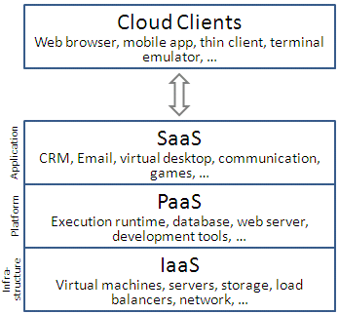

OPPORTUNITIES

Even though Cloud Computing has its own set of advantages and disadvantages, it portrays its own opportunities

- It enables services to be used without any understanding of the infrastructure.
- Cloud Computing works using economies of scale.
- It potentially lowers the outlay expense for start up companies, as they would no longer need to buy their own software or servers.
- Cost would be by on-demand pricing.
- Vendors and Service providers claim costs by establishing an ongoing revenue stream.
- Data and services are stored remotely but are accessible anywhere.

THREATS

- Use of cloud computing means dependence on others and that could possibly limit flexibility and innovation:
- The others are likely become the bigger Internet companies like Google and IBM, who may monopolise the market.
- Some argue that this use of supercomputers is a return to the time of mainframe computing that the PC was a reaction against.

- Security could prove to be a big issue:
- It is still unclear how safe out-sourced data is and when using these services ownership of data is not always clear.

- There are also issues relating to policy and access:
- If your data is stored abroad whose policy do you adhere to?
- What happens if the remote server goes down?
- How will you then access files?
- There have been cases of users being locked out of accounts and losing access to data.

PURPOSE

- Cloud computing enables companies and applications, which are system infrastructure dependent, to be infrastructure-less.
- By using the Cloud infrastructure on “pay as used and on demand”, all of us can save in capital and operational investment!

- Clients can:
  - Put their data on the platform instead of on their own desktop PCs and/or on their own servers.
  - They can put their applications on the cloud and use the servers within the cloud to do processing and data manipulations etc.

CLOUD STORAGE

- Several large Web companies are now exploiting the fact that they have data storage capacity that can be hired out to others.
  - allows data stored remotely to be temporarily cached on desktop computers, mobile phones or other Internet-linked devices.
- Amazon’s Elastic Compute Cloud (EC2) and Simple Storage Solution (S3) are well known examples
  - Mechanical Turk

FUTURE OF CLOUD COMPUTING

- Many of the activities loosely grouped together under cloud computing have already been happening and centralised computing activity is not a new phenomena
- Grid Computing was the last research-led centralised approach
- However there are concerns that the mainstream adoption of cloud computing could cause many problems for users
- Many new open source systems appearing that you can install and run on your local cluster
  - should be able to run a variety of applications on these systems

