MESSAGE TO ICAI BY FACULTY OF SHAKYAMUNI ACADEMY FOR CA
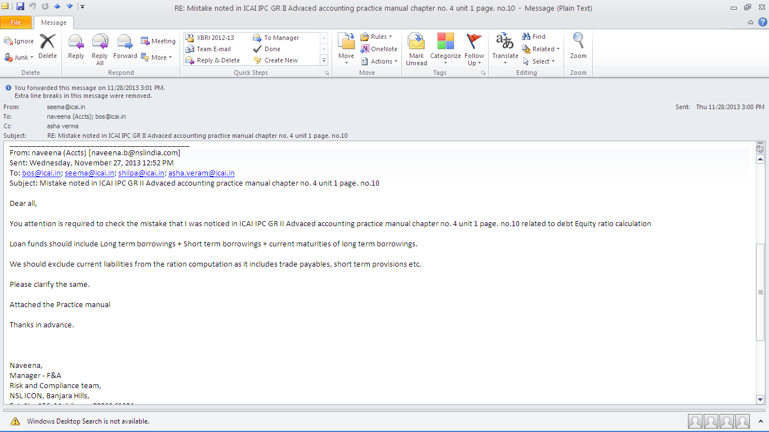

RESPONSE FROM DEPUTY DIRECTOR OF ICAI
