Chapter 21
THEORETICAL ASPECTS
CHAPTER INDEX
VALUE CHAIN ANALYSIS
UNIFORM COSTING
VALUE ENGINEERING
COST PLUS CONTRACTS
BENCH MARKING
MRP
ERP
GENERAL TOPICS
- OPERATIONAL DATABASE
(b) DISINVESTMENTS
(c) OUTSOURCING
(d) CHANGING MANUFACTURING COSTS
(e) INVENTORY HOLDING DURING INFLATIONARY CONDITIONS

VALUE CHAIN ANALYSIS

21.1-1 CONCEPT
Value chain Analysis (VCA) is a strategy to gain competitive advantage. By gaining competitive advantage we mean to be and stay ahead of your competitors. VCA has been conceptualized and described by Michael Porter in his book Competitive Advantage: Creating and Sustaining Superior Performance.

Value means the amount the customer is willing to pay for the product. A value chain is a series of activities that a firm performs in order to deliver the product. It includes all activities to design, produce, market, deliver, and support the product/service. Products pass through activities of a chain in order, and at each activity the product gains some value. The chain consists of a series of activities that create and build value. They culminate in the total value delivered by an organization. The goal of these activities is to create value that exceeds cost of providing the product/service, thus earning profit for the company.

VCA identifies these activities and evaluates their strength and weaknesses. It is a tool for systematically examining (i) the activities of a firm, and (ii) how they interact with one another and affect each other’s cost and performance. VCA is a way of identifying the activities which should be outsourced.

Value Chain Analysis helps in identifying a firm's core competencies and distinguishes those activities that achieve competitive advantage. According to Porter there are two ways of achieving the competitive advantage (i) Cost leader ship and (ii) Product differentiation.

Cost Leadership: Cost leadership requires a reduction in the costs associated with the value chain activities. For example, VCA may find that some of the activities may be outsourced, production activities may be located near supplier’s place, labour cost may be saved through mechanization, improved efficiency, improvement in design etc. A firm can achieve competitive advantage by cost leader ship in two ways (i) Increasing the market share through lower price (ii) Increased amount of profit.

Porter identifies several cost drivers related to value chain activities:
- Economies of scale
- Learning
- Capacity utilization
- Linkages among activities
- Interrelationships among business units
- Degree of vertical integration
- Geographical location
- Institutional factors (Union Activity, taxes etc.)
Product Differentiation: Product differentiation brings unique value to the customer. It may be in the form of better quality, timely delivery, quick response to after-sales-service demand, added features to the product etc. Differentiation creates a unique position in the market through product functionality, service, or quality. A firm can gain competitive advantage through product differentiation either by charging premium price or by increased market share.

Porter identifies several product differentiation drivers related to value chain activities:
- Improved after sales service
- Learning
- Delivery Timings
- Linkages among activities
- Interrelationships among business units
- Integration
- Geographical location
- Institutional factors (Union Activity, taxes etc.)
21.1-2 GROUPING OF ACTIVITIES
Porter suggests that the activities of a business could be grouped under two headings:

- Primary Activities – Activities directly concerned with the creation, sale and transfer of products (including after-sales service)

1. Inbound logistics: materials handling, warehousing, inventory control, transportation;
2. Operations: machine operating, assembly, packaging, testing and maintenance;
3. Outbound logistics: order processing, warehousing, transportation and distribution;
4. Marketing and sales: advertising, promotion, selling, pricing, channel management;
5. Service: installation, servicing, spare part management;

(B) Support activities: These merely support the primary activities.

1. Firm infrastructure: general management, planning, finance, legal, investor relations;
2. Human resource management: recruitment, education, promotion, reward systems;
3. Technology development: research & development, IT, product and process development;
4. Procurement: purchasing raw materials, lease properties, supplier contract negotiations.
21.1-3 ASSESSING THE COMPETITIVE ADVANTAGE

There are three tiers of Value Chain Analysis for assessing the competitive advantage:
- Internal Cost Analysis: A firm needs to understand its own costs in order to compare to its competitors.

The principal steps of internal cost analysis are:
1. Identify the firm's value-creating processes.
2. Determine the portion of the total cost of the product or services attributable to each value-creating process.
3. Identify the cost drivers for each process.
4. Identify the links between processes.
5. Evaluate the opportunities for achieving relative cost advantage.

- Internal Differentiation Analysis: A firm needs to identify the processes that distinguish its products or services from that of its competitors.

The principal steps of internal differentiation are:
(a) Identify the customers' value-crating processes;
(b) Evaluate differentiation strategies for enhancing customer value; and
(c) Determine the best sustainable differentiation strategies.

- Vertical Linkage Analysis: It includes all upstream and downstream value creating processes in an industry. The analysis (i) identifies industry’s value chain and assign cost revenue and assets to the value creating processes (ii) diagnoses the cost driver for each value creating process (iii) evaluates the opportunities for sustainable competitive advantage.

21.1-4 STRATEGIC FRAMEWORK

VCA requires strategic framework for organizing internal and external information, analyzing the information and for summarizing the findings and recommendations.

Three useful strategic frameworks identified for value chain analysis are as follows:

Industry Structure Analysis: Porter recommends five points for Industry Structure Analysis.
- Bargaining power of suppliers
- Bargaining power of buyers
- Threat of substitute products or services
- Threat of new entrants
- Intensity of Competition
Core Competencies: A core competence is identified by the following tests:
- Can it be leveraged? — does it provide potential access to a wide variety of markets?
- Does it enhance customer value?
- Can it be imitated? — does it reduce the threat of imitation by competitors?
Segmentation Analysis – Segment analysis helps in deciding to exit a new segment, exit some existing segmented etc. The following steps are recommended for segmentation analysis:
- Identify segmentation variables and categories;
- Construct a segmentation matrix;
- Analyze segment attractiveness;
- Identify key success factors for each segment.

21.1-5 IMPORTANCE FOR COST MANAGEMENT
- Controlling the cost: Cost Management aims at controlling the costs of the products and services. Value chain analysis is a big help in not only controlling the costs but also lowering the costs.
- Improving the understanding of processes and activities: VCA improves the understanding of processes and activities. This leads to effective cost management.
- Eliminating the non-value added activities: By eliminating the non-value added activities, VCA avoids wastage of resources; this is one of goals of cost management.
- Industry comparison: Industry Structure Analysis made under VCA provides the company with an opportunity of bench marking.
- Improving the profits: Cost Management aims at improving the profits of the company. VCA aims at achieving the competitive advantage through cost leadership or/and product differentiation way. Either way the profits of the company are expected to increase.

21.1-6 COST REDUCITON
VCA aims at gaining competitive advantage through cost leadership/product differentiation. It may lead to cost reduction on account:
- Analysis of activities may lead to:
- elimination/reduction of non-value creating activities
- increased efficiency
- outsourcing some activities
- elimination/reduction of wastages
- bench marking with the competitors
- Economies of scale on account of increased sales due to quality improvement
- Linkages among activities – improvement of one activity may lead to cost
saving of many activities; for example change in design may lead to cost
reduction on many fronts.
- Knowledge gained through the VCA may help in understanding the interrelationships among the activities. Sometimes, realignment of the activities may lead to cost reduction.

Porter identifies several cost drivers related to value chain activities for reducing the costs:
- Economies of scale
- Learning
- Capacity utilization
- Linkages among activities
- Interrelationships among business units
- Degree of vertical integration
- Geographical location
- Institutional factors (Union Activity, taxes etc.)

QUESTIONS

Q. No. 21.1T What is the concept of ‘value chain’? Why it is important for Cost management?
(CA Final May 2006)
Answer : Please refer paragraphs 21.1-1 and 21.1- 5.

Q. No. 21.2T Define the term value chain. Mention three useful strategic frame works of value chain analysis.(CA Final June 2009)
Answer : Please refer paragraphs 21.1-1 and 21.1- 4.

Q. No. 21.3T Explain, how value chain approach helps an organization to assess its competitive advantage. (CA FINAL Nov. 2002, May 2005, Nov. 2005)
Answer : Please refer paragraphs 21.1-3.

Q. No. 21.4T. Explain with a diagram the value chain activities within the firm with suitable classification under primary and support activities and also the industry value chain indicating what the end use consumer pays for. (CA Final Nov. 2006)

Answer: Please refer paragraph 21.1-2.
For competitive advantage, a firm should not only analyze its own activities, it should also analyze the value chain of the industry to which it belongs. This analysis is known as vertical Linkage Analysis. It includes all upstream and downstream value creating processes in an industry. The analysis (i) identifies industry’s value chain and assign cost revenue and assets to the value creating processes (ii) diagnoses the cost driver for each value creating process (iii) evaluates the opportunities for sustainable competitive advantage.

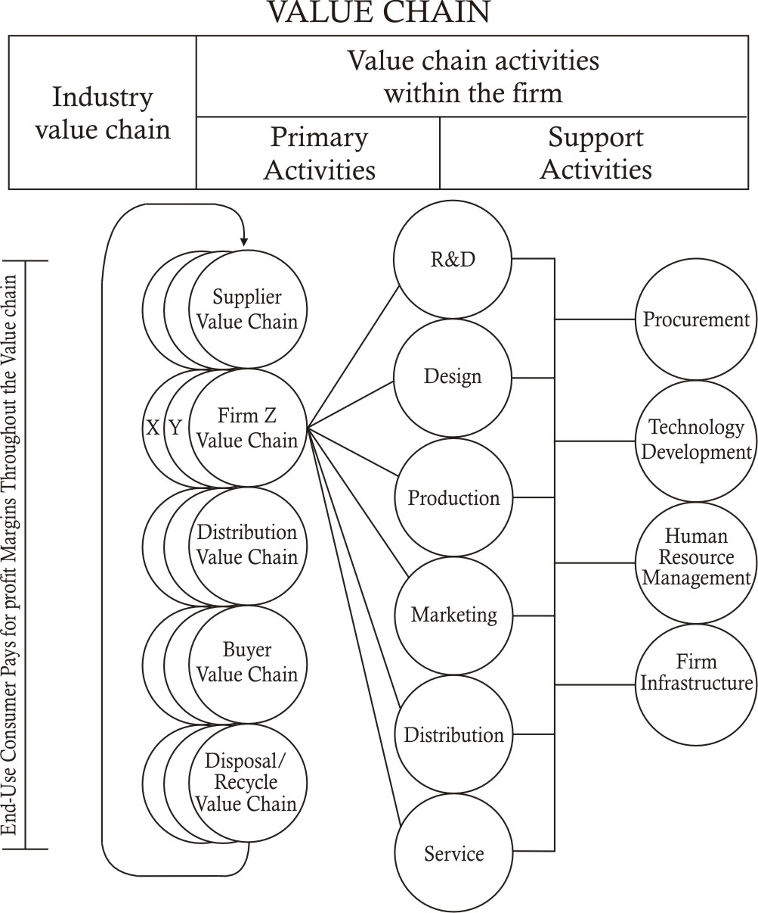

Q. No. 21.5T How can value analysis achieve cost reduction? (CA Final Nov. 2009)
Answer: Please refer paragraph 21.1-6.

Q. No. 21.6T In the context of Activity Based costing system, explain the following statement “Strategic cost Analysis should exploit internal linkages’. (CA Final Nov.12) (RTP REVISED SYLLABUS ICWA FINAL DEC. 2010)

Answer
A value chain is a series of activities that a firm performs in order to deliver the product. It includes all activities to design, produce, market, deliver, and support the product/service.
Under Value chain Analysis, we identify the various activities of the value chain, analyze them to gain competitive advantage in the form of cost leadership/product differentiation.
Most activities within a chain are interlinked. Internal linkages are relationships among activities that are performed within a firm’s portion of the value chain. Exploiting internal linkages is recognizing the relationships among the activities within a firm’s value chain and using those relationships to identify low-cost strategies.
For example, product designing activity takes place before the production activities. Production activities take place before the after – sales – service activities. However all these activities are inter-linked. By improving the design the firms may produce better quality products and save production cost. The improved quality may also require less cost of after-sales-service. These linkages among the activities can be as important as the activities themselves.

Activity costing is based on the cost of the activities. It is based on the fact that activities consume resources. Hence, analysis of various activities and their internal-linkage help the firm in saving the resources and achieve cost leadership.

Q. No. 21.7T. Compare value chain analysis from Traditional Management Accounting.
(CA Final Nov. 2003, Nov.2008)
Answer:
 | Value chain Analysis | Traditional Management Accounting
Focus | External (Focus on competitors) | Internal improvement
Cost preference | Cost Leadership | Cost control and cost reduction
Value | Value creation | Value addition
Cost Drivers | Many cost drivers (separate for each activity) | Single cost driver
Bench marking | Bench marking with competitors | Internal bench marking
Emphasis | Activities and their inter-linking | Products/services produced
Alignment with strategy | Yes | No
Cost information | Internal | Internal and external both
Orientation | Long-term | Short term

Q. No. 21.8T. Classify the following items under the more appropriate category: (cost control or cost reduction)
(i) Cost exceeding budgets or standards are investigated.
(ii) Preventive function
(iii) Corrective function
(iv) Measures to standardize for increasing productivity
(v) Provision of proper storage facilities for materials
(vi) Continuous comparison of actual with the standards set
(vii) Challenges of the standards set
(viii) Value analysis (CA Final May 2012)

Answer
Cost exceeding budgets or standards are investigated | Cost control
Preventive function | Cost control
Corrective function | Cost reduction
Measures to standardize for increasing productivity | Cost reduction
Provision of proper storage facilities for materials | Cost control
Continuous comparison of actual with the standards set | Cost control
Challenges of the standards set | Cost reduction
Value analysis | Cost reduction

UNIFORM COSTING

21.2-1 CONCEPT
Uniform costing is not a distinct method of costing. It implies the use of same costing system by the several undertakings. It involves adoption of same costing principles, practices and procedures by different undertakings to facilitate inter-firm comparison. The undertakings may belong to the same group or same trade/industry. The system is made operative through some central agency say trade association or holding company.

Uniform costing makes the results of the firms comparable. This helps them to identify the potential areas for improvement. The firms get the opportunities of learning from each others’ experience.

Co-operation for survival and growth is the basic principal of uniform costing.

21.2-2 ADVANTAGES OF UNIFORM COSTING:
Uniform costing is recommended on account of its following advantages:

- Uniform costing promotes co-operation among the participating firms. They learn from the each others’ experience. Rivalries and enmities are removed.
- Selling prices are determined on sound principles. Unhealthy competition is avoided.
- Environment of cost consciousness promotes cost reduction; inefficiencies, deficiencies and wastages are eliminated.
- R & D activities may be carried jointly; the costs and benefits may be shared by all member units.
- Cost expert consultation may be carried jointly; the costs and benefits may be shared by all member units.
- The central agency, association or holding company, can present the reliable cost data to the government to draw the attention and seek help in solving the
problems of the member units.
- The common cost data helps the government in regulating the selling prices and wage rates.
- Payment of bonus to employees is felicitated by cost data made available by uniform costing.
- Labour turnover is reduced due to uniformity in rewarding the workers.
- Monopolistic tendencies are curbed.
- Smooth supply of finished goods may be achieved through co-operation.

21.2-3 ESSENTIAL REQUISITES FOR INSTALLATION
- Co-operation for survival and growth is the basic principal of uniform costing. Hence, uniform costing may be installed only if the member units express their desire to co-operate with each other. There should be spirit of mutual trust and helping attitude among the members units.
- The member firms should agree to freely share the information with each other/ central agency. Modalities and frequencies regarding sharing the information may be pre-decided.
- Code of visit to each other’s office/factory may be developed.
- Lead may be taken by the big firms. They must believe in the proverb that a candle loses nothing by lighting another candle.
- Cost Manual may developed. Standard costs may be set. Formats for reports must be pre-decided. Common terms should be defined. The cost manual is of immense help in guiding the participating firms to operate their accounts on uniform basis.
- Secrecy of the member firms about other strategic information like list of suppliers/customers, tax planning etc. should be respected.
QUESTIONS

Q.No.21.9T What is uniform costing? Why is it recommended? (CA Final May 2009)
Answer: Please refer paragraphs 21.2-1 and 21.2-2.

Q.No.21.10T Discuss the essential requisites for installation of uniform costing system.
(CA Final Nov. 2008, May 2010, Nov. 2012)
Answer: Please refer paragraph 21.2-3.

Value Engineering

21.3 CONCEPT
All commercial activities are performed with the objective of providing value of some kind. Value Engineering is an approach to improve the value of a product or service, value being defined as the ratio of the benefits gained from the activity and the cost of achieving these benefits. Value Engineering is an approach to improving the value of an item or process by first understanding the functions of the item and their value, then by identifying its
constituent components and their associated costs. It then seeks to find improvements to the components by either reducing their cost or increasing the value of their functions. Value engineering (VE) was developed during World War II by the General Electric Company to deal effectively with shortages of skilled labour and raw materials.

The challenge of Value Engineering is to identify what functions must be done to increase the value.

Q. No.1
ABC Electronics makes audio player model ‘AB 100’. The model has 80 components. ABC sells 10,000 units each month at Rs.3000 per unit. The cost of manufacturing is Rs.2000 per unit. The monthly manufacturing costs incurred are as follows:
 | Rs. Lakhs
Direct materials | 100.00
Direct labour | 20,00
Machining costs | 20.00
Testing costs | 25.00
Rework costs | 15.00
Ordering costs | 0.20
Engineering costs | 19.80
Total | 200.00
Labour is paid on piece basis.

The following additional information is available for ‘AB 100’:
- Testing and inspection time is 2 hours per unit
- 10% of the units manufactured are reworked
- It currently takes one hour to manufacture each unit.
- ABC places two orders per month for each component. Each component is supplied by a different supplier

ABC has identified activity cost pools and cost drivers for each activity. The cost per unit of the cost driver for each activity is as follows:

Manufacturing activity | Description of activity | Cost Driver | Cost per unit of cost driver
Machining cost | Machining components | Machine hours of the capacity | Rs.200 per hour of capacity
Testing cost | Testing components and finished products (each unit of AB 100 is tested individually) | Testing hours | Rs.125 per testing hour
Rework cost | Correcting and fixing errors and defects | Units reworked | Rs.1500 per unit
Ordering cost | Ordering components | Number of orders | Rs.125 per order
Engineering cost | Designing and managing the products and processes | Engineering hours | Rs.1980 per engineering hour

Over a long-run horizon, each of the overhead costs described above varies with chosen cost driver.

In response to competitive pressure ABC must reduce the selling price by Rs.400. The management wants the cost reduction of Rs.400 per unit.

Cost reduction on the existing model is almost impossible. Therefore, decided to replace AB100 by a new model ‘AB200’, which is a modified version of AB100. The expected effects are as follows:
- Number of components will be reduced to 50.
- Direct material cost will be lower by Rs.200 per unit
- Direct labour cost will be lower by Rs.20 per unit
- Machining time will be reduced by 20%
- Testing time will be reduced by 20%
- Rework to decline to 5%
- Machining capacity and engineering capacity to remain unchanged.
- ABC outsources the rework of defective units.
Will the company be able to achieve the cost reduction target?
(Adapted CA Final May 2002)

Answer
Calculation of expected cost per unit of new model
 | Calculations | Rs.
Material | 1000 = 200 = 800 | 800
Labour | 200 – 20 = 180 | 180
Machining costs | Fixed cost , no change | 200
Testing costs | 1.60 hours @ Rs.125/hour | 200
Rework costs | (500 units @Rs.1500)/10,000 | 75
Ordering costs | (100 orders @ Rs.125/order)/10,000 | 1.25
Engineering costs | Fixed cost , no change | 198
Total |  | 1,654.25

The cost reduction target cannot be achieved with the proposed changes.

COST PLUS CONTRACTS

21.4-1 CONCEPT
Under a cost plus contract, the contractor firm is paid all allowed expenses incurred by it (subject to certain limits) for executing the contract plus a predetermined amount or percentage based on total costs. These contracts are used for (i) R and D projects (ii) Projects where quality is more important than the cost (iii) projects that include the provision of goods and services associated with new technologies. Initially cost plus contracts were given by American government to corporations to develop war fares during World Wars.

21.4-2 ADVANTAGES
- Preferred for unknown technology and R & D projects.
- Using a cost plus contract tends to result in better quality projects as the contractors do not bargain about the quality of inputs. It can focus on quality instead of costs.
- Risk for the contractor is minimized.
- The cost to the contractee may be lower than in a normal contract, as the contractor usually will not “inflate” prices to unforeseen situations.
- Suitable when many changes are expected to be involved.
21.4-3 DISADVANTAGES
- Promotes overspending by the contractors, there is less incentive for the contractor to control the costs.
- Contractees face uncertainty regarding the final cost.
- Requires extensive monitoring by the contractee.
- Competition is ignored.
- Generally the contractor charges full cost while the relevant costs may be lower than the full cost.
QUESTIONS
Q.No.21.11T State the merits of cost-plus contracts. (CA Final May 2004)
Answer: Please refer Paragraph 21.4-2.

Q.No.21.12T What are the disadvantages of cost-plus-contracts? (CA Final May 2011)
Answer: Please refer Paragraph 21.4-3.

BENCHMARKING

21.5-1 CONCEPT
Benchmarking can be defined as a process for improving performance by constantly
- identifying,
- understanding, and
- adapting best practices and processes followed inside and outside the company.

It is described as the fast learning through adaptation. The main emphasis of benchmarking is on improving a given business operation or a process by understanding 'best practices.' It
Benchmarking is the process of identifying "best practice" in relation to both (i) products, and (ii) the processes by which those products are created and delivered. The search for "best practice" can take place both inside a particular industry, and also in other industries (for example – there may be lessons to be learned from other industries?).
The objective of benchmarking is to understand and evaluate the current position of a business or organization in relation to "best practice" and to identify areas and means of performance improvement.
In simple way, we can say that Benchmarking aims at learning from those who are best in their field. The philosophy of benchmarking is “Look at what everybody else does, take the best of it & make it better”.
21.5-2 THE BENCHMARKING PROCESS
Benchmarking involves looking outward to examine how others achieve their performance levels and to understand the processes they use. In this way benchmarking helps explain the processes behind excellent performance. When the lessons learnt from a benchmarking exercise are applied appropriately, they facilitate improved performance in critical functions within an organization.
STAGES Application of benchmarking involves four key steps:
(1) Understand in detail existing business processes; identify the problem areas.
(2) Identify those who are leaders in the areas,
(3) Survey these leaders and visit them if permissible; analyze their business processes,
(4) Compare own business performance with that of others analyzed
(5) Implement the steps necessary to close the performance gap

Understand current performance

Identify leaders

Comparison with leaders

Learn from leaders

Implement to close performance gap

Benchmarking should not be considered a one-off exercise. To be effective, it must become an ongoing, integral part of an ongoing improvement process with the goal of keeping abreast of ever-improving best practice.
21.5-3 PREREQUISITES FOR EFFECTIVE BENCHMARKING
The prerequisites for effective benchmarking are:
- Leadership commitment: Bench marking may require complete reorientation of the organization. This is possible only if it is fully endorsed by the higher management and they lead the benchmarking process. They should have a clear vision about the benchmarking. They should be committed to change and adapt the benchmarking based findings. The initial hurdles should not upset them.
- Culture experience with continuous quality improvement: The culture of the organization must support the idea of quality improvement. The people should not be satisfied with status quo. They realise that the competition is constantly changing.
- Preparation of the organization: Without the participation of all the stakeholders, the benchmarking may not yield the desired results. Hence, aims and objectives of the benchmarking should be communicated to all the stakeholders and the entire procedure should be transparent.
- Training to staff: Ensure that the staff people fully understand what the benchmarking is, what its benefits are and how it is to be implemented.
- Benchmarking partner: In case of external bench marking the selection and willingness of the other partner are quite important prerequisites.
- Continuous process: Benchmarking is a continuous process as the road to improvement is never ending. It is guided by three guideposts: “Adopt, Adapt, Advance”
- Willingness to share information with other partners particularly the external partners.
    - TYPES OF BENCHMARKING
- Strategic Benchmarking: Aimed at improving a company’s overall performance by studying the strategies that helped the best practice companies to succeed.
- Competitive Benchmarking: Competitive benchmarking involve companies from the same sector.
- Process Bench marking: Used by the companies to improve specific key processes with the help of best practice organizations.
- Internal Benchmarking: This involves bench marking against its own units or branches.
- External Benchmarking: Used by companies to seek the help of organizations that succeeded on account of their own practices. This kind of bench marking provides opportunities to learn from high-end performers.
- International Benchmarking: Involves benchmarking against the companies outside the country.

21.5-5 LIMITATION
The main limitation of the approach is that it is not easy to get the co-operation of the “best practice firm”

21.5-6 BENCHMARKING CODE OF CONDUCT

- Exchange: Be willing to provide the same level of information that you request, in any bench marking exchange. (Be willing to give what you get)
- Respect Confidentiality: The information obtained under benchmarking process should be treated as confidential and it should not be passed on to other people without the permission of the external partner. Even an organization’s willingness to participate in benchmarking should be kept confidential.
- Use: The information obtained under benchmarking process should be used only for improvement of processes. (Keep the information internal). Never use the information to harm the other partner.
- Do not ask the other partner for sensitive data.
- Be honest and complete. Follow through with each commitment made to your benchmarking partner in a timely manner.
- Do not waste the time of benchmarking partner.

QUESTIONS

Q. No. 21.13T What do you mean by Bench Marking? What are prerequisites of Bench Marking? (CA Final Nov. 2003)
Answer: Please refer paragraphs 21.5-1 and 21.5-3.

Q. No. 21.14T What is bench marking? What is the code of conduct suggested for ethical and effective bench marking? (CA Final Nov. 2004, May 2010)
Answer: Please refer paragraphs 21.5-1 and 21.5-6.

Q. No. 21.15T Explain briefly stages involved in Bench marking. (CA Final Nov.2009)
Answer: Please refer paragraphs 21.5-2.

Q. No. 21.16T Describe the four types of bench marking. (CA Final Nov. 2008)
Answer: Please refer paragraphs 21.5-4

MRP

21.6-1 CONCEPT
Material Requirements Planning (MRP) is a computer-based production planning and inventory control system. It is used in the organizations producing different products of different variations (colours, sizes, features etc) using a fairly large number of input items (raw materials, parts, components, sub-assemblies etc.). For example, Maruti –Suzuki is producing about 20 types of cars of different variations using about 8000 components in each car. (Many of these components may be of common use, making the inventory control more difficult). The company can neither afford ‘not supplying at promised time’ nor ‘huge inventory pile-up’. Hence, MRP is applied so as to plan the operations and control the inventory in such a way that, in spite of keeping the inventories of both inputs and outputs at lowest possible levels, the goods by delivered to the customers at the promised time.

21.6-2 TWO PLANS
The MRP consists of two plans:
Manufacturing Plan: This plan depends upon demand forecast of end products and production lead time. The demand for the end products is independent demand. The plan provides answers to three questions (i) What end products are to be produced (ii) How many units of these end products are to be produced, and (iii) when the products should be ready for being delivered.
Procurement Plan: This is plan regarding purchasing the parts, components, materials etc. and producing the sub-assemblies. The demand for the procured items is dependent demand; it depends upon the demand of end product items. MRP aims that the right quality materials are available in right quantities at the right place at the right time. The planning is done on the basis of manufacturing plan and lead time for procurement. The plan provides answers to four questions (i) What input items are to be procured (ii) How many units of these items are to be procured; economic order quantity should be decided. (iii) Suppliers choice and, (iv) what should be the reorder level; when the items should be available on the shop floor.
21.6-3 OBJECTIVES OF MRP
- Keeping the inventories of both inputs and outputs at lowest possible levels to minimize the inventory related costs. (The inventory related costs are interest, rent, insurance, ordering cost, setting up cost for sub-assemblies and components produced, theft, damage, and obsolescence).
- Delivering of products to the customers at the promised time. This is quire necessary for long-term relationship with the customers.
- Improved Performance through making the right quality materials are available in right quantities at the right place at the right time.
- Scheduling: MRP schedules delivery dates and manufacturing & purchasing activities.
- The overall objective is to maximize the value of the firm.

21.6-4 REQUIREMENTS/INPUT/DATA REQUIREMENT OF MRP
(A) Master production schedule: It specifies the specific quantities of each finished product or the highest -level assemblies to be produced. It also specifies the time by which it should be produced. It is the time-phased plan specifying timing and quantity of production for each end item. In other words, the schedule specifies what and when to make.
The schedule is being prepared on the basis of following items:
- The customer orders and Demand forecast
- Production capacity
- Availability of labour
- Availability of materials
- Availability of financial resources
- Bills of materials (BOM): The BOM shows the relationship of the components or sub-assemblies with the main product in terms of the quantity needed per product.

- Inventory file – presents the number of parts on hand and in transit.

- Lead time – the time the parts are expected to arrive (if the part is externally sourced) or expected to be assembled (if the part is internally manufactured) from the time the order is issued.

- Other items – Batch size, quantity discount, safety stock, wastage etc.
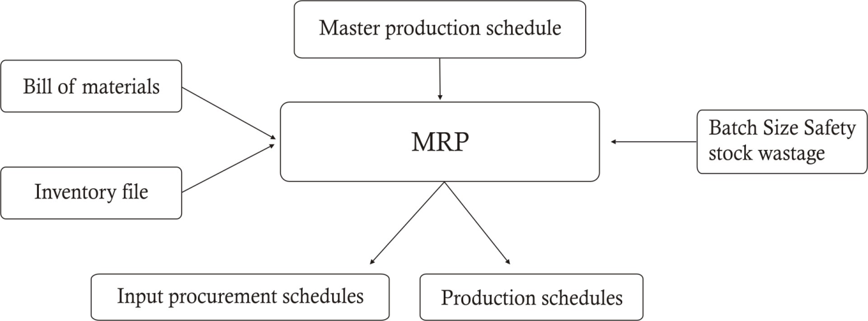

21.6-5 PREREQUISITES FOR SUCCESSFUL OPERATION
(i) Committed Management: Management should have a clear vision about the MRP. They should be committed to implement it. The initial hurdles should not upset them. Commitment implies that they are willing to spend not only significant amount of money but also their time.
(ii) Accurate data: The outputs of MRP (Production and procurement schedules) depend up on accurate data regarding Master Production Schedule, Bill of materials, inventory files, lead time, safety stock, quantity discount, wastages, batch size etc.
(iii) Training to staff: Ensure that the staff people fully understand what the MRP is, what are its benefits and how it is to be implemented.
(iv) Customized software to suit the company’s requirements.
(v) Continuous monitoring through internal control to ensure total adherence to schedule.
(vi) Strict Standards should be set regarding usage of inputs.

21.6-6 BENEFITS
Implementing or improving Material Requirements Planning can provide the following benefits:
- Reduced Inventory Levels resulting in savings of cost and investments
- Reduced input Shortages leading to higher profitability.
- Improved Shipping Performance leading to customers satisfaction
- Improved Productivity leading to satisfied worker
- Simplified and Accurate Scheduling
- Less Scrap and Rework
- Improved Communication
- Improved Competitive Position

QUESTIONS

Q. No. 21.17T State the requirement of a Material Requirement Planning (MRP) system.
(CA Final Nov. 2002)
Answer: Please refer paragraph 21.6-4

Q. No.21.18T Outline the objectives of MRP. (CA Final May 2004).
Answer: Please refer paragraph 21.6-3.

Q. No.21.19T Mention the data required to operate the MRP system. (CA Final Nov. 2010).
Answer: Please refer paragraph 21.6-4.

Q. No.21.20T Explain the pre requisites for successful operation of MRP.
(CA Final May 2011).
Answer: Please refer paragraph 21.6-5.

ENTERPRISE RESOURCES PLANNING

21.7-1 CONCEPT
ERP system fully integrates all the departments and functions throughout an organization into a single information system that can serve the particular needs of the different departments. (Integration is the key word for ERP systems). It co-ordinates enterprise-wide resources, information and activities needed to complete business processes carried at different locations in different countries speaking and writing different languages in different time zones using different technologies. It is a method for the effective planning and controlling of all the resources needed to take, make, ship and account for customer orders in a manufacturing, distribution or service company. Many companies use ERP to get integrated with important outside stakeholders like customers, suppliers etc.

ERP is a management information system that integrates and automates many of the business processes associated with the operations of a company. These typically include manufacturing, logistics, warehousing, marketing, distribution, inventory, packing, shipping, invoicing, and accounting. ERP software can aid in the control of many business activities, like sales, delivery, billing, production, inventory management, and Human Resource Management Systems. ERPs are cross-functional and enterprise wide.

ER involves building a single software program that serves the needs of people in various departments. Each of those departments typically has its own computer system suitable for the particular ways that the department does its work. But ERP combines them all together into a single, integrated software program that runs on a single database so that the various departments can more easily share information and communicate with each other.

To implement ERP systems, companies often seek the help of the consulting companies. Consulting in ERP involves two levels, namely business consulting and technical consulting. A business consultant studies an organization’s current business processes and matches them to the corresponding processes in the ERP system, thus 'integrating' the ERP system to the organization’s needs. Technical consulting often involves programming.
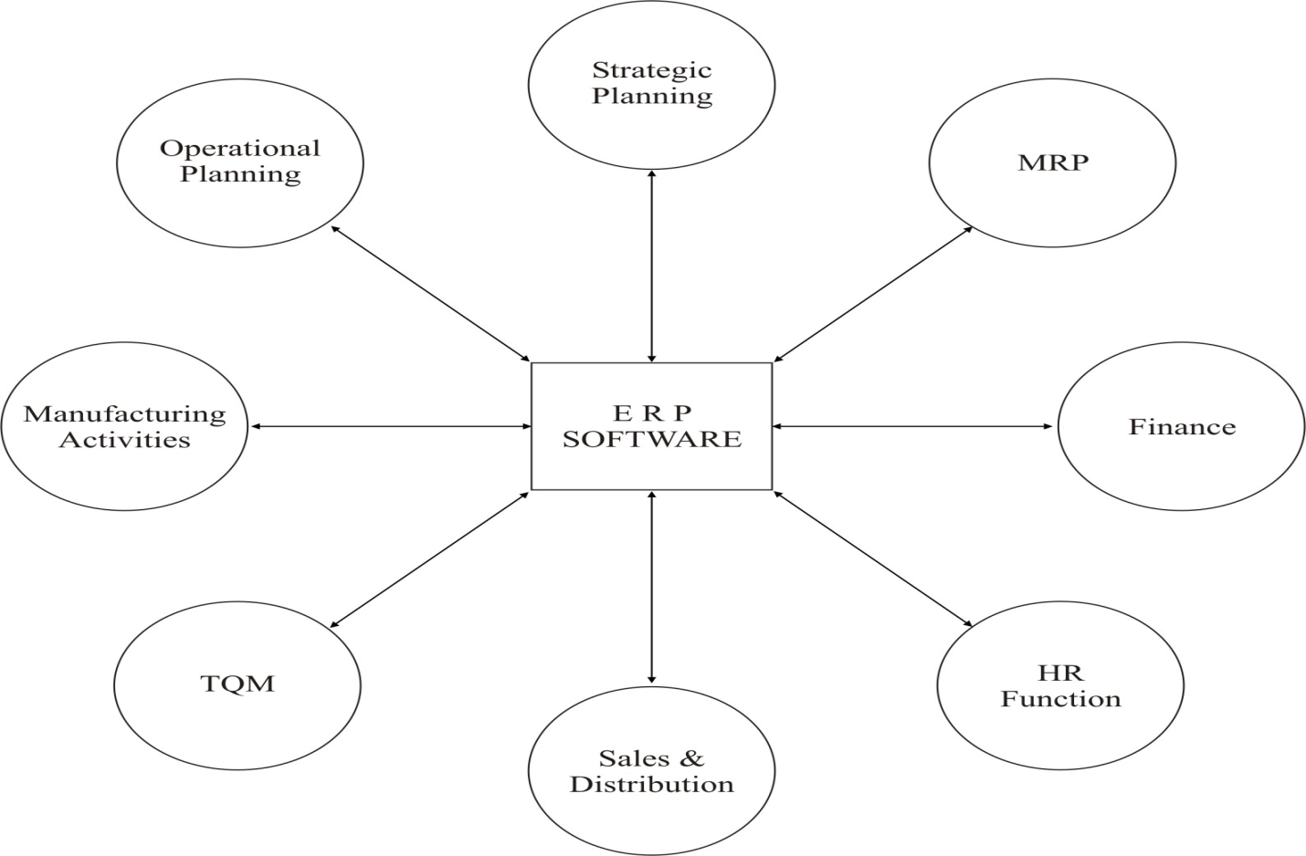

21.7-2 FEATURES
- ERP system fully integrates all the departments and functions throughout an organization into a single information system.
- It co-ordinates enterprise-wide resources, information and activities needed to complete business processes carried at different locations in different countries speaking and writing different languages in different time zones using different technologies.
- Limited access to the data bank of the organization may be provided to some outside stakeholders like valued customers, critical suppliers etc.



- Allows access to information in a real-time environment. ERP systems always provide updated information.
- ERP provides facilities for integrating the future requirements of the business and adaption of new technologies.
- ERP allows use of video-conferencing, electronic funds transfer, SMS ad mass mailing services etc.
- ERP shares common data and practices across the enterprise.
- No double encoding of information.
- Automates tasks by integrating business process
- Notoriously difficult to implement. ERP vendors lay heavy blame on unreasonable expectations of the client companies and the client companies blame the ERP vendors for lack of support.

21.7-3 BENEFITS OF ERP
- Multinational companies of today run the complex businesses. Such businesses are carried at different locations, in different countries, speaking and writing different languages, in different time zones, using different technologies, transacting in different currencies, employing multilingual people and governed by different laws rules and regulations). ERP systems make the running of such complex businesses quite handy.
- ERP systems help the organization in drastically improving the capacity and resource utilization. This leads to improved profitability.
- ERP systems improve the quality and efficiency of a business. This leads to improved customers satisfaction.
- ERP systems support the upper level management by providing them with critical decision making information.
- ERP systems provide the enterprise-wide single source of real time updated information.
- ERP systems lay down the foundation for the strong future by providing the facilities for integrating the future requirements of the business and adaption of new technologies.
- ERP systems make the processes and operations more flexible.
- ERP systems help in reducing the errors due to better coordination.
- ERP systems serve the customers efficiently by way of prompt response and follow up.
- ERP systems lead to reduced requirement of workforce.
21.7-4 LIMITATIONS OF ERP
- Too costly in terms of money and time
- Profoundly complex
- Notoriously difficult to implement. ERP vendors lay heavy blame on unreasonable expectations of the client companies and the client companies blame the ERP vendors for lack of support.
- Difficult to managing the transition.

QUESTIONS

Q. No. 21.21T State the major features of ERP. (CA Final May 2003, Nov. 2004)
Answer: Please refer paragraph 21.7-2

Q. No. 21.22T State the benefits accruing from ERP. (CA Final May 2004, Nov. 2010).
Answer: Please refer paragraph 21.7-3

Q. No. 21.23T What do you mean by ERP? Name the six benefits of ERP.
(CA Final Nov. 2006)
Answer: Please refer paragraphs 21.7-1 and 21.7-3.

GENERAL TOPICS

21.8-1 OPERATIONAL DATABASE
The operational database contains and provides efficient access to detailed data used to run the day-to-day operations of the business. Such database is accessed by an Operational System to carry out regular operations of an organization. Such databases allow a firm to enter, gather, and retrieve the related information. It stores detailed data to support the operations of the entire organization. The data continually changes as updates are made.

The simplest example is the database of customers’ accounts by a bank. On being accessed by the operational system of the bank, it allows to enter, gather and retrieve any transaction of the customer with the bank.

The key attributes of an operational database are:
- Related information : The database should contain and provide the related information.
- Real time update: The database should be capable to track real-time information. For example, the customer’s account in the bank’s database should be immediately updated on the transaction with the bank.
- Optimized to support the transactions: The database should provide the optimum support to the system. For example, when the sales transaction is entered into the database, the inventory record should be immediately and automatically modified.
- Data sharing: Data should be available to all persons authorized to operate the system. For secrecy and safety, these persons may be given passwords.

21.8-2 ROUTINELY RECORDED DATA
The cost accounting system is expected to accumulate data for three purposes (i) cost ascertainment (ii) decision making, and (iii) planning and control. The system should convert the data into information required for different purposes.

Cost ascertain is required for pricing and inventory valuation. For this purpose, the data should be converted into information in such a way that costs may be ascertained on the basis of proper allocation of costs after classifying the overheads into three categories (i) Manufacturing overheads (ii) Administration overheads and (iii) Selling and distribution overheads. All three types of overheads are allocated for selling price fixation. Selling and distribution overheads are never part of inventory valuation and hence should be allocated on the basis of sales. The other two overheads may be allocated on the basis of production or sales depending the company’s accepted policy.

For decision making we require the estimated future data. For some decisions, we need opportunity costs. Distinction between fixed and variable costs is of utmost importance for this purpose.

For planning and control, the budgeted and actual data should be made available. If the company follows responsibility accounting approach, responsibility centres based information should be available. If standard costing is followed, the cost element based data may be made available.

Hence, the data in the formation system should be properly classified and recorded otherwise there is danger that the data may be misleading. Information system is not a dumping ground of information. It is a well organized warehouse of information required for various purposes.

Q. No.21.24T Outline the key attributes of an operational database. (CA Final May 2003)
OR State the characteristic features of a database created for operational control
and decision making. (CA Final Nov. 2008)
Answer: Please refer paragraph 21.8-1.

Q. No.21.25T “The diverse use of routinely recorded cost data give rise to a fundamental danger – information prepared for one purpose can be grossly misleading to another context”. Discuss to what extent the above statement is valid and explain your conclusion.
Answer: Please refer paragraph 21.8-2.

21.9 DISINVESTMENT
A disinvestment (also referred as divestment) is the opposite of an investment. Disinvestment is an action of company selling a segment of its business or liquidating an asset or subsidiary. The term also covers sale of a whole/part of its share-holding by the controlling shareholders of the company. In India, the term is quite popular with reference of sale of shares of Public Sector companies by Government of India.

Reasons for disinvestments
- To put the proceeds from the disinvestment to better use that garners a higher return on investment.
- The company may have to divest unwillingly to meet its needs of cash to sustain operations or to redeem the heavy burden of borrowings.
- Underperformance of segments of the business.
- To focus on its core business i.e. to focus on what it does best, a company may sell the businesses that are not part of its core operations.
- Forced by the authority in operation.
- Sometimes, the breakup value of the business is more than value of the entire entity. In this situation disinvestment may be used to increase the wealth of the shareholders.

Q. No.21.26 T What is disinvestment strategy? Highlight the main reasons for disinvestment. (CA Final May 2009)
Answer: Please refer paragraph 21.9.

21.10 QUALITATIVE FACTORS AFFECTING OUTSOURCING DECISIONS
- Focus resources on core competencies: Companies can achieve best possible success by concentrating what they do best and outsource the rest.

- Improve time to market: By outsourcing companies can considerably improve the time of launching the products.

- Sharing the risk : Through outsourcing the company shares its business risk with the suppliers of outsourced activity.

- Delivery and quality: Outsourcing is favoured if it improves the delivery and quality of the product/service.

- Availability of trained, qualified manpower: One motive of outsourcing is gaining access to such talents which are not available in house.

- Effect on employee morale: Sometimes, the outsourcing may demoralize the employees. Trade unions generally oppose the outsourcing.

- Availability of reliable vendor: For successful outsourcing, the vendor must be capable and culturally compatible. It must be reliable in terms of timely delivery of required quantity at the required place and maintaining quality and confidentiality and long term association.

- Savings in management time: Management people have to devote less time and attention to the outsourced activities.

- Access to new technology: Outsourcing may provide access to new technology especially in the areas where the technology changes fast.

- Get rid of problem functions: Outsourcing may be considered for the activities which are difficult to manage in house and employees are underperforming.
Q. No.21.27T What qualitative factors should be considered in a decision to outsource manufacturing a product? (CA Final Nov.2012)
Answer: Please refer paragraph 21.10.

21.11 CHANGING MANUFACTURING COSTS
In recent years the composition of manufacturing costs has changed on the following lines:
- Decrease in labour cost: The manufacturing processes are carried by mechanization and automation resulting in decrease in labour cost. In high tech environment, the direct labour disappears. Generally, a few engineers operate the plant.
- Labour cost is fixed cost: It is not easy to fire the labour. Most of the organizations have permanent labour force. Hence, even the small amount of labour cost does not vary with the volumes of output.
- Increased amount of depreciation: Mechanization and automation results in increased amount of cost on account of depreciation.
- Increased amount of other manufacturing fixed overheads: Mechanization and automation results in increased amount of cost on account of other fixed overheads like repairs, insurance, salary of factory managers and supervisors, lightings, rent of factory building etc.
The cost accounting systems have been affected by the changes in manufacturing costs in the following two ways:
- Overhead Assignment: Traditional costing has been discarded as the method of assignment costs to the products/services. It has been widely incurred that the overheads are not incurred on the basis of units of output; rather these are incurred on the basis of activities. Activity based costing has widely been accepted for assignment of cost to the products/services.

- Decision making: Throughput costing has been accepted as the method of decisions making. In this approach, only material costs are assumed to be variable. All other costs are treated as fixed costs. Contribution under this approach is referred as throughput or throughput contribution.

- Value change Analysis is gaining wide acceptability for getting the competitive advantage in the form of Cost leadership and Product differentiation.

Q. No.21.28T How has the composition of manufacturing costs changed during recent years? How has this change affected the design of cost accounting systems?
(CA Final May 2006) Answer: Please refer paragraph 21.11.

21.12 INVENTORY HOLDING DURING INFLATIONARY CONDITIONS
Generally it is believed that that holding large inventories during inflationary conditions is beneficial for the concern. This may be true in hyperinflation situations.

It may not always hold good. The reasons are as follows:
- Quality may deteriorate
- May perish
- May become obsolete
- Theft
- Storage cost
- Interest cost
- May attract action from regulatory authorities

To face the inflationary situations, the firms may opt for commodities futures contracts in the required items, rather to hold the inventory during the inflationary conditions.

21.29T Critically examine “It is prudent to hold large inventories in an inflationary economy”.
(CA Final Nov. 2005)
Answer: Please refer paragraph 21.12.

