Chapter 18

LINEAR PROGRAMMING
CHAPTER INDEX
Basic Concept
- Assumptions of LP
Problem Formulation
Graphic Method
Simplex Method
(a) Maximization Problems
(with all the constraints having “≤” sign)
(b) MINIMIZATION PROBLEMS
(with all constraints having “≥” sign)
(c) MINIMIZATION PROBLEMS
(with some constraints having “≤”/ “=”sign)
(d) MAXIMIZATION PROBLEMS
(with some constraints having “≥”/“=”sign)
Primal and Dual
Uses of LP
Limitations of LP
Advantages of LP
Applications of LP

18.1 BASIC CONCEPT Management is concerned with utilization of limited resources to the best advantage. Linear Programming (LP) is a method of allocating the resources in an optimal way. It is a procedure to optimize the resource allocation for obtaining a particular objective when there are alternative uses of the resources. The objective in the resource allocation may be either cost minimization or profit maximization with limits on resources. In this way, we can say that the LP technique is applied to find the optimal product mix in such a way that total profits are maximized or total costs are minimized.

18.1-1 ASSUMPTIONS UNDER LP
- Objective function and every constraint are linear.
- Decision variables are not negative
- Proportionality: Increase or decrease in the quantities of decision variables will affect the objective function and every constraint in the proportional way.
- Certainty: All parameters (all coefficients in the objective function and the constraints) are known with certainty.
- Decision variables can be fractions.
- The products, labour efficiency, machines etc are assumed to be identical.

18.2 We shall be studying this technique in three parts:
- Problem formulation
- Graphic Method of Linear Programming
- Simplex Method of Linear Programming

18.2-1 PROBLEM FORMULATION
Problem formulation refers to translating the real life problem into a format of mathematical equalities and inequalities that abstracts all the essential elements of the problem. There are three parts of the formation (i) Objective function (ii) a set of constraints and (iii) Non-negativity restriction.

LP problem has got three points:
- Objective function: This describes the object of the management in precise and clear terms in quantitative form. We identify the decision variables and assume optimal values. For example if we have to find the optimal mix of two products, we may assume that we shall be producing x units of the first and y units of the second product. Suppose contribution per unit of the first product is Rs.5 and the second one is Rs.7, the objective function will be : Maximize Z = 5x + 7y.
- A set of constraints: These are the limitations of the management expressed in quantitative form.
- Non-negative restriction: This restriction prescribes that the decision variables
should only be zero or positive.

Q.No.18.1 A company has three operational departments (weaving, processing and packing) with capacity to produce three types of clothes namely suiting, shirting and woolens yielding the profit Rs.2, Rs.4 and Rs. 3 per meter respectively. One meter suiting require 3 minutes in weaving, 2 minutes in processing and 1 minute in packing; one meter shirting require 4minutes in weaving, 1 minutes in processing and 3 minute in packing; One meter woolen require 3 minutes in each department. In a week, total run time of each department is 60, 40 and 80 hours for weaving, processing and packing departments respectively. Formulate the linear programming problem to find the product mix to maximize the profit. (CA Final Nov. 1998)
Answer
Time per meter in minutes
 | Weaving | Processing | Packing
Suitings | 3 | 2 | 1
Shirtings | 4 | 1 | 3
woollens | 3 | 3 | 3

Let’s produce x meters of suitings, y meters of shirtings and z meters of woolens.

Objective function: Maximize Z = 2x + 4y + 3z
Subject to :
3x +4y + 3z ≤ 3600
2x +y + 3z ≤ 2400
x +3y + 3z ≤ 4800
x , y , z ≥ 0

Q. No.18.2
A farm is engaged in breeding pigs. The pigs are fed on various products grown on the farm. In view of the need to ensure certain nutrient constituents (call them as X, Y and Z). It becomes necessary to two additional products say A and B. One unit of A contains 36 units of X, 3 units of Y and 20 units of Z. One unit of B contains 6 units of X, 12 units of Y and 10 units of Z. The minimum requirement of X, Y and Z is 108 units, 36 units and 100 units respectively. Product A costs Rs. 20 per unit and product B costs Rs.40 per unit. Formulate LPP to minimize the total cost. (CA Final May 2002)

Answer:
Let’s purchase x units of A and y units of B
Objective function :Z = Minimize 20x + 40y
Subject to :
36x + 6y ≥ 108
3x +12y ≥ 36
20x + 10y ≥ 100
x, y, z ≥ 0

Q. No. 18.3:
The most recent audited summarized Balance sheet of Stop and Shop Financial services is given below:

Balance-Sheet as on 31st march, 2004
Liabilities | Rs. (Lakhs) | Assets | Rs. (Lakhs)
Equity share capital | 65 | Fixed assets ( given on lease) | 375
Reserve and surplus | 110 | Other fixed assets | 50
Term loan from IFCI | 80 | Investments | 20
Public deposits | 150 | Current assets  -Stock on hire  -Receivables  -Other current assets | 80  30  35
Bank borrowings | 147 | Misc. expenditure | 12
Other Current liabilities | 50
Total | 602 | Total | 602

The company intends to enhance its investments in the lease portfolio by another Rs.1000 Lakhs. For this purpose it would like to raise a mix of debt and equity in such a way that the overall cost of raising the additional funds is minimized. The following constraints apply to the way the funds can be mobilized:
- Total debt divided by net owned funds cannot exceed 10.
- Amount borrowed from the financial institutions cannot exceed 25% of the net worth.
- Maximum amount of bank borrowings cannot exceed three times the net owned funds.
- The company would like to keep the total public deposits limited to 40% of total debt.

The post tax costs of different sources of finance are as follows:
Equity | Term loans | Public deposits | Bank borrowings
25% | 8.50% | 7% | 10%

Formulate the funding problem as LPP.

Notes: (a) Total debt = Term loans from FIs + Public deposits + Bank borrowings
(b) Net worth = Equity share capital and Reserve and surplus
(c) Net owned funds = Net worth minus Misc. expenditure.
(CA Final May 1994)
Answer
Let’s raise x₁ from equity, x₂ term loans from FIs and x₃ from public deposits and x₄ from bank borrowings.
Objective function: Minimize 0.25x₁ + 0.0850x₂ + 0.07x₃ + 0.10x₄
Subject to:
x₁ + x₂ + x₃ + x₄ = 1,000 ----------------(i)

377 + x₂ + x₃ + x₄ ≤ 10
163 + x₁
–10x₁ + x₂ + x₃ + x₄ ≤ 1253 ----------------------(ii)
80 + x₂ ≤ 0.25(175 + x₁)
0.25x₁ – x₂ ≥ 36.25 ---------------------------------------(iii)

147 + x₄ ≤ 3(163 + x₁)
x₄ – 3x₁ ≤ 342 -------------------------------------------------(iv)

150 +x₃ ≤ 0.40(377 + x₂ + x₃ + x₄ )
0.60x₃ – 0.40x₂ – 0.40x₄ ≤ 0.80 -----------------------(v)

x₁, x_{2,}, x₃ , x₄ ≥ 0 ----------------------------------------(vi)

Q. No. 18.4:
Welltype Manufacturing Company produces three types of typewriters: manual, electronic and deluxe. All the three models are required to be machined first and then assembled. The time required for various models are as follows:
Types | Machine time (Hours) | Assembly time ( Hours)
Manual | 15 | 4
Electronic | 12 | 3
Deluxe | 14 | 5

The total available machine time and assembly time are 3000 hours and 1200 hours respectively. The data regarding the selling price and variable costs for three types are:
 | Manual | Electronic | Deluxe
Selling price (Rs) | 4100 | 7500 | 14600
V. Cost | 2500 | 4500 | 9000

The company sells all the three types on credit basis, but will collect the amounts on the first of next month. The variable costs will have to be paid in cash. This company has taken a loan of Rs.40000 from a cooperative bank and this company will have to repay it to the bank on 1st April, 2003. The TNC Bank from whom this company has borrowed Rs.60000 has expressed its approval to renew the loan.

Balance-Sheet of the company as on 31.3.2003
Liabilities | Amount Rs. | Assets | Amount Rs.
Equity share capital | 1,50,000 | Land | 90,000
Capital reserve | 15,000 | Building | 70,000
General reserve | 1,10,000 | Plant | 1,00,000
Profit and Loss account | 25,000 | Furniture | 15,000
Long term loan | 1,00,000 | Vehicles | 30,000
Loan from TNC Bank | 60,000 | Inventory | 5,000
Loan from Co-op. Bank | 40,000 | Receivables | 50,000
 |  | Cash | 1,40,000
Total | 5,00,000 | Total | 5,00,000

The company has to pay a sum of Rs.10000 towards fixed overheads for the month. Interest on long term loan is to be paid every month at 24% per annum. Interest on loans from TNC and Co-operative banks may be taken at Rs.1200 for the month. Also the company has promised to deliver 2 manual and 8 deluxe typewriters to one of the valued customer next month. Also make sure that the level of operations in this company is subject of availability of cash next month. This company will also be able to sell all three types of type writers in the market. The Senior Manager of this company desires to know as to how many units of each typewriter must be manufactured next month so as to maximize the profit of the company. Formulate LPP. (CA Final May 1993)

Answer
Let’s produce x units of manual, y units of electronic and z units of Deluxe
Objective function: Maximize 1600x + 3000y + 5600z
Subject to :
x ≥ 2 ------------------------------(i)
z ≥ 8 ------------------------------(ii)
15x +12y + 14z ≤ 3,000 ------(iii)
4x + 3y + 5z ≤ 1,200 ----------(iv)
2,500x + 4,500y + 9,000z ≤ 1,40,000 + 50000 – 40,000 – 10000 – 2000 – 1200
25x + 45y + 90z ≤ 1,368 ---------------------------(v)
z ≥ 0 -----------------------------------------------(vi)

Q. No. 18.5:
Consider a company that must produce two products over three month duration. The company can pay for materials and labour from two sources: company funds and borrowed funds.
The firm faces three decisions:
- How many units should it produce of Product 1?
- How many units should it produce of product 2?
- How much money should it borrow to support the production of the two products?
In making these decisions, the firm wishes to maximize the profit contribution subject to the conditions stated below:
- It can sell as many units it can produce. The capacity constraints, together with the cost and price data, are given in Table I:
Table I: Capacity, Price and cost data
Product | Selling price | Cost of production/ unit | Required hours per unit
 | (Rs.) | (Rs.) | Department A | Department B | Department C
1 | 14 | 10 | 0.50 | 0.30 | 0.20
2 | 11 | 8 | 0.30 | 0.40 | 0.10
Available hours ( three months period) |  |  | 500 | 400 | 200

- The available company funds during the production period will be Rs.3 lakhs.
- A bank will give loans up to Rs.2,00,000 for the production period of three months at an interest rate of 20% p.a. provided the company’s acid-test ratio is at least 1 to 1 while the loan is outstanding. Take acid test ratio given by :
Surplus cash on hand after production + Accounts receivable
------------------------------------------------------------------------------------
Bank borrowings + interest accrued thereon

- Also make sure that the needed funds are made available for meeting the production costs.
Formulate LPP. (CA Final Nov.1992)
Answer
Let’s produce x units of product 1 and y units of product 2. Let’s borrow Rs.z.
Objective function: Maximize 4x + 3y – 0.05z
Subject to :
Z ≤ 2,00,000 -------------------------------------(i)
0.50x + 0.30y ≤ 500 ----------------------------(ii)
0.30x + 0.40y ≤ 400 ----------------------------(iii)
0.20x + 0.10y ≤ 200 ----------------------------(iv)

3,00,000 + z +14x + 11y – 10x – 8y ≥ 1
z + 0.05z

3,00,000 + z +14x + 11y – 10x – 8y ≥ z + 0.05z

3,00,000 + z +4x + 3y ≥ z + 0.05z

3,00,000 + 4x + 3y ≥ 0.05z

– 4 x – 3y + 0.05z ≤ 3,00,000 --------------------(v)

10x + 8y ≤ 3,00,000 + z
10x + 8y – z ≤ 3,00,000 ------------------------------(vi)

x, y, z ≥ 0 -----------------------------------------------(vii)

Q. No. 18.6:
A computer company produces three types of models, which are first to be machined and then assembled. The time (hours per unit) for these operations are as follows:
Model | Machine Time | Assembly time
P III | 20 | 5
P II | 15 | 4
Celeron | 12 | 3

The total available machine time and assembly time are 1,000 hours and 1500 hours respectively. The selling price and variable cost for the three models are:
 | P III | P II | Celeron
Selling price (Rs.) | 3,000 | 5,000 | 15,000
Variable cost /unit (Rs.) | 2,000 | 4,000 | 8,000

The company has taken a loan of Rs.50,000 from a nationalized bank which is required to be re paid on 1.4.2001. In addition, the company has borrowed Rs.1,00,000 from a co-operative bank. However, this bank has given the consent to renew the loan.

The Balance Sheet of the company as on 31.3.2001 is as follows:
Liabilities | Rs. | Assets | Rs.
Equity share capital | 1,00,000 | Land | 80,000
Capital reserve | 20,000 | Building | 50,000
P & L A/c | 30,000 | P & Machinery | 1,00,000
Long-term Loan | 2,00,000 | Furniture | 20,000
Loan (co-operative bank) | 1,00,000 | Vehicles | 40,000
Loan (nationalized bank) | 50,000 | Cash | 2,10,000
Total | 5,00,000 | Total | 5,00,000
The company is required to a sum of Rs.15,000 towards the salary. Interest on Long-term loan is to be paid every month @ 18% per annum. Interest on loan from nationalized bank and Loan co-operative bank amounts to Rs.1,500 per month. The company has already promised to deliver the three PIII, two PII and five Celeron type of computers to M/s ABC Ltd next month. The level of operation in the company is subject to the availability of cash next month.

The company Manager is willing to know that how many units of each model must be manufactured next month, so as to maximize the profit. Formulate a LPP for the above.
(CA Final May, 2001)

Answer:

Let’s produce x units of PIII , y units of PII and z units of Celeron
Objective function: Maximize : 1000x + 1000y + 7000z

Calculation of cash Availability
Opening cash in hand | + 2,10,000
Loan repayment | - 50,000
Interest on Long term loan | - 3,000
Other interests | - 1,500
Cost of production | - (2000x + 4000y + 8000z)
Salary | - 15,000
Total | 1,40,500 - (2000x + 4000y + 8000z)

1,40,500 - (2000x + 4000y + 8000z) ≥ 0
2000x + 4000y + 8000z ≤ 1,40,500 ----------------------------------------(i)
x ≥ 3 ---------------------------------------------------------------------------(ii)
y ≥ 2 ----------------------------------------------------------------------------(iii)
z ≥ 5 ----------------------------------------------------------------------------(iv)
20x + 15y + 12z ≤ 1000 ----------------------------------------------------(v)
5x + 4y + 3z ≤ 1500 -----------------------------------------------------(vi)

Q. No. 18.7
A city hospital has the following minimal daily requirement for nurses:
Period | Clock time ( 24 hours day) | Minimal number of nurses required
1 | 6 AM – 10 AM | 2
2 | 10 AM – 2 PM | 7
3 | 2 PM – 6 PM | 15
4 | 6 PM – 10 PM | 8
5 | 10PM – 2 AM | 20
6 | 2 AM – 6 AM | 6

Nurses report to the hospital at the beginning of each period and work for consecutive 8 hours. The hospital wants to determine the minimal number of nurses to be employed so that there will be sufficient number of nurses available for each period. Formulate LPP. Do not solve. (University of Delhi)

Answer
Let the number of nurses reporting at 6 AM = x₁
Let the number of nurses reporting at 10 AM = x₂
Let the number of nurses reporting at 2 PM = x₃
Let the number of nurses reporting at 6 PM = x₄
Let the number of nurses reporting at 10 PM = x₅
Let the number of nurses reporting at 2 AM = x₆
Objective function: Minimize x₁ ₊ x₂ ₊ x₃ ₊ x₄ ₊ x₅ ₊ x_{6.}
Subject to:→ | (i) x₆ ₊ x₁ ≥ 2 | (ii) x₁ ₊ x₂ ≥ 7 | (iii) x₂ ₊ x₃ ≥ 15
(iv) x₃ ₊ x₄ ≥ 8 | (v) x₄ ₊ x₅ ≥ 20 | (vi) x₅ ₊ x₆ ≥ 6 | (vii) x_{1,} x_{2,,} x₃, x₄, x₅, x₆ ≥ 0

Q. No. 18.8
The following matrix gives the unit cost of transporting a product from production plants P₁ , P₂ , and P₃ to destinations D_{1 ,} D₂ ,and D₃ . Plants P₁ , P₂ , and P₃ have a maximum production of 65, 24, and 111 units respectively and destinations D_{1 ,} D₂ ,and D₃ must receive at least 60,65 and 75 units respectively.
To  From | D₁ | D₂ | D₃ | Supply
P₁ | Rs.400 | Rs.600 | Rs. 800 | 65
P₂ | Rs.1,000 | Rs.1,200 | Rs.1400 | 24
P₃ | Rs.500 | Rs.900 | Rs.700 | 111
Demand | 60 | 65 | 75 | 200

You are required to formulate the above as linear programming problem. (Only formulation is needed. Please do not solve) (CA Final Nov. 2008)
Answer
Let the units transferred from P₁ to D₁ = p₁d₁
Let the units transferred from P₁ to D₂ = p₁d₂
Let the units transferred from P₁ to D₃ = p₁d₃
Let the units transferred from P₂ to D₁ = p₂d₁
Let the units transferred from P₂ to D₂ = p₂d₂
Let the units transferred from P₂ to D₃ = p₂d₃
Let the units transferred from P₃ to D₁ = p₃d₁
Let the units transferred from P₃ to D₂ = p₃d₂
Let the units transferred from P₃ to D₃ = p₃d₃

Subject to:
p₁d₁ + p₁d₂ + p₁d₃ ≤ 65
p₂d₁ + p₂d₂ + p₂d₃ ≤ 24
p₃d₁ + p₃d₂ + p₃d₃ ≤ 111
p₁d₁ + p₂d₁ + p₃d₁ ≤ 60
p₁d₂ + p₂d₂ + p₃d₂ ≤ 65
p₁d₃ + p₂d₃ + p₃d₃ ≤ 75

p₁d₁, p₁d₂, p₁d₃ , p₂d₁, p₂d₂, p₂d₃, p₃d₁, p₃d₂, p₃d₃ ≥ 0

Q. No. 18.9
A firm buys castings of P and Q type parts and sets as finished product after machining, boring and polishing. The purchasing cost for castings are Rs.3 and Rs.4 each for parts P and Q and selling casts are Rs.8 and Rs.10 respectively. Per hour capacity of machines used for machining, boring and polishing for two products is given below:
 | Parts
Capacity (per hour) | P | Q
Machining | 30 | 50
Boring | 30 | 45
Polishing | 45 | 30
The running costs for machining, boring and polishing are Rs.30, Rs.22.50 and Rs.22.50 per hour respectively. Formulate the linear programming problem to find out the product mix to maximize the profit. (CA Final May 1998)

Answer
Working notes:
Minutes per unit of P and Q
 | Minutes required per unit of P and Q |  | Cost per minute
 | P | Q | Cost per minute
Machining | 2 | 1.20 | 0.50
Boring | 2 | 1.3333 | 0.375
Polishing | 1.3333 | 2 | 0.375

Variable cost and contribution per unit of P and Q
 | P | Q
Material cost | 3.00 | 4.00
Finishing cost :
Machining | 1.00 | 0.60
Boring | 0.75 | 0.50
Polishing | 0.50 | 0.75
Total | 5.25 | 5.85
Selling Price | 8.00 | 10.00
Contribution per unit | 2.75 | 4.15

Main answer
Assume that the factory operates only for 1 hour
Let’s finish x units of P and y units of Q.
Objective function: Maximize 2.75x + 4.15y
Subject to:
2x + 1.20y ≤ 60 | 2x + 1.3333y ≤ 60
1.3333x + 2y ≤ 60 | x, y, z ≥ 0

Q. No. 18.10
In a chemical factory two products A and B are made involving two operations. The production of B also results in a by-product C. The product A can be sold at a profit of Rs.3 per unit and B at a profit of Rs.8 per unit. The by-product C has a profit of Rs.2 per unit. Forecasts show that up to 5 units of C can be sold. The company gets 3 units of C for each unit of B produced. The manufacturing times are 3 hours per unit for A on each of operation one and two and 4 hours and 5 hours per unit for B operation one and two respectively. Because the product C results from producing B, no time is used in producing C. The available times are 18 hours and 21 hours for operation one and two respectively. The company desires to know that how many A and B should be produced keeping C in mind to make the highest profit. Formulate LP model for this problem. (CA Final May 2000)

Answer
 | Operation I | Operation II
A | 3 | 3
B | 4 | 5
Total hours | 18 | 21

Let’s produce x units of A, y units of B and z units of C.
Objective function : Maximize 3x + 8y + 2z
Subject to:
3x + 4y ≤ 18 |  | 3x + 5y ≤ 21
z ≤ 5 | 3y = z |  | x, y, z ≥ 0

Q. No. 18.11
Transport Ltd. provides tourist vehicles of 3 types – 20-seater vans, 8-seater big cars and 5-seater small cars. These seating capacities are excluding the drivers. The company has 4 vehicles of the 20-seater van type, 10 vehicles of the 8-seater big car types and 20 vehicles of the 5-seater small car types. These vehicles have to be used to transport employees of their client company from their residences to their offices and back. All the residences are in the same housing colony. The offices are at two different places, one is the Head Office and the other is the Branch. Each vehicle plies only one round trip per day, if residence to office in the morning and office to residence in the evening. Each day, 180 officials need to be transported in Route I (from residence to Head Office and back) and 40 officials need to be transported in Route II (from Residence to Branch office and back). The cost per round trip for each type of vehicle along each route is given below.

You are required to formulate the information as a linear programming problem, with the objective of minimizing the total cost of hiring vehicles for the client company, subject to the constraints mentioned above. (Only formulation is required. Solution is not needed).
(Rs/round trip)
 | 20 - Seater Vans | 8 – Seater big cars | 5 – Seater small cars
Route I ─  Residence ─ Head Office and Back | 600 | 400 | 300
Route II ─  Residence ─ Branch Office and Back | 500 | 300 | 200
(CA Final May 2008)
Answer:
Route 1 :
Let the number of 20-seater vans = x₁, 8-seater big cars = x₂ and 5-seater small cars = x₃
Route 2:

Let the number of 20-seater vans = y₁, 8-seater big cars = y₂ and 5-seater small cars = y₃
Objective function: Minimize 600x₁ + 400x₂ + 300x₃ + 500y₁ + 300y₂ + 200y₃
Subject to :
x₁ + y₁ ≤ 4 | x₂ + y₂ ≤ 10 | x₃ + y₃ ≤ 20
20x₁ + 8x₂ + 5x₃ ≥ 180 | 20y₁ + 8y₂ + 5y₃ ≥ 40 | x₁ , x₂ , x₃ , y₁ , y₂ , y₃ ≥ 0

Q. No. 18.12
An oil refinery can blend three grades of crude oil to produce quality A and quality B petrol. Two possible blending processes are available. For each production run, the older process uses 5 units of crude Q, 7 units of crude P and 2 units of crude R and produces 9 units of A and 7 units of B. The newer process uses 3 units of crude Q, 9 unit of crude P and 4 units of crude R to produce 5 units of A and 9 units of B. Because of prior contract commitments, the refinery must produce at least 500 units of A and at least 300 units of B for the next month. It has 1,500 units of crude Q, 1,900 units of crude P and 1,000 of crude R. For each unit of A, refinery receives Rs.60 while for each unit of B it receives Rs.90. Formulate the problem as linear programming model so as to maximize the revenue.
(CA Final Nov. 2009)

Answer:
Working note
 | Q | P | R
Requirement to produce 9 units of A and 7 units of B | 5 units | 7 units | 2 units
Requirement to produce 5 units of A and 9 units of B | 3 units | 9 units | 4 units

Main Answer
Let’s produce 9x units of A and 7y units of B from older process
Let’s produce 5x units of A and 9y units of B from newer process
Objective function: Maximize: 60(9x + 5x) + 90(7y + 9y)
Subject to:
9x + 5x ≥ 500  (Minimum production of A) | 7y + 9y ≥ 300  (Minimum production of B) | 5x + 3y ≤ 1,500 (Crude Q)
7x + 9y ≤ 1,900 (Crude P) | 2x +4y ≤ 1,000 (Crude R) | x, y ≥ 0

Q. No. 18.13
A manufacturer produces three products A, B and C from three raw materials X, Y and Z. The cost of raw materials X, Y and Z is Rs.30, Rs.50 and Rs.120 per Kg respectively and they are available in a limited quantity of 20Kg of X, 15 kg of Y and 10 Kg of Z. The selling price of A, B and C is Rs.90, Rs. 100 and Rs.120 per Kg respectively. In order to produce one kg of A, 1/2 Kg of X, 1/4 Kg of Y and 1/4 Kg of Z are required. To produce one kg of B, 3/7 Kg of X, 2/7 Kg of Y and 2/7 Kg of Z are required. To produce one kg of C, 2/3 Kg of Y and 1/3 Kg of Z are required. Formulate the LPP to maximize the profit.
(CA Final Nov, 2000)

Answer
Cost per unit of output (Rs.)
 | A | B | C
Material X | 30x1/2 = 15.0000 | 30x3/7 = 12.8571 | ----
Material Y | 50x1/4 = 12.5000 | 50x2/7 = 14.2857 | 50x2/3 = 33.3333
Material Z | 120x1/4 = 30.0000 | 120x2/7 = 34.2857 | 120x1/3 = 40.0000
Cost per unit | 57.5000 | 61.4285 | 73.3333

Let’s produce x units of A, y units of B and z units of C
Objective function : maximize 32.50x + 38.5715y + 46.6667z
Subject to:
1/2.x + 3/7.y ≤ 20 | 1/4.x + 2/7.y + 2/3.z ≤ 15
1/4.x + 2/7.y + 1/3.z ≤ 10 | x , y , z ≥ 0

Q. No. 18.14
A firm produces three products A, B and C. It uses two types of raw materials I and II of which 5000 and 7500 units respectively are available. The raw material requirement (per unit of output) is given below:
Raw materials | Raw material requirement per unit of output
Raw materials | A | B | C
I | 3 | 4 | 5
II | 5 | 3 | 5

The labour time for each units of product A is twice that of product B and three times that of product C. The entire labour force of the firm can work for 3000 hours. The minimum demand of the three products is 600, 650 and 500 units respectively. Also the ratio of number of units produced must be equal to 2:3:4. Assuming the profits per unit of A, B and C as Rs.50, Rs.50 and Rs.80 respectively. Formulate LPP to maximize profit. (Adapted CA Final Nov. 1997)

Answer
Let’s produce x units of A, y units of B and z units of C.
Objective function : Maximize 50x + 50y + 80z
Subject to:
3x +4y + 5z ≤ 5000 -------------------------(i) | 5x +3y + 5z ≤ 7500---------------------------(ii)
3x + 1.50y + z ≤ 3000 ------------------(iii) | x : y :: 2:3  3x = 2y --------------------------------(iv)
y : z :: 3:4  4y = 3z -----------------------------------(v) | x ≥ 600 ----------------------------------------(vi)
y ≥ 650 --------------------------------------(vii) | z ≥ 500 -------------------------------------(viii)

Q. No. 18.15
A farm is engaged in breeding pigs. The pigs are fed on various products grown on the farm. In view of the need to ensure certain nutrient constituents (call them as X, Y and Z). It becomes necessary to two additional products say A and B. One unit of A contains 36 units of X, 3 units of Y and 20 units of Z. One unit of B contains 6 units of X, 12 units of Y and 10 units of Z. The minimum requirement of X, Y and Z is 108 units, 36 units and 100 units respectively. Product A costs Rs. 20 per unit and product B costs Rs.40 per unit. Formulate LPP to minimize the total cost. (CA Final May 2002)

Answer:
Let’s purchase x units of A and y units of B
Objective function: Minimize 20x + 40y
Subject to :
36x + 6y ≥ 108 | 3x +12y ≥ 36
20x + 10y ≥ 100 | x, y ≥ 0

Q.No. 18.16
A carpenter has started a workshop in which he manufactures handcarts. Each cart consists of a frame and two wheel. A frame uses 3 hours and a wheel uses 2 hours of labour of which 90 hours per week are available. The carpenter wants that he should manufacture at least 10 carts during the week. The cost of a frame is Rs.500 and that of wheel is Rs.200. Formulate the above as a linear programming problem.

Answer:
Let’s produce x units of frame and y units of wheel
Objective function : Minimize 500x + 200y
Subject to :
2x – y = 0 | 3x + 2y ≤ 90
x ≥ 10 | x, y ≥ 0

Q. No. 18.17
An investor is interested in investing Rs.15,00,000 in a portfolio of investments. The investment choices and expected rates of return on each one of them are:
Investment | Mutual Fund XY | Mutual Fund HN | Money Market Fund | Govt. Bonds | Share P | Share Q
Projected rate of return | 15% | 9% | 8% | 8.75% | 17% | 18%

The investor wants at least 40% of the investments in Government bonds. Because of the higher perceived risk of the two shares, he has specified that the combined investment in these two shares not to exceed Rs.2.60,000. The investor has also specified that at least 25% of the investment should be in the money market fund and that the amount of money invested in the shares should not exceed the amount invested in the mutual funds. His final condition is that the amount invested in the Mutual fund XY should not be more than the amount invested in mutual fund MN. The problem is to decide the amount of money to invest in each alternative so as to obtain the highest annual return.
Formulate the above as a LPP. (CA Final Nov. 2012)

Answer
Let Investment in Mutual fund XY = Rs.x₁, Mutual Fund HN = Rs.x₂, Money market fund = Rs.x₃,, Govt. Bonds = Rs.x₄, Share P = Rs.x₅ and Share Q = Rs.x₆.
Objective function: 0.15x₁ + 0.09x₂ + 0.08x₃ + 0.0875x₄ + 0.17x₅ + 0.18x₆
Subject to :
x₁ + x₂ + x₃ + x₄ + x₅ + x₆ = 15,00,000 |  | x₄ ≥ 6,00,000 |  |  | x₅ + x₆ ≤ 2,60,000
x₃ ≥ 3,75,000 | x₅ + x₆ ≤ x₁+x₂ |  | x₁ ≤ x₂ | x₁, x₂, x_{3,} x₄, x₅, x₆ ≥ 0

18.2-2 GRAPHIC METHOD OF LINEAR PROGRAMMING

This method can be used if there are two decision variables. Let’s understand the method of solving the LPP by applying graphic method with the help of an example.

Example: A company manufactures two electronic items – Item A and Item B. Given the following data, determine the optimal product mix.
 | A | B
Contribution per unit | Rs.2 | Rs.3
Labour hour per unit | 0.06 | 0.08
Machine hour per unit | 0.04 | 0.12
Total available hours : Labour 2400 and Machine 2400.

Answer:
Step(i) Assume optimal values of the of the two decision variables

Let’s manufacture x units of A and y units of B.

Step(ii) Formulate the LPP.

Let produce x units of A and y units of B
Objective function: Maximize 2x + 3y
Subject to:
0.06x + 0.08y ≤ 2,400
0.04x + 0.12y ≤ 2,400
x, y ≥ 0

Step(iii) Find the values of x and y based on each constraint considering the inequality as equality.

Let’s convert the inequalities to equalities:
 | x | y
0.06x + 0.08y = 2,400 | 0 | 30,000
0.06x + 0.08y = 2,400 | 40,000 | 0
0.04x + 0.12y = 2,400 | 0 | 20,000
0.04x + 0.12y = 2,400 | 60,000 | 0

Step(iv) Draw the graph of each of the constraints.
Labour hour constraint Line | Graph showing lines of each of the two constraints.
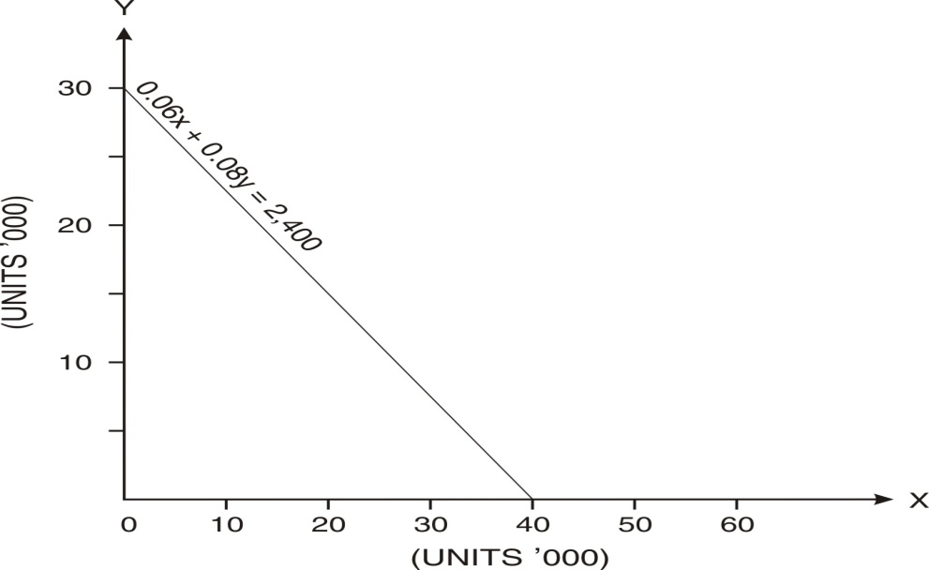 | 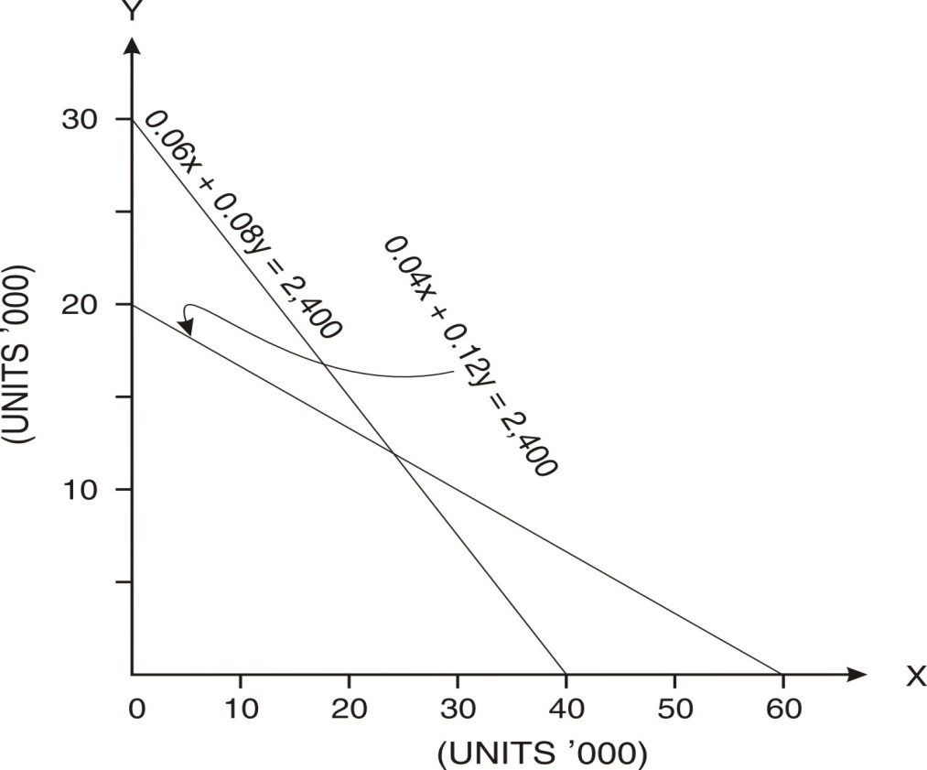

Step(v) Determine the valid side of each constraint. | Step(vi) Find the common feasible solution area.
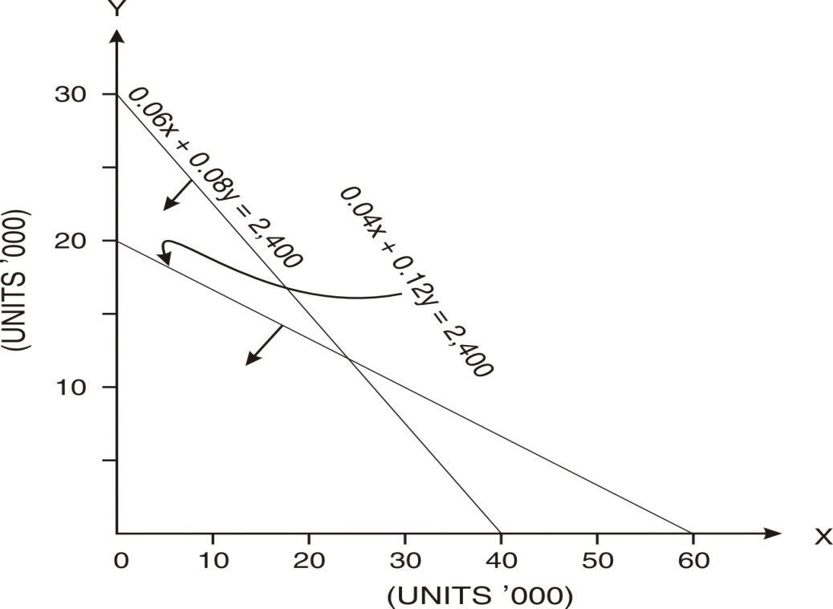 | 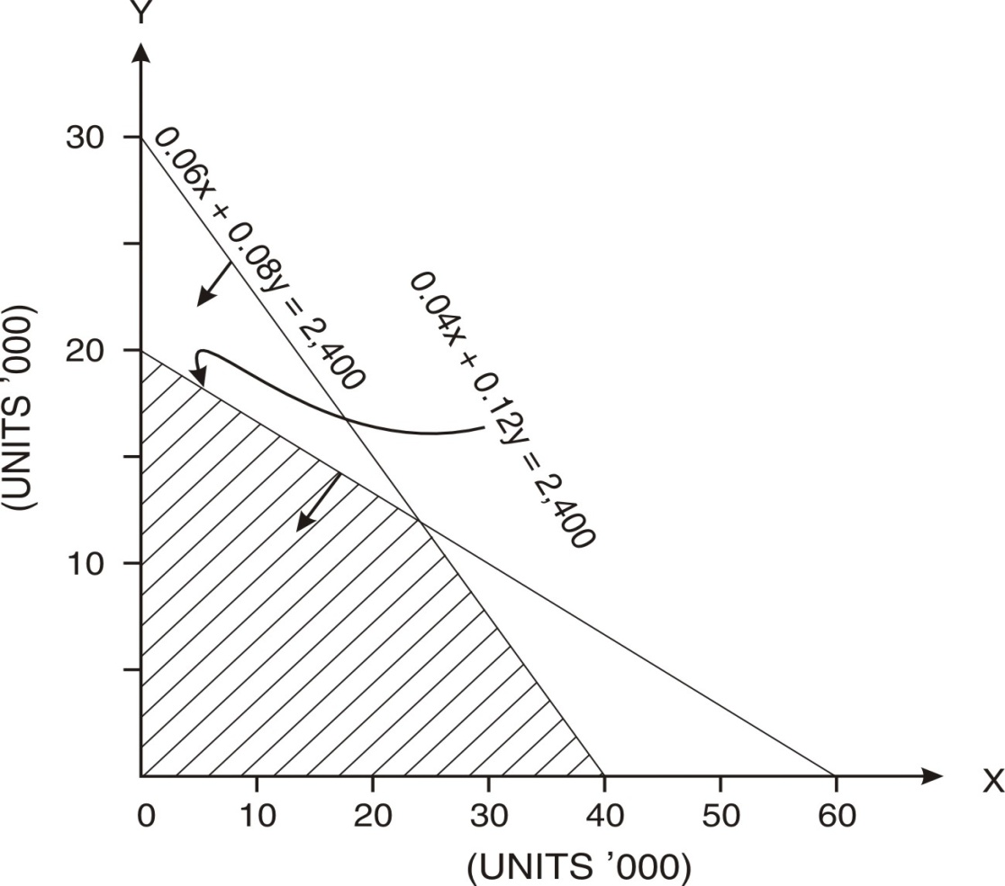

The shaded area of the graph comprises the area common to all the regions defined by the constraints. This area is known as the feasible solution area.

Step(vii) Find the extreme points of common feasible solution area.
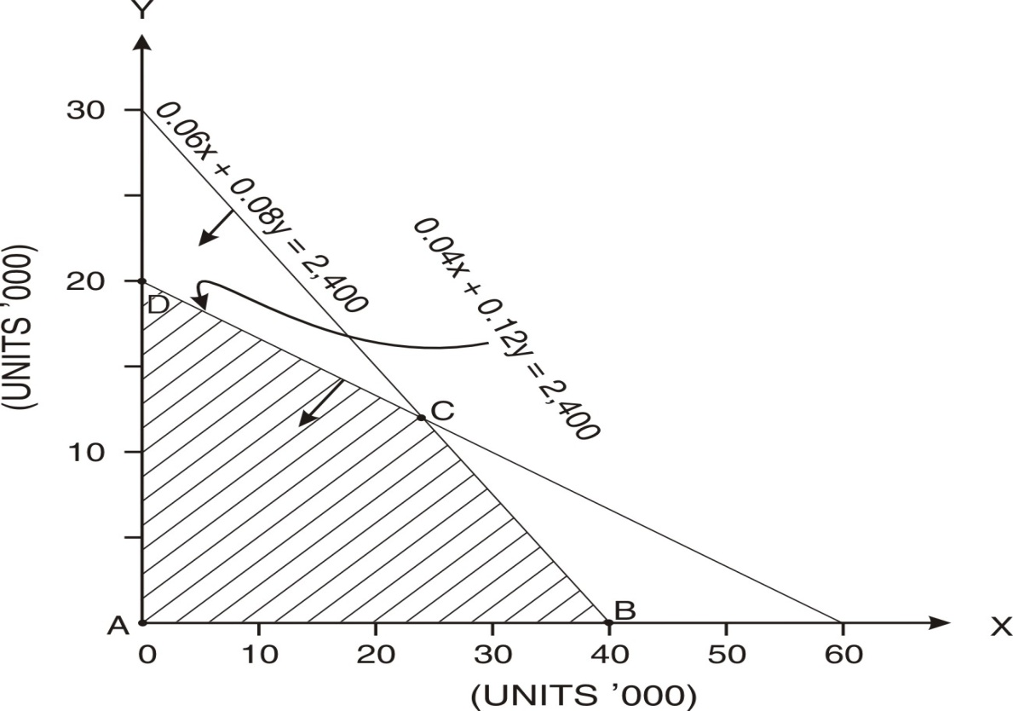

Step (viii) Find the co-ordinates of the extreme points of common feasible solution area. These sets of co-ordinates are the candidates for being selected as optimal solution.
Corner points |  | x | y
A |  | 0 | 0
B |  | 40,000 | 0
C | 0.06x + 0.08y = 2,400  0.04x + 0.12y = 2,400 | 24,000 | 12,000
D |  | 0 | 20,000

Step (ix) Find the values of objective function on the basis of different sets of values of co-ordinates of extreme corner points.
Corner points |  | x | y | Contribution
A |  | 0 | 0 | 0
B |  | 40,000 | 0 | 80,000
C | 0.06x + 0.08y = 2,400  0.04x + 0.12y = 2,400 | 24,000 | 12,000 | 84,000
D |  | 0 | 20,000 | 60,000

Step (x) The maximum amount of contribution is at point C. Hence the company may manufacture 24000 units of A and 12000 units of B.

Q. No. 18.18
A company manufactures plastic-covered steel fencing in two qualities: standard and heavy gauge. Both products pass through the same processes involving
steel-forming and plastic-bonding.

The standard gauge sells at Rs.15 per roll and the heavy gauge at Rs.20 per roll. There is an unlimited market for the standard gauge but outlets for the heavy gauge are limited to 13,000 rolls per year. However, the factory operations of each process are limited to 2,400 hours each per year.
Variable cost per roll: | Direct material | Direct wages | Direct expenses
Standard Gauge | Rs.5 | Rs.7 | Rs.1
Heavy Gauge | Rs.7 | Rs.8 | Rs.2

Processing hours per 100 rolls:
Gauge | Steel forming | Plastic-bonding
Standard | 6 | 4
Heavy | 8 | 12

Agreement has been reached on revised working methods that will increase output of all processes by 10%. This could be achieved without additional manpower or longer working hours.

Formulate the LP problem for maximization of contribution

You are required to calculate (using graphic method):
- The production mix which will maximize total contribution :
- At present output levels; and
- Assuming the 10% work improvement is achieved
- The total amount of productivity bonus which will be paid to employees on the basis of their receiving 40% of additional contribution.(CIMA)

Answer
- (i)
Let produce x units of standard and y units of heavy
Objective function: Maximize Z = 2x + 3y
Subject to:
0.06x + 0.08y ≤ 2,400 | 0.04x + 0.12y ≤ 2,400
y ≤ 13,000 | x, y ≥ 0

Let’s convert the inequalities to equalities:
 | x | y
0.06x + 0.08y = 2,400 | 0 | 30,000
0.06x + 0.08y = 2,400 | 40,000 | 0
0.04x + 0.12y = 2,400 | 0 | 20,000
0.04x + 0.12y = 2,400 | 60,000 | 0
y = 13,000 |  | 13,000

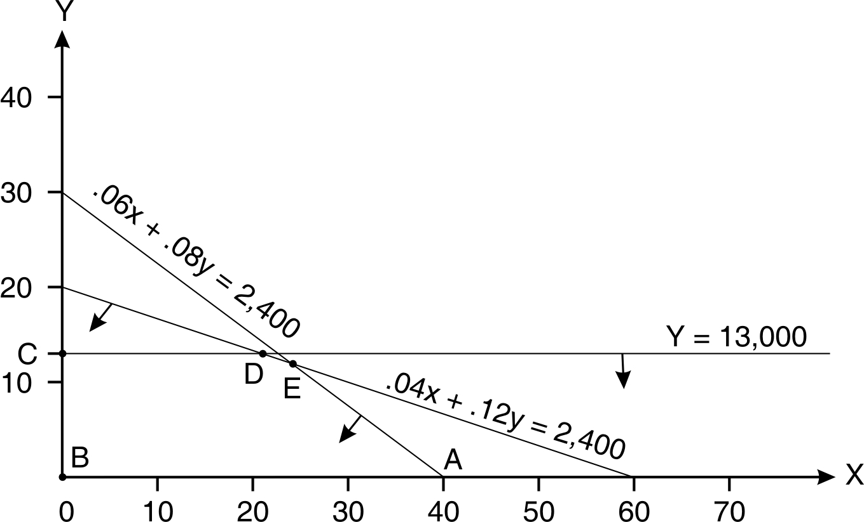
  Corner points |  | x | y | Contri-bution
  A |  | 40,000 | 0 | 80,000
  B |  | 0 | 0 | 0
  C |  | 0 | 13,000 | 39,000
  D | y = 13,000  .04x+.12y  = 2,400 | 21,000 | 13,000 | 81,000
  E | .06x +.08y  = 2,400  .04x+ .12y  = 2,400 | 24,000 | 12,000 | 84,000

Recommendation | Produce 24,000 Standard Gauge and 12,000 Heavy Gauge.  Contribution Rs. 84,000

(a)(ii)
Let produce x units of standard and y units of heavy
Objective function: Maximize 2x + 3y

Subject to:
(6/110)x + (8/110)y ≤ 2,400
(4/110)x +(12/110)y ≤ 2,400
y ≤ 13,000
x, y ≥ 0
Let’s convert the inequalities to equalities:
 | x | y
(6/110)x + (8/110)y = 2,400 | 0 | 33,000
(6/110)x + (8/110)y = 2,400 | 44,000 | 0
0.04x + 0.12y = 2,400 | 0 | 22,000
0.04x + 0.12y = 2,400 | 66,000 | 0
y = 13,000 |  | 13,000

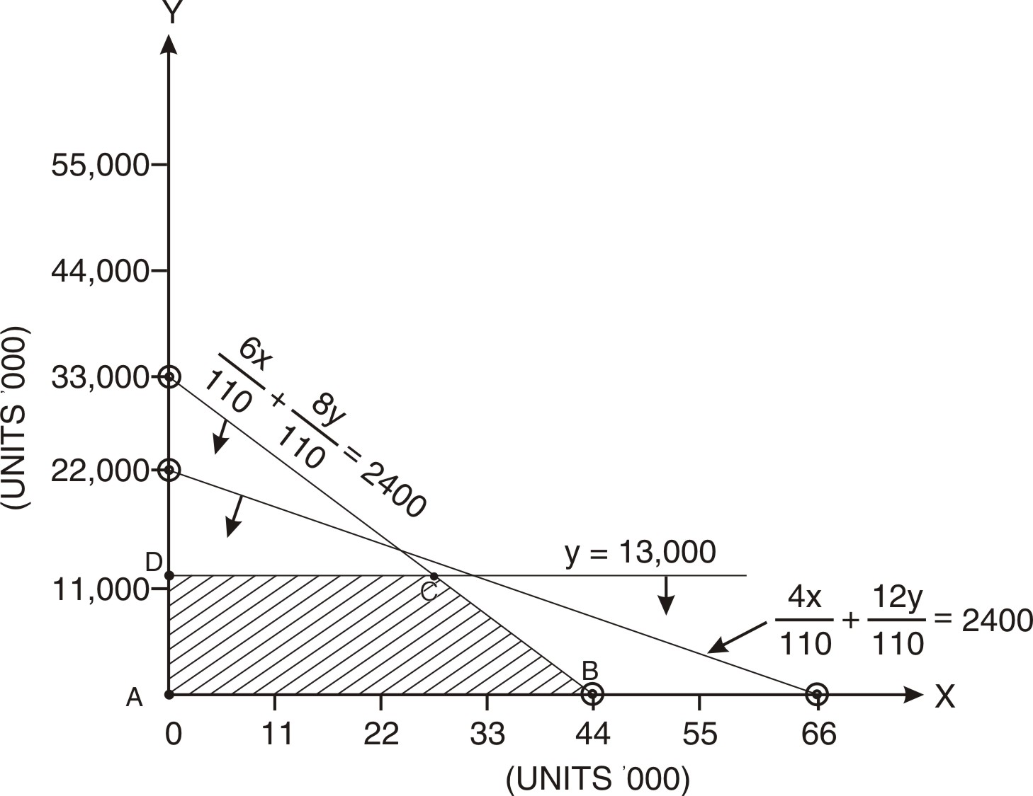

 | Recommendation  Produce 26,667.67 Standard Gauge and 13,000 Heavy Gauge. Contribution Rs.92,333. (The incomplete units of current period may be completed in the next period)
  Corner  points |  | x | y | Contri-bution
  A |  | 0 | 0 | 0
  B |  | 44,000 | 0 | 88,000
  C | y= 13,000  6x/110 + 8y/110 = 2400 | 26,666.67 | 13,000 | 92,333
  D |  | 0 | 13,000 | 39,000

(b)
Contribution before Work improvement Rs.84,000 | Contribution after Work improvement Rs.92,333 | Bonus =0.40(92,333 – 84,000)  = Rs.3,333

Q. No. 18.19
Let’s assume that you have inherited Rs.1,00,000 from your Great-Grand-Father that you want to invest in a combination of two portfolios with maximum investment in either portfolio set at Rs.75,000. Expected return from I portfolio is 10% and that from II is 20%. The risk is 4 in case of I and 9 in case of II. Your desired return is minimum 12% and you will not accept risk above 6. You want to decide your investment strategy. Formulate the LP problem. Solve the same by graphic method. (CA Final May, 1999)

Answer
Let’s invest Rs.x in I and Rs.y in II
Objective function: Maximize: 0.10x + 0.20y
Subject to
x + y ≤ 1,00,000 --------(1) | x ≤ 75,000 ------------ (2) | y ≤ 75,000 -------------- (3)
0.10x + 0.20y ≥ 0.12( x + y) Or  - 0.02x + 0.08y ≥ 0 ------(4) | 4x + 9y ≤ 6(x + y) Or  – 2x + 3y ≤ 0 ------(5) | x , y ≥ 0

Let’s convert the inequalities to equalities:
 | x | y
x + y = 1,00,000 | 0 | 1,00,000
x + y = 1,00,000 | 1,00,000 | 0
- 0.02x + 0.08y = 0 | 0 | 0
- 0.02x + 0.08y = 0 | 1,00,000* (assumed) | 25,000
– 2x + 3y = 0 | 0 | 0
– 2x + 3y = 0 | 75,000*(assumed) | 50,000
x = 75,000 | 75,000
y = 75,000 |  | 75,000

* We can assume any other reasonable figure (keeping in mind that x + y ≤ 1,00,000)

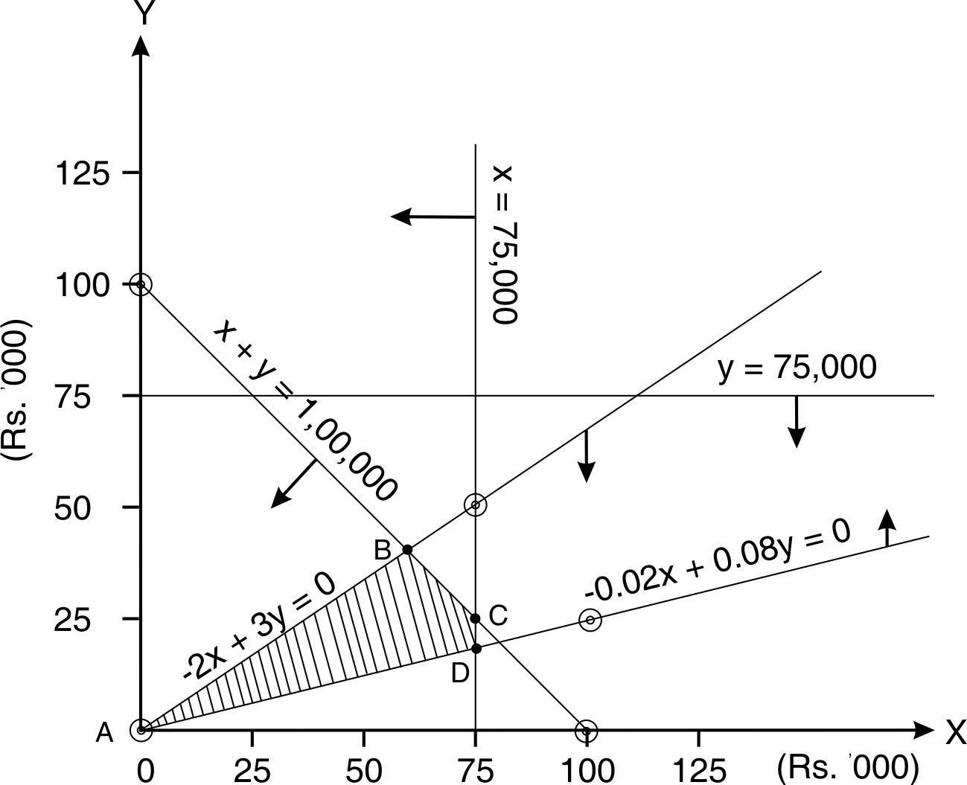

Corner points |  | x | y | Return
A |  | 0 | 0 | 0
B | -2x + 3y =0  x + y = 1,00,000 | 60,000 | 40,000 | 14,000
C | x + y = 1,00,000  x = 75,000 | 75,000 | 25,000 | 12,500
D | x = 75,000  - 0.02x + 0.08y = 0 | 75,000 | 18,750 | 11,250

Optimum portfolio: Portfolio I Rs.60,000 Portfolio II Rs.40,000 ; Return Rs.14,000

Q. No 18.20
An advertising firm desires to reach two types of audiences – high income group (referred as target audience A) and middle income group (referred as targeted audience B). The total advertising budget is Rs.2,00,000. One TV advertisement cost Rs.50000 while one radio advertisement cost Rs.20,000. There should be at least 3 TV programmes. The number of radio programmes should not exceed 5. One TV program targets 7,50,000 type A audience and 1,50,000 type B audience. One radio program targets 40000 type A and 260000 type B audience. Formulate the LP problem to find the mix of TV and Radio programmes for maximize the total reach. Solve the same by graphic method. (CA Final Nov. 1999)

Answer
Let’s produce x number of TV Programmes and y number of radio programmes
Objective function: Maximize 9,00,000x + 3,00,000y
Subject to:
50,000x + 20,000y ≤ 2,00,000 | x ≥ 3
y ≤ 5 | x , y ≥ 0

Let’s convert the inequalities to equalities:
 | x | y
50,000x + 20,000y = 2,00,000 | 0 | 10
50,000x + 20,000y = 2,00,000 | 4 | 0
x | 3
y |  | 5

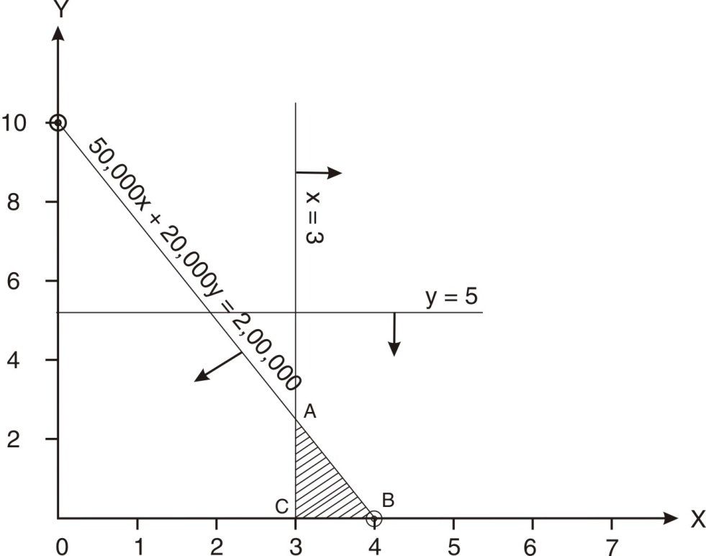

Corner points |  | x | y | Audience
A | 50,000x + 20,000y = 2,00,000  x= 3 | 3 | 2.50 | 35,50,000
B |  | 4 | 0 | 36,00,000
C |  | 3 | 0 | 27,00,000

Recommendation : 4 TV Programmes : Viewers 36,00,000

Q. No. 18.21
A sports club is engaged in the development of their players for feeding them certain minimum amount of vitamins (say A, B and C), in addition to their normal diet. In view of this, two types of products X and Y are purchased from the market. The contents of vitamin constituents per unit are shown in the following table:
Vitamins | Vitamin contents in products X and Y |  | Minimum requirement for each player
 | X | Y
A | 36 | 6 | 108
B | 3 | 12 | 36
C | 20 | 10 | 100

Formulate the LP problem to find the minimum cost of vitamins per player. Solve the same by graphic method. The cost per unit of product X is Rs.20 and that of Y Rs.40.(CA Final Nov. 2001)

Answer Let’s purchase x units of X and y units of Y.
Objective function: Minimize 20x + 40y
Subject to:
36x + 6y ≥ 108 | 3x +12y ≥ 36
20x + 10y ≥ 100 | x, y ≥ 0

Let’s convert the inequalities to equalities:
 | x | y
36x + 6y = 108 | 0 | 18
36x + 6y = 108 | 3 | 0
3x +12y = 36 | 0 | 3
3x +12y = 36 | 12 | 0
20x + 10y =100 | 0 | 10
20x + 10y =100 | 5 | 0

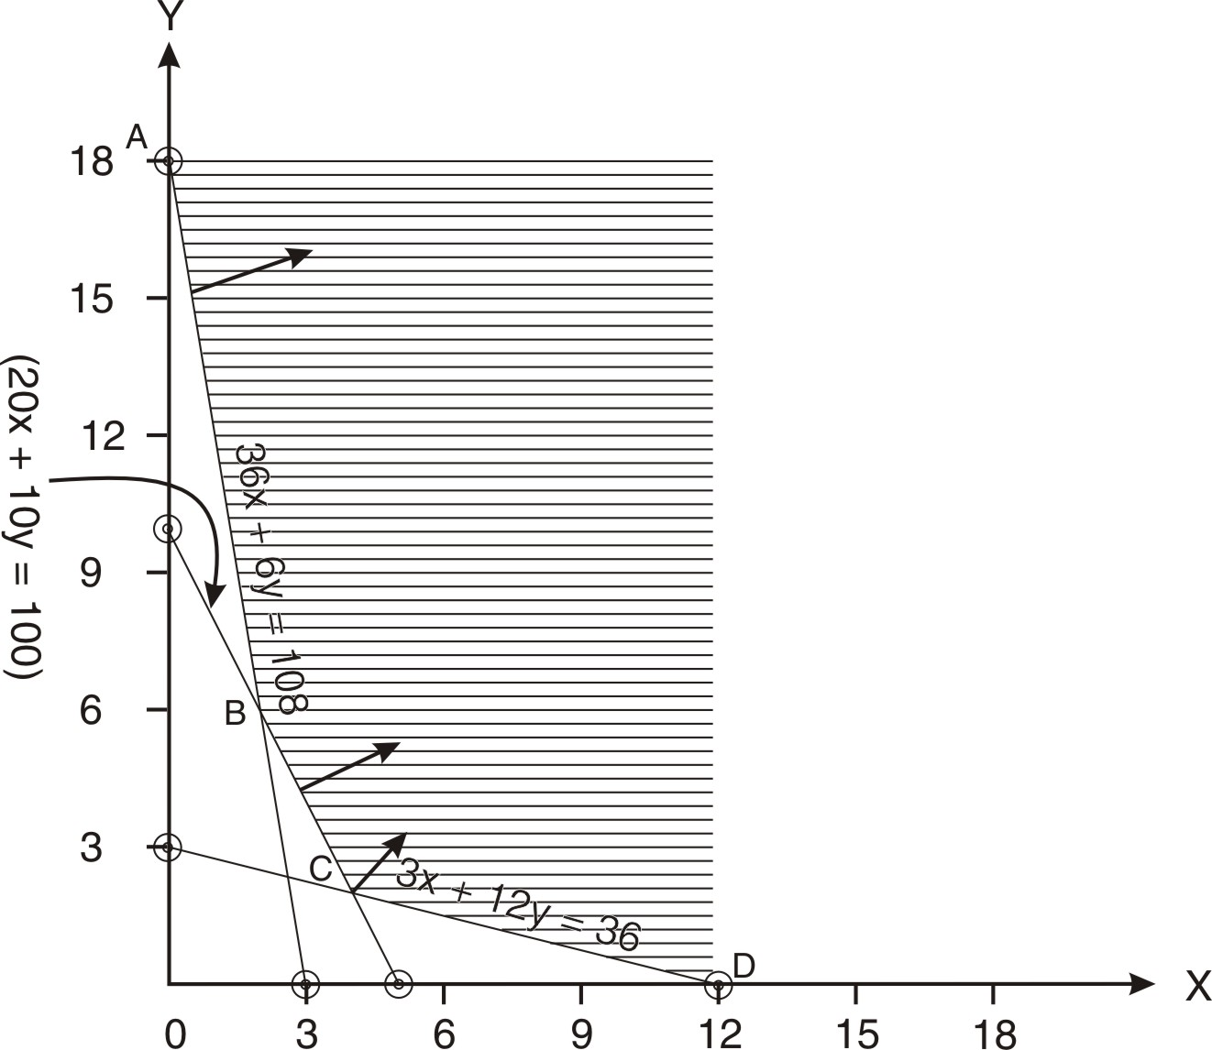

Corner points |  | x | y | Cost
A |  | 0 | 18 | 720
B | 36x + 6y = 108  20x +10y = 100 | 2 | 6 | 280
C | 20x +10y = 100  3x +12y = 36 | 4 | 2 | 160
D |  | 12 | 0 | 240

Recommendation: 4 units of X and 2 units of Y. Minimum cost Rs.160

Q. No. 18.22
A local travel agent is planning a charter trip to a major sea resort. The eight day seven night package includes the fare for the round trip, surface transportation, board and lodging and selected tour options. The charter trip is restricted to 200 persons and past experience indicates that there will not be any problem for 200 persons. The problem for the travel agent is to determine the number of Deluxe, Standard and Economy tour packages to offer for this charter. These three plans each differ according to seating and service for the flight, quality of accommodations, meal plans and tour options. The following table summarizes the estimated prices for the three packages and corresponding expenses for the travel agent. The travel agent has hired an aircraft for the flat fee of Rs.2,00,000 for the entire trip.

Price and costs for tour packages per person
Tour plan | Price (Rs.) | Hotel cost (Rs.) | Meal and other expenses (Rs.)
Deluxe | 10,000 | 3000 | 4750
Standard | 7,000 | 2,200 | 2,500
Economy | 6,500 | 1,900 | 2,200

In planning the trip, the following considerations must be taken into accounts:
- At least 10% of the packages must be of deluxe type.
- At least 35% but not more than 70% must be of standard type.
- At least 30% must be of economy type
- The maximum number of deluxe packages is restricted to 60.
- The hotel desires that at least 120 tourists should be on deluxe and standard packages taken together.
The travel agent wishes to determine the number of packages to offer in each type so as to maximize the total profit.

(a) Formulate the LP problem to maximize the profit of the travel agent.
(b) Restate the above LPP in terms of two decision variables, taking advantage of the fact that 200 packs will be sold.
(c ) Find the optimum solution using graphic method for the restated LPP.
(CA final May 1991)
(d) Is there some redundant constraint? Explain with the help of your answer (c).

Answer
- Let’s sell x number of deluxe, y number of standard and z number of economy packages.
Objective function: Maximize Z = 2250x + 2300y + 2400z
Subject to :
x + y + z = 200 --------------------(i) | x ≥ 20 ------------------------------(ii)
y ≥ 70 ------------------------------(iii) | y ≤ 140 ---------------------------- (Iv)
z ≥ 60 ----------------------------- (v) | x ≤ 60 ----------------------------- (vi)
x + y ≥ 120 ----------------------- (vii) | x + y + z ≥ 0 ---------------------- (viii)

- x + y + z = 200
z = 200 – x - y
Objective function : Maximize contribution: 2250x + 2300y + 2400(200 – x – y)
Maximize contribution: -150x -100y + 4,80,000

Subject to :
x ≥ 20 -----------------------(i) | x ≤ 60 ------------------- (ii) |  | y ≥ 70 -------------------(iii)
y ≤ 140 ---------------------------- (Iv) |  | x + y ≥ 120 ----------------------- (v)
x + y ≤ 140 -------------------------(vi) |  | x + y + z ≥ 0 ---------------------- (vii)

(c) Let’s convert the inequalities to equalities:
 | x | y
x + y = 120 | 0 | 120
x + y = 120 | 120 | 0
x + y = 140 | 0 | 140
x + y = 140 | 140 | 0
x = 20 | 20
x = 60 | 60
y = 70 |  | 70
y = 140 |  | 140

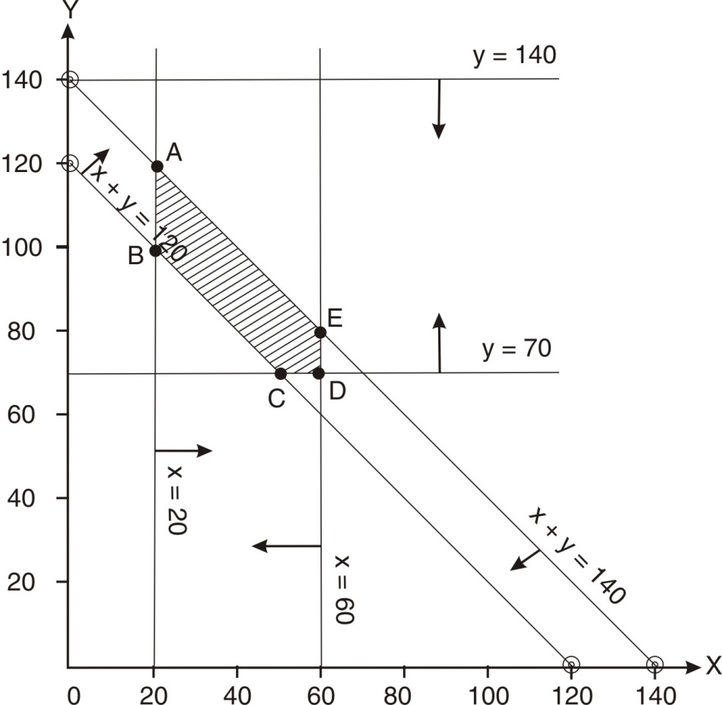

Corner points |  | x | y | Contribution
A | x = 20  x + y =140 | 20 | 120 | -150x -100y + 4,80,000  -150x20 -100x120 + 4,80,000 = 4,65,000
B | x = 20  x + y =120 | 20 | 100 | -150x20 -100x100 + 4,80,000 = 4,67,000
C | x + y =120  y= 70 | 50 | 70 | -150x50 -100x70 + 4,80,000 = 4,65,500
D |  | 60 | 70 | -150x60 -100x70 + 4,80,000 = 4,64,000
E | x = 60  x + y =140 | 60 | 80 | -150x60 -100x80 + 4,80,000 = 4,63,000

Recommendation : 20 units of Deluxe and 120 units of standard and 60 units of economy . Contribution Rs.4,67,000. Profit Rs.2,67,000.

(d) A constraint is said to be redundant if it does not affect the feasible solution area. In this problem, the feasible solution area is bounded by A-B-C-D-E–A. It is not affected by the constraint y ≤ 140. Hence, this constraint is redundant.

Q. No. 18.23: Semicond is an electronics company manufacturing tape recorders and radio. Its per unit labour costs, raw material costs and selling prices are given in Table 1. An extract from its balance sheet as on 31.3.2004 is shown in Table 2. Its current assets/current liability (called the current ratio) is 2.

Table 1
Items → | Tape recorder (Rs.) | Radio (Rs.)
Selling price | 1000 | 900
Labour cost | 500 | 350
Raw material cost | 300 | 400
Table 2
 | Current Liabilities (Rs.) | Current assets (Rs.)
Cash |  | 1,00,000
Accounts receivables |  | 30,000
*Inventory |  | 70,000
Short term bank borrowings | 1,00,000

*100 units of the raw material which is used for tape recorder and 100 units of the raw material which is used for radio.

Semicond must determine how many tape recorders an radios should be produced during April, 2004. Demand is large enough to ensure that all goods produced will be sold. All sales are on credit and the payment for goods sold in April will be received in May. During April, 2004 it will collect Rs.20000 from Accounts receivables and will pay Rs.10,000 against short term bank borrowings and Rs.10000 towards rent. Raw material shipment will be received only on 30th April, 2004 (this raw material will be used in May, 2004) and it will be paid only on 31st May 2004. The amount of this shipment will be Rs.20,000. The cash balance on 30th April 2004 should be at least Rs.40,000. The banker wants the current ratio should be at least 2 on 30th April, 2004. In order to maximize the contribution for April, 2004, the company has to decide the product mix. Assume that the labour cost is paid in the month in which it is incurred. Formulate LPP and solve the same graphically. (CA Final Nov. 1994)

Answer
Let’s produce x units of tape recorders and y units of radios

Current assets
Cash 1,00,000 + 20,000 – 10,000 – 10,000 – 500x – 350y | 1,00,000 – 500x – 350y
Inventory 70,000 + 20,000 –300x – 400y | 90,000 – 300x – 400y
Drs 30000 – 20,000 + 1000x + 900y | 10000 + 1000x + 900y
Total | 2,00,000 + 200x +150y
Current Liabilities :
Short term bank Borrowings And Creditors | 90,000 + 20,000 = 1,10,000

Objective function: Maximize 200x + 150y
Subject to:
x ≤ 100 ----------------------------------(i) | Y ≤ 100 -----------------------------------------(ii)

Cash Balance on 30th April 2004 : 1,00,000 – 500x – 350y ≥ 40,000
500x + 350 y ≤ 60,000 --------------(iii)

Current ratio :
2,00,000 + 200x +150y ≥ 2
1,10,000

2,00,000 + 200x +150y ≥ 2,20,000
200x +150y ≥ 20,000 ------------------------------------------------------------(iv)

x, y ≥ 0 ---------------------------------------------------------------------------------(v)

Let’s convert the inequalities to equalities:
 | x | y
500x + 350 y = 60,000 | 0 | 171
500x + 350 y = 60,000 | 120 | 0
200x +150y = 20,000 | 0 | 133
200x +150y = 20,000 | 100 | 0
x =100 | 100
y = 100 |  | 100

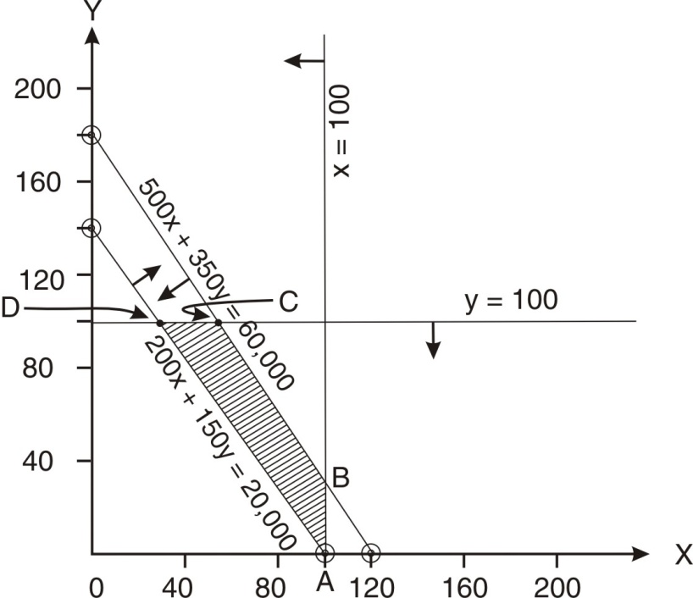

Corner points |  | x | y | Contribution
A |  | 100 | 0 | 20,000
B | X= 100  500x + 350 y = 60,000 | 100 | 28.57 | 24,286
C | Y = 100  500x + 350 y = 60,000 | 50 | 100 | 25,000
D | Y = 100  200x + 150 y = 20,000 | 25 | 100 | 20,000

Recommendation: 50 units of tape-recorders and 100 units of radios. Contribution Rs.25,000

Q. No. 18.24:
A manufacturer produces two products A and B. The manufacturer wishes to establish the weekly production plan which maximizes the contribution. Suggest the production plan using the data given below and using the graphic method:
 | Per unit |  |  |  | Production
 | Machine hours | Labour hours | Material  Units | Contribution  (Rs) | Maximum quantity | Minimum quantity
A | 4 | 4 | 1 | 3 | 20
B | 2 | 6 | 1 | 4 |  | 10
Total available per week | 100 | 180 | 40

Answer
- Let’s produce x units of A and y units of B
Objective function: Maximize 3x + 4y
Subject to:
4x + 2y ≤ 100 | 4x + 6y ≤ 180 | x + y ≤ 40
x ≤ 20 | y ≥ 10 | x, y ≥ 0
Let’s convert the inequalities to equalities:
 | x | y
4x + 2y = 100 | 0 | 50
4x + 2y = 100 | 25 | 0
4x + 6y = 180 | 0 | 30
4x + 6y = 180 | 45 | 0
x + y = 40 | 0 | 40
x + y = 40 | 40 | 0
x = 20 | 20
y = 10 |  | 10

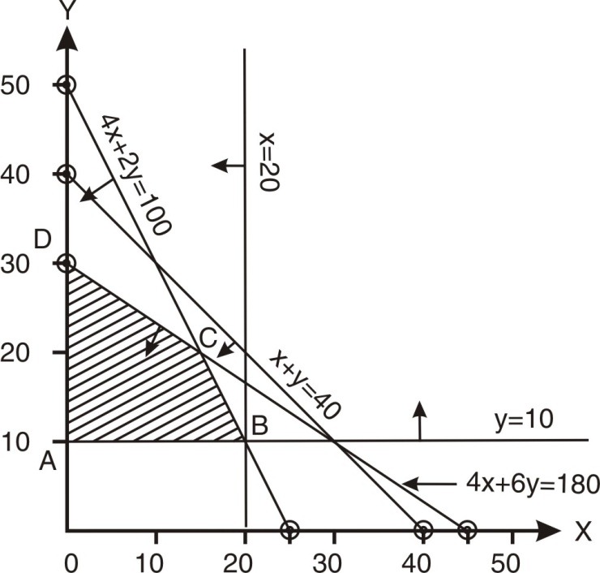 | * contribution
  Corner points |  | x | y | C*
  A |  | 0 | 10 | 40
  B |  | 20 | 10 | 100
  C | 4x + 2y = 100  4x + 6y = 180 | 15 | 20 | 125
  D |  | 0 | 30 | 120

Recommendation: 15 units of A and 20 units of B. Contribution Rs.125

Q. No. 18.25:
The budgeted data relating to two products manufactured by a company for a month are as under:
 | Product A | Product B
Selling price | 300 | 200
Variable manufacturing cost | 160 | 60
Sales commission | 60 | 40
Maximum sales (Units) | 400 | 400
Hours per unit of output: P  Q | 2  5 | 4  4

Each unit of product incurs costs in the company’s two departments P and Q. The total capacity available for the month under review is 1400 hours in department P and 2000 hours in department Q. The capacity costs amount to Rs.14,000 and Rs.20,000 respectively per month for P and Q irrespective of the level of usage made of it.

(a)Formulate LPP and solve by graphic method for maximization of profit.
(CA Final May 2004)
(b)Is there some redundant constraint? Explain with the help of your answer (a).

Answer
- Let’s produce x units of A and y units of B

Objective function : Maximize 80x + 100y
2x + 4y ≤ 1400 |  | 5x + 4y ≤ 2000
x ≤ 400 | y ≤ 400 |  | x, y ≥ 0
Let’s convert the inequalities to equalities:
 | x | y
2x + 4y = 1400 | 0 | 350
2x + 4y = 1400 | 700 | 0
5x + 4y = 2000 | 0 | 500
5x + 4y = 2000 | 400 | 0
x = 400 | 400
y = 400 |  | 400

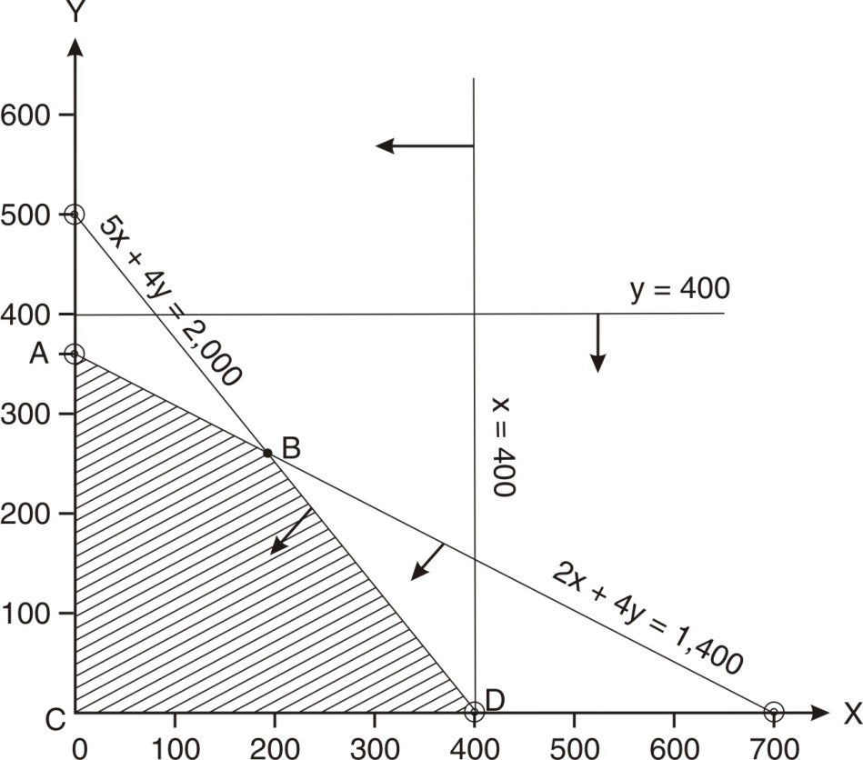 | * contribution
  Corner  points |  | x | y | C*
  A |  | 0 | 350 | 35,000
  B | 2x + 4y  = 1400  5x + 4y  = 2000 | 200 | 250 | 41,000
  C |  | 0 | 0 | 0
  D |  | 400 | 0 | 32,000

Recommendation: 200 units of A and 250 units of B. Contribution Rs.41,000

- A constraint is said to be redundant if it does not affect the feasible solution area. In this problem, the feasible solution area is bounded by A-B-D-C–A. It is not affected by the constraint y ≤ 400. Hence, this constraint is redundant.

Q. No. 18.26:
(a) A Ltd makes two products T and C which must be processed through assembly and finishing departments. Assembly department has 60 hours per week; finishing has 48 hours per week. Manufacture of one table requires 4 hours of assembly and 2 hours of finishing. Each chair requires 2 hours in assembly and 4 hours in finishing. Profit is Rs.80 per table and Rs.60 per chair. (a) Determine the product mix to maximize the profit using graphic method. (CA Final Nov. 2006):

(b) Explain the concept of shadow price of one assembly hour with the help (a) above.
(c) Calculate the shadow price of one finishing hour.

Answer
(a) Let’s produce x units of T and y units of C
Objective function : Maximize 80x + 60y
Subject to → | 4x + 2y ≤ 60 | 2x + 4y ≤ 48 | x, y ≥ 0

Let’s convert the inequalities to equalities:
 | x | y
4x + 2y = 60 | 0 | 30
4x + 2y = 60 | 15 | 0
2x + 4y = 48 | 0 | 12
2x + 4y = 48 | 24 | 0

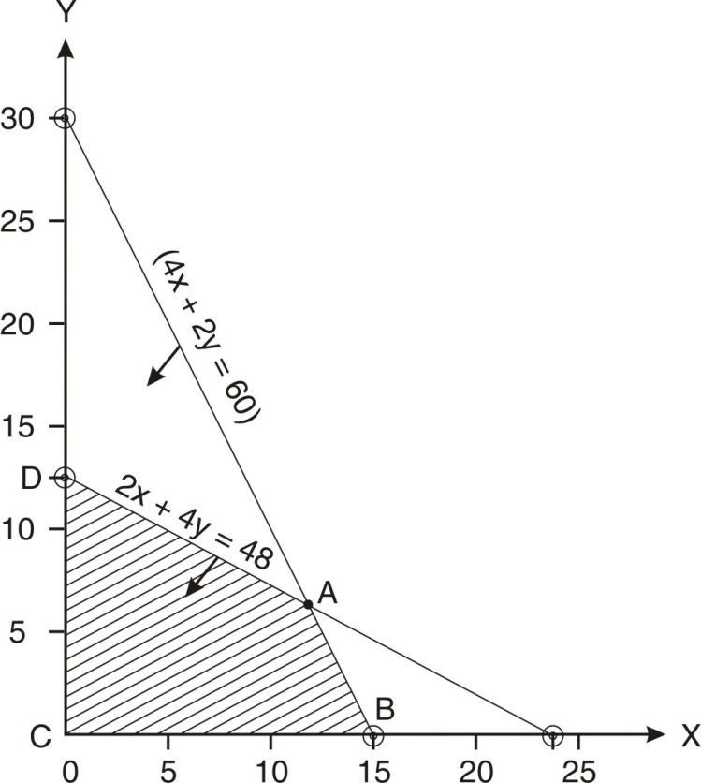
  Corner  points |  | x | y | Contri-bution
  A | 4x + 2y  = 60  2x + 4y  = 48 | 12 | 6 | 1320
  B |  | 15 | 0 | 1200
  C |  | 0 | 0 | 0
  D |  | 0 | 12 | 720

Recommendation: 12 units of T and 6 units of C. Contribution Rs. 1320

(b) Shadow Price (also known as marginal worth of the resource) of a constraint is the amount by which the objective function value will change if we change the right-hand side of the constraint by one unit.
In this problem, the position of constraints is as follows:
Optimum Mix↓ | Assembly hours | Finishing hours
T :12 units | 48 | 24
C : 6 units | 12 | 24
Total hours used | 60 | 48
Total hours available | 60 | 48
Spare capacity | Nil | Nil

Suppose there is additional one hour available with assembly department:
4x + 2y = 61 -----------------(1)
2x + 4y = 48 ---------------- (2)
Multiplying the second by 2,
4x + 8y = 96 ________(3)
4x + 2y = 61 -------(1)

Solving the equations, we get x = 12.33333 and y = 5.833333
Profit : 12.33333x80 + 5.83333x60 = 1336.67

Profit with original quantity of resources | 1320.00
Profit with additional one hour of assembly | 1336.67

Shadow price of one hour of Assembly: Rs.16.67.

(c) Suppose there is additional one hour available with finishing department:
4x + 2y = 60 -----------------(1)
2x + 4y = 49 ---------------- (2)
Multiplying the second by 2,
4x + 8y = 98 ________(3)
4x + 2y = 60 -------(1)

Solving the equations, we get x = 11.8333 and y = 6.3333
Profit : 11.8333x80 + 6.3333x60 = 1326.67

Profit with original quantity of resources | 1320.00
Profit with additional one hour of assembly | 1326.67

Shadow price of one hour of finishing: Rs.6.67.

Q. No. 18.27: Applying graphic method, Maximize Z = 4x + 6y
Subject to:
x + y = 5 | x ≥ 2 | y ≤ 4 | x, y ≥ 0

Let’s convert the inequalities to equalities:
 | x | y
x = 2 | 2
y = 4 |  | 4
x + y = 5 | 0 | 5
x + y = 5 | 5 | 0

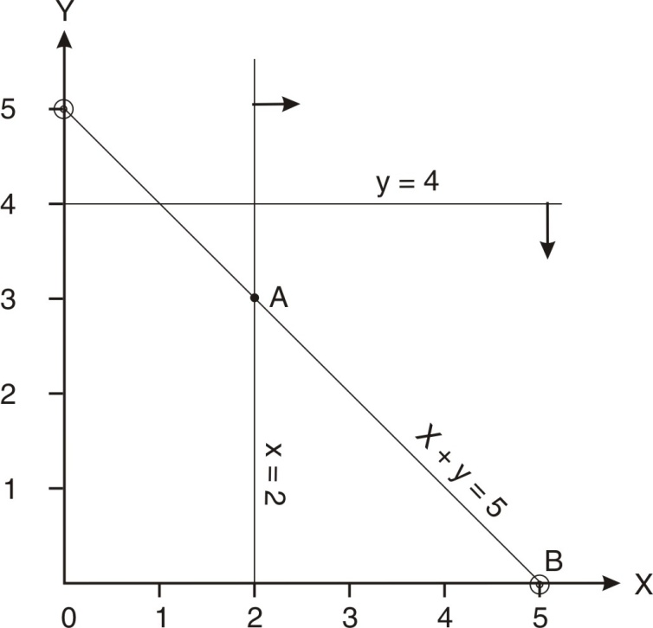
  Corner  points | x | y | Contribution
  A | 2 | 3 | 26
  B | 5 | 0 | 20
  Recommendation:
  2 units of x and 3 units of y.
  Contribution Rs.26

Q. No. 18.28:
The standard weight of a special product is 5 kg. It contains two basic ingredients B₁ and B₂. B₁ costs Rs.5 per Kg and B₂ costs Rs.8 per Kg. strength considerations dictate that the brisk contains not more than 4 Kg of B₁ and minimum 2 Kg of B₂. Since the demand for the product is likely to be related to the price of the brisk, find the minimum cost. Apply graphic method. (University of Delhi)

Answer
Let’s use x Kg. of B₁ and y Kg of B₂.
Objective function: Minimize 5x + 8y
Subject to:
x+ y = 5 | x≤ 4 | y ≥ 2 | x, y ≥ 0

Let’s convert the inequalities to equalities:
 | x | y
x = 4 | 4
y = 2 |  | 2
x + y = 5 | 0 | 5
x + y = 5 | 5 | 0

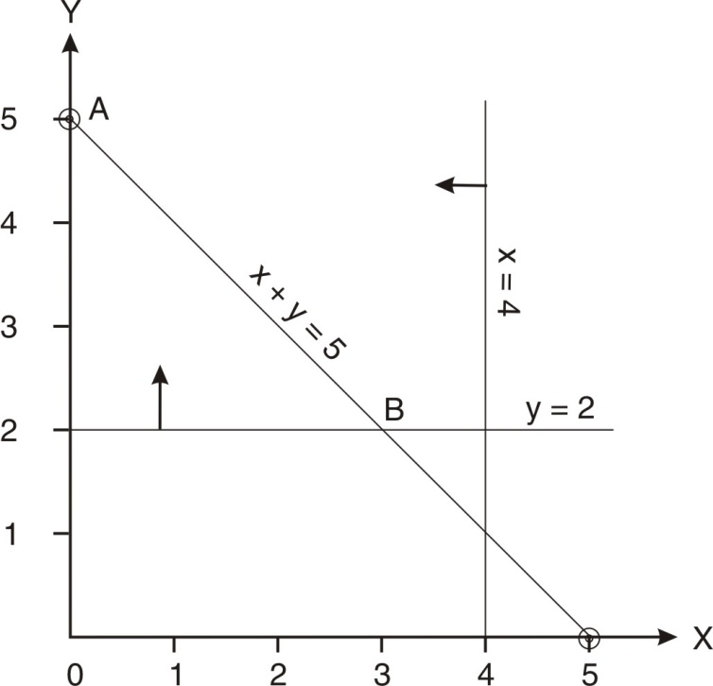
  Corner  points |  | x | y | Contribution
  A |  | 0 | 5 | 40
  B | x + y  = 5  y= 3 | 3 | 2 | 31
  Recommendation: 5 units of y.
  Contribution Rs.40
Q. No. 18.29
In a linear programming problem what is an infeasible solution? Solve the following by applying graphic method and comment on the result.
Maximize Z = 4x + 2y
Subject to → | 2x + 3y ≤ 18 | x + y ≥ 10 | x, y ≥ 0

Answer
Infeasible solution: In such a situation, there is no point which satisfies all the constraints.
Let’s convert the inequalities to equalities:
 | x | y
2x + 3y = 18 | 0 | 6
2x + 3y = 18 | 9 | 0
x + y = 10 | 0 | 10
x + y = 10 | 10 | 0

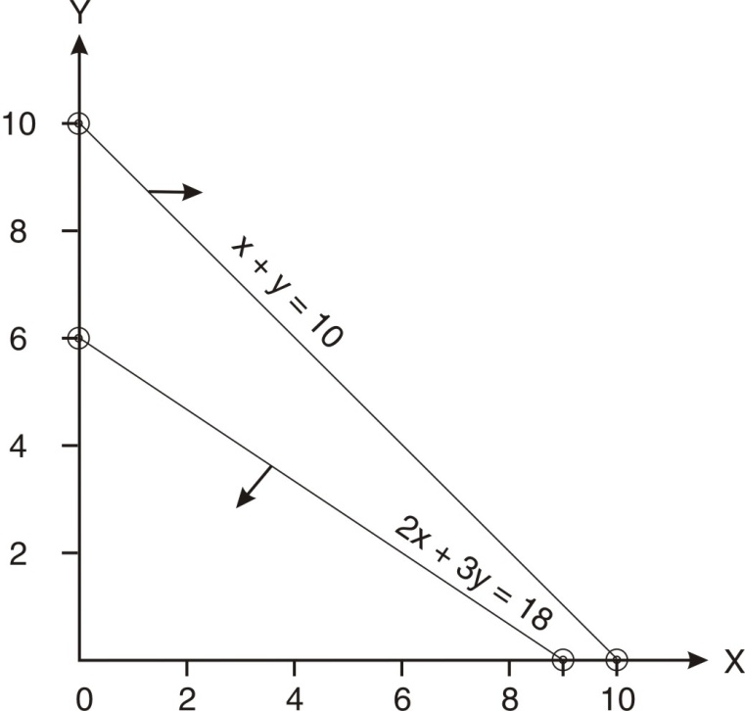 | Comment  Since there is no point which satisfies both the constraints, there is no solution to this problem. The problem is infeasible.  Teacher Note: When there is no point that satisfies all the constraints of the problem, there is no feasible solution to the problem.

Q. No. 18.30: What is unbounded solution? Solve the following by applying graphic method and comment on the result.
Maximize Z = 4x + 3y
Subject to :
3x + 2y ≥ 160 | 5x + 2y ≥ 200
x + 2y ≥ 80 | x, y ≥ 0

Answer
If the common feasible area is not bounded on upper side in a maximization problem the problem is said to be unbounded. Similarly in case of minimization problem if the common feasible area is not bounded on the lower side the problem is said to be unbounded. In other words, if the value of the objective function can be increased or decreased indefinitely the solution is called unbounded solution.

In case of unbounded solution, there are infinite feasible solutions but none is optimal.
In case of a maximization problem, if all the constraints have ≥ sign, the problem is unbound.

Let’s convert the inequalities to equalities:
 | x | y
3x + 2y = 160 | 0 | 80
3x + 2y = 160 | 53.33 | 0
5x + 2y = 200 | 0 | 100
5x + 2y = 200 | 40 | 0
x + 2y = 80 | 0 | 40
x + 2y = 80 | 80 | 0

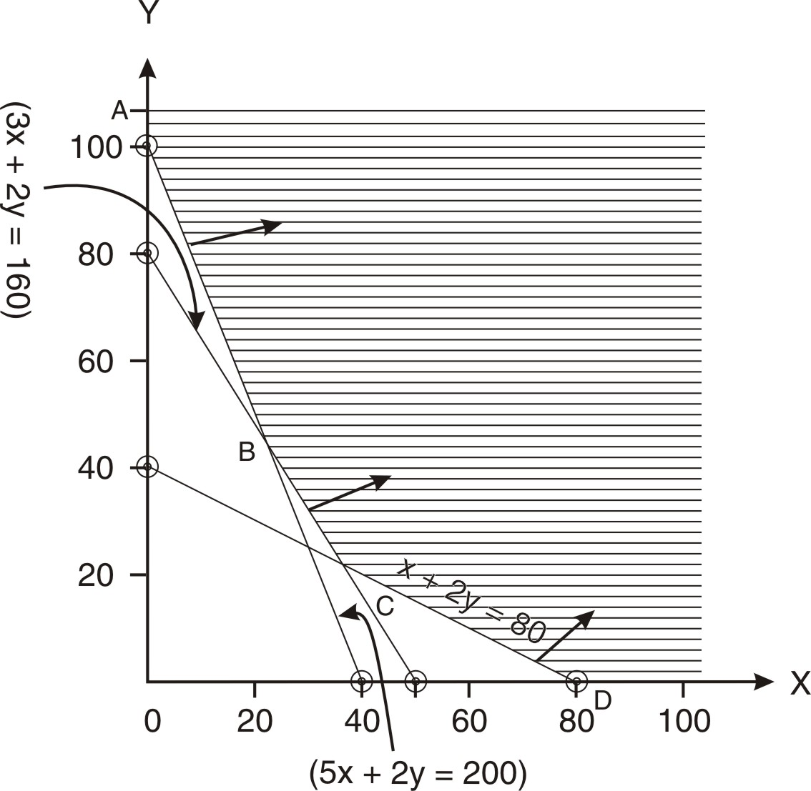 | Comment: The solution is unbounded as it does not offer finite solution.  Teaching note:  - In case of infeasible solution, there is no feasible solution for the problem.  - In case of unbounded solution, there are infinite feasible solutions but none of them is feasible.
Q. No. 18.31
A farm is engaged in breeding pigs. The pigs are fed on various products grown on the farm. In view of the need to ensure certain nutrient constituents (call them as X, Y and Z). It becomes necessary to two additional products say A and B. One unit of A contains 36 units of X, 3 units of Y and 20 units of Z. One unit of B contains 6 units of X, 12 units of Y and 10 units of Z. The minimum requirement of X, Y and Z is 108 units, 36 units and 100 units respectively. Product A costs Rs. 20 per unit and product B costs Rs.40 per unit. Formulate LPP to minimize the total cost. Solve through graphic method. (CA Final May 2002)
Answer:
Let’s purchase x units of A and y units of B
Objective function: Minimize 20x + 40y
Subject to:
36x + 6y ≥ 108 | 3x + 12y ≥ 36
20x + 10y ≥ 100 | x, y ≥ 0
Let’s convert the inequalities to equalities:
 | x | y
36x + 6y = 108 | 0 | 18
36x + 6y = 108 | 3 | 0
3x +12y = 36 | 0 | 3
3x +12y = 36 | 12 | 0
20x + 10y = 100 | 0 | 10
20x + 10y = 100 | 5 | 0

Corner points |  | x | y | Cost
A |  | 0 | 18 | 720
B | 36x + 6y  = 108  20x + 10y  = 100 | 2 | 6 | 280
C | 3x +12y  = 36  20x + 10y  = 100 | 4 | 2 | 160
D |  | 12 | 0 | 240

Suggested Product mix: 4 units of Product A and 2 units of Product B. Cost : Rs.160.

Q. No. 18.32
A firm makes two products X and Y and has a total production capacity of 16 tonnes per day. X and Y require the same production capacity. The firm has a permanent contract to supply at least 3 tonnes of X and 6 tonnes of Y per day to another company. Each tone of X requires 14 machines hours of production time and each tone of Y requires 20 machines hours of production time. The daily maximum possible number of machine hours is 280. All the firm’s output can be sold, and the profit made is Rs.20 per tonne of X and Rs.25 per tonne of Y. (CA Final Nov. 2010)

Answer
Let’s produce x tonnes of X an Y tonnes of y.
Objective function: Maximize: 20x + 25y
Subject to:
x ≥ 3 | y ≥ 6 | x + y ≤ 16
14x + 20y ≤ 280 | x , y ≥ 0
Let’s convert the inequalities to equalities:
x = 3 | y = 6 | x = 0, y = 16
y = 0, x = 16 | x = 0, y = 14 | y = 0, x = 20

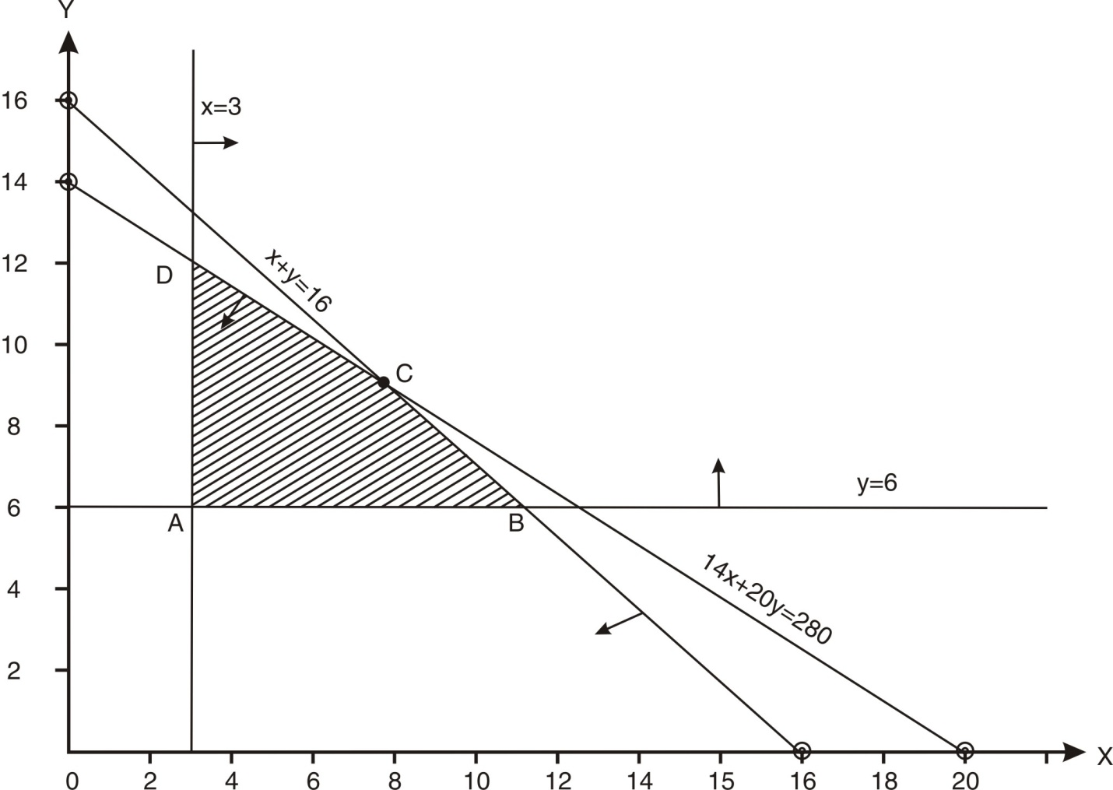

Corner points |  | x | y | Contribution
A |  | 3 | 6 | 60 + 150 = 210
B | x + y = 16  y = 6 | 10 | 6 | 200 + 150 = 350
C | x + y = 16  14x +20y = 280 | 6.67 | 9.33 | 6.67x20 + 9.33x25 = 366.67
D | 14x +20y = 280  x = 3 | 3 | 11.90 | 3x20 + 11.90x25 = 357.50

Suggested Product mix: 6.67 units of X and 9.33 units of Y. The incomplete units will be completed next day. Contribution Rs.366.67.

Q. No. 18.33
A company manufactures two products namely A and B. The contribution per Kg of out is Rs.240 and Rs.140 respectively for A and B. The total fixed cost is Rs.1,200 per week. Raw materials P, Q and R are required to produce these products. Using the following details, calculate maximum profit. Apply Graphic method Of LPP:
 | Raw material quantity to produce one unit of product
 | Product A | Product B | Total quantity of raw material available per week (Kg.)
Raw Material P | 16 Kg. | 20 Kg. | 160
Raw Material Q | 10 Kg. | 25 Kg. | 150
Raw Material R | 4 Kg. | 0 | 32
(CA Final Nov. 2002)

Answer
Let’s produce x units of A and y units of B.
Objective function: Maximize 240x + 140y
Subject to:
16x + 20y ≤160 | 10x + 25y ≤150
4x ≤ 32 | x , y ≥ 0

Let’s convert the inequalities to equalities:
 | x | y
4x = 32 | 8
16x + 20y = 160 | 10 | 0
16x + 20y = 160 | 0 | 8
10x + 25y ≤ 150 | 0 | 6
10x + 25y ≤ 150 | 15 | 0

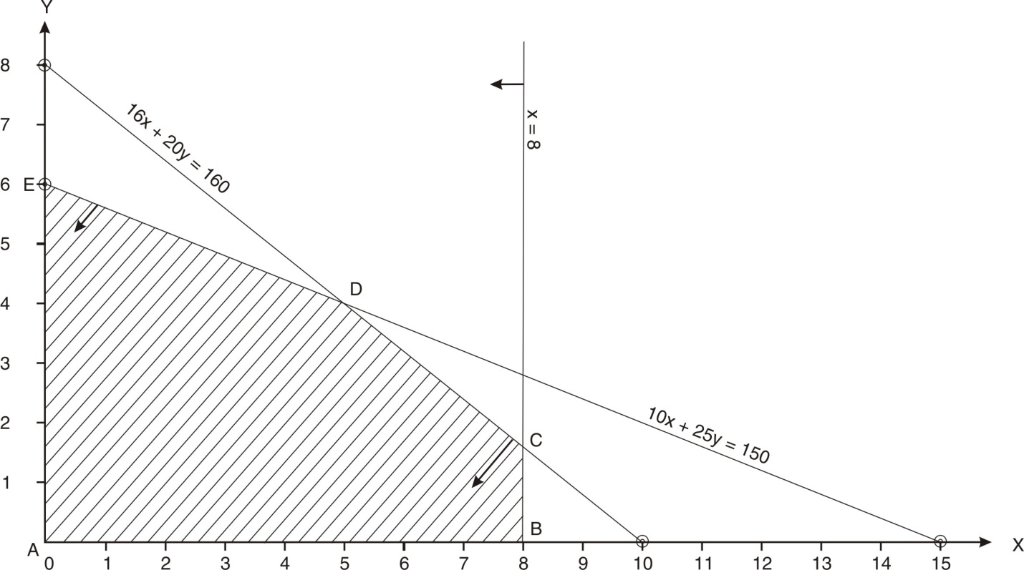

Corner points |  | x | y | Contribution
A |  | 0 | 0 | 0
B |  | 8 | 0 | 1,920
C | 16x + 20y =160  x = 8 | 8 | 1.60 | 2,144
D | 16x + 20y =160  10x + 25y =150 | 5 | 4 | 1,760
E |  | 0 | 6 | 840

Suggested Product mix: 8 units of A and 1.60 units of B. The incomplete units will be completed next week. Contribution Rs.2,144.

Q.No. 18.34
The costs and selling prices per unit of two products manufacturing by a company are as under:
Product→ | A (Rs.) | B (Rs.)
Selling Price | 500 | 450
Direct Materials @ Rs. 25 per kg. | 100 | 100
Direct Labour @ Rs. 20 per hour | 80 | 40
Painting @ Rs.30 per/hour | 30 | 60
Variable overheads | 190 | 175
Total Variable cost per unit | 400 | 375
Fixed costs @ Rs. 17.50/Direct Labour Hour | 70 | 35
Total cost | 470 | 410
Profit | 30 | 40

In any month the maximum availability of inputs is limited to the following:
Direct Materials | 480 kg.
Direct Labour hours | 400 hours
Painting hours | 200 hours

Required:
(i) Formulate a linear programme to determine the production plan which maximizes the profits by using graphical approach.
(ii) State the optimal product mix and the monthly profit derived from your solution in (i) above.
(iii) If the company can sell the painting time at Rs. 40 per hour as a separate service, show what modification will be required in the formulation of the linear programming problem. You are required to re-formulate the problem but not to solve. CA Final Nov. 2008)

Answer
- Let’s produce x units of A and y units of B

Objective function: Maximize 100x + 75y
Subject to:
4x + 4y ≤ 480 | 4x + 2y ≤ 400
x + 2y ≤ 200 | x , y ≥ 0

(ii)
Let’s convert the inequalities to equalities:
 | x | y
4x + 4y = 480 | 0 | 120
4x + 4y = 480 | 120 | 0
4x + 2y = 400 | 0 | 200
4x + 2y = 400 | 100 | 0
x + 2y ≤ 200 | 0 | 100
x + 2y ≤ 200 | 200 | 0

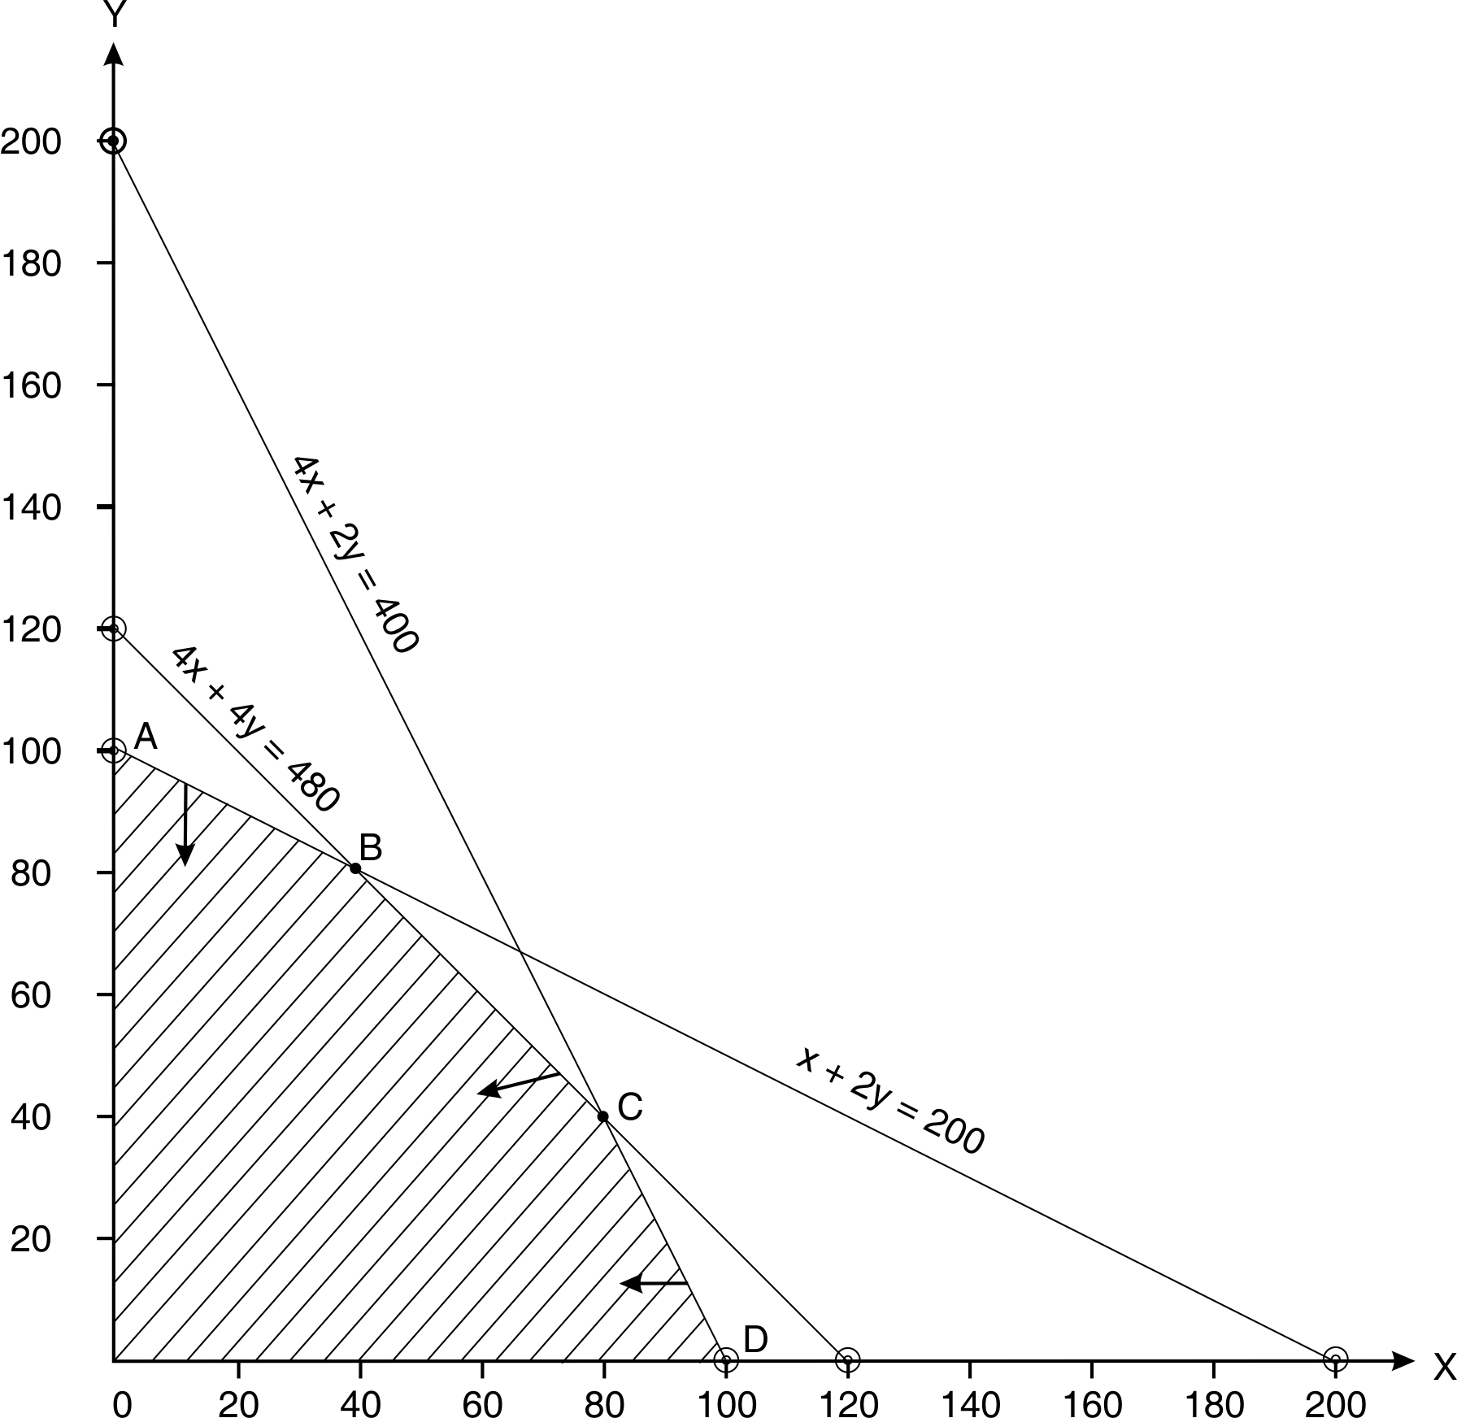

Corner points |  |  |  | Contribution
A |  | 0 | 100 | 7,500
B | 4x + 4y = 480  x + 2y = 200 | 40 | 80 | 10,000
C | 4x + 4y = 480  4x + 2y = 400 | 80 | 40 | 11,000
D |  | 100 | 0 | 10,000
E |  | 0 | 0 | 0

Suggested Product mix: 80 units of A and 40 units of B. Contribution Rs.11,000. Fixed cost (400 direct labour hours @ Rs.17.50/ hour) Rs.7000. Profit Rs.4000.

(iii) If the company can sell the painting time at Rs. 40 per hour as a separate service, we should take opportunity cost of painting A and B. The opportunity cost is Rs.40 per unit of A and Rs.80 per unit of B.

Calculation of contribution per unit (on the basis of opportunity cost of painting time)
Product→ | A (Rs.) | B (Rs.)
Selling Price | 500 | 450
Direct Materials @ Rs. 25 per kg. | 100 | 100
Direct Labour @ Rs. 20 per hour | 80 | 40
Painting @ Rs.40 per/hour | 40 | 80
Variable overheads | 190 | 175
Total Variable cost per unit | 410 | 395
Contribution per unit | 90 | 55

Objective function: Maximize 90x + 55y
Subject to:
4x + 4y ≤ 480 | 4x + 2y ≤ 400
x + 2y ≤ 200 | x , y ≥ 0

Q. No. 18.35
The following LPP is given to you:
Objective: Maximize: Z = 30x + 45y
Subject to:
2x + 3y ≤ 1440 ------ (constraint 1) | 9x + 12y ≥ 2160 ------ (constraint 2)
3x + 4y ≥ 1080 ------ (constraint 3) | x, y ≥ 0

Applying graphic method, determine Optimality and offer your comments on the solution and the constraints. (CA Final May 2012)

Answer
Let’s convert the inequalities to equalities:
 | x | y
2x + 3y = 1440 | 0 | 480
2x + 3y = 1440 | 720 | 0
9x + 12y = 2160 | 0 | 180
9x + 12y = 2160 | 240 | 0
3x + 4y = 1080 | 0 | 270
3x + 4y = 1080 | 360 | 0

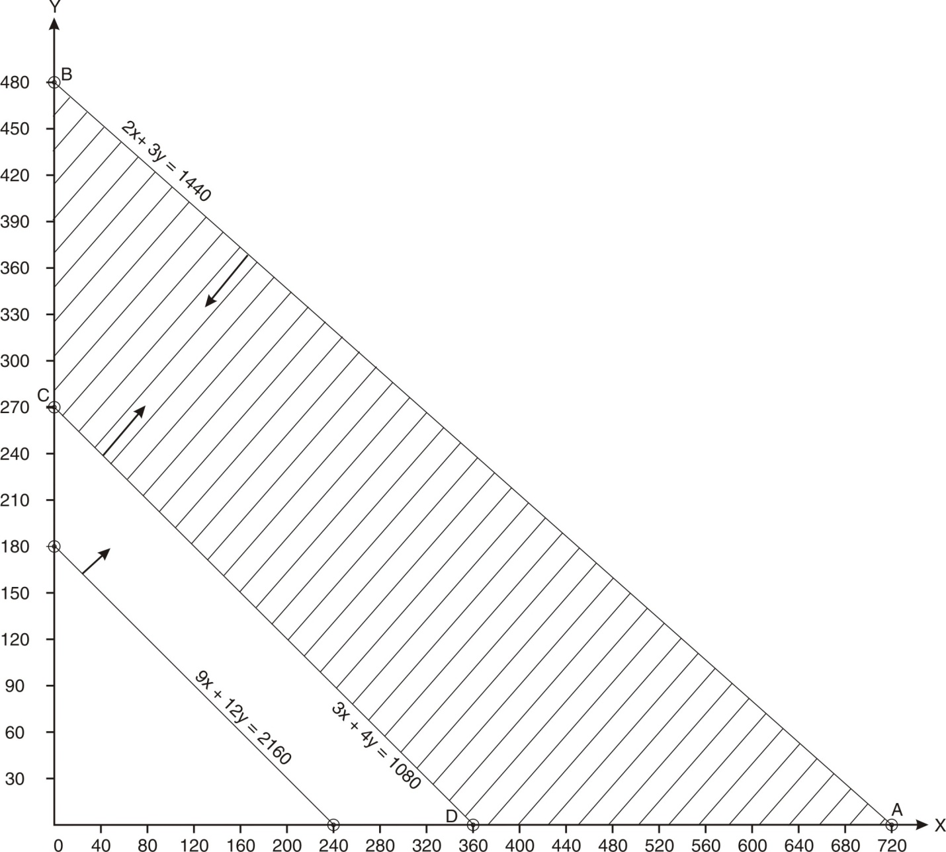

Corner points |  | x | y | Contribution (Rs.)
A |  | 720 | 0 | 21,600
B |  | 0 | 480 | 21,600
C |  | 0 | 270 | 12,150
D |  | 360 | 0 | 10,800

Suggested Product mix: It is a multiple solutions problem. There are two optimum solutions: (i) x =720 units (ii) y = 480. In each of the two cases the contribution will be Rs.21,600.
Comment on constraints: The constraint 9X + 12Y = 2160 is a redundant constraint.

Comment on solution: It is a case of multiple solutions problem.
This happens when the objective function is parallel to one of the lines bounding the feasible solution. In this problem, constraint 2 is redundant. The feasible solution is bounded by constraint 1 and constraint 3. These two constraints form boundary of feasible solution. For the problem to be multiple solutions problem, the objective function line should be parallel to the line of either constraint 1 or constraint 3. Let’s plot the objective function line on the graph. For this purpose, we can assume any value of Z. Let’s Z = 22,500.

30x + 45y = 22,500
If x = 0, y = 500
If y = 0, x = 750

Graph
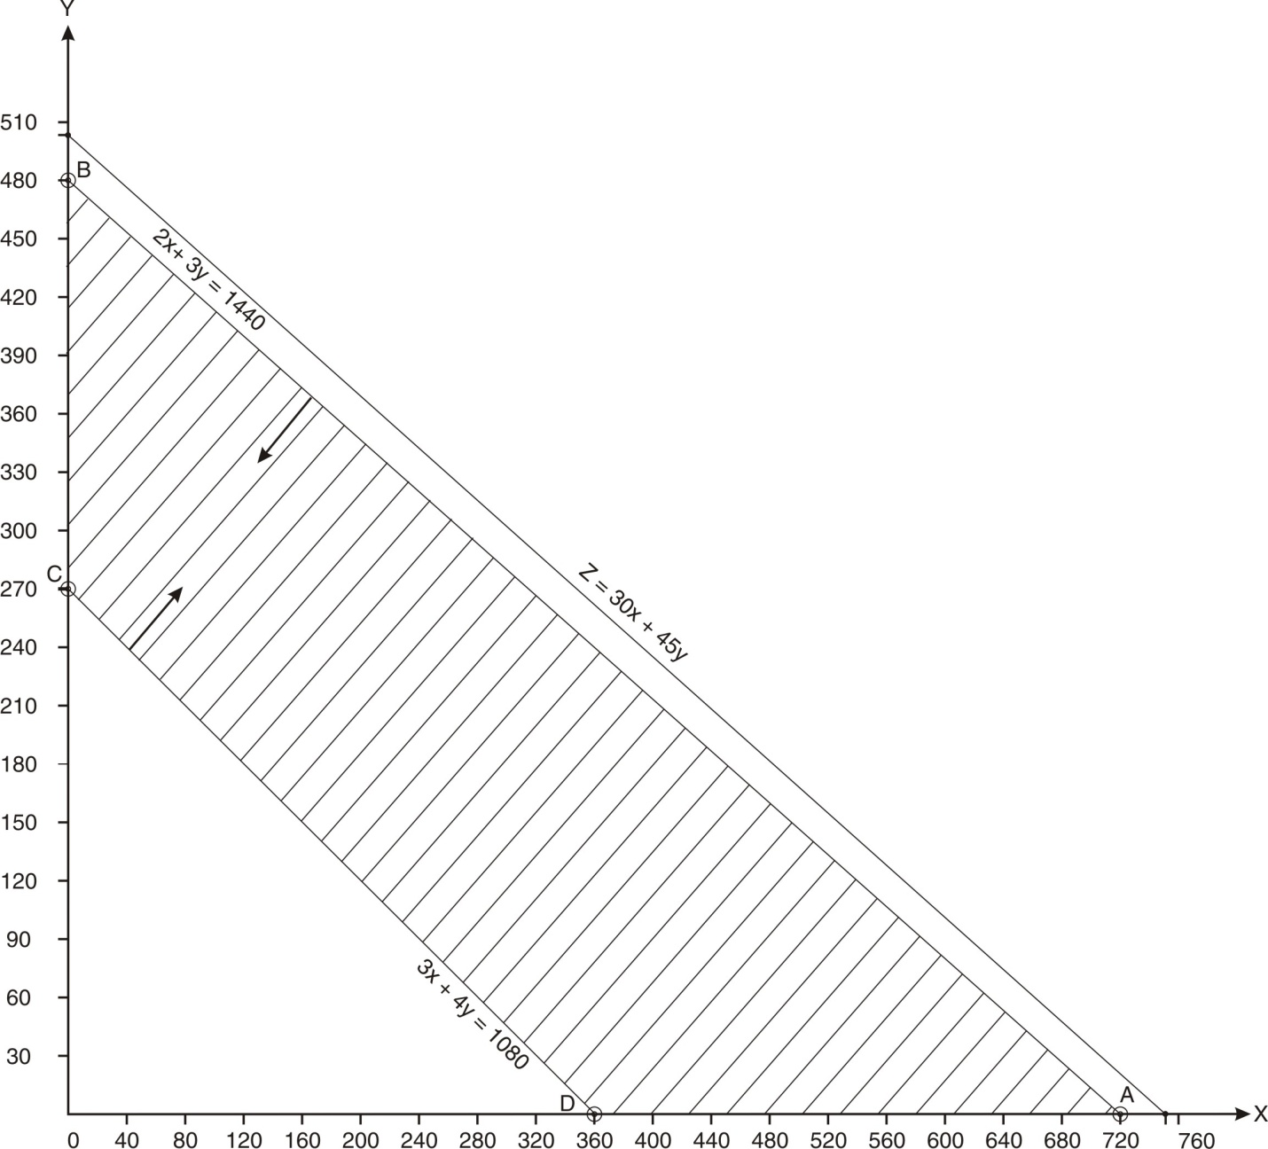

The objective function line is parallel to the line of first constraint (a line which forms boundary of the feasible solution). In this case multiple optimal solutions are there.

Q. No. 18.36
Explain the concept of multiple solutions with the help of the following problem applying the graphic method:
Maximize Z = 4x + 3y
Subject to:
3x + 4y ≤ 24 (constraint 1) | 8x + 6y ≤ 48 (constraint 2)
x ≤ 5 (constraint 3) | y ≤ 6 (Constraint 4) | x, y ≥ o

Answer
If there are 2 or more optimum solutions, the problem is described as multiple solutions problem.
Let’s convert the inequalities to equalities:
 | x | y
x = 5 | 5
y = 6 |  | 6
3x + 4y = 24 | 0 | 6
3x + 4y = 24 | 8 | 0
8x + 6y = 48 | 0 | 8
8x + 6y = 48 | 6 | 0

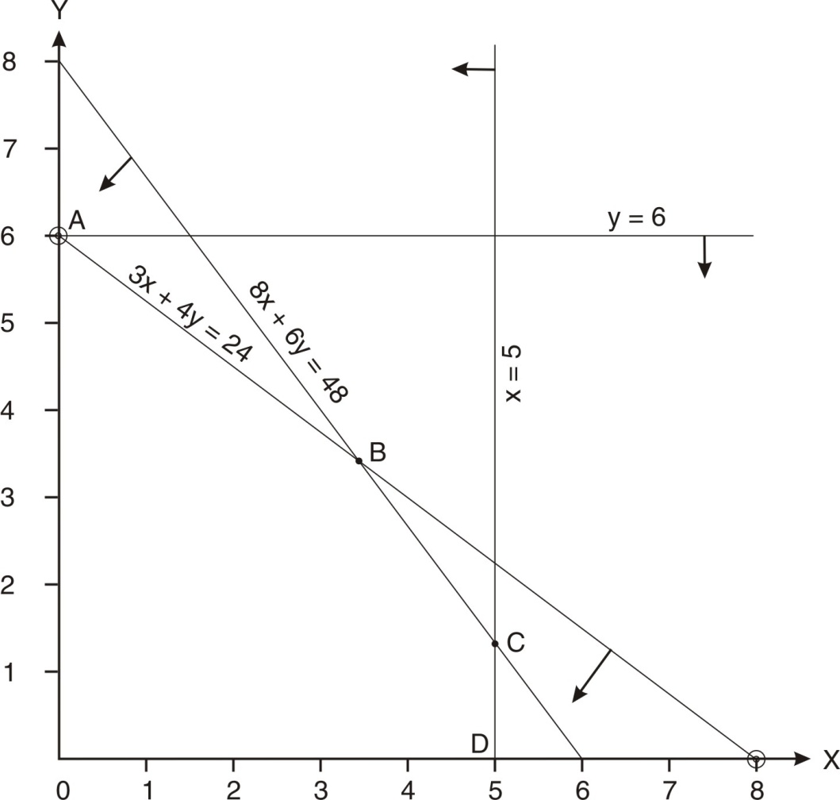
  Corner points | x | y | Contribution
  A | 0 | 6 | 18
  B | 24/7 | 24/7 | 24
  C | 5 | 4/3 | 24
  D | 5 | 0 | 20

It is a multiple solutions problem. There are two optimum solutions. (i) x =24/7 and y = 24/7 (ii) x=5 and y = 4/3.

This happens when the objective function is parallel to a constraint which forms boundary of feasible solution. In this problem, constraint 4 is redundant. The feasible solution is bounded by constraint 1, Constraint 2 and Constraint 3. These three constraints form boundary of feasible solution. For the problem to be multiple solutions problem, the objective function should be parallel to any constraints forming boundary of feasible solution. Let’s plot the objective function on the graph. For this purpose, we can assume any value of Z. Let’s Z = 12.

4x + 3y = 12 → | If x = 0, y = 4 | If y = 0, x = 3

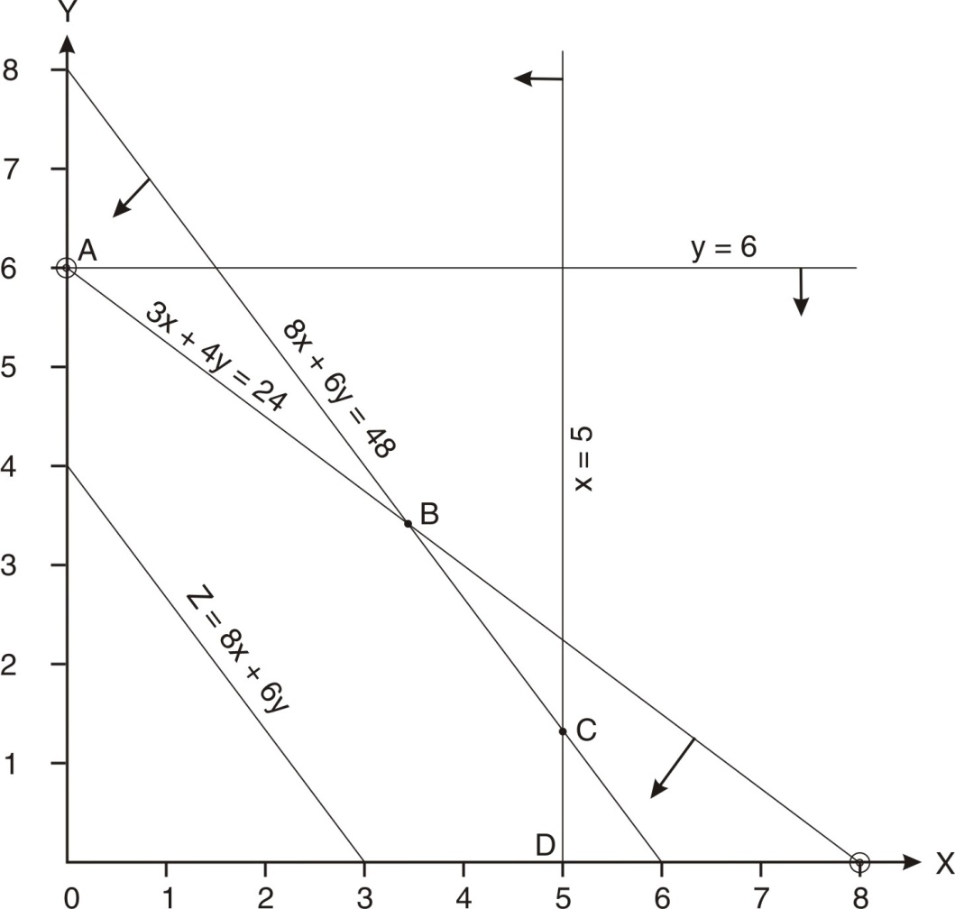

The objective function line is parallel to the line of first constraint (a line which forms boundary of the feasible solution). In this case multiple optimal solutions are there.

Q, No. 18.37
A company manufactures two products X and Y. The company’s fixed cost is Rs.5L per annum, the selling price of X is Rs.288 and that of Y is Rs.432. The standard cost data are:
 | Product X | Product Y
 | Rs. | Rs.
Material | 40 | 80
Direct wages Rs.8 per hour:  Department 1  Department 2  Department 3  Department 4 | 48  24  72  - | 72  48  -  96
Variable overheads | 32 | 28
The company operates 8 hours a day for 300 days in a year. Number of workers, in each department, are as follows:
Department | 1 | 2 | 3 | 4
No. of workers | 45 | 24 | 27 | 36

- How many units should be manufactured and what is the resultant profit if number of employees cannot be changed [CA FINAL May 2006]
- Is there some redundant constraint?

Answer
Contribution per unit : Product X Rs.72 Product Y Rs.108

Let’s produce and sell x units of Product X and y units of product Y.
Objective function: Maximize Z = 72x + 108y
Subject to :
6x + 9y ≤ 1,08,000 |  | 3x + 6y ≤ 57,600
9x ≤ 64,800 | 12y ≤ 86,400 |  | x , y ≥ 0

Let’s convert the inequalities to equalities:
 | x | y
9x = 64,800 | 7200
12y = 86400 |  | 7,200
6x + 9y = 1,08,000 | 0 | 12,000
6x + 9y = 1,08,000 | 18,000 | 0
3x + 6y = 57,600 | 0 | 9,600
3x + 6y = 57,600 | 19,200 | 0

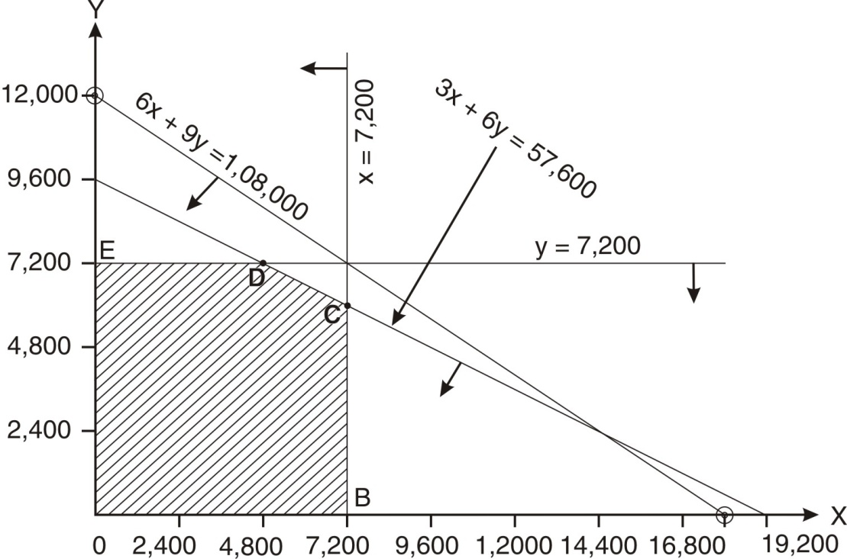

Corner points |  | x | y | Contribution
A |  | 0 | 0 | 0
B |  | 7200 | 0 | 5,18,400
C | 3x + 6y = 57,600  9x = 64,800 | 7,200 | 6,000 | 11,66,400
D | 3x + 6y = 57,600  12y = 86,400 | 4,800 | 7,200 | 11,23,200
E |  | 0 | 7200 | 7,77,600

Suggested Product mix: 7200 units of X and 6000 units of Y. Contribution: Rs.11,66,400.

A constraint is said to be redundant if it does not affect the feasible solution area. In this problem, the feasible solution area is bounded by A-B-C-D-E–A. It is not affected by the constraint 6x + 9y ≤ 1,08,000. Hence, this constraint is redundant.

18.2-2 SIMPLEX METHOD OF LINEAR PROGRAMMING

Simplex method is an algebraic procedure to solve the Linear Programming problems. It can be applied even if the decision variables are more than 2. The method is based on repetitive process (called is iterative process). We begin with the initial feasible solution, go on improving the value of objective function and finally find the optimal value.

We shall be studying Simplex method of Linear programming in five parts:
- Maximization Problems (with all constraints having “≤” sign)
- Minimization Problems (with all constraints having “≥” sign)
- Minimization Problems (with some constraints having “≤”/ “=”sign)
- Maximization Problems (with some constraints having “≥”/“=”sign)
- Primal and Dual

18.2-3.1 MAXIMIZATION PROBLEMS
(with all the constraints having “≤” sign)
Let’s understand the steps with the help of an example:
Example: A company manufactures two electronic items – Item A and Item B. Given the following data, determine the optimal product mix.
 | A | B
Contribution per unit | Rs.2 | Rs.3
Labour hour per unit | 0.06 | 0.08
Machine hour per unit | 0.04 | 0.12
Total available hours : Labour 2400 and Machine 2400.

Step I : Formulate the Linear Programming Problem;

Let’s produce x units of A and y units of B.
Objective function : Maximize Z = 2x + 3y
Subject to :
0.06x + 0.08y ≤ 2400 ( Constraint 1 )
0.04x + 0.12y ≤ 2400 ( Constraint 2 )
x, y ≥ 0 ( Non-negativity restrictive )

Step II : Convert the inequalities into equalities by introducing a slack variable for each constraint. A slack variable represents unutilized resource. It is a variable that is added to the left hand side of a less than or equal to type constraint to convert the constraint to equality. The value of this variable is non-negative. As no profit is made on unused resources, its value is taken as zero (in the objective function).

Let s₁ represents unutilized labour hours
s₂ represents unutilized machine hours
0.06x + 0.08y + s₁ = 2400 | 0.04x + 0.12y + s₂ = 2400 | x, y ≥ 0

Step III
Rewrite the objective function considering the slack variables. There is no contribution from unutilized resources, i.e., contribution from slack variables is zero.

Hence, the rewritten objective function is : Z = 2x + 3y + 0s₁ + 0s₂

Step IV Draw the initial simplex table. This table contains the rewritten objective function and all constraints converted in to equalities. The shaded area is the main body of the table.
Simplex table 1

First row of shaded area:
We write contribution from all the variables (including from slack variables). These are given in the objective function.
Simplex table 1
 |  |  | 2 | 3 | 0 | 0

Second row of shaded area:
We write all the variables (including from slack variables).
Simplex table 1
 |  |  | 2 | 3 | 0 | 0
 |  |  | x | y | 0 | 0

Third row of the shaded area:
We write the coefficients of first constraint (converted into equality)

Simplex table 1
 |  |  | 2 | 3 | 0 | 0
 |  |  | x | y | 0 | 0
 |  |  | 0.06 | 0.08 | 1 | 0

Fourth row of the shaded area:
We write the coefficients of second constraint (converted into equality)

Simplex table 1
 |  |  | 2 | 3 | 0 | 0
 |  |  | x | y | 0 | 0
 |  |  | 0.06 | 0.08 | 1 | 0
 |  |  | 0.04 | 0.12 | 0 | 1

Step V To the left of the main body we write contribution per unit of basic variables, names of the basic variables and their respective quantities. Contribution per unit of basic variables is represented by C.

Simplex table 1
C→ |  |  | 2 | 3 | 0 | 0
C↓ | Basic variables | Quantity | x | y | s₁ | s₂
 |  |  | 0.06 | 0.08 | 1 | 0
 |  |  | 0.04 | 0.12 | 0 | 1

The set of basic variables offer a feasible solution (not necessarily an optimal one). We begin with ‘inaction’ i.e. we neither produce A not B. In that case, value of x will be zero; also the value of y will be zero. All the labour hours will be unutilized; hence s₁ will be 2400. All the machine hours will be unutilized, hence s₂ will be 2400.

Simplex table 1
C→ |  |  | 2 | 3 | 0 | 0
C↓ | Basic variables | Quantity | x | y | s₁ | s₂
0 | s₁ | 2400 | 0.06 | 0.08 | 1 | 0
0 | s₂ | 2400 | 0.04 | 0.12 | 0 | 1
Step VI Find the value of Z for each variable.

x | y | s₁ | s₂
0 x 0.06  0 x 0.04 | 0 x 0.08  0 x 0.12 | 0 x 1  0 x 0 | 0 x 0  0 x 1
Total : 0 | Total : 0 | Total : 0 | Total : 0

Simplex table 1
C→ |  |  | 2 | 3 | 0 | 0
C↓ | Basic variables | Quantity | x | y | s₁ | s₂
0 | s₁ | 2400 | 0.06 | 0.08 | 1 | 0
0 | s₂ | 2400 | 0.04 | 0.12 | 0 | 1
Z |  |  | 0 | 0 | 0 | 0

Step VII Find C- Z for each variable. The set of C-Z is known as Net Evaluation row (NER).

Simplex table 1
C→ |  |  | 2 | 3 | 0 | 0
C↓ | Basic variables | Quantity | x | y | s₁ | s₂
0 | s₁ | 2400 | 0.06 | 0.08 | 1 | 0
0 | s₂ | 2400 | 0.04 | 0.12 | 0 | 1
Z  C-Z |  |  | 0 | 0 | 0 | 0
 |  |  | 2* | 3** | 0*** | 0****

Interpretation:
- *If we improve our solution and produce one unit of x, the contribution will be Rs.2.
- **If we improve our solution & produce one unit of y, the contribution will be Rs.3.
- ***Shadow Price of Labour hour is zero,
- ****Shadow price of machine hour is zero.
- We neither produce A nor B. hence, the total contribution as per the feasible solution offered by this table is zero.
- In case of optimal solution, all the elements of C – Z must be less than 0. Hence, the solution, though feasible, is not optimal.

Step VIII We want to improve the value of the objective function. We identify the most positive value in Net Evaluation row (C - Z). It is 3.

Simplex table 1
C→ |  |  | 2 | 3 | 0 | 0
C↓ | Basic variables | Quantity | x | y | s₁ | s₂
0 | s₁ | 2400 | 0.06 | 0.08 | 1 | 0
0 | s₂ | 2400 | 0.04 | 0.12 | 0 | 1
Z  C-Z |  |  | 0 | 0 | 0 | 0
 |  |  | 2 | 3↑ | 0 | 0
The shaded column is key column.

Step IX We find the replacement ratios.
Replacement ratio = Quantity/corresponding value in key column.

Simplex table 1
C→ |  |  | 2 | 3 | 0 | 0 | Replacement ratios
C↓ | Basic variables | Quantity | x | y | s₁ | s₂ | Replacement ratios
0 | s₁ | 2400 | 0.06 | 0.08 | 1 | 0 | 2400/0.08  = 30,000
0 | s₂ | 2400 | 0.04 | 0.12 | 0 | 1 | 2400/0.12  = 20,000→
Z  C-Z |  |  | 0 | 0 | 0 | 0
 |  |  | 2 | 3↑ | 0 | 0
This table provides a feasible (but not optimal) solution. The solution is Produce neither A not B. Total contribution is zero.

Identify the minimum positive ratio. The corresponding row (shaded row) is key row. This is out going row or leaving row, i.e., in the next table we shall not be taking this row. (Let’s call this row as Row2 and the row above this row as Row1)

The cell which is common in both key column and key row is known as key / pivotal element. In this table, the key element is 0.12.

It is the column of y. This shows that we give the priority to produce y (because its contribution per unit is highest). Hence y will come in, i.e. s₂ will be replaced by y.

Step IX
Simplex table 2
C→ |  |  | 2 | 3 | 0 | 0 | Replacement ratios
C↓ | Basic variables | Quantity | x | y | s₁ | s₂ | Replacement ratios
0 | s₁ | 800 | 1/30 | 0 | 1 | -2/3
3 | y | 20,000 | 1/3 | 1 | 0 | 25/3
Z
C-Z
Row 4 (Incoming row) = Leaving row/ Key element
2400/0.12  = 20,000 | 0.04/0.12  = 1/3 | 0.12/0.12  = 1 | 0/0.12  = 0 | 1/0.12  = 25/3

Let the row above Row4 is Row3.
Row3 = Row1 – Corresponding element of key column x Row4
2400 | 0.06 | 0.08 | 1 | 0
- (20,000x0.08) | - (1/3 x0.08) | - (1 x0.08) | - (0 x0.08) | - (25/3 x0.08)
800 | 1/30 | 0 | 1 | -2/3

Step X : Repeat steps VI to IX

Simplex table 2
C→ |  |  | 2 | 3 | 0 | 0 | Replacement ratios
C↓ | Basic variables | Quantity | x | y | s₁ | s₂ | Replacement ratios
0 | s₁ | 800 | 1/30 | 0 | 1 | -2/3 | 24000→
3 | y | 20,000 | 1/3 | 1 | 0 | 25/3 | 60000
Z  C-Z |  |  | 1 | 3 | 0 | 25
 |  |  | 1↑ | 0 | 0 | -25
This table provides a feasible (but not optimal) solution. The solution is : produce 20,000 units of B. Total contribution is 20000x3 i.e. Rs.60,000. Unutilized Labour hours 800.

Step XI
Row 5 (Incoming row) = Leaving row/ Key element
800/(1/30)  = 24,000 | 1/30/(1/30)  = 1 | 0/(1/30)  = 0 | 1/(1/30)  =30 | -2/3/(1/30)  = -20

Let the row below Row5 is Row6.

Row6 = Row4 – Corresponding element of key column x Row5

20,000 | 1/3 | 1 | 0 | 25/3
-(24000x1/30) | -(1x1/3) | -(0 x1/3) | -(30 x1/3) | -(-20 x1/3)
12000 | 0 | 1 | -10 | 15

Simplex table 3
C→ |  |  | 2 | 3 | 0 | 0 | Replacement ratios
C↓ | Basic variables | Quantity | x | y | s₁ | s₂ | Replacement ratios
2 | x | 24,000 | 1 | 0 | 30 | -20
3 | y | 12000 | 0 | 1 | -10 | 15
Z  C-Z |  |  | 2 | 3 | 30 | 5
 |  |  | 0 | 0 | -30 | -5
This table provides optimal solution. The solution is : produce 24,000 units of A and 12000 units of B. Total contribution is 24000x 2 + 12000x3 i.e. Rs. 84,000.

In case of optimal solution, all the elements of C – Z must be ≤ 0. Hence, the solution optimal.
Teaching note : The successive tables have shown improved value of objective function.
Table 1 | Table 2 | Table 3
Contribution nil | Contribution Rs.60,000 | Contribution Rs.84,000

Q. No. 18.38
XXX company has three departments – Assembly, painting and packing with the capability of making three types of almirahs. An almirah of type I requires one hour of assembly, 40 minutes of painting and 20 minutes of packing. Similarly, an almirah of type II needs 80 minutes, 20 minutes and one hour respectively. The last type requires 40 minutes of each assembly, painting and packing. The total time available at assembly, painting and packing departments are 600 hours, 400 hours and 800 hours respectively.
- Determine the number of each type of almirahs that should be produced to maximize the profit. The unit profits for types I, II and III are Rs.40, Rs.80 and Rs.60 respectively. (CA Final May 1990)
- Does the problem have an alternative optimal solution?
Teaching note: A problem has got multiple optimal solutions, if in the final solution, at least one of the non-basic variables gets zero value in C –Z row.

Answer
LPP
Let’s produce x units of I type, y units of II type and z units of III type.
Objective function: Maximize Z = 40x + 80 y + 60 z
Subject to :
60x + 80y + 40 x ≤ 36,000 | 40x + 20y + 40 x ≤ 24,000
20x + 60y + 40 x ≤ 48,000 | x , y , z ≥ 0

Simplex
Maximize Z = 40x + 80y + 60z + 0s₁ + 0s₂ +0s₃
Subject to :
60x + 80y + 40 x + s₁ = 36,000 | 40x + 20y + 40 x + s₂ = 24,000
20x + 60y + 40 x + s₃ = 48,000 | x , y , z ≥ 0

C → |  |  | 40 | 80 | 60 | 0 | 0 | 0 | Ratio
C↓ | Basic Variables | Quantity | x | y | z | s₁ | s₂ | s₃ | Ratio
0 | s₁ | 36,000 | 60 | 80 | 40 | 1 | 0 | 0 | 36,000/80= 450→
0 | s₂ | 24,000 | 40 | 20 | 40 | 0 | 1 | 0 | 24,000/20= 1200
0 | s₃ | 48,000 | 20 | 60 | 40 | 0 | 0 | 1 | 48,000/60= 800
Z  C – Z |  |  | 0 | 0 | 0 | 0 | 0 | 0
 |  |  | 40 | 80 ↑ | 60 | 0 | 0 | 0
-----------------------------------------------------
80 | y | 450 | 3/4 | 1 | 1/2 | 1/80 | 0 | 0 | 450/(1/2) = 900
0 | s₂ | 15,000 | 25 | 0 | 30 | -1/4 | 1 | 0 | 15,000/30 =500→
0 | s₃ | 21000 | -25 | 0 | 10 | -3/4 | 0 | 1 | 21000/10 = 2100
Z  C – Z |  |  | 60 | 80 | 40 | 1 | 0 | 0
 |  |  | – 20 | 0 | 20↑ | -1 | 0 | 0
---------------------------------------------------------------------------------------------------------------------
80 | y | 200 | 1/3 | 1 | 0 | 1/60 | –1/60 | 0
60 | z | 500 | 5/6 | 0 | 1 | – 1/120 | 1/30 | 0
0 | s₃ | 16,000 | –100/3 | 0 | 0 | –2/3 | –1/3 | 1
Z  C – Z |  |  | 76.67 | 80 | 60 | 5/6 | 2/3 | 0
 |  |  | -36.67 | 0 | 0 | -5/6 | -2/3 | 0
As all the elements of net evaluation row are non-positive, the optimal solution has been reached. The solution is the company may produce 200 units of Type II and 500 units of Type III.

The basic variables in the final solution are y, z and s₃. The non-basic variables are x, s₁ and s₂. As none of the non-basic variables have got zero value in C –Z row, multiple optimal solutions are not there i.e., there is no alternative solution.
Non-basic variables | x | s₁ | s₂
Value in C –Z row | -36.67 | -5/6 | -2/3

Working notes

24,000 | 40 | 20 | 40 | 0 | 1 | 0
–450x20 | –3/4 x20 | –1x20 | –1/2 x20 | –1/80 x20 | –0x20 | –0x20
15,000 | 25 | 0 | 30 | -1/4 | 1 | 0

48,000 | 20 | 60 | 40 | 0 | 0 | 1
–450x60 | –3/4x60 | –1x60 | –1/2x60 | –1/80x60 | –0x60 | –0x60
21000 | -25 | 0 | 10 | -3/4 | 0 | 1

(iii)
450 | 3/4 | 1 | 1/2 | 1/80 | 0 | 0
–500 x1/2 | –5/6 x 1/2 | –0 x1/2 | –1 x1/2 | –(– 1/120) x1/2 | –1/30 x 1/2 | –0 x 1/2
200 | 1/3 | 1 | 0 | 1/60 | –1/60 | 0

(iv)
21000 | -25 | 0 | 10 | -3/4 | 0 | 1
–500x10 | (–5/6 )x10 | –0x10 | –1x10 | –(– 1/120)x10 | –1/30 x10 | –0x10
16,000 | –100/3 | 0 | 0 | –2/3 | –1/3 | 1
Q.No. 18.39
For a company engaged in the manufacture of three products X, Y and Z the available data are given in Tables 1,2,and 3.
Table 1 | Table 3
  Product | Minimum sales requirement per month
  X | 10
  Y | 20
  Z | 30
  Product | Profit per unit (Rs.)
  X | 10
  Y | 15
  Z | 8
Table 2
Operations | Time ( Hours) required per item of |  |  | Total hours available per month
 | X | Y | Z | Total hours available per month
1 | 1 | 2 | 2 | 200
2 | 2 | 1 | 1 | 220
3 | 3 | 1 | 2 | 180

Find the product mix to maximize profit. (CA Final May 1988) Does the problem have alternative optimal solution?

Teaching note: A problem has got multiple optimal solutions, if in the final solution, at least one of the non-basic variables gets zero value in C –Z row.

Answer
Hours requirement for minimum sales :
Operation 1 | 10 x 1 + 20 x 2 + 30 x 2 | 110
Operation 2 | 10 x 2 + 20 x 1 + 30 x 1 | 70
Operation 3 | 10 x 3 + 20 x 1 + 30 x 2 | 110

LPP
Let’s produce x units of X, y units of Y and z units of Z over and above minimum sales.
Objective function: Maximize Z = 10x + 15y + 8z

Subject to:
x + 2y + 2z ≤ 90 | 2x + y + z ≤ 150
3x + y + 2z ≤ 70 | x , y , z ≥ 0

Simplex
Maximize Z = 10x + 15y + 8z +0s₁ +0s₂ +0s₃
Subject to:
x + 2y + 2z +s₁ = 90 | 2x + y + z +s₂ = 150
3x + y + 2z +s₃ = 70 | x , y , z ≥ 0

C → |  |  | 10 | 15 | 8 | 0 | 0 | 0 | Ratio
C↓ | Variables | Quantity | x | y | z | s₁ | s₂ | s₃ | Ratio
0 | s₁ | 90 | 1 | 2 | 2 | 1 | 0 | 0 | 45→
0 | s₂ | 150 | 2 | 1 | 1 | 0 | 1 | 0 | 150
0 | s₃ | 70 | 3 | 1 | 2 | 0 | 0 | 1 | 70
Z  C – Z |  |  | 0 | 0 | 0 | 0 | 0 | 0
 |  |  | 10 | 15↑ | 8 | 0 | 0 | 0
--------------------------------------------------------------
15 | y | 45 | ½ | 1 | 1 | 1/2 | 0 | 0 | 90
0 | s₂ | 105 | 3/2 | 0 | 0 | -1/2 | 1 | 0 | 70
0 | s₃ | 25 | 5/2 | 0 | 1 | -1/2 | 0 | 1 | 10→
Z  C – Z |  |  | 7.50 | 15 | 15 | 7.50 | 0 | 0
 |  |  | 2.50↑ | 0 | -7 | -7.50 | 0 | 0
------------------------------------------------------------
15 | y | 40 | 0 | 1 | 4/5 | 3/5 | 0 | -1/5
0 | s₂ | 90 | 0 | 0 | -3/5 | -1/5 | 1 | -3/5
10 | x | 10 | 1 | 0 | 2/5 | -1/5 | 0 | 2/5
Z  C – Z |  |  | 10 | 15 | 16 | 7 | 0 | 1
 |  |  | 0 | 0 | -8 | -7 | 0 | -1

As all the elements of net evaluation row i.e. C-Z are ≤ 0, the optimal solution has been reached. The company may produce 10 units of X and 40 units of Y in addition to the units required for minimum sales. Total recommended production is 20 units of X, 60 units of Y and 30 units of Z. Profit Rs.1340.

The basic variables in the final solution are x, y, and s₂. The non-basic variables are z, s₁ and s₃. As none of the non-basic variables have got zero value in C –Z row, multiple optimal solutions are not there i.e., there is no alternative solution.
Non-basic variables | z | s₁ | s₃
Value in C –Z row | -8 | -7 | -1

Working note (i)
150 | 2 | 1 | 1 | 0 | 1 | 0
–45 x1 | –½ x1 | –1 x1 | –1 x1 | –1/2 x1 | –0 x1 | –0 x1
105 | 3/2 | 0 | 0 | -1/2 | 1 | 0

Working note (ii)
70 | 3 | 1 | 2 | 0 | 0 | 1
–45 x1 | –½ x1 | –1 x1 | –1 x1 | –1/2 x1 | –0 x1 | –0 x1
25 | 5/2 | 0 | 1 | -1/2 | 0 | 1

Working note (iii)
45 | ½ | 1 | 1 | 1/2 | 0 | 0
–10x1/2 | –1x1/2 | –0x1/2 | –2/5x1/2 | –(-1/5x1/2) | –0x1/2 | –2/5x1/2
40 | 0 | 1 | 4/5 | 3/5 | 0 | -1/5

Working note (iv)
105 | 3/2 | 0 | 0 | -1/2 | 1 | 0
–10x3/2 | –1x3/2 | –0x3/2 | –2/5x3/2 | –(-1/5x3/2) | –0x3/2 | –2/5x3/2
90 | 0 | 0 | -3/5 | -1/5 | 1 | -3/5

Q. No. 18. 40
You were given a maximization problem:
Maximize Z = 3x +2y
Subject to :
-x +2y ≤ 4 | 3x +2y ≤ 14 | x – y ≤ 3 | x , y ≥ 0

You solved it by simplex. The table below gives the final iteration of the above problem.
C → |  |  | 3 | 2 | 0 | 0 | 0
C↓ | Basic Variables | Quantity | x | y | s₁ | s₂ | s₃
0 | s₁ | 6 | 0 | 0 | -1 | -1/5 | 8/5
2 | x₂ | 1 | 0 | 1 | 0 | 1/5 | -3/5
3 | x₁ | 4 | 1 | 0 | 0 | 1/5 | 2/5
Z  C – Z |  |  | 3 | 2 | 0 | 1 | 0
 |  |  | 0 | 0 | 0 | -1 | 0

Does the problem have alternative optimal solution? If yes, find the same.

Answer
As per the table given in the question the contribution is Rs.14.

A problem has got multiple optimal solutions, if in the final solution, at least one of the non-basic variables gets zero value in C –Z row.
Non-basic variables | s₂ | s₃
Value in C –Z row | -1 | 0

As s₃ has got zero value, there is alternative solution to this problem.

Let’s enter s₃ in the solution.
C → |  |  | 3 | 2 | 0 | 0 | 0 | Ratio
C↓ | Basic Variables | Quantity | x | y | s₁ | s₂ | s₃ | Ratio
0 | s₁ | 6 | 0 | 0 | -1 | -1/5 | 8/5 | 3.75→
2 | x₂ | 1 | 0 | 1 | 0 | 1/5 | -3/5 | -5/3
3 | x₁ | 4 | 1 | 0 | 0 | 1/5 | 2/5 | 10
Z  C – Z |  |  | 3 | 2 | 0 | 1 | 0
 |  |  | 0 | 0 | 0 | -1 | 0↑

Working notes for Next Simplex table
Working note 1
1 | 0 | 1 | 0 | 1/5 | -3/5
-3.75x(-3/5) | -0 x(-3/5) | -0 x(-3/5) | -{-5/8 x(-3/5)} | -(-1/8)x(-3/5) | -1 x(-3/5)
3.25 | 0 | 1 | 3/8 | 0.125 | 0

Working note 2
4 | 1 | 0 | 0 | 1/5 | 2/5
-3.75x(2/5) | -0 x(2/5) | -0 x(2/5) | -(-5/8x(2/5) | -(-1/8)x(2/5) | -1 x(2/5)
2.50 | 1 | 0 | 1/4 | 0.25 | 0

Next Simplex Table
C → |  |  | 3 | 2 | 0 | 0 | 0 | Ratio
C↓ | Basic Variables | Quantity | x | y | s₁ | s₂ | s₃ | Ratio
0 | S₃ | 3.75 | 0 | 0 | -5/8 | -1/8 | 1
2 | x₂ | 3.25 | 0 | 1 | 3/8 | 0.125 | 0
3 | x₁ | 2.50 | 1 | 0 | 1/4 | 0.25 | 0
Z  C – Z |  |  | 3 | 2 | 9/8 | 1 | 0
 |  |  | 0 | 0 | -9/8 | -1 | 0

As all the elements of net evaluation row i.e. C-Z are ≤ 0, the optimal solution has been reached. The company may produce 2.50 units of X and 3.25 units of y. The contribution will be Rs.14.

Q. No. 18.41: A factory is engaged in the manufacturing of pistons, rings and valves. Contribution per unit is Rs.10, Rs.6 and Rs.4 per unit respectively. The time requirement for manufacture of one unit in given below:
 | Pistons | Rings | Valves | Hours available
Preparatory work | 1 | 1 | 1 | 100
Machining | 10 | 4 | 5 | 600
Packing | 2 | 2 | 6 | 300
- Formulate and solve the LP problem for maximization of contribution. (CA Final)
- Does the problem have alternative optimal solution?

Teaching note: A problem has got multiple optimal solutions, if in the final solution, at least one of the non-basic variables gets zero value in C –Z row.

Answer
LPP
Let’s produce x units of Pistons, y units of Rings and z units of valves

Objective function: Maximize 10x + 6y + 4z
Subject to:
x + y + z ≤ 100 | 10x + 4y + 5z ≤ 600
2x +2 y + 6z ≤ 300 | x, y, z ≥ 0
Simplex
Maximize Z = 10x +6y + 4z +0s₁ +0s₂ +0s₃
Subject to:
x + y + z +s₁ = 100 | 10x + 4y + 5z +s₂ = 600
2x +2y + 6z +s₃ = 300 | x , y , z ≥ 0

C → |  |  | 10 | 6 | 4 | 0 | 0 | 0 | Ratio
C↓ | Variables | Quantity | x | y | z | s₁ | s₂ | s₃ | Ratio
0 | s₁ | 100 | 1 | 1 | 1 | 1 | 0 | 0 | 100
0 | s₂ | 600 | 10 | 4 | 5 | 0 | 1 | 0 | 60→
0 | s₃ | 300 | 2 | 2 | 6 | 0 | 0 | 1 | 150
Z  C – Z |  |  | 0 | 0 | 0 | 0 | 0 | 0
 |  |  | 10↑ | 6 | 4 | 0 | 0 | 0
--------------------------------------------------------------
0 | s₁ | 40 | 0 | 6/10 | 5/10 | 1 | -1/10 | 0 | 66.67→
10 | x | 60 | 1 | 4/10 | 5/10 | 0 | 1/10 | 0 | 150
0 | s₃ | 180 | 0 | 6/5 | 5 | 0 | -2/10 | 1 | 150
Z  C – Z |  |  | 10 | 4 | 5 | 0 | 1 | 0
 |  |  | 0 | 2↑ | -1 | 0 | -1 | 0

6 | y | 200/3 | 0 | 1 | 5/6 | 10/6 | -1/6 | 0
10 | x | 100/3 | 1 | 0 | 1/6 | -2/3 | 1/6 | 0
0 | s₃ | 100 | 0 | 0 | 4 | -2 | 0 | 1
Z  C – Z |  |  | 10 | 6 | 6.67 | 3.33 | 0.67 | 0
 |  |  | 0 | 0 | -2.67 | -3.33 | -0.67 | 0

As all the elements of net evaluation row i.e. C-Z are ≤ 0, the optimal solution has been reached. The company may produce 100/3 units of Piston and 200/3 units of Rings. (The work on incomplete units will be completed in the next period). The contribution will be Rs.733.33.

The basic variables in the final solution are x, y, and s₃. The non-basic variables are z, s₁ and s₂. As none of the non-basic variables have got zero value in C –Z row, multiple optimal solutions are not there i.e., there is no alternative solution.
Non-basic variables | z | s₁ | s₂
Value in C –Z row | -2.67 | -3.33 | - 0.67

Working note (i)
100 | 1 | 1 | 1 | 1 | 0 | 0
–60 x1 | –1x1 | –4/10 x1 | –5/10 x1 | –0/10 x1 | –1/10 x1 | –0/10 x1
40 | 0 | 6/10 | 5/10 | 1 | -1/10 | 0

Working note (ii)
300 | 2 | 2 | 6 | 0 | 0 | 1
–60 x2 | –1x2 | –4/10 x2 | –5/10 x2 | –0/10 x2 | –1/10 x2 | –0/10 x2
180 | 0 | 6/5 | 5 | 0 | -2/10 | 1

Working note (iii)
60 | 1 | 4/10 | 5/10 | 0 | 1/10 | 0
-66.67x4/10 | -0x4/10 | -1x4/10 | -5/6x4/10 | -10/6x4/10 | -(-1/6)x4/10 | -0x 4/10
100/3 | 1 | 0 | 1/6 | -2/3 | 1/6 | 0

Working note (iv)
180 | 0 | 6/5 | 5 | 0 | -2/10 | 1
-66.67x 1.20 | -0x1.20 | -1x1.20 | -5/6x1.20 | -10/6x1.20 | -(-1/6)x1.20 | -0x1.20
100 | 0 | 0 | 4 | -2 | 0 | 1

Q, No. 18.42: A company makes three products X, Y and Z out of three raw materials A, B and C. The raw – material requirement is given below:
Raw materials | The number of units of raw materials required to produce one unit of product
 | X | Y | Z
A | 1 | 2 | 1
B | 2 | 1 | 4
C | 2 | 5 | 1
The unit contribution of the products X, Y and Z are Rs.40, Rs.25 and Rs.50 respectively. The number of units of raw materials available is 36, 60 and 45.
- Formulate and solve the LP problem for maximization of contribution.
(CA Final May 1989)
- What is shadow price? Indicate the shadow prices of the B raw material.

Answer
LPP
Let’s produce x units of X, y units of Y and z units of Z
Objective function: Maximize 40x + 25y and 50z
Subject to:
x + 2y +z ≤ 36 | 2x + y + 4z ≤ 60
2x + 5y + z ≤ 45 | x, y, z ≥ 0

Simplex
Maximize Z = 40x +25y + 50z +0s₁ +0s₂ +0s₃
Subject to:
x + 2y + z + s₁ = 36 | 2x + y + 4z +s₂ = 60
2x + 5y + z +s₃ = 45 | x, y, z ≥ 0

C → |  |  | 40 | 25 | 50 | 0 | 0 | 0 | Ratio
C↓ | Variables | Quantity | x | y | z | s₁ | s₂ | s₃ | Ratio
0 | s₁ | 36 | 1 | 2 | 1 | 1 | 0 | 0 | 36
0 | s₂ | 60 | 2 | 1 | 4 | 0 | 1 | 0 | 15→
0 | s₃ | 45 | 2 | 5 | 1 | 0 | 0 | 1 | 45
Z  C – Z |  |  | 0 | 0 | 0 | 0 | 0 | 0
 |  |  | 40 | 25 | 50↑ | 0 | 0 | 0

0 | s₁ | 21 | 1/2 | 7/4 | 0 | 1 | -1/4 | 0 | 42
50 | z | 15 | 1/2 | 1/4 | 1 | 0 | 1/4 | 0 | 30
0 | s₃ | 30 | 3/2 | 19/4 | 0 | 0 | -1/4 | 1 | 20→
Z  C – Z |  |  | 25 | 12.50 | 50 | 0 | 12.50 | 0
 |  |  | 15↑ | 12.50 | 0 | 0 | -12.50 | 0

0 | s₁ | 11 | 0 | 1/6 | 0 | 1 | -1/6 | -1/3
50 | z | 5 | 0 | -4/3 | 1 | 0 | 1/3 | -1/3
40 | x | 20 | 1 | 19/6 | 0 | 0 | -1/6 | 2/3
Z  C – Z |  |  | 40 | 60 | 50 | 0 | 10 | 10
 |  |  | 0 | -35 | 0 | 0 | -10 | -10

As all the elements of net evaluation row i.e. C-Z are ≤ 0, the optimal solution has been reached. The company may produce 20 units of X and 5 units of Z. The contribution will be Rs.1,050.

Working note (i)
36 | 1 | 2 | 1 | 1 | 0 | 0
-15x1 | -1/2x1 | -1/4x1 | -1x1 | -0x1 | -1/4x1 | -0x1
21 | 1/2 | 7/4 | 0 | 1 | -1/4 | 0

Working note (ii)
45 | 2 | 5 | 1 | 0 | 0 | 1
-15x1 | -1/2x1 | -1/4x1 | -1x1 | -0x1 | -1/4x1 | -0x1
30 | 3/2 | 19/4 | 0 | 0 | -1/4 | 1

Working note (iii)
21 | 1/2 | 7/4 | 0 | 1 | -1/4 | 0
-20x1/2 | -1x1/2 | -19/6x1/2 | -0x1/2 | -0x1/2 | -(-1/6)x1/2 | -2/3x1/2
11 | 0 | 1/6 | 0 | 1 | -1/6 | -1/3
Working note (iv)
15 | 1/2 | 1/4 | 1 | 0 | 1/4 | 0
-20x1/2 | -1x1/2 | -19/6x1/2 | -0x1/2 | -0x1/2 | -(-1/6)x1/2 | -2/3x1/2
5 | 0 | -4/3 | 1 | 0 | 1/3 | -1/3

Shadow Price
Shadow Price (also known as marginal worth of the resource) of a constraint is the amount by which the objective function value will change if we change the right-hand side of the constraint by one unit. It is shown in C-Z row of the final solution corresponding to the slack variable of that constraint.

Resource (Raw Materials) | A | B | C
Corresponding slack variable | S1 | S2 | S2
Shadow price | 0 | 10 | 10

Interpretation:
If we increase the quantity of availability of A by one, our contribution will increase by Rs.0
If we increase the quantity of availability of B by one, our contribution will increase by Rs.10.
If we increase the quantity of availability of C by one, our contribution will increase by Rs.10.

For example, we have seen in this question that we the given resources the optimal contribution is Rs.1050. Now suppose that for B we have 61 hours (instead of 60). The new scenario is:
C → |  |  | 40 | 25 | 50 | 0 | 0 | 0 | Ratio
C↓ | Variables | Quantity | x | y | z | s₁ | s₂ | s₃ | Ratio
0 | s₁ | 36 | 1 | 2 | 1 | 1 | 0 | 0 | 36
0 | s₂ | 61 | 2 | 1 | 4 | 0 | 1 | 0 | 15.25→
0 | s₃ | 45 | 2 | 5 | 1 | 0 | 0 | 1 | 45
Z  C – Z |  |  | 0 | 0 | 0 | 0 | 0 | 0
 |  |  | 40 | 25 | 50↑ | 0 | 0 | 0

Working note (i)
36 | 1 | 2 | 1 | 1 | 0 | 0
-15.25x1 | -1/2x1 | -1/4x1 | -1x1 | -0x1 | -1/4x1 | -0x1
20.75 | 1/2 | 7/4 | 0 | 1 | -1/4 | 0

Working note (ii)
45 | 2 | 5 | 1 | 0 | 0 | 1
-15.25x1 | -1/2x1 | -1/4x1 | -1x1 | -0x1 | -1/4x1 | -0x1
29.75 | 3/2 | 19/4 | 0 | 0 | -1/4 | 1

0 | s₁ | 20.75 | 1/2 | 7/4 | 0 | 1 | -1/4 | 0 | 41.50
50 | z | 15.25 | 1/2 | 1/4 | 1 | 0 | 1/4 | 0 | 30.50
0 | s₃ | 29.75 | 3/2 | 19/4 | 0 | 0 | -1/4 | 1 | 19.83→
Z  C – Z |  |  | 25 | 12.50 | 50 | 0 | 12.50 | 0
 |  |  | 15↑ | 12.50 | 0 | 0 | -12/50 | 0

Working note (iii)
20.75 | 1/2 | 7/4 | 0 | 1 | -1/4 | 0
-1(119/6) x(1/2) | -1  x(1/2) | -(19/6) x(1/2) | -0  x(1/2) | -0  x(1/2) | -(-1/6) x(1/2) | -(2/3)  x(1/2)
65/6 | 0 | 1/6 | 0 | 1 | -1/6 | -1/3

Working note (iv)
15.25 | 1/2 | 1/4 | 1 | 0 | 1/4 | 0
-1(119/6) x(1/2) | -1  x(1/2) | -(19/6) x(1/2) | -0  x(1/2) | -0  x(1/2) | -(-1/6) x(1/2) | -(2/3)  x(1/2)
16/3 | 0 | -4/3 | 1 | 0 | 1/3 | -1/3

0 | s₁ | 65/6 | 0 | 1/6 | 0 | 1 | -1/6 | -1/3
50 | z | 16/3 | 0 | -4/3 | 1 | 0 | 1/3 | -1/3
40 | x | 119/6 | 1 | 19/6 | 0 | 0 | -1/6 | 2/3
Z  C – Z |  |  | 40 | 60 | 50 | 0 | 10 | 10
 |  |  | 0 | -35 | 0 | 0 | -10 | -10

As all the elements of net evaluation row i.e. C-Z are ≤ 0, the optimal solution has been reached. The company may produce 119/6 units of X and 16.33 units of Z. The contribution will be Rs.1,060.
- This shows that increase of one unit of raw material B increased the value of objective function by Rs.10. Hence, the shadow price of R1 is Rs.10 per unit of raw material B.

Q. No. 18.43 A company produces two products D1 and D2 using two machines R1 and R2. Product D1 requires 2 hours on R1 and 6 hours on R2. Product D2 uses 5 hours on machine R1 only. Available hours R1: 16 hours and R2: 30 hours. Profit per unit: D1: Rs.2 and D2: Rs.10. Using simplex finds the optimum production mix to maximize the profit. (CA Final Nov. 2003) What is shadow price? Indicate the shadow prices of the two resources.

Answer
LPP
Let’s produce x units of D1and y units of D2
Objective function: Maximize 2x + 10y
Subject to: | 2x +5y ≤ 16 | 6x ≤ 30 | x , y ≥ 0

Simplex
Maximize Z = 2x +10y +0s₁ +0s₂
Subject to: | 2x + 5y + s₁ = 16 | 6x +s₂ = 30 | x, y ≥ 0

C → |  |  | 2 | 10 | 0 | 0 | Ratio
C↓ | Variables | Quantity | x | y | s₁ | s₂ | Ratio
0 | s₁ | 16 | 2 | 5 | 1 | 0 | 3.20→
0 | s₂ | 30 | 6 | 0 | 0 | 1 | ∞
Z  C – Z |  |  | 0 | 0 | 0 | 0
 |  |  | 2 | 10↑ | 0 | 0
--------------------------------------------------------------
10 | y | 3.20 | 2/5 | 1 | 1/5 | 0
0 | s₂ | 30 | 6 | 0 | 0 | 1
Z  C – Z |  |  | 4 | 10 | 2 | 0
 |  |  | -2 | 0 | -2 | 0

Working note (i)
30 | 6 | 0 | 0 | 1
- 3.20 x 0 | - 2/5 x 0 | -1x0 | -1/5x0 | -0x0
30 | 6 | 0 | 0 | 1

As all the elements of net evaluation row i.e. C-Z are ≤ 0, the optimal solution has been reached. The company may produce 3.20 units of D2. The contribution will be Rs.32. (The work on incomplete units will be completed in the next period).

Shadow Price
Shadow Price (also known as marginal worth of the resource) of a constraint is the amount by which the objective function value will change if we change the right-hand side of the constraint by one unit. It is shown in C-Z row of the final solution corresponding to the slack variable of that constraint.

Resource | R1 | R2
Corresponding slack variable | s₁ | s₂
Shadow price | -2 | 0

Interpretation:
If we increase the hours available R1 by one, our contribution will increase by Rs.2
If we increase the hours available R2 by one, our contribution will increase by zero.

For example, we have seen in this question that we the given resources the optimal contribution is Rs.32. Now suppose that for R1 we have 17 hours (instead of 16). The new scenario is:

C → |  |  | 2 | 10 | 0 | 0 | Ratio
C↓ | Variables | Quantity | x | y | s₁ | s₂ | Ratio
0 | s₁ | 17 | 2 | 5 | 1 | 0 | 3.40→
0 | s₂ | 30 | 6 | 0 | 0 | 1 | ∞
Z  C – Z |  |  | 0 | 0 | 0 | 0
 |  |  | 2 | 10↑ | 0 | 0
--------------------------------------------------------------
10 | y | 3.40 | 2/5 | 1 | 1/5 | 0
0 | s₂ | 30 | 6 | 0 | 0 | 1
Z  C – Z |  |  | 4 | 10 | 2 | 0
 |  |  | -2 | 0 | -2 | 0

Working note (ii)
30 | 6 | 0 | 0 | 1
- 3.40 x 0 | - 2/5 x 0 | -1x0 | -1/5x0 | -0x0
30 | 6 | 0 | 0 | 1

As all the elements of net evaluation row i.e. C-Z are ≤ 0, the optimal solution has been reached. The company may produce 3.40 units of D2. The contribution will be Rs.34. (The work on incomplete units will be completed in the next period).
- This shows that increase of one hour of R1 increased the value of objective function by Rs.2. Hence, the shadow price of R1 is Rs.2 per hour.

Q. No. 18.44 : A manufacturing company produces two types of product Super and Regular. Resource requirement of production are given below in the table. There are 1600 hours of assembly worker, 700 hours of paint workers and 300 hours of inspection team. Regular customers demand at least 150 units of regular type and 90 units of Super type.
Product | Profit/contribution  (Rs.) | Assembly time  (Hrs.) | Paint time (Hrs.) | Inspection time  (Hrs.)
Regular | 50 | 1.2 | 0.8 | 0.2
Super | 75 | 1.6 | 0.9 | 0.2
Formulate and solve the LPP using Simplex method to maximize the profit.
(Nov. 2004 CA Final) Does the problem have degeneracy?

Teaching note:
- A solution degenerates if the quantity of one or more basic variables is zero.
In this situation the successive tableau does not give an improvement in the value of the objective function. Generally degeneracy does not prevent the simplex method to find the optimal solution; it just slows the process down.

Answer
Time to meet the regular demand
Product | Assembly time  (Hours) | Paint time  (Hours) | Inspection time  (Hours)
Regular | 1.2x150 | 0.8x150 | 0.2x150
Super | 1.6x90 | 0.9x90 | 0.2x90
Total | 324 | 201 | 48
Available time after minimum Production | 1600-324 = 1276 | 700 – 209 = 499 | 300 – 48 = 252

LPP
Let’s produce x units of Regular and y units of Super (over above the units required to meet the regular demand)
Objective function : Maximize Z = 50x + 75y
Subject to :
1.20x + 1.60y ≤ 1276 | 0.80x + 0.90y ≤ 499
0.20x + 0.20y ≤ 252 | x , y ≥ 0

Simplex
Maximize Z = 50x + 75y + 0s₁ + 0s₂ + 0s₃
Subject to :
1.20x + 1.60y + s₁ = 1276 | 0.80x + 0.90y + s₂ = 499
0.20x + 0.20y + s₃ = 252 | x , y ≥ 0

C → |  |  | 50 | 75 | 0 | 0 | 0 | Ratio
C↓ | Variables | Quantity | x | y | s₁ | s₂ | s₃ | Ratio
0 | s₁ | 1276 | 1.20 | 1.60 | 1 | 0 | 0 | 797.50
0 | s₂ | 499 | 0.80 | 0.90 | 0 | 1 | 0 | 554.44 →
0 | s₃ | 252 | 0.20 | 0.20 | 0 | 0 | 1 | 1260.00
Z  C – Z |  |  | 0 | 0 | 0 | 0 | 0
 |  |  | 50 | 75↑ | 0 | 0 | 0
-----------------------------------------------------------
0 | s₁ | 388.90 | -0.22 | o | 1 | -1.776 | 0
75 | y | 554.44 | 8/9 | 1 | 0 | 1.11 | 0
0 | s₃ | 141.11 | 0.022 | 0 | 0 | -0.222 | 1
Z  C – Z |  |  | 66/67 | 75 | 0 | 83.25 | 0
 |  |  | -16.67 | 0 | 0 | -83.25 | 0

As all the elements of net evaluation row i.e. C-Z are ≤ 0, the optimal solution has been reached. The company may produce 554.44 units of super (over above the units required to meet the regular demand). (The work on incomplete units will be completed in the next period). Total production: 150 units of Regular and 644.44 units of Super. Total contribution: Rs.55,833.

A solution degenerates if the quantity of one or more basic variables is zero.
Basic variables | S1 | y | S3
Quantity | 388.90 | 554.44 | 141.11
As the quantity of none of the basic variables is zero, the solution would not degenerate.

Working note (i)
1276 | 1.20 | 1.60 | 1 | 0 | 0
-554.44x1.6 | -8/9 x1.6 | -1 x1.6 | -0 x1.6 | -1.11 x1.6 | -0 x1.6
388.90 | -0.22 | o | 1 | -1.776 | 0

Working note (ii)
252 | 0.20 | 0.20 | 0 | 0 | 1
-554.44x0.20 | -8/9 x0.20 | -1 x0.20 | -0 x0.20 | -1.11 x0.20 | -0 x0.20
141.11 | 0.022 | 0 | 0 | -0.222 | 1

Q. No. 18.45: A company manufactures two products A and B involving three departments – Machine, Fabrication and Assembly. The process time, profit per unit and total capacity of each department is given below:
 | Machine hours | Fabrication hours | Assembly hours | Profit (Rs.)
A | 1 | 5 | 3 | 80
B | 2 | 4 | 1 | 100
Capacity | 720 | 1800 | 900
Formulate and solve the LPP using Simplex method to maximize the profit.
(CA Final May 2005) (CA Final May 2011) Does the problem have degeneracy?

Teaching note: A solution degenerates if the quantity of one or more basic variables is zero. Degeneracy may occur at initial stage or at subsequent iteration stage In this situation the successive tableau does not give an improvement in the value of the objective function. Generally degeneracy does not prevent the simplex method to find the optimal solution; it just slows the process down.

Answer
Let’s produce x units of A and y units of B
Objective function : Maximize Z = 80x + 100y
Subject to :
x + 2y ≤ 720 | 5x + 4y ≤ 1800
3x + y ≤ 900 | x , y ≥ 0

Simplex
Maximize Z = 80x + 100y + 0s₁ + 0s₂ + 0s₃
Subject to :
x + 2y + s₁ = 720 | 5x + 4y + s₂ = 1800
3x + y + s₃ = 900 | x , y ≥ 0

C → |  |  | 80 | 100 | 0 | 0 | 0 | Ratio
C↓ | Variables | Quantity | x | y | s₁ | s₂ | s₃ | Ratio
0 | s₁ | 720 | 1 | 2 | 1 | 0 | 0 | 360 →
0 | s₂ | 1800 | 5 | 4 | 0 | 1 | 0 | 450
0 | s₃ | 900 | 3 | 1 | 0 | 0 | 1 | 900
Z  C – Z |  |  | 0 | 0 | 0 | 0 | 0
 |  |  | 80 | 100↑ | 0 | 0 | 0
---------------------------------------------------------
100 | y | 360 | 1/2 | 1 | 1/2 | 0 | 0 | 720
0 | s₂ | 360 | 3 | 0 | -2 | 1 | 0 | 120→
0 | s₃ | 540 | 5/2 | 0 | -1/2 | 0 | 1 | 216
Z  C – Z |  |  | 50 | 100 | 50 | 0 | 0
 |  |  | 30↑ | 0 | -50 | 0 | 0

100 | y | 300 | 0 | 1 | 5/6 | -1/6 | 0
80 | x | 120 | 1 | 0 | -2/3 | 1/3 | 0
0 | s₃ | 240 | 0 | 0 | 7/6 | -5/6 | 1
Z  C – Z |  |  | 80 | 100 | 30 | 10 | 0
 |  |  | 0 | 0 | -30 | -10 | 0

As all the elements of net evaluation row i.e. C-Z are ≤ 0, the optimal solution has been reached. The company may produce 120 units of A and 300 units of B. Total contribution: Rs.39600.
A solution degenerates if the quantity of one or more basic variables is zero.
Basic variables | x | y | s₃
Quantity | 120 | 200 | 240
As the quantity of none of the basic variables is zero, the solution would not degenerate.

Working note (i)
1800 | 5 | 4 | 0 | 1 | 0
-360x4 | -1/2x4 | -1x4 | -1/2x4 | -0x4 | -0x4
360 | 3 | 0 | -2 | 1 | 0

Working note (ii)
900 | 3 | 1 | 0 | 0 | 1
-360x1 | -1/2 x1 | -1 x1 | -1/2 x1 | -0 x1 | -0 x1
540 | 5/2 | 0 | -1/2 | 0 | 1

Working note (iii)
360 | 1/2 | 1 | 1/2 | 0 | 0
-120x1/2 | -1 x1/2 | -0 x1/2 | -(-2/3) x1/2 | -1/3 x1/2 | -0 x1/2
300 | 0 | 1 | 5/6 | -1/6 | 0
Working note (iv)
540 | 5/2 | 0 | -1/2 | 0 | 1
-120x5/2 | -1 x5/2 | -0 x5/2 | -(-2/3) x5/2 | -1/3 x5/2 | -0 x5/2
240 | 0 | 0 | 7/6 | -5/6 | 1

Q. No. 18.46
Three grades of coal A, B and C contain phosphorus and ash as impurities. In a particular industrial process, fuel up to 100 ton (maximum) is required which could contain ash not more than 3% and phosphorus not more than 0.03%. It is desired to maximize the profit while satisfying these conditions. There is an unlimited supply of each grade. The percentages of impurities and the profits of each grade are as follows:
Coal | Phosphorus (%) | Ash (%) | Profit per ton (Rs.)
A | 0.02 | 3 | 12
B | 0.04 | 2 | 15
C | 0.03 | 5 | 14

Formulate LPP and solve. Find the optimal Profit. (CA Final Nov. 2005)

Teaching note: Replacement ratios corresponding to zero or negative values in key column are not considered. This point is explained with the help of this question.

Answer
LPP
Let’s use x tons of A, y tons of B and z tons of C.
Objective function: Maximize Z =12x + 15y + 14z
Subject to:
0.0002x + 0.0004y + 0.0003z ≤ 0.0003(x + y + z)  2x + 4y +3z ≤ 3(x + y + z)  –x + y ≤ 0 ------------------------------------(i) | 0.03x + 0.02y + 0.05z ≤ 0.03(x + y + z)  3x + 2y + 5z ≤ 3x + 3y + 3z  –y + 2z ≤ 0 ----------------------------------(ii)
x + y + z ≤ 100 ----------------------------(iii) | x , y , z ≥ 0 ---------------------------------(iv)

Simplex
Maximize Z =12x + 15y + 14z +0s₁ + 0s₂ +0s₃
Subject to:
–x + y + s₁= 0 | –y + 2z + s₂ = 0
x + y + z + s₃ = 100 | x , y , z ≥ 0

C → |  |  | 12 | 15 | 14 | 0 | 0 | 0 | Ratio
C↓ | Basic Variables | Quantity | x | y | z | s₁ | s₂ | s₃ | Ratio
0 | s₁ | 0 | -1 | 1 | 0 | 1 | 0 | 0 | 0→
0 | s₂ | 0 | 0 | -1 | 2 | 0 | 1 | 0 | 0
0 | s₃ | 100 | 1 | 1 | 1 | 0 | 0 | 1 | 100
Z  C – Z |  |  | 0 | 0 | 0 | 0 | 0 | 0
 |  |  | 12 | 15↑ | 14 | 0 | 0 | 0

Teaching note:
The replacement ratio corresponding to s₂ is not considered as in the key column there is negative value i.e. -1.
It is a case degeneracy as two basic variables have got zero value. As per this tableau the total contribution is zero.
-----------------------------------------------------------
15 | y | 0 | - 1 | 1 | 0 | 1 | 0 | 0 | 0
0 | s₂ | 0 | -1 | 0 | 2 | 1 | 1 | 0 | 0
0 | s₃ | 100 | 2 | 0 | 1 | -1 | 0 | 1 | 100→
Z  C – Z |  |  | -15 | 15 | 0 | 15 | 0 | 0
 |  |  | 27↑ | 0 | 14 | -15 | 0 | 0

Teaching note:
The replacement ratios corresponding to y and s₂ are not considered as in the key column there are negative values i.e. -1 each case.
As per this tableau also, the total contribution is zero. It means there is no improvement in the solution. This situation is referred as degeneracy.

15 | y | 50 | 0 | 1 | 1/2 | 1/2 | 0 | 1/2 | 100
0 | s₂ | 50 | 0 | 0 | 5/2 | 1/2 | 1 | 1/2 | 20→
12 | x | 50 | 1 | 0 | 1/2 | -1/2 | 0 | 1/2 | 100
 |  |  | 12 | 15 | 27/2 | 3/2 | 0 | 27/2
 |  |  | 0 | 0 | 1/2↑ | -3/2 | 0 | -27/2

Teaching note: As per this tableau also, the total contribution is Rs.1350. It means there is improvement in the solution. Degeneracy has stopped.

15 | y | 40 | 0 | 1 | 0 | 4/10 | -1/5 | 4/10
14 | z | 20 | 0 | 0 | 1 | 1/5 | 2/5 | 1/5
12 | x | 40 | 1 | 0 | 0 | -6/10 | -2/10 | 4/10
 |  |  | 12 | 15 | 14 | 16/10 | 1/5 | 68/5
 |  |  | 0 | 0 | 0 | -16/10 | -1/5 | -68/5

Recommendation: As all the elements of net evaluation row i.e. C-Z are ≤ 0, the optimal solution has been reached. The company may use 40 tons of coal A and 40 tons of coal B and 20 tons of coal C.
Total profit : Rs.1360

Working note (i)
0 | 0 | -1 | 2 | 0 | 1 | 0
-0x(-1) | -(- 1x)(-1) | -1x(-1) | -0x(-1) | -1x(-1) | -0x(-1) | -0x(-1)
0 | -1 | 0 | 2 | 1 | 1 | 0

Working note (ii)
100 | 1 | 1 | 1 | 0 | 0 | 1
-0x(1) | -(- 1)x(1) | -1x(1) | -0x(1) | -1x(1) | -0x(1) | -0x(1)
100 | 2 | 0 | 1 | -1 | 0 | 1

Working note (iii)
0 | - 1 | 1 | 0 | 1 | 0 | 0
-50x(-1) | -1x(-1) | -0x(-1) | -1/2x(-1) | -(-1/2x(-1) | -0x(-1) | -1/2x(-1)
50 | 0 | 1 | 1/2 | 1/2 | 0 | 1/2
Working note (iv)
0 | -1 | 0 | 2 | 1 | 1 | 0
-50x(-1) | -1x(-1) | -0x(-1) | -1/2x(-1) | -(-1/2x(-1) | -0x(-1) | -1/2x(-1)
50 | 0 | 0 | 5/2 | 1/2 | 1 | 1/2

Working note (v)
50 | 0 | 1 | 1/2 | 1/2 | 0 | 1/2
-20x1/2 | -0x1/2 | -0x1/2 | -1x1/2 | -1/5x1/2 | -2/5x1/2 | -1/5x1/2
40 | 0 | 1 | 0 | 4/10 | -1/5 | 4/10

Working note (vi)
50 | 1 | 0 | 1/2 | -1/2 | 0 | 1/2
-20x1/2 | -0x1/2 | -0x1/2 | -1x1/2 | -1/5x1/2 | -2/5x1/2 | -1/5x1/2
40 | 1 | 0 | 0 | -6/10 | -2/10 | 4/10

Q. No. 18.47
Maximize: Z = 14x + 15y
Subject to:
4x + 2y ≤ 10 | y ≤ 1.80
6x + 8y ≤ 24 | x , y ≥ 0
Solve graphically as well as by simplex and offer your comments.

Answer
GRAPHIC METHOD
Let’s convert the inequalities to equalities:
 | x | y
y = 1.80 |  | 1.80
4x + 2y = 10 | 0 | 5
4x + 2y = 10 | 2.50 | 0
6x + 8y = 24 | 0 | 3
6x + 8y = 24 | 4 | 0

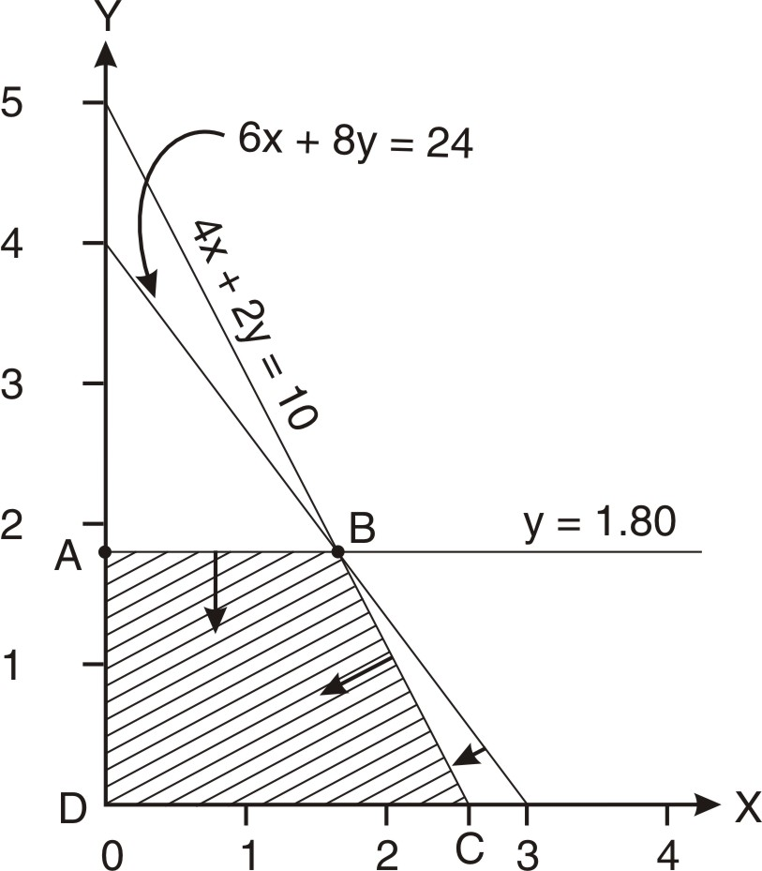

Corner points |  | x | y | Contribution
A |  | 0 | 1.80 | 27
B |  | 1.60 | 1.80 | 49.40
C |  | 2.50 | 0 | 35
D |  | 0 | 0 | 00

Comment : In this question there are three constraints. All the three constraint intersect at the optimal point. This is the case of degeneracy. There is no effect of degeneracy on graphic method.

SIMPLEX MTHOD
Maximize: Z = 14x + 15y + 0s₁ + 0s₂ + 0s₃
Subject to:
4x + 2y + s₁ = 10 | y + s₂ = 1.80
6x + 8y + s₃ = 24 | x , y, s₁ , s₂ ,s₃ ≥ 0

Simplex table 1
C → |  |  | 14 | 15 | 0 | 0 | 0 | Ratio
C↓ | Variables | Quantity | x | y | s₁ | s₂ | s₃ | Ratio
0 | s₁ | 10 | 4 | 2 | 1 | 0 | 0 | 5
0 | s₂ | 1.80 | 0 | 1 | 0 | 1 | 0 | 1.80→
0 | s₃ | 24 | 6 | 8 | 0 | 0 | 1 | 3
Z  C – Z |  |  | 0  14 | 0  15↑ | 0  0 | 0  0 | 0  0
Total contribution = 0

Working notes for Simplex Table 2
Working note (i)
10 | 4 | 2 | 1 | 0 | 0
-1.80x2 | -0 x 2 | -1 x2 | -0 x2 | -1 x2 | -0 x2
6.40 | 4 | 1 | 1 | -2 | 0

Working note (ii)
24 | 6 | 8 | 0 | 0 | 1
-1.80x8 | -0 x8 | -1 x8 | -0 x8 | -1 x8 | -0 x8
9.60 | 6 | 1 | 0 | -8 | 1

Simplex table 2
C → |  |  |  |  |  |  |  | Ratio
C↓ | Variables | Quantity |  |  |  |  |  | Ratio
0 | s₁ | 6.40 | 4 | 1 | 1 | -2 | 0 | 1.60
15 | y | 1.80 | 0 | 1 | 0 | 1 | 0 | ∞
0 | s₃ | 9.60 | 6 | 1 | 0 | -8 | 1 | 1.60→
Z  C – Z |  |  | 0  14↑ | 15  0 | 0  0 | 15  -15 | 0  0
Total contribution = Rs.27

NOTE : Alternatively we could take s₁ as leaving row.

Working notes for Simplex Table 3
Working note (iii)
6.40 | 4 | 1 | 1 | -2 | 0
-1.60x4 | -1x4 | -1/6 x4 | -0x4 | -(-8/6) x4 | -1/6 x4
0 | 0 | 2/6 | 1 | 10/3 | -2/3

Working note (iv)
1.80 | 0 | 1 | 0 | 1 | 0
-1.60x0 | -1x0 | -1/6x0 | -0x0 | -(-8/6x0) | -1/6x0
1.80 | 0 | 1 | 0 | 1 | 0

Simplex table 3
C → |  |  | 14 | 15 | 0 | 0 | 0 | Ratio
C↓ | Variables | Quantity | x | y | s₁ | s₂ | s₃ | Ratio
0 | s₁ | 0 | 0 | 2/6 | 1 | 10/3 | -2/3 | 0→
15 | y | 1.80 | 0 | 1 | 0 | 1 | 0 | 1.80
14 | x | 1.60 | 1 | 1/6 | 0 | -8/6 | 1/6 | 0.27
Z  C – Z |  |  | 22.40  -8.60 | 52/3  14/6↑ | 0  0 | -11/6  11/6 | 14/6  -14/6
Total contribution Rs.49.40

Working notes for Simplex Table 4
Working note (v)
1.80 | 0 | 1 | 0 | 1 | 0
-0x1 | -0 x1 | -1 x1 | -3 x1 | -10 x1 | -(-2) x1
1.80 | 0 | 0 | -3 | -10 | 4

Working note (vi)
1.60 | 1 | 1/6 | 0 | -8/6 | 1/6
-0x1/6 | -0 x1/6 | -1 x1/6 | -3 x1/6 | -10 x1/6 | -(-2) x1/6
1.60 | 1 | 0 | -3/6 | 3 | 1/2

Simplex table 4
C → |  |  | 14 | 15 | 0 | 0 | 0 | Ratio
C↓ | Variables | Quantity | x | y | s₁ | s₂ | s₃ | Ratio
15 | y | 0 | 0 | 1 | 3 | 10 | -2 | 0
15 | y | 1.80 | 0 | 0 | -3 | -10 | 4 | Negative
14 | x | 1.60 | 1 | 0 | -3/6 | 3 | 1/2 | Negative
Z  C – Z |  |  | 14  0 | 15  0 | -42/6  ↑ | 42  -42 | 37  -37
Total contribution Rs.49.40

Note: The solution has degenerated. Total contribution under Simplex table 4 has not improved as compared to Simplex Table 3.

Working note (vii)
1.80 | 0 | 0 | -3 | -10 | 4
-0x(-3) | -0x(-3) | -1/3 x(-3) | -1x(-3) | -10/3x(-3) | -(-2/3)x(-3)
1.80 | 0 | 1 | 0 | 0 | 2

Working note (viii)
1.60 | 1 | 0 | -3/6 | 3 | 1/2
-0x(-3/6) | -0x(-3/6) | -1/3 x(-3/6) | -1x(-3/6) | -10/3x(-3/6) | -(-2/3)x(-3/6)
1.60 | 1 | 1/5 | 0 | 14/3 | 1/6

Simplex table 5
C → |  |  | 14 | 15 | 0 | 0 | 0 | Ratio
C↓ | Variables | Quantity | x | y | s₁ | s₂ | s₃ | Ratio
0 | s₁ | 0 | 0 | 1/3 | 1 | 10/3 | -2/3
15 | y | 1.80 | 0 | 1 | 0 | 0 | 2
14 | x | 1.60 | 1 | 1/5 | 0 | 14/3 | 1/6
Z  C – Z |  |  | 14  0 | 17.80  -2.80 | 0  0 | 65.33 -65.33 | 32.33  -32.33
Total contribution Rs.49.40

As all the elements of net evaluation row i.e. C-Z are ≤ 0, the optimal solution has been reached. Optimal Solution : x = 1.60 and y = 1.80 Contribution Ras.49.40

Teaching Note: The solution has degenerated. Total contribution under Simplex table 5 has not improved as compared to Simplex Table 4. Generally degeneracy does not prevent the simplex method to find the optimal solution; it just slows the process down.

Q. No. 18.48 : A gear manufacturing company makes two types of gears- A and B. Both gears are processed on three machines, Hobbing Machine, Shaping Machine and Grinding Machine. The time required by each gear and total time available per week on each m/c is as follows:
Machine | Gear (A) Hours | Gear (B) Hours | Available hours
Hobbing Machine | 3 | 3 | 36
Shaping Machine | 5 | 2 | 60
Grading Machine | 2 | 6 | 60
Other data :  Selling Price (Rs.)  Variable cost (Rs.) | 820  780 | 960  900
Determine the optimum production plan for maximization of contribution using Simplex. (CA Final May, 2007)

Answer
Let’s produce x units of Gear(A) and y units of Gear(B)
Objective function : Maximize Z = 40x + 60y
Subject to :
3x + 3y ≤ 36 | 5x + 2y ≤ 60
2x + 6y ≤ 60 | x , y ≥ 0

Simplex
Maximize Z = 40x + 60y + 0s₁ + 0s₂ + 0s₃
Subject to :
3x + 3y + s₁ = 36 | 5x + 2y + s₂ = 60
2x + 6y + s₃ = 60 | x , y ≥ 0

C → |  |  | 40 | 60 | 0 | 0 | 0 | Ratio
C↓ | Variables | Quantity | x | y | s₁ | s₂ | s₃ | Ratio
0 | s₁ | 36 | 3 | 3 | 1 | 0 | 0 | 12
0 | s₂ | 60 | 5 | 2 | 0 | 1 | 0 | 30
0 | s₃ | 60 | 2 | 6 | 0 | 0 | 1 | 10→
Z  C – Z |  |  | 0 | 0 | 0 | 0 | 0
 |  |  | 40 | 60↑ | 0 | 0 | 0
---------------------------------------------------------
0 | s₁ | 6 | 2 | 0 | 1 | 0 | -1/2 | 3 →
0 | s₂ | 40 | 13/3 | 0 | 0 | 1 | -1/3 | 120/13
60 | y | 10 | 1/3 | 1 | 0 | 0 | 1/6 | 30
Z  C – Z |  |  | 20 | 60 | 0 | 0 | 10
 |  |  | 20↑ | 0 | 0 | 0 | -10
---------------------------------------------------------
40 | x | 3 | 1 | 0 | 1/2 | 0 | -1/4
0 | s₂ | 27 | 0 | 0 | -13/6 | 1 | 3/4
60 | y | 9 | 0 | 1 | -1/6 | 0 | 1/4
Z  C – Z |  |  | 40 | 60 | 10 | 0 | 5
 |  |  | 0 | 0 | -10 | 0 | -5

As all the elements of net evaluation row i.e. C - Z are ≤ 0, the optimal solution has been reached. The company may produce 3 units of A and 9 units of B. Total contribution: Rs.660.

Working note (i)
36 | 3 | 3 | 1 | 0 | 0
-10x3 | -1/3 x3 | -1 x3 | -0 x3 | -0 x3 | -1/6 x3
6 | 2 | 0 | 1 | 0 | -1/2
Working note (ii)
60 | 5 | 2 | 0 | 1 | 0
-10x2 | -1/3 x2 | -1 x2 | -0 x2 | -0 x2 | -1/6 x2
40 | 13/3 | 0 | 0 | 1 | -1/3

Working note (iii)
40 | 13/3 | 0 | 0 | 1 | -1/3
-3x13/3 | -1 x13/3 | -0 x13/3 | -1/2 x13/3 | -0 x13/3 | -(-1/4) x13/3
27 | 0 | 0 | -13/6 | 1 | 3/4

Working note (iv)
10 | 1/3 | 1 | 0 | 0 | 1/6
-3x1/3 | -1 x1/3 | -0 x1/3 | -1/2 x1/3 | -0 x1/3 | -(-1/4) x1/3
9 | 0 | 1 | -1/6 | 0 | 1/4

Q. No. 18.49
Given below is the simplex table for a maximization Linear Programming problem:

C→ | 10 | 6 | 4 | 0 | 0 | 0 | Quantity
Basic variables | x₁ | x₂ | x₃ | s₁ | s₂ | s₃
x₂ | 0 | 1 | 5/6 | 5/3 | -1/6 | 0 | 200/3
x₁ | 1 | 0 | 1/6 | -2/3 | 1/6 | 0 | 100/3
s₃ | 0 | 0 | 4 | -2 | 0 | 1 | 100

Answer the following questions
- Does the table above give an optimal solution?
- Is this solution feasible?
- Does the problem have alternative optimal solution?
- Is this solution degenerate?
- Write the optimal product mix and profit contribution shown by the above solution.
- Indicate the shadow prices of the three resources.
- If the company wishes to expand the production capacity, which of the three resources should be given the priority?
- If the customer is prepared to pay higher Price for x₃, how much should the price be increased so that the company’s profit remains unchanged?
- Write down the objective function of the problem.
(University of Delhi, 2012)
Answer
C → |  |  | 10 | 6 | 4 | 0 | 0 | 0 | Ratio
C↓ | Basic variables | Quantity | x₁ | x₂ | x₃ | s₁ | s₂ | s₃ | Ratio
6 | x₂ | 200/3 | 0 | 1 | 5/6 | 5/3 | -1/6 | 0
10 | x₁ | 100/3 | 1 | 0 | 1/6 | -2/3 | 1/6 | 0
0 | s₃ | 100 | 0 | 0 | 4 | -2 | 0 | 1
Z  C – Z |  |  | 10 | 6 | 20/3 | 10/3 | 2/3 | 0
 |  |  | 0 | 0 | -8/3 | -10/3 | -2/3 | 0

- As all the elements of net evaluation row i.e. C - Z are ≤ 0, the optimal solution has been reached.

- Yes, every optimal solution is a feasible solution.

- The basic variables in the final solution are x₁, x₂, and s₃. The non-basic variables are x₃, s₁ and s₂. As none of the non-basic variables have got zero value in C –Z row, multiple optimal solutions are not there i.e., there is no alternative solution.
Non-basic variables | x₃ | s₁ | s₂
Value in C –Z row | -8/3 | -10/3 | -2/3

A solution degenerates if the quantity of one or more basic variables is zero.
Basic variables | x₁ | x₂ | s₃
Quantity | 100/3 | 200/3 | 100
As the quantity of none of the basic variables is zero, the solution would not degenerate.

- The optimal product mix and Profit of this mix
 | x₁ | x₂ | Total
Contribution per unit | 10 | 6
Optimal Product Mix | 100/3 | 200/3
Total contribution | 333.33 | 400.00 | 733.33

- Shadow Prices
Representative of Constraint | s₁ | s₂ | s₃
Shadow Price | 10/3 | 2/3 | 0

Teaching note : Shadow Price of a constraint is the amount by which the objective function value will change if we change the right-hand side of the constraint by one unit. It is shown in C-Z row of the final solution corresponding to the slack variable of that constraint.

- Resource I (Represented by s₁) may be given the priority as its shadow price is the highest. [If we increase one unit of resource I, the value of objective function (contribution) increases by Rs.10/3.]
- Having produced 100/3 units of x₁ and 200/3 units of x₂, if we increase our production by one unit of x₃, our contribution will decrease by Rs.8/3. (Please refer the C-Z row of the last table). To neutralize this loss, the selling price of x₃ should be increased by Rs.8/3.
- Maximize Z = 10x₁ +6x₂ + 4x_{3.}

Q No. 18.50 Given below is the simplex table for a maximization L.P. problem:
C→ | 3 | 4 | 0 | 0 | Quantity
Basic variables | x₁ | x₂ | s₁ | s₂
x₂ | 1 | 1 | 1 | 0 | 6
s₂ | 1 | 0 | -1 | 1 | 2

Answer the following questions
- Does the table above give an optimal solution?
- Is this solution feasible?
- Does the problem have alternative optimal solution?
- Is this solution degenerate?
- If s₁ is the slack variable of Machine 1 (Hours/week) and s₂ is the slack variable of Machine 2 (Hours/week), which of these two machines is used at full capacity to produce the optimum production?
- A customer would like to have one unit of product x1 and is willing to in excess of normal price in order to get it. How much the price should be increased to ensure no reduction in profit?
- What is optimum production mix? Profit ?
- Machine 1 has to be shut down for 2 hours for repairs next week. How much will be reduction in profit?
- What is the maximum you would be prepared to pay for another hour (per week) of capacity each on Machine A and Machine B?
- What are the shadow prices of machine-hours?

Answer
C → |  |  | 3 | 4 | 0 | 0 | Ratio
C↓ | Basic Variables | Quantity | x₁ | x₂ | s₁ | s₂ | Ratio
4 | x₂ | 6 | 1 | 1 | 1 | 0
0 | s₂ | 2 | 1 | 0 | -1 | 1
Z  C – Z |  |  | 4 | 4 | 4 | 0
 |  |  | -1 | 0 | -4 | 0

- As all the elements of net evaluation row i.e. C - Z are ≤ 0, the optimal solution has been reached.
- Yes, every optimal solution is feasible.
- The basic variables in the final solution are x₂, and s₂. The non-basic variables are x₁, and s₁. As none of the non-basic variables have got zero value in C –Z row, multiple optimal solutions are not there i.e., there is no alternative solution.
Non-basic variables | x₁ | s₁
Value in C –Z row | -1 | -4

- A solution degenerates if the quantity of one or more basic variables is zero.
Basic variables | x₂ | s₂
Quantity | 6 | 2
As the quantity of none of the basic variables is zero, the solution would not degenerate.

- Machine 1 is being used to full capacity as its slack variable s₁ in not appearing in the list of basic variables of the final solution.
- Having produced 6 units of x₂, if we increase our production by one unit of x₁, our contribution will decrease by Re.1. (Please refer the C-Z row of the last table). To neutralize this loss, the selling price of x₁ should be increased by Rs.1.
- Produce 6 units of the second product. The contribution would be Rs.24.
- The reduction in profit on shutting down the machine 1 for 2 hours will be Rs.8.

 | Machine 1 | Machine 2
Maximum Price for another one hour | 4 | 0

- Shadow Price
 | Machine 1 | Machine 2
Shadow Price | 4 | 0

Q. No. 18.51
Given below is the relevant portion of the first iteration of a Linear Programme under the simplex method:
 |  |  | x₁ | x₂ | s₁ | s₂ | s₃
Quantity | Basic Variables | Contribution per unit | 50 | 40 | 0 | 0 | 0
150 | s₁ | 0 | 3 | 5 | 1 | 0 | 0
20 | s₂ | 0 | 0 | 1 | 0 | 1 | 0
296 | s₃ | 0 | 8 | 5 | 0 | 0 | 1

- Write the initial LP with the objective function and the in equalities.
- The following questions are to be answered independent of each other and based on iteration given above:
- What is the opportunity cost of bringing one unit of x₁ into the solution?
- If we bring 4 units of x₁ into the solution, by how much will the basic variables change?
- What will be the change in the value of objective function if 4 units of x₂ are brought into solution?
- What will be the quantity of the incoming variable? (CA Final Nov. 2011)

Answer
(i) Objective function: Maximize Z = 50x₁ + 40x₂
Subject to:
3x₁ + 5x₂ ≤ 150 | x₂ ≤ 20 | 8x₁ + 5x₂ ≤ 296 | x_{1 ,} x₂ ≥ 0

Equalities:
Maximize Z = 50x₁ + 40x₂ ₊ 0s₁ + 0s₂ + 0s₃
Subject to:
3x₁ + 5x₂ ₊ s₁ = 150 | x₂ + s₂ = 20 | 8x₁ + 5x₂ + s₃ = 296 | x_{1 ,} x₂ ≥ 0
(ii)
(a) The opportunity cost of bring one unit of x₁ into the solution is zero as we do not have to forgo the production of the other product.
(b) If we bring 4 units of x₁ into the solution, s₁ will be reduced by 12 units and s₃ will be reduced by 32 units. The resultant units s₁of will be 138 and that of s₃ will be 264.
(c) The value of objective function (if 4 units of x₂ are brought into solution) will increase by Rs.160
(d)
 |  |  | 50 | 40 | 0 | 0 | 0 | Ratio
C↓ | Variables | Quantity | x₁ | x₂ | s₁ | s₂ | s₃
0 | s₁ | 150 | 3 | 5 | 1 | 0 | 0 | 50
0 | s₂ | 20 | 0 | 1 | 0 | 1 | 0 | ∞
0 | s₃ | 296 | 8 | 5 | 0 | 0 | 1 | 37→
Z  C – Z |  |  | 0 | 0 | 0 | 0 | 0
 |  |  | 50↑ | 40 | 0 | 0 | 0
After first iteration, 37 units of first product (represented by x₁) will come in.

Q. No. 18.52
A company produces two products x₁ and x₂ with respective contribution per unit of Rs.8 and Rs.6.

Each product passes through two machines M1 and M2 whose capacities are limited to 60 hours and 48 hours respectively with corresponding slack variables s₁ and s₂.

The following table gives the values for an iteration under simplex method for maximizing the contribution:
Basic variables | x₁ | x₂ | s₁ | s₂
x₁ | 1 | 0 | 1/3 | -1/6 | Machine I constraint
x₂ | 0 | 1 | -1/6 | 1/3 | Machine II constraint
- Evaluate if this iteration represents the optimum solution.
- Evaluate if this iteration represents the feasible solution.
- Find out what will be the optimal contribution. (CA Final May 10)

Answer
(i)
C → |  |  | 8 | 6 | 0 | 0 | Ratio
C↓ | Variables | Quantity | x₁ | x₂ | s₁ | s₂ | Ratio
8 | x₁ |  | 1 | 0 | 1/3 | -1/6
6 | x₂ |  | 0 | 1 | -1/6 | 1/3
Z  C – Z |  |  | 8 | 6 | 5/3 | 2/3
 |  |  | 0 | 0 | -5/3 | -2/3

As all the elements of net evaluation row i.e. C - Z are ≤ 0, the optimal solution has been reached.
(ii) Yes, as every optimal solution is feasible solution.
(iii)
 | First constraint | Second constraint
Contribution per hour | 5/3 | 2/3
No. of hours | 60 | 48
Total contribution | 100 | 32 | Rs.132

Teaching note: It is neither required nor possible to calculate the quantity of basic variables i.e. the number of units of the two products produced.

Q. No. 18.53
The following is a printout from a computer program. It is to be used to solve a problem concerned with maximizing profit of three variables and four constraints on resources as under:
Objective function variable (Z) Rs.1,20,000

  Variable | Value | Relative Loss
  X₁ | 500 | 0
  X₂ | 0 | 25
  X₃ | 320 | 0
  Constraints | Stock/surplus | Worth
  1 | 0 | 12
  2 | 0 | 10
  3 | 150 | 0
  4 | 200 | 0

Explain what is indicated by the printout. (ICWA Stage IV June 2005)

Answer
- Maximum profit is Rs.1,20,000 by producing 500 units of X₁ and 320 units of X_{3.}
- For producing 500 units of X₁ and 320 units of X₃ , constraints 1 and 2 will be fully utilized and 150 units constraint 3 and 200 units of constraint 4 will remain unutilized.
- Each additional unit of constraint 1 will contribute Rs.12. The corresponding amount for each unit of constraint 2 is Rs.10.
- Production of each unit of X₂ will result in reduction in contribution of Rs.25 from X₁ and X₃.

18.2-3.2 MINIMIZATION PROBLEMS
(with all constraints having “≥” sign)
Let’s understand the steps with the help of an example:
Example:
Solve the following: Minimize Z = 8x + 12y
Subject to | 2x + 2y ≥ 1 | x + 3y ≥ 2 | x, y ≥ 0

Step I: Formulate the Linear Programming Problem;

Step II: Convert the inequalities into equalities by subtracting a surplus variable and adding an artificial variable for each constraint.

A surplus variable is a positive variable subtracted from the to the left hand side of a greater than or equal to type constraint to convert the constraint to equality. Surplus variables represent over fulfillment of the requirement.

Artificial variables are temporary slack variables which are used for purposes of calculations, and are later on removed. Such variables are introduced to facilitate the computation of the initial basic solution. The contribution per unit of an artificial variable is taken as M (a very large number) in the objective function in case of minimization problem.
It is taken as -M (a very small number) in the objective function in case of maximization problem.

2x + 2y – s₁ +A₁ = 1 | x + 3y – s₂ +A₂ = 2 | x, y, s₁, s_{2,} A₁ A₂ ≥ 0

Step III Rewrite the objective function considering the surplus as well as artificial variables. There is no cost of Surplus variable. The cost of artificial variable is taken as M (very large)
Hence, the rewritten objective function is: Z = 8x + 12y + 0s₁ + 0s₂ +MA₁ + MA₂

Subsequent steps
Subsequent steps are similar to maximization case except the following points:
- Surplus variables are never taken as basic variables in the first Simplex table.
- We begin with artificial variables. i.e., in Simplex Table 1 we take artificial variables as Basic variables.
- If all the elements of C – Z are ≥ 0, the solution is optimal. If not, identify the most negative value in C – Z row. The column having this most negative value is referred as key column.

Q. No. 18.54
Solve the following: Minimize Z = 5x + 6y
Subject to → | 2x + 5y ≥1500 | 3x + y ≥ 1200 | x , y ≥0
(CA Final May 1985)
Answer
Introducing the surplus and artificial variables
Minimize Z = 5x + 6y + 0s₁ + 0s₂ +MA₁ + MA₂
Subject to → | 2x + 5y –s₁ + A₁ = 1500 | 3x + y –s₂ + A₂ = 1200 | x , y, s₁ , s_{2 ,} A₁ ,A₂ ≥ 0

C → |  |  | 5 | 6 | 0 | 0 | M | M | Ratio
C↓ | Basic variables | Quantity | x | y | s₁ | s₂ | A₁ | A₂ | Ratio
M | A₁ | 1500 | 2 | 5 | -1 | 0 | 1 | 0 | 300→
M | A₂ | 1200 | 3 | 1 | 0 | -1 | 0 | 1 | 1200
Z  C – Z |  |  | 5M | 6M | -M | -M | M | M
 |  |  | 5 – 5M | 6 - 6m↑ | M | M | 0 | 0

6 | y | 300 | 2/5 | 1 | - 1/5 | 0 |  | 0 | 750
M | A₂ | 900 | 13/5 | 0 | 1/5 | -1 |  | 1 | 346.15→
Z  C – Z |  |  | 12/5 +  13/5M | 6 | -6/5 +1/5M | -M |  | M
 |  |  | 13/5 -13/5M↑ | 0 | 6/5 -1/5M | M |  | 0

6 | y | 161.54 | 0 | 1 | -15/65 | 2/13
5 | x | 346.15 | 1 | 0 | 1/13 | -5/13
Z  C – Z |  |  | 5 | 6 | -1 | -1
 |  |  | 0 | 0 | 1 | 1

As there is no negative number in the NER i.e., C-Z row, the optimal solution has been reached.
Recommendation : x = 346.15 units and y = 161.54 units . Total cost = 2700

Working note (i)
1200 | 3 | 1 | 0 | -1 | 0 | 1
-300x1 | -2/5 x1 | -1 x1 | -(-1/5) x1 | -0 x1 | -1/5 x1 | -0 x1
900 | 13/5 | 0 | 1/5 | -1 | -1/5 | 1

Working note (ii)
300 | 2/5 | 1 | - 1/5 | 0
-346.15x2/5 | -1x2/5 | -0x2/5 | -1/13x2/5 | -(-5/13)x2/5
161.54 | 0 | 1 | -15/65 | 2/13

Q. No. 18.55
Solve the following: Minimize Z = 4x + y
Subject to → | 3x + 4y ≥ 20 | -x -5y ≤ -15 | x, y ≥ 0
(CA Final May 1986)
Answer
Minimize Z = 4x + y + 0s₁ + 0s₂ + MA₁ + MA₂
Subject to → | 3x + 4y –s₁ + A₁ = 20 | x + 5y –s₂ + A₂ = 15 | x , y, s₁ , s_{2 ,} A₁ ,A₂ ≥ 0

C → |  |  | 4 | 1 | 0 | 0 | M | M | Ratio
C↓ | Basic variables | Quantity | x | y | s₁ | s₂ | A₁ | A₂ | Ratio
M | A₁ | 20 | 3 | 4 | -1 | 0 | 1 | 0 | 20
M | A₂ | 15 | 1 | 5 | 0 | -1 | 0 | 1 | 3→
Z  C – Z |  |  | 4M | 6M | -M | -M | M | M
 |  |  | 4-4M | 1-6M↑ | M | M | 0 | 0

C → |  |  | 4 | 1 | 0 | 0 | M | M | Ratio
C↓ | Basic variables | Quantity | x | y | s₁ | s₂ | A₁ | A₂ | Ratio
M | A₁ | 8 | 11/5 | 0 | -1 | 4/5 | 1 |  | 40/11→
1 | y | 3 | 1/5 | 1 | 0 | -1/5 | 0 |  | 15
Z  C – Z |  |  | 1/5 +11/5M | 1 | -M | 4/5M-1/5 | M
 |  |  | 19/5 -11/5M↑ | 0 | M | 1/5 - 4/5M | -M

C → |  |  | 4 | 1 | 0 | 0 | M | M | Ratio
C↓ | Basic variables | Quantity | x | y | s₁ | s₂ | A₁ | A₂ | Ratio
4 | x | 40/11 | 1 | 0 | -5/11 | 4/11 |  |  | 10→
1 | y | 25/11 | 0 | 1 | 1/11 | -3/11 |  |  | Negative
Z  C – Z |  |  | 4 | 1 | -19/11 | 13/11
 |  |  | 0 | 0 | 19/11 | -13/11↑

C → |  |  | 4 | 1 | 0 | 0 | M | M | Ratio
C↓ | Basic variables | Quantity | x | y | s₁ | s₂ | A₁ | A₂ | Ratio
0 | s₂ | 10 | 11/4 | 0 | -5/4 | 1
1 | y | 5 | 3/4 | 1 | -1/4 | 0
Z  C – Z |  |  | 3/4 | 1 | -1/4 | 0
 |  |  | 13/4 | 0 | 1/4 | 0

As there is no negative number in the NER i.e., C-Z row, the optimal solution has been reached.
Recommendation: y = 5 Total cost = 5

Working note (i)
20 | 3 | 4 | -1 | 0 | 1
-3x4 | -1/5 x4 | -1 x4 | -0x4 | -(-1/5)x4 | -0 x4
8 | 11/5 | 0 | -1 | 4/5 | 1

Working note (ii)
3 | 1/5 | 1 | 0 | -1/5
-40/11x1/5 | -1x1/5 | -0x1/5 | -(-5/11)x1/5 | -4/11x1/5
25/11 | 0 | 1 | 1/11 | -3/11

Working note (iii)
25/11 | 0 | 1 | 1/11 | -3/11
-10x(-3/11) | -11/4x(-3/11) | -0x(-3/11) | -(-5/4)x(-3/11) | -1x(-3/11)
5 | 3/4 | 1 | -1/4 | 0

Q. No. 18.56 Solve the following: Minimize Z = 600x + 400y +800z
Subject to
4x/3 + y/3 +z ≥80 | 2x/3 + 2y/3 + 2z/3 ≥60
x +2y/3 + z/3 ≥ 40 | x, y, z ≥ 0
(Adapted CA Final May 1990)

Answer
Z = 600x + 400y +800z + 0s₁ + 0s₂ + 0s₃ + MA₁ + MA₂ + MA₃
Subject to :
x +2y/3 + z/3 – s₁ + A₁ = 40 | 4x/3 + y/3 +z – s₂ + A₂ = 80
2x/3 + 2y/3 + 2z/3 – s₃ + A₃ = 60 | x , y , z , s₁ ,s₂ ,s₃ ,A₁ ,A₂ ,A₃ ≥ 0

Simplex Table 1
C  → |  |  | 600 | 400 | 800 | 0 | 0 | 0 | M | M | M | Ratio
C  ↓ | Basic  vari-  ables | Quan-tity | x | y | z | s₁ | s₂ | s₃ | A₁ | A₂ | A₃
M | A₁ | 40 | 1 | 2/3 | 1/3 | -1 | 0 | 0 | 1 | 0 | 0 | 40→
M | A₂ | 80 | 4/3 | 1/3 | 1 | 0 | -1 | 0 | 0 | 1 | 0 | 60
M | A₃ | 60 | 2/3 | 2/3 | 2/3 | 0 | 0 | -1 | 0 | 0 | 1 | 90
C  C – Z |  |  | 3M | 5/3M | 2M | -M | -M | -M | M | M | M
 |  |  | 600 -3M↑ | 400 -5/3M | 800 -2/3M | M | M | M | 0 | 0 | 0

Working notes for Simplex Table 2
Working note (i)
80 | 4/3 | 1/3 | 1 | 0 | -1 | 0 | 0 | 1 | 0
-40  x4/3 | -1  x4/3 | -2/3  x4/3 | -1/3  x4/3 | -(-1) x4/3 | -0 x4/3 | -0 x4/3 |  | -0 x4/3 | -0 x4/3
80/3 | 0 | -5/9 | 5/9 | 4/3 | -1 | 0 |  | 1 | 0

Working note (ii)
60 | 2/3 | 2/3 | 2/3 | 0 | 0 | -1 | 0 | 0 | 1
-40  x2/3 | -1  x2/3 | -2/3  x2/3 | -1/3  x2/3 | -(-1) x2/3 | -0 x2/3 | -0 x2/3 |  | -0 x2/3 | -0 x2/3
100/3 | 0 | 2/9 | 4/9 | 2/3 | 0 | -1 |  | 0 | 1

Simplex Table 2
600 | x | 40 | 1 | 2/3 | 1/3 | -1 | 0 | 0 |  | 0 | 0 | – 4 0
M | A₂ | 80/3 | 0 | -5/9 | 5/9 | 4/3 | -1 | 0 |  | 1 | 0 | 20→
M | A₃ | 100/3 | 0 | 2/9 | 4/9 | 2/3 | 0 | -1 |  | 0 | 1 | 50
C  C – Z |  |  | 600 | 400  -1/3 M | 200 | -600 +2M | -M | -M |  | M | M
 |  |  | 0 | +1/3 M | 600-  M | 600 –  2M↑ | M | M |  | 0 | 0

Working notes for Simplex Table 3
Working note (iii)
40 | 1 | 2/3 | 1/3 | -1 | 0 | 0 |  |  | 0
-20  x(-1) | -0  x(-1) | -(-5/12) x(-1) | -5/12 x(-1) | -1  x(-1) | -(-3/4) x(-1) | -0  x(-1) |  |  | 0  x(-1)
60 | 1 | 3/12 | 9/12 | 0 | -3/4 | 0 |  |  | 0
Working note (iv)
100/3 | 0 | 2/9 | 4/9 | 2/3 | 0 | -1 |  |  | 1
-20  x(2/3) | -0  x(2/3) | -(-5/12) x(2/3) | -5/12 x(2/3) | -1  x(2/3) | -(-3/4) x(2/3) | -0  x(2/3) |  |  | 0  x(2/3)
20 | 0 | 1/2 | 1/6 | 0 | 1/2 | -1 |  |  | 1

Simplex Table 3
600 | x | 60 | 1 | 3/12 | 9/12 | 0 | -3/4 | 0 |  |  | 0 | 240
0 | s₁ | 20 | 0 | -5/12 | 5/12 | 1 | -3/4 | 0 |  |  | 0 | – 48
M | A₃ | 20 | 0 | 1/2 | 1/6 | 0 | 1/2 | -1 |  |  | 1 | 40→
C  C – Z |  |  | 600 | 150 +M/2 | 450 + M/6 | 0 | -450 +M/2 | -M |  |  | M
 |  |  | 0 | 250 –M/2↑ | 350 –M/6 | 0 | 450 – M/2 | M |  |  | 0

Working notes for Simplex Table 4
Working note (v)
60 | 1 | 3/12 | 9/12 | 0 | -3/4 | 0
-40 x(3/12) | -0 x(3/12) | -1 x(3/12) | -1/3 x(3/12) | -0 x(3/12) | -1 x(3/12) | -(-2) x(3/12)
50 | 1 | 0 | 8/12 | 0 | -1 | 1/2

Working note (vi)
20 | 0 | -5/12 | 5/12 | 1 | -3/4 | 0
-40 x  (-5/12) | -0 x  (-5/12) | -1x (-5/12) | -1/3 x (-5/12) | -0 x  (-5/12) | -1 x  (-5/12) | -(-2)  x(-5/12)
110/3 | 0 | 0 | 5/9 | 1 | -1/3 | -10/12

Simplex Table 4
600 | x | 50 | 1 | 0 | 8/12 | 0 | -1 | 1/2
0 | s₁ | 110/3 | 0 | 0 | 5/9 | 1 | -1/3 | -10/12
400 | y | 40 | 0 | 1 | 1/3 | 0 | 1 | -2
C  C – Z |  |  | 600 | 400 | 1600/3 | 0 | -200 | -500
 |  |  | 0 | 0 | 800/3 | 0 | 200 | 500

As there is no negative number in the NER i.e., C-Z row, the optimal solution has been reached.
Recommendation: x = 50; y = 40; z = 0 Total cost = 46,000

Q. No. 18.57:
Solve the following: Minimize Z = 8x + 12y
Subject to → | 2x + 2y ≥ 1 | x + 3y ≥ 2 | x, y ≥ 0

Answer
Minimize Z = 8x + 12y +0s₁ +0s₂ +MA₁ +MA₂
Subject to→ | 2x + 2y –s₁ + A₁ = 1 | x + 3y –s₂ + A₂ = 2 | x , y, s₁ , s_{2 ,} A₁ ,A₂ ≥ 0

C → |  |  | 8 | 12 | 0 | 0 | M | M | Ratio
C↓ | Basic variables | Quantity | x | y | s₁ | s₂ | A₁ | A₂ | Ratio
M | A₁ | 1 | 2 | 2 | -1 | 0 | 1 | 0 | ½ →
M | A₂ | 2 | 1 | 3 | 0 | -1 | 0 | 1 | 2/3
Z  C – Z |  |  | 3M | 5M | -M | -M | M | M
 |  |  | 8 -3M | 12 – 5M↑ | M | M | 0 | 0

C → |  |  | 8 | 12 | 0 | 0 | M | M | Ratio
C↓ | Basic variables | Quantity | x | y | s₁ | s₂ | A₁ | A₂ | Ratio
12 | y | 1/2 | 1 | 1 | -1/2 | 0 |  | 0 | Negative
M | A₂ | 1/2 | -2 | 0 | 3/2 | -1 |  | 1 | 1/3→
Z  C – Z |  |  | 12 – 2 M | 12 | 1.50M -6 | -M |  | M
 |  |  | 2M - 4 | 0 | 6 - 1.50M↑ | M |  | 0

C → |  |  | 8 | 12 | 0 | 0 | M | M | Ratio
C↓ | Basic variables | Quantity | x | y | s₁ | s₂ | A₁ | A₂ | Ratio
12 | y | 2/3 | 1/3 | 1 | 0 | -1/3
0 | s₁ | 1/3 | -4/3 | 0 | 1 | -2/3
Z  C – Z |  |  | 4 | 12 | 0 | -4
 |  |  | 4 | 0 | 0 | 4

As there is no negative number in the NER i.e., C-Z row, the optimal solution has been reached.
Recommendation: y = 2/3 Total cost = 8

Working note (i)
2 | 1 | 3 | 0 | -1 |  | 1
–1/2 x3 | –1 x3 | –1 x3 | –(-1/2) x3 | –0 x3 |  | –0 x3
1/2 | -2 | 0 | 3/2 | -1 |  | 1

Working note (ii)
1/2 | 1 | 1 | -1/2 | 0
-1/3x(-1/2) | -(-4/3) (-1/2) | -0(-1/2) | -1(-1/2) | -(-2/3) (-1/2)
2/3 | 1/3 | 1 | 0 | -1/3

18.2-3.3 MINIMIZATION PROBLEMS
(with some constraints having “≤”/ “=”sign)

Set of constraints:
Type of constraint
≥ | Deduct Surplus | Add artificial variable
= | ------------ | Add artificial variable
≤ | Add slack variables | ---------------

Objective function: Coefficient of surplus variable is zero. Coefficient of artificial variable is M (very high amount).

Q. No. 18.58 The standard weight of a special purpose brick is 5 Kg and it contains two basic ingredients A and B. A costs Rs. 5 per kg. and B costs Rs.8 per kg. strength considerations dictate that the brick contains not more than 4 Kg of A and minimum 2 kg of B. find the minimum cost of a brick. (University of Delhi)

Answer
Let’s use x Kg of A and y Kg of B
Objective function: Minimize Z: 5x + 8y
Subject to:
x + y = 5 | x ≤ 4 | y ≥ 2 | x, y ≥ o

Simplex
Z = 5x + 8y + 0S1 +0S2 +MA1 + MA2
Subject to:
x + S1 = 4  S1 is the slack variable | x + y + A1 = 5  A1 is the artificial variable | y - S2 +A2 = 2  S2 is the slack variable. A2 is the artificial variable | x, y, S1, S2, A1, A2 ≥0

Simplex Table 1
C → |  |  | 5 | 8 | 0 | 0 | M | M | Ratio
C↓ | Basic variables | Quantity | x | y | s₁ | s₂ | A₁ | A₂ | Ratio
0 | s₁ | 4 | 1 | 0 | 1 | 0 | 0 | 0 | ∞
M | A1 | 5 | 1 | 1 | 0 | 0 | 1 | 0 | 5
M | A2 | 2 | 0 | 1 | 0 | -1 | 0 | 1 | 2→
Z  C – Z |  |  | M | 2M | 0 | -M | M | M
 |  |  | 5 -M | 8 -2M↑ | 0 | M | 0 | 0
Working notes for Simplex Table 2
4 | 1 | 0 | 1 | 0 | 0 | 0
–2 x0 | –0 x0 | –1 x0 | –0 x0 | –(–1)x0 | –0x0 | –1 x0
4 | 1 | 0 | 1 | 0 | 0 | 0

5 | 1 | 1 | 0 | 0 | 1 | 0
–2 x1 | –0 x1 | –1 x1 | –0 x1 | –(–1)x1 | –0x1 | –1 x1
3 | 1 | 0 | 0 | 1 | 1 | -1

Simplex Table 2
C → |  |  | 5 | 8 | 0 | 0 | M | M | Ratio
C↓ | Basic variables | Quantity | x | y | s₁ | s₂ | A₁ | A₂ | Ratio
0 | s₁ | 4 | 1 | 0 | 1 | 0 | 0 |  | 4
M | A₁ | 3 | 1 | 0 | 0 | 1 | 1 |  | 3→
8 | y | 2 | 0 | 1 | 0 | -1 | 0 |  | ∞
Z  C – Z |  |  | M | 8 | 0 | M – 8 | M
 |  |  | 5-M↑ | 0 | 0 | 8 - M | 0

Working notes for Simplex Table 3
4 | 1 | 0 | 1 | 0
–3x1 | –1 x1 | –0 x1 | –0 x1 | –1 x1
1 | 0 | 0 | 1 | -1

2 | 0 | 1 | 0 | -1
–3x0 | –1x0 | –0x0 | –0x0 | –1x0
2 | 0 | 1 | 0 | -1

Simplex Table 3
C → |  |  | 5 | 8 | 0 | 0 | M | M | Ratio
C↓ | Basic variables | Quantity | x | y | s₁ | s₂ | A₁ | A₂ | Ratio
0 | s₁ | 1 | 0 | 0 | 1 | -1
5 | x | 3 | 1 | 0 | 0 | 1
8 | y | 2 | 0 | 1 | 0 | -1
Z  C – Z |  |  | 5 | 8 | 0 | -3
 |  |  | 0 | 0 | 0 | 3

As there is no negative number in the NER i.e., C-Z row, the optimal solution has been reached.
Recommendation: x =3; y = 2 Total cost = 31

Q. No. 18.59
XYZ Chemical Corporation must produce exactly 1000 Kg of a special mixture of Chemical A and Chemical B for a customer. Chemical A costs Rs.50 per Kg and chemical B costs Rs.60 per Kg. Not more than 300 kg of chemical A can be used and at least 150 Kg of chemical B must be used. Using the Simplex method determine the least cost blend of the two ingredients. (University of Delhi)

Answer
Let’s consume x Kg of A and y Kg of B
Objective function : Minimize Z = 50x +60y
Subject to :
x + y = 1000 | x ≤ 300 | y ≥ 150 | x, y ≥ 0

Simplex
Minimize Z = 50x + 60y + 0s₂ + 0_{S3} + MA₁ +MA₃
Subject to :
x + y + A₁ = 1000 | x + s₂ = 300 | y – s₃ + A₃ = 150 | x , y , s₂ , _{S3} , A₁ , A₃ ≥ 0

Simplex Table 1
C → |  |  | 50 | 60 | 0 | 0 | M | M | Ratio
C↓ | Basic variables | Quantity | x | y | s₂ | s₃ | A₁ | A₃ | Ratio
M | A₁ | 1000 | 1 | 1 | 0 | 0 | 1 | 0 | 1000
0 | S₂ | 300 | 1 | 0 | 1 | 0 | 0 | 0 | ∞
M | A₃ | 150 | 0 | 1 | 0 | -1 | 0 | 1 | 150→
Z  C – Z |  |  | M | 2M | 0 | -M | M | M
 |  |  | 50 – M | 60 – 2M ↑ | 0 | M | 0 | 0

Working note for Simplex table 2
1000 | 1 | 1 | 0 | 0 | 1
–150x1 | –0 x1 | –1 x1 | –0 x1 | – (-1) x1 | –0 x1
850 | 1 | 0 | 0 | 1 | 1

300 | 1 | 0 | 1 | 0 | 0
–150x0 | –0 x0 | –1 x0 | –0 x0 | – (-1) x0 | –0 x0
300 | 1 | 0 | 1 | 0 | 0

Simplex Table 2
C → |  |  | 50 | 60 | 0 | 0 | M |  | Ratio
C↓ | Basic variables | Quantity | x | y | s₂ | s₃ | A₁ |  | Ratio
M | A₁ | 850 | 1 | 0 | 0 | 1 | 1 |  | 850
0 | S₂ | 300 | 1 | 0 | 1 | 0 | 0 |  | 300→
60 | y | 150 | 0 | 1 | 0 | -1 | 0 |  | ∞
Z  C – Z |  |  | M | 60 | 0 | M - 60 | M
 |  |  | 50 - M↑ | 0 | 0 | 60 - M | 0

Working note for Simplex table 3
850 | 1 | 0 | 0 | 1 | 1
-300x1 | -1x1 | -0x1 | -1x1 | -0x1 | -0x1
550 | 0 | 0 | -1 | 1 | 1

150 | 0 | 1 | 0 | -1 | 0
-300x0 | -1x0 | -0x0 | -1x0 | -0x0 | -0x0
150 | 0 | 1 | 0 | -1 | 0

Simplex Table 3
C → |  |  | 50 | 60 | 0 | 0 | M | M | Ratio
C↓ | Basic variables | Quantity | x | y | s₂ | s₃ | A₁ | A₃ | Ratio
M | A₁ | 550 | 0 | 0 | -1 | 1 | 1 |  | 550→
50 | x | 300 | 1 | 0 | 1 | 0 | 0 |  | ∞
60 | y | 150 | 0 | 1 | 0 | -1 | 0 |  | -150
Z  C – Z |  |  | 50 | 60 | 50 - M | M - 60 | M
 |  |  | 0 | 0 | M-50 | 60 - M↑ | 0

Working note for Simplex table 4
300 | 1 | 0 | 1 | 0 | 0
-550x0 | -0 x0 | -0 x0 | -(-1) x0 | -1 x0 | -1 x0
300 | 1 | 0 | 1 | 0 | 0

150 | 0 | 1 | 0 | -1 | 0
–550x(-1) | –0 x(-1) | –0 x(-1) | –(-1 x)(-1) | –1 x(-1) | –1 x(-1)
700 | 0 | 1 | -1 | 0 | 1

Simplex Table 4
C → |  |  | 50 | 60 | 0 | 0 | M | M | Ratio
C↓ | Basic variables | Quantity | x | y | s₂ | s₃ | A₁ | A₃ | Ratio
0 | s₃ | 550 | 0 | 0 | -1 | 1
50 | x | 300 | 1 | 0 | 1 | 0
60 | y | 700 | 0 | 1 | -1 | 0
Z  C – Z |  |  | 50 | 60 | -10 | 0
 |  |  | 0 | 0 | 10 | 0

As there is no negative number in the NER i.e., C-Z row, the optimal solution has been reached.
Recommendation: x =300; y = 700 Total cost = 57,000

Q. No. 18.60
Minimize ; Z = 8x + 4y.
Subject to :
3x + y ≥ 27 | x + y = 21
x + 2y ≤ 40 | x , y ≥ 0
(University of Delhi)
Answer
Minimize ; Z = 8x + 4y +0s₁+ 0s₃ + MA₁ + MA₂ .
Subject to
3x + y - S1 + A₁ = 27 | x + y + A₂ = 21
x + 2y + S₃ = 40 | x , y , s₃ , A₁ , A₂ ≥ 0

Simplex Table 1
C → |  |  | 8 | 4 | 0 | 0 | M | M | Ratio
C↓ | Basic variables | Quantity | x | y | s₁ | s₃ | A₁ | A₂ | Ratio
M | A₁ | 27 | 3 | 1 | -1 | 0 | 1 | 0 | 9→
M | A₂ | 21 | 1 | 1 | 0 | 0 | 0 | 1 | 21
0 | S₃ | 40 | 1 | 2 | 0 | 1 | 0 | 0 | 40
Z  C – Z |  |  | 4M | 2M | -M | 0 | M | M
 |  |  | 8 – 4M↑ | 4 – 2M | M | 0 | 0 | 0

Working note for Simplex table 2
21 | 1 | 1 | 0 | 0 |  | 1
- 9x1 | – 1 x1 | – 1/3 x1 | – (-1/3) x1 | – 0 x1 |  | – 0 x1
12 | 0 | 2/3 | 1/3 | 0 |  | 1

40 | 1 | 2 | 0 | 1 |  | 0
- 9x1 | – 1 x1 | – 1/3 x1 | – (-1/3) x1 | – 0 x1 |  | – 0 x1
31 | 0 | 5/3 | 1/3 | 1 |  | 0

Simplex table 2
C → |  |  | 8 | 4 | 0 | 0 | M | M | Ratio
C↓ | Basic variables | Quantity | x | y | s₁ | s₃ | A₁ | A₂ | Ratio
8 | x | 9 | 1 | 1/3 | -1/3 | 0 |  | 0 | 27
M | A₂ | 12 | 0 | 2/3 | 1/3 | 0 |  | 1 | 18→
0 | S₃ | 31 | 0 | 5/3 | 1/3 | 1 |  | 0 | 18.60
Z  C – Z |  |  | 8 | 8/3 + 2/3M | M/3 -8/3 | 0 |  | M
 |  |  | 0 | 4/3 -2/3M↑ | 8/3 –M/3 | 0 |  | 0

Working note for Simplex table 3
9 | 1 | 1/3 | -1/3 | 0
–18x1/3 | –0 x1/3 | –1 x1/3 | –1/2 x1/3 | –0 x1/3
3 | 1 | 0 | -1/2 | 0

31 | 0 | 5/3 | 1/3 | 1
–18x5/3 | –0 x5/3 | –1 x5/3 | –1/2 x5/3 | –0 x5/3
1 | 0 | 0 | -1/2 | 1

Simplex table 3
C → |  |  | 8 | 4 | 0 | 0 | M | M | Ratio
C↓ | Basic variables | Quantity | x | y | s₁ | s₃ | A₁ | A₂ | Ratio
8 | x | 3 | 1 | 0 | -1/2 | 0
4 | y | 18 | 0 | 1 | 1/2 | 0
0 | S₃ | 1 | 0 | 0 | -1/2 | 1
Z  C – Z |  |  | 8 | 4 | -2 | 0
 |  |  | 0 | 0 | 2 | 0

As there is no negative number in the NER i.e., C-Z row, the optimal solution has been reached.

Recommendation: x =3; y = 18 Total cost = 96

18.2-3.4 MAXIMIZATION PROBLEMS
(with some constraints having “≥”/“=”sign)
Set of constraints:
Type of constraint
≥ | Deduct Surplus | Add artificial variable
= | ------------ | Add artificial variable
≤ | Add slack variables | ---------------

Objective function: Coefficient of surplus variable is zero. Coefficient of artificial variable is -M (very small amount).

Q. No. 18.61
You are given the following linear program. Introduce appropriate variables and restate the problem to set the simple tableau. (Do not attempt further solution)

Maximize : 8x₁ + 4x₂ - 3x₃ +10x₄
Subject to
2x₁ – x₂ + x₃ + 2x₄ ≥ 40 | 3x₁ – x₃ + x₄ ≤ 90
2x₁ + x₂ + x₄ = 60 | x_{1 ,} x₂ , x₃ , x₄ ≥ 0
(CA Final Nov.2010 )
Answer
Maximize :8x₁ + 4x₂ - 3x₃ +10x₄ +0s₁ +0s₂ – MA₁ – MA₂
Subject to
2x₁ – x₂ + x₃ +2x₄ – s₁ + A₁ = 40 | 2x₁ + x₂ + x₄ + A₃ = 60
3x₁ – x₃ + x₄ ₊ s₂ = 90 | x_{1 ,} x₂ , x₃ , x_{4,} s₁ , s₂ , A₁ , A₃ ≥ 0

Q . No. 18.62
Maximize : 8x + 12y
Subject to→ | x + y = 5 | x ≥ 2 | y ≤ 4 | x , y ≥ 0
(University of Delhi)
Answer
Maximize : Z = 8x + 12y + 0s₂ +0s₃ - MA₁ – MA₂
Subject to→ | x + y + A₁ = 5 | x – s₂ + A₂ = 2 | y + s₃ = 4 | x , y, s_{2,} , s₃ , A₁ , A₂ ≥ 0

Simplex Table 1
C → |  |  | 8 | 12 | 0 | 0 | -M | -M | Ratio
C↓ | Basic variables | Quantity | x | y | s₂ | s₃ | A₁ | A₂ | Ratio
-M | A₁ | 5 | 1 | 1 | 0 | 0 | 1 | 0 | 5
-M | A₂ | 2 | 1 | 0 | -1 | 0 | 0 | 1 | 2→
0 | s₃ | 4 | 0 | 1 | 0 | 1 | 0 | 0
Z  C – Z |  |  | -2M | -M | M | 0 | -M | -M
 |  |  | 8 + 2M↑ | 12+ M | -M | 0 | 0 | 0

Working notes for Simplex Table 2
5 | 1 | 1 | 0 | 0 | 1
-2x1 | -1 x1 | -0 x1 | -(-1) x1 | -0 x1 | -0 x1
3 | 0 | 1 | 1 | 0 | 1

4 | 0 | 1 | 0 | 1 | 0
-2x0 | -1 x0 | -0 x0 | -(-1) x0 | -0 x0 | -0 x0
4 | 0 | 1 | 0 | 1 | 0

Simplex Table 2
C → |  |  | 8 | 12 | 0 | 0 | -M | -M | Ratio
C↓ | Basic variables | Quantity | x | y | s₂ | s₃ | A₁ | A₂ | Ratio
-M | A₁ | 3 | 0 | 1 | 1 | 0 | 1 |  | 3→
8 | x | 2 | 1 | 0 | -1 | 0 | 0 |  | ∞
0 | s₃ | 4 | 0 | 1 | 0 | 1 | 0 |  | 4
Z  C – Z |  |  | 8 | -M | -M-8 | 0 | -M
 |  |  | 0 | 12+M↑ | M+8 | 0 | M

Working notes for Simplex Table 3
2 | 1 | 0 | -1 | 0
-3x0 | -0x0 | -1x0 | -1x0 | -0x0
2 | 1 | 0 | -1 | 0

4 | 0 | 1 | 0 | 1
-3x1 | -0x1 | -1x1 | -1x1 | -0x1
1 | 0 | 0 | -1 | 1

Simplex Table 3
C → |  |  | 8 | 12 | 0 | 0 | -M | -M | Ratio
C↓ | Basic variables | Quantity | x | y | s₂ | s₃ | A₁ | A₂ | Ratio
12 | y | 3 | 0 | 1 | 1 | 0
8 | x | 2 | 1 | 0 | -1 | 0
0 | s₃ | 1 | 0 | 0 | -1 | 1
Z  C – Z |  |  | 8 | 12 | 4 | 0
 |  |  | 0 | 0 | -4 | 0

As all the elements of net evaluation row i.e. C - Z are ≤ 0, the optimal solution has been reached. The company may produce 2 units of x and 3 units of y. Total contribution: Rs.52.

Q. No. 18.63
Maximize Z = x + 2y + 3z
Subject to:
x – y + z ≥ 4 | x + y + 2z ≤ 8
x – z ≥ 2 | x , y , z ≥ 0
(CA Final May 1992)
Answer
Maximize Z = x + 2y + 3z + 0s₁ +0s₂ +0s₃ – MA₁ – MA₂
Subject to:
x – y + z – s₁ + A₁ = 4 | x + y + 2z + s₂ = 8
x – z – s₃ + A₃ = 2 | x , y , z , s₁ , s₂ , s₃ , A₁ , A₂ ≥ 0
Simplex Table 1
C  → |  |  | 1 | 2 | 3 | 0 | 0 | 0 | -M | -M | Ratio
C  ↓ | Basic  vari-  ables | Quan-tity | x | y | z | s₁ | s₂ | s₃ | A₁ | A₃
-M | A₁ | 4 | 1 | -1 | 1 | -1 | 0 | 0 | 1 | 0 | 4
0 | s₂ | 8 | 1 | 1 | 2 | 0 | 1 | 0 | 0 | 0 | 8
-M | A₃ | 2 | 1 | 0 | -1 | 0 | 0 | -1 | 0 | 1 | 2→
C  C – Z |  |  | -2M | M | 0 | M | 0 | M | -M | -M
 |  |  | 1+ 2M↑ | 2 – M | 3 | -M | 0 | -M | 0 | 0

Working notes for Simplex table 2
4 | 1 | -1 | 1 | -1 | 0 | 0 | 1 | 0
– 2 x1 | – 1x1 | – 0x1 | – (-1x1) | – 0x1 | – 0x1 | – (-1)x1 | – 0x1 | – 1x1
2 | 0 | -1 | 2 | -1 | 0 | 1 | 1 | -1

8 | 1 | 1 | 2 | 0 | 1 | 0 | 0 | 0
– 2 x1 | – 1x1 | – 0x1 | – (-1x1) | – 0x1 | – 0x1 | – (-1)x1 | – 0x1 | – 1x1
6 | 0 | 1 | 3 | 0 | 1 | 1 | 0 | -1

Simplex Table 2
C  → |  |  | 1 | 2 | 3 | 0 | 0 | 0 | -M | -M | Ratio
C  ↓ | Basic  vari-  ables | Quan-tity | x | y | z | s₁ | s₂ | s₃ | A₁ | A₃
-M | A₁ | 2 | 0 | -1 | 2 | -1 | 0 | 1 | 1 |  | 1→
0 | s₂ | 6 | 0 | 1 | 3 | 0 | 1 | 1 | 0 |  | 2
1 | x | 2 | 1 | 0 | -1 | 0 | 0 | -1 | 0 |  | -2
C  C – Z |  |  | 1 | M | -2M-1 | M | 0 | -M -1 | -M
 |  |  | 0 | 2 -M | 4 +2M↑ | -M | 0 | M+1 | 0

Working notes for Simplex table 3
6 | 0 | 1 | 3 | 0 | 1 | 1
-1x3 | -0x3 | -(-1/2)x3 | -(1x3) | -(-1/2)x3 | -0x3 | -(1/2)x3
3 | 0 | 5/2 | 0 | 3/2 | 1 | -1/2

2 | 1 | 0 | -1 | 0 | 0 | -1
-1x(-1) | -0  x(-1) | -(-1/2)  x(-1) | -(1)  x(-1) | -(-1/2)  x(-1) | -0  x(-1) | -(1/2)  x(-1)
3 | 1 | -1/2 | 0 | -1/2 | 0 | -1/2

Simplex Table 3
C  → |  |  | 1 | 2 | 3 | 0 | 0 | 0 | -M | -M | Ratio
C  ↓ | Basic  vari-  ables | Quan-tity | x | y | z | s₁ | s₂ | s₃ | A₁ | A₃
3 | z | 1 | 0 | -1/2 | 1 | -1/2 | 0 | 1/2 |  |  | -2
0 | s₂ | 3 | 0 | 5/2 | 0 | 3/2 | 1 | -1/2 |  |  | 6/5→
1 | x | 3 | 1 | -1/2 | 0 | -1/2 | 0 | -1/2 |  |  | -6
C  C – Z |  |  | 1 | -2 | 3 | -2 | 0 | 1
 |  |  | 0 | 4↑ | 0 | 2 | 0 | -1

Working notes for Simplex table 4
1 | 0 | -1/2 | 1 | -1/2 | 0 | 1/2
-6/5  x(-1/2) | -0  x(-1/2) | -1  x(-1/2) | -0  x(-1/2) | -3/5  x(-1/2) | -2/5  x(-1/2) | -(-1/5) x(-1/2)
8/5 | 0 | 0 | 1 | -1/5 | 1/5 | 2/5

3 | 1 | -1/2 | 0 | -1/2 | 0 | -1/2
-6/5  x(-1/2) | -0  x(-1/2) | -1  x(-1/2) | -0  x(-1/2) | -3/5  x(-1/2) | -2/5  x(-1/2) | -(-1/5) x(-1/2)
18/5 | 1 | 0 | 0 | -1/5 | 1/5 | -3/5

Simplex Table 4
C  → |  |  | 1 | 2 | 3 | 0 | 0 | 0 | -M | -M | Ratio
C  ↓ | Basic  vari-  ables | Quan-tity | x | y | z | s₁ | s₂ | s₃ | A₁ | A₃
3 | z | 8/5 | 0 | 0 | 1 | -1/5 | 1/5 | 2/5
2 | y | 6/5 | 0 | 1 | 0 | 3/5 | 2/5 | -1/5
1 | x | 18/5 | 1 | 0 | 0 | -1/5 | 1/5 | -3/5
C  C – Z |  |  | 1 | 2 | 3 | 2/5 | 8/5 | 1/5
 |  |  | 0 | 0 | 0 | -2/5 | -8/5 | -1/5

As all the elements of net evaluation row i.e. C - Z are ≤ 0, the optimal solution has been reached. The company may produce 18/5 units of x, 6/5 units of y and 8/5 units of Z. Total contribution: Rs.10.80.

Q. No. 18.64 Given below is a table appearing in the course of the simplex solution of an LP problem:
C  → |  |  | 2 | 4 | 1 | 0 | 0 | 0 | -M
C  ↓ | Basic  vari-  ables | Quan-tity | x | y | z | s₁ | s₂ | s₃ | A₁
2 | x | 4 | 1 | 2 | 1/2 | 0 | 0 | 7/8 | 0
0 | s₂ | 12 | 0 | 0 | -1 | 0 | 1 | -1/2 | 0
0 | s₁ | 12 | 0 | 6 | 0 | 1 | 0 | 1 | -1
C  C – Z |  |  | 2 | 4 | 1 | 0 | 0 | 7/4 | 0
 |  |  | 0 | 0 | 0 | 0 | 0 | -7/4 | -M

Answer the following questions:
- What is the objective function of the problem?
- Is the solution indicated above optimal? If yes, what is optimal mix? What is the optimal profit?
- Is the above solution degenerate?
Does the problem have multiple optimal solutions? If yes, write an alternative solution. (University of Delhi)

Teaching note: In the maximization problem the coefficient of artificial variable is negative M. In this question, the coefficient of A₁ is negative M. Hence, it is a problem of maximization.

Answer
- Maximize Z = 2x + 4y + z
- As all the elements of net evaluation row i.e. C - Z are ≤ 0, the optimal solution has been reached.
Recommendation: Produce 4 units of x. Optimal profit = Rs.8
- A solution degenerates if the quantity of one or more basic variables is zero.
Basic variables | x | s₂ | s₁
Quantity | 4 | 12 | 12
As the quantity of none of the basic variables is zero, the solution would not degenerate.

- The basic variables in the final solution are x, s₂ and s₁. The non-basic variables are y , z , s₃ and A₁.
Non-basic variables | y | z | s₃ | A₁
Value in C –Z row | 0 | 0 | -7/4 | -M
A problem has got multiple optimal solutions, if in the final solution, at least one of the non-basic variables gets zero value in C –Z row. In this case, the problem has got multiple alternatives as two non-basic variables have got zero value.

If a non-basic variable having a zero value in C –Z row is entered into the solution, we get the alternative optimal solution. Suppose we enter y into the solution,
C → |  |  | 2 | 4 | 1 | 0 | 0 | 0 | -M | Ratio
C  ↓ | Basic  variables | Quantity | x | y | z | s₁ | s₂ | s₃ | A₁
2 | x | 4 | 1 | 2 | 1/2 | 0 | 0 | 7/8 | 0 | 2
0 | s₂ | 12 | 0 | 0 | -1 | 0 | 1 | -1/2 | 0 | ∞
0 | s₁ | 12 | 0 | 6 | 0 | 1 | 0 | 1 | -1 | 2→
C  C – Z |  |  | 2 | 4 | 1 | 0 | 0 | 7/4 | 0
 |  |  | 0 | 0↑ | 0 | 0 | 0 | -7/4 | -M

C → |  |  | 2 | 4 | 1 | 0 | 0 | 0 | -M | Ratio
C  ↓ | Basic  variables | Quantity | x | y | z | s₁ | s₂ | s₃ | A₁
2 | x | 0 | 1 | 0 | 1/2 | -1/3 | 0 | 26/48
0 | s₂ | 12 | 0 | 0 | -1 | 0 | 1 | -1/2
4 | y | 2 | 0 | 1 | 0 | 1/6 | 0 | 1/6
C  C – Z |  |  | 2 | 4 | 1 | 0 | 0 | 3/4
 |  |  | 0 | 0 | 0 | 0 | 0 | -3/4

As all the elements of net evaluation row i.e. C - Z are ≤ 0, the optimal solution has been reached.
Recommendation: Produce 2 units of y. Optimal profit = Rs.8

Working note 1:
4 | 1 | 2 | 1/2 | 0 | 0 | 7/8
-2x2 | -0 x2 | -1 x2 | -0 x2 | -1/6 x2 | -0 x2 | -1/6 x2
0 | 1 | 0 | 1/2 | -1/3 | 0 | 26/48

Working note 2:
12 | 0 | 0 | -1 | 0 | 1 | -1/2 | 0
-2x0 | -0 x0 | -1 x0 | -0 x0 | -1/6 x0 | -0 x0 | -1/6 x0 | -(-1/6) x0
12 | 0 | 0 | -1 | 0 | 1 | -1/2 | 0

Q. No. 18.65:
Maximize 4x + 6y. Subject to
x - 2y ≤ 6 | x ≤ 10
y ≥ 1 | x, y ≥ 0

Answer
Maximize: 4x + 6y +0s₁ +0s₂ +0s₃ - MA₁ . Subject to:
x - 2y + s₁ = 6 | x _ s₃ = 10
y – s₂ + A₂ = 1 | x , y , s₁ , s₂ , s₃ , A₁ ≥ 0

Simplex table 1
C  → |  |  | 4 | 6 | 0 | 0 | 0 | -M | Ratio
C  ↓ | Basic  variables | Quantity | x | y | s₁ | s₂ | s₃ | A₂
0 | s₁ | 6 | 1 | -2 | 1 | 0 | 0 | 0 | -3
-M | A₂ | 1 | 0 | 1 | 0 | -1 | 0 | 1 | 1→
0 | s₃ | 10 | 1 | 0 | 0 | 0 | 1 | 0 | ∞
C  C – Z |  |  | 0 | -M | 0 | M | 0 | -M
 |  |  | 4 | 6+M↑ | 0 | -M | 0 | 0

Working notes for Simplex Table 2
6 | 1 | -2 | 1 | 0 | 0
-1x(-2) | -0x(-)2 | -1x(-)2 | -0x(-2) | -(-1)x(-2) | -0x(-2)
8 | 1 | 0 | 1 | -2 | 0

10 | 1 | 0 | 0 | 0 | 1
-1x0 | -0 x0 | -1 x0 | -0 x0 | -(-1)xx0 | -0 x0
10 | 1 | 0 | 0 | 0 | 1

C  → |  |  | 4 | 6 | 0 | 0 | 0 | -M | Ratio
C  ↓ | Basic  variables | Quantity | x | y | s₁ | s₂ | s₃ | A₂
0 | s₁ | 8 | 1 | 0 | 1 | -2 | 0 |  | ∞
6 | y | 1 | 0 | 1 | 0 | -1 | 0 |  | -1
0 | s₃ | 10 | 1 | 0 | 0 | 0 | 1 |  | ∞
C  C – Z |  |  | 0 | 6 | 0 | -6 | 0
 |  |  | 4 | 0 | 0 | 6↑ | 0

The replacement ratios are either negative or infinite, the solution is unbounded.

Q.No. 18.66
Maximize: X₁ + 2/3(X₂)
Subject to:→ | 3X₁ + 2X₂ ≥ 24 | -X₁ +3X₂ ≤ 3 | X₁, X₂ ≥ 0
Apply both the Simplex as well as Graphic methods.

Answer
SIMPLEX METHOD
Maximize: X₁ + 2/3(X₂) +0s₁ +0s₂ –MA₁
Subject to:→ | 3X₁ + 2X₂ –s₁ + A₁ = 24 | -X₁ +3X₂ + s₂ = 3 | X₁ , X₂ ,s₁ , s₂ , A₁ ≥ 0

Simplex Table 1
C → |  |  | 1 | 2/3 | 0 | 0 | -M | Ratio
C↓ | Basic variables | Quantity | X₁ | X₂ | s₁ | s₂ | A₁ | Ratio
-M | A₁ | 24 | 3 | 2 | –1 | 0 | 1 | 8→
0 | S2 | 3 | –1 | 3 | 0 | 1 | 0 | –3
Z  C – Z |  |  | –3M | –2M | M | 0 | –M
 |  |  | 3M + 1 ↑ | 2M + 2/3 | –M | 0 | 0

Working note for Simplex Table 2
3 | - 1 | 3 | 0 | 1 | 0
–8x(-1) | –1 x(-1) | –2/3 x(-1) | –(-1/3) x(-1) | –0 x(-1) | –1/3 x(-1)
11 | 0 | 11/3 | -1/3 | 1 | 1/3

Simplex Table 2
C → |  |  | 1 | 2/3 | 0 | 0 | -M | Ratio
C↓ | Basic variables | Quantity | X₁ | X₂ | s₁ | s₂ | A₁ | Ratio
1 | X₁ | 8 | 1 | 2/3 | –1/3 | 0 | 1/3 | –24
0 | S₂ | 11 | 0 | 11/3 | -1/3 | 1 | 1/3 | –33
Z  C – Z |  |  | 1 | 2/3 | –1/3 | 0 | 1/3
 |  |  | 0 | 0 | 1/3↑ | 0 | –M -1/3

Both the replacement ratios are negative, the solution is unbounded.

Teaching note: In case of unbounded solution, there are infinite feasible solutions but none of them is optimal. Examples of a few feasible solutions are given below:
X₁ | 9 | 10 | 11 | 12 | 15 | 16
X₂ | 3 | 3 | 4 | 4 | 5 | 5

GRAPHIC METHOD
Let’s convert the inequalities to equalities:
 | X₁ | X₂
3X₁ + 2X₂ = 24 | 0 | 12
3X₁ + 2X₂ = 24 | 8 | 0
-X₁ + 3X₂ = 3 | 0 | 1
-X₁ + 3X₂ = 3 | -3 | 0
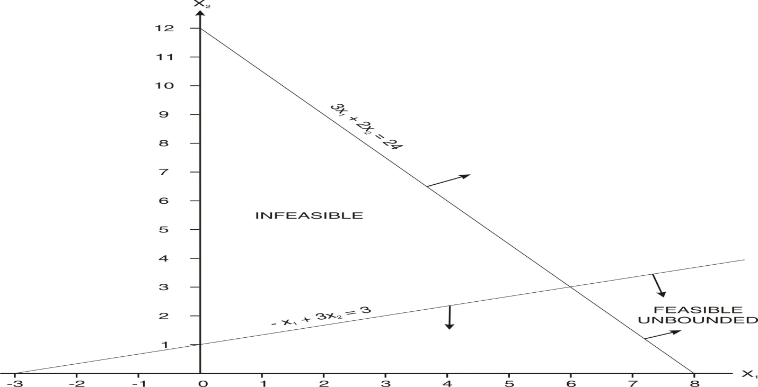

Q. No. 18.67
In a linear programming problem what is an infeasible solution? Solve the following by applying simplex method and comment on the result.
Maximize 7x + 4y
Subject to:→ | x + y ≤ 5 | y ≥ 10 | x, y ≥ 0

Answer
Infeasible solution is indicated by presence of artificial variable in the final solution.
C → |  |  | 7 | 4 | 0 | 0 | -M | Ratio
C↓ | Basic variables | Quantity | x | y | s₁ | s₂ | A₂ | Ratio
0 | s₁ | 5 | 1 | 1 | 1 | 0 | 0 | 5 →
-M | A₂ | 10 | 0 | 1 | 0 | -1 | 1 | 10
C  C – Z |  |  | 0 | -M | 0 | M | -M
 |  |  | 7 | M +4↑ | 0 | -M | 0

C → |  |  | 7 | 4 | 0 | 0 | -M | Ratio
C↓ | Basic variables | Quantity | x | y | s₁ | s₂ | A₂ | Ratio
4 | y | 5 | 1 | 1 | 1 | 0 | 0
-M | A₂ | 5 | -1 | 0 | -1 | -1 | 1
C  C – Z |  |  | 4 +M | 4 | 4 +M | M | -M
 |  |  | 3 - M | 0 | -4-M | -M | 0

As all the elements of net evaluation row i.e. C-Z are ≤ 0, the final solution has been reached. It is not optimal solution as Artificial variable 2 appears in the solution

Q. No. 18.68
Maximize: x + 2y
Subject to:→ | x + y ≤ 8 | 4x + 3y ≥ 36 | x , y ≥ 0

Answer
Maximize: x + 2y +0s₁ +0s₂ –MA₂
Subject to:→ | x + y +s₁ = 8 | 4x + 3y – s₂ +A₂ = 36 | x , y , s₁ , s_{2,} A₂ ≥ 0

Simplex Table 1
C → |  |  | 1 | 2 | 0 | 0 | – M | Ratio
C↓ | Basic variables | Quantity | x | y | s₁ | s₂ | A₂ | Ratio
0 | s₁ | 8 | 1 | 1 | 1 | 0 | 0 | 8→
-M | A₂ | 36 | 4 | 3 | 0 | – 1 | 1 | 9
C  C – Z |  |  | – 4M | – 3M | 0 | M | – M
 |  |  | 1 +4M↑ | 2 + 3M | 0 | –M | –2M

Working note for Simplex Table 2
36 | 4 | 3 | 0 | – 1 | 1
–8x4 | –1 x4 | –1 x4 | –1 x4 | –0 x4 | –0 x4
4 | 0 | -1 | -4 | -1 | 1

Simplex Table 2
C → |  |  | 1 | 2 | 0 | 0 | – M | Ratio
C↓ | Basic variables | Quantity | x | y | s₁ | s₂ | A₂ | Ratio
1 | x | 8 | 1 | 1 | 1 | 0 | 0
-M | A₂ | 4 | 0 | -1 | -4 | -1 | 1
C  C – Z |  |  | 1 | 1 +M | 1 + 4M | M | -M
 |  |  | 0 | 1-M | -1-4M | -M | 0

As all the elements of net evaluation row i.e. C-Z are ≤ 0, the final solution has been reached. It is not optimal solution as artificial variable A₂ appears in the solution.

GRAPHIC METHOD
Let’s convert the inequalities to equalities:
 | x | y
x + y = 8 | 0 | 8
x + y = 8 | 8 | 0
4x + 3y = 36 | 0 | 12
4x + 3y = 36 | 9 | 0

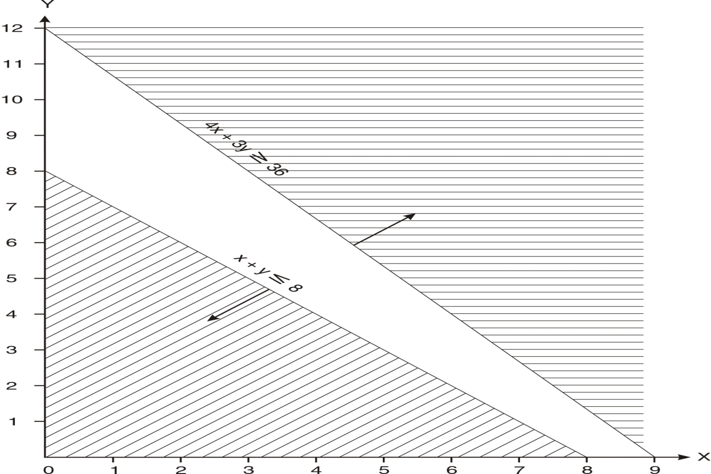

Teaching note:
- In case of infeasible solution, there is no feasible solution for the problem.
- In case of unbounded solution, there are infinite feasible solutions but none of them is optimal.

18.4 PRIMAL AND DUAL

The theory of duality simply states that every linear programming problem can be written in two forms: the primal form and the dual form. The original problem is called the primal problem. The other is called as its ‘dual’. In other words, each maximization problem in LP has its corresponding problem, called the dual, which is a minimization problem. Similarly, each minimization problem has its corresponding dual, a maximization problem. For example, if the primal is concerned with maximizing the contribution from the three products A, B, and C and from the three departments X, Y, and Z, then the dual will be concerned with minimizing the costs associated with the time used in the three departments to produce those three products. An optimal solution from the primal and the dual problem would be same as they both originate from the same set of data.

Sometimes it is easier to solve the dual problem than it is to solve the primal problem.

Example:
A worker is to decide what to purchase some food from a food manufacturer store for the breakfast. There are two choices of food: F₁, which costs Rs.55 each, and food F₂, which costs Rs.88 each. The store allows its customers to purchase even a fraction of a food item.

F1 contains 3 units of vitamin A and 2 units of vitamin B and 2 units of Vitamin C
F2 contains 4 units of vitamin B and 5 units of Vitamin C (It does not contain Vitamin A)

Being health-conscious, the worker has decided that he needs at least 6 units of A, at least ten units of B and at least eight units of Vitamin C in the breakfast.

He requests you to find the least expensive combination of F1 and F2 that meets these requirements.

The data given above can be summarized as follows:
 | Vitamin A | Vitamin B | Vitamin C | Cost
Food F1 | 3 | 2 | 2 | 55
Food F2 | 0 | 4 | 5 | 88
Minimum Requirements | 6 | 10 | 8

LPP
Let she purchases x units of F1 and y units of F2.
Minimize Z = 55x + 88y
Subject to:
3x ≥ 6 | 2x + 4y ≥ 10
2x +5y ≥ 8 | x, y ≥ 0

Let’s look at the problem from another point of view. The store purchases the three inputs Vitamin A, Vitamin B and Vitamin C from supplier X. The store intends to purchase at least six units of Vitamin A, at least ten units of Vitamin B, and at least eight units of vitamin C. What is the maximum amount the supplier should charge inputs.

Let us assume that the supplier charges a, b and c prices for these inputs.

Maximize Z : 6a + 10b + 8c
Subject to→ | 3a + 2b + 2c ≤ 55 | 4b + 5c ≤ 88 | a, b, c ≥ 0

Steps for converting the primal to dual:
- Before conversion, ensure that if the given problem is of maximization, all the constraints have ≤ sign and vice - versa.
- Number of decision variables in primal is equal to number of constraints in dual. Number of constraints in primal is equal to number of decision variables in dual.
- RHS values of constraints become coefficients of objective function.
- Coefficients of objective function become RHS of constraints.
- Transpose the coefficients of LHS of constraints i.e. rows to columns and columns to rows.

Q. No. 18.69: Find the dual of the following problem and then obtain solution.
Minimize Z = 20x + 10y
Subject to → | x + y ≥ 10 | 3x + 2y ≥ 24 | x , y ≥ 0
(CA Final Nov. 1987)
Answer
Maximize: Z = 10x + 24y
Subject to:→ | x + 3y ≤ 20 | x + 2y ≤10 | x, y ≥ 0

Simplex :
Maximize : Z = 10x + 24y + 0s₁ + 0s₂
Subject to:→ | x + 3y + s₁ = 20 | x + 2y +s₂ =10 | x, y, s₁ , s₂ ≥ 0

Simplex Table 1
C → |  |  | 10 | 24 | 0 | 0 | Ratio
C↓ | Basic Variables | Quantity | x | y | s₁ | s₂ | Ratio
0 | s₁ | 20 | 1 | 3 | 1 | 0 | 6.67
0 | s₂ | 10 | 1 | 2 | 0 | 1 | 5 →
Z  C – Z |  |  | 0 | 0 | 0 | 0
 |  |  | 10 | 24↑ | 0 | 0

Working note for Simplex Table 2
20 | 1 | 3 | 1 | 0
-5x3 | - ½ x 3 | -1x3 | -0x3 | -1/2 x3
5 | -1/2 | 0 | 1 | -3/2

Simplex Table 2
C → |  |  | 10 | 24 | 0 | 0 | Ratio
C↓ | Basic Variables | Quantity | x | y | s₁ | s₂ | Ratio
0 | s₁ | 5 | -1/2 | 0 | 1 | -3/2
24 | y | 5 | 1/2 | 1 | 0 | 1/2
Z  C – Z |  |  | 12 | 24 | 0 | 12
 |  |  | -2 | 0 | 0 | -12

As all the elements of net evaluation row i.e. C-Z are ≤ 0, the optimal solution has been reached. Recommendation: y = 5 units. Solution of dual : Z = 10x0 + 24x5 = 120

Q. No. 18.70: The final simplex table for the problem
Maximize Z = 3x₁ + 4x₂ + x₃
Subject to :
x₁ + 2x₂ + 3x₃ ≤ 90 | 2x₁ + x₂ + x₃ ≤ 60
3x₁ + x₂ + 2x₃ ≤ 80 | x₁, x₂, x₃ ≥ 0

is given below:
Program | Profit | Quantity | 3  x₁ | 4  x₂ | 1  x₃ | 0  s₁ | 0  s₂ | 0  s₃
x₂ | 4 | 40 | 0 | 1 | 10/6 | 4/6 | -1/3 | 0
x₁ | 3 | 10 | 1 | 0 | -1/3 | -1/3 | 2/3 | 0
s₃ | 0 | 10 | 0 | 0 | 8/6 | 8/6 | -10/6 | 1
C – Z |  |  | 0 | 0 | -28/6 | -10/6 | -2/3 | 0

- Find the solution, maximum profit, idle capacity and loss of total contribution of every one unit reduced from the right hand side of the constraints
- Write the dual the given problem and give the initial simplex table. (CA Final Nov. 1988)
Answer
- Solution :
x₁ | x₂ | x₃
10 | 40 | 0

- Maximum profit = 3x₁ + 4x₂ + x₃ ₌ 3x10 + 4x40 = 190
- Idle capacity : 3rd Constraint: 10 units
- Loss of contribution of one unit is reduced from right hand side of the first constraint : Rs.10/6 = Rs.1.6667
- Loss of contribution of one unit is reduced from right hand side of the second constraint : Rs.2/3 = Re..0.6667
- Loss of contribution of one unit is reduced from right hand side of the third constraint : nil
(ii) Let A, B and C be three positive dual variables. The dual problem will be :

Minimize Z = 90A + 60B + 80C
Subject to:
A + 2B + 3C ≥ 3 | 2A + B + C ≥ = 4
3A + B + 2C ≥ = 1 | A, B , C ≥ 0

Simplex
Minimize Z = 90A + 60B + 80C + 0s₁ +0s₂ +0s₃ +MA₁ +MA₂ + MA₃
Subject to:
A + 2B + 3C – s₁ + A₁ = 3 | 2A + B + C – s₂ + A₂ = 4
3A + B + 2C –s₃ + A₃ = 1 | A, B , C, s₁, s₂, s₃, A₁, A₂, A₃ ≥ 0

Simplex Table 1
C  → |  |  | 90 | 60 | 80 | 0 | 0 | 0 | M | M | M | Ratio
C  ↓ | Basic  vari-  ables | Quan-tity | x | y | z | s₁ | s₂ | s₃ | A₁ | A₂ | A₃
M | A₁ | 3 | 1 | 2 | 3 | -1 | 0 | 0 | 1 | 0 | 0
M | A₂ | 4 | 2 | 1 | 1 | 0 | -1 | 0 | 0 | 1 | 0
M | A₃ | 1 | 3 | 1 | 2 | 0 | 0 | -1 | 0 | 0 | 1
C  C – Z |  |  | 6M | 4M | 6M | -M | -M | -M | M | M | M
 |  |  | 90-6M | 60-4M | 80-6M | M | M | M | 0 | 0 | 0

Q. No. 18.71: A company makes three products X, Y and Z out of three raw materials A, B and C. The raw –material requirement is given below:
Raw materials | The number of units of raw materials required to produce one unit of product
 | X | Y | Z
A | 1 | 2 | 1
B | 2 | 1 | 4
C | 2 | 5 | 1
The unit contribution of the products X, Y and Z are Rs.40, Rs.25 and Rs.50 respectively. The number of units of raw materials available are 36, 60 and 45.
- Formulate and solve the LP problem for maximization of contribution.
- Through the final simplex table, write the solution to the dual problem and give the economic interpretation. (CA Final May 1989)
Answer
Let’s produce x units of X, y units of Y and z units of Z
Objective function: Maximize 40x + 25y and 50z
Subject to:
x + 2y +z ≤ 36 | 2x + y + 4z ≤ 60
2x + 5y + z ≤ 45 | x, y, z ≥ 0

Simplex
Maximize Z = 40x +25y + 50z +0s₁ +0s₂ +0s₃. Subject to:
x + 2y + z + s₁ = 36 | 2x + y + 4z +s₂ = 60
2x + 5y + z +s₃ = 45 | x, y, z ≥ 0

C → |  |  | 40 | 25 | 50 | 0 | 0 | 0 | Ratio
C↓ | Variables | Quantity | x | y | z | s₁ | s₂ | s₃ | Ratio
0 | s₁ | 36 | 1 | 2 | 1 | 1 | 0 | 0 | 36
0 | s₂ | 60 | 2 | 1 | 4 | 0 | 1 | 0 | 15→
0 | s₃ | 45 | 2 | 5 | 1 | 0 | 0 | 1 | 45
Z  C – Z |  |  | 0 | 0 | 0 | 0 | 0 | 0
 |  |  | 40 | 25 | 50↑ | 0 | 0 | 0

0 | s₁ | 21 | 1/2 | 7/4 | 0 | 1 | -1/4 | 0 | 42
50 | z | 15 | 1/2 | 1/4 | 1 | 0 | 1/4 | 0 | 30
0 | s₃ | 30 | 3/2 | 19/4 | 0 | 0 | -1/4 | 1 | 20→
Z  C – Z |  |  | 25 | 12.50 | 50 | 0 | 12.50 | 0
 |  |  | 15↑ | 12.50 | 0 | 0 | -12.50 | 0

0 | s₁ | 11 | 0 | 1/6 | 0 | 1 | -1/6 | -1/3
50 | z | 5 | 0 | -4/3 | 1 | 0 | 1/3 | -1/3
40 | x | 20 | 1 | 19/6 | 0 | 0 | -1/6 | 2/3
Z  C – Z |  |  | 40 | 60 | 50 | 0 | 10 | 10
 |  |  | 0 | -35 | 0 | 0 | -10 | -10

As all the elements of net evaluation row i.e. C-Z are ≤ 0, the optimal solution has been reached. The company may produce 20 units of X and 5 units of Z. The contribution will be Rs.1,050.

Working note (i)
36 | 1 | 2 | 1 | 1 | 0 | 0
-15x1 | -1/2x1 | -1/4x1 | -1x1 | -0x1 | -1/4x1 | -0x1
21 | 1/2 | 7/4 | 0 | 1 | -1/4 | 0

Working note (ii)
45 | 2 | 5 | 1 | 0 | 0 | 1
-15x1 | -1/2x1 | -1/4x1 | -1x1 | -0x1 | -1/4x1 | -0x1
30 | 3/2 | 19/4 | 0 | 0 | -1/4 | 1

Working note (iii)
21 | 1/2 | 7/4 | 0 | 1 | -1/4 | 0
-20x1/2 | -1x1/2 | -19/6x1/2 | -0x1/2 | -0x1/2 | -(-1/6)x1/2 | -2/3x1/2
11 | 0 | 1/6 | 0 | 1 | -1/6 | -1/3

Working note (iv)
15 | 1/2 | 1/4 | 1 | 0 | 1/4 | 0
-20x1/2 | -1x1/2 | -19/6x1/2 | -0x1/2 | -0x1/2 | -(-1/6)x1/2 | -2/3x1/2
5 | 0 | -4/3 | 1 | 0 | 1/3 | -1/3

Dual
Let A, B and C be three positive dual variables. The dual problem will be :
Minimize Q = 36A + 60B + 45C
Where A is the shadow price of first constraint
Where B is the shadow price of second constraint
Where C is the shadow price of third constraint
Subject to :
A + 2B + 2C ≥ 40 | 2A + B + 5C≥ 25
A + 4B + C ≥ 45 | A, B, C ≥ 0

Solution to dual problem : Minimize Q = 36(0)+ 60(10) + 45(10) = 1050

Interpretation : Shadow price (economic worth) of the first constant is zero and that of other two Rs.10 each. The quantities of the three constraints are 36, 60 and 45 respectively.

Q. No. 18.72 Noah’s Boats makes three different kinds of boats. The company’s monthly production is constrained by the limited amount of labour, wood and screws available each month. The director will choose the combination of boats that maximizes his revenue in view of the information given the following table:
Input | Row boat | Canoe boat | Kayak boat | Monthly availability
Labour ( hours) | 12 | 7 | 9 | 1260 hours
Wood (Board feet) | 22 | 18 | 16 | 19008 board feet
Screws | 2 | 4 | 3 | 396 Kg.
Selling price (Rs.) | 4000 | 2000 | 5000
- Formulate and solve the LPP.
- Answer the following questions:
- How many boats of each type will be produced and what will be the resulting revenue?
- Which, if any, of the resources are not fully utilized? If so, how much spare capacity is left?
- How much wood will be used to make all the boats given in optimal solution?
- State the dual of the formulated linear programming problem.
(CA Final Nov. 1993)

Answer
- Let’s produce and sell x units of Row Boats, y units of Canoe boats, and z units of Kayak boats.
Objective function: Maximize Z = 4000x + 2000y + 5000z
Subject to:
12x + 7y + 9z ≤ 1260 | 22x + 18y + 16z ≤ 19008
2x + 4y + 3z ≤ 396 | x, y, z ≥ 0

Simplex
Maximize Z = 4000x +2000y +5000z +0s₁ +0s₂ +0s₃
Subject to :
12x + 7y + 9z +s₁ = 1260 | 2x + 4y + 3z + s₃ = 396
22x + 18y + 16z +s₂ = 19008 | x, y, z, s_{1 ,} s_{2 ,} s₃ ≥ 0

Simplex Table 1
C → |  |  | 4000 | 2000 | 5000 | 0 | 0 | 0 | Ratio
C↓ | Basic variables | Quantity | x | y | z | s₁ | s₂ | s₃ | Ratio
0 | s₁ | 1260 | 12 | 7 | 9 | 1 | 0 | 0 | 140
0 | s₂ | 19008 | 22 | 18 | 16 | 0 | 1 | 0 | 1188
0 | S₃ | 396 | 2 | 4 | 3 | 0 | 0 | 1 | 132→
Z  C – Z |  |  | 0 | 0 | 0 | 0 | 0 | 0
 |  |  | 4000 | 2000 | 5000↑ | 0 | 0 | 0

Working notes for Simplex table 2
1260 | 12 | 7 | 9 | 1 | 0 | 0
-132x9 | -2/3 x9 | -4/3 x9 | -1 x9 | -0 x9 | -0 x9 | -1/3x9
72 | 6 | -5 | 0 | 1 | 0 | -3

19008 | 22 | 18 | 16 | 0 | 1 | 0
-132x16 | -2/3 x16 | -4/3 x16 | -1 x16 | -0 x16 | -0 x16 | -1/3x16
16896 | 11.33 | -10/3 | 0 | 0 | 1 | -16/3

Simplex Table 2
C → |  |  | 4000 | 2000 | 5000 | 0 | 0 | 0 | Ratio
C↓ | Basic variables | Quantity | x | y | z | s₁ | s₂ | s₃ | Ratio
0 | s₁ | 72 | 6 | -5 | 0 | 1 | 0 | -3 | 12→
0 | s₂ | 16896 | 11.33 | -10/3 | 0 | 0 | 1 | -16/3 | 1491
5000 | z | 132 | 2/3 | 4/3 | 1 | 0 | 0 | 1/3 | 198
Z  C – Z |  |  | 3333 | 6667 | 5000 | 0 | 0 | 1667
 |  |  | 667↑ | -4667 | 0 | 0 | 0 | -1667

Working notes for Simplex table 3
16896 | 11.33 | -10/3 | 0 | 0 | 1 | -16/3
-12 x34/3 | -1 x34/3 | -(-5/6) x34/3 | -0 x34/3 | -1/6 x34/3 | -0 x34/3 | -(-1/2) x34/3
16760 | 0 | 55/9 | 0 | -17/9 | 1 | 1/3

132 | 2/3 | 4/3 | 1 | 0 | 0 | 1/3
-12 x2/3 | -1 x2/3 | -(-5/6) x2/3 | -0 x2/3 | -1/6 x2/3 | -0 x2/3 | -(-1/2) x2/3
124 | 0 | 17/9 | 1 | -1/9 | 0 | 2/3

Simplex Table 3
C → |  |  | 4000 | 2000 | 5000 | 0 | 0 | 0 | Ratio
C↓ | Basic variables | Quantity | x | y | z | s₁ | s₂ | s₃ | Ratio
4000 | x | 12 | 1 | -5/6 | 0 | 1/6 | 0 | -1/2
0 | s₂ | 16760 | 0 | 55/9 | 0 | -17/9 | 1 | 1/3
5000 | z | 124 | 0 | 17/9 | 1 | -1/9 | 0 | 2/3
Z  C – Z |  |  | 4000 | 55,000/9 | 5000 | 1000/9 | 0 | 4000/3
 |  |  | 0 | -37000/9 | 0 | -1000/9 | 0 | -4000/3

As all the elements of net evaluation row i.e. C - Z are ≤ 0, the optimal solution has been reached.

(ii) (a) The company may produce 12 units of Row and 124 units of Kayak. Total revenue: Rs.6,68,000.
(b) Wood board is not fully utilized. It is spare capacity is 16,760 Board feet.
(c) 2248 Board feet wood would be used.
(d) Let A, B and C be three positive dual variables. The dual problem will be:

Minimize Z = 1260A + 19008B + 396C
Subject to :
12A + 22B + 2C ≥ 4000 | 9A + 16B + 3C ≥ 5000
7A + 18B + 4C ≥ 2000 | A ,B ,C ≥ 0

Q. No. 18.73 A firm buys casting of P and Q type of parts and sells them as finished product after machining and polishing. The purchasing cost for casting are Rs.3 and Rs.4 for parts P and Q respectively and selling prices are Rs.8 and Rs.10 respectively. The per hour capacity of machines used for machining, boring and polishing the two products are:

 | Capacity per hour
 | P | or | Q
Machining | 30 | or | 50
Boring | 30 | or | 45
Polishing | 45 | or | 30

The running costs for machining, boring and polishing are Rs.30, Rs.22.50 and Rs.22.50 per hour respectively. Formulate the linear programming problem to find the product mix to maximize the Profit and solve the same using Simplex. Also write its dual and read the solution of the dual from the optimum solution of the primal. (University of Delhi)

Answer
Let’s assume that capacity available is only 60 minutes for each department.

Calculation of contribution per hour of each of P and Q (Rs.)
 | P |  | Q
Selling Price |  | 8 |  | 10
Material cost |  | 3 |  | 4
Machining cost | Rs.30/30 | 1 | Rs.30/50 | 0.60
Boring cost | Rs.22.50/30 | 0.75 | Rs.22.50/45 | 0.50
Polishing cost | Rs.22.50/45 | 0.50 | Rs.22.50/30 | 0.75
Total Variable cost |  | 5.25 |  | 5.85
Contribution per unit |  | 2.75 |  | 4.15

Let’s produce x units of P and y units of Q
Objective function: Maximize Z = 2.75x + 4.15 y
Subject to :
60/30 x + 60/50y ≤ 60  5x + 3y ≤ 150 ---------------------------(i) | 60/30 x + 60/45y ≤ 60  3x + 2y ≤ 90 ---------------------------(ii)
60/45x + 60/30y ≤ 60  2x + 3y ≤ 90 ----------------------------(iii) | x, y ≥ 0 …………………………………….(iv)

Simplex
Maximize Z = 2.75x + 4.15y +0s₁ + 0s₂
Subject to :
5x + 3y +s₁ = 150 | 3x + 2y + s₂ = 90
2x + 3y + s₃ = 90 | x, y, s₁ , s₂, s₃ ≥ 0

Simplex Table 1
C → |  |  | 2.75 | 4.15 | 0 | 0 | 0 | Ratio
C↓ | Basic variables | Quantity | x | y | s₁ | s₂ | s₃ | Ratio
0 | s₁ | 150 | 5 | 3 | 1 | 0 | 0 | 50
0 | s₂ | 90 | 3 | 2 | 0 | 1 | 0 | 45
0 | S₃ | 90 | 2 | 3 | 0 | 0 | 1 | 30→
C  C – Z |  |  | 0 | 0 | 0 | 0 | 0
 |  |  | 2.75 | 4.15↑ | 0 | 0 | 0

Working note for Simplex Table 2
150 | 5 | 3 | 1 | 0 | 0
–30x3 | –2/3 x3 | –1 x3 | –0 x3 | –0 x3 | –1/3 x3
60 | 3 | 0 | 1 | 0 | -1

90 | 3 | 2 | 0 | 1 | 0
–30x2 | –2/3 x2 | –1 x2 | –0 x2 | –0 x2 | –1/3 x2
30 | 5/3 | 0 | 0 | 1 | -2/3

Simplex Table 2
C → |  |  | 2.75 | 4.15 | 0 | 0 | 0 | Ratio
C↓ | Basic variables | Quantity | x | y | s₁ | s₂ | s₃ | Ratio
0 | s₁ | 60 | 3 | 0 | 1 | 0 | -1
0 | s₂ | 30 | 5/3 | 0 | 0 | 1 | -2/3
4.15 | y | 30 | 2/3 | 1 | 0 | 0 | 1/3
C  C – Z |  |  | 2.77 | 4.15 | 0 | 0 | 1.383333
 |  |  | -0.02 | 0 | 0 | 0 | -1.383333

As all the elements of net evaluation row i.e. C - Z are ≤ 0, the optimal solution has been reached. The company may produce zero units of P and 30 units of Q. Total contribution: Rs.124.50.
Dual
Let A, B and C be three positive dual variables. The dual problem will be :
Minimize Z = 150A + 90B + 90C
Where A is the shadow price of first constraint
Where B is the shadow price of second constraint
Where C is the shadow price of third constraint

Subject to :
5A + 3B + 2B ≥ 2.75 | 3A + 2 B + 3B ≥ 4.15 | A, B, C ≥ 0

Minimize Z = 150A + 90B + 90C
= 150(0) + 90(0) + 90(1.383333) = 124.50

18.5 USES OF LP
Linear programming technique is used:
- to find the optimal quantity of a product to be produced
- to find the profit /loss for the optimal production
- to find any surplus capacity
- to find the marginal cost of each resource
- to find the opportunity cost of producing a product.

LP is used in the following areas:
- in industries to find the optimal production to maximize the contribution
- in hospitals it is used to find the optimal diet
- in agriculture to find the optimum yield
- in advertising agencies to find the optimal pattern of advertising
- in airlines to find the optimal utilization of aircrafts fleet
- In mutual funds to find the optimal portfolios

18.6 LIMITATIONS OF LP
- The assumptions may not hold good
- The solution needs not to be in integers and any rounding off will result in non-optimal results.
- Any moderate size problem requires a lot of calculations
- It deals with problems with single objective.

18.7 ADVANTAGES OF LP
- LP based decisions ensure optimum use of limited resources.
- LPP offer quality decisions by making them objective rather subjective.
- LP has applications in various decision making problems such as product-mix, portfolio management problems, advertising media selection problems, transportation problems, balanced diet problems, and so on.
- LP helps in decision making when we are faced with complex problems involving many variables.
- Linear programming highlights the bottlenecks in the production processes and helps in finding the best possible way(s) to remove them.

18.8 APPLICATIONS OF LP
LP is applied for allocating limited resources to the competing activities. It applications can be studies in two parts:
- Industrial Applications

- Product Mix problem
A firm may use its limited resources for various products. LP is applied to find the most profitable product-mix.
- Blending problem
In blending, the cost of the ingredients is to be minimized, while adhering to certain specifications and using certain ingredients. LP is applied to find the minimum cost of the blended products.
- Transportation problem
LP is applied for decision-making regarding transporting the products from plants to sales –counters.
- Assignment problem
LP is applied for assigning various jobs to various available staff members for obtaining the optimal results.
- Production scheduling problem
LP is applied for production scheduling decisions. For example, the demand for a company’s product fluctuates in different seasons. It has two alternatives (i) production at constant rate, and (ii) production as per demand. In first case, the units produced in lean period will be carried as inventory and sold during the high demand period; the company has to bear the inventory carrying cost. In the second case, it has to bear the cost of high level of production (for example, overtime premium to labour) during high demand period.
- Other applications
- The Diet Problem
LP is applied to find the cheapest combination of foods that satisfy all the nutritional requirements.
- Portfolio Optimization
LP is applied for allocation of funds among various assets to that the risk is minimized subject to achieving a certain return.
- Capital structure determination
LP is applied for determining the optimum capital structure to keep the cost of capital at low level, risk at optimal level and meeting various conditions of fund provides.
- Advertising Media selection Problem
LP is applied for selection of Optimum advertising plan considering various alternative ways, their respective costs and effectiveness.

Theoretical Questions
18.1T Enumerate the industrial applications of linear programming.
(CA Final May 2003)
Answer: Please refer to paragraph 18.8.

18.2T Distinguish between slack variables and artificial variables in Linear programming.
(CA Final May 2003)
Answer: Please refer to paragraphs 18.2-2.1 and 18.2-2.2.
18.3T Explain the limitations of linear programming. (CA Final May 2004)
Answer: Please refer to paragraph 18.6.
18.4T What are the practical applications of LP? (CA Final May 2007)
Answer: Please refer to paragraph 18.8.

18.5T Write a short note on characteristic of a dual problem. (CA Final Nov. 2012)
Answer: Please refer to paragraph 18.3.

