CHAPTER 1

COST VOLUME PROFIT ANALYSIS
CHAPTER INDEX
CONCEPT
- ASSUMPTIONS OF COST-VOLUME –PROFIT ANALYSIS
- MARGIN OF SAFETY
INTRODUCTORY PROBLEMS
MULTIPLE PRODUCTS
SEMI-FIXED AND SEMI-VARIABLE COSTS
COST INDIFFERENCE POINT
BREAKEVEN CHARTS
- ANGLE OF INCIDENCE
PROFIT VOLUME CHARTS
THEORETICAL QUESTIONS

1.1 CONCEPT
All the techniques that we study in Cost-Accounting, may be divided into three categories: (i) techniques of cost ascertainment - example are unit costing, operating costing, contract costing, process costing etc, (ii) techniques of planning and control - examples are standard costing and budgetary control, and (iii) techniques of decision-making - examples are marginal cost and differential costing. The point we should clearly understand at this stage is that marginal costing a technique of decision-making. It helps the management in taking routine decision.

We begin with the assumption that only two types of costs are there (i) variable costs and (ii) fixed cost. (Later on we shall be discussing the other types of costs as well). Accordingly:

Sale = VC + FC + Profit
Sale – VC = FC + Profit = Contribution

1.1-1 ASSUMPTIONS OF COST-VOLUME-PROFIT ANALYSIS
- Costs can be accurately classified as fixed and variable
- Selling price remains constant for any volume
- Unit variable cost remains constant for any volume
- Sales mix is constant
- No inventory

The simplest possible decision that we take with the help of marginal costing is determination of Break Even Point (BEP).

BEP can be explained in three different ways:
- BEP is that sales level at which total cost (VC + FC) is equal to sales amount.
- It is that sales level at which there is no profit no loss,
- It is that sales level at which the amount of fixed cost is equal to total contribution
BEP can be calculated either in units or in amount.

B.E.P.(Units) = | Fixed cost  --------------------  Contribution per unit

Sales (units) for required  amount of profit = | Fixed Cost + Required Profit  ----------------------------------------  Contribution per unit

To calculate the BEP in terms of amount, we take the help of Profit Volume Ratio (PV Ratio). PV ratio denotes contribution made by one rupee sales (it is generally expressed in percentage; in that situation, it denotes contribution made by sales of Rs.100).

P/V Ratio = | Contribution  ---------------------X 1000  Sales

Two important points about PV Ratio:
- PV Ratio denotes contribution made by Re.1 or Rs.100 sales. For example, if PV ratio is 20%, it means for every Rs.100 sales, contribution is Rs.20 i.e. variable cost is Rs.80. Another example, suppose PV ratio is 30%; it means for every Rs.100 sales, contribution is Rs.30 i.e. variable cost is Rs.70.
- For calculation of PV ratio, we may take any amount of sales; the only point to be kept in mind is that we have to take corresponding contribution.

B.E.P.(Amount) = | Fixed Cost  ---------------- X 100  P/V Ratio
Sales (Amount) for required  amount of profit = | Fixed Cost + Required Profit  ------------------------------------------ X 100  P/V Ratio

1.1-2 Margin of Safety: It is excess of actual sales over BEP. It may be calculated in units or in amount.
Breakeven point | Actual sales | Selling price | Margin of safety
10,000 units | 15,000 units | Rs.10 | 5000 units
Rs.100000 | Rs.1,50,000 | Rs.10 | Rs.50,000

This is post-breakeven point sales. The contribution made by this amount of sales is Profit. It is an indicator of strength of the business. Higher the margin of safety, more vital the business is. Even if the sales decline by the amount of margin of safety, the firm is safe against loss. In other words, if the margin of safety is small, firm may not be able to tolerate even a small set back in sales. If the margin of safety is large, the business may sail through the troubled periods.
Margin of Safety = | Actual sales – B.E.P. sales
Margin of Safety Ratio  (M. S. Ratio) = | Margin of Safety  ------------------------- x 100  Total Sales

Relationship between Margin of Safety, PV ratio and Profit: Up to Breakeven point, whatever contribution is there, that is contribution towards fixed cost. After breakeven point whatever contribution is there, that is contribution towards profit. In other words we can say that the contribution made by post-breakeven –sales is, i.e., the contribution made by Margin of safety is contribution wards profit. On multiplying margin of safety with PV Ratio, we get contribution made by margin of safety and this contribution is Profit. This relationship can be stated as:
Profit = | Margin of Safety x P. V. Ratio  --------------------------------------------  100

Improving Margin of safety:
- Reduce variable cost per unit
- Reduce fixed costs
- Increase selling price (assuming that inelastic demand)
- Change sales mix in such a way that weighted average PV ratio improves.
- Increase sales volume

Profit in Relation to Sales:
Margin of safety x PV ratio
Profit = ----------------------------------------------------
100
Multiplying both the sides by ‘100/Sales’, we get:

Profit x 100 Margin of Safety x PV Ratio x 100/sales
---------------- = ------------------------------------------------------
Sales 100

Putting in simple way, we get
Profit M.S. Ratio x PV ratio
-------- x 100 = ----------------------------------
Sales 100

PV Ratio Revisited: We know that for calculation of PV ratio, we may take any amount of sales; the only point to be kept in mind is that we have to take corresponding contribution. For the calculation of PV ratio, we may take Margin of safety; we have to take contribution made by margin of safety. Contribution made by margin of safety is Profit. Hence,
P. V. Ratio = | Profit  ----------------------- X 100  Margin of Safety

1.2 INTRODUCTORY PROBLEMS

Q.No.1.1 Madhav & Co. sells five different types of ball pens with identical purchase cost and selling prices. The co. is trying to find out possibility of opening another store, which will have the following expenses and revenue:

 | Per Pen (Rs.)
Selling Price | 30.00
Variable Cost | 19.50
Salesmen commission | 1.50
Total variable cost | 21.00
Annual fixed expenses are:  Rent  Salaries  Advertising  Other fixed expenses  Total | (Rs.)  60,000  2,00,000  80,000  20,000  3,60,000

Required:
- Calculate the annual breakeven point in units and in value. Also determine the profit or loss if 35000 ball pens are sold.

- The sales commission is proposed to be discontinued, but instead a fixed amount of Rs. 90,000 is to be incurred as fixed salaries. A reduction in selling price of 5% is also proposed. What will be the breakeven point in units?

- It is proposed to pay 50 paisa per ball pen as further commission. The selling price is also proposed to be increased by 5%. What would be the breakeven point in units?

- Refer to the original data. If the store’s manager were to be paid 30 paisa commission on each ball pen sold in excess of breakeven point, what would be the store’s net profit if 50000 ball pens were sold? (Note: Consider each part of question separately)
Answer
(1)
FC 3,60,000
BEP ( units) = ---------------------------- = ---------------- = 40,000
Contribution per unit 9
9
PV ratio = ------------- = 0.30
30

FC 3,60,000
BEP ( amount) = ------------------ = ---------------- = Rs.12L
PV ratio 0.30
Sales  Contribution  FC  Loss | Rs.10,50,000  Rs.3,15,000 (30% of sales)  Rs.3,60,000  Rs.45,000

(2)
FC 4,50,000
BEP ( units) = ---------------------------- = ------------------- = 50,000
Contribution per unit 28.50 – 19.50

(3)
FC 3,60,000
BEP ( Units) = -------------------------- = --------------------- = 36,000
Contribution per unit 31.50 – 21.50

(4)
BEP = 40,000 units
Actual sales = 50,000 units
Margin of safety = 10,000 Units
Profit = contribution made by MOS = 10000x 8.70 = Rs.87,000.

Q.No.1.2 The following figures are available from records of V Enterprises as at 31st March:
 | 2008 | 2009
 | Rs. Lakhs | Rs. Lakhs
Sales | 150 | 200
Profit | 30 | 50

Calculate:
- The P.V. ratio and total fixed expenses.
- The breakeven level of sales
- Sales required earning a profit of Rs. 90 Lakhs.
- Profit or loss that would arise if the sales were Rs. 280 Lakhs.
Answer

(a)
PV ratio | Contribution 20  ----------------- = -------- = 0.40  Sales 50
Total contribution on Rs.150L sales = Rs.60L
Profit on Rs.150L sales = Rs.30L
FC = Rs.30L

(b)
FC 30L
BEP ( amount) = ------------------ = ---------------- = Rs.75L
PV ratio 0.40

(c)
FC + Desired profit 30L+90L
Sales for desired profit = ---------------------------- = --------------- = Rs.300L
PV ratio 0.40

(d)
Sales  Contribution  FC  Profit | Rs.280L  40% of Rs.280L = Rs.112L  Rs.30L  Rs.82L

Q.No.1.3 A Japanese soft drink co. is planning to establish a subsidiary in India to produce mineral water. Based on the estimated annual sales of 40,000 bottles of mineral water, cost studies have produced the following estimates for the Indian subsidiary.
 | Total annual cost (Rs.) | % of Total annual cost which is variable
Material | 2,10,000 | 100
Labour | 1,50,000 | 80
Factory overheads | 92,000 | 60
Administrative expenses | 40,000 | 35

The Indian production will be sold by manufacturer’s representative who will receive a commission of 8% of sale price. No portion of Japanese office expenses is to be allocated to the Indian subsidiary.
- Compute the sale price bottle to enable the management to realize an estimated 10% profit on sale proceeds in India.
- Calculate the breakeven point in sales value and also in number of bottles for Indian subsidiary on the assumption that S.P. is Rs. 14 per bottle.
Answer (i)
Commission + profit | 18% of sales
Total cost (other than commission) | Rs.4,92,000 (It is 82% of sales)
Sales | 4,92,000/0.82 = Rs,6,00,000
SP | Sales/Sales units =Rs.6,00,000/40,000=Rs.15

(ii)
FC = 150000x0.20 + 92000x0.40 + 40000x0.65 = Rs.92800
VC (other than commission) | Rs.492000 – 92800 = Rs.3,99,200
VC (other than commission) per unit | Rs.399200/40000 = 9.98
Commission per unit | 8% of 14 = Rs.1.12
VC per unit | 9.98 + 1.12 = 11.10
PV ratio | 14 - 11.10  -------------------- = 20.714  14
FC 92800
BEP ( amount) = --------------- = ------------------------ = Rs.4,48,006
PV ratio 0.20714
FC 92800
BEP (Units) = ----------------------------- = -------------------- = 32000
Contribution per unit 14 – 11.10

Q.No.1.4
(i) Ascertain profit, when sale is Rs. 200000, F.C. Rs. 40000 & BEP Rs.160000.
(ii) Ascertain sales, when F.C. is Rs. 20000, profit Rs. 10000 and BEP Rs. 40000.

Answer
(i)
Margin of safety | Rs.40,000
FC
BEP = -------------------------
PV ratio

40000
160000 = -------------------------
PV ratio

PV ratio = 25%
Profit | Margin of safety x PV ratio = 40000x0.25 = Rs.10000

(ii)
FC
BEP = -----------------------
PV ratio

20000
40000 = ---------------------
PV ratio

PV ratio = 50%
Contribution = FC + Profit = Rs.30,000 (it is 50% of sales)
Sales = Rs.60,000

Q.No.1.5 A single product company sells its product at Rs. 60 per unit. In 2006, the co. operated at a margin of safety of 40%. The fixed cost amounted to Rs. 360000 and the variable cost ratio to sales was 80%.

In 2007, it is estimated that variable cost will go up by 10% and the fixed cost will increase by 5%.

Find the selling price required in 2007 to earn the same P.V. ratio as in 2006.

Assume the same selling price of Rs. 60 per unit in 2007; find the number of units required to be produced and sold to earn the same profit as in 2006.

Answer

2006
VC | 80% of sales = Rs.48 per unit
PV ratio | 20%

2007
VC per unit | Rs.52.80 per unit
PV ratio | 20%
Selling price | Rs.52.80/0.80 = Rs.66

2006
BEP | FC/PV ratio = Rs.3,60,000/0.20 = 18,00,000  ( As MOS is 40%, BEP is 60% of sales)
Sales | Rs.30,00,000
Margin of safety | Rs.12,00,000
Profit | Margin of Safety x PV ratio = 1200000 x 0.20 = Rs.2,40,000

2007
FC | Rs.3,78,000
Sales(units) | FC + desired profit Rs.3,78,000 + 2.40,000  = -------------------------------= --------------------------------  Contribution per unit 60 – 52.80  = 85,834

Q.No.1.6 Operating leverage (contribution/ profit) of an organization has been increased from 4 last year to 5 during the current year. Fixed overheads have increased by 5% during the current year compared to last year. Sales have also increased by 8% over last year. Assess to what the profit of current year is likely to change over last year. Trace the reasons for such change.

Answer
Last year : | This year
Let contribution = Rs.100  4 =100/(100-FC)  FC = 75  Profit = 25 | FC = Rs.78.75
5 = Contribution / (Contribution – 78.75)

Contribution = 98.4375
Profit = 98.4375 – 78.75 = 19.6875
% change (Decline) in profit = [(25 – 19.6875) / 25 ] x 100 = 21.25

Reasons for Decline in Profit:
- Increase in FC and
- Decline in PV ratio.

PV ratio declines for either or both of the following two reasons
- Increase in Unit VC
- Decrease in SP.

Q. No.1.7 The following information is given by Z Ltd:
Margin of safety | Rs.1,87,500
Total cost | Rs.1,93,750
Margin of safety | 7500 units
Breakeven sales | 2500 units
Calculate profit, PV ratio, breakeven sales in rupees, and fixed cost. (CA Final Nov. 2010)
Answer :
SP = Rs.1,87,500 / 7,500 units = Rs.25
Breakeven sales in Rupees: 25x2,500 = Rs. 62,500
Total sales = 10,000units @ Rs.25 i.e., Rs.2,50,000
Total profit = total sales – total cost = 2,50,000 – 193750 = Rs.56,250
P V Ratio = Profit/Margin of Safety = 56250/187500 = 30%
B E Sales = Fixed Cost/PV Ratio
62500 = Fixed cost /0.30
FC = Rs.18,750

Q.NO.1.8 A Ltd makes and sells a single product. The trading results for year 2007 ate given below: (Rs. Thousands)
Sales |  | 3,000
Material | 900
Labour | 600
Overheads | 900
Total cost |  | 2400

For the year 2008, the following are expected:
- Reduction in sale price by 10%
- Increase in quantity sold : 50%
- Inflation of material cost : 8%
- Price inflation in variable overhead by 6%
- Reduction in fixed overheads expenses by 25%

It is also known that:
- In 2006 overhead expenditure totaled Rs.8,00,000
- Total overhead cost inflation for 2007 has been 5% more than 2006
- Production and sales volumes have been 25% higher in 2007 than in 2006
High and low method is used by the company to estimate overhead expenditure.
You are required to:
- Prepare a statement showing the estimated trading results for 2008.
- Calculate the Breakeven points for 2007 and 2008.
- Comment on the BEPs and profits for the years 2007 and 2008.
(CA Final May 2008)
Answer
Working note :
Let VO in 2006 = X |  |  | Let FO in 2006 = Y
Year 2006 : X + Y = 800 thousands |  |  | Year 2007 : 1.05(1.25X + Y) = 900 thousands
Solving the equations, we find : X = Rs.228.57 thousands
 | 2006 | 2007 |  | 2008
V O | 228.57 | 228.57(1.05)(1.25) =300 |  | 300(1.06)(1.50) =477
FO | 571.43 | 571.53(1.05) = 600 |  | 450
Total | 800 | 900 |  | 927

- Statement showing estimated trading results in 2008
 | Rs. thousands
Sales 3000thou.x1.50x0.90 | 4050
Costs:  Direct Materials 900thou.x1.50x1.08  Direct labour 600thou.x1.50  Variable overheads | 1458  900  477
Total VC | 2835
Contribution | 1215
FC | 450
Profit | 765

- Calculation of BEPs for 2007 and 2008
 | 2007 | 2008
Contribution | 1200 | 1215
Sales | 3000 | 4050
P.V. Ratio | 40% | 30%
FC | 600 | 450
BEP | 600  -------------------x100  40  = 1500thou. | 450  -------------------x100  30  =1500thou.
Profit | 600 | 765

(iii)
In the year 2008, the BEP has remained unchanged as both the FC and PV ratio have declined by the same %.
In spite of (i) decline in selling price and (ii) increase in variable overheads and material prices, profit has increased because of decline in overheads and increase in sales quantity.

Q.No.1.9 The following information of a company is available for the year 2006:
 | Rs.
Sales (200 units) | 40,000
Raw material | 20,000
Direct Wages | 6,000
Variable and fixed overheads | 10,000
Profit | 4,000

In the year 2007, wages will increase by 50% and fixed cost will be reduced by Rs.600. If 300 units are sold in 2007, the total fixed and variable overhead will be Rs.11,400. How many units must be sold in 2007, so that the same amount of profit per unit as in year 2006 may be earned? (CA Final May 2007)
Answer Working note:
Let V.O. in 2006 = X Let FO in 2007 = Y
Year 2006 X + Y = 10000
Year 2007 1.50X + Y - 600 = 11400
X = 4000 Y = 6000
VO in 2007: 6000
FO in 2007: 5400
Calculation of PV ratio for the year 2007
Sales | 60,000
Material  wages  VO  Total VC | 30,000  13,500  6,000  49,500
Contribution | 10,500
Contribution per unit | Rs.35

Let number of units sold for same amount of profit per unit = Z
5400 + 20Z
Z = -----------------------------
35
Z = 360 units

Q.No.1.10 Processed Food Ltd., which had recently launched a new product, after initial estimation of demand and costs, would like to have a review through fresh projections based on available information on actual production, costs and revenues. The product is sold in one Kg. home packs. Performance, pertaining to the previous two quarters, detailed below, can be taken as representing pattern of costs and operations that can be projected to the future. There were no inventories at the end of each quarter. Tax Rate: 40 per cent.
 | First Quarter | Second Quarter
Sales  62,000 packs at Rs.160  82,000 packs at Rs.160 | 99,20,000  ------- | ------  1,31,20,000
Cost of goods sold | 77,20,000 | 89,20,000
Gross profit | 22,00,000 | 42,00,000
Selling and Administration | 30.40,000 | 34,40,000
Profit before Tax | -8,40,000 | 7,60,000
Tax | ------ | 3,04,000
Profit after Tax | -8,40,000 | 4,56,000

(a) What is the Break-even volume in terms of quarterly sales of home packs?

(b) On an average investment of Rs. 10,00,000 an annual after-tax return of 48 per cent is expected. What should be the annual volume of sales and the annual sales revenue for getting this return?

(c) The Marketing Manager of Processed Foods Ltd., expected a 20 per cent increase in sales volumes over the second quarter, if a reduction of Rs. 10 per pack in price is coupled with an advertisement outlay of Rs. 6,00,000. Should this proposal be is coupled with an advertisement outlay of Rs. 6,00,000. Should this proposal be accepted? (Adapted ICWA, Final, Dec. 1989)

Answer (a)
Sales | Cost
Rs.1,31,20,000 | Rs.89,20,000 + 34,40,000 = 1,23,60,000
Rs.99,20,000 | Rs.77,20,000 + 30,40,000 = 1,07,60,000
Change in sales Rs.32,00,000 | Change in cost = VC = Rs.16,00,000
VC = 50% of sales
PV ratio = 50%
SP = Rs.160
VC /unit = Rs.80 Contribution per unit = Rs.80
Calculation of FC per Quarter:
Total cost of 62000 units : 1,07,60,000
VC of 62000 units :62000x80 : 49,60,000
FC : 58,00,000

58,00,000
BEP (Units) = ---------------- = Sale of 72,500 units per quarter
80

(b) Expected return: 48% post tax
100 100
Gross Return = 48 x------ -------------- = 48 x ------------ = 80%
100 – Tax rate 100 – 40
Expected return on Rs. 10L investment = Rs.8,00,000
Annual Fixed cost : Rs.58,00,000 x 4 = Rs.2,32,00,000

2,32,00,000 + 8,00,000
Annual sale units for desired return =--------------------------------=3,00,000 units
80

2,32,00,000+8,00,000
Annual sale amount for desired return= ---------------------------------= Rs.48,00,00,000
0.50
(c) New SP = Rs.150
New Sales quantity per quarter = 82,000 + 20% = 98,400 units
Sales per quarter : 98,400 x 150 = Rs.1,47,60,000
VC : 98400 x 80 = Rs.78,72,000
Statement showing quarterly profit under the proposal
Sales | 1,47,60,000
VC  FC  Special advertising  Total cost | 78,72,000  58,00,000  6,00,000  1,42,72,000
Profit before tax | 4,88,000

Recommendation: The proposal may not be accepted as it results in reduced amount of pre-tax quarterly profit. (Pre-tax profit without this proposal is Rs.7,60,000 per quarter)
Q.No.1.11 A company has an opening stock of 6000 units of output. The production planned for the current period is 24000 units and expected sales for the current period amount to 28000 units. The selling price per unit of output is Rs. 10. V.C. per unit is expected to be Rs. 6 while it was Rs. 5 per unit during previous period. F.C. for current period is Rs. 86000. BEP? Assume FIFO [CA Final Nov. 1987]
Answer
BEP is that minimum sales level at which total fixed cost is equal to total contribution. Hence, for breakeven, the total contribution should be Rs.86,000.
Sales | Contribution
Sale of opening stock | 30,000
Sale out of current production | 56,000(Balancing figure)
 | Total Rs.86,000

Contribution made by sale of current production is Rs.4 per unit. Hence 14000 units should be sold out of current production to obtain contribution of Rs.56,000.

Hence BEP = sale of 20,000 units (6000 units out of Opening Stock and 14000 units out of current production).

BEP is sales of 108400 units (including 30000 units of Opening stock)

Q.No. 1.12 A distribution agency receives 10 per cent commission on all sales affected by it. Its establishment cost is Rs. 18,000 p.a. and other fixed expenses amount to Rs. 16,500 p.a. The cost of after sale service is 3 per cent of sales which is borne by the agency. Causal labour is employed at Rs. 5 per day handling the forwarding work. This works out to one man day labour for every Rs. 5,000 sales. BEP?
Answer
Note: There is no mention of sale units in the question. Hence, we calculate the BEP in terms of amount. For this purpose we require PV ratio. For PV ratio we can take any amount of sales (we have to take corresponding amount of contribution). We take the sales of Rs.5000 as the basis of our calculation as it is given in the question.
Sales | Rs.5,000
VC | 150 + 5 + 4,500 = 4,655
Contribution | 345
PV ratio | 345/5000 = 0.069
FC | 16,500 + 18,000 = 34,500
BEP ( sales amount) | 34,500  = -------------------- = Rs.5,00,000  0.069

Q.No. 1.13 X produces a range of products with an average contribution / sales ratio of 30 per cent on current prices. Currently, fixed costs are Rs. 1,50,000 per year and estimates are being prepared for the next budget period for which the following forecasts have been selected.

Sale at Current Prices | Probability
Rs. 4,00,000 | 0.2
Rs .7,00,000 | 0.7
Rs. 9,00,000 | 0.1

Inflation rate for the Next budget period | Probability
12% | 0.3
6% | 0.5
2% | 0.2

The inflation rate is expected to affect all variable costs and 60 per cent of the fixed costs. The company anticipates being able to raise selling prices in line with inflation without losing sales.

(a) Prepare a table of all possible results and calculate the probability of at least breaking even:
(b) Calculate the probability of making at least a Rs. 70,000 profit.
[CIMA, London, May 1989]
Answer
Possible results and their respective probabilities
Sales | FC | Contribution  (30% of Sales) | Profit/ Loss | Probabilities
4,48,000 | 60000+90000(1.12) | 1,34,400 | (26400) | 0.20x0.30 =0.06
4,24,000 | 60000+90000(1.06) | 1,27,200 | (28200) | 0.20x0.50 =0.10
4,08,000 | 60000+90000(1.02) | 1,22,400 | (29400) | 0.20x0.20 =0.04
7,84,000 | 60000+90000(1.12) | 2,35,200 | 74,400 | 0.70x0.30 =0.21
7,42,000 | 60000+90000(1.06) | 2,22,600 | 67,200 | 0.70x0.50 =0.35
7,14,000 | 60000+90000(1.02) | 2,14,200 | 62,400 | 0.70x0.20 =0.14
10,08,000 | 60000+90000(1.12) | 3,02,400 | 1,41,600 | 0.10x0.30 =0.03
9,54,000 | 60000+90000(1.06) | 2,86,200 | 1,30,800 | 0.10x0.50 =0.05
9,18,000 | 60000+90000(1.02) | 2,75,400 | 1,23,600 | 0.10x0.20 =0.02

- Probability of at least Breakeven i.e. probability of no loss :
= 0.21 + 0.35 + 0.14 + 0.03 + 0.05 + 0.2 = 0.80
Alternative way: Probability of loss = 0.06 + 0.10 + 0.04 = 0.20
Probability of no loss i.e. Probability of at least Breakeven : 1 - 0.20 = 0.80
- Probability of at least 70,000 profit = 0.21+0.03+0.05 +0.02 = 0.31

Q.No. 1.14
 | 1 year | II year
Sales | Rs. 2,00,000 | Decrease in sales price and Decrease in fixed cost.
M/s ratio | 25% | 40%
P/V ratio | 33.50% | 30%

Find sales, profit, fixed cost and BEP in II year

Answer
I year
Sales | 2,00,000
PV ratio | 33.50%
VC | 66.50% of sales
VC | 2,00,000 x 0.665 = 1,33,000

Assumption: No change in total VC

II year
VC | 1,33,000
PV ratio | 0.30%
Sales | 1,33,000 x 1/(1- 0.30) = 1,90,000
Margin of safety | 40% of sales i.e. 76,000
BEP | Rs.1,90,000 – Rs.76,000 = Rs.1,14,000
FC = BEP x PV ratio  (FC is contribution made by BEP sales) | 1,14,000 x 0.30 = 34,200
Profit = M. of S. x PV ratio  (Profit is contribution made by Margin of safety) | 76,000 x 0.30 = 22,800

Q. No. 1.15 PV ratio of a business is 30 per cent, BEP is 40 per cent of the capacity, Capital turnover is 2.5 and profit is 15 per cent on capital employed. At what level (per cent of the capacity) the business is operating? (C. Turnover= Sales / C.E.)

Answer
Let sales = Rs. x Contribution = Rs.0.30x
Sales
-------- = 2.50
CE

x
-------- = 2.50
CE
CE = 0.40x

Profit is 15% of CE. Profit = 0.15 x 0.40x = 0.06x
FC = contribution minus profit = 0.30x – 0.06x = 0.24x BEP = FC/PV ratio = 0.24x/0.30 = 0.80x
BEP = 0.80x = 40% capacity
x = 50% capacity
The business is running at 50% of its total capacity.
Q. No. 1.16 If M.S. Ratio is changed from 30 per cent to 60 per cent how will the profitability be affected, taking 20 per cent PV Ratio?

Teaching Note
Key factor means the limiting factor, i.e., the factor that limits the size of business. In every business, some key factor is there. Sometimes it is finance; sometimes it is labour or material, sometimes sales. Profitability means profit in relation to key factor.

If no key factor given in question, we assume sales as key factor. For example, in this question we shall calculate profitability as profit in relation to sales.

Profitability (Profit in relation to sales) changes in the same ratio, in which there is change in M.S. Ratio, provided P.V. Ratio remains unchanged.

Answer
Profit
Profitability = --------- x 100 = MS ratio x PV ratio/100
Sales
M. S. Ratio | Profitability
30% | MS ratio x PV ratio/100 = 30x20/100 = 6%
60% | MS ratio x PV ratio/100 = 60x20/100 = 12%

As M.S. ratio increased from 30% to 60%, Profitability increased from 6% to 12%.

Q. No. 1.17 At the budgeted activity of 75 per cent of total capacity, a company earns a PV-ratio of 25 per cent and profit of 10 per cent on sales. During the course of the year, they had to reduce the price by 10 per cent to recession. The company was able to produce and sell equivalent to 50 per cent of its total capacity. The sales volume at this level was Rs. 13,50,000 at the reduced price of Rs. 9. Due to reduction in production the actual variable cost went up by 2 per cent of the budget. Find PV ratio and BEP (in value) in changed situation? (CA Final)

Answer
Budgeted sales = 13,50,000 x 10/9 x 75/50 = Rs.22,50,000
Budgeted Contribution : 0.25 x 22,50,000
Budgeted profit : 0.10 x 22,50,000
Budgeted FC : 0.15 x 22,50,000 = Rs.3,37,500
(Assumption: No change in FC)
 | Budgeted | Actual
SP | 10 | 9
Unit VC | 7.50 | 7.65
PV ratio | 0.25 | 1.35  = ----------- = 0.15  9
BEP in changed Scenario = 3,37500/0.15 = Rs.22,50,000
Q. No. 1.18 Sales of two products are Rs. 1,20,000 and Rs. 1,60,000 with PV ratios of 25 per cent and 20 per cent respectively. The fixed overheads of the organization are Rs. 78,000. To avoid loss, which is being incurred at present, it is proposed to increase sales as capacities are sufficient. Calculate the percentage of increase required of both lines.
Answer
Total contribution at present | (1,20,000).(0.25) + (1,60,000).(0.20)  = Rs.62,000
FC | Rs.78000
Loss | Rs.16000

To avoid this loss, we should have additional contribution of Rs.16000. Let’s increase the sales of each of the two products by y% to avoid the loss.
(120000.y/100).(0.25) + (160000.y/100).(0.20) = 16,000
y = 25.80%
Q.No.1.19 A company has two plants, both producing homogeneous item. From the following calculate the BEP for the company as a whole:
 | I | II
Fixed Cost | Rs. 40,000 | Rs.30,000
V.C. per unit | Rs.5 | Rs.6
Selling Price | Rs.10 | Rs.10
Capacity | 10,000 units | 15,000 units

Teaching Note
Before attempting this question, we should understand three points:
- In any question of decision-making, we may assume shut down but we should not assume closing down. Shut down means shut down temporarily. In case of shut down, production facilities continue to exist but we do not use them. Fixed costs are continued to be incurred. Closing down means closing down permanently. In this case production facilities cease to exist, i.e., staff services are terminated, Plant and Machinery are disposed off, premises being vacated. Fixed cost are stopped to be incurred in case of closing down.
- If we are given two or more plants owned by a company, we should not think of merger unless clearly given in the question. For example, we are given in this question that there are two plants, so we assume that they are working separately. These are not be merged. Without merger the plants can operate at different capacity levels, for example one may work at 20 per cent capacity level and other may work at 40 per cent capacity level, After merger, the merged plant may operate only at the one capacity level.
- There are three situations, when a firm will have multiple break even points:
(a) if V.C. per unit is not the same for all level of production,
(b) if selling price per unit is not the same for all levels of sales, and, (c) if there are different amounts of fixed cost for different possible levels of output. In these situations of multiple B.E. points, we are supposed to calculate breakeven point at lowest operation level.

Answer We have to find the BEP for the company as a whole. FC for the company as a whole is Rs.70000. It means we have production capacities in both the plants; we may produce either from I plant or from II plant. We shall give priority to I plant as the though the two plants are producing the same product, unit variable cost is lower in case of I.
For the company as a whole:
FC | Rs.70,000
Unit variable cost: First 10,000 units  Next 15,000 units | Rs.5  Rs.6
BEP is the minimum sales level at which total contribution is Rs.70,000.
Contribution from first 10000 units @ Rs. 5 /unit = Rs.50,000 Contribution from next 5000 units @ Rs.4/ unit = Rs.20,000
BEP for the company as a whole: 15,000 units (including 10,000 units from the first plant)

Q.No.1.20: Ever forward Ltd. is manufacturing and selling two products: Splash and Flash at selling prices of Rs.3 and Rs.4 respectively. The following sales strategy has been outlined for the year 2012:

1. To meet the competition, the selling price of Splash will be reduced by 20% and that of Flash by 12.50%
2. Sales planned for the year: Rs.7.20L in case of Splash and Rs.3.50L in case of Flash.
3. Breakeven is planned at 60% of total sales of each product
4. Profit for the year is planned at Rs.69120 and Rs.17500 in case of Splash and Flash respectively. Present fixed costs amount to Rs. 108000 in case of Splash and Rs.27000 in case of Flash; these would be reduced.
Find (i) BEPs (Units) for each of the two products (ii) number of units of each of the two products to be sold during the year.
Find the proposed reduction in fixed cost of each of the two products.
(Adapted CA Final)
Answer :
 | Sales amt. | SP | Sales Units | BEP Amt. | BEP units
Splash | 7,20,000 | 2.40 | 3,00,000 | 720000 x0.60 =432000 | 1,80,000
Flash | 3,50,000 | 3.50 | 1,00,000 | 350000x0.60 =210000 | 60,000

 | M. of S. | Profit | PV ratio* | BEP(Rs.) | FC= BEP X PV ratio
Splash | 2,88,000 | 69120 | 0.24 | 4,32,000 | 432000 x 0.24 = 1,03,680
Flash | 1,40,000 | 17500 | 0.125 | 2,10,000 | 210000 x0.125 = 26,250
* Profit /M of S = PV ratio
Reduction in FC Splash : 108000 -103680 = 4320
Flash : 27000 – 26250 = 750
Q.No.1.21: A company has developed a new product. The sales volume of the new product was estimated to be between 15,000 and 20,000 units per month at a price of Rs.20 per unit. Alternatively, if the selling price is reduced to Rs.18, the sales volume will be between 24,000 and 36,000 units per month. If the production is maintained below 20,000 units per month, the variable manufacturing cost will be Rs.16.50 per unit and fixed cost Rs.48,500 per month. If the production exceeds 20,000 units per month, the variable manufacturing cost will be reduced to Rs.15.50 per unit but the fixed cost will increase to Rs.64,500 per month. The company paid Rs.40,000 as fee for the market survey and in addition incurred a cost of Rs.60,000 for developing the product.
In the event of taking up this new line of business, it will be necessary to use the building space, which has been let out for a rental of Rs.5,600 per month.
You are required to analyze the Potential profitability proposal of the company at different levels of output and make suitable recommendation relating to the price and volume of output to be set. (CA Final Nov. 2002)
Answer:
Statement showing Total Profit, BE point and Margin of Safety at different levels (month wise calculations)
Selling Price | Rs.20 |  | Rs.18
Sales Units | 15000 | 20000 | 24000 | 36000
Sales  VC  Contribution  FC  Profit | 15000 x20  15000 x 16.50  15000 x 3.50  48500 +5600  (1600) | 20000x20  20000x16.50  20000x3.50  48500+5600  15900 | 24000x18  24000x15.50  24000x2.50  64500+5600  (10100) | 36000x18  36000x15.5  36000x2.5  64500+5600  19900
BEP (units) | 54100  = ---------------- = 15458  3.50 |  | 70100  ------------------------- = 28040  2.50
Margin of safety | (458) | 4,542 | (4040) | 7960

Analysis
- BEP is 15458 units.
Sale between 15458 – 20000 will result in profit.

If sale price fixed is Rs.18, BEP is 28040 units.
Sale between 28041 – 36000 will result in profit.
- Out of the two prices, the price of Rs.20 is less risky. If this price is fixed, maximum loss may be Rs.1600. At the other price of Rs.18, the corresponding amount is loss of Rs.10100.
- Maximum profit will be there if the price is fixed at Rs.18 and the sale level of 36000 units is achieved.
- At Rs.20 price, the maximum profit is Rs.15900. At other price this profit can be achieved if the sales level is: (64500+5600+15900)/2.50 i.e. 34400 units. If the sale level is expected to cross 34400 units, the selling price may be fixed at reduced level of Rs.18; otherwise it may be kept at Rs.20.

1.3 MULTIPLE PRODUCTS
Teaching Note: BEP of multiple product firms:
- If to be calculated in units, find weighted average contribution per unit. Weights being ratio between units sold.
- If to be calculated in amount, find weighted average of P.V. Ratio. Weights being ratio between amounts of sales.

Q.No.1.22 Hetax manufacturers two products- tape recorders and electronic calculators- and sells them nationally. The Hewtax management is very pleased with the company’s performance for the current fiscal year. Projected sales through December 31,2007, indicate that 70,000 tape recorders and 140,000 electronic calculators will be sold this year. The projected earnings statement, which appears below shows that Hewtax will exceed its earnings goal of 9 per cent on sales after taxes.
Hewtax Electronics Projected earnings Statement for the year ended December 31, 2007:
 | Tape  Recorder | Per unit  Tape Rec. | Electronic  Calculator | Per Unit  E. Cal | Total  Amount  (000)
 | Amount  (000) | Rs. | Amount  (000) | Rs. | Total  Amount  (000)
Sales | Rs. 1050 | 15.00 | Rs. 3150 | 22.50 | Rs. 4,200
Production costs:
Material | 280 | 4.00 | 630 | 4.50 | 910.00
Direct Labour | 140 | 2.00 | 420 | 3.00 | 560.00
Variable overhead | 140 | 2.00 | 280 | 2.00 | 420.00
Fixed overheads | 70 | 1.00 | 210 | 1.50 | 280.00
Total production Costs | 630 | 9.00 | 1540 | 11.00 | 2170.00
Gross Margin | Rs.420 | Rs. 6.00 | Rs. 1610 | 11.50 | 2030.00
Fixed Sell. & adm. Over. |  |  |  |  | 1040
Net income before tax |  |  |  |  | 990.00
Income taxes (55%) |  |  |  |  | 544.50
Net Income |  |  |  |  | Rs.445.50

The tape recorder business has been fairly stable for the last few years and the company does not intend to change the tape recorder price. However, the competition among manufacturers of electronic calculators has been increasing. Hewtax’s calculators have been very popular with consumers. In order to sustain that interest in their calculators and to meet the price reductions expected from competitors, management has decided to reduce the wholesale price of its calculators from 22.50 to 20.00 per unit effective January 1, 2008. At the same time the company plans to spend an additional Rs. 57,000 on advertising during fiscal year 2008. As a consequence of these actions, management estimates that 80 per cent of its total revenue will be derived from calculators sales as compared to 75 per cent in 2007.
The total fixed production overhead costs will not change in 2008, nor will the variable overhead cost rates (applied on a direct labour hour base.) However, the cost of materials and direct labour is expected to change. The cost of solid state electronic components will be cheaper in 2008. Hewtax estimates that material costs will drop 10 per cent for the tape recorder and 20 per cent for the calculators in 2008. However, direct labour costs for both products will increase 10 per cent in the coming year.

Required A. How many tape recorder and electronic calculator units did Hewtax Electronic have to sell in 2007 to break even?

Required B. What value of sales is required if Hewtax electronics is to earn a profit in 2008 equal to 9 per cent on sales after taxes? [CMA U.S.A]

Answer
2007
 | TR | EC
Unit contribution  (SP - Material – Labour - VO) | 15 – 4 – 2 – 2 = 7 | 22.50 – 4.50 – 3 – 2 = 13
Units sold | 70,000 | 1,40,000
Ratio between units sold | 1 | 2
Weighted average contribution/unit | (7x1) + (13x2)  ----------------------- = Rs.11  3
FC | 280 thousands + 1040 thousands  = 1320 thousands
BEP (Units) = FC/ unit contribution | 13,20,000/11 = 1,20,000 units  i.e. 40,000 units of T and 80,000 units of E.

2008
 |  | T | E
Unit contribution  (SP - Material – Labour - VO) |  | 15 – 3.60 – 2.20 – 2 = 7.20 | 20 – 3.60 – 3.30 – 2 = 11.10
SP |  | 15 | 20
PV ratio |  | 7.20/15 = 0.48 | 11.10/20 = 0.555
Ratio between sales amounts |  | 0.20 | 0.80
Weighted average PV ratio | (0.48x0.20) + (0.555x0.80) = 0.54
FC | 280000 + 1040000 +57000= 1377000
Required return | 9% post tax return on sales; Tax rate is 55%  20% pre-tax return on sales
Sales for required return | 13,77,000 + 0.20(sales)  Sales = ----------------------------------------  0.54  Sales = Rs.40,50,000  i.e. Rs.810000 sales of T and Rs.32,40,000 sales of E

Q.No.1.23 Anuradha Enterprises manufactures and sells four products, details given below:
Products | Monthly Sales (Rs.) | Variable cost as % of sales (Rs.)
A | 20,000 | 60
B | 25,000 | 68
C | 10,000 | 80
D | 5,000 | 40
Total | 60,000

The fixed cost is Rs.14,700 per month. The management of the company is interested in knowing the sales volume at which it will start earning profit. Please help them. (CA Final May 1999)
Answer
Calculation of weighted average PV ratio
 | PV ratio (X) | Sales (W) | XW
A | 40 | 20thou. | 800 thou.
B | 32 | 25thou. | 800 thou.
C | 20 | 10thou. | 200 thou.
D | 60 | 5thou. | 300 thou.
Total |  | 60thou. | 2100thous

Weighted average PV ratio = 2100thou/60thou =0.35 = 35%
BEP =14700/0.35 = Rs.42,000 The company will start earning profit if the monthly sales exceed Rs.42,000.
Alternative Answer:
Total Variable cost : 20000x0.60 + 25000x0.68 + 10000x0.80 + 5000x0.40
= Rs.39,000
Sales Rs.6,00,00
PV ratio = 21000/60000 = 35%
BEP =14700/0.35 = Rs.42,000
The company will start earning profit if the monthly sales exceed Rs.42,000.

Q.No.1.24: Entertain Ltd hires an air-conditioned theatre to stage plays on weekend evenings. One play is staged per evening. The following are the seating arrangement:
VIP rows : first 3 rows of 30 seats per row priced at Rs.320 per seat.
Middle rows : the next 18 rows of 20 seats per row priced at Rs.220 per seat.
Last Level – 6 rows of 30 seats per row priced at Rs.120 per seat.
For each evening a drama troupe has to be hired at Rs.71000, rent has to be paid for the theatre at Rs.14000 per evening and air-conditioning cost Rs.7400 per evening. Every time a play is staged, the drama troop’s friends and guests occupy first row of VIP class free of charge by virtue of passes granted to these guests. The Troupe ensures 50% of remaining seats of the VIP class and 50% of the seats of other two classes are sold to outsiders and the money is passed on to Entertain Ltd. The troupe also finds for every evening a sponsor who puts up his advertisements banner near the stage and pays Entertain Ltd a sum of Rs.9000 per evening.
Entertain Ltd supplies snacks during the intervals free of charge to all guests in the hall including the VIP free guests. The snacks cost Rs.20 per person.
Entertain Ltd sells the remaining tickets and observes that for one seat demanded from the last level, there are 3 seats demanded from the middle level and 1 seat is demanded from the VIP level. You may assume that in case any level is filled , the visitor buys the next higher or lower level, subject to availability.
- You are required to calculate the number of seats that Entertain has to sell in order to breakeven and give the category wise total seat occupancy at BEP
- Instead of the given pattern of demand, if Entertain Ltd finds that the demand for VIP, Middle and Last level is in the ratio of 2:2:5, how many seats each category will Entertain Ltd have to sell in order to breakeven? (CA Final May 2011)

Answer (i): Analysis of Seats
 | VIP seats | Middle level | Last Row
Total No. of seats | 90 | 360 | 180
Free passes | -30 | - | -
Tickets sold by Troupe | -30 | -180 | -90
Seats available for sale by Entertain Ltd | 30 | 180 | 90
Contribution per seat (Fees – Snacks cost) | 320-20 = 300 | 220-20 =200 | 120-20= 100

Total FC:
Troupe charges + air-conditioning + Hire charges + VIP snack cost + Snack cost of tickets sold by Troupe : 71000 + 7400 + 14000 +600 + 6000 = 99,000

Total Fixed Realizations: Sponsorship fees + tickets sold by Troupe
: 9000 + (30 x 320) + (180 x 220) + (90 x 120) = 69000
Net FC = 30000

Weighted average contribution per seat (ratio of seats 1:3:1)
= [(1x300) + (3x200) + (1x100)] / 5 = 200

Break point = 30000/200 = 150 seats
= 30 VIP seats + 90 Middle level seats + 30 Last row seats

Total number of seats occupied in case of breakeven:
 | VIP seats | Middle level | Last Row
Free passes | 30
Tickets sold by Troupe | 30 | 180 | 90
Tickets sold by Entertain Ltd | 30 | 90 | 30
Total | 90 | 270 | 120

Answer (ii): Ratio of Seats 2:2:5
Weighted average contribution per seat = [(2x300) +(2x200) + (5x100)] / 9 = 1500/9
30000
Break point = ----------------- = 180 seats
1500/9
180 seats in the ratio of 2:2:5, i.e., 40: 40: 100
Allocation of 180 seats for breakeven:
 | VIP seats | Middle level | Last Row
Seats available for sale by Entertain Ltd | 30 | 180 | 90
40 seats( who opted for VIP seats) | 30 | 10
40 seats ( who opted for Middle level seats ) |  | 40
100 seats ( who opted for last level seats) |  | 10 | 90

Contribution: (30x300) + (60x200) + (90x100) = Rs.30,000.
This allocation will result in breakeven as total contribution is equal to net fixed cost.
1.4 SEMI-FIXED AND SEMI-VARIABLE COSTS

Q.No.1.25The Columbus Hospital operates a general hospital but rents space and beds to separate entities for specialized areas such as skin, pediatrics, maternity, psychiatric, and so an on. Columbus charges each separate entity for common services to its patients such as meals and laundry and for administrative services such as billings, collections, and so. Space and bed rentals are fixed for the year.

For the entire year ended June 30, 2003, the Skin Department at Columbus Hospital, Charges each patient an average of Rs. 65 per day, had a capacity of 60 beds, operated 24 hours per day for 365 days, and had revenue of Rs. 11,38,800.

Expenses charges by the hospital to the skin Department for the year ended June 30, 2003 are in Table A.

The only personnel directly employed by the Skin department are supervising nurses, nurses, and assistants. The hospital has minimum personnel requirements based on total annual patient days. Hospital requirements of personal are given in Table B.

Table A: Expenses (Skin Department)
Basis of allocation
 | Patient days | Bed Capacity
Dietary | 42952
Janitorial |  | 12800
Laundry | 28000
Laboratory | 47800
Pharmacy | 33800
Repairs | 5200
General Services |  | 131760
Rent |  | 275320
Billing and Collections | 87000
Other expenses | 18048 | 33120
Total | 262800 | 453000

Table B : Expected Level of Operation Data
Annual Patient days | Assistants | Nurses | Supervising Nurses
10,000-14,000 | 21 | 11 | 4
14,001-17,000 | 22 | 12 | 4
17,001-23,725 | 22 | 13 | 4
23,726-25,550 | 25 | 14 | 5
25,551-27,375 | 26 | 14 | 5
27,376-29,200 | 29 | 16 | 6

Annual salaries for each class of employee:
Supervision nurses- Rs. 18,000, Nurses- Rs.13,000, and Assistants – Rs. 5,000
CALCULATE: BEP (in terms of patients’ days) [CMA USA]

Teaching Note:
Variable cost is the amount incurred on which varies proportionately with each revenue generating unit. (In this question, ‘patient-day’ is revenue generating unit because the Skin Department collects its revenue on the basis of patient-day, i.e. Rs 65 per patient-day. Last year, it collected Rs. 11,38,800 at the rate of Rs. 65 per patient-day, last year the skin department had 11,38,800÷65, i.e. 17,520 patient-days: The cost that depends upon patient-day is variable cost. From table A we find that cost depending upon patient-days is Rs. 2,62,800. This is V.C. in this question).

Fixed cost is the cost amount INCURRED on which remain unchanged from zero per cent capacity utilization to 100 per cent capacity utilization. (With reference to this question zero per cent capacity utilization means zero patient-day i.e. no patient in the whole year, 100 per cent capacity utilization means all 60 beds occupied by patients for all 365 days of the year, i.e. 60x365 = 21900 patient – days. Whether skin Department has zero patient –days, 1000 patient- days, 10,000 patients days, 20000 patient – days or as many as 21900 patient- days, it has to pay Rs. 4,53,000 to the Columbus Hospital. From Table A, we find that this amount is payable on the basis of bed capacity, i.e., it has to be paid irrespective of the fact whether the beds are occupied by the patients or not. Hence, F.C. for the skin Department is Rs. 453,000 p.a.)
There are two aspects of fixed costs (i) INCURRED, (ii) RECOVERED OR ABSORBED. Recovery of fixed cost or fixed overheads means adding appropriate amount of fixed-overhead to the cost. Recovery is done on the basis of pre-determined recovery rate. Recovery rate is determined on the basis of budgeted F.O. and normal capacity. Suppose budgeted F.O. Rs. 5,00,000, installed capacity 1,20,000 units, normal capacity 1,00,000 units. It means the firm would add Rs. 5.00 to the cost of each unit i.e. it will recover fixed overheads at the rate of Rs. 5.00 per unit. In other words, recovery will change according to production but incurring will remain unchanged, i.e, amount incurred on fixed overheads will not be influenced by production level (up to 100 per cent of installed capacity).

Continuing the above example:
Output  (units) | Incurred  Rs. | Recovered  Rs. | Under Recovery  Rs. | Over Recovery  Rs.
0 | 5,00,000 | NIL | 5,00,000 | -
10,000 | 5,00,000 | 50,000 | 4,50,000 | -
50,000 | 5,00,000 | 2,50,000 | 2,50,000 | -
90,000 | 5,00,000 | 4,50,000 | 50,000 | -
1,00,000 | 5,00,000 | 5,00,000 | - | -
1,10,000 | 5,00,000 | 5,50,000 | - | 50,000
1,20,000 | 5,00,000 | 6,00,000 | - | 1,00,000

(Under-recovery is debited to P& L A/c. over-recovery is credited to P&L A/c)
How much amount would be incurred on fixed overhead if (in the above example) output is more than 1,20,000 units? Sorry, we cannot answer this question because there is no theory in cost accounting which explains the behavior of fixed costs beyond 100 per cent of the installed capacity. (In the examination, F.C. beyond 100 per cent of the installed capacity will be given in the question, if not given, we have to make some appropriate assumption after considering the data given in the question.

Semi-variable cost is the cost amount incurred on which varies with each revenue generating unit (but not proportionately), i.e. there are different rates of variations for different ranges. For one range there is one rate which is applicable for that entire range, for the other range there is other rate which is applicable for that entire range and so on.

Example:
Output | Wages per unit
First 10,000 | Rs. 5.00
Next 10,000 | Rs. 5.50
Next 10,000 | Rs. 6.00
Over and above | Rs. 7.00

For decision-making, this cost is treated as variable cost for the range. This cost is also known as SLAB-type S.V. cost.
Semi-fixed cost (it is also known at Step-type S.V.Cost): In this case there are different fixed cost for different ranges. For one range there is one total fixed amount, it remains fixed for the entire range, for the other range there is another total fixed amount which remain unchanged for that entire range and so on:

Example:
 | 10000-14000  Patient-Days | 14001- 17000  Patient – Days
Assistants | 21 X 5000 | 22 X 5000
Nurses | 11 X 13000 | 12 X 1300
Supervisory nurses | 4 X 18000 | 4 X 18000
 | 3,20,000 | 3,38,000

For the patient- day in the range of 10000-14000 patient-days, staff cost is fixed, i.e. Rs. 3,20,000. Whether there are 10000 patient-days, 11000 patient-days, 12000 patient-days, 13,000 patient-days or even 14000 patient days, staff cost is fixed at Rs. 3,20,000. i.e, staff cost is fixed within the range. But as soon as we cross the limit of 14000 units, it will jump to Rs. 3,38,000. It will continue to the same up to the upper limit of this range, i.e., 17000 patient – days. Beyond this level, it will again change. This cost is treated as fixed cost for the range for decision- making.

Comparison of Semi-variable and Semi-fixed Cost:
In case of Semi-variable costs, there are different fixed rates for different ranges (one rate for one range, other rate for the other range etc.) In case of semi-fixed costs, there are different total fixed amounts for different ranges.

Finding BEPs in case of semi-fixed and semi-variable costs

Equal Step-type semi fixed costs | All other cases
- Assume a lot size that makes the semi-fixed cost as variable cost per lot size  - Find Breakeven point in terms of number of lots (batches) taking semi-fixed cost as variable cost for batch.  - Calculations under step ii gives us range within which the breakeven point is expected to lie.  - Find unit based BEP taking semi-fixed cost as fixed cost. | - Identify various ranges. A new range starts when there is change in variable cost per unit or SP per unit or semi-fixed cost.  - Calculate BEP at the lowest range. If Breakeven point is there at this range, the answer is there/  - If not, try next range. And so on.

Answer to Q. No. 1.25
Total Revenue | Rs.11,38,800
Revenue per patient day : | Rs.65
No. of patient days | Rs.11,38,800/65 = 17520
Total VC (VC is the cost that depends upon revenue generating units.) | Rs.2,62,800
VC/ patient day | Rs.262,800/17520 = 15
Contribution / patient day | Rs.50
Total FC | Rs.4,53,000

Staff cost is semi-fixed cost.
 | 10000 -14000 patient days | 14001 -17000 patient days | 17001 - 23725 patient days
Assistants  Nurses  Supervisory nurses | 5000 x 21  13000x11  18000x4 | 5000 x 22  13000x12  18000x4 | 5000 x 22  13000x13  18000x4
 | 3,20,000 | 3,38,000 | 3,51,000

Maximum Possible no of patient days : 365x60 i.e. 21900 patient days. We need not to find the semi-fixed cost at higher levels.
I Range 10000 – 14000 patient days
Total FC for this range: 4,53,000 + 3,20,000 = 7,73,000
Maximum contribution at the range: 14000 patient days @ Rs.50 i.e. Rs.7,00,000.
Total FC is more than maximum contribution, loss is unavoidable i.e. BE is not possible in this range.
II Range 14,001 – 17,000 patient days
Total FC for this range: 4,53,000 + 3,18,000 = 7,91,000
Maximum contribution at the range: 17000 patient days @ Rs.50 i.e. Rs.8,50,000. This amount is more than FC. Hence, BEP is possible in this range.
791000
BEP = -------------- = 15820 patient days.
50
We have got our BEP. We need not to try the other range.

Q.No.1.26 S.P. Rs.245 per unit. Production cost per unit:
Material | 70
Labour (10Hrs. @ Rs. 8) | 80
Variable Production overhead | 50
Fixed Production overhead | 10
TOTAL | 210

Installed capacity 20000 units. Normal capacity 10,000 units. Selling overhead (fixed) Rs. 1,00,000. Under an agreement with trade union, labour has to be paid for minimum 1,00,000 hours. For labour in excess of 1,50,000 hours, labour has to be paid at the rate of Rs. 12 per hour (a) Find BEP, (b) find BEP if fixed selling overhead to Rs. 3,95,000, (c) Find BEP if fixed selling overhead increase to Rs. 6,00,000.

Answer Fixed production overhead is Rs.10 per unit. It is recovery rate (also called as absorption rate). This rate is determined on the basis of normal capacity. Normal capacity is 10000 units. Hence, Fixed production overhead is Rs.1,00,000.
 | SP | VC per unit | Contribution /unit
First 10000 units | 245 | 70+50 = 120 | 125
Next 5000 units | 245 | 70 + 80 + 50 = 200 | 45
Next 5000 units | 245 | 70+120+50 = 240 | 5

- FC
Fixed production overhead | Rs.1,00,000
Labour | Rs.8,00,000
Selling overhead | Rs.1,00,000
Total | Rs.10,00,000
BEP is that minimum sales level at which contribution is Rs.10,00,000. Contribution is Rs.125 per unit. Hence, BEP is 8000 units.
- FC
Fixed production overhead | Rs.1,00,000
Labour | Rs.8,00,000
Selling overhead | Rs.3,95,000
Total | Rs.12,95,000

BEP is that minimum sales level at which contribution is Rs.12,95,000.
Units | Contribution/unit | Total contribution
10000 | 125 | Rs.12,50,000
1000 | 45 | Rs.45,000 (Balancing figure)
Total units 11000 |  | Rs.12,95,000

BEP is 11,000 units sale.
(iii) FC
Fixed production overhead | Rs.1,00,000
Labour | Rs.8,00,000
Selling overhead | Rs.6,00,000
Total | Rs.15,00,000

BEP is that minimum sales level at which contribution is Rs.15,00,000
Units | Contribution/unit | Total contribution
10000 | 125 | Rs.12,50,000
5000 | 45 | Rs.2,25,000
5000 | 5 | Rs.25000 ( balancing figure)
Total units : 20000 |  | Rs.15,00,000

BEP is 20,000 units sale.

Q.No.1.27: A company makes 1,500 units of a product for which the profitability statement is given below: (Rs)
Sales |  | 1,20,000
Direct materials  Direct Labour  VO  Fixed cost | 30,000  36,000  15,000 | 81,000  16800
Total cost | 2,64,400 | 97800
Profit |  | 22,200

After the first 500 units of production, the company has to pay a premium of Rs.6 per unit towards overtime premium. The premium so paid has been included in the direct labour cost or Rs.36000 given above. Compute the breakeven point.
[CA Final May 2007]

Answer:
Let Labour cost (exclusive of overtime Premium) per unit = Rs. y
1500y + 1000x6 = 36000
y = Rs.20
 | 1-500 units | 501-1500 units
SP | 80 | 80
VC per unit | 20+20+10 = 50 | 20+26+10 = 56
Contribution per unit | 30 | 24

Breakeven point is that minimum sales level at which the contribution amounts to Rs.16,800.
 | Contribution
500 units | 500x30 = 15,000
75 | 75 x24 = 1,800 ( balancing figure)
 | 16,800

BEP = Sale of 575 units

Q.No.1.28: Navbharat Commerce College, Bombay has six sections of B.Com. and two sections of M.Com. with 40 and 30 students per section respectively. The college plans one day pleasure trip around the city for the students once in an academic session during winter break to visit park, zoo, planetarium and aquarium.
A transport used to provide the required number of buses at a flat rate of Rs.700 per bus for the aforesaid purpose. In addition, a special permit fee of Rs.50 per bus is required to be deposited with city Municipal Corporation. Each bus is a 52 seater. Two seats are reserved for teachers who accompany in each bus. Each teacher is paid daily allowance of Rs.100 for the day. No other costs in respect of the teachers are relevant to the trip.
The approved caterers of the college supply breakfast, lunch and afternoon tea respectively at Rs.7, Rs.30 and Rs.3 per student.
No entrance fee is charged at the park. Entrance fee come to Rs.5 per student both for the zoo and aquarium. As regards planetarium the authorities charge block entrance fee as under for group of students of educational institutions depending upon the number of students in group:
No. of students in a Group | Block Entrance Fees
Up to 100  101-200  201 and above | Rs.200  Rs.300  Rs.450

Cost of prizes to be awarded to the winners in different games being arranged in the park depend upon the strength of the students I n a trip. Cost of prizes to be distributed:

No. of students in a trip | Cost of prizes (Rs.)
Up to 50  51-125  126-150  151-200  201-250  251 and above | 900  1050  1200  1300  1400  1500

To meet the above costs the college collects Rs.65 from each student who wish to join the trip. The college releases subsidy of Rs.10 per student in the trip towards it.
- Prepare a tabulated statement showing total costs at the levels of 60, 120, 180, 240 and 300 students indicating each item of cost.
- Compute average cost per student at each of the above levels.
- Calculate the number of students to break even for the trip as the college suffered loss during the previous year despite 72% of the students having joined the trip.
(CA Final)
Answer: (a) and (b)
No. of Students → | 60 | 120 | 180 | 240 | 300
Variable costs:  Breakfast  Lunch  Tea  Entrance fees Zoo etc. | 420  1,800  180  300 | 840  3,600  360  600 | 1,260  5,400  540  900 | 1,680  7,200  720  1,200 | 2,100  9,000  900  1,500
Total variable cost (A) | 2,700 | 5,400 | 8,100 | 10,800 | 13,500
Semi-fixed cost:  Charges of buses  Special permit fees  Allowance to teachers  Block entrance fees  Cost of prizes | 1,400  100  400  200  1,050 | 2,100  150  600  300  1,050 | 2,800  200  800  300  1,300 | 3,500  250  1,000  450  1,400 | 4,200  300  1,200  450  1,500
Total semi-fixed cost (B) | 3,150 | 4,200 | 5,400 | 6,600 | 7,650
Total cost (A+B) | 5,850 | 9,600 | 13,500 | 17,400 | 21,150
Average cost per student | 97.50 | 80.00 | 75.00 | 72.50 | 70.50

Answer (c)
Contribution per student: Amount contributed by student + amount contributed by College minus payment to caterer minus entrance fees to Zoo etc.
= 65 + 10 – 40 – 5 = 30
Calculation of BEP
No. of students → | 1-50 | 51-100 | 101-125 | 126-150 | 151-200 | 201-250 | 251-300
Charges of buses  Special permit fees  Block entrance fees  Teachers Allowance  Cost of prizes  Total semi-fixed cost | 700  50  200  200  900  2050 | 1400  100  200  400  1050  3150 | 2100  150  300  600  1,050  4200 | 2100  150  300  600  1200  4350 | 2800  200  300  800  1300  5400 | 3500  250  450  1000  1400  6600 | 4200  300  450  1200  1500  7650
Max. contribution | 1500 | 3000 | 3750 | 4500 | 6000 | 7500 | 9000
BEP | Not possible | Not possible | Not possible | 4350/30  i.e. 145 students | 5400/30  i.e. 180 students | 6600/30  i.e. 220 students | 7650/30  i.e. 255 students

BEP = 145 students
In case of semi-fixed costs, there may be different BEPs for different ranges. 72% of students i.e. 216 students lie in the range of 201-250. For this range the BEP is 220 students. As the number of student was 216 i.e. less than the BEP for the range, the loss was there.
Q.No.1.29: Ret Ltd, a retail store buys computers from Comp Ltd and sells them in retail. Comp Ltd pays Ret. Ltd a commission of 10% on the selling price at which Ret sells to the outside market. The commission is paid at the end of the month in which Ret. Ltd submits a bill for the commission. Ret Ltd sells the computers to its customers at its store at Rs.30,000 per piece. Comp Ltd has a policy of not taking back computers once dispatched from its factory. Comp Ltd sells a minimum of 100 computers to its customers.
Comp Ltd charges prices to Ret Ltd as follows:
- Rs.29,000 per unit, for order quantity 100 units to 140 units
- Rs.26,000 per unit, for the entire order, if the quantity is 141 to 200 units.
- Ret Ltd cannot order less than 100 or more than 200 units from Comp Ltd.
Due to recession, Ret Ltd will be forced to offer a free gift, a digital camera costing it Rs.4,500 per piece, which is compatible with the computer. These cameras are sold by another company Photo Ltd only in boxes, where each box contains 50 units. Ret Ltd can order cameras only in boxes and these cameras cannot be sold without computers. In its own store, Ret can only 110 units of the computer. At another far location, Ret can sell up to 80 units of computer (along with free camera) provided it is will to spend Rs.5,000 per unit on shipping cost. In this market also, the selling price that each unit will fetch is Rs.30.000 per unit.
You are required to :
- State what is Ret’s best strategy along with the supporting calculations
- Compute the breakeven point in units, considering only the above costs.
(CA Final June 2009)
Answer
(i)
Units → | 100 | 110 | 140 | 150 | 190
Contribution  (ignoring shipping cost)  Shipping cost  Cost of cameras | 100x4,000  -4,50,000 | 110x4,000  -6,75,000 | 140x4,000  -30x5,000  -6,75,000 | 150x7,000  -40x5,000  -6,75,000 | 190x7,000  -80x5,000  -9,00,000
Profit/(Loss) | (50000) | (2,35,000) | (2,65,000) | 1,75,000 | 30,000

Suggested Sales: 150 Units
(ii) Breakeven is not possible at 100 or 110 or 140.
141-150
141 Units:
Camera cost Rs.6,75,000
Contribution Rs.110 x 7000 + 31x2000 = Rs.8,32,000
Profit Rs.1,57,000
150 units: Profit Rs.1.75,000
Breakeven is not there in this range.
151-190
151 units:
Camera cost Rs.9.00,00 ( it is semi - fixed cost)
Contribution 110x Rs.7000 + 41x Rs.2000 = Rs.8,52,000
Loss Rs.48,000
190 units : Profit Rs.30,000
BE is there in this range.
Contribution for Breakeven:
110 units 110 x Rs.7000
65 units 65 x Rs.2000
Total Rs.9,00,000
BE point : sales of 175 units ( including 65 from far location)

Q. No. 1.30 Vivek School has a total of 150 students. The school plans a picnic to places such as Zoo, planetarium etc. A private bus operator has come forward to lease out the bus(es) for taking the students. Each bus will have 50 seats for the students (besides 2 seat reserved for the teachers). The school will employ two teachers for each bus, paying them an allowance of Rs. 50 per teacher. The following are cost estimates:
 | Cost per Student
Bread fast | Lunch | Tea | Entrance at Zoo
Rs. 5 | Rs.10 | Rs. 3 | Rs. 2

Rent per bus Rs. 650 Special permit fee Rs. 50 per bus (to be paid by the school). Block entrance fees at planetarium Rs. 250. Prizes to students for games Rs. 250. No costs are incurred in respect of the accompanying teachers (except the allowance of Rs. 50 per teacher). Find B.E.P. (in terms of no. of students). The school charges Rs. 45 per student.
[C.A. Inter, Nov. 1988]

Answer
Fixed cost | Rs.250 Prizes +Rs.250 Block Entrance | Rs.500
Semi-fixed cost per 50 students | Bus 650  Permit 50  Teachers Allowance 100 | Rs.800
VC per student |  | Rs.20
Fees per student |  | Rs.45

Batch based Calculations
Let 50 student = 1 batch
Fees per batch : Rs.2250
VC per batch : 50x20 + 800 = 1800
Contribution per batch = Rs.450
BEP ( in terms of batches) = 500/450 = 1.11 batches
This calculation indicates BEP lies in the range of 51-100 students
Per Student based calculations
Fixed cost for the range  Prizes 250  Block entrance 250  Bus 1300  Permit 100  Teachers’ Allowance 200 | 2100
VC per student | 20
Fees per student | 45
Contribution per student | 25
Fixed cost 2100
BEP ( No of students) = -------------------------------------- = --------------------- = 84 students
Contribution/unit 25

Q.No.1.31 An institution conducts an entrance examination for admission to a course. Each candidate is charged a fee of Rs. 50. The relevant cost of the entrance examination are: F.C. Rs. 20,000 V.C. Rs. 30 per candidate. Besides these costs, one more cost is there and that is supervision cost @ Rs. 200 for every 100 candidate. Find B.E.P.

Answer Supervision cost is Rs.200 for every 100 students.
Batch based calculations
Let 100 students = 1 batch
Fees per batch Rs.5000
VC per batch Rs.3200
(Rs.30 per candidate for every 100 students + Rs.200 supervision cost for every 100 students))
Contribution per batch Rs.1800
FC Rs.20,000

BEP (No. of Batches) = 20,000/1800 = 11.11 batches.
This calculation shows that BEP is likely to be in the range of 1100- 1200 students.
Student based calculations
Range 1100 -1200 Fees per student : Rs.50
VC per student : Rs.30
Contribution per students : Rs.20
FC for the range = Rs.20000 + supervision cost Rs.2400 = Rs.22400
22400
BEP = --------------------------- = 1120 students
20
Q.No.1.32 X Ltd manufactures a semiconductor for which the cost and price structure is given below:
 | Rs. per unit
Selling Price | 500
Direct material | 150
Direct labour | 100
Variable overhead | 50
Fixed cost Rs.2 Lakhs

The product is manufactured by a machine, whose spare part costing Rs.2,000 needs replacement after every 100 pieces of output. This is in addition to the above costs. Assume that no defectives are produced and that the spare part is readily available in the market at all times at Rs.2,000.
- Prepare profitability statement for production levels of 2,000 units and 3,000 units, when fixed cost = Rs.1L
- What is the break-even point for the above data?
Comment on the BEP, if the fixed cost can be reduced to Rs.1,80,000 from the existing level of 2 Lakhs. (CA Final Nov. 2006)
Answer
- Profit Statement for 2000 units and 3000 units levels
 | 2000 units | 3000 units
Contribution  Spare parts  FC | 200xRs.2000  -40,000  -1,00,000 | 200xRs.3000  -60,000  -1,00,000
Profit | 2,60,000 | 4,40,000

- Assumption (a): FC is Rs.2,00,000 ( as given in the main part of the question)
Assumption (b): Production is done the batches of 100 units
Contribution per batch: 500x100 – 300x100 – 2000 = Rs.18000
Break even ( batches) = 2,00,000/18000 = 11.11 batches
Range for break even : 1100-1200 units
Unit based calculations :
FC for this range 2,00,000 + 24,000 =Rs. 2,24,000
Contribution per unit = 500 – 150 – 100-50 = Rs.200
Break even point ( Units) = 2,24,000/200 = 1120
- Assumption :Production is done the batches of 100 units
Contribution per batch: 500x100 – 300x100 – 2000 = Rs.18000
Break even (batches) = 1,80,000/18000 = 10 batches = 1000 units
Verification;
Sales of 1000 units 1000 x 500 | 5,00,000
VC of 1000 units 1000 x 300 | 3,00,000
Spare parts for 1000 units | 20,000
FC | 1,80,000
Total cost for 1000 units | 5,00,000

Q.No.1.33 : A bank conducts competitive examination for selection of probationary officers in January of every year. Each candidate is charged a fee of Rs.75 for admission to the examination. Data generated from the last 2 years are as under:
 | 2011 | 2012
Fees collected | Rs.3,00,000 | Rs.3,75,000
Costs :  Valuation of answer books  Question papers  Hire of halls  Honorarium to Superintendent  Invigilators (Rs.100/day for two days for every 50 students  General expenses | 1,20,000  80,000  12,000  10,000  16,000  12,000 | 1,50,000  1,00,000  12,000  10,000  20,000  12,000
 | 2,50,000 | 3,04,000
Net income | 50,000 | 71,000

In 2013, 6000 candidates are expected to appear in the examination. The hell rent is expected to increase by 25% and general expenses by 66.66667%. You are required to calculate the following for the year 2013:
- Budgeted Income (ii) Breakeven number of candidates
- Find the number of students required to sit for the examination to earn a net revenue of Rs.1,00,000 (CA Final)

Answer:
 | 2011 | 2012
No. of candidates | 3,00,000/75 = 4,000 | 3,75,000/75 = 5,000
Cost of valuation /candidate | 1,20,000/4000 = 30 | 1,50,000/5000 = 30
Cost of Question Paper | 80,000/4000 = 20 | 1,00,000/5000 = 20

Notes: The costs of valuation and question papers are variable. The cost of invigilators is semi-fixed cost. Other costs are fixed costs
- Budged Income for the year 2013
Revenue | 6000x75
Costs :  Valuation  Q. papers  Hire of hall  Honorarium  Invigilation  G. Expenses  Total | 6000x30  6000x20  15000  10000  24000  20000  3,69,000
Net Income | 81,000

(ii)
Batch based calculations
Let 50 students = 1 batch
Fees per batch | Rs.3750
VC per batch (cost of valuation, question papers and invigilation) | Rs.2700
Contribution per batch | Rs.1050
FC ( Hire, honorarium and general expenses) | Rs.45000
45,000
BEP = ------------------ = 42.86 batches = About 2143 candidates
1050

The BEP is likely to be in the range of 2101- 2150 candidates.
Candidate Based calculations
2101 -2150 Candidates
Fixed costs for the range:
Hire of hall | 15000
Honorarium | 10000
G. Expenses | 20000
Invigilation | 8,600
Total | 53600

VC per candidate : Cost of valuation and question papers = Rs.50
Fees per candidate: Rs.75 Contribution per candidate : Rs.25
Breakeven point = FC/ contribution per candidate = 53600/25 = 2144 candidates
(iii)
Batch based calculations
Let 50 students = 1 batch

Fees per batch | Rs.3750
VC per batch (cost of valuation, question papers and invigilation) | Rs.2700
Contribution per batch | Rs.1050
FC ( Hire, honorarium and general expenses) | Rs.45000
45,000 +100000
No of batches for desired income = ------------------------- = 138.09 batches
1050
= App. 6905 candidates

No. of candidates lie in the range of 6900-6950

Candidate Based calculations
6901-6950 Candidates
Fixed costs for the range:
Hire of hall | 15000
Honorarium | 10000
G. Expenses | 20000
Invigilation | 27800
Total | 72800

VC per candidate : Cost of valuation and question papers = Rs.50
Fees per candidate : Rs.75
Contribution per candidate : Rs.25
Required no. of candidates for Rs.1,00,000 income :
(72,800+1,00,0000)/25 = 6912
1.5 COST INDIFFERENCE POINT
Q.No.1.34 Find Cost break even points between each pair of plants whose cost functions are : plant A: Rs. 600000+ Rs. 12 X; Plant, B: Rs. 900000 + Rs. 10X; plant C: Rs. 1500000 + Rs. 8 x; (where x is the number of units sold)? Which PLANT should be purchased? [CA (Final]

Teaching Note
The concept of cost breakeven point is relevant when we have to make a choice out of alternative methods of production. One method of production may be cheaper for one level of output, other method may be cheaper for other level of output. Cost breakeven point is that production level at which total cost of production is the same under both the methods under consideration. Determination of cost breakeven point is possible when one method results in higher fixed cost and lower unit variable cost as compared to other. If we have to produce at a level lower than cost breakeven point, we should go for the Method with lower fixed cost, if we have to produce more than cost breakeven point, we should go for the method with lower unit variable cost and if we have to produce equal to cost breakeven point, we may go for either of two methods.
For preparing the decision-table with the help of cost BEPs, third comparisons are not required in following four cases, i.e. in these cases, decision should be taken only on the basis of relevant cost BEPs.
- Production less than minimum cost BEP
- Production equal to minimum cost BEP
- Production equal to maximum cost BEP
- Production greater than maximum cost BEP

Answer
Cost BEP between A & B
Let cost BEP = x units
6,00,000 + 12x = 9,00,000 + 10x
x = 1,50,000
Cost BEP between A & B = 1,50,000 units
Cost BEP between A & C
Let cost BEP = x units
Cost BEP between B & C
Let cost BEP = x units
9,00,000 + 10x = 15,00,000 +8x
x= 3,00,000
Cost BEP between B & C = 3,00,000 units

Output | Plant
Less than 1,50,000 | A
1,50,000 | A or B
1,50,001 -2,99,999 | B
3,00,000 | B or C
More than 3,00,000 | C

Q.No.1.35 New Ltd. Plans to completely manufacture a single product Z, whose selling price is Rs.100 per unit and variable manufacturing cost Rs.80 per unit. If the complete production is done in its own factory, fixed manufacturing cost will be Rs.3,62,000 and fixed administration and selling overheads will be Rs.30000 for the production period. Alternatively, the product can be finished outside by sub-contracting the machining operations at Rs.10 per unit but this will increase the fixed administration cost by Rs.1,20,000 while fully avoiding the machining cost of Rs.3,62,000.
Based on the above figures and assuming a production capacity of 30,000 units for the production period, advise with the relevant supporting figures, from a financial perspective, for what volumes of market demand will
- A manufacture be recommended at all
- A fully in-house production will be recommended
- The sub-contracting option will be recommended. (CA Final Nov.2011)
Answer
(i)
Manufacturing | Sub-contracting
VC per unit Rs.80 | VC per unit Rs.90
FC Rs.3,92,000 | FC Rs.1,50,000
SP Rs.100 | SP Rs.100
3,92,000  BEP = ---------------------- = 19,600 units  20 | 1,50,000  BEP = ---------------------- = 15,000 units  10
The company should go for the product if the minimum demand is 15,000.
(ii) and (iii)
Let indifference (between manufacture and subcontracting) point = X units
Cost function of manufacturing = 80X + 392,000 Cost function of subcontracting = 90X +1,50,000
For indifference point:
80X + 392000 = 90X + 150000
X = 24200 units
If demand is more than 24200 we should opt for manufacturing. If demand is less than 24200 we should opt for subcontracting. If the demand is 24200, we shall be indifferent between manufacture and subcontracting.

Q. No. 1.36 XY Ltd. Makes two products X and Y, whose respective fixed costs are F₁ and F₂. You are given that the unit contribution of Y is one fifth less than the unit contribution of X, that the total of F₁ and F₂ is Rs. 1,50,000, that the BEP of X is 1,800 units (for BEP of X, F₂ is not considered) and that 3,000 units is the indifference point between X and Y (i.e. X and Y make equal profits at 3,000 unit volume, considering their respective fixed costs). There is no inventory build up as whatever is produced is sold. You are required to find out the values of F₁ and F₂ and unit contribution of X and Y. (CA Final May 2013)
Answer
Let contribution per unit of X = z | Contribution per unit of Y = 0.80z
Fixed cost of X = F₁ | Fixed cost of Y = F₂
F₁ + F₂ = Rs.1,50,000
F₁ = 1800z | F₂ = 1,50,000 – 1800z
3000z – F₁ = 3000(0.80z) – F₂
3000z –1800z = 2400z – (150,000 – 1800z)
Z = Rs.50
F₁ = 1800(50) = Rs.90000 | F₂ = Rs.60000
Contribution per unit of X = Rs.50 | Contribution per unit of Y = Rs.40

1.6 BREAKEVEN CHARTS
Q. No. 1.37. From the following data draw a BE chart: FC Rs. 10,000 selling price Rs. 10 trade discount 5 per cent VC Rs. 7 per unit. If sales are 10 per cent above BEP, determine the net profits (from the chart)
Teaching Note B.E. chart (when units are given). On X-axis, take sales units, on Y-axis take the amounts of sales and cost. Draw sales line. Draw cost line. Intersection point is BEP. Before drawing the chart, we should prepare a table showing sales, VC, FC and total cost at any two levels. (For a good chart, one of these levels may be zero sale level and other may be sales level above BEP)
Trade discount is not taken cost. It is taken as reduction out of sale.
Units | Sale | VC | FC | Profit /Loss
0 | 0 | 0 | 10,000 | Loss 10,000
5,000 | 47,500 | 35,000 | 10,000 | Profit Rs.2,500

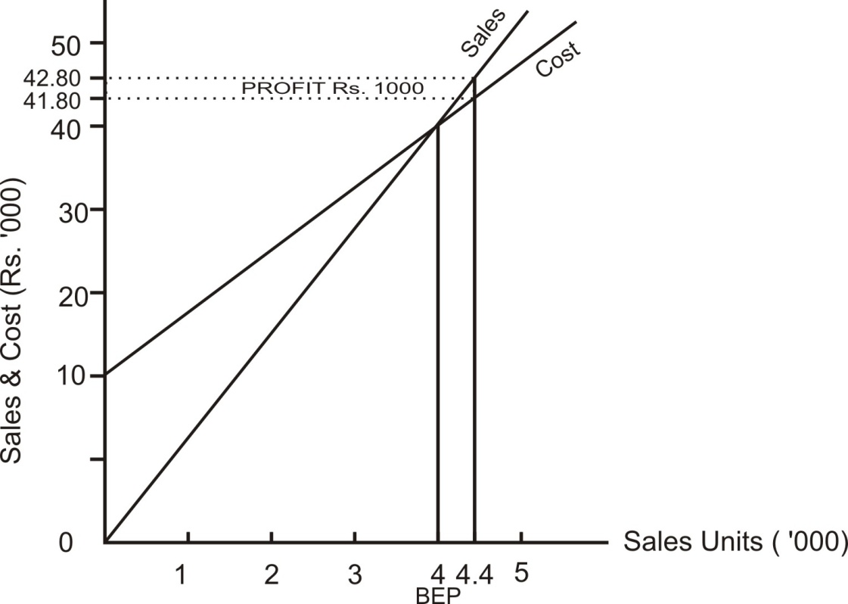

Q. No. 1.38
The following figures relate to a company: | Rs.
Annual sales at 100% effective capacity | 1200000
Fixed Overhead | 400000
Total variable cots | 600000

It is proposed to increase the capacity by the acquisition of 30 per cent additional space and plant. It was result in increase of fixed overheads by Rs. 1,00,000 per annum. Plot the forgoing on a single breakeven chart and determine from the chart at what level of sales the same profit as before will be produced after the extensions have been made.

Teaching Note: B.E. chart (when units are not given). On X-axis, we take sales amount (this axis will always represent sales amount). On Y-axis, we take the amounts of sales and cost (To draw sales line, Y-axis represents sales. To draw cost line Y-axis represents cost). Before drawing the chart, we should prepare a table showing sales, VC, FC and total cost at any two levels. (For a good chart, one of these levels may be zero sales level and other be level beyond BEP)

Answer
Original Scenario
Total Sale | VC | FC | Profit /Loss
0 | 0 | 4,00,000 | Loss 4,00,000
12,00,000 | 6,00,000 | 4,00,000 | Profit Rs.2,00,000

Revised Scenario
Total Sale | VC | FC | Profit /Loss
0 | 0 | 5,00,000 | Loss 5,00,000
12,00,000 | 6,00,000 | 5,00,000 | Profit Rs.1,00,000

Notes: (i) The cost lines shall be parallel to each other as the cost has gone up by Rs.1,00,000 at all levels. (ii) Profit is the difference between sales and cost. Hence, for profit we will take that scale which is applicable to sales as well cost. Y axis is applicable to sales as well cost. Hence this scale will be taken for profit as well.
Even after expansion, the company shall be earnings same amount of profit as before expansion (i.e. Rs.2,00,000) when its sales will be Rs.14,00,000

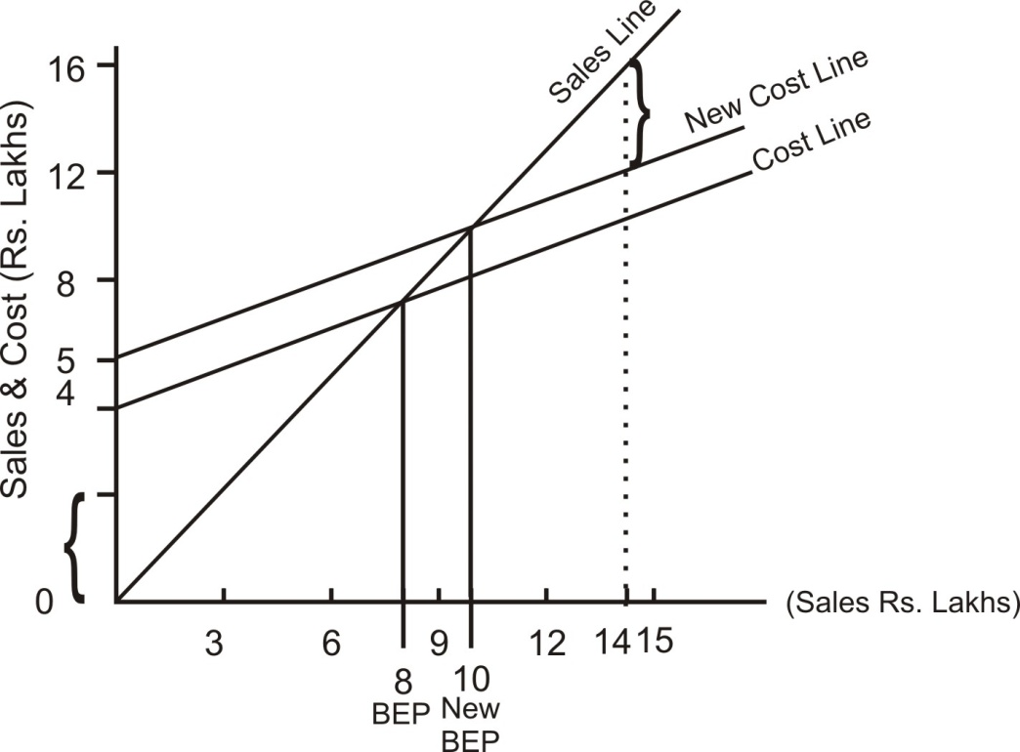

1.6-1 ANGLE OF INCIDENCE
A Breakeven chart exhibits two lines (i) Total sales line and (ii) total cost line. The angle formed at the intersection point of these two lines is referred as the angle of incidence. It is an indicator of profitability of margin of safety. This angle is an indicator of Profit volume ratio.
Situation | Profitability i.e. Profit/margin of safety
Large angle indicates high PV ratio | Higher
Small angle indicates small PV ratio | Lower

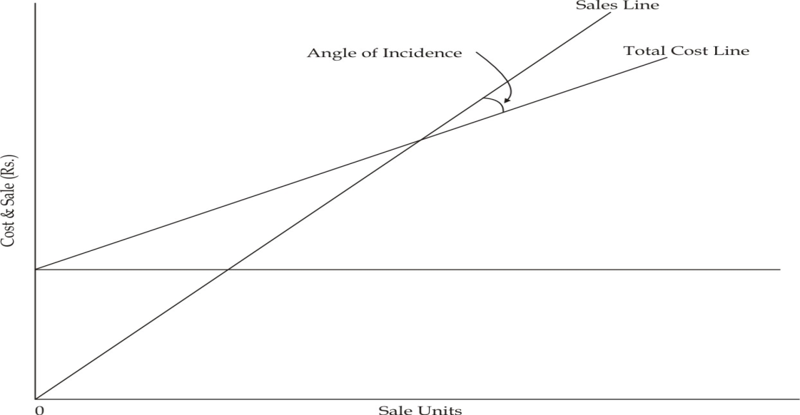

1.7 PROFIT VOLUME CHARTS
Q. No. 1.39 Draw profit volume chart.
 | Sales (Rs.Lakhs) | Profit (Rs.Lakhs)
Year-1 | 160 | 4
Year-2 | 175 | 10

Teaching Note : A P/V chart exhibits profit/ loss at various sales levels. On X-axis, we take sales. On Y-axis, we take profit / loss.

Sales | Contribution
160L | FC + 4L
175L | FC + 10 L
6L
PV ratio = -------------------- = 0.40
15L
Sales | 160L
VC (60% of Sales) | 96L
Contribution | 64L
Profit | 4L
FC | 60L

For PV chart, we should prepare a table showing sales and the corresponding profit /loss at any two levels. (For a good chart, one of these levels may be zero sales level and other may be the sales level above BEP)
Let’s take sales at zero level and Rs.200L level.
Sales | Contribution | FC | Profit /Loss
0 | 0 | 60L | Loss 60L
200L | 80L | 60L | Profit 20L

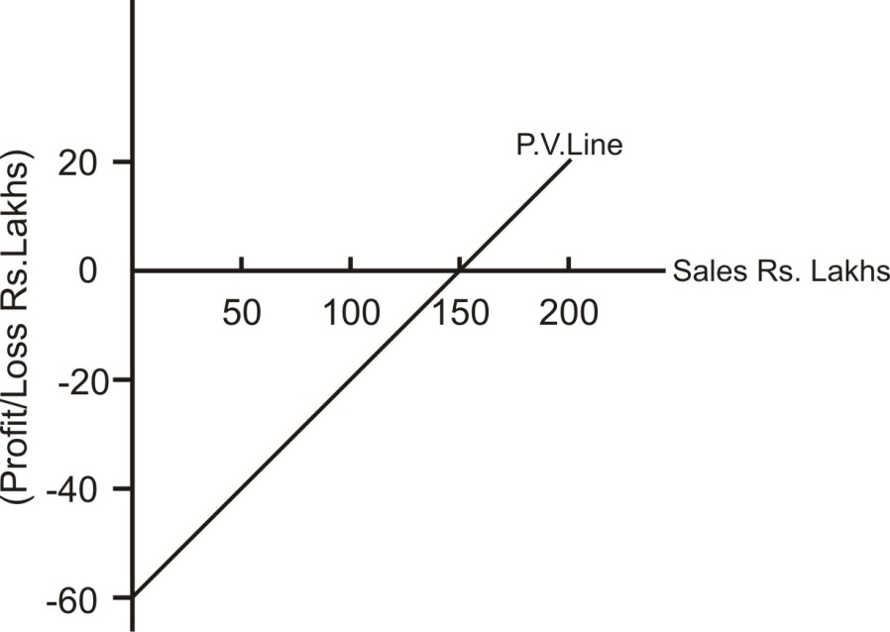

Q.No.1.40
From the following figures relating to manufacturing company, prepare a profit volume-graph. Total fixed cost is Rs. 25,000.
Product | Annual sales(Rs.) | Variable Costs (Rs.)
A | 40,000 | 20,000
B | 25,000 | 15,000
C | 35,000 | 30,000
 | 1,00,000 | 65,000
Teaching Note: While drawing P.V. chart of a multiple-products firm, we should draw one more line called PROFIT PATH (In addition to P.V. Line). Before drawing profit path, we calculate P.V. ratios of various products; first we plot the profit/ loss of the product with highest P.V. ratio, then that of second highest P.V. ratio and so on.

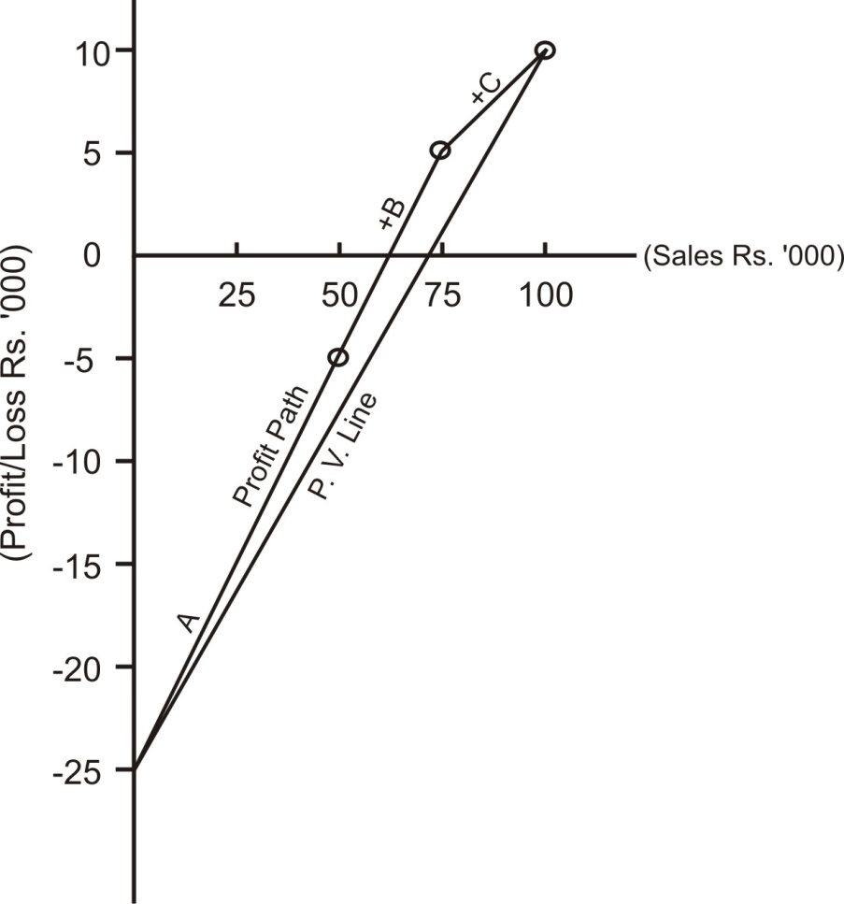

THEORETICAL QUESTIONS
Q.No.1.1T State the assumptions of cost-volume-profit analysis. (CA Final May 2003)
Answer : Please refer to paragraph 1.1-1.

Q.No.1.2T What is Margin of safety? How, margin of safety can be improved?
(CA Final Nov. 2009)
Answer : Please refer to paragraph 1.1-2.

Q.No.1.3T Two companies, H and L, have the same values for turnover and net profit and make a similar product. H has a higher P/V ratio than L. Which company will perform better when (i) the market demand is high? (ii) the market demand is low.
(CA Final Nov. 2011)
Answer : “Same values for turnover and net profit” – This clause suggests that H has lower variable costs and higher fixed costs; in case of L variable cost is higher and Fixed cost is lower.
H : Higher PV ratio : Perform better when the demand is high
L : Lower PV ratio : Perform better when the demand is low

Q.No.1.4T Draw and explain the angle of incidence in break-even chart. What is its significance to the management? (CA Final May 2008)
Answer: Please refer to paragraph 1.6-1.

