REVERSE CHARGE MECHANISM
List of Services under RCM
S.  No. | Description of Services | Provided By | Provided To | % of ST payable by Provider | % of ST payable by Receiver
1 | Insurance Auxiliary Service | Insurance Agent | Person carrying on Insurance business | NIL | 100%
2 | Sponsorship Service | By any service provider | Body Corporate or Partnership firm | NIL | 100%
3 | Transport of goods by Road | Good Transport Agency | Consignor or consignee in organized sector | NIL | 100%
4 | Legal Service | Arbitral Tribunal | Business Entity | NIL | 100%
5 | Legal Service | Individual advocate or firm of advocates | Business Entity | NIL | 100%
6 | Support Service by  Government or  localauthority | Government  or Local  Authority | Business  Entity | NIL | 100%
7 | Any Service | Person in Non Taxable territory | Person in Taxable Territory | NIL | 100%
8 | Any Taxable  Service | Director of  the company | Company | NIL | 100%
9 | Renting or hiring of motor vehicle to carry passenger on abated value. (60%abatement)* | Individual, HUF, Firm, AOP, BOI | Business Entity registered as body corporate | NIL | 100% (i.e. 40% of liability)
10 | Renting or hiring of motor vehicle to carry passenger on non abated value* | Individual, HUF, Firm, AOP, BOI | Business Entity registered as body corporate | 60% | 40%
11 | Supply of Manpower** | Individual, HUF, Firm, AOP, BOI | Business Entity registered as body corporate | 25% | 75%
12 | Security Service | Individual, HUF, Firm, AOP, BOI | Business Entity registered as body corporate | 25% | 75%
13 | Work Contract  Service | Individual, HUF, Firm, AOP, BOI | Business Entity registered as body corporate | 50% | 50%

* If motor vehicle is taken on hire without driver it is ‘transfer of right in goods’. It is deemed sale of goods VAT will apply – Service Tax will not be charged.
**Service tax in such cases shall be payable on – SALARY + PF + ESI + Commission of labour contractor.

Notes:
- No SSI Exemption to service receiver.
- Explanation to Rule 3(4) of CENVAT Credit Rule - Service Receiver cannot use the CENVAT credit to dispose off his liability. He is required to pay the amount in cash only.
- The service provider is required to charge only that on the invoice for which he is liable to pay. For e.g. If the service providers liability is of 25% and the remaining liability is of service receiver. Then the service provider is required to charge only 25% of the service tax amount in the invoice.
- Rule 7 of Point of Taxation Rule,2011- where the service tax is payable by the recipient of service like GTA service, POT would be the date of payment of value of service, if made within 6 months from the date of invoice. In case, value of service is not paid within prescribed 6 months period, service tax would become payable as per rule 3 of POT rule.
- Utilization of CENVAT credit by Service Receiver:-
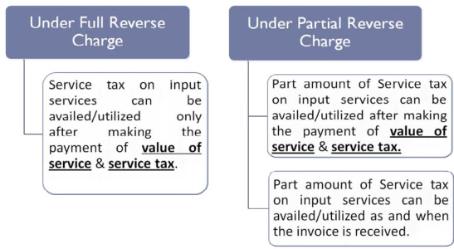
- No RCM if service provider is business entity.

