IMPORTANT AMENEDMENDS IN ISCA
Five Principles of COBIT
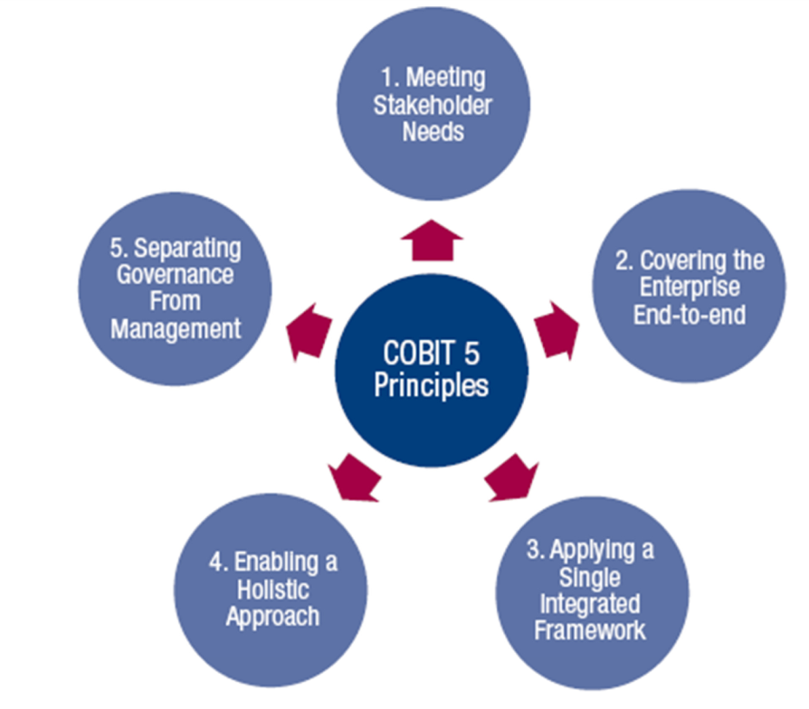
Principle 1 Meeting Stakeholder Needs
- Enterprises exist to create value for their stakeholders by maintaining a balance between the realization of benefits and the optimization of risk and use of resources.
- COBIT 5 provides all of the required processes and other enablers to support business value creation through the use of IT. Because every enterprise has different objectives, an enterprise can customize COBIT 5 to suit its own context through the goals cascade, translating high-level enterprise goals into manageable, specific, IT-related goals and mapping these to specific processes and practices.
Principle 2: Covering the Enterprise End-to-End

- COBIT 5 integrates governance of enterprise IT into enterprise governance. It covers all functions and processes within the enterprise.
- It considers all IT-related governance and management enablers to be enterprise-wide and end-to-end, i.e., inclusive of everything and everyone—internal and external—that is relevant to governance and management of enterprise information and related IT.

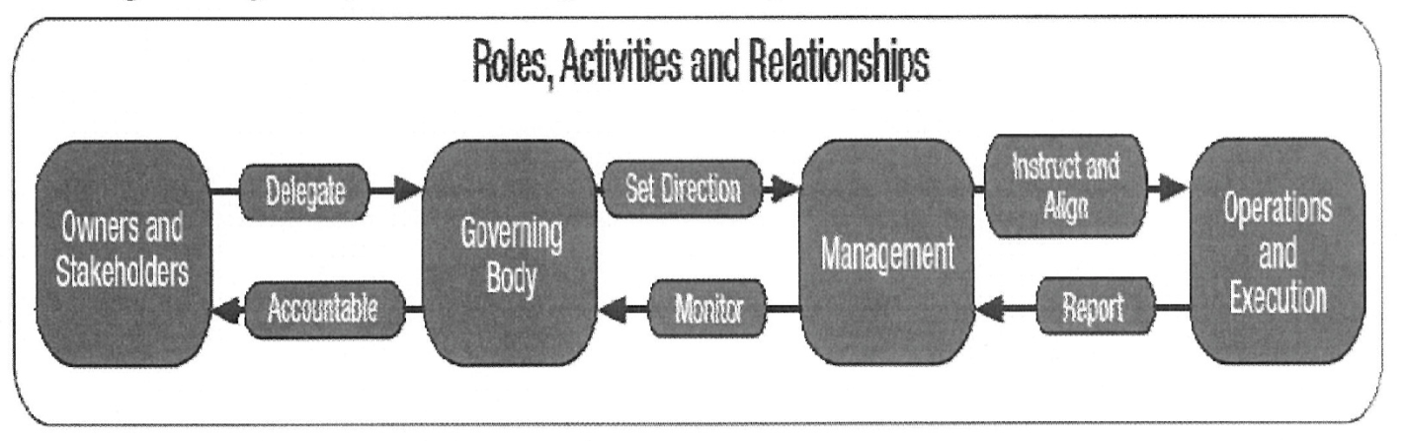

Principle 3: Applying a Single Integrated Framework

- COBIT 5 is a single and integrated framework as it aligns with other latest relevant standards and frameworks, and thus, allows the enterprise to use COBIT 5 as the overarching governance and management framework integrator.
- It is complete in enterprise coverage, providing a basis to integrate effectively other frameworks, standards and practices used.

Principle 4: Enabling a Holistic Approach

- COBIT 5 defines a set of enablers to support the implementation of a comprehensive governance and management system for enterprise IT.
- Enablers are broadly defined as anything that can help achieve the objectives of the enterprise.

Principle 5: Separating Governance from Management

- The COBIT 5 framework makes a clear distinction between governance and management.
- Governance: ensures that stakeholder needs, conditions and options are evaluated to determine balanced, agreed-on enterprise objectives to be achieved; setting direction through prioritization and decision making; and monitoring performance and compliance against agreed-on direction and objectives.
- Management: plans, builds, runs and monitors activities in alignment with the direction set by the governance body to achieve the enterprise objectives.
- From the definitions of governance and management, it is clear that they comprise different types of activities, with different responsibilities; however, given the role of governance—to evaluate, direct and monitor—a set of interactions is required between governance and management to result in an efficient and effective governance system.

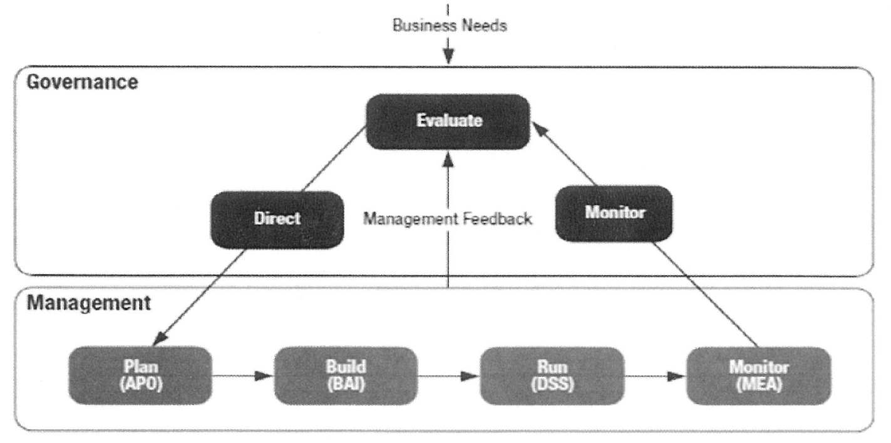

- COBIT Enablers
- Enablers are factors that, individually and collectively, influence whether something will work — in this case, governance and management over enterprise IT.
- The COBIT 5 framework describes seven categories of enablers

1. Principles, policies and frameworks are the vehicle to translate the desired behavior into practical guidance for day-to-day management.

2. Processes describe an organized set of practices and activities to achieve certain objectives and produce a set of outputs in support of achieving overall IT-related goals.

3. Organizational structures are the key decision-making entities in an enterprise.

4. Culture, ethics and behavior of individuals and of the enterprise are very often underestimated as a success factor in governance and management activities.

5. Information is pervasive throughout any organization and includes all information produced and used by the enterprise. Information is required for keeping the organization running and well governed, but at the operational level, information is very often the key product of the enterprise itself.

6. Services, infrastructure and applications include the infrastructure, technology and applications that provide the enterprise with information technology processing and services.

7. People, skills and competencies are linked to people and are required for successful completion of all activities and for making correct decisions and taking corrective actions.

Details of ITIL Framework
- Service Strategy
* Service Strategy deals with the strategic management approach in respect of IT Service Management; strategic analysis, planning, positioning, and implementation relating to service models, strategies, and strategic objectives.
* It provides guidance on leveraging service management capabilities to effectively deliver value to customers and illustrate value for service providers.
* It provides guidance on the principles underpinning the practice of service management to aid the development of service management policies, guidelines, and processes across the ITIL Service Lifecycle.

- Service Design
* Service Design translates strategic plans and objectives and creates the designs and specifications for execution through service transition and operations.
* It provides guidance on combining infrastructure, applications, systems, and processes, along with suppliers and partners, to present feasible service offerings.
* The Service Design volume provides guidance on the design and development of services and service management processes. It includes design principles and methods for converting strategic objectives into portfolios of services and service assets.
- Service Transition
* Service Transition provides guidance on the service design and implementation, ensuring that the service delivers the intended strategy and that it can be operated and maintained effectively.
* The Service Transition volume provides guidance on the development and improvement of capabilities for transitioning new and changed services into operations.
* Guidance is provided on how the requirements of Service Strategy encoded in Service Design are effectively realized in Service Operation, whilst controlling the risks of failure and disruption.
* Service Transition provides guidance on managing the complexity of changes to services and service management processes to prevent undesired consequences whilst permitting for innovation.

- Service operation
* Service Operatio+n provides guidance on the management of a service through its day-to-day production life.
* It also provides guidance on supporting operations by means of new models and architectures such as shared services, utility computing, web services, and mobile commerce.
* This volume presents practices in the management of service operations and includes guidance on achieving efficiency and effectiveness in the delivery and support of services to ensure value for the customer and the service provider.
* Service Operation provides detailed guidelines on processes, methods, and tools in addressing the proactive and reactive control perspectives. Managers and practitioners are provided with knowledge; enabling them to make better informed decisions.

- Continual Service Improvement
*Continual Service Improvement provides guidance on the measurement of service performance through the service life-cycle, suggesting improvements to ensure that a service delivers the maximum benefit.
* This volume provides guidance on creating and maintaining value for customers through improved design, introduction, and operation of services.
* It combines principles, practices, and methods from change management, quality management, and capability improvement to achieve incremental and significant improvements in service quality, operational efficiency, and business continuity.

