KEY POINTS ON NATIONAL SEMINAR ON INTERNATIONAL FINANCIAL REPORTING STANDARD
(Conducted by Institute of Chartered Accountants of India & Shivaji University at Kolhapur)

In present era of globalization Indian accounting are mainly divided in two parts:
- INDIAN GAAP :
Indian GAAP presently follows all accounting standards issued by the ICAI (Institute of Chartered Accountants of India), it comprising of total 32 accounting standards and interpretations. Compliance of AS is compulsory for every organization.

- IFRS
With the growth of Indian economy & increasing integration with the global economies, Indian corporate is raising capital globally. Under the circumstances it would be imperative for Indian corporate to adopt IFRS for their financial reporting. Presently Indian companies which listed on global stock exchanges are following IFRS for their financial reporting.
IFRS Composition
29 (IAS) + 11 (SIC) + 8 (IFRS) + 16 (IFRIC) = 64 IFRS
IAS stands for International Accounting standard issued before April 2001
IFRS stands for International financial reporting standards issued after April 2001
SIC & IFRIC are stands for Interpretations on IAS & IFRS respectively
Some of the divergences between Indian GAAP and IFRS are summarized as under:
- Special Purpose Entities (SPE) falling under the definition of ‘control’ as per IAS 27 on “Consolidated and Separate Financial Statements” shall be consolidated

- Potential Voting Rights’ that are currently exercisable or convertible shall be considered to assess the Existence of control

- All business combinations shall be accounted as per purchase method at fair values.

- Contingent liabilities, taken over in a business combination, shall be included in net Assets, measured at fair value, if contingencies have since been resolved, a reliable estimate can be made and payment is probable.

- Negative goodwill arising on business combination/ consolidation shall be accounted as income instead of capital reserve.

- Goodwill shall not be amortized. It shall only be tested for impairment.
- PP&E and Intangible assets shall be measured either at cost or at revalued amount. Periodical valuation of entire classes’ of assets is required when revaluation option is chosen.

- Intangible assets can be revalued only when there is an active market for the same.

- Depreciation on revalued portion cannot recoup out of revaluation reserve.

- Depreciation to be calculated based on useful life, which along with residual value and depreciation method shall be reviewed annually.

- Intangible assets may have an indefinite life e.g. Trademarks, Goodwill, Franchise.

- Investment Properties. Land or building held to earn rentals or for capital appreciation, shall be measured either at cost or fair values.

- If fair value model is adopted changes in fair value measured annually, shall be recognized in the income statement.

- No distinction shall be made between integral and non –integral foreign operations. All foreign operations to be consolidated using non-integral approach.

- Exchanges differences shall not be capitalized except to the extent of that allowed by IAS 23 Borrowing Costs.

- Share Based Payments shall be measured at fair value.

- Deferred Tax shall be created on temporary difference instead of timing difference.

- Liability portion of compound financial instruments, such as convertible debentures, shall be separately accounted for.

- Financial assets and Liabilities shall be classified and measured accordingly as per the requirements of IAS 39 Financial Instruments: Recognition and Measurement.

- All derivative financial assets and liabilities including embedded derivatives shall be accounted for as on the balance sheet items.

- Derivatives classified as ‘hedge’ shall have to comply with various requirements of IAS 39 viz. documentation. Hedge effective testing and ineffectiveness measurement.

- De-recognition of financial assets, as in the case of securitization, shall be based on risks and reward, transfer of ‘control’ being a secondary test.

- Provision shall be created only to the extent they relate to a specified risk that can be measured reliable and for incurred losses. No provisions are permitted for future or expected losses i.e. general provisions.
Current Perspective in India:
The accounting standards board (ASB) of ICAI formulates accounting standards based on IFRS keeping in view the local conditions including legal & economic environment, which have recently notified by central government. New Indian IFRS is renamed as IND-AS.
Now Indian accounting standards are getting converted into IND-AS (Convergence with IFRS)
Here convergence means to achieve harmony with IFRS. Convergence doesn’t mean that IFRS adopted word by word (as it did by Pakistan & Lanka)
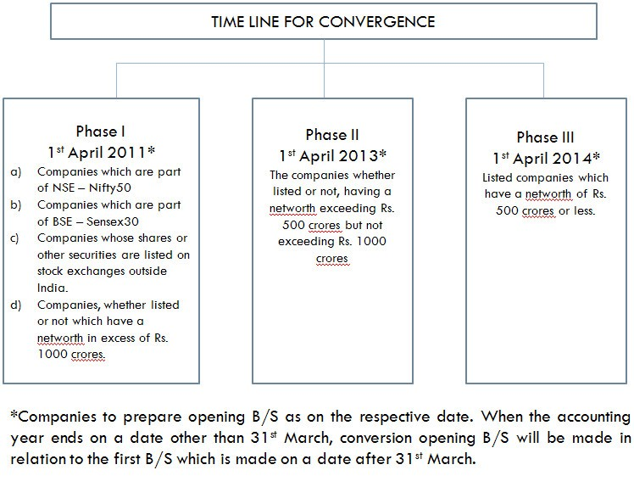

Consistent financial reporting basis:
A consistent financial reporting basis would allow a multinational company like us to apply common accounting standards with its Holding / Subsidiaries worldwide, which would improve internal communications, quality of reporting and group decision making.

On the basis of this examination, the ICAI has classified various IFRSs into the following five categories:
Category I - IFRSs which do not involve any legal or regulatory issues nor have any issues with regard to their suitability in the existing economic environment, preparedness of industry and any conceptual differences from the Indian Accounting Standards. This category has further been classified into two parts as follows:
Category IA - IFRSs which can be adopted immediately as these do not have any differences with the corresponding Indian Accounting Standards. The following IFRSs have been identified in this category:
- IAS 11, Construction Contracts
- IAS 23, Borrowing Costs
Category I B - IFRSs which can be adopted in near future as there are certain minor differences with the corresponding Indian Accounting Standards. The following IFRSs have been identified in this category:
- IAS 2 Inventories
- IAS 7,Cash Flow Statements
- IAS 20, Accounting for Government Grants and Disclosure of Government Assistance
- IAS 33, Earnings Per Share
- IAS 36, Impairment of Assets
- IAS 38, Intangible Assets
Category II - IFRSs which may require some time to reach a level of technical preparedness by the industry and professionals keeping in view the existing economic environment and other factors. This category also includes those IFRSs corresponding to which Indian Accounting Standards are under preparation/revision. The following IFRSs have been identified in this category:
- IAS 18, Revenue
- IAS 21,The Effects of Changes in Foreign Exchange Rates
- IAS 26, Accounting and Reporting by Retirement Benefit Plans
- IAS 40, Investment Property (Corresponding Indian Accounting Standard is under preparation)
- IFRS 2, Share-based Payment (Corresponding Indian Accounting Standard is under preparation)
- IFRS 5, Non-current Assets Held for Sale and Discontinued Operations (Corresponding Indian Accounting Standard is under preparation)
Category III - IFRSs which have conceptual differences with the corresponding Indian Accounting Standards. This category has further been divided into two parts as follows:
Category III A - IFRSs having conceptual differences with the corresponding Indian Accounting Standards that should be taken up with the IASB. The following IFRSs have been identified in this Category:
- IAS 17,Leases
- IAS 19, Employee Benefits
- IAS 27,Consolidated and Separate Financial Statements
- IAS 28, Investments in Associates
- IAS 31, Interests in Joint Ventures
- IAS 37, Provisions, Contingent Liabilities and Contingent Assets
Category III B - IFRSs having conceptual differences with the corresponding Indian Accounting Standards that need to be examined to determine whether these should be taken up with the IASB or should be removed by the ICAI itself. The following IFRSs have been identified in this Category:
- IAS 12, Income Taxes
- IAS 24, Related Party Disclosures
- IAS 41, Agriculture (Corresponding Indian Accounting Standard is under preparation)
- IFRS 3, Business Combinations
- IFRS 6, Exploration for and Evaluation of Mineral Resources
- IFRS 8, Operating Segments
Category IV - IFRSs, the adoption of which would require changes in laws/regulations because compliance with such IFRSs is not possible until the regulations/laws are amended. The following IFRSs have been identified in this Category:
- IAS 1, Presentation of Financial Statements
- IAS 8, Accounting Policies, Changes in Accounting Estimates and Errors
- IAS 10, Events After the Balance Sheet Date
- IAS 16, Property, Plant and Equipment
- IAS 32, Financial Instruments: Presentation (Exposure Draft of the Corresponding Indian Accounting Standard has been issued)
- IAS 34, Interim Financial Reporting
- IAS 39, Financial Instruments: Recognition and Measurement (Exposure Draft of the Corresponding Indian Accounting Standard has been issued)
- IFRS 1, First-time Adoption of International Financial Reporting Standards
- IFRS 4, Insurance Contracts
- IFRS 7, Financial Instruments: Disclosures
Category V - IFRSs corresponding to which no Indian Accounting Standard is required for the time being. However, the relevant IFRSs, when adopted upon full convergence, can be used as the “fallback” option where needed.
- IAS 29, Financial Reporting in Hyper-inflationary Economies

MODIFICATIONS TO SCHEDULE VI TO THE COMPANIES ACT, 1956 (Applicable for 1.04.2011 – 31.03.2012)
The Revised Schedule VI is however a step towards convergence to IFRS to some extent with regard to presentation of financial statements, as many features has been adopted from these international standards. But it is important to note that the notification for Revised Schedule VI contains reference to the existing Accounting Standards not converged IND-IFRS.
Following are the changes in the Balance Sheet format:
Items on the Liability Side: | Items on the Asset Side:
I. EQUITY AND LIABILITIES  (1) Shareholder’s fund  a. Share Capital  b. Reserves and Surplus  c. Money received against share warrants  (2) Share Application Money pending Allotment  (3) Non Current Liabilities  a. Long Term Borrowings  b. Deferred Tax Liabilities (Net)  c. Other Long Term Liabilities  d. Long Term Provisions  (4) Current Liabilities  a. Short Term Borrowings  b. Trade Payables  c. Other Current Liabilities  d. Short Term Provisions | II. ASSETS  Noncurrent Assets  (1) (a) Fixed Assets  (i) Tangible Assets  (ii)Intangible Assets  (iii)Capital Work in Progress  (iv)Intangible Assets under Development  (b) Non‐Current Investments  (c) Deferred Tax Assets (Net)  (d) Long Term loans and advances  (e) Other non‐current assets  (2) Current Assets  (a) Current Investments  (b) Inventories  (c) Trade Receivables  (d) Cash and Cash equivalents  (e) Short term loans and advances  (f) Other Current Assets

Changes in the format of the Profit and Loss Account
Revenue
- Revenue from operations
- Other income
Total Revenue (I + II)

Expenses:
- Cost of materials consumed
- Purchases of Stock-in-Trade
- Changes in inventories of finished goods work-in-progress and Stock-in-Trade
- Employee benefits expense
- Finance costs
- Depreciation and amortization expense
- Other expenses
Total expenses
Profit before exceptional and extraordinary items and tax (III-IV)
Exceptional items
Profit before extraordinary items and tax (V - VI)
Extraordinary Items
Profit before tax (VII- VIII)
Tax expense:
- Current tax
- Deferred tax
Profit (Loss) for the period from continuing operations (VII-VIII)
Profit/(loss) from discontinuing operations
Tax expense of discontinuing operations
Profit/(loss) from Discontinuing operations (after tax) (XII-XIII)
Profit (Loss) for the period (XI + XIV)
Earnings per equity share:
- Basic
- Diluted

