ARTICLE ON OFFSHORE BANK ACCOUNT
By CS PANKAJ KHANNA

OFFSHORE BANK ACCOUNT
Having an offshore bank account conjures up many images in people's minds. Anything criminal or black money. Almost everyone links offshore bank account in a negative way but not always it is such. "Offshore" means a place other than your place of residence. In other words, doing "business" somewhere else.

Choosing the type of account you can maintain foreign (local) currency accounts in banks outside India. Under the Liberalized Remittance Scheme (LRS), you can make remittances up to $2,00,000 (Rs 90 lakh) every financial year for current or capital account transactions. There are no restrictions on the types of bank accounts that can be opened, so, depending on your requirement and interest rates applicable, you can choose to open a savings account, checking or current account, term deposit, etc.
Offshore banking allows international entrepreneurs and global organizations to conduct financial transactions through a bank account outside their country of residence or incorporation. An offshore bank is any bank that is outside a person's place of residence, or companies place of incorporation. Healy Consultants offshore banking services include setting up offshore bank accounts and developing effective offshore banking strategies. Offshore banking includes full set of financial services:
- Deposit taking;
- Credit;
- wire- and electronic funds transfers;
- Foreign exchange;
- Letters of credit and trade finance;
- Investment management and investment custody;
- Fund management;
- Trustee services;

Offshore Company Formation
If properly structured, offshore company formation is an ideal, tax-efficient strategy for entrepreneurs to conduct international business. In our opinion, the ideal offshore jurisdictions for international entrepreneurs include Singapore, Hong Kong, Ireland, New Zealand and Dubai (see our Top Four jurisdictions page). These jurisdictions boast i) excellent international reputations ii) have investor-friendly business environments and iii) are economically and politically stable. The following information will help you determine whether registering an offshore company is the optimum solution to fulfill your international business objectives.
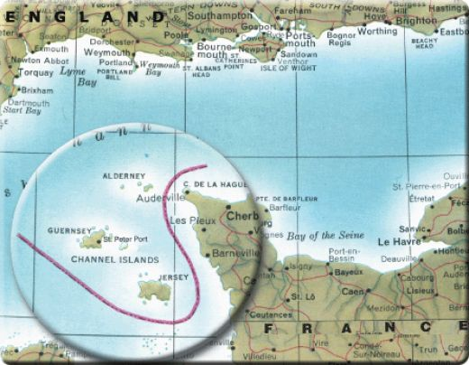

Advantages of Offshore Company Formation

1. Offshore company formation procedures are usually less complex than those in traditional trading jurisdictions. For example, some offshore markets require only limited information on shareholders, directors and beneficial owners. As a result, setting up an offshore company is quick and cost-effective.
2. Offshore company incorporation is popular with entrepreneurs for a range of purposes, including i) setting up an import-export company, ii) establishing an international trading company, iii) as an asset holding company and iv) to hold property investments or intellectual property.
3. Entrepreneurs choosing company formation offshore in a jurisdiction such as Singapore and Hong Kong portray a positive, reputable image to customers, suppliers, investors and banks.
4. Clients who choose offshore incorporation are typically successful, independent contractors, consultants and traders. For example, offshore company registration is perfect for global commodity traders, IT consultants, and financial services consultants. For more information, visit our Reasons to set up an offshore company page.
5. If properly structured, offshore company incorporation is an excellent way to legitimately minimise international taxation. Offshore tax planning is a key offshore company registration service provided by Healy Consultants. For example, in Singapore, international profits are legally tax-exempt provided funds are not remitted to a Singapore corporate bank account.
6. To support company formation in an offshore jurisdiction, Healy Consultants provides offshore corporate services that include assisting clients with their international banking requirements. When opening corporate bank accounts, our firm works with internationally recognized banks such as HSBC, Standard Chartered Bank and Citibank. For more information, visit our offshore corporate bank accounts page.

Disadvantages of Offshore Company Formation

1. While offshore company formation is a legitimate way to minimize international tax, concealing information about offshore investments is illegal in the majority of countries.
2. If the incorrect offshore jurisdiction is chosen, the company can project a poor image to international customers, suppliers, investors and banks.
3. Traditional offshore jurisdictions are increasingly insecure. For example, many offshore jurisdictions are subject to pressure from the Organization for Economic Cooperation and Development (OECD) to exchange company and bank account details of foreign clients. The OECD seeks to minimize tax evasion, money laundering and terrorist financing. That said, Singapore and Hong Kong are two jurisdictions not carrying any tax haven stigma.

Legality of Offshore Banking

1. Offshore banking is a legal practice. It is not illegal for an individual, or a company, to set up Legality of Offshore Banking1.
2. The offshore banking banking industry is an important sector for the economies of many jurisdictions around the world and offshore bank accounts are a core service for numerous international financial institutions.

3. What is illegal is using an offshore bank account for criminal activity such as money laundering and evading the legislative obligations within your country of residence. Different countries have different requirements in terms of taxable income and information disclosure so offshore banking strategies need to meet these legal obligations.

Procedures for Setting up Offshore Bank Accounts

The procedures to open an offshore bank account vary depending on the jurisdiction and the financial institution. Generally the procedures are similar to opening a local bank account and may require steps such as i) proof of identification and residence, ii) bank account application forms, iii) reference for signatory, iv) account setup.

Offshore Banking Jurisdictions
There are a variety of options when choosing the best offshore banking jurisdiction. From popular small markets such as BVI and Panama to international financial hubs, choosing a market depends on the needs of the investor, or business. Using the services of a specialist such as Healy Consultants gives the benefits of i) effective strategy development and ii) efficient management of offshore bank account set up processes

Offshore financial centre’s include:
- Antigua and Barbuda
- Bahamas
- Barbados
- Belize
- Bermuda
- British Virgin Islands
- Cayman Islands
- Channel Islands (Jersey, Guernsey, Alderney, Sark and Herm)
- Cook Islands
- Cyprus
- Dominica
- Gibraltar is no longer an offshore centre since 30 June 2006. No new Exempt Company certificates are being issued from that date.^{[8][9]}
- Ghana
- Hong Kong
- Isle of Man
- Labuan, Malaysia
- Liechtenstein
- Luxembourg
- Malta
- Macau
- Mauritius
- Monaco
- Montserrat
- Nauru
- New Zealand
- Panama
- Saint Kitts and Nevis
- Seychelles
- Singapore
- Switzerland
- Turks and Caicos Islands
- Bank secrecy
- Corporate haven
- List of finance topics
- Private bank
- Banking in Switzerland
- Tax haven

Data taken from- From Wikipedia, the free encyclopedia
economictimes.indiatimes.com
healyconsultants.com
offshorebankingtoday.com

