

THE INSTITUTE OF
CHARTERED ACCOUNTANTS OF INDIA
“ICAI BHAWAN”
CHENNAI-600034

A PROJECT REPORT SUBMITTED BY

Naveen Kumar J M (REG NO: SRO0273351)
ROLL NO – A40
Submitted in partial fulfillment of the requirements for
INFORMATION TECHNOLOGY TRAINING
DEPARTMENT OF ITT
ICAI
CHENNAI

THE INSTITUTE OF
CHARTERED ACCOUNTANTS
OF INDIA
“ICAI BHAWAN”
CHENNAI 600034

DEPARTMENT OF INFORMATION TECHNOLOGY
TRAINING

BONAFIDE CERTIFICATE

This is to certify that the project work
Is carried out by

Naveen Kumar J M
(REG NO: SRO0273351)

This is to certify that the project work entitled is carried out by ………………………………under my supervision and guidance during the ITT COURSE.

ITT Dept
INDEX
- Acknowledgement
- System Requirement
- About ICAI
- About Project
- Tally Report
- All Voucher Entries
- Trail Balance – Detailed
- P/L Account - Detailed
- Balance Sheet – Normal, Detailed, Vertical
- Trial Balance - Quarterly
- Profit & Loss Account – Half yearly
- Balance sheet for different period
- Outstanding Report with Ageing Analysis
- Budget Variance report - Rent, Conveniences
- Bank Book Before and after Reconciliation
- Day Book from day 1 to last day
- Stock Summary report - LG 2 ton Split A/C
- Stock Movement Analysis – Samsung 3 ton Window A/C
- Stock Query report – Sony DVD Box R/W
- Stock Category report – 29 Inches Flat TV
- Godown Summary report – Stacking Godown
- VAT Annexure
- Service tax payable report
- Form 16A Report
- Cash flow & Fund flow Statement
- Cost Center Break-up Report
- Sales & Purchase Bill Pending
- List of Accounts, Stock Groups, Stock items report
- Conclusion
- Bibliography

Acknowledgement

At the outset, I would like to thank THE INSTITUTE OF CHARTERED ACCOUNTANTS OF INDIA for organizing this course, which served as a vibrant platform for learning the dynamic areas of computer relevant to us as a future Chartered Accountant.

I would also acknowledge my gratitude to faculty advisors their lectures and guidance Throughout the course and their valuable advices in our practical sessions Also, I would record my gratitude to my family, friends and Collogues for being with me during all my success and failures.

At the completion of my ITT project work in the partial fulfillment of the requirements to complete the course would like to thanks THE INSTITUTE OF CHARTERED ACCOUNTANTS OF INDIA for conducting this course and making it extremely convenient for the students to obtain knowledge for the very renowned institute. I would like to thank the southern India regional council of ICAI having this platform created for the students helping them gain new heights in the field of professionalism.
Thanking You
Naveen Kumar J M
Reg No:SRO0273351

System Requirement

- Hardware Requirement:

The minimum hardware requirements for using the latest version of Tally (that is Tally 9 ERP) are:

- Processor: Intel Pentium 4 and above or any other equivalent.

- Memory: 256 MB RAM (recommended 512MB RAM)

- Free Hard Disk Space: 40MB Minimum (excluding the data).
.

- Operating System:
The following operating systems of Microsoft support the project.

Microsoft Windows 98
Microsoft Windows ME
Microsoft Windows NT
Microsoft Windows 2000
Microsoft Windows 2003
Microsoft Windows XP
Windows VISTA
Windows 2007.etc

- Software Requirements:
Microsoft Word
Microsoft Access
Tally ERP 9

- Monitor:
In order to enjoy effective use of Tally ERP 9, a monitor having resolution of 1024 x 768 or higher is recommended.

About ICAI

The Institute of Chartered Accountants of India (ICAI) is a statutory body established under the Chartered Accountants Act, (Act No. XXVIII of 1949) for the regulation of the profession of Chartered Accountants in India. During its more than five decades of existence, ICAI has achieved recognition as a premier accounting body not only in the country but also globally, for its contribution in the fields of education, professional development, maintenance of high accounting, auditing and ethical standards. ICAI now is the second largest accounting body in the whole world.

ICAI has its Headquarters at New Delhi with 5 Regional Offices at Mumbai, Chennai, Kanpur, Kolkata, New Delhi and 114 branches spread all over the country. In addition, it has also set up 18 chapters outside India and an office in Dubai.

Currently over 350,000 students are pursuing the Chartered Accountancy course and the total membership of ICAI is about 139,841. Out of the total members, nearly 55% are in Practice and the rest are in employment among the members in government, industry, banks, financial institutions, private enterprises etc.

A significant number of members occupy eminent positions in their respective organizations such as Chairman of regulatory body, Chairperson of banks and insurance companies, Chairperson & Managing Directors of reputed enterprises, Executive Directors of innumerable enterprises / organizations.

About project

The given project on Tally has been done to show various applications of Tally as accounting software and its usage in the computerized environment.
The project herewith contains the details of the company named NAVEEN KUMAR J M LIMITED, indulged in trading of books and mainly the accounting package of the company is Tally and about how the records are been maintained. This company mainly includes the Trading of Electronic Items like TV A/c etc.

- Trial Balance:

This is a statement which shows the debit and credit balances of all the account grouping them into various heads as on the date requirement.

- Profit and Loss Account:

This shows the current period profit/ loss along with the subdivision of expenses and income under different groups of accounts. It gives the Gross Profit / Loss and the Net Profit / Loss. If enabled it has the feature if giving percentage of various items.

- Balance Sheet:

This is a Statement of Assets and Liabilities as on the date of requirement grouping the items into various heads

- Cash and Bank Books:

The cash and the bank books give a detailed look of all the receipts and payment during the year.

- Cash Flow and Funds Flow Statement:
Cash flow and Funds flow statement gives the gross inflow and outflow of the cash and various funds and the resultant net flows.
6. Stock Summary:
The inventory record maintenance shows the inflow and outflow of the raw materials, the transfer of the materials purchased to the production department and the sale of the finished goods .Every category of the raw material stock can be found here.
7. Bank Reconciliation:
Tally provides the user a facility to reconcile accounts with his bank statement and hence providing the user with information regarding transactions, which haven’t, been cleared as yet by the bank

Tally Report

TALLY 9 ERP is the world’s best concurrent multi-lingual business accounting and inventory management software. Tally has been designed specifically for Indian business owners, who have always wanted to maintain accounts in an Indian language of your choice. TALLY 9 ERP is so technologically advanced that it can operate in almost all Indian languages concurrently! That means, you can maintain accounts in any Indian language, view it in another and print it in yet another language of your choice.

TALLY 9 ERP empowers business owners to manage business smoothly. Designed keeping in mind the needs of the Indian businessman, it has several key additions in terms of functionalities.
You can send separate documents to suppliers, business associates, customers etc., in their language, while maintaining accounts in your language. In effect, you can conveniently transact business across the length and breadth of India.
Freedom from dependence on accounting professionals is yet another clear benefit that TALLY 9 ERP enables right from day one! You can let your accountant enter information in any Indian language that he is comfortable with and you can review it in your preferred language –at just the click of a button.
Backed by the heritage of incredible simplicity, TALLY 9 ERP takes one more significant step towards ensuring that concrete business advantages are realised from accounting on computers.

Following are the some report generated from the tally for ITT project report.

Purchase Entries with VAT

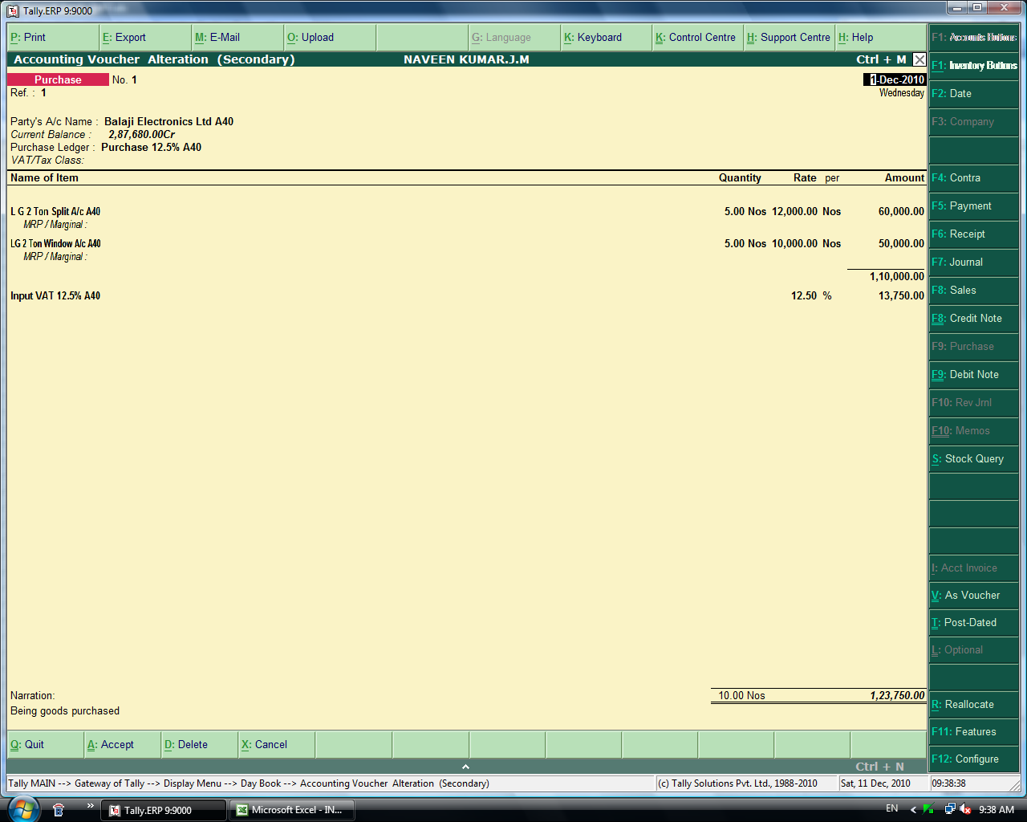

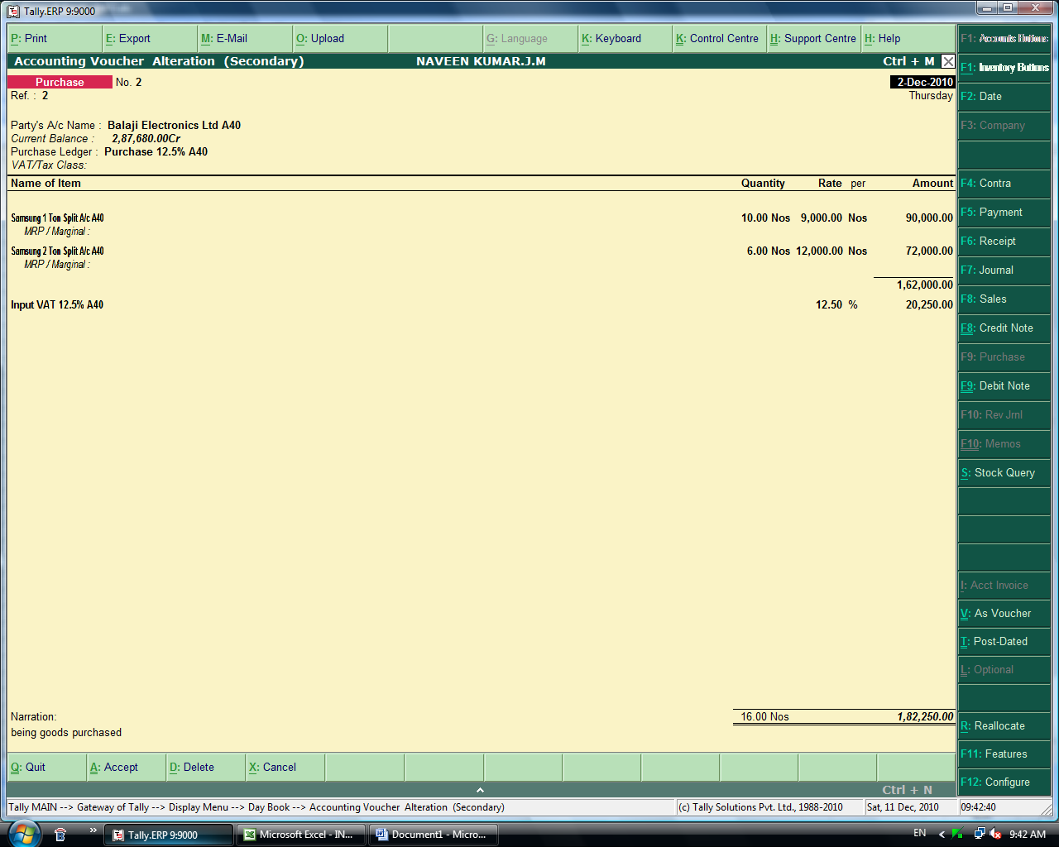

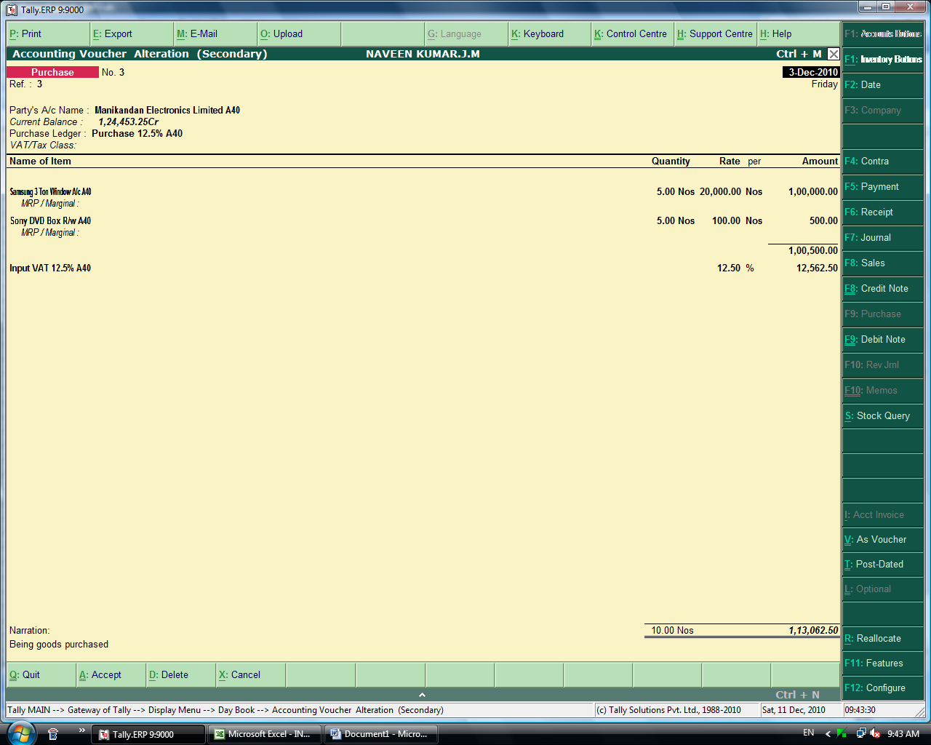

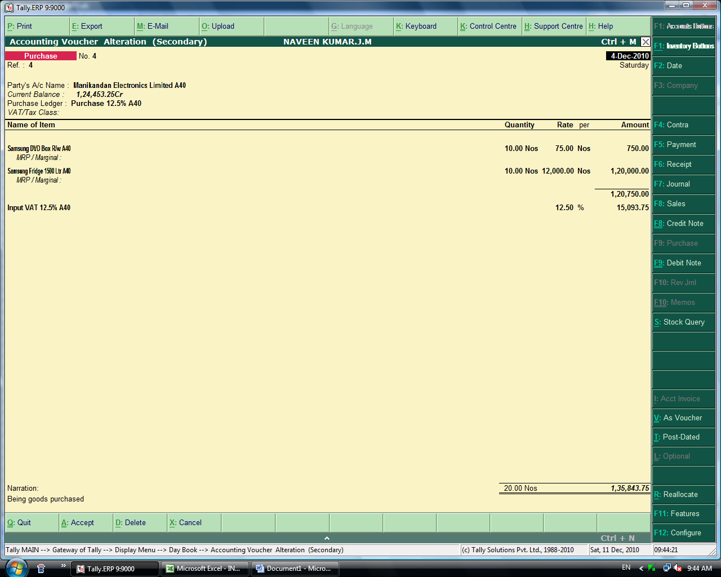

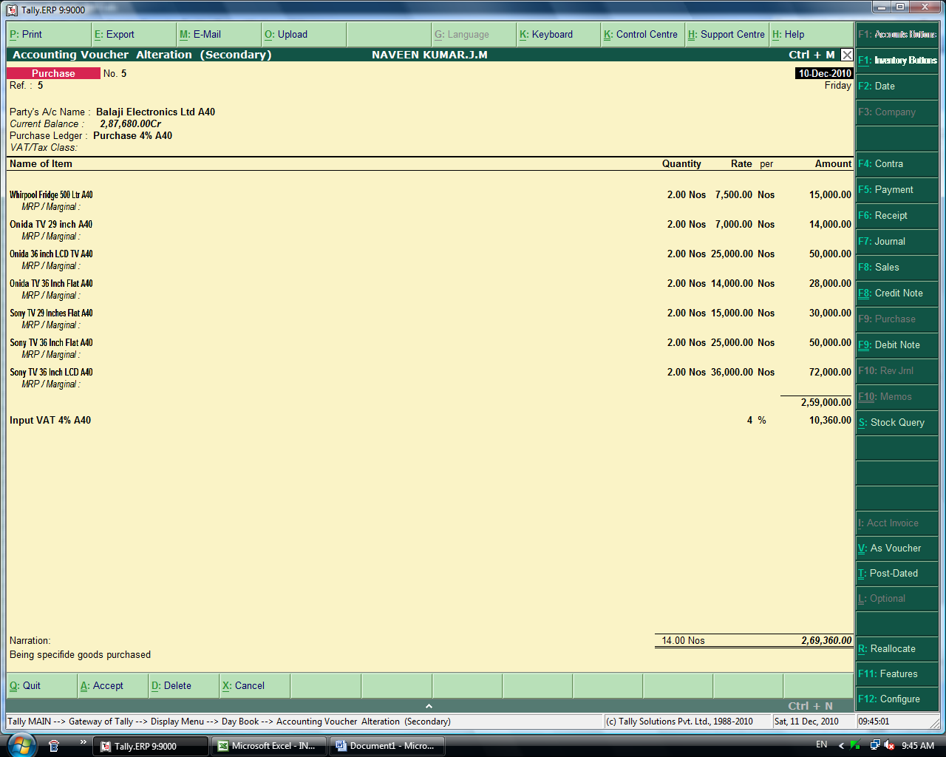

Sales Entries with VAT

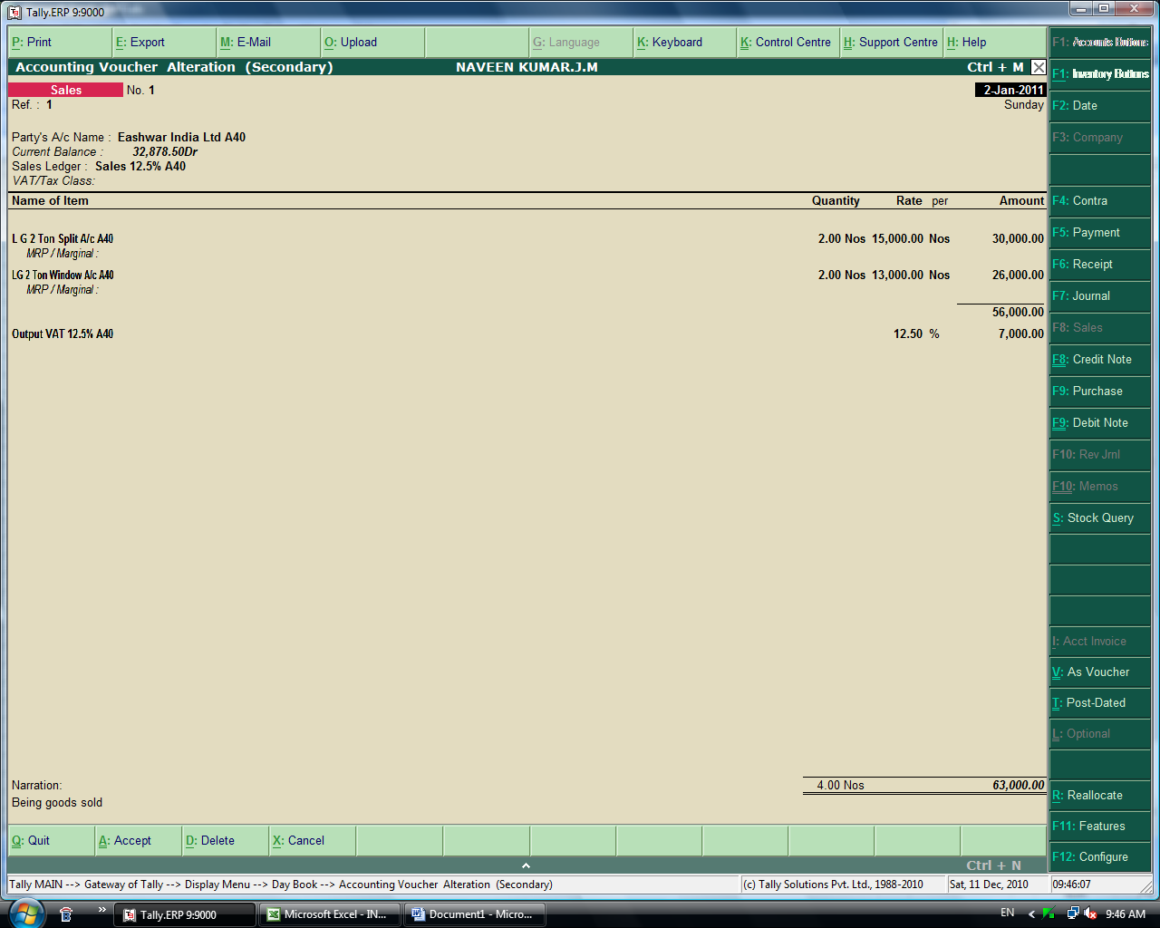

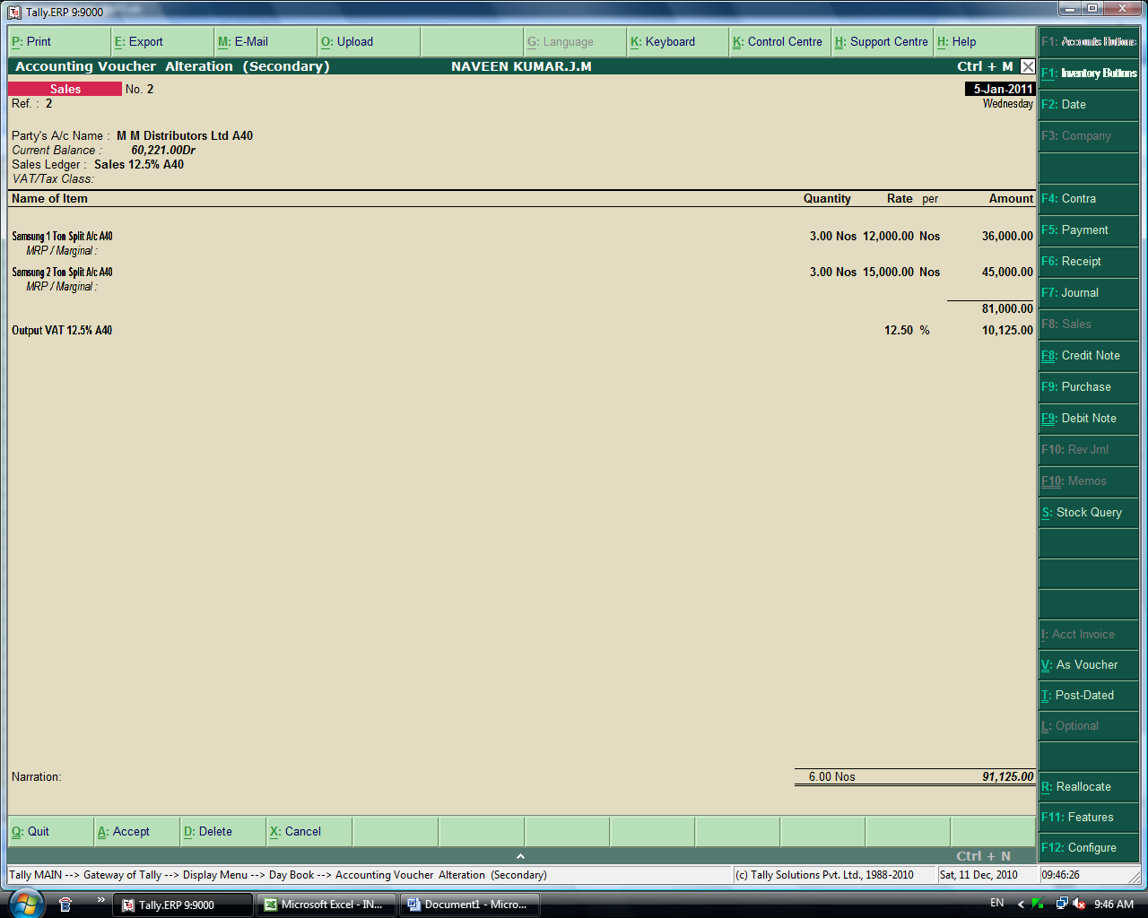

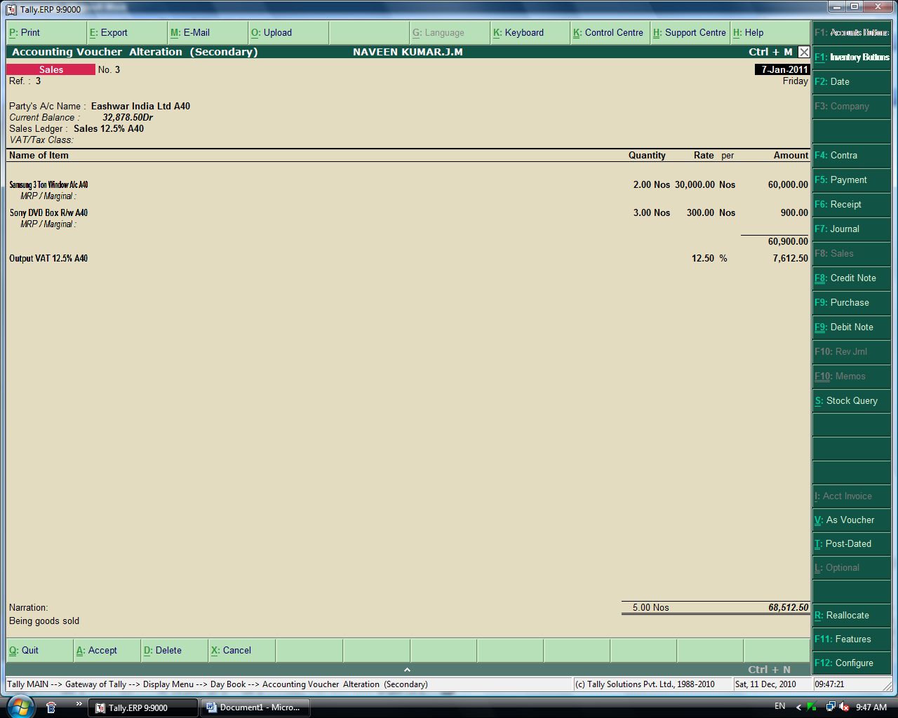

4
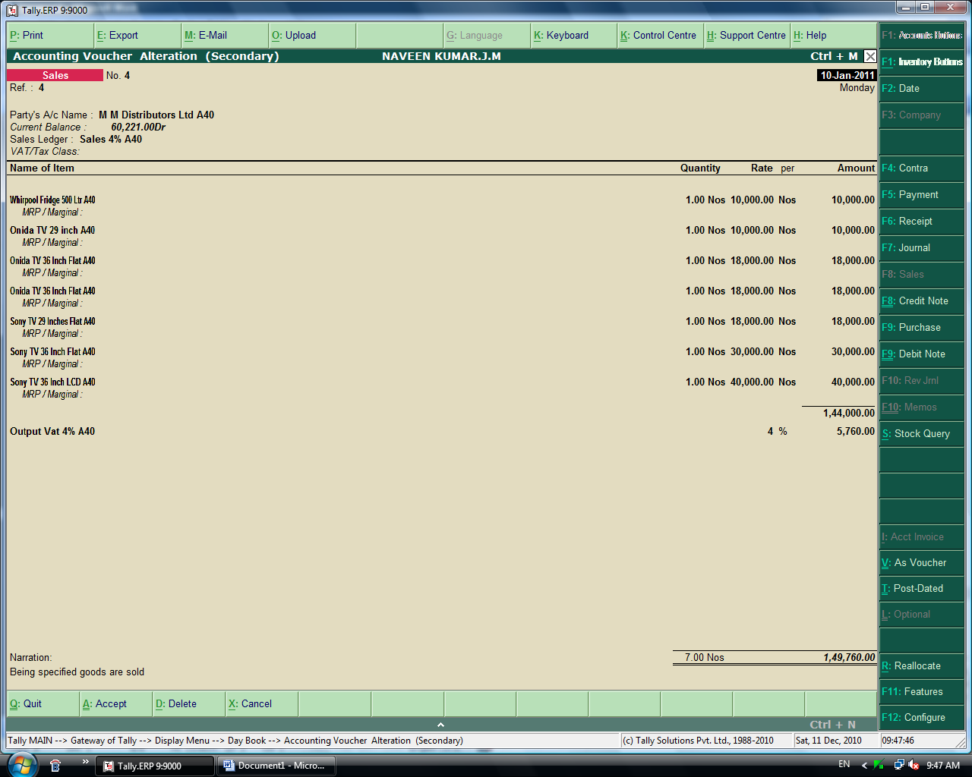

Payment & Receipt Entries.
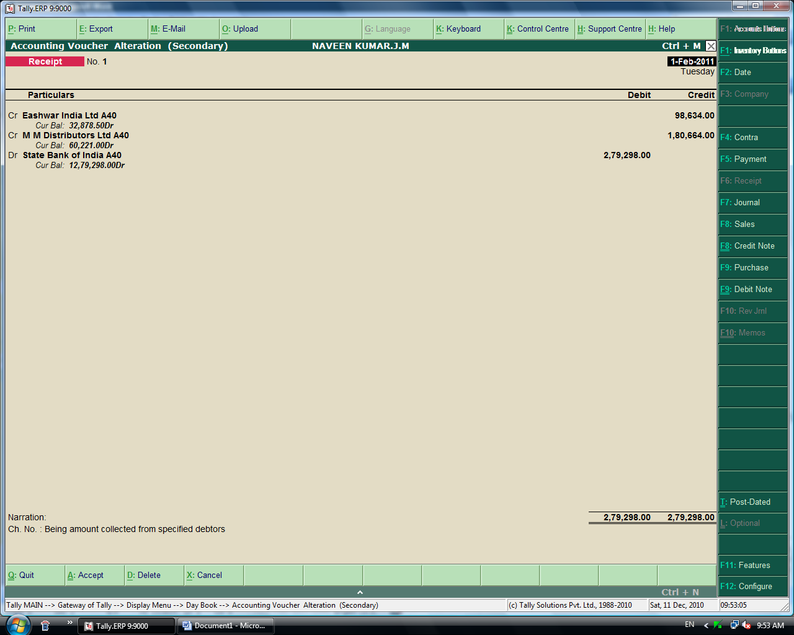

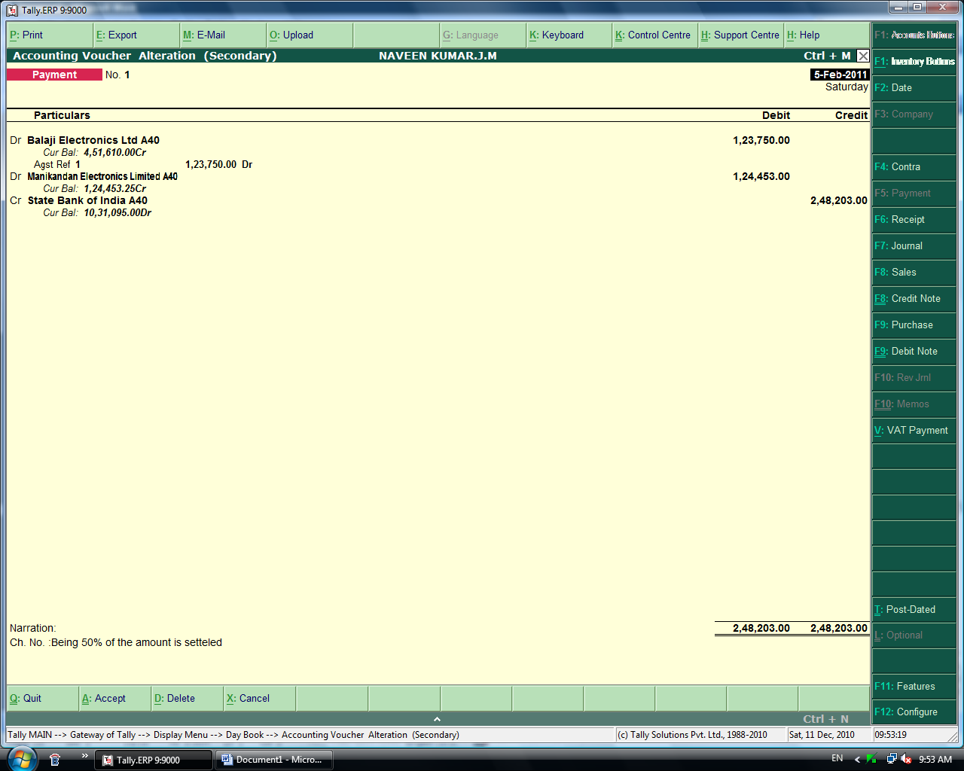

Income Expenses & Statutory Entries.

1. Loan from ICICI
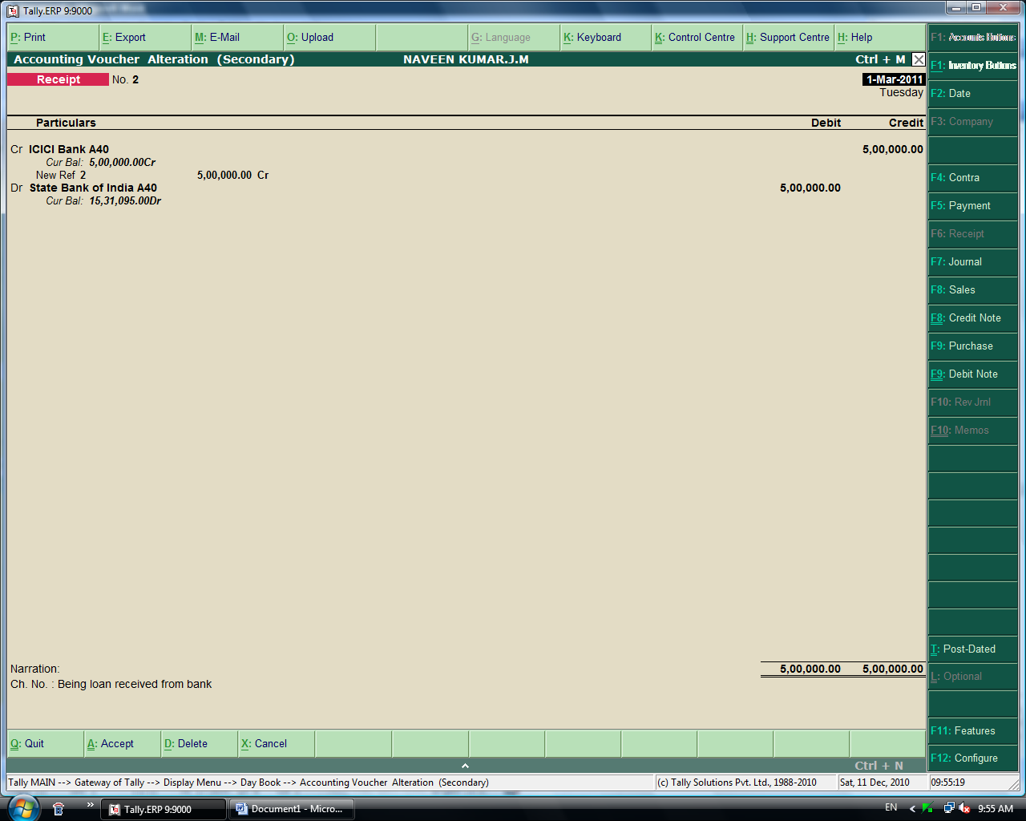

2. Booking Different Expenses in a single voucher.
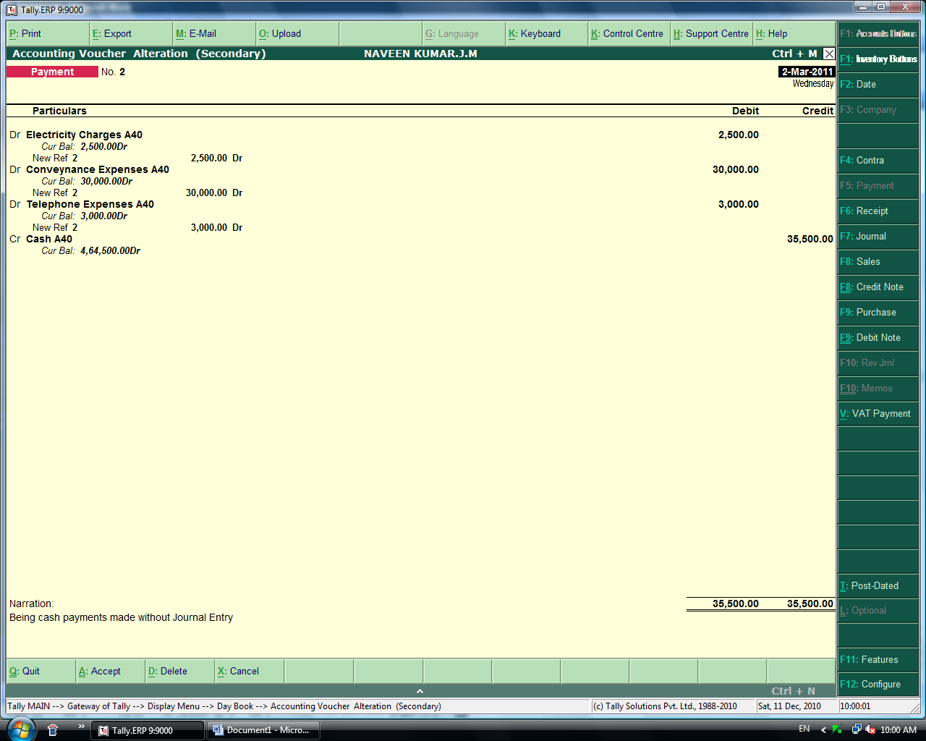

3. Journal Entry for rent Expenses with TDS Entries.
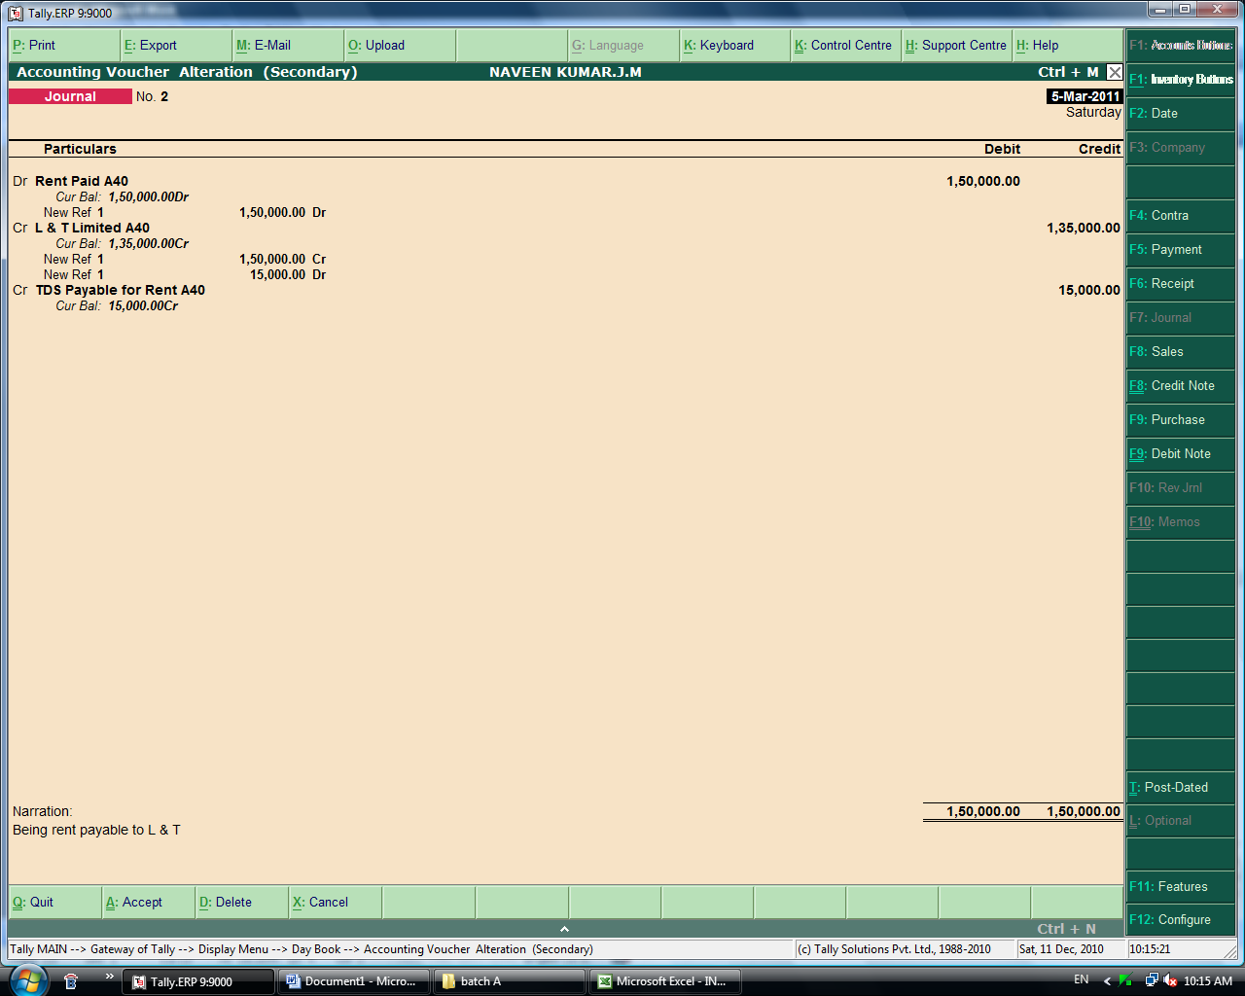

4. Rent Payment Entry.

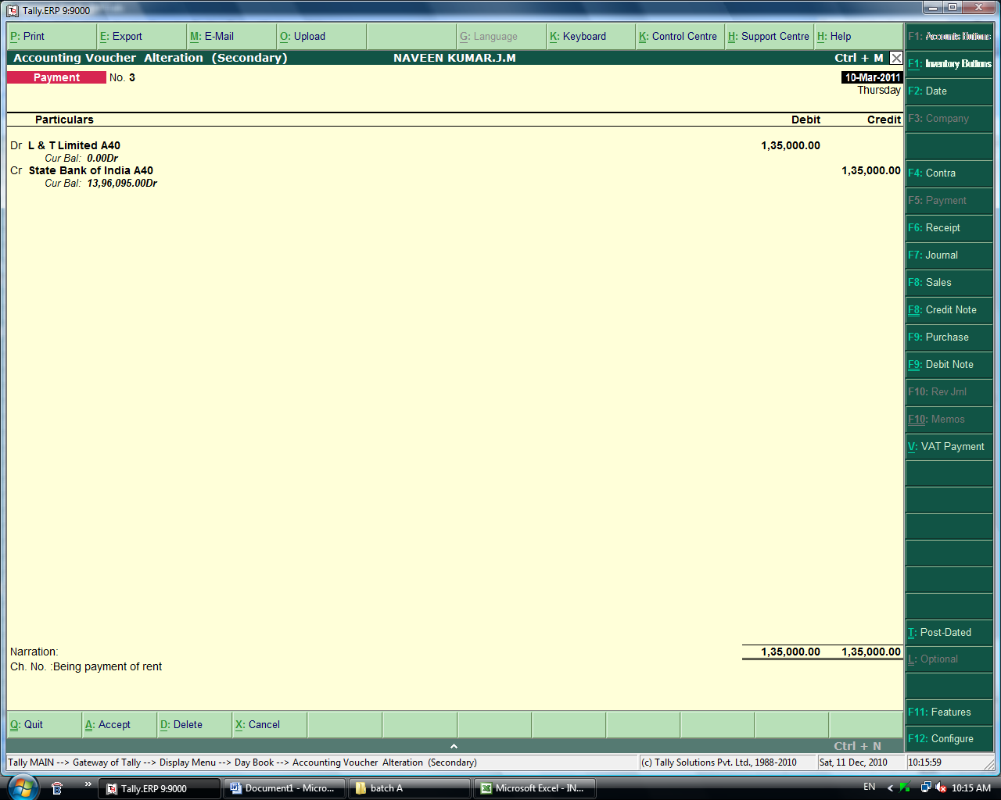

5. TDS Payment on rent
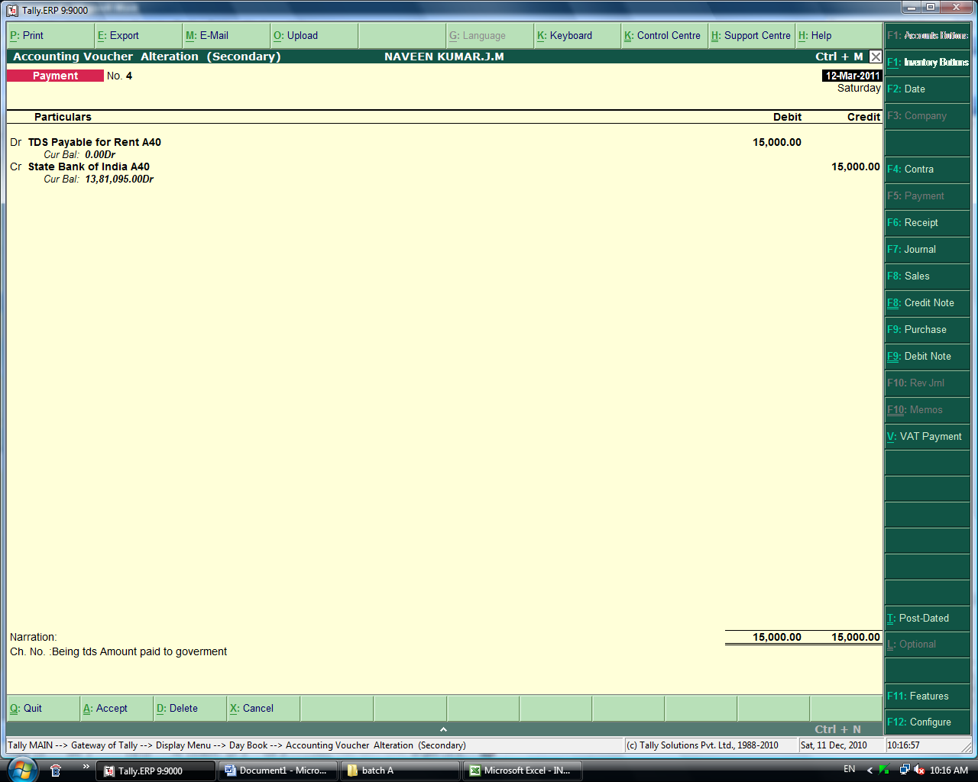

6.
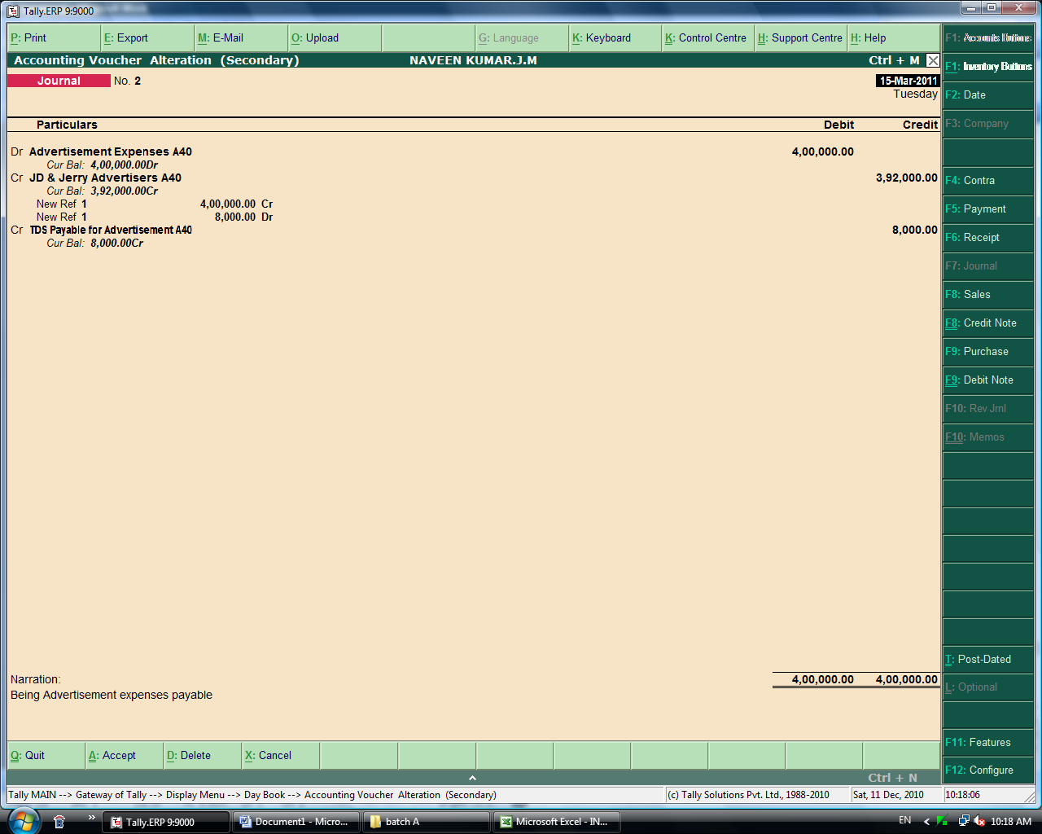

- Income from repairs & Maintenance with service tax.
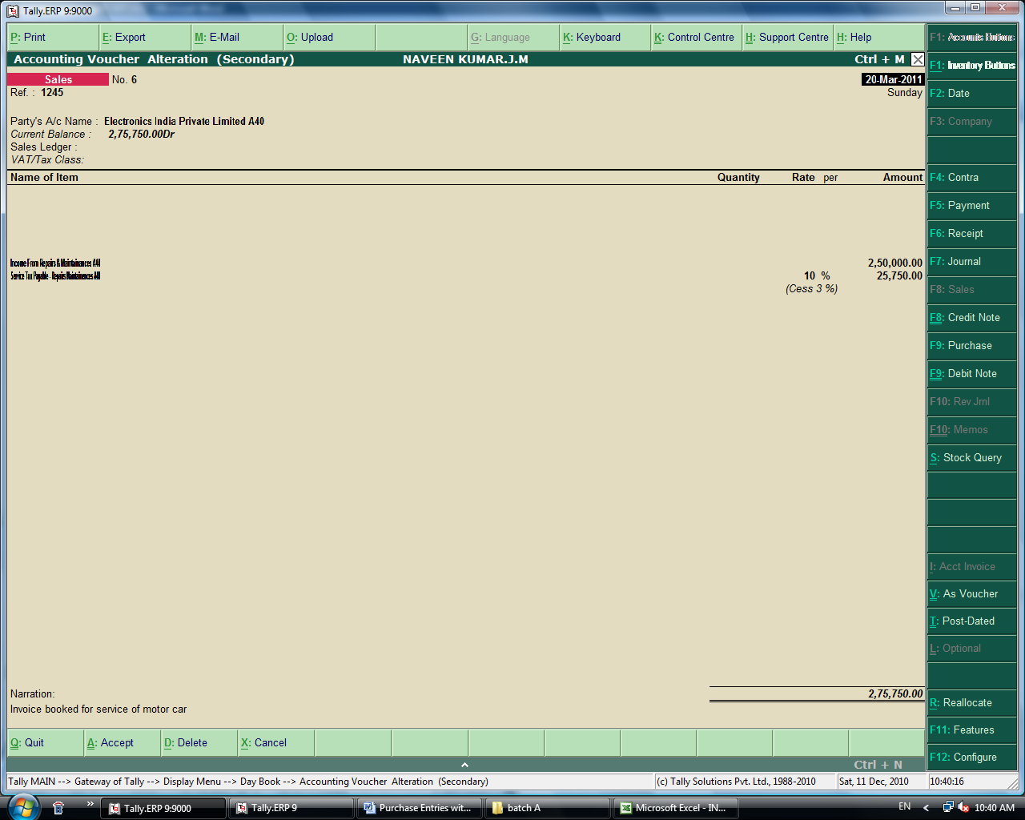

- Receipt
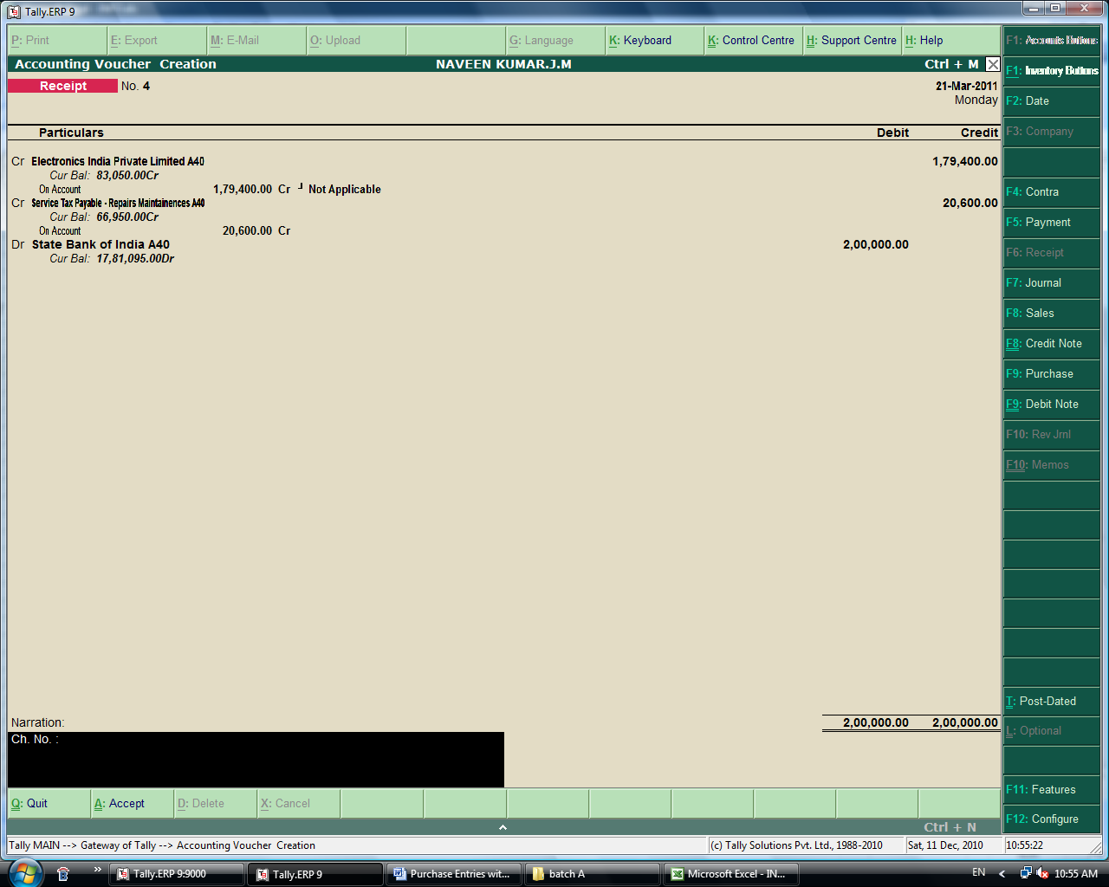

9. Service tax payment entry
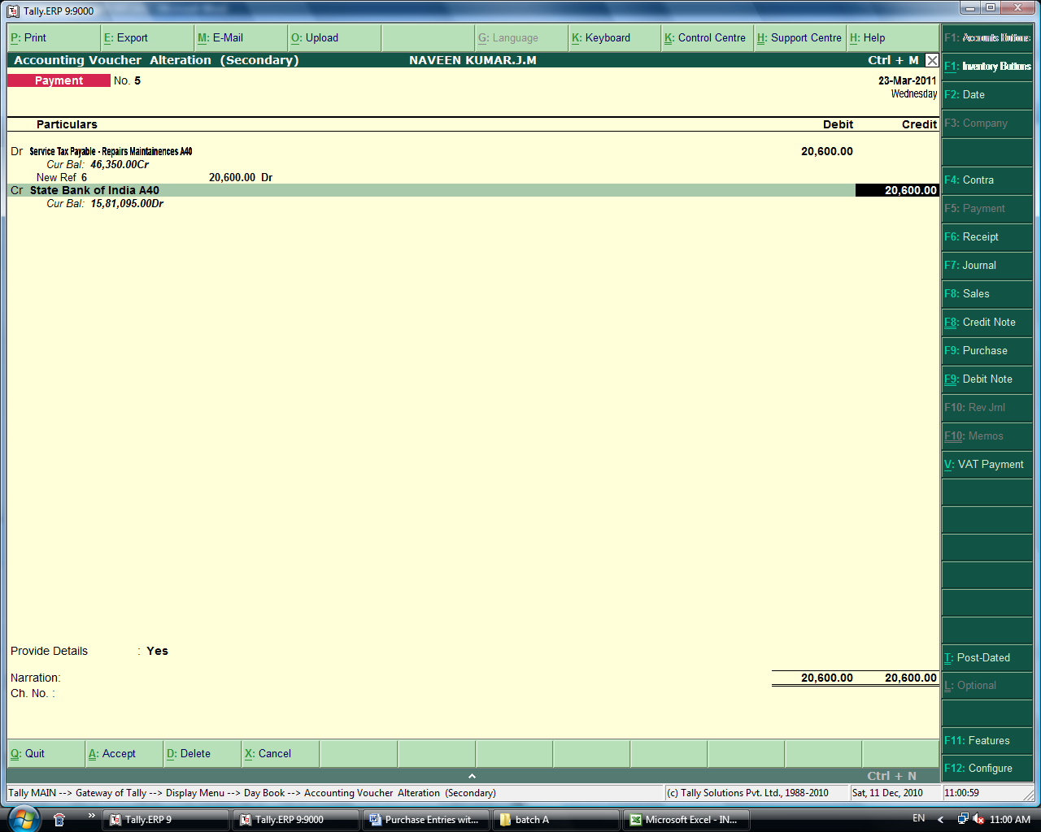

10. Making of sales voucher for sales order.

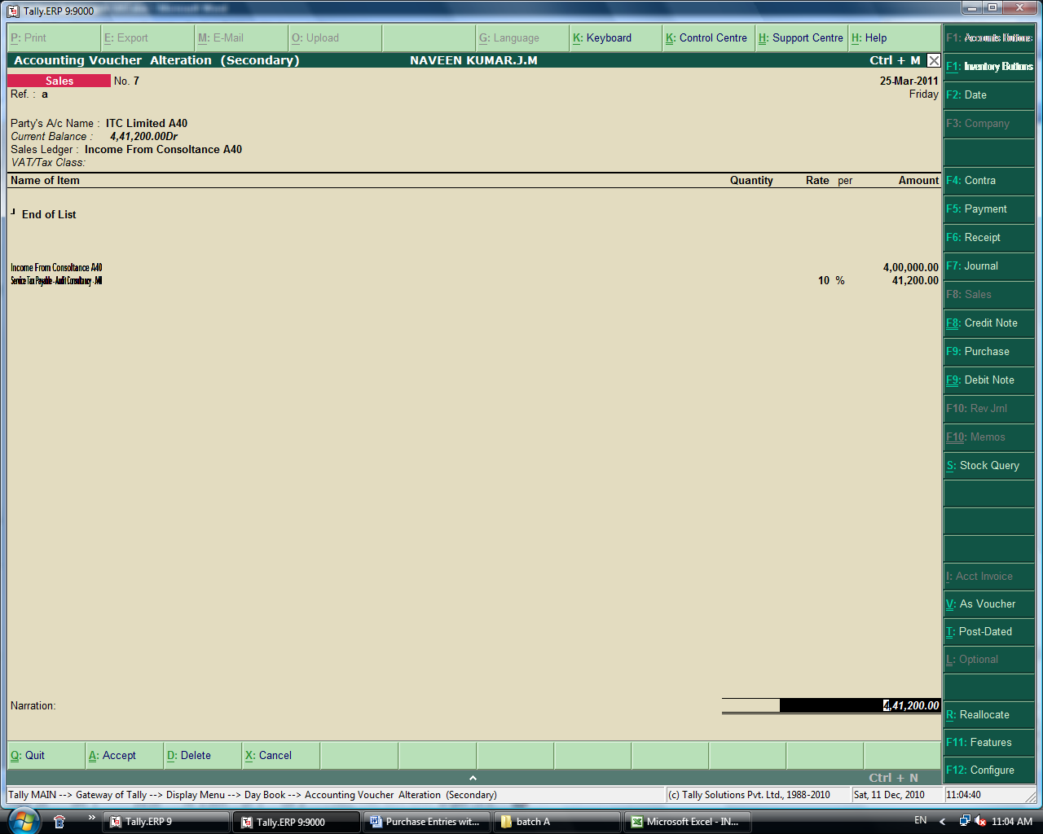

Adjustment Entries with VAT.
1.
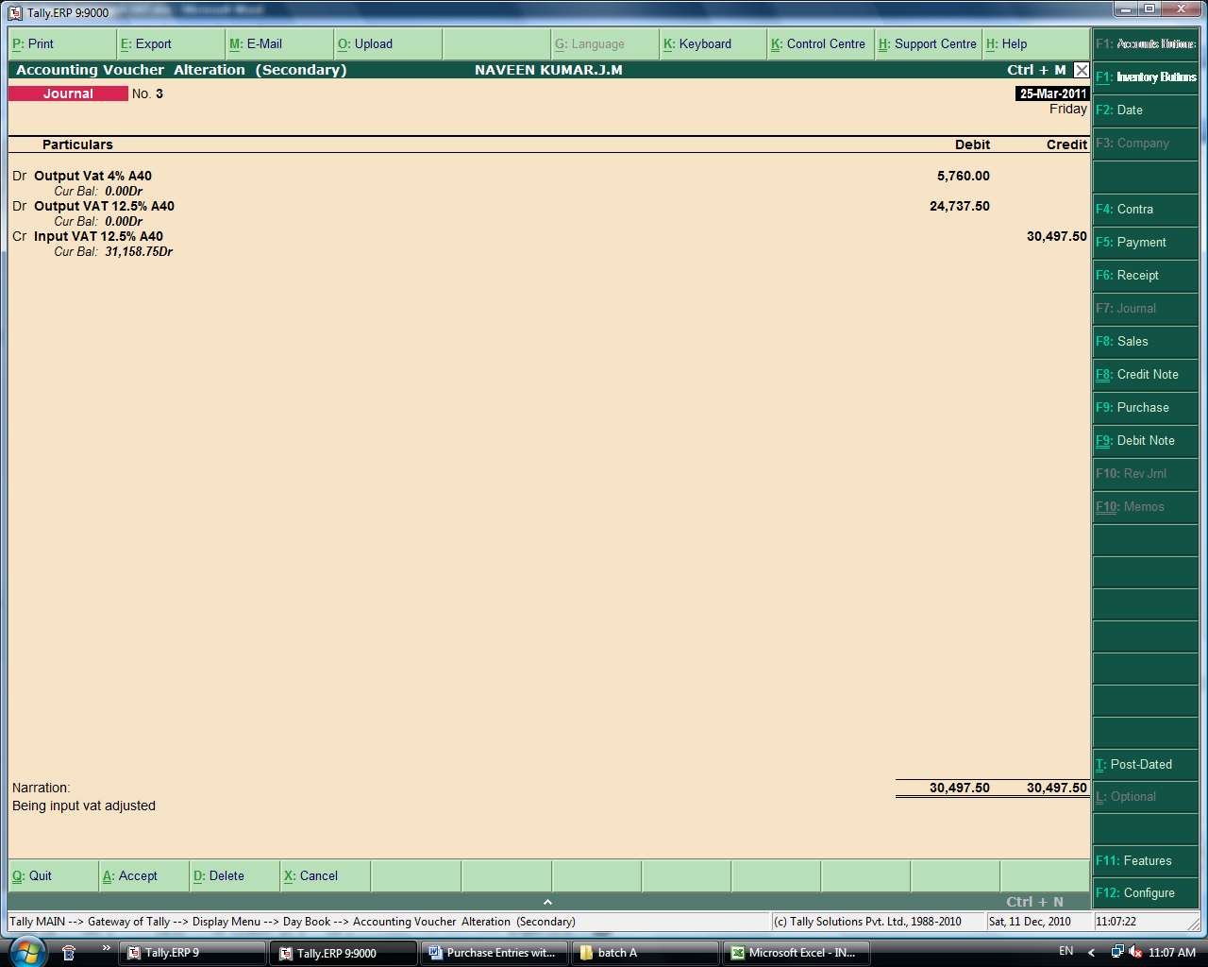

2. Purchase return
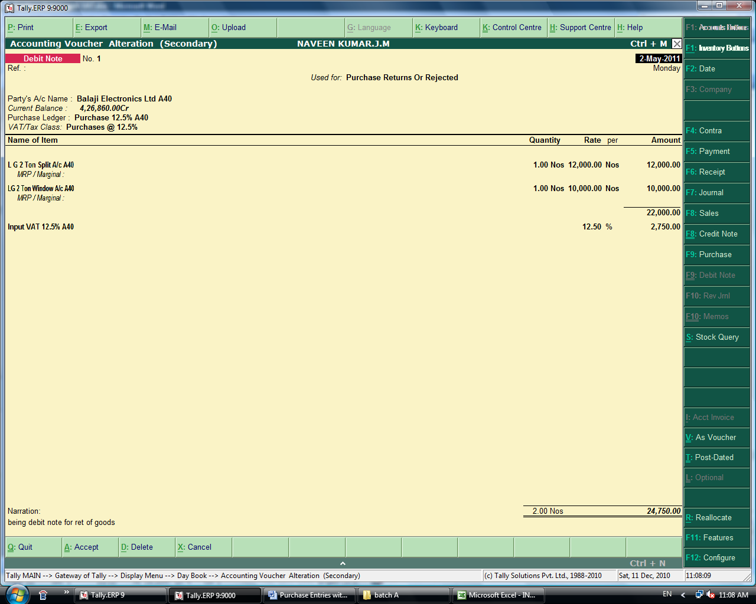

- Transfer of stock
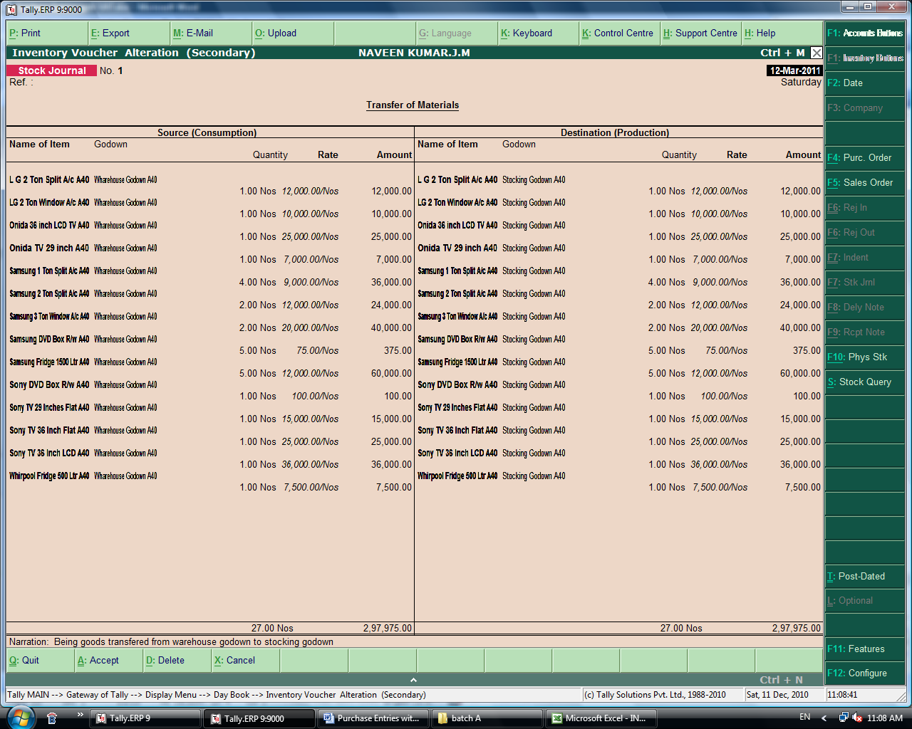

- Sales Return
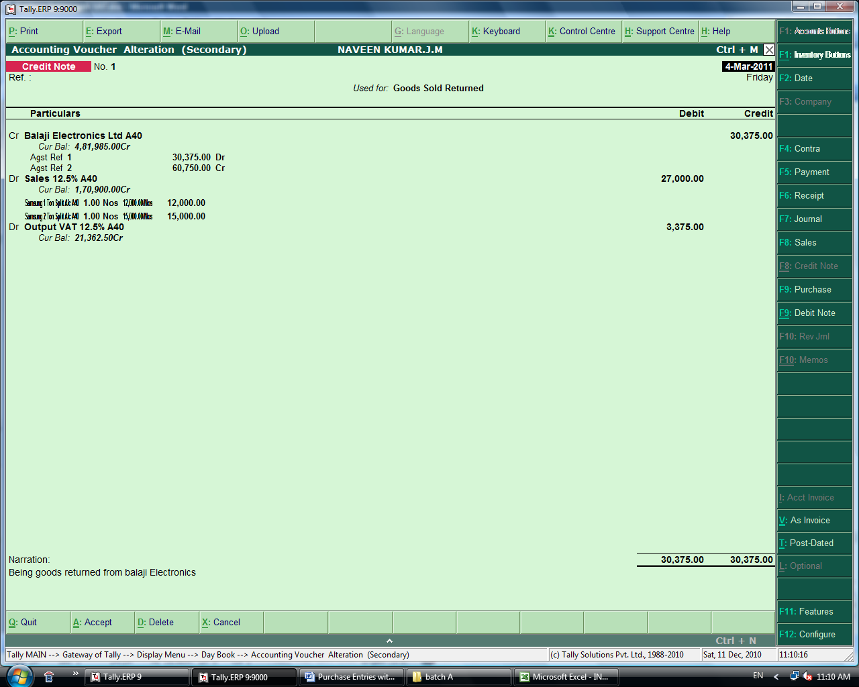

- Sales order processing
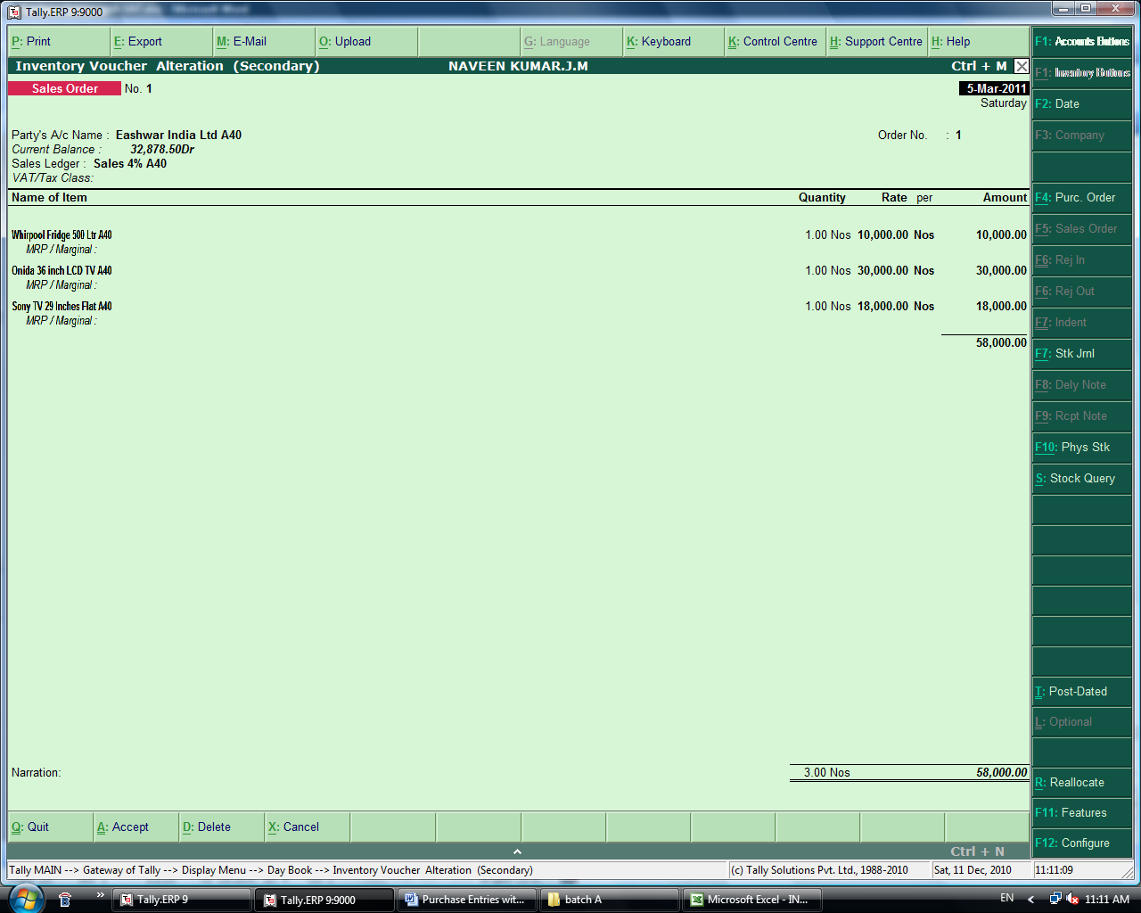

6. Making a sales bill for sales order
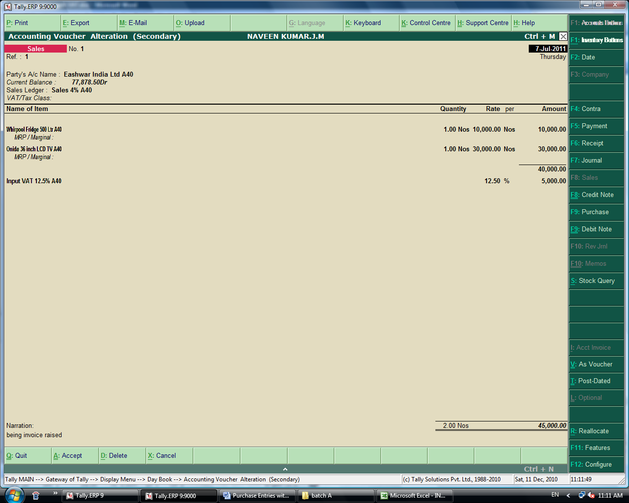

7. Making of Purchase order
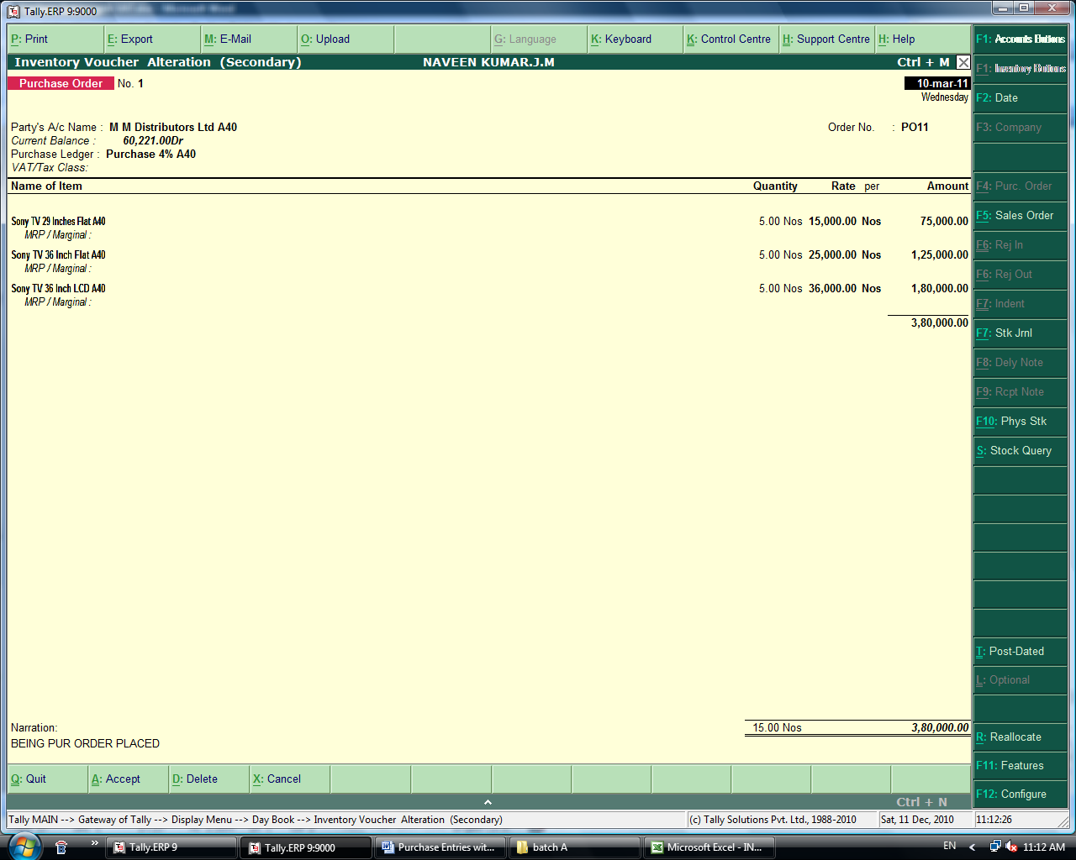

Trial Balance (Detailed).
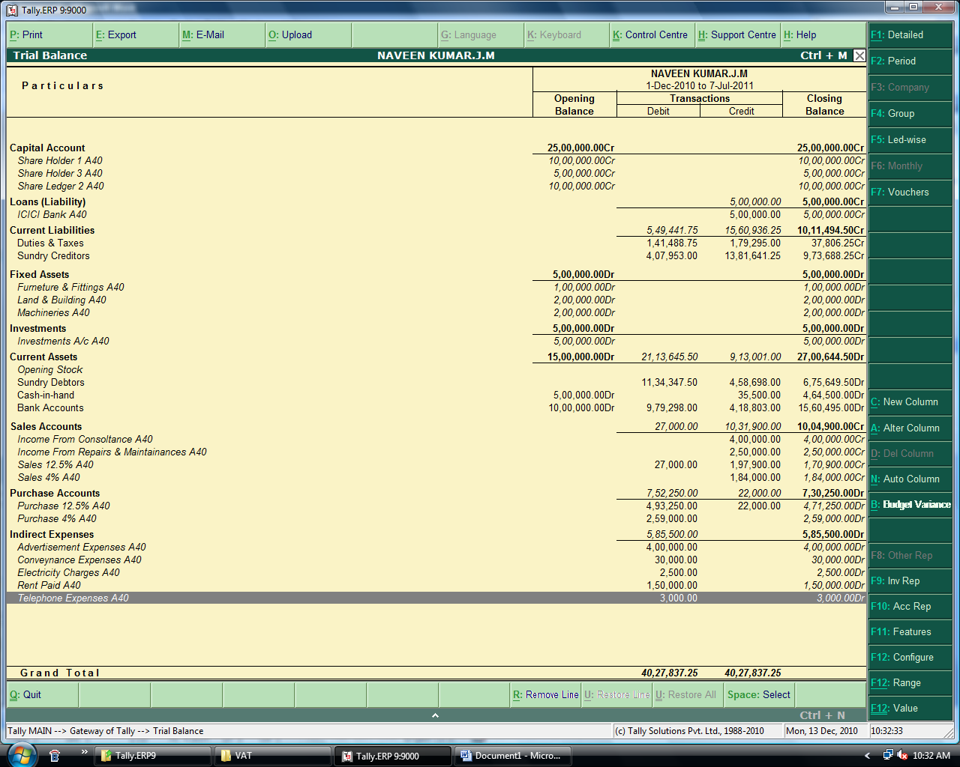

Profit and Loss Account (Detailed).
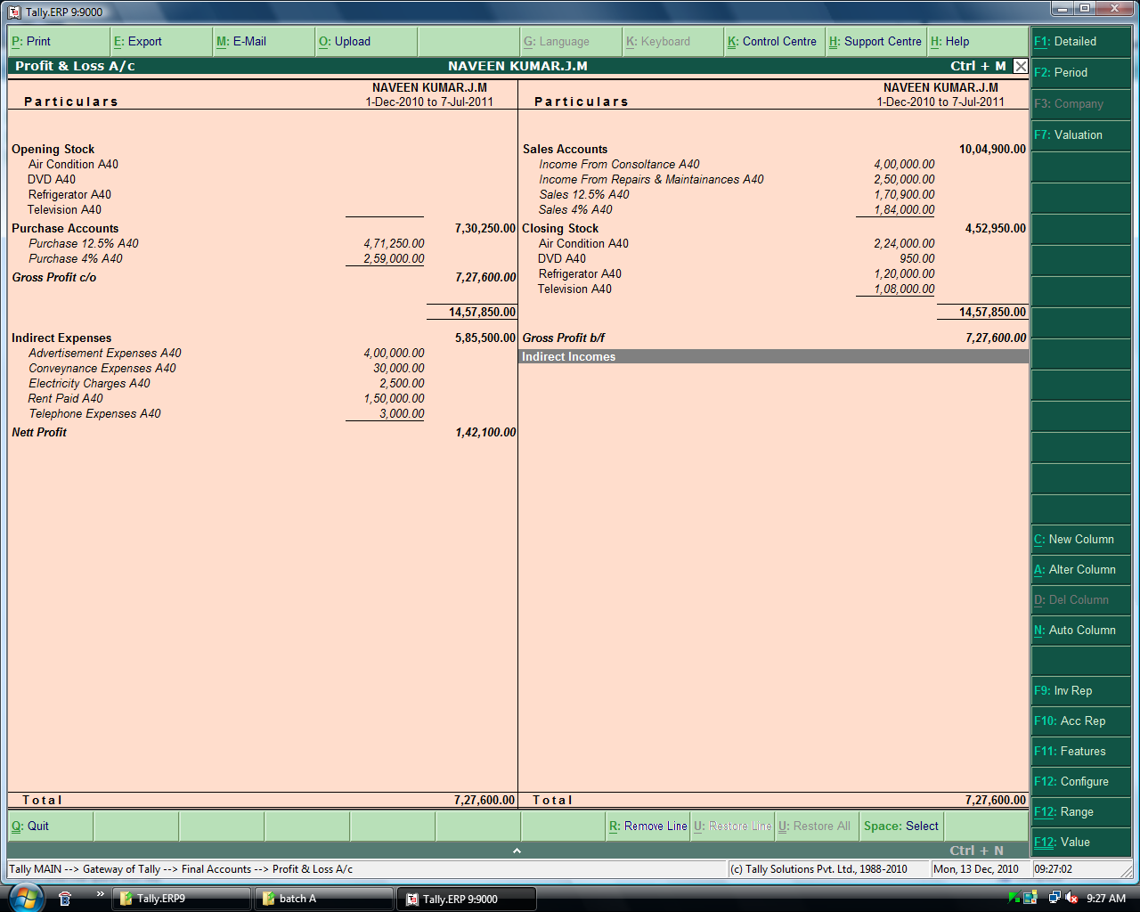

Balance Sheet – Normal
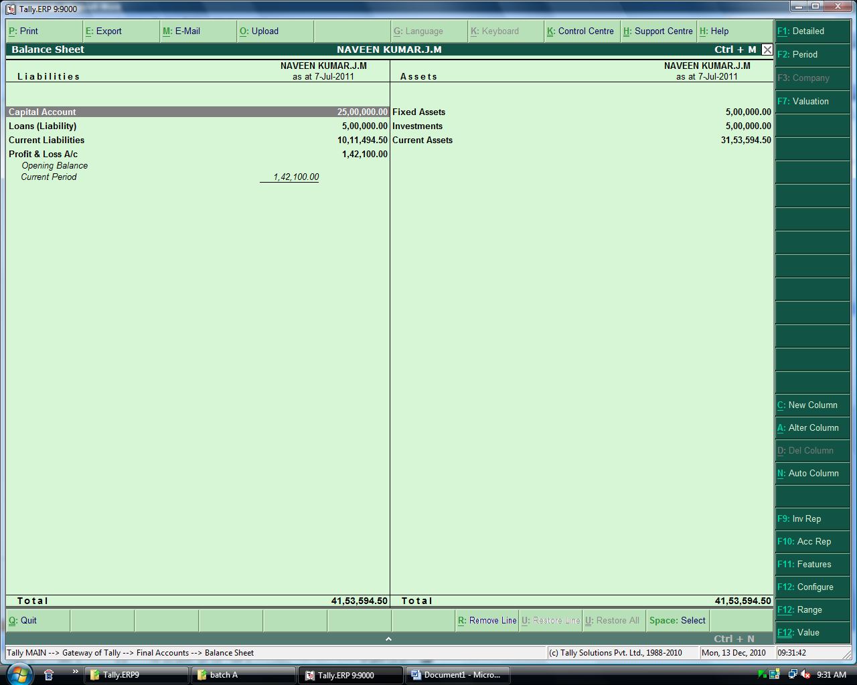

Balance Sheet – Detailed
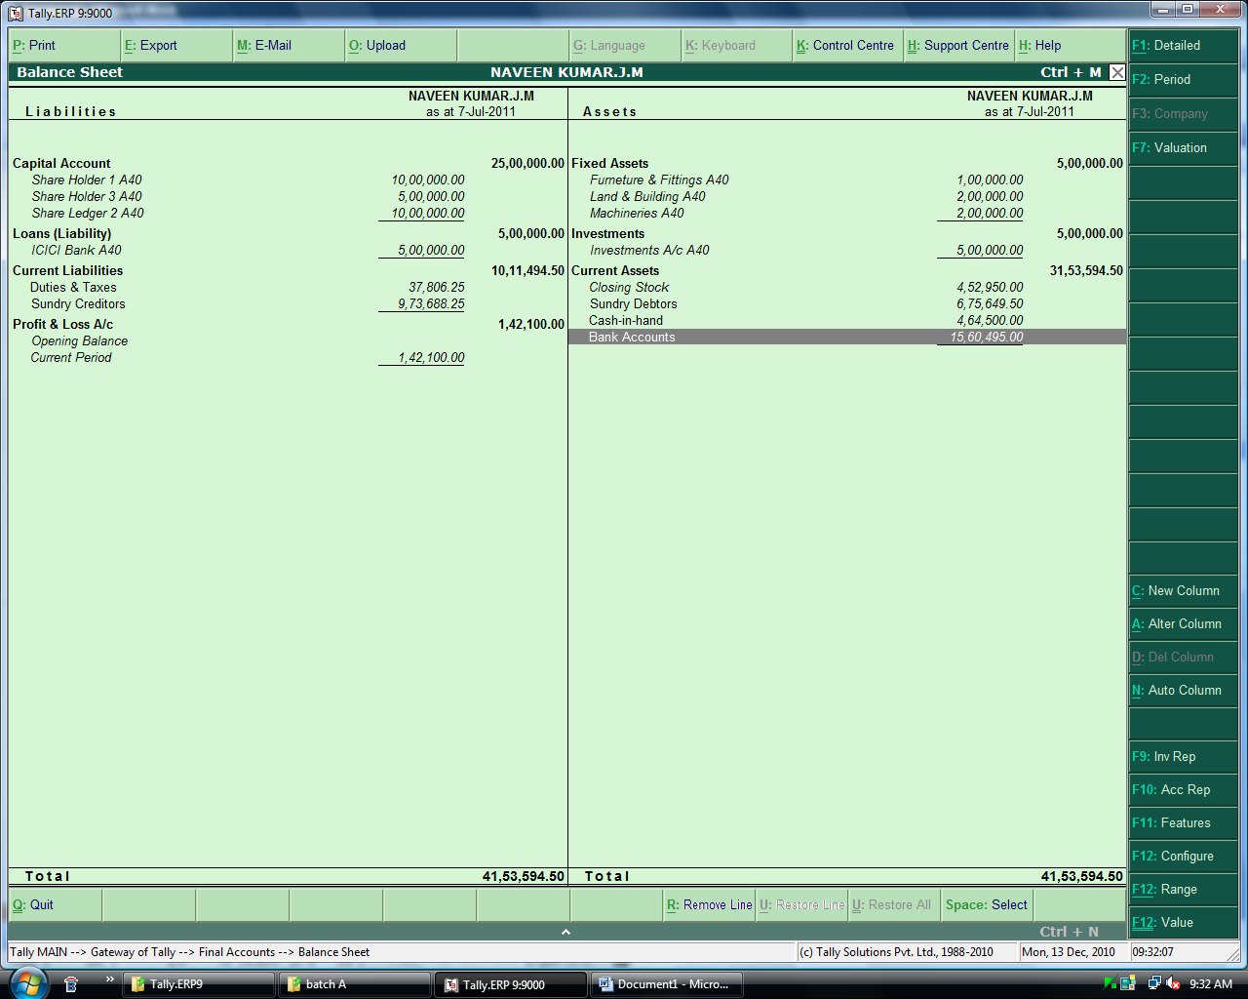

Balance Sheet - Vertical
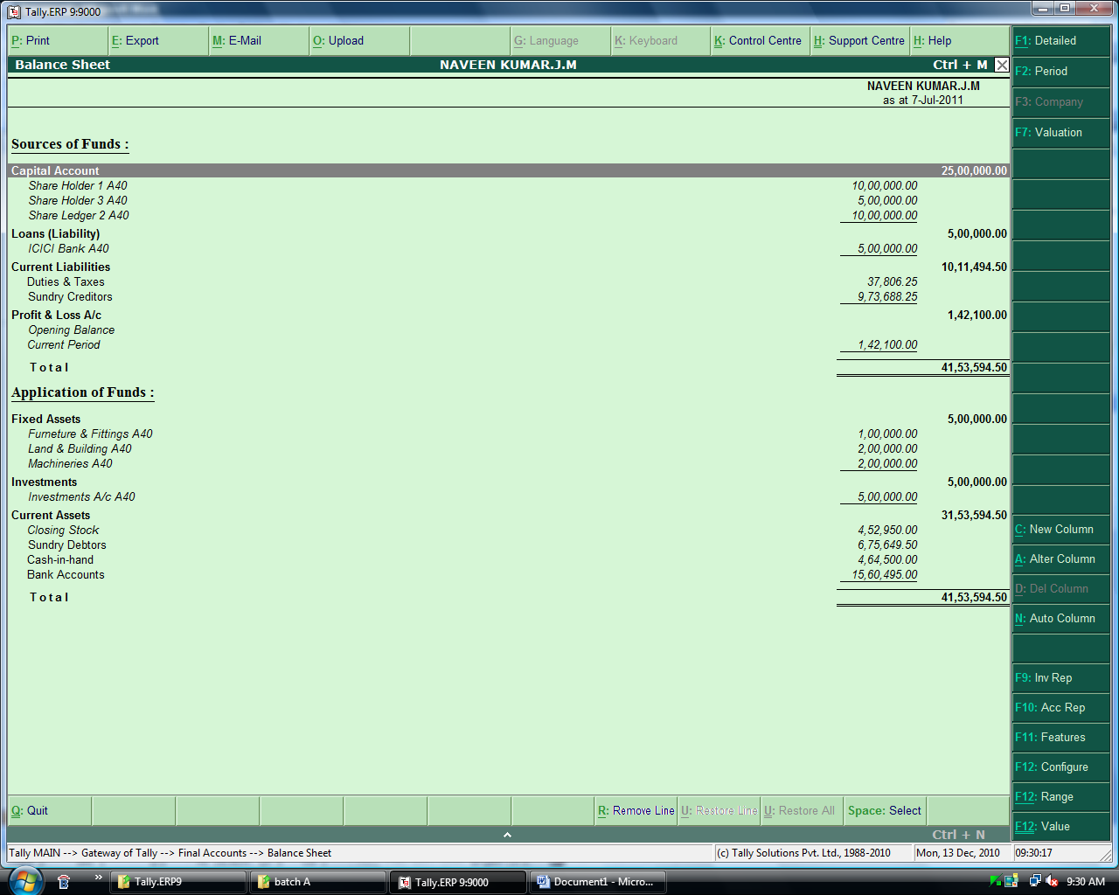

Trial Balance – Quarterly
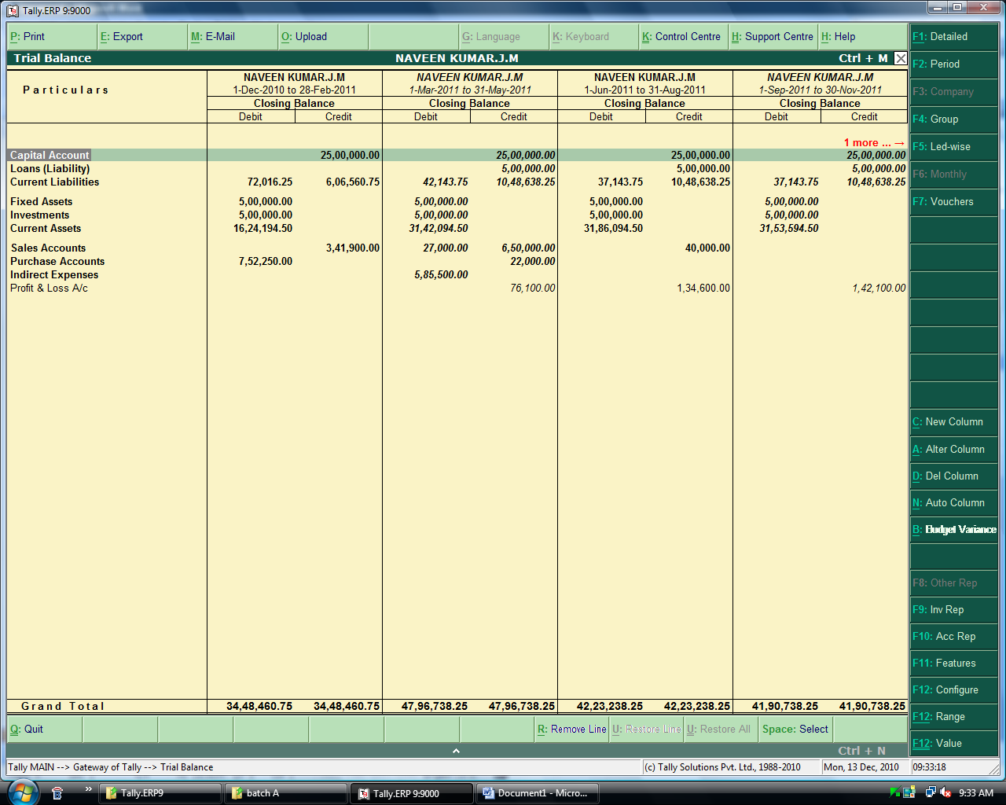

Profit and Loss Account – Half yearly.

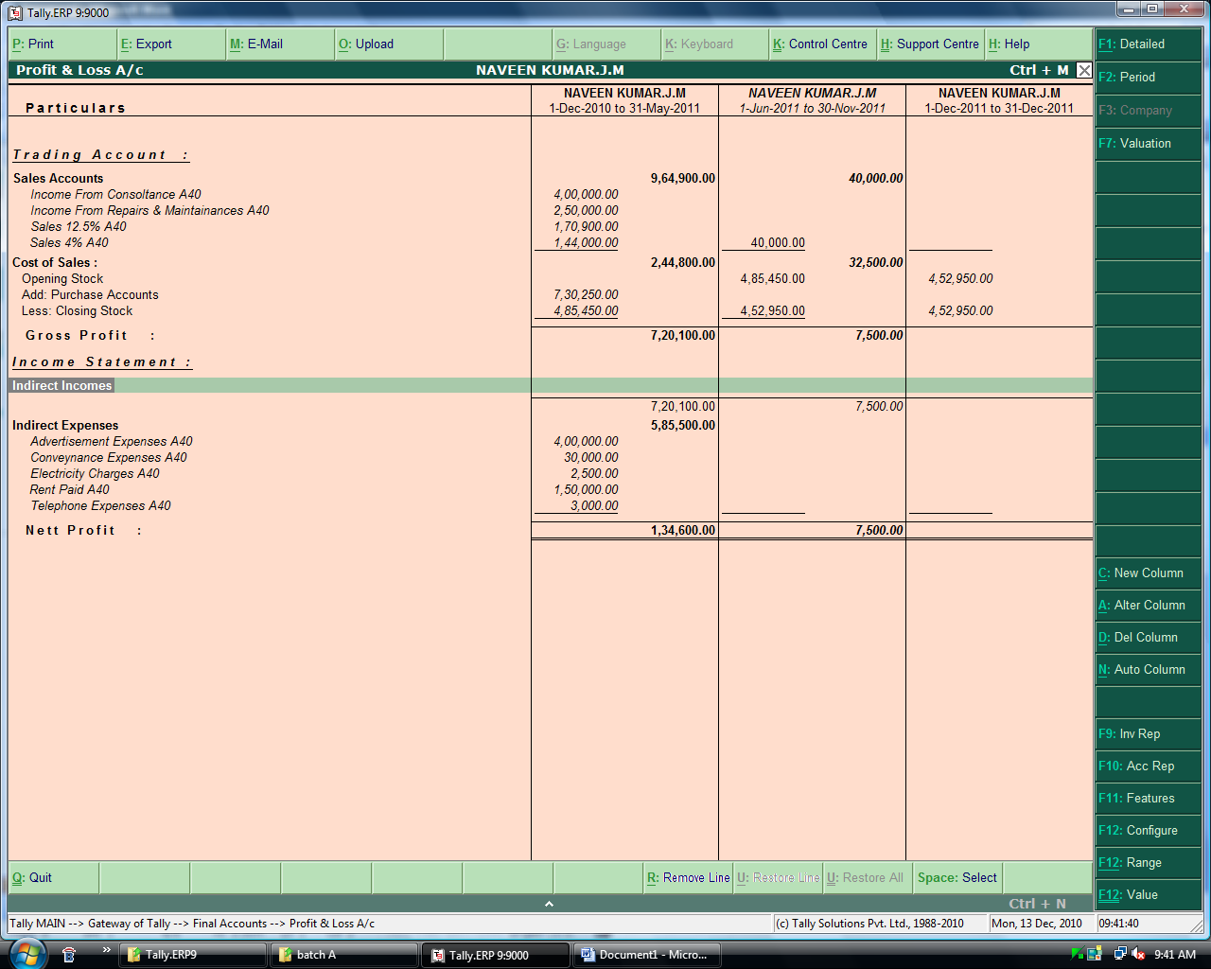

Balance Sheet for Different Months.
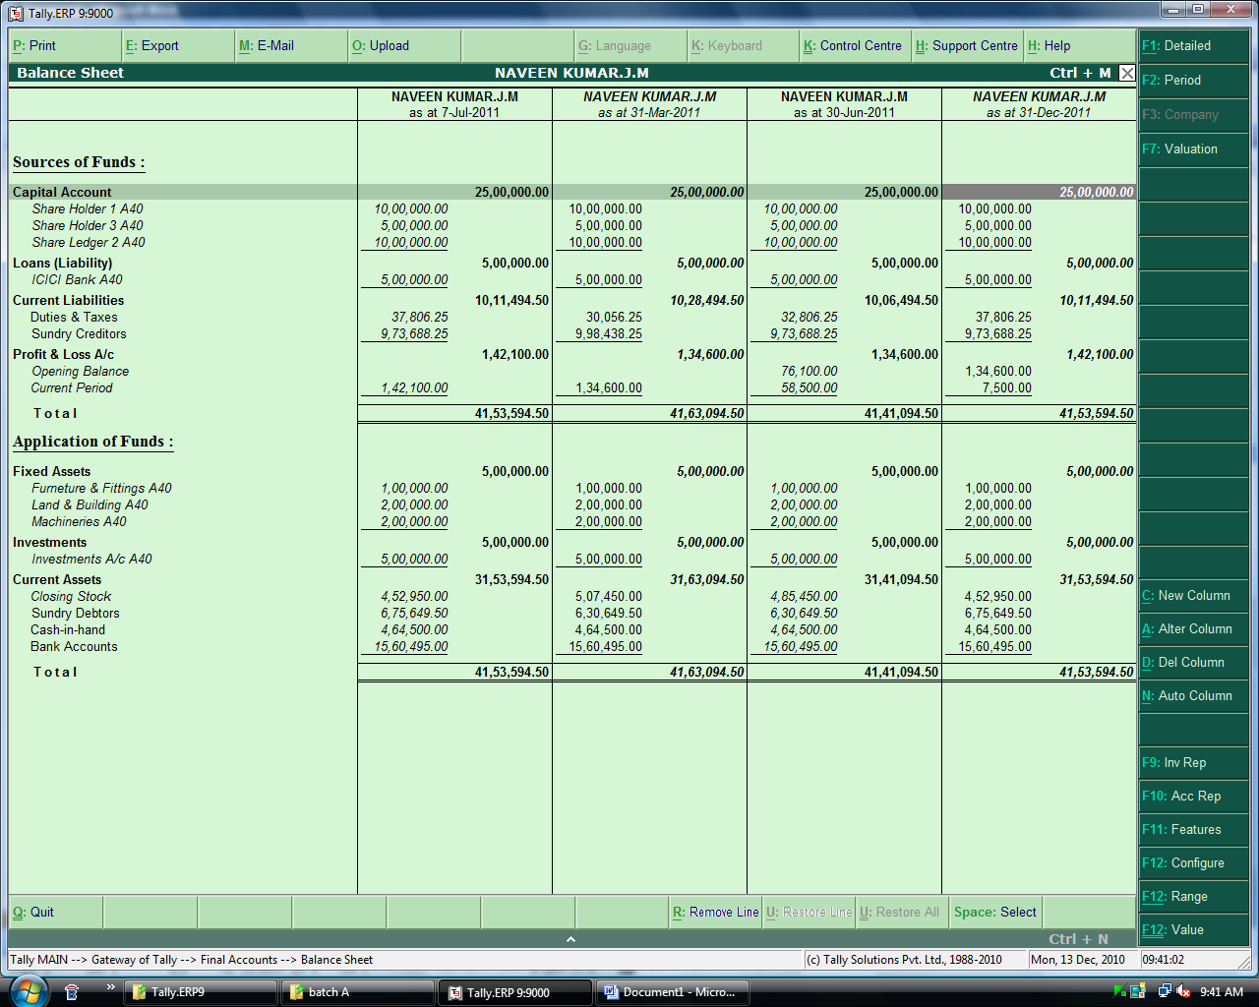

Debtors Ageing
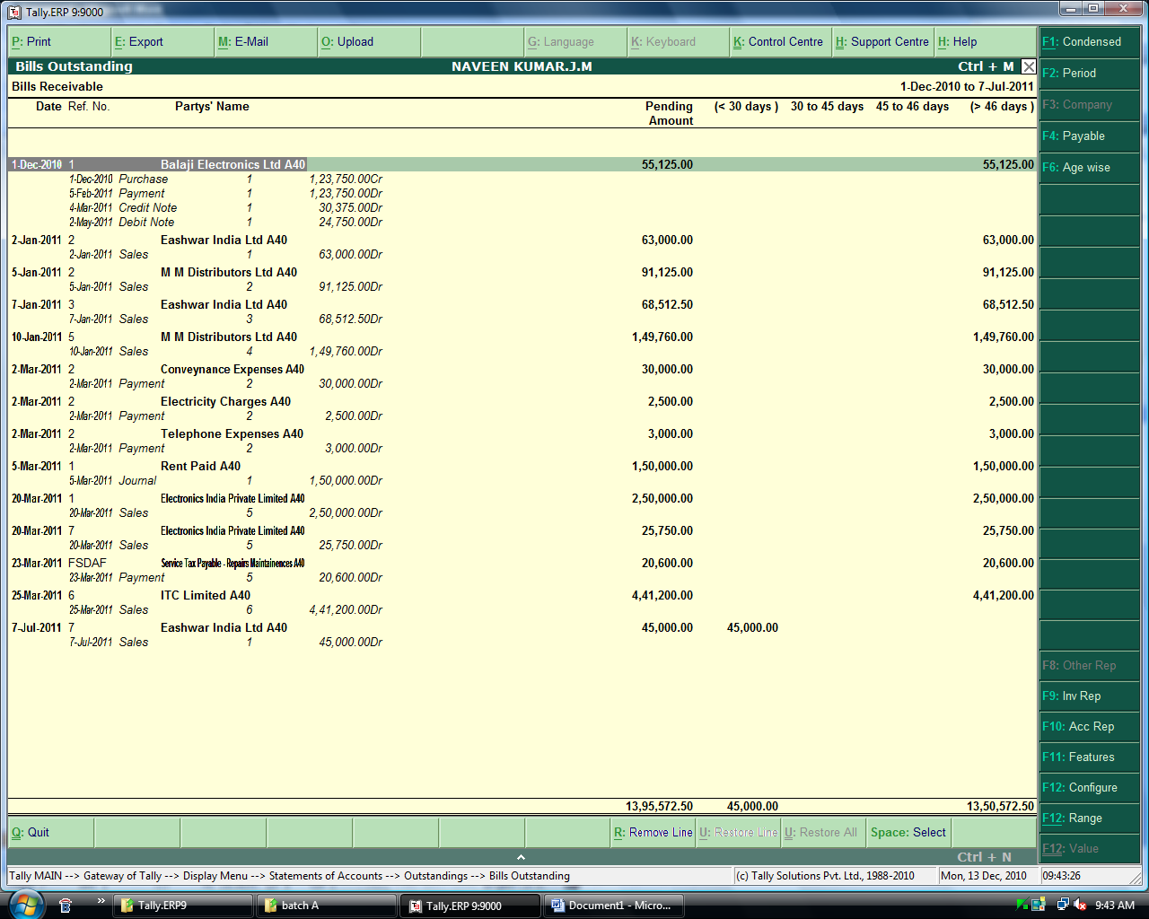

Creditors Ageing.
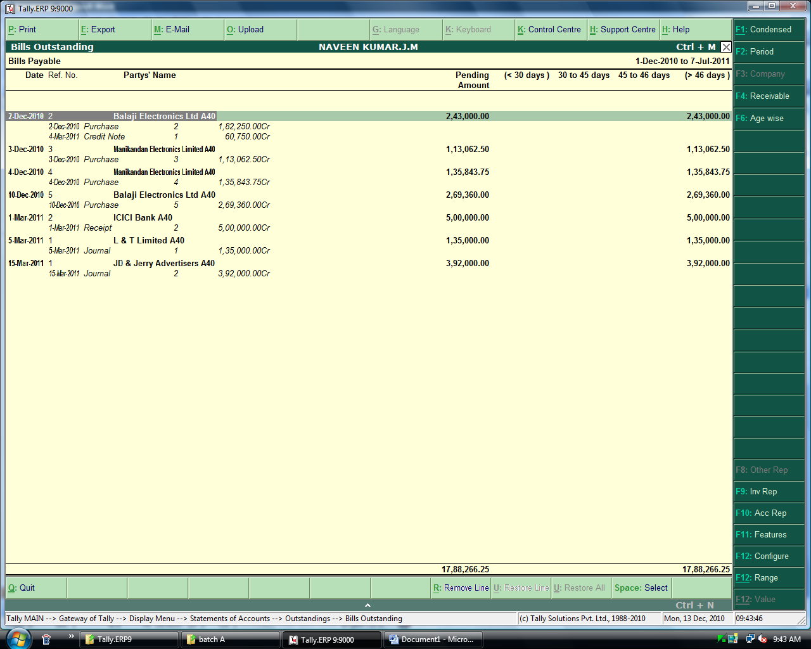

Budget Variance Report – Conveniences
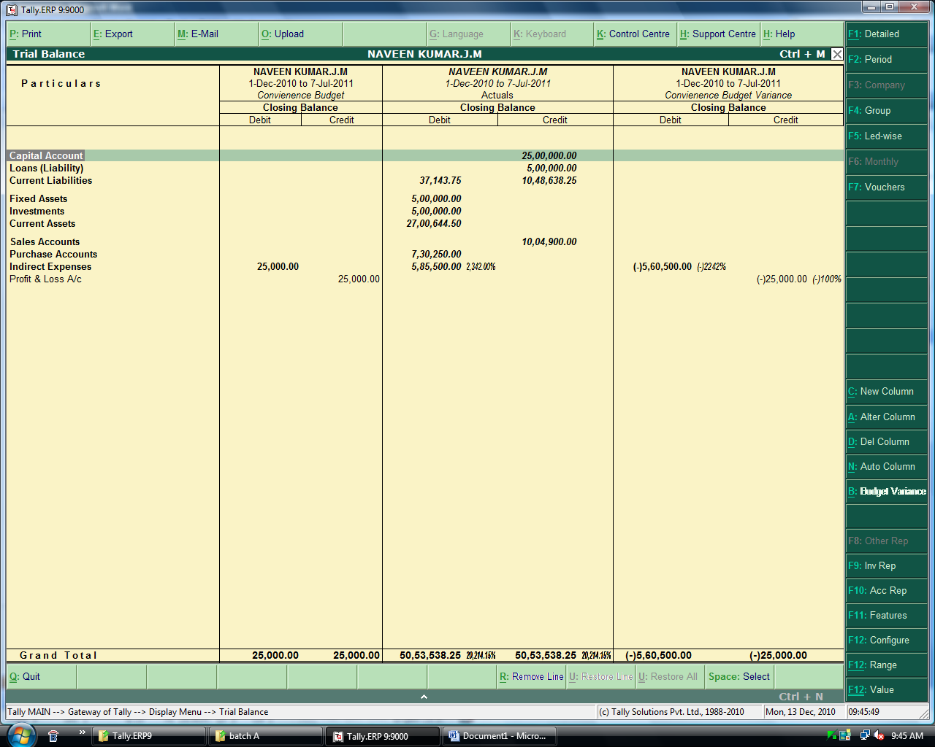

Budget Variance Report – Rent.
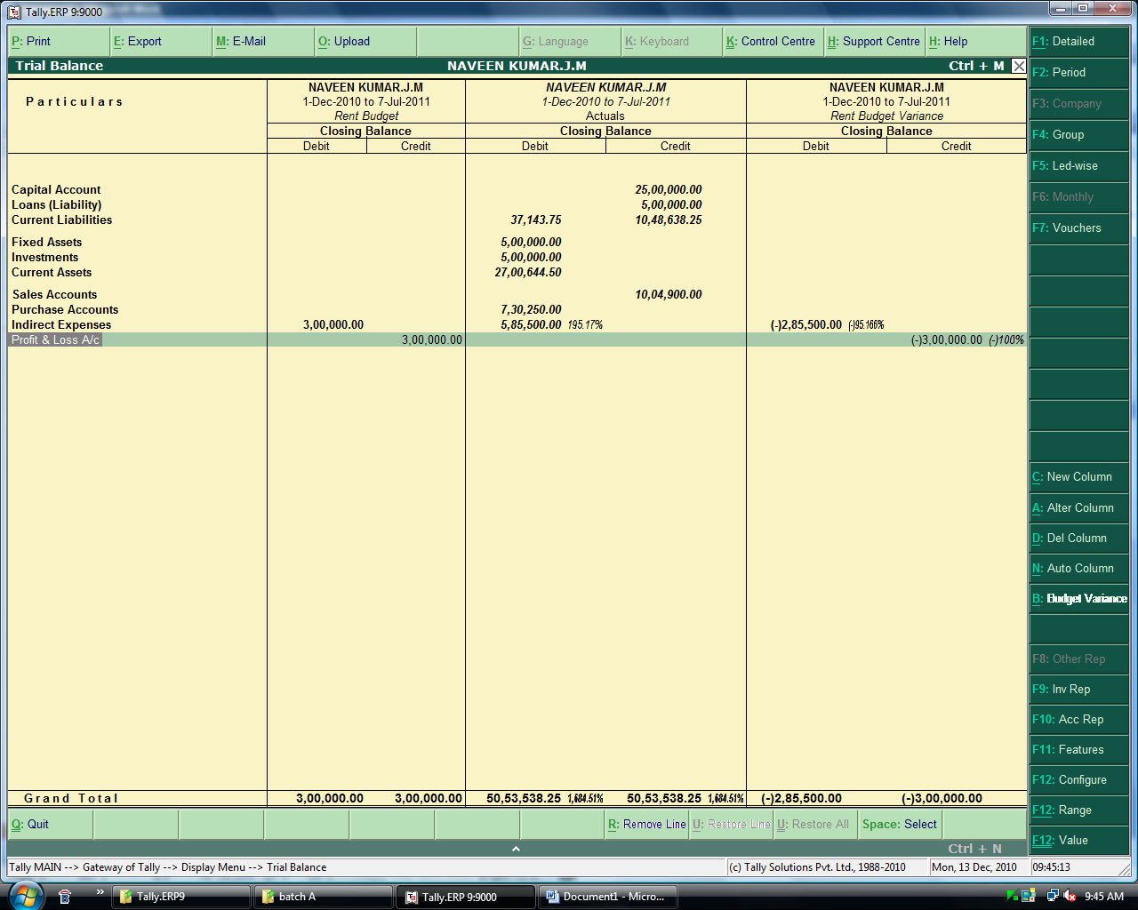

Bank Book before Reconciliation
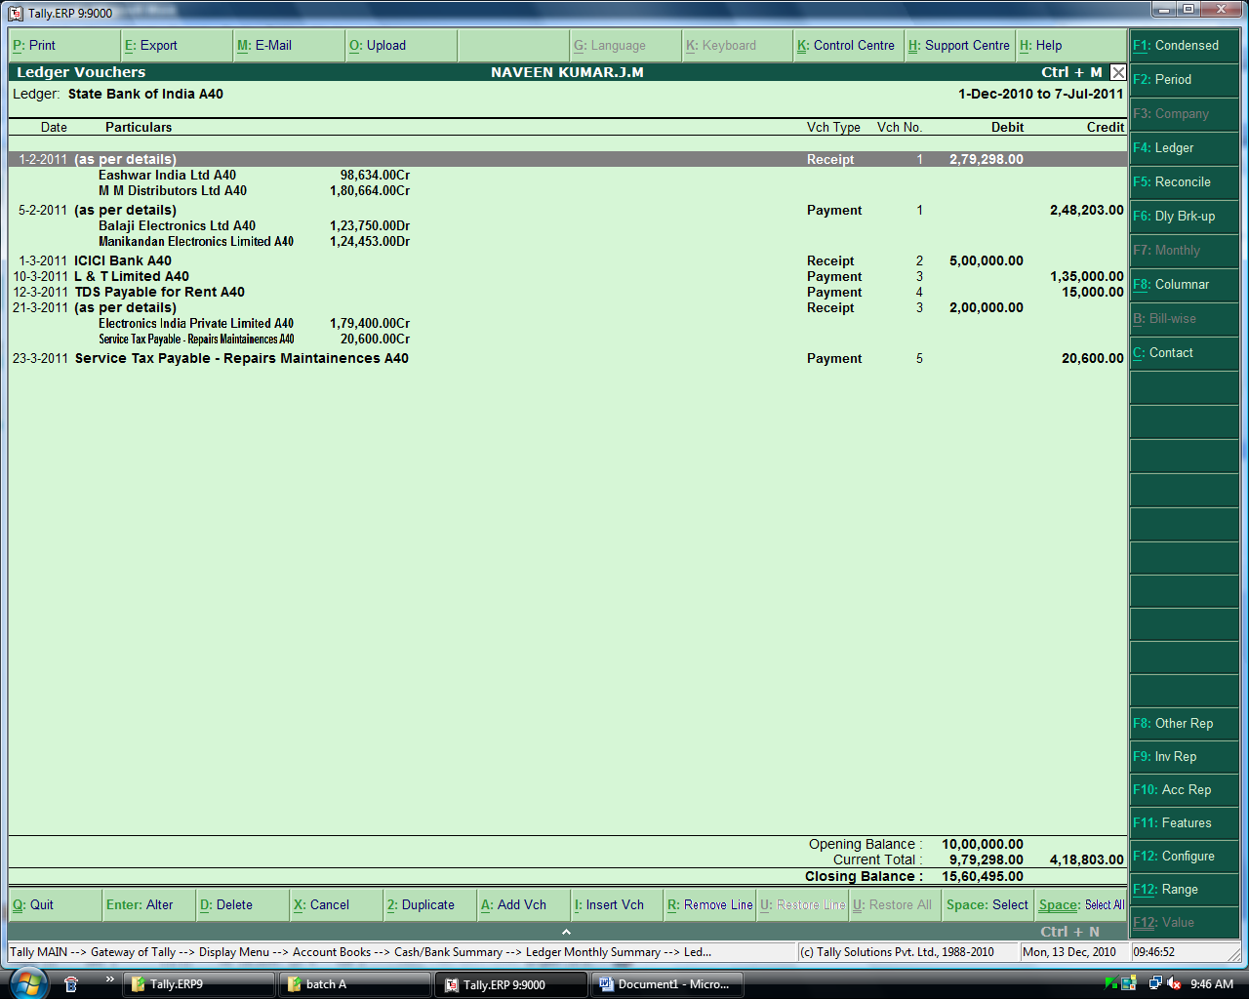

Bank Book after Reconciliation.
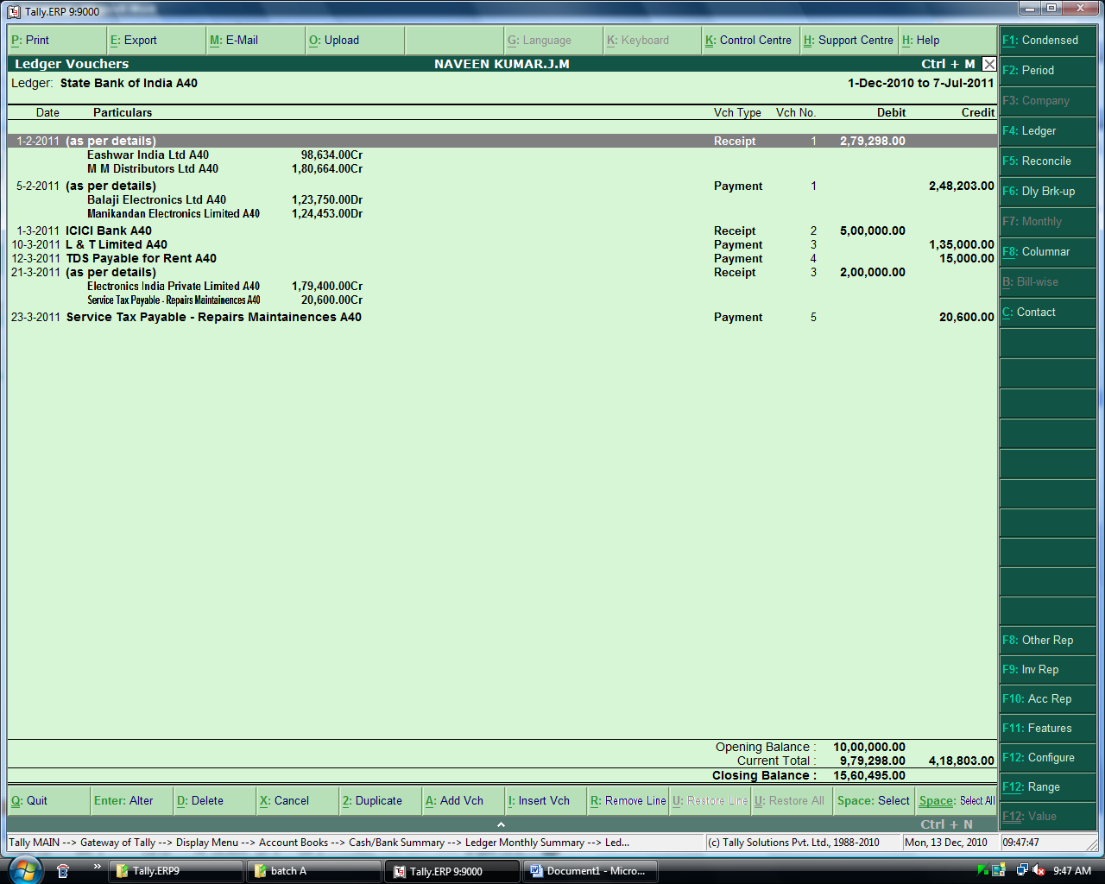

Day Book from Day 1 to Last Day.
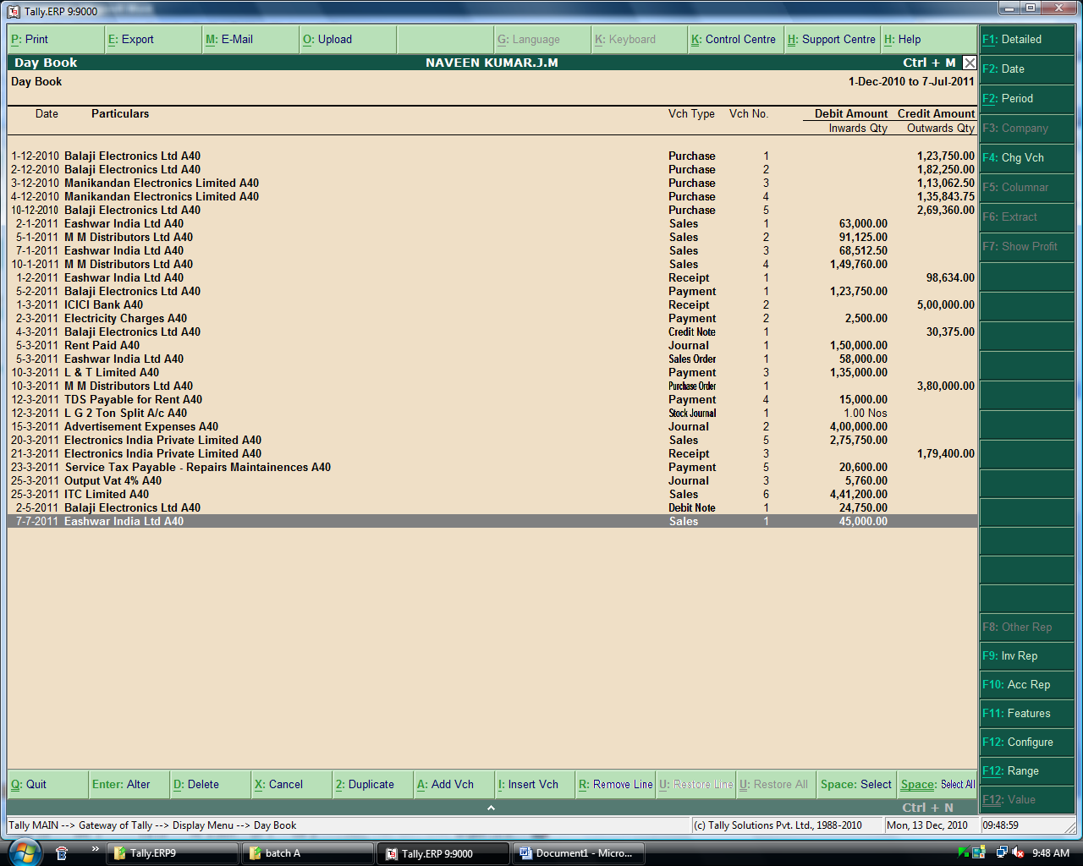

Stock Summary Report
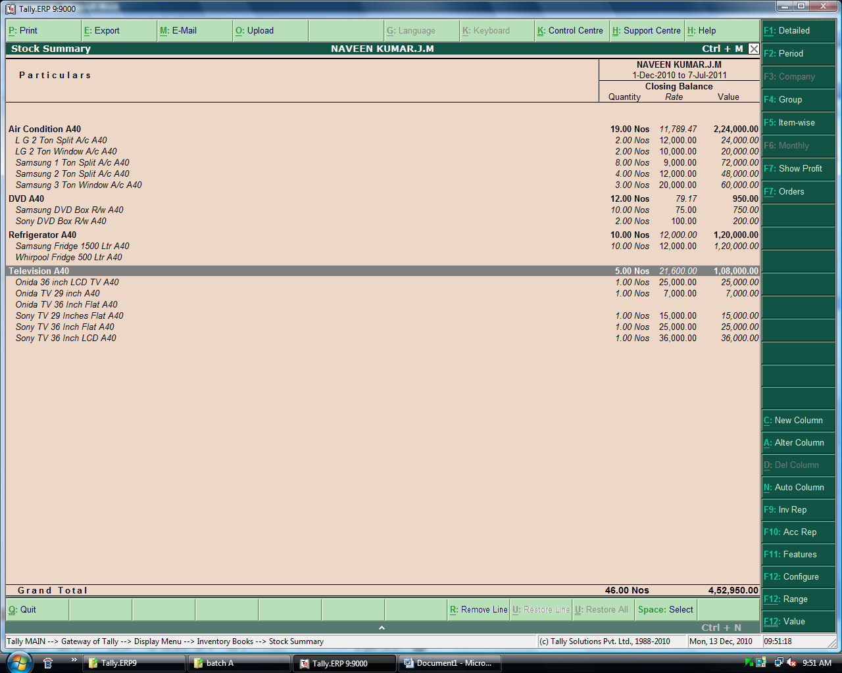

Stock Movement Analysis - Samsung 3 Ton A/C.
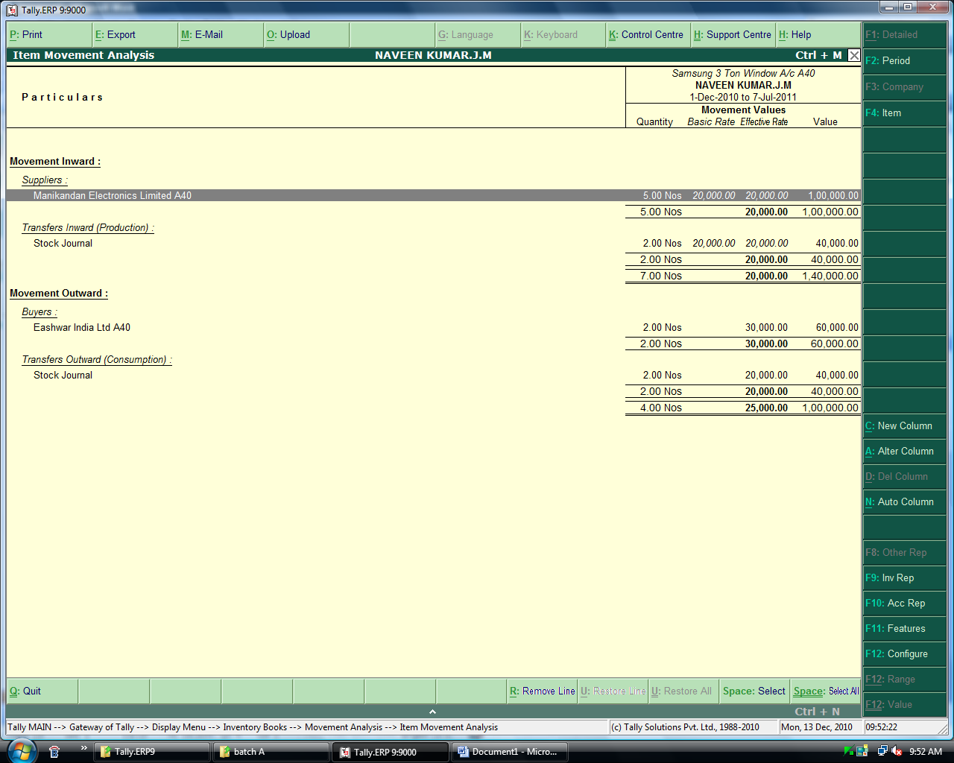

Stock Query Report – LG 2 ton Split A/C
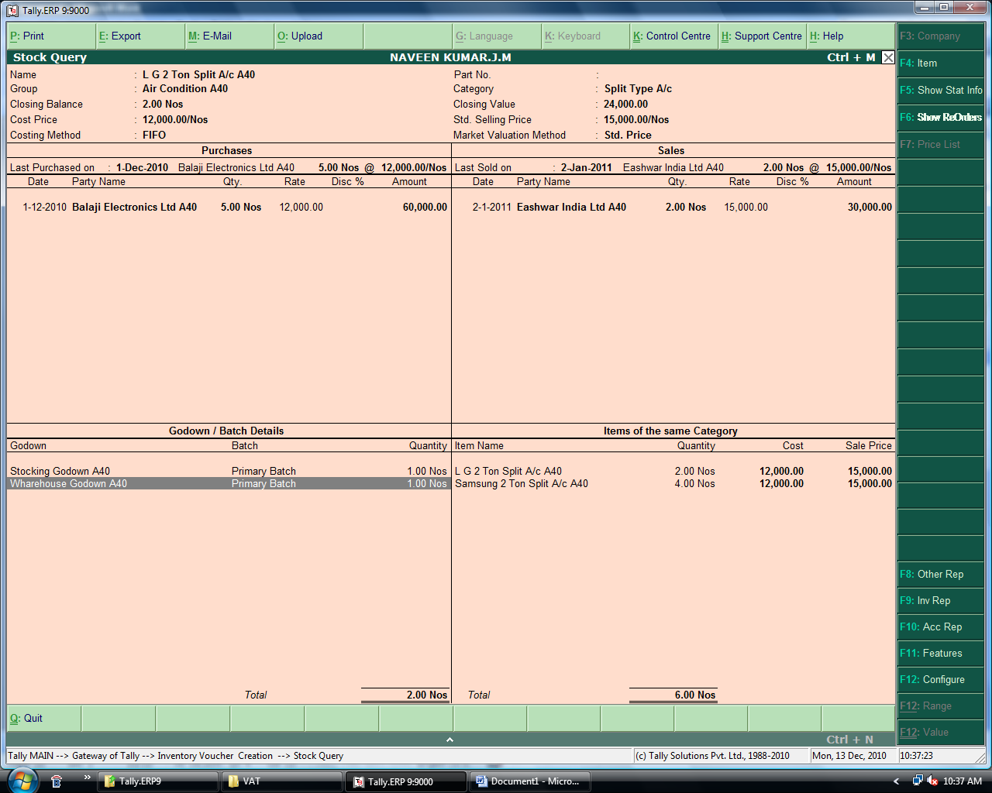

Stock Category Report
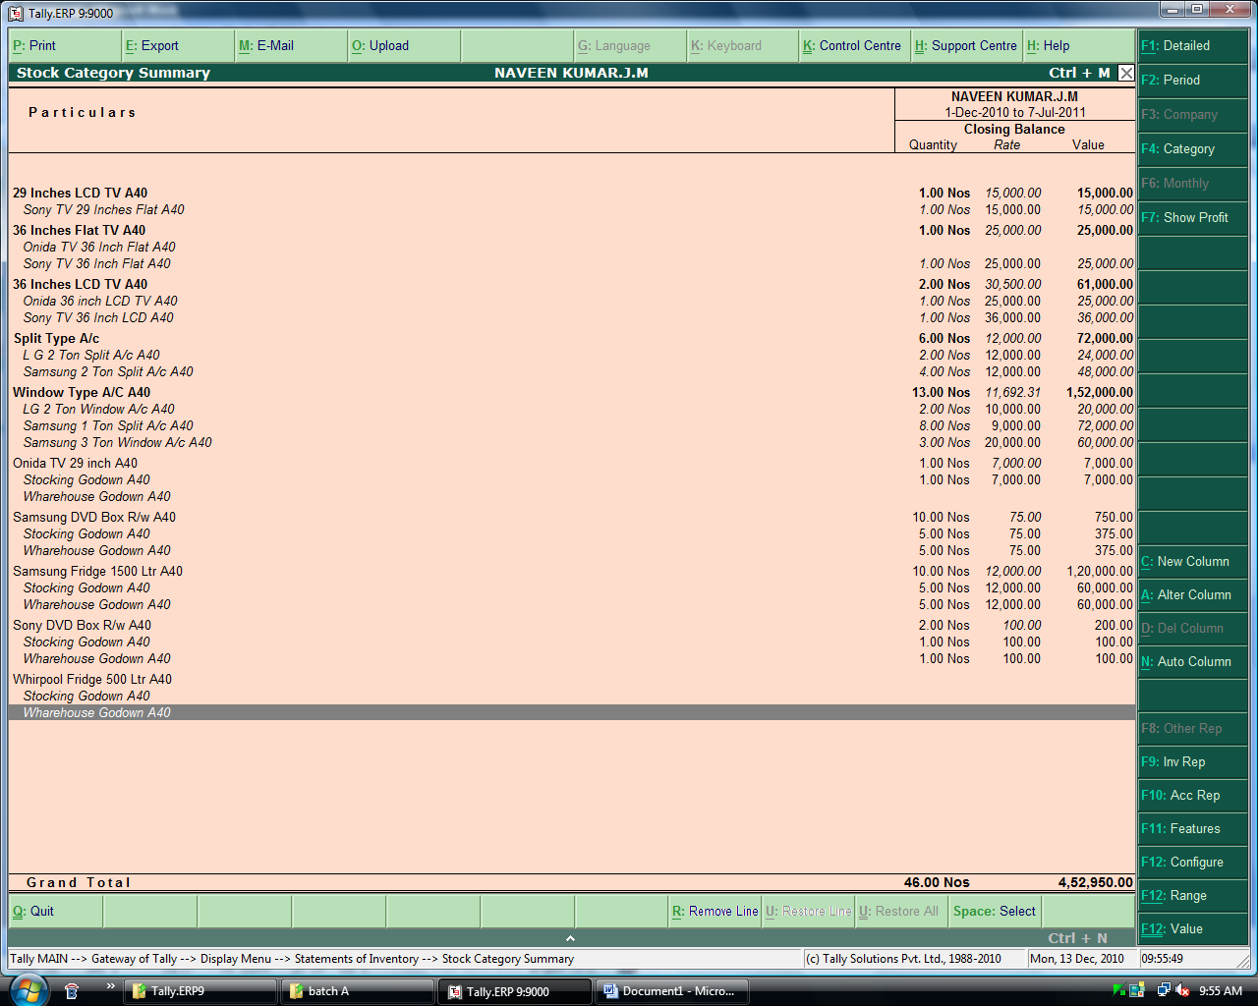

Godown Summary Report – Stacking Godown.
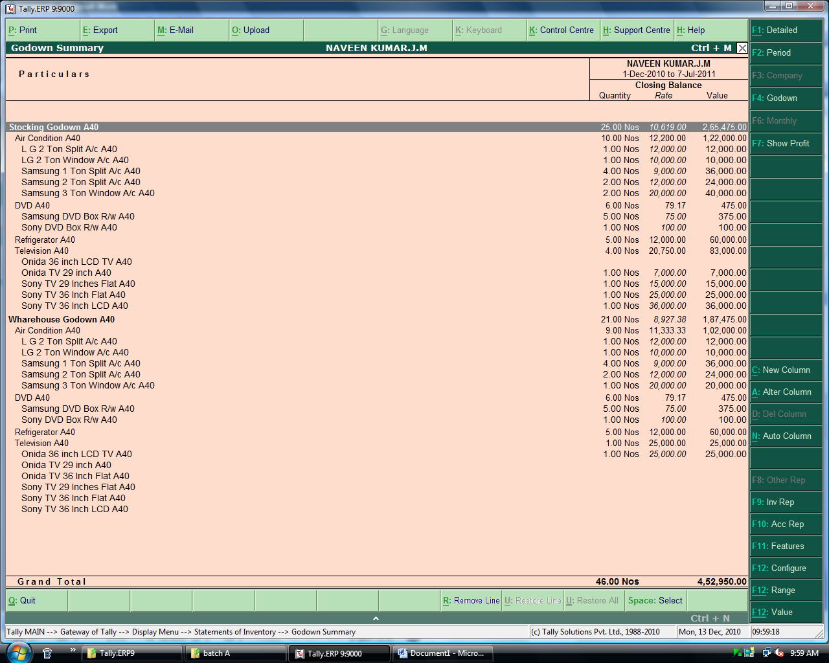

VAT Annexure - 1
I.
VAT Annexure - 2
VAT Annexure - 3
VAT Annexure - 4

Service Tax Payable Report
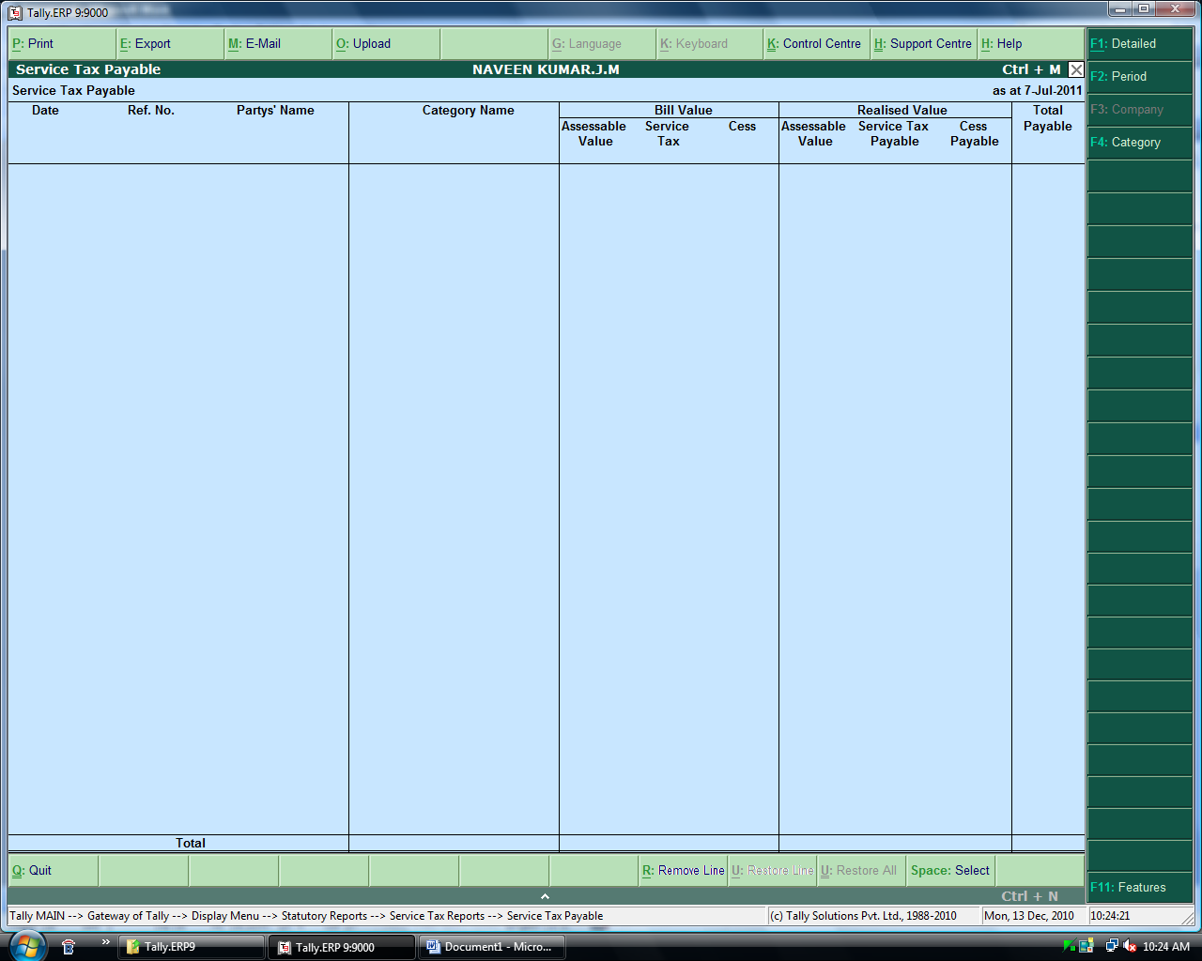

Cash Flow Statement
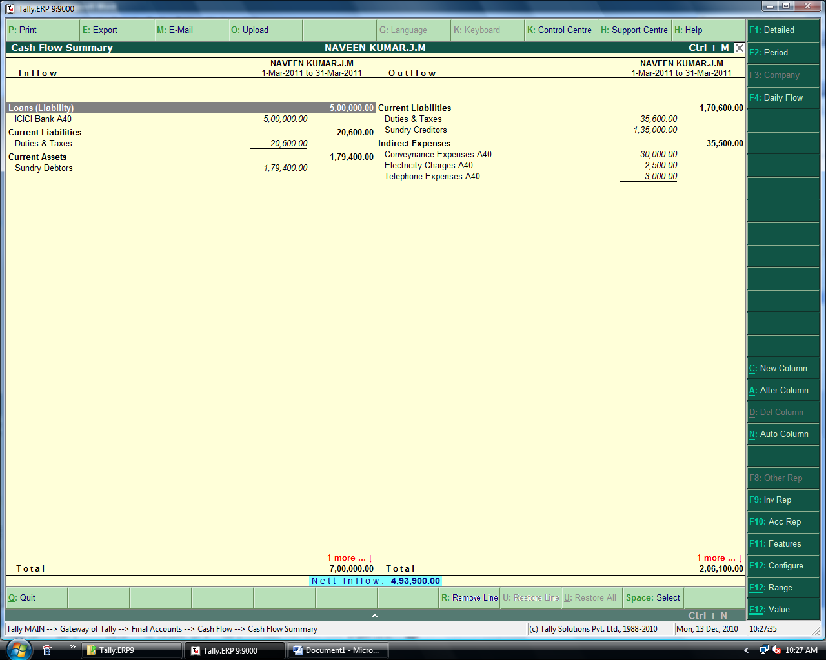

Fund Flow Statement.
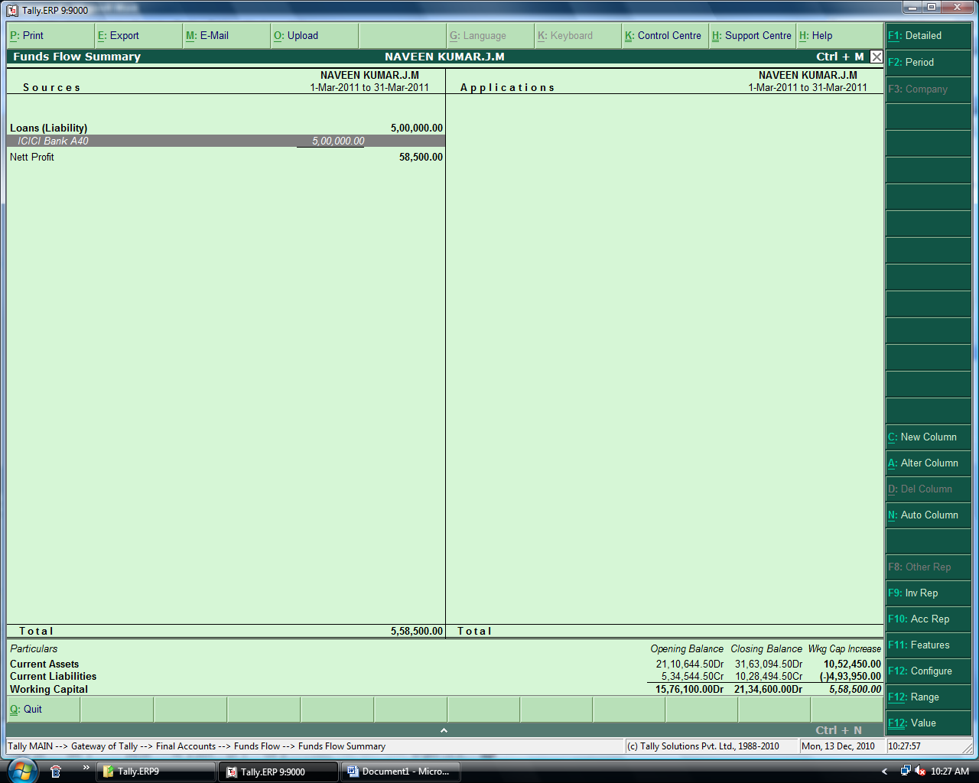

Cost Centere Break Up.
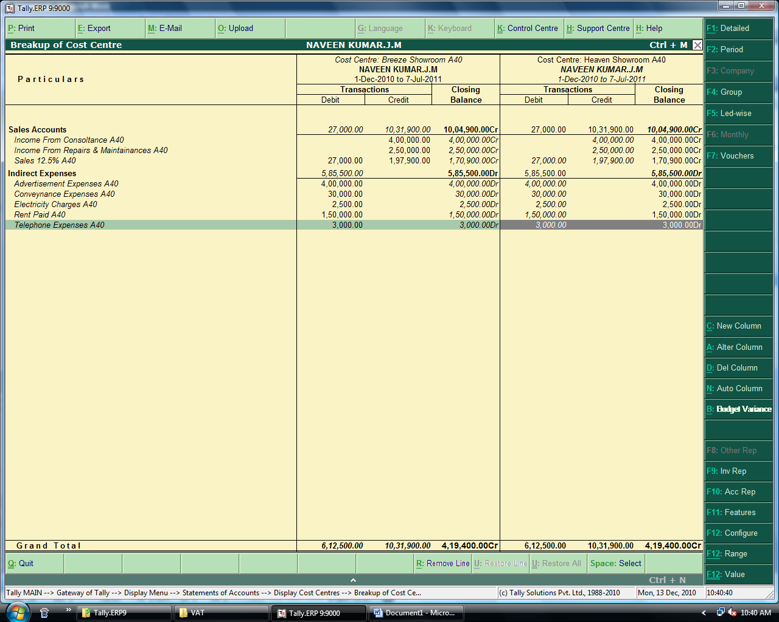

Sales Bill Pending.
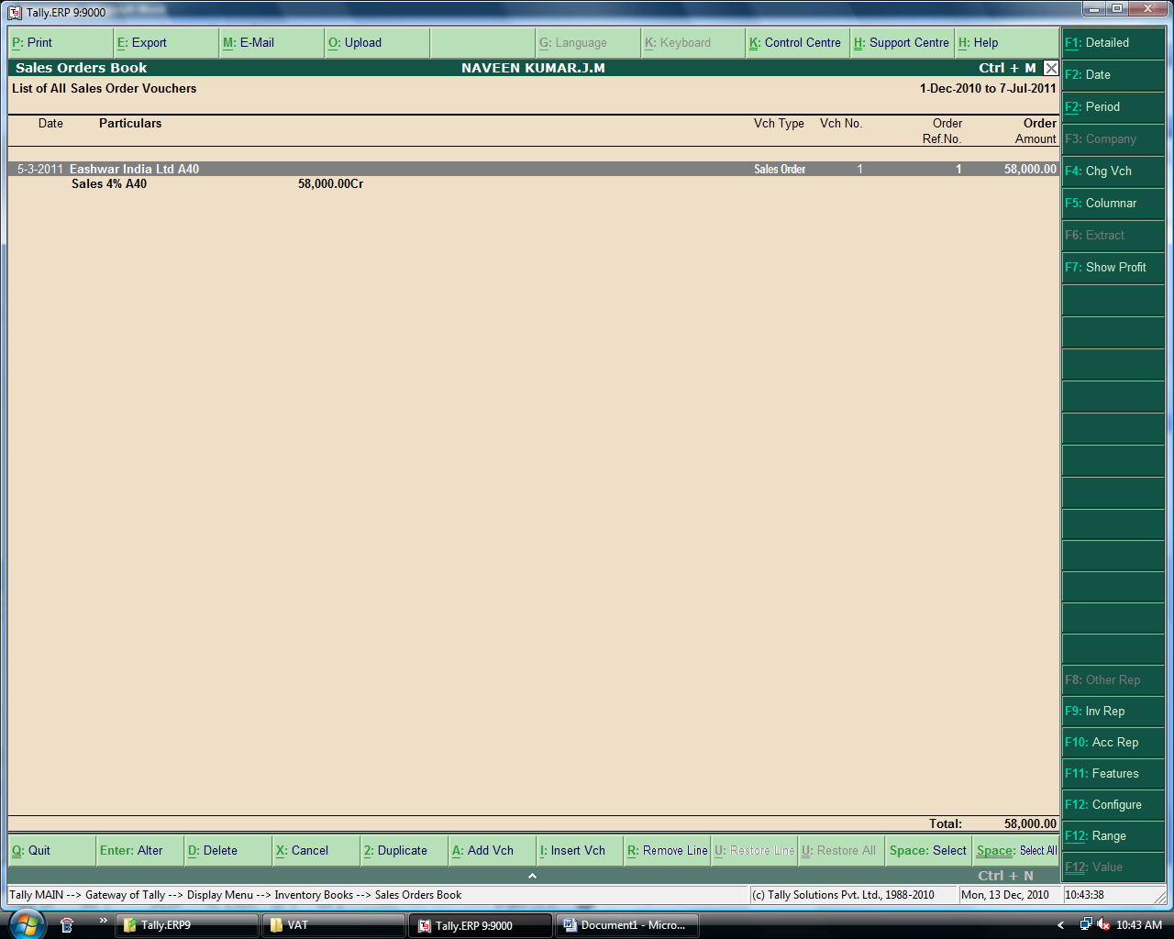

Purchase order Pending
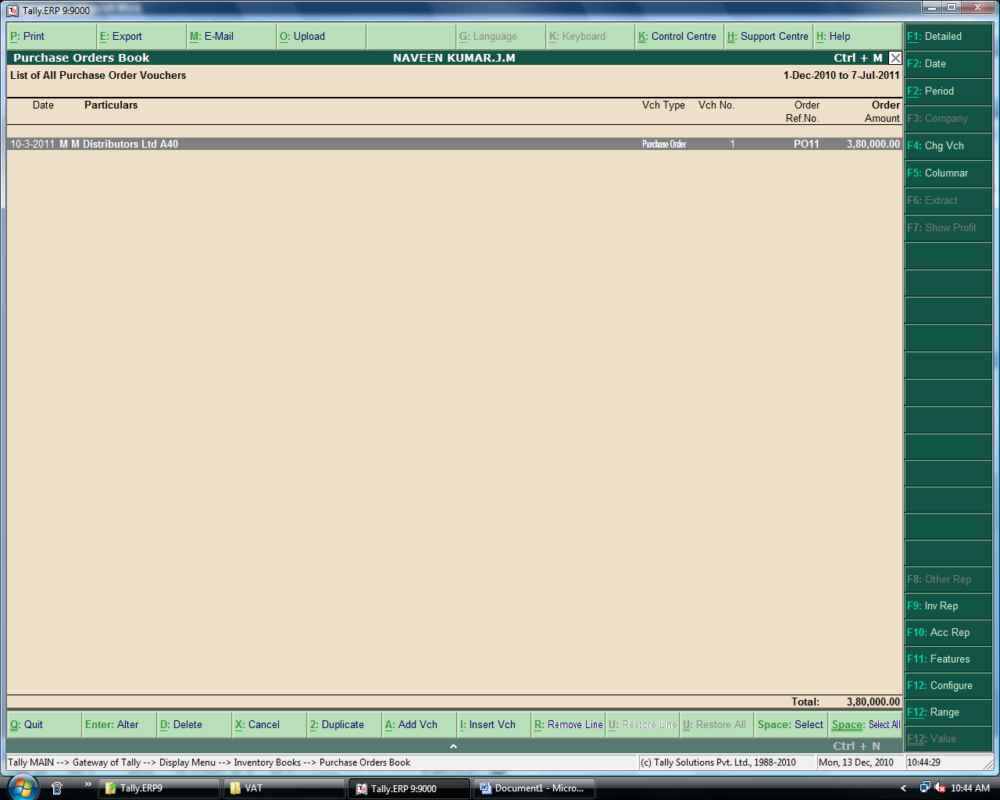

List of Accounts.
List of Ledgers | 25-Nov-2010 to 7-Jul-2011
Branch / Divisions
Capital Account
Reserves & Surplus | (Retained Earnings)
Share Holder 1 A40
Share Holder 3 A40
Share Ledger 2 A40
Current Assets
Bank Accounts
State Bank of India A40
Cash-in-hand
Cash
Cash A40
Deposits (Asset)
Loans & Advances (Asset)
Stock-in-hand
Sundry Debtors
Debtors for Service Income A40
Electronics India Private Limited A40
ITC Limited A40
Debtors - Local A40
Eashwar India Ltd A40
M M Distributors Ltd A40
Debtors-Oversees A40
Vikas Singapore Ltd A40
Current Liabilities
Duties & Taxes
Service Tax Accounts A40
Service Tax Payable - Audit Consultancy - A40
Service Tax Payable - Repairs Maintainences A40
TDS Account A40
TDS Payable for Advertisement A40
TDS Payable for Rent A40
VAT Accounts A40
Input VAT 12.5% A40
Input VAT 4% A40
Output VAT 12.5% A40
Output Vat 4% A40
Vat Payable Account A40
Provisions
Sundry Creditors
Creditor for Expenses A40
JD & Jerry Advertisers A40
L & T Limited A40
Creditors - Local
Balaji Electronics Ltd A40
Manikandan Electronics Limited A40
Creditors - Overseas A40
Ever Win Company Limited A40
Direct Expenses | (Expenses (Direct))
Direct Incomes | (Income (Direct))
Fixed Assets
Furneture & Fittings A40
Land & Building A40
Machineries A40
Indirect Expenses | (Expenses (Indirect))
Advertisement Expenses A40
Conveynance Expenses A40
Discount Allowed A40
Electricity Charges A40
Rent Paid A40
Salaries Paid A40
Telephone Expenses A40
Indirect Incomes | (Income (Indirect))
Discount Recieved A40
Rent Recieved A40
Investments
Investments A/c A40
Loans (Liability)
Bank OD A/c | (Bank OCC A/c)
Secured Loans
Unsecured Loans
ICICI Bank A40
Misc. Expenses (ASSET)
Purchase Accounts
Purchase 12.5% A40
Purchase 4% A40
Sales Accounts
Income From Consoltance A40
Income From Repairs & Maintainances A40
Sales 12.5% A40
Sales 4% A40
Suspense A/c
Profit & Loss A/c

Stock Group Summary
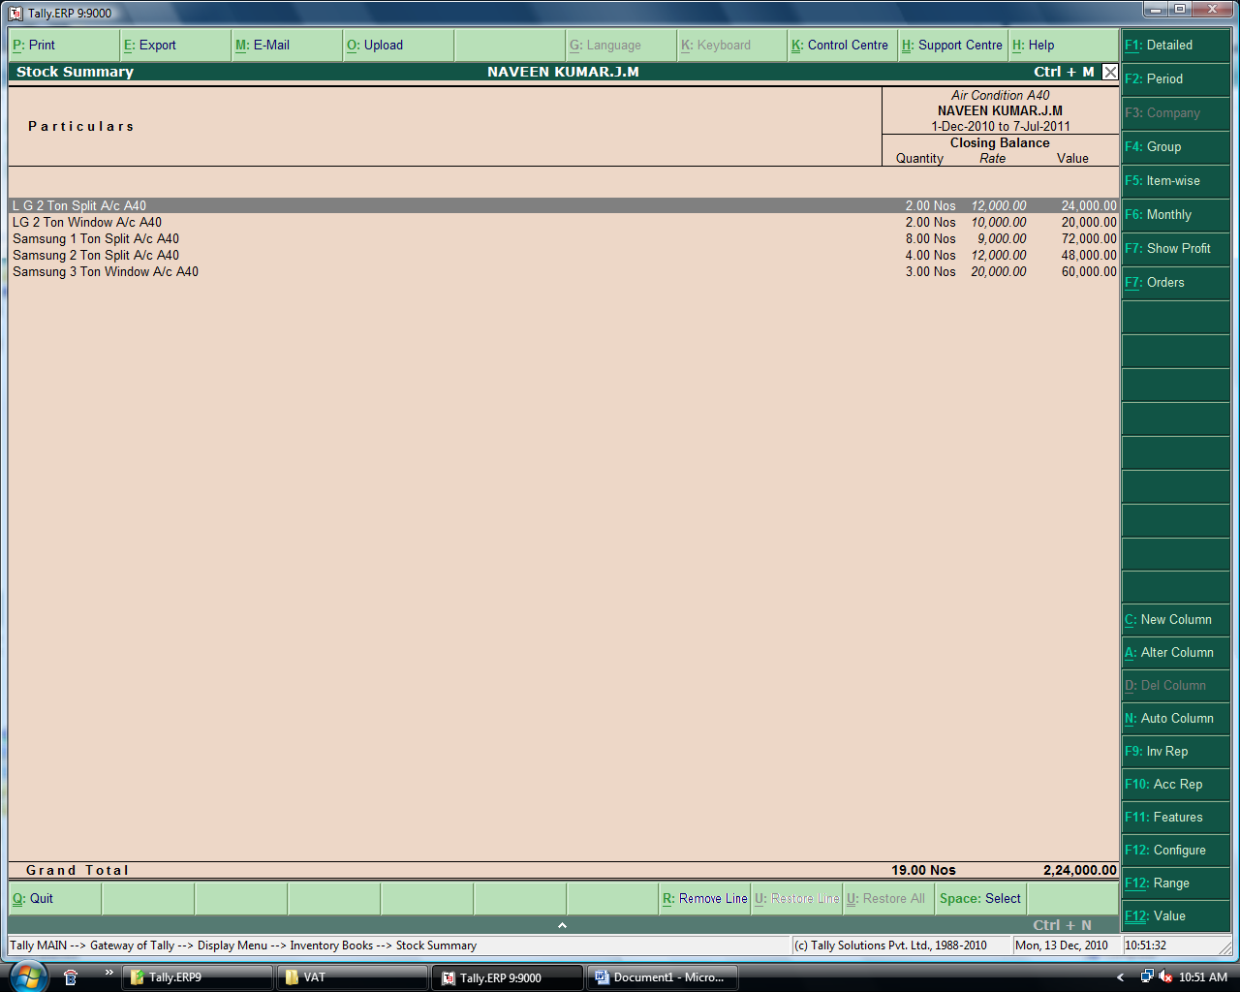

Stock Items Report
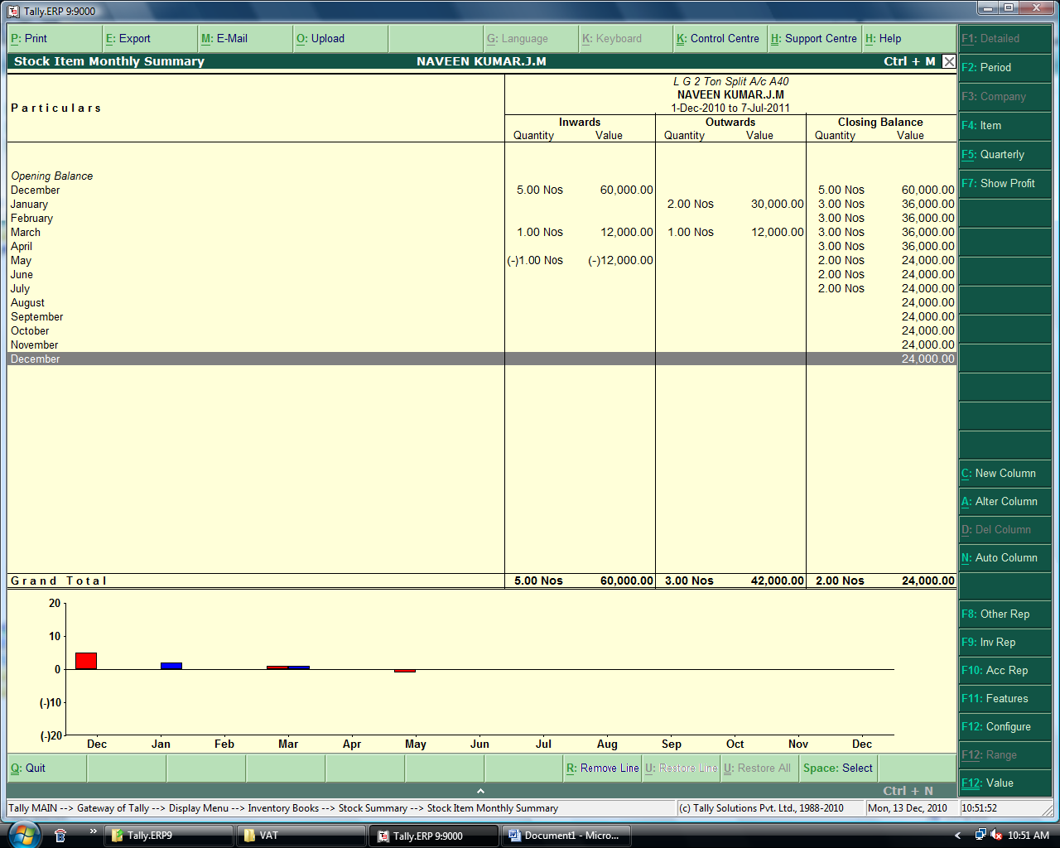

Conclusion

I would like to take this opportunity to thank the ICAI and the faculty of the department of the department of ITT for their valuable support and assistance in enabling me to complete this project on a successful note. Also I believe that my project on Tally complied in partial fulfillment of 100 hours course satisfactorily meet the requirement of department of ITT.

Besides, I hereby thank all kind hearts that helped for completion of this project without which this would have not been possible. I also think that the management would have been satisfied with the reports produced as per their need for future decision-making and productive measures.

To conclude, I do hope my project satisfies the requirement of the course as it has to me.

Naveen Kumar J M
Reg No: SRO0273351
Reg No:A 40

Bibliography

Various Websites


- www.icai.org

- Tally Gold – Multi User – Auditor Edition.

- Caclubindia.com

