Impact of Macroeconomic Factors On Money Supply
Managerial Economics and Business Environment

Effect of Macroeconomic factors on Money Supply

INTRODUCTION:

Inflation and monetary policy are closely related concepts wherein the latter can be used efficiently to reduce the effect of the former. Inflation is the rise in prices and wages that reduces the purchasing power of money. Monetary policy is the regulation adopted by the central bank, which stabilizes the prices and maximizes production and employment of the country.
Monetary policy is a regulation of a central bank which controls size and growth rate of the money supply. Monetary policy directly influences the interest rates which in turn has a negative relation with the price level. In the face of inflation the central bank of the country generally resorts to a rise in the cash reserve ratio, repo rate and reverse repo rate. The basic idea is to reduce the money supply in the economy. This would reduce aggregate demand. This reduction would again help reduce the price level. Monetary policy is adopted with an objective to make the most of production and employment and consequently stabilize the price level of a country. Monetary policy also regulates the interest rate, availability of credit and at the same time promotes the overall economic growth of a country.

Inflation occurs when the general level of prices is increasing. Today we calculate inflation by using price indexes-weighted averages of the prices of thousands of individual products. The CPI measures the cost of a market basket of consumer goods and services relative to the cost of that bundle during a particular base year. The GDP deflator is the price of GDP. In India, inflation is measured through WPI (Wholesale Price

Index) which includes a basket of 435 goods sans services. The recent WPI Index of Indian inflation is given below:-

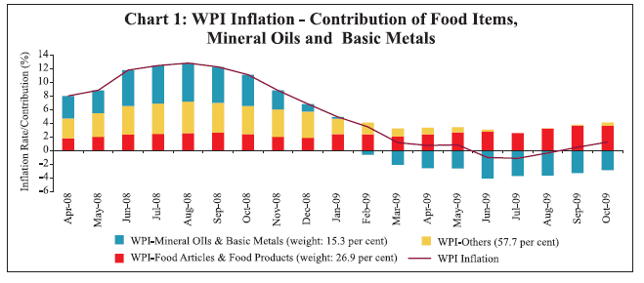
Source: www.rbi.org.in/scripts/AnnualPublications.aspx?head=Macroeconomic and Monetary Developments.html

Impacts of inflation:

Inflation affects the real economy in two specific areas: it can harm economic efficiency, and it can affect total output. We begin with the efficiency impacts:-
Inflation impairs economic efficiency because it distorts prices and price signals. In a low inflation economy, if the market price of a good rises, both buyers and sellers know that there has been an actual change in supply and/or demand conditions for that good, and they can react appropriately. By contrast in a high inflation economy, its much harder to distinguish between changes in relative prices and changes in the overall price level.
Inflation also distorts the use of money. Currency is money that bears a zero nominal interest rate. If the if the inflation rate rises from 0 to 10% annually, the real interest rate on currency falls from 0 to -10% per year. There is no way to correct this distortion. As a result of the negative real interest rate on money, people devote real resources to reducing their money holdings during inflationary times. They go to the bank more often. Corporations set up elaborate cash management schemes. Real resources are thereby consumed simply to adapt to a changing monetary yardstick rather than to make productive investments. The annual Inflation rate Y-o-Y basis for India:-

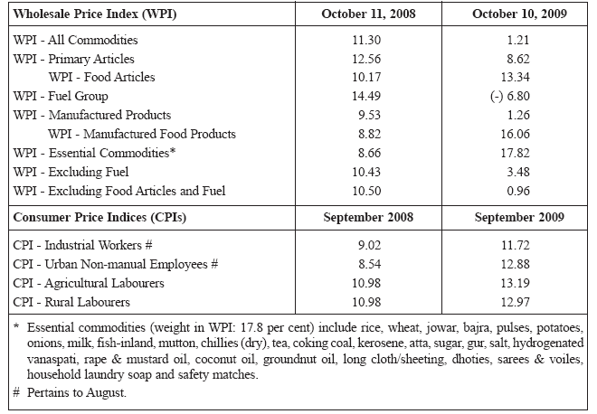

Source: http://www.rbi.org.in/scripts/AnnualPublications.aspx?head=Macroeconomic and Monetary Developments

Types of money:

Commodity money: Money as a medium of exchange first came into human history in the form of commodities. A great variety of items have served as money at one time or other-cattle, olive oil, beer or wine, copper, iron, gold, silver, diamonds etc. By the eighteenth century commodity money was almost exclusively limited to metals like silver and gold. These forms of money had intrinsic value, meaning that they had use value in themselves. Because money had intrinsic value, there was no need for the government to guarantee its value, and the quantity of money was regulated by the market through the supply and demand for gold or silver. The advent of monetary control had led to a much more stable currency system. The intrinsic value of money is now the least important thing about it.
Modern money: The age of commodity money gave way to the age of paper money. The essence of money is now laid bare. Money is wanted not for its own sake but for the things it will buy. We do not wish to consume money directly; rather we use it by getting rid of it. Even when we choose to keep money it is valuable only because we can spend it later on. The use of paper money has become wide spread because it is a convenient medium of exchange. Currency is easily carried and stored. The fact that private individuals cannot legally create money keeps it scarce. Given this limitation on supply currency has value. It can buy things.

COMPONENTS OF THE MONEY SUPPLY:

The major monetary aggregates are the quantitative measures of the supply of money. They are known today as M₁ , M₂, M₃ and M₄
Narrow (Transactions) money: - One important and closely watched measure of money is narrow or transactions money denoted by M₁, which consists of items that are actually used for transactions. The following are the components of M₁:-
- Coins- Includes coins not held by banks.
- Paper Currency- More significant is paper currency. Most of us know little more about a 100/- or 500/- bill than it is inscribed with the picture of a statesman, that it bears some official signatures, and that each has a numeral showing its face value.
Paper currency and coins are legal tender, which must be accepted for all debts, public and private.
- Checking Accounts- There is a third component of narrow money; checking deposits or bank money. These are funds, deposited in banks and other financial institutions, on which we can write checks. The deposit is like any other medium of exchange. Possessing the essential properties of money, bank checking account deposits are counted as narrow money as part of M₁.
Broad Money: - Sometimes called near money, M₂ includes M₁ as well as other close substitutes for M_{1.} More precisely the components of M₂ are:-

M₁

Savings accounts and small time deposits.
- Retail money market mutual funds.
These are near money because they are safe, guaranteed by the government and can be quickly converted into M₁.
M3: Equals M2 + large time deposits, institutional money-market funds, short-term repurchase agreements, along with other larger liquid assets. M3 is no longer published or revealed to the public by the US central bank. However, it is estimated by the web site Shadow Government Statistics. It is also estimated on a weekly basis by the web site Now and the Future.
M4: M3 + All deposits with post office savings banks (excluding National Savings Certificates)
The following figure gives the annual variations in monetary aggregates (%) of India:-

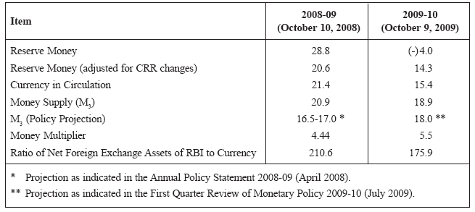

Source: http://www.rbi.org.in/scripts/AnnualPublications.aspx?head=Macroeconomic and Monetary Developments

The variations in US monetary aggregates are given below from a period of 1970-2007:-
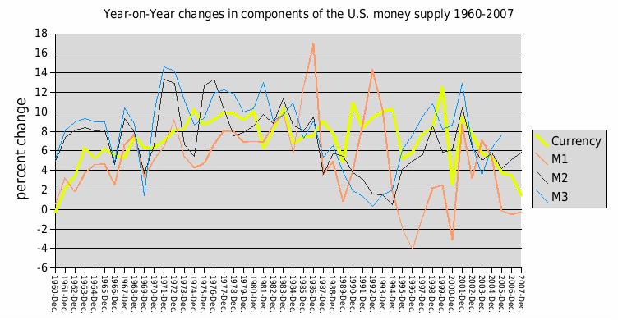

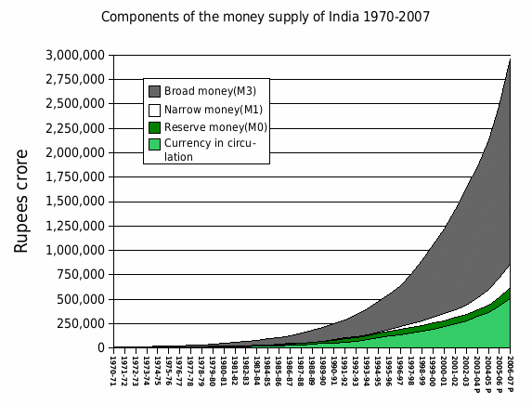
Source: http://en.wikipedia.org/wiki/Monetary_policy

LINK OF GDP WITH MONEY SUPPLY:

Monetary exchange equation
Money supply is important because it is linked to inflation by the equation of exchange:
MV = PQ
- M is the total dollars in the nation’s money supply
- V is the number of times per year each dollar is spent (velocity)
- P is the average price of all the goods and services sold during the year
- Q is the quantity of assets, goods and services sold during the year
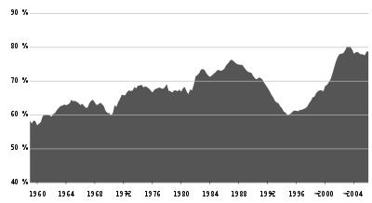
U.S. M3 money supply as a proportion of gross domestic product.
Source: http://en.wikipedia.org/wiki/Monetary_policy
- velocity = the number of times per year that money turns over in transactions for goods and services (if it is a number it is always simply nominal GDP / money supply)
- nominal GDP = real Gross Domestic Product × GDP deflator
- GDP deflator = measure of inflation.
The quantity of assets goods and service sold during the year could be grossly estimated by GDP back in the 1960s. This is not the case anymore because of the rise of financial transactions relative to real transaction. Money supply may be less than or greater than the demand of money in the economy. If the money supply grows faster than its use, inflation in a class of goods or assets is likely to follow (according to Milton Friedman, "inflation is always and everywhere a monetary phenomenon"). This statement must be qualified slightly, due to changes in velocity. While the monetarists presume that velocity is relatively stable, in fact velocity exhibits variability at business-cycle frequencies, so that the velocity equation is not particularly useful as a short run tool. Moreover, in the US, velocity has grown at an average of slightly more than 1% a year between 1959 and 2005.
Monetarists reckon that to stabilize prices the rate of growth of the money supply needs to be carefully controlled. However, implementing this has proven difficult, as the relationship between measures of the money supply identified by monetarists and the rate of inflation has typically broken down as soon as policymakers have tried to target it. Keynesian economists believe that inflation can occur independently of monetary conditions. Other economists focus on the importance of institutional factors, such as whether the interest rate is set by politicians or (preferably) by an independent central bank, and whether that central bank is set an inflation target.
Economists have noted that M3 growth may not affect all assets or goods equally. For example, an almost constant rise in M3 in the 1970s, '80s and '90s produced a rise in consumer goods prices "inflation" in the seventies and a rise in the stock market in the '80s and '90s and a rise in home prices after 2001. When home prices went down, the Federal Reserve kept its loose monetary policy and lowered interest rates; the attempt to slow price declines in one asset class, e.g. real estate, may well have caused prices in other asset classes to raise, e.g. commodities.

Effect of GDP on Money Supply:

Money supply and GDP do not automatically affect each other, but Money Supply can affect GDP depending on monetary policy; the expressed intention in economic management is to monitor the money supply to allow transactions to take place. Therefore, if money supply is severely restricted it is likely to affect the GDP: i.e.: reduce the volume of transactions. The GDP can only increase the demand of money... and transactions will stall if that demand is not met. GDP is also inadequate as a measure of real production, because it does not truly represent production, but it is a statistic of dollar value of all transactions that have taken place. A comparison of the two statistics maybe valuable after the fact to examine the difference in growth ratio, to maybe predict near term inflation, if money growth was too much larger than GDP.
Money is NOT increased as a result of greater ability to produce, but it is increased intentionally to attempt to allow the greater ability potential to materialize. Money supply affects GDP by making transactions more efficient. You don't need to find someone to trade with to get what you want, everyone takes money. The more of it there is, the larger this effect becomes.
GDP affects money supply through the banking system. When growth is high, banks make additional loans and expand the money supply. The Federal Reserve also has something to do with it, but the dynamic aspects of money supply rest with the banking sector.

THE EFFECT OF INFLATION ON MONETARY TRANSMISSION

Having examined the building blocks of money, we now describe the monetary transmission mechanism, the route by which changes in the supply of money are translated into changes in output, employment, prices and inflation. The Reserve Bank is concerned about inflation and has decided to slow down the economy. There are five steps in the process:-

- To start the process, the Reserve Bank takes steps to reduce bank reserves. Reserve Bank reduces bank reserves primarily by selling government securities in the open market. This open market operation changes the balance sheet of the banking system by reducing total bank reserves.
- Each dollar reduction in bank reserves produces a multiple contraction in checking deposits, thereby reducing the money supply. Since the money supply equals currency plus checking deposits, the reduction in checking deposits reduces the money supply.

- The reduction in the money supply increases interest rates and tightens credit conditions. With an unchanged demand for money, a reduced supply of money will raise interest rates. In addition the amount of credit (loans and borrowing) available to people will decline. Interest rates will rise for mortgage borrowers and for businesses that want to build factories, buy new equipment, or add to inventories. Higher interest rates tend to reduce asset prices (such as those of stocks, bonds, houses) and therefore depress the values of peoples’ assets.

- With higher interest rates and lower wealth, interest sensitive spending-especially investment, tends to fall. The combination of higher interest rates, tighter credit and lower wealth tends to reduce investment and consumption spending. Businesses will scale down their investment plans, as will state and local governments. For example, higher interest rates may lead airlines to stretch out their purchases of new aircraft. Similarly consumers may decide to but a smaller house, or to renovate their existing one, when rising mortgage interest rates increase monthly payments relative to monthly income. In an economy increasingly open to international trade, higher interest rates may raise the foreign exchange rate depressing net exports. Hence, tight money will raise interest rates and reduce spending on interest sensitive components of aggregate demand.

- Finally, the pressures of tight money, by reducing aggregate demand, will reduce income, output, jobs and inflation. The aggregate supply and demand analysis shows how a drop in investment and other autonomous spending may depress output and employment sharply. Furthermore, as output and employment fall below the levels that would otherwise occur, prices tend to rise less rapidly or even to fall. Inflationary forces subside.

THE SUPPLY OF AND DEMAND FOR MONEY

One major step in the transmission mechanism is the response of interest rates and credit conditions to changes in the supply of money. The demand for money depends primarily on the need to undertake transactions. Households, businesses and governments hold money so that they may buy goods, services and other items. In addition, some part of the demand for money derives from the need for a safe and highly liquid asset.
The supply of money is jointly determined by the private banking system and the nation’s central bank. The central bank, through open market operations and other instruments, provides reserves to the banking system. Commercial banks then create deposits out of the central bank reserves. By manipulating reserves, the central bank can determine the money supply within a narrow margin of error.
The supply and demand for money jointly determine the market interest rates. The following figure shows the total quantity of money M on the horizontal axis and the nominal interest rate i on the vertical axis. The supply curve is drawn as a vertical line on the assumption that the Central Bank keeps the money supply constant at M*. In addition we show the money demand schedule as a downward sloping curve because the holdings of money decline as interest rates rise during inflation. At higher interest rates, people and businesses shift more of their funds to higher yield assets.
i
D
Interest Rate Percent per Year
S

D
S
0
M*
M
MONEY
The intersection of the supply and demand schedules in the figure determines the market interest rate. Interest rates are the prices paid for the use of money. In the figure, the equilibrium interest rate at the point of intersection of supply and demand. Only at this point is the level of the money supply that the Central Bank has targeted consistent with the desired money holdings of the public. During inflation, at a higher interest rate, there would be excessive money balances. People would get rid of their excessive money holdings by buying bonds and other financial instruments, thereby lowering market interest rates towards the equilibrium rate.

Shifts in the Money Market due to Inflation:

To understand the monetary transmission mechanism, we need to see how changes in the money market due to Inflation affect interest rates. The Central Bank becomes worried about Inflation and tightens monetary policy by selling securities and reducing the money supply. The impact of a monetary tightening is shown in the following figure. The leftward shift of the money supply schedule means that market interest rates must rise to induce people to swap their money for bonds and other non-monetary assets. The gap between E and N shows the extent of excess demand for money at the old interest rate. Interest rates rise until the new equilibrium is attained shown at point E’, with a new and higher interest rate.

i
Interest Rate Percent per Year
D
S’
S

N
E
D
0
M
M*
M*1
Money

There are also frequent shocks to money demand due to cost push Inflation. With higher prices the demand for money would increase, shifting the money demand curve to the right from DD to D’D’ as shown in the following figure and leading to an increase in equilibrium interest rates.
Interest Rate Percent per Year
i
0
Money
E
E’’
S
D’
D’
D
D
M
M*

The money market is affected by a combination of the public’s desire to hold money (represented by demand-for-money DD curve) and the Central Bank’s monetary policy (which is shown as a fixed money supply SS). Their interaction determines the market interest rate, i. During Inflation a restrictive monetary policy shifts the SS curve to the left, raising market interest rates. Likewise due to Inflation an increase in the cost of goods and services shifts the DD curve to the right and raises interest rates.

REGRESSION ANALYSIS

SAMPLE DATA:

YEAR | GDP (% change) | Inflation rates (%change) | money supply(% change)
1993-1994 | 10.61188595 | -46.03 | 7.7565
1994-1995 | 9.393857595 | 60.52 | 4.7655
1995-1996 | 12.74847483 | 0.13 | 5.3455
1996-1997 | 4.934554847 | -12.21 | 6.8756
1997-1998 | 5.826574949 | -20.2 | 5.98765
1998-1999 | 4.162765716 | -64.7 | 6.951871658
1999-2000 | 11.46848531 | -14.15 | 6
2000-2001 | 7.698581224 | -5.74 | 6.132075472
2001-2002 | 8.544774948 | 13.71 | 9.777777778
2002-2003 | 7.564094249 | -11.43 | 1.214574899
2003-2004 | 12.22462998 | -1.02 | 4
2004-2005 | 14.33173045 | 12.72 | 5.769230769
2005-2006 | 14.74366444 | 45.48 | 3.745454545
2006-2007 | 14.26298757 | 3.16 | 5.152471083
2007-2008 | 14.39094463 | 18.71 | 4.333333333
2008-2009 | 12.66788754 | 12.18 | 3.514376997

THE GDP FIGURES ARE GIVEN BELOW:-
Source: www.rbi.org.in/scripts/AnnualPublications.aspx

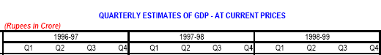

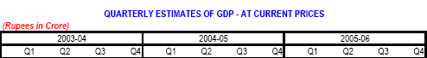

THE MONEY SUPPLY FIGURES ARE GIVEN BELOW:-
Source: www.rbi.org.in/scripts/AnnualPublications.aspx

THE INFLATION FIGURES ARE GIVEN BELOW:-

Source: http://www.financegurukul.com/?p=986

YEAR RATE %CHANGE
1993 | 6.362 | -46.03 %
1994 | 10.212 | 60.52 %
1995 | 10.225 | 0.13 %
1996 | 8.977 | -12.21 %
1997 | 7.164 | -20.20 %
1998 | 13.231 | 84.69 %
1999 | 4.67 | -64.70 %
2000 | 4.009 | -14.15 %
2001 | 3.779 | -5.74 %
2002 | 4.297 | 13.71 %
2003 | 3.806 | -11.43 %
2004 | 3.767 | -1.02 %
2005 | 4.246 | 12.72 %
2006 | 6.177 | 45.48 %
2007 | 6.372 | 3.16 %
2008 | 5.18 | -18.71 %

From the above found sources of data the following table has been generated for the purpose of regression analysis:-

GDP at market prices(rupees in crores) | Money supply | Inflation Rate | Year
1276558 | 1507000 | 10.212 | 1994
1395845 | 1694090 | 10.225 | 1995
1548579 | 1740000 | 8.977 | 1996
1689595 | 1985758 | 7.164 | 1997
1751199 | 2000000 | 13.231 | 1998
1952035 | 2120000 | 4.67 | 1999
2102314 | 2250000 | 4.009 | 2000
2281952 | 2470000 | 3.779 | 2001
2454561 | 2500000 | 4.297 | 2002
2754622 | 2600000 | 3.806 | 2003
3149407 | 2750000 | 3.767 | 2004
3613745 | 2853000 | 4.246 | 2005
4129173 | 3000000 | 6.177 | 2006
4723400 | 3130000 | 6.372 | 2007
5321755 | 3240000 | 5.18 | 2008

Analysis :

For the purpose of analysis, a 15 year period data is being considered.
Through the data given above, the following data regression analysis has been done using Microsoft Excel software by copying the data into a spreadsheet. Then through Data Analysis add-in, the results are generated by running Regression. The first summary output obtained below is a simple regression model between money supply and GDP while the next summary output model is the result showing the multiple regression model between money supply, GDP, inflation rate.

Interpretation:

In our regression analysis we have considered money supply as the dependent variable while GDP and Inflation as the independent variables. Herein we are studying the effect of these independent variables on the dependent variable i.e. money supply and how far are these significant in explaining the change in money supply.

In our first summary output we did a simple regression between money supply and GDP and found the R square value to be 93% which shows that the change in money supply is significant to an extent of 93% due to a corresponding change in GDP. Further the P value is 1.3E which is less than the value of α which is 0.05 for a 95% level of significance. This means that GDP is a significant explanatory variable to correlate the changes in money supply.

In our last summary output we did a multiple regression wherein we took money supply as the dependent variable and GDP and inflation as the independent variables. Through this analysis we come to know that the R square value is 96% an increase of 3% over the simple regression output. This explains that the relation of GDP and inflation with the money supply together is more than it is individually. It explains for 96% significance in the value of money supply relative to GDP and Inflation. Further the P value of 0.03 and 2.99E is less than α value of 0.05, so we again conclude that each one is a significant explanatory variable.

CONCLUSION

The money supply is ultimately determined by the policies of the Central Bank. By setting reserve requirements and the discount rate, and especially by undertaking open market operations, the Central Bank determines the level of reserves, the money supply and short term interest rates based on the Inflation rate and the GDP figures. Inflation rates and GDP figures have a direct impact on the money supply since their increase and decrease determines the level of circulating money in the system as and when required by the Central Bank. Banks and the public are cooperating partners in this process. Banks create money by multiple expansions of reserves; the public agrees to hold money in depository institutions.

Through our regression analysis we have come to conclude that both GDP and Inflation rate have a significant impact on the changes in money supply observed over a period of 15 years in this project work. The regression values are highly significant in explaining the relationship between the dependent and independent variables.

Thus, we conclude that macroeconomic factors like GDP and Inflation rate have a considerable impact on money supply.

