~Beauty of Mathematics~
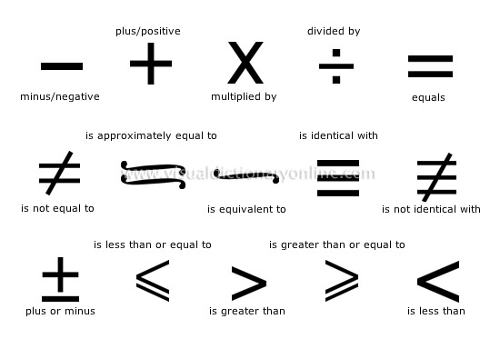
1 x 8 + 1 = 9
12 x 8 + 2 = 98
123 x 8 + 3 = 987
1234 x 8 + 4 = 9876
12345 x 8 + 5 = 98765
123456 x 8 + 6 = 987654
1234567 x 8 + 7 = 9876543
12345678 x 8 + 8 = 98765432
123456789 x 8 + 9 = 987654321
1 x 9 + 2 = 11
12 x 9 + 3 = 111
123 x 9 + 4 = 1111
1234 x 9 + 5 = 11111
12345 x 9 + 6 = 111111
123456 x 9 + 7 = 1111111
1234567 x 9 + 8 = 11111111
12345678 x 9 + 9 = 111111111
123456789 x 9 +10= 1111111111
9 x 9 + 7 = 88
98 x 9 + 6 = 888
987 x 9 + 5 = 8888
9876 x 9 + 4 = 88888
98765 x 9 + 3 = 888888
987654 x 9 + 2 = 8888888
9876543 x 9 + 1 = 88888888
98765432 x 9 + 0 = 888888888
Brilliant, isn't it?
And look at this symmetry:
1 x 1 = 1
11 x 11 = 121
111 x 111 = 12321
1111 x 1111 = 1234321
11111 x 11111 = 123454321
111111 x 111111 = 12345654321
1111111 x 1111111 = 1234567654321
11111111 x 11111111 = 123456787654321
111111111 x 111111111 = 12345678987654321
Now, take a look at this...
From a strictly mathematical viewpoint,
What Equals to 100%?
What does it mean to give MORE than 100%?
Ever wonder about those people who say they are giving more than 100%...
We have all been in situations where someone wants you to GIVE OVER 100%.
How about ACHIEVING 101%?
What equals to 100% in life?
Here's a little mathematical formula that might help answering these questions:
If:
A B C D E F G H I J K L M N O P Q R S T U V W X Y Z
Is represented as:
1 2 3 4 5 6 7 8 9 10 11 12 13 14 15 16 17 18 19 20 21 22 23 24 25 26
It is
H-A-R-D-W-O- R- K
8+1+18+4+2 3+15+18+11 = 98%
And
K-N-O-W-L-E- D-G-E
11+14+15+23+ 12+5+4+7+ 5 = 96%
But
A-T-T-I-T-U- D-E
1+20+20+9+20+ 21+4+5 = 100%
AND
L-O-V-E-O-F- G-O-D
12+15+22+5+15+ 6+7+15+4 = 101%

