March 2023 | 38TH EDITION

In this Update:

Content | Page No
Company Law | Page- 2
Securities Law | Page- 2 to 3
Posh | Page- 3
Bar Council of India | Page- 4
Insolvency Law: | Page- 4
Case Laws | Page- 5 to 6
Due Dates | Page- 7

Company Law:
1. MCA establishes a Centre for Processing Accelerated Corporate Exit (C-PACE)

Securities Law:
- SEBI Master Circular for Foreign Venture Capital Investors (FVCIs)
- Additional affirmations by Practicing Company Secretaries in Annual Secretarial Compliance Report
- SEBI prescribes time limits for FPIs to disclose information to Board and DPs

POSH:
1. Survey reveals only 8% employees aware of the PoSH Act

Bar Council of India
1. Bar Council Allows Foreign Lawyers, Law Firms To Practice in India

Insolvency Law:
IBBI revises format for serving copy of application to Board.

Case Laws:
Company law:
- Regulator disapproves of crowdfunding by startups
- Penalty imposed for not numbering Board meeting & Pages in Minutes. Insolvency Law:
- SC clarifies, Extinguishment of Debt under IBC will not lead to discharge of Criminal Charges under Negotiable Instrument Act.
POSH:
- Bombay HC quashed POSH FIR and directs ex-executive to pay charities Rs 1 lakh.

Due Dates
MARCH 2023
KNOWLEDGE UPDATE


COMPANY LAW

  - MCA establishes a Centre for Processing Accelerated Corporate Exit (C-PACE)

- C-PACE is expected to expedite the voluntary winding-up of bankrupt companies to less than six months from the mandatory two years at present.
- In Union Budget 2023-23, FM had proposed to establish the Centre for Processing Accelerated Corporate Exit (C-PACE) for speedy winding-up of companies and it is going to get implemented effective from April 1, 2023
- Click here for Notification

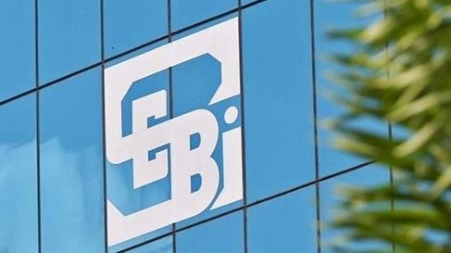
SECURITIES LAW

SEBI Master Circular for Foreign Venture Capital Investors (FVCIs)

- Firm commitment from their investors for a contribution of at least USD 1 million.
- The quarterly report on venture capital activity within seven days after the end of each calendar quarter in the format prescribed by SEBI.
- The report must be posted online on the portal created by SEBI for filings connected to FVCIs in order to simplify operations.
- Online system to be used for application for registration, reporting and filing
- Click here for Master Circular

Additional affirmations by Practicing Company Secretaries in Annual Secretarial Compliance Report

- Additional columns have been inserted to be effective from the financial year ending March 31, 2023, onwards such as Compliance with secretarial standards, performance evaluation, related party transactions, maintenance of websites, preservation of documents and others
- Click here for Annexure
DECEMBER 2022 KNOWLEDGE UPDATE
MARCH 2023
KNOWLEDGE UPDATE


SECURITIES LAW

SEBI prescribes time limits for FPIs to disclose information to Board and DPs

- If there is any material change in the direct or indirect in FPIs structure or ownership or control, FPIs are required to inform the Board and designated depository participants (DPs) within 7 working days.
- FPIs must maintain accurate details of their investor group with DPs at all times.
- DPs are obligated to inform to the Board, depositories and stock exchanges within 2 working days if any penalty, pending litigation or proceedings, findings of inspections or investigations have been initiated against them.
- Any information or particulars previously submitted to the Board by DPs are found to be materially false or misleading, it must inform the Board within 2 working days.
- Click here for Notification


POSH

1. Survey reveals only 8% employees aware of the PoSH Act.

- Survey conducted by Stratefix Consulting, in collaboration with the National Human Resource Development (NHRD).
- A total of 400 working professionals, comprising all genders and different age groups, participated in this survey where it revealed that only 8% of the respondents were aware of the PoSH policy prior to 2021.

It was found that 37% largely women have experienced sexual harassment at work and 11% said that they would leave the organisation rather than choose to report the harassment.
- It was also reported, 950 cases of virtual harassment versus 487 incidents of physical harassment at workplaces.
- 22% of respondents were not aware of what constitutes virtual sexual harassment
DECEMBER 2022 KNOWLEDGE UPDATE
MARCH 2023
KNOWLEDGE UPDATE

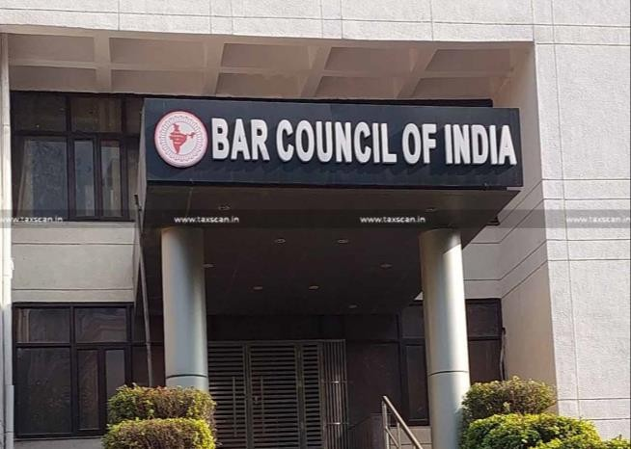
BAR COUNCIL OF INDIA

1. Bar Council Allows Foreign Lawyers, Law Firms To Practice in India

- The three broad areas which have been opened up for them include foreign law, arbitration matters and international legal issues.
- As per the rules, foreign lawyers and law firms will be entitled to practice only
in non-litigious matters.
- According to the BCI, a statutory body, opening up of law practice in India to foreign lawyers in cases would go a long way in helping legal profession/domain grow in India to the benefit of lawyers in India too.
- The registration fee for a foreign lawyer is US$25,000, and for a law firm it is US$50,000, without registration with BCI foreign lawyers or firms would not be able to practice in India.
- Click here for Notification


INSOLVENCY LAW

1. IBBI revises format for serving copy of application to Board

- Application for CIRP to be filed first with the Board and the Board shall forward the same to Information Utility who shall inform the other creditors of the Corporate Debtor (CD) and issue notice to applicant to file information of default as IU regulations.
- It’s a pre requirement for getting the case admitted by Adjudicating Authority.
- The revised format is provided in ‘Annexure A’ attached to the circular and a step by step guide in Annexure B.
- Click here for Circular
DECEMBER 2022 KNOWLEDGE UPDATE
MARCH 2023
KNOWLEDGE UPDATE


CASE LAWS

Company law
- Regulator disapproves of crowdfunding by startups

- The ROC order imposed the fine 2 lakhs on a small company in Delhi and Mumbai-based company has been fined Rs 1 lakh each on two of its directors for allegedly violating a provision of the Companies Act by raising capital through a technology platform
- Action was against the firms that raise equity investments through online pitch- making platforms to investors in violation of the Companies Act.
- Act prohibits companies going for private placement of securities from issuing any public advertisement or using marketing or distribution channels or agents to inform the public about such issue prevents from doing it also states that private placement cannot be offered to more than 200 individuals.
- Click here for Order

Penalty imposed for not numbering Board meeting & Pages in Minutes.

- The company and its officers, have defaulted in the provisions of the Act for not numbering Board Meeting and the pages in the minute book of the company and Minutes book were not signed by the Chairman and the minute book of the Company was also not paginated.
- ROC has imposed penalty of Rs. 25,000 on the Company and Rs. 5,000 on officer in default.
- Click here for Order

Insolvency Law
- SC clarifies, Extinguishment of Debt under IBC will not lead to

discharge of Criminal Charges under Negotiable Instrument Act.
- In this case the issue for consideration before the Supreme Court was whether during the pendency of the proceedings under the IBC, the proceedings under the Negotiable Instrument Act can continue simultaneously or not.
- In which it was held that the proceedings under the Negotiable Instrument Act had already commenced and during the pendency the plan is approved or the
DECEMBER 2022 KNOWLEDGE UPDATE
MARCH 2023
KNOWLEDGE UPDATE

DECEMBER 2022 KNOWLEDGE UPDATE
MARCH 2023
KNOWLEDGE UPDATE
CASE LAWS

- company gets dissolved, the directors and the other accused cannot escape from their liability by citing its dissolution.
- Further it was held that what is dissolved is only the company, not the personal penal liability covered under the Negotiable Instrument Act.
- Click here for Order

POSH
- Bombay HC quashed POSH FIR and directs ex-executive to pay charities Rs 1 lakh.

- High Court quashed a sexual harassment FIR against a former high-ranking officer after dispute was amicably settled.
- The complainant had received objectionable messages from former senior vice president back in the years.
- Respondent further tendered the unconditional apology which settled the matter.
- Bombay high court by considering the nature of the dispute and relying on Supreme Court judgments directed respondent to pay Rs 1 lakh cost to four charities.


 DUE DATES

SUN | MON | TUE | WED | THU | FRI | SAT
 |  |  |  |  |  | 1
2 | 3 | 4 | 5 | 6 | 7 | 8
9 | 10 | 11 | 12 | 13 | 14 | 15
16 | 17 | 18 | 19 | 20 | 21 | 22
23 | 24 | 25 | 26 | 27 | 28 | 29
30
Due Dates under various laws

01st April 2023 | Accounting Software having audit trail in terms of MCA Notification G.S.R. 247(E)
07th April 2023 | Disclosure of Aggregate shareholding for year ended 31st March 2023
21st April 2023 | Corporate Governance Report for period ended 31st March 2023
21st April 2023 | Statement of Grievance Redressal Mechanism for the period ended 31st March 2023
21st April 2023 | Disclosure of Shareholding Pattern for the period ended 31st March 2023
30th April 2023 | Form MSME-1 for half year ended 31st March 2023
30th April 2023 | Compliance Certificate certifying maintaining physical & electronic transfer facility for half year ended 31st March 2023
30th April 2023 | Reconciliation of Share Capital Audit for period ended 31st March 2023
30th April 2023 | Annual Disclosure to confirm whether Large Corporate or not
30th April 2023 | Certificate from Practicing Company Secretary for Regulation 40(9) of LODR for half year ended 31st March 2023.
Disclaimer
This newsletter is a compilation of updates prepared and circulated from the academic point of view only and are not intended to constitute professional advice on any matter. The views and opinions expressed in this newsletter are those of the author of this document and are based on the internal research done by the Author.
DECEMBER 2022 KNOWLEDGE UPDATE
MARCH 2023
KNOWLEDGE UPDATE

