FCRA Registration Procedure

The process for applying for FCRA has been made quite simple. Here are the steps on how to register and apply for FCRA:

Step 1: Visit FCRA’s website at https://fcraonline.nic.in/home/fcra_onlineform.aspx
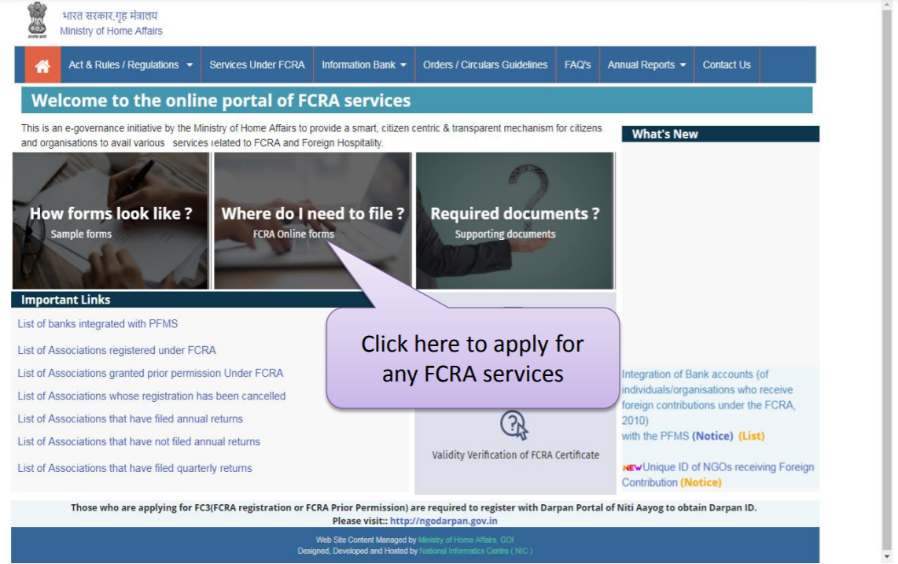

Step 2: Click on FC-3A (Application for FCRA Registration). If applying for Prior Permission, you can fill for FC-3B

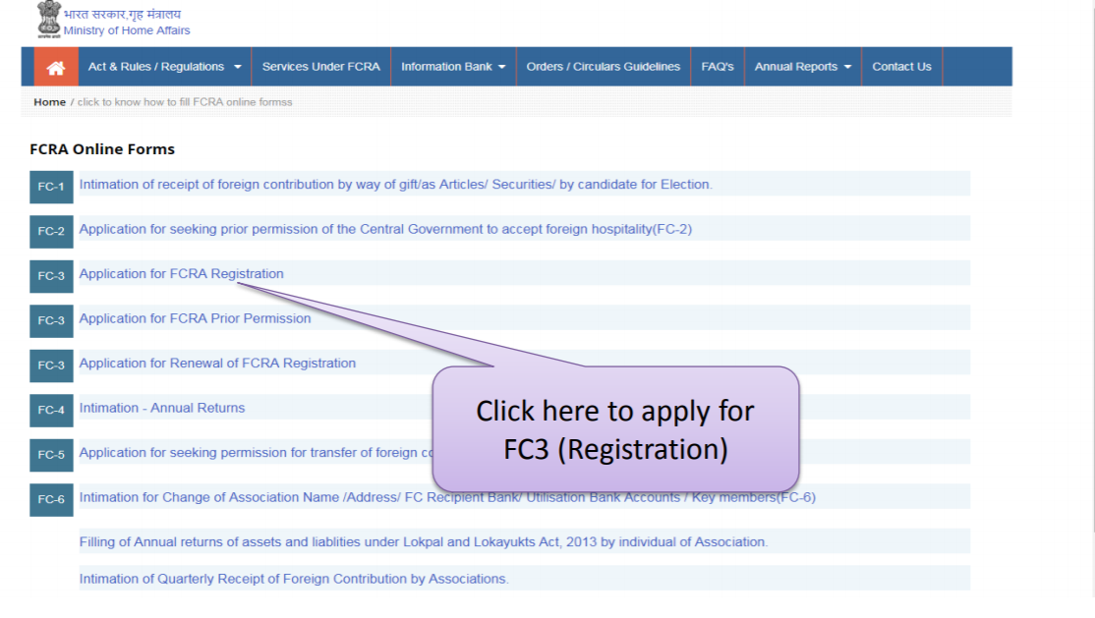

Step 3: You will be next presented with an option to “Click to Apply Online”

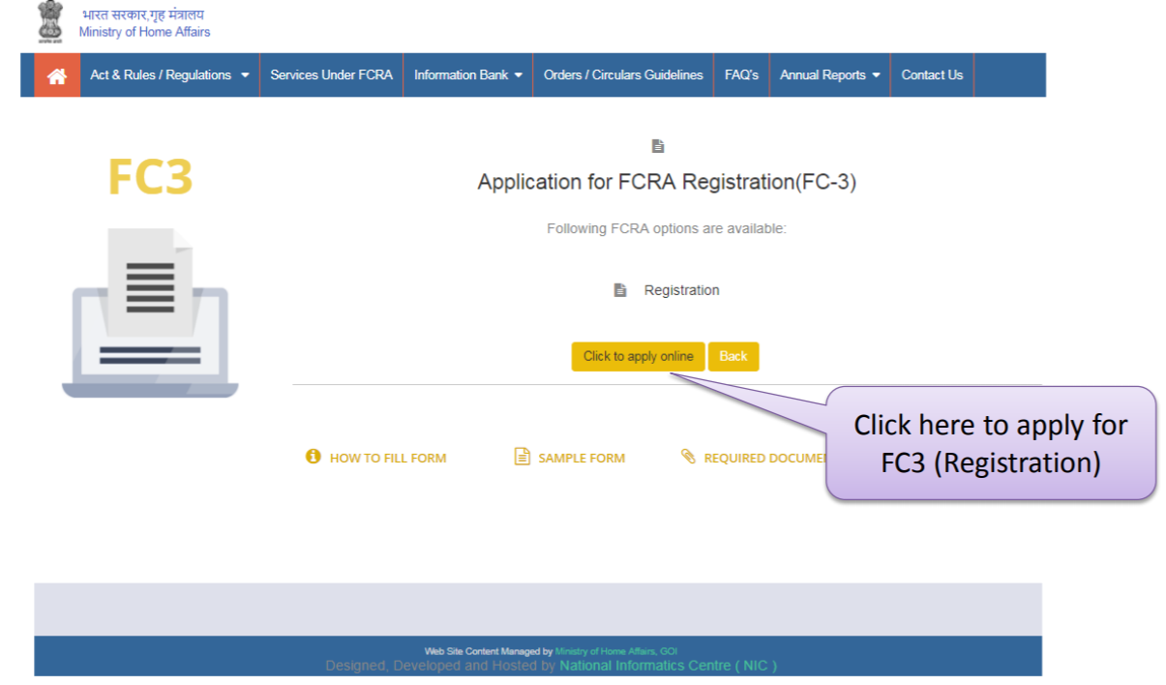

Step 4: The next step is to Sign Up. After clicking on “Sign Up” the following page will appear

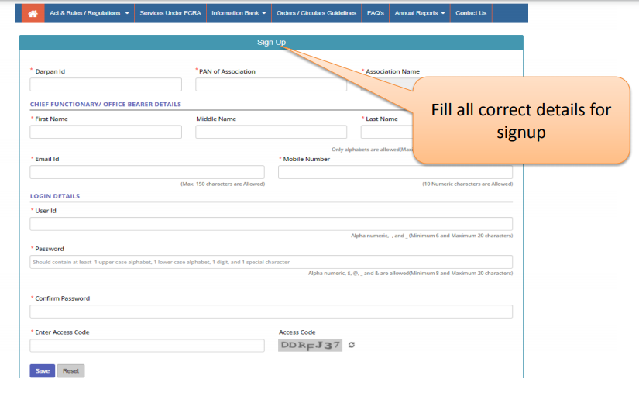
Fill in the required information and click on Save. Your account is now created.

Step 5: Once you are signed up, you can log in using your user id and password. After logging in, the following screen will appear. Select FCRA Registration in the “I am applying for” section and then click on “Apply Online”
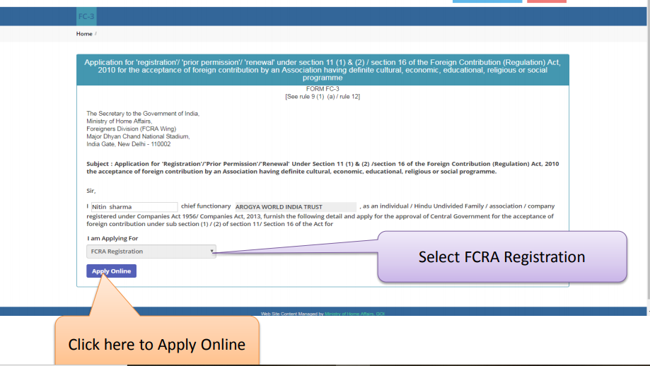

In the next screen, click on “Proceed New Registration”

Step 6: This will lead you to the Association Details Form
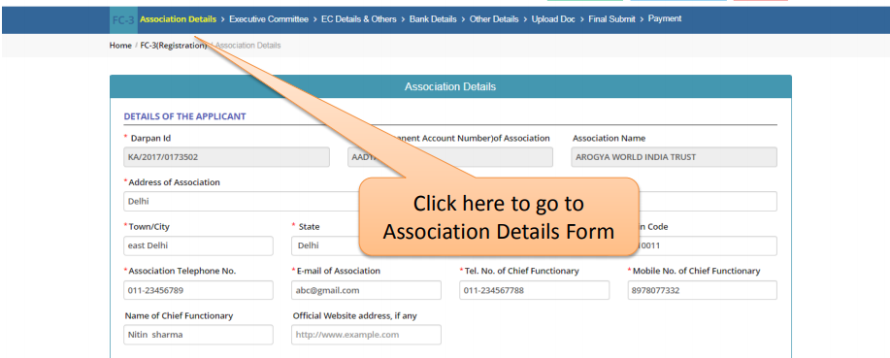

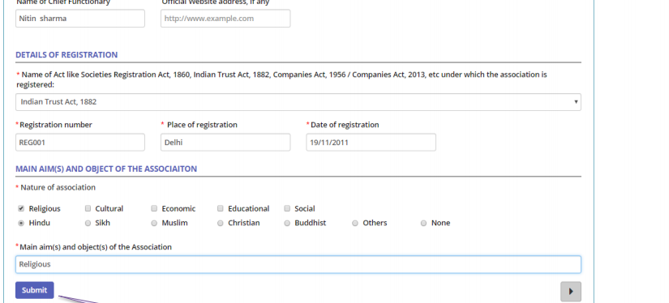
Herein, the user needs to fill the following information-
- Darpan ID
- Association address
- Registration number
- Registration date
- Nature of the association
- Main aims of the association

Once all the information is fed, click on Submit.

Step 7: Next, select the Executive Committee tab and fill in relevant details of all the association’s functionaries, including Chief Functionary, President, Vice-President, Secretary and Treasurer. Click on “Add details of Key Functionary” to add/delete/edit the details entered.

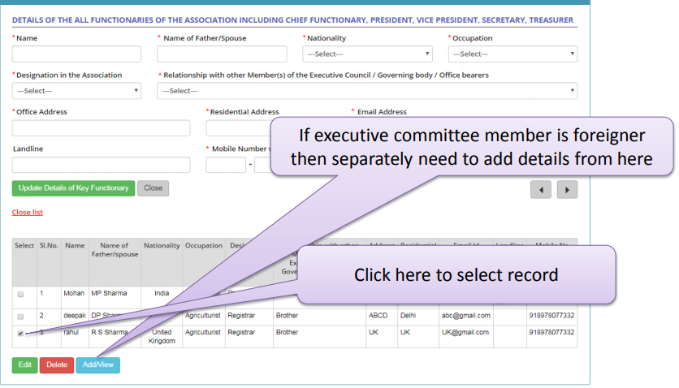

Step 8: In case a member of the executive committee is a foreigner, then their details need to be added separately.

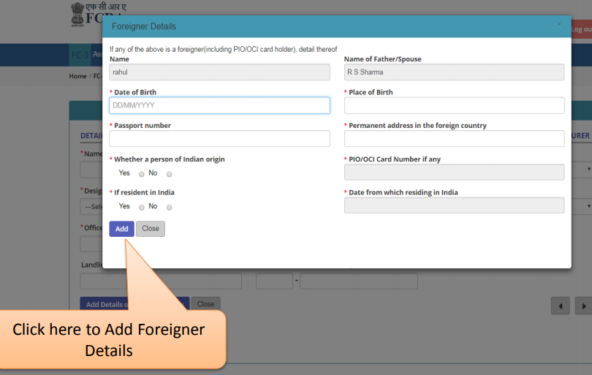

Once all the Executive Committee details are filled, click on ‘Save.’

Step 9: Next, click on the EC Details & Others menu tab. The following screen will be displayed-

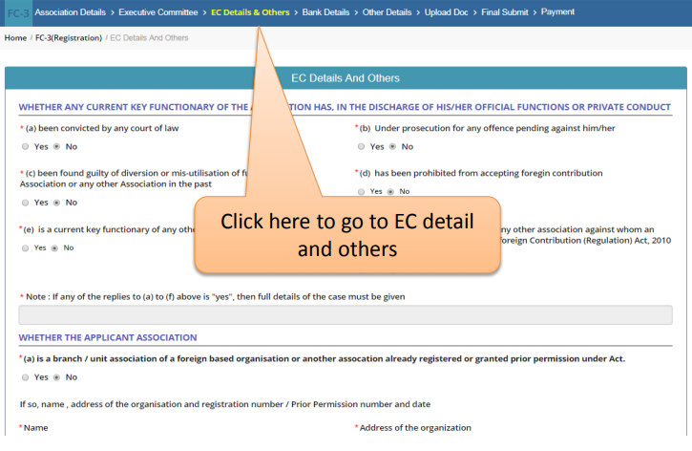
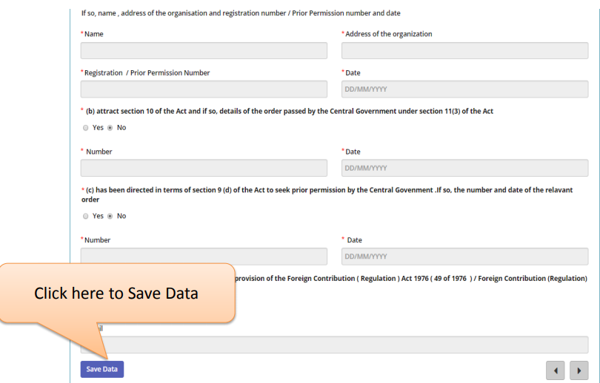

Step 10: Next, click on the Bank Details menu tab
Herein, you have to fill in the designated bank account details, including bank name, account number, IFSC and address for receipt of foreign contribution.

Step 11: After that, click on “Other Details” and fill in the relevant information

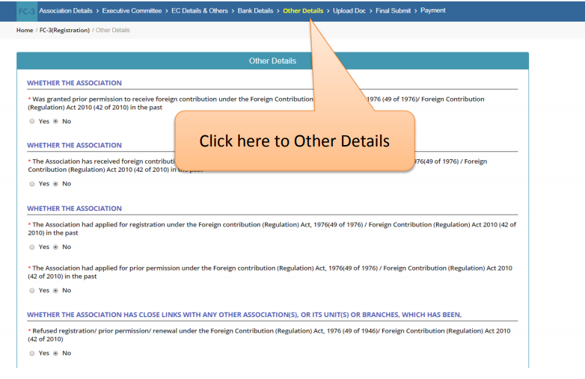
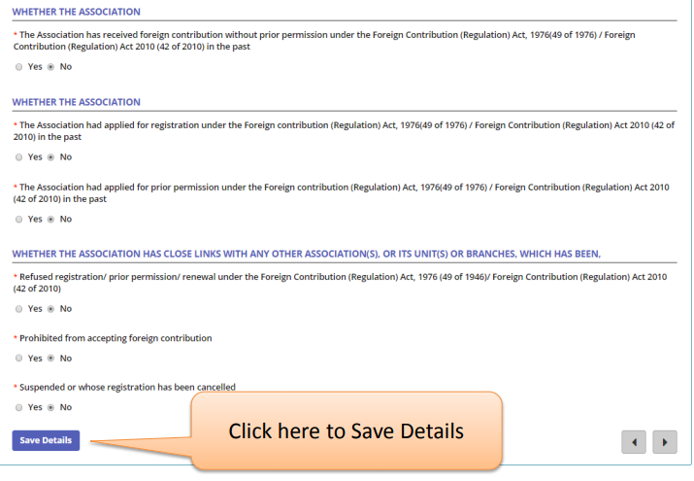

Step 12: After this you have to upload all the required documents

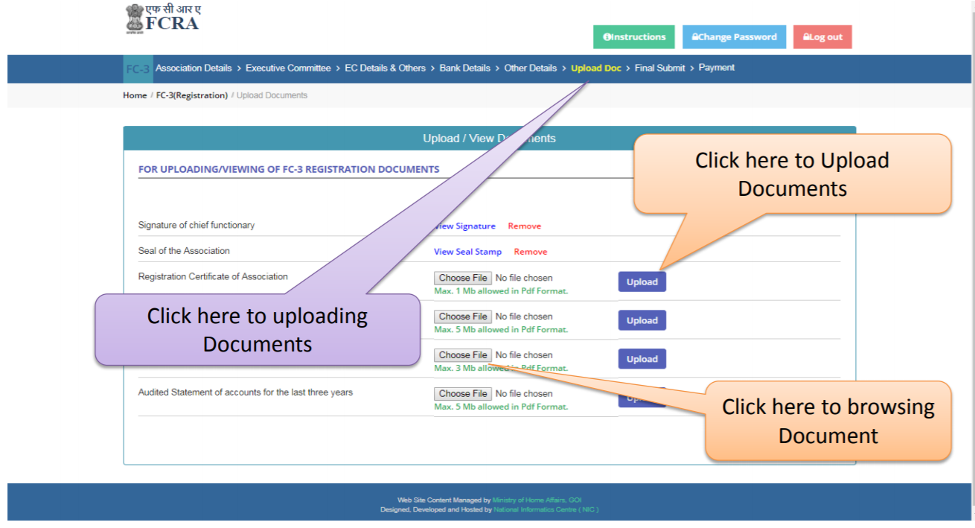

Step 13: Next, the place and date have to be filled, after which the final submission button may be selected. Make sure that you have filled in the correct information as no modification can be made after this.

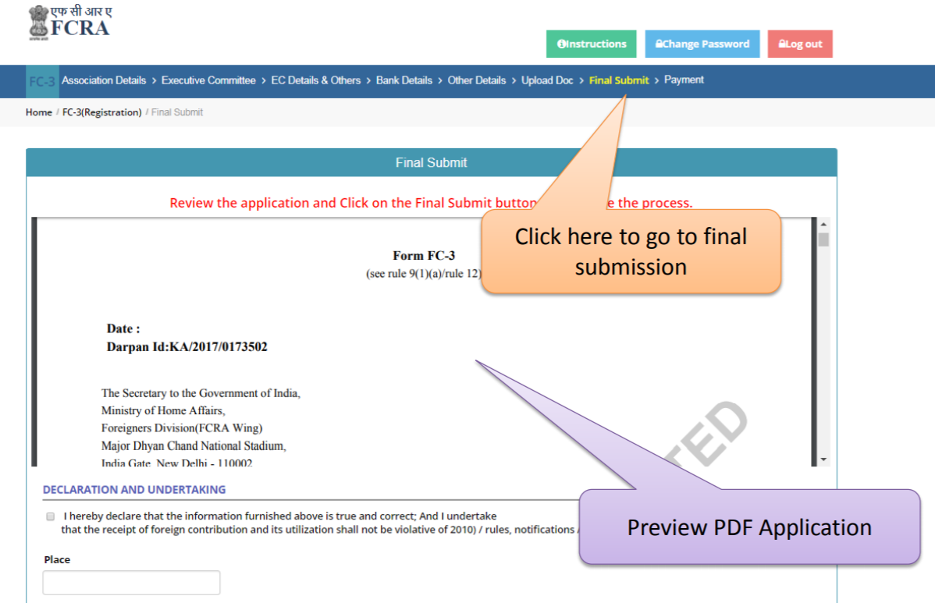

Step 14: The last step is to make the online payment and then the form is submitted

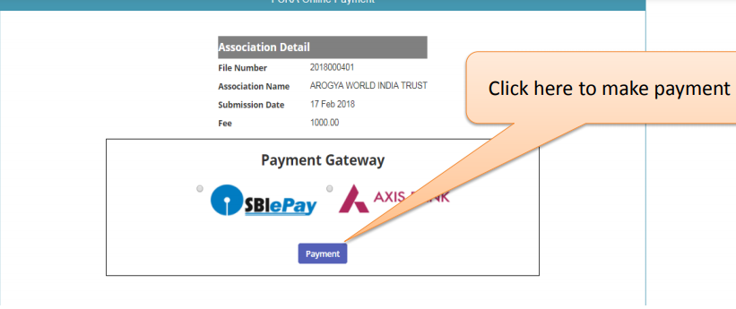

Once the application is submitted, the Central government, after making the relevant inquiry, may grant a registration certificate or prior permission within 90 days from the date of application.

