NATIONAL COMPANY LAW TRIBUNAL — A SINGLE WINDOW INSTITUTION FOR CORPORATE JUSTICE

INTRODUCTION

There is visible trend around the world towards rationalization of business processes and simplification of Legislations governing them. This trend is being driven partly by the use of electronic communication and information technology that has speeded up business transactions as well as making them international.

Time is, therefore, ripe to ensure that dispensation of justice and disposal of business matters by the court and authorities should be in tune with the speed with which business is being transacted. Further certain business matters require specialized domain knowledge for dealing with the matters justifiably. Keeping in view the pendency of legal matters and need for specialized knowledge of the persons discharging the responsibility of adjudicating the matters involving intricate issues relating to the subjects, the process of setting up of specialized tribunals has gained acceptability over a period of time.

Here, it is important to point out that though the theory of alternative institutional mechanisms was propounded in respect of the Administrative Tribunals, the concept itself - that of creating alternative modes of dispute resolution which would relieve High Courts of their burden while simultaneously providing specialized justice.

Existing Corporate Litigation Structure:

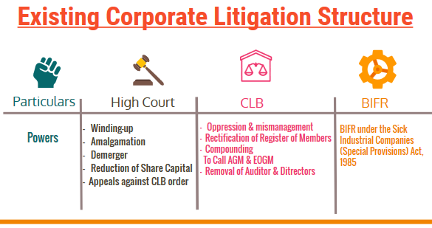

The issue of having a specialized Tax Court had been discussed for several decades. After much hue and cry Part XIVA of the Constitution was inserted by Constitution (42nd Amendment) Act, 1976 containing Articles 323 A and 323 B, providing for Administrative Tribunal and Tribunals for other matters, respectively.

In pursuance of the power conferred upon it by clause (1) of Article 323A of the Constitution, Parliament enacted the Administrative Tribunals Act, 1985. The Statement of Objects and Reasons of the Act indicates that it was in the express terms of Article 323A of the Constitution and is being enacted because a large number of cases relating to service matters were pending before various Courts; it is expected that the setting up of such Administrative Tribunals to deal exclusively with service matters would go a long way in not only reducing the burden of the various courts and thereby giving them more time to deal with other cases expeditiously but would also provide to the persons covered by the Administrative Tribunals speedy relief in respect of their grievances.

The constitutional provision, therefore, invests Parliament or the State Legislatures with powers to divest the traditional courts of a considerable portion of their judicial work.

A number of quasi- judicial forums and tribunals have been established by the Government like Debt Recovery Tribunal, Securities Appellate Tribunal, CESTAT, etc. with a view to provide a speedier and specialized forum for dispensation of justice and disposal of various matters.

Establishment of National Company Law Tribunal
A constitution bench of the Supreme Court of India in its recent judgment in Madras Bar Association vs. Union of India and Another1 has paved the way for the establishment of the National Company Law Tribunal (NCLT) and the National Company Law Appellate Tribunal (NCLAT) under the provisions of the Companies Act, 2013. The NCLT and the NCLAT will act as a comprehensive and overarching quasi-judicial body which will adjudicate all disputes relating to companies in India.
Existing tribunals and authorities, such as the Company Law Board, the Board of Industrial and Financial Reconstruction, the Appellate Authority for Industrial and Financial Reconstruction and the Company Courts in the jurisdictional High Courts which deal with various issues relating to companies will be done away with, and will be subsumed in the NCLT and the NCLAT once these are established and functioning. Matters currently pending before these for a too would be transferred to the NCLT and the NCLAT (as applicable).
The demand for the establishment of NCLT which will take over the Company Law Board (CLB) matter was earlier made in Companies (Amendment) Act, 2002. Thereafter, after much deliberations and long gap the Companies Act, 2013 has formalized this issue with the establishment of Specialized Tribunals under Section 408 and 410 namely National Company Law Tribunal (NCLT) National Company Law Appellate Tribunal (NCLAT), respectively.

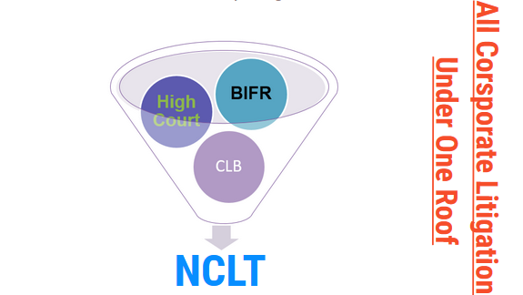

The Creation of a single forum (NCLT) which is dedicated to solely the Corporate Matters is a welcome move, and will remove the problem of multiple regulators.

The Principal Bench of the Tribunal shall be at New Delhi which shall be presided over by the President of the Tribunal and such number of benches shall be constituted as the Central Government may specified.

After the constitution of the NCLT and NCLAT the corporate matters shall follow the below flow chart. All the corporate matters will be dealt by the NCLT and any person aggrieved with the decision of the NCLT may prefer an appeal with the NCLAT and Appeal to the Supreme Court is available against the orders of the NCLAT only on the question of the Law.
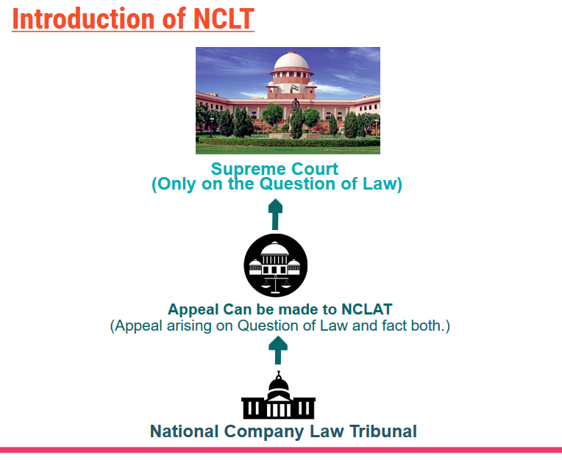

Legal Representation:

A party to any proceeding or appeal before the Tribunal or the Appellate Tribunal, as the case may be, may either appear in person or authorize one or more CA or CS or CWA or legal practitioners or any other person to present his case before the Tribunal or Appellate Tribunal, as the case may be.

This has opened up a dedicated and massive scope for the Company Secretary as this is the domain of the Company Secretary profession and earlier we have to obtain the services of the legal practitioners to appear before the High Court.

Powers of NCLT:

The NCLT has been empowered to exercise the following powers:
1. Most of the powers of the Company Law Board under the Companies Act, 1956.
2. All the powers of BIFR for revival and rehabilitation of sick industrial companies;
3. Power of High Court in the matters of mergers, demergers, amalgamations, winding up, etc.;
4. Power to order repayment of deposits accepted by Non-Banking Financial Companies as provided in section 45QA of the Reserve Bank of India Act, 1934;
5. Power to wind up companies;
6. Power to Review its own orders.

The NCLT shall have powers and jurisdiction of the Board for Industrial and Financial Reconstruction (BIFR), the Appellate Authority for Industrial and Financial Reconstruction (AAIFR), Company Law Board, High Courts relating to compromises, arrangements, mergers, amalgamations and reconstruction of companies, winding up etc. Thus, multiplicity of litigation before various courts or quasi-judicial bodies or forums have been sought to be avoided.

Scope of Services for Practicing Company Secretaries under NCLT:
The establishment of NCLT/NCLAT shall offer various opportunities to Practicing Company Secretaries as they have been authorized to appear before the Tribunal/ Appellate Tribunal. Therefore, Practicing Company Secretaries would for the first time be eligible to appear for matters which were hitherto dealt with by the High Court viz.
mergers, amalgamations under Section 391-394 and winding up proceedings under the Companies Act, 1956.

With the establishment of NCLT, a whole new area of practice will open up for Company Secretary in Practice with respect to advising and assisting corporate sector on:

Merger and Amalgamation
Merger, amalgamation, demerger, reverse merger, compromise and other arrangements right from the conceptual to implementation level. Company Secretaries in practice will be able to render services in preparing schemes, appearing before NCLT/NCLAT for approval of schemes and post merger formalities.

Sick Companies
(a) Timely detection of sick company
(b) Making a reference of sick industrial company to NCLT

Winding up
The National Company Law Tribunal has also been empowered to pass an order for winding up of a company. Therefore Practising Company Secretaries may represent the winding up case before the Tribunal. Unlike the earlier position allowing only government officers to act as Official Liquidators, now professionals like Practicing
Company Secretaries have been permitted to act as Liquidator in case of winding up by the Tribunal.

Reduction of Capital
As per amended section 100 of the Companies Act, subject to confirmation by the Tribunal, a company limited by shares or a company limited by guarantee and having a share capital may if so authorized by its articles by special resolution reduce its share capital. The Practicing Company Secretaries will be able to represent cases of reduction
of capital before the Tribunal.

PCS as Member of NCLT
A Practising Company Secretary can be appointed as a Technical Member of NCLT, provided he has 15 years working experience as secretary in whole-time practice.

Appearance before National Company Law Appellate Tribunal
As stated earlier a Practicing Company Secretary has been authorized to appear before National Company Law Appellate Tribunal.

CONCLUSION
In view of vast opportunities emerging with the establishment of National Company Law Tribunal, the Practicing Company Secretaries should standardize their competencies with the global benchmarks to provide value added services in assisting the Tribunal in dispensation of justice and speedier disposal of matters like merger, amalgamation, Restructuring, revival and rehabilitation of sick companies and winding up of companies.

