Winding Up
- 3 Types of Winding ups:
- Compulsory or by Court
- Voluntary by Members or Creditors
- Subject to supervision of Court
There can be direct Dissolution without Winding up also as under Section 394
- Compulsory Winding Up:
- Section 433 & 434: Grounds for Winding up
- Section 439 & 440: Petition for winding up to Court
- Section 441: Commencement of Wing Up
- Section 442 & 443: Powers of Court after the petition has been presented
- Section 444- 447: Consequences of Winding up order
- Section 448- 463: Provisions relating to Liquidators
- Section 464- 465: Committee of Inspection
- Section 466- 483: Powers of Court after Winding up order
- Voluntary Winding up Provisions:
- Provisions common to CVWU and MVWU
  - Part A: Section 484- 487
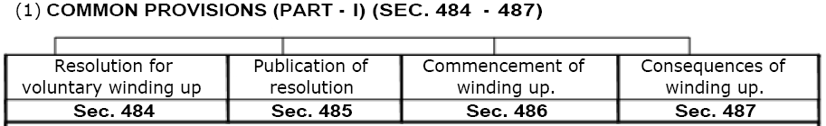
  - Part B: Section 510- 520
- Declaration of Solvency: Section 488
- Provisions applicable to CVWU: Section 499- 509
- Meeting of Creditors – 500
- Filing copy of Resolution with ROC
- Appointment of Liquidator
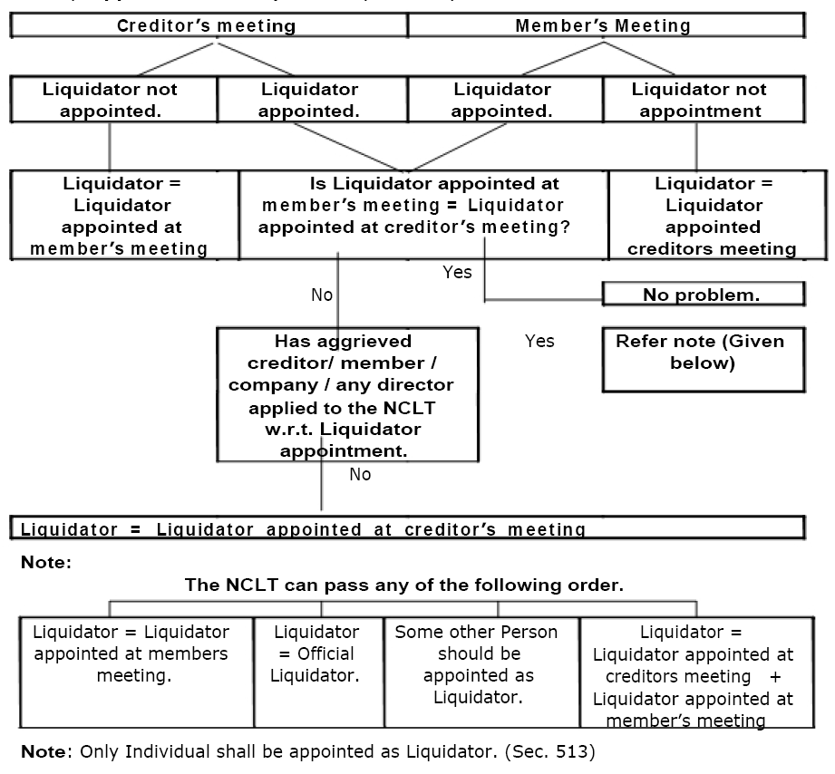
- Fixing of Liquidator’s Remuneration
- Filling of Vacancy & Appointment of Committee of Inspection
- Cessation of BOD’s power after appointment of Liquidator
- Duty of Liquidator to call meeting of members & creditors
- Final Meeting & dissolution
- Provisions applicable to MVWU: Section 489- 494, 496, 497
  - Appointment of Liquidator and Fixation of Remuneration - 490
  - Filling of Casual Vacancy - 492
  - Notice to ROC - 493
  - Consequences of appointment of Liquidator - 491
  - Duty of Liquidator to call GM - 496
  - Final Meeting and Dissolution - 497
- Provisions when MVWU is converted into CVWU: Section 495, 498
- Creditors and Contributories can inspect the Statement of affairs submitted by Company to the liquidator / Provisional liquidator. Liquidator makes a report to Court on the basis of Statement of affairs.
Liquidator / Provisional liquidator takes all the property of the Company in his custody which is deemed to be in the custody of Court. Liquidator can call meeting of creditors or contributories suo moto or on request of specified number of creditors / members.
- A committee of inspection may be appointed to act alongside liquidator. It contains creditors and contributories
- The function of liquidator is to realize and divide the assets in the agreed proportion b/w creditors and contributories. But first he must assist them in reaching such an agreement. Also preparation of correct list of contributories and creditors is a must.
Committee inspects the a/cs of liquidator and represent their respective group in meetings. The meetings may be of creditors or members or just committee. Its purpose is to safeguard the interests of its group and to take the decision at the committee meeting via simple majority. Members and creditors jointly appoint the committee. Creditors have a say through this committee only. It safeguards their interests.
- The Court has power to enforce payment of any sum, other than calls, due from contributories. It can make calls separately by virtue of powers u/s 470 [PDF-91]
- Prior to passing of resolution in GM, the BOD must make the Declaration of Solvency
- In Compulsory winding up, the liquidator is appointed by the Court whereas in VWU, the liquidator is appointed in the meeting
- In CVWU, creditors alone cannot wind up the Company by passing a resolution. Their resolution should be preceded by members’ resolution u/s 484. But since members pass this under pressure from creditors so this winding up is known as Creditors voluntary winding up
- Committee of inspection may be appointed in compulsory as well as CVWU but not in MVWU
- In CVWU, any resolution to be passed by the creditors in the creditors meeting should be preceded by same resolution in the corresponding members meeting. This is ensured by the Inspection committee in advance

