Service Tax code verification online

Service tax code verification can be done online using simple 3 steps. It is helpful to determine the genuineness of the party whom we are paying service tax. Here, we have explained the manner of verification of service tax number and basics of service tax number.
SERVICE TAX CODE VERIFICATION ONLINE:
WHY SERVICE TAX NUMBER VERIFICATION IS IMPORTANT?
If we are working with someone in the area of service and we take some services from such persons who provide the same service which we required but how we know about that whether the Service Tax Code Number Provide or mentioned on the bill is genuine or related with such entity who provide us the same service. For this we have an online system to verify the Service Tax Code Online.
Basically the Service Tax Code Number is PAN Based in the New System of Service Tax, Service Tax Code Number is 15 Digit Code and Based on PAN Number.
First Ten (10) character are same as PAN ,11-12 digit is “ST” in all service tax code(In few cases “SD” is also used) ,13-15 is serial Number no for service tax number allotted against a pan number ,if you have applied for one service tax number against a pan than your service tax number will pan+st+001. So if you have a PAN number of the firm then checks service tax number as below:-
Assessee code to be digitized in case of Service Tax (major account head 0044) as:
1-10 digits: 10-digit PAN / TAN
11-12 digits: ST
13-15 digits: ZZZ
In case the Assessee is unable to provide a valid location code, the location code may be digitized as :
1-2 digits: any Commissionerate Code associated to the bank branch
3-6 digits: ZZZZ
If you have service tax number and just want to verify it is it correct or not than follow this steps:
Step 1:
Go to the following Link:-
https://cbec-easiest.gov.in/

Following screen will be appeared:
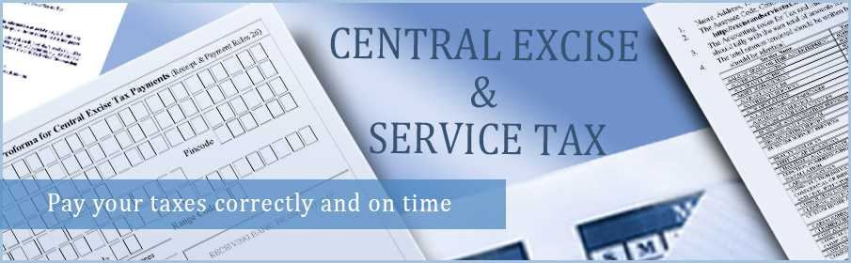
service tax code verification
Step 2:
Click on assessee code based search
Step 3:
Input Your Assessee Code and Verification Image you get the following result
INPUT:15 digit SERVICE TAX CODE
OUTPUT:
REGISTER UNDER SERVICE TAX/EXCISE
NAME OF ASSESSEE
ADDRESS OF ASSESSEE
LOCATION CODE.
Similar steps should be followed to determine excise number verification online. I hope this post helps you to do service tax code verification.

For any queries you can contact me at nimisha.agarwal29@gmail.com

Thank You !!!

