- SIGNIFICANCE OF POT
All these 3 points
are taken with respect to the
POT
determined as per POT rules 2011
- Rate of service tax
- Value of taxable service
- Rate of exchange as notified by CUSTOMS
u/s 14 Of Customs Act 1962(Don’t take bank rates)

POT – Rule 2(e) of POT rules 2011
- means the point in time when a service shall be deemed to have been provided.

Time limit for issuing of INVOICE u/r 2(d) of POT rules 2011, read with rule 4(A) of ST rules 1994.
Invoice to be issued

- Every person providing taxable service shall issue an invoice
- Within 30 days
- from the date of completion of such taxable service
or
- receipt of any payment towards the value of such taxable service,

- whichever is earlier.
In case of continuous supply of service invoice to be issued within 30 days from completion of
Each Specified Event, which requires the SR to make payment to SP.
Where service provider is banking company Or financial institution
(including NBFC)
- Invoice to be issued Within 45 days
- from the date of completion of such taxable service
or
- receipt of any payment towards the value of such taxable service
- whichever is earlier

Continuous Supply of services RULE 2(c) of POT rules2011

Taxable Service
In case of continuous supply of service the TIME LIMIT FOR ISSUING INVOICE IS 30 DAYS FROM THE COMPLETION OF EACH SPECIFIED EVENT. Normally on completion of such EVENT the SR has to pay some amount to SP as per terms of agreement.
EG of SPECIFIED EVENT- % (10 % or 20%)-of completion of project in case of construction service ;
In case of services of director (period of service exceeding 3 months) – Specified event is date every of board meeting , In case of telecom service month/s for which billing is done for usage of telephone by consumer.
1. Construction of complex
2 .Commercial or Industrial
construction
3. Works Contract Service
4. Internet
5. Telecommunication
NORMAL
SERVICE
CONTINOUS SUPPLY OF SERVICE
If contract period is
Upto 3 months
If contract period is more than 3 months
All other TAXABLE SERVICE

Date of completion of service shall be that day when all auxiliary like quality testing, measurement etc. are completed (after physically completion of main service).However unnecessary delay in issuing of invoice by saying services are not complete won`t be considered by the department.

Rule 2A: Date of payment (V.IMP)

Date of payment
If credit in bank after next 4 working days from
The date of change in rates or
New levy

THEN DATE OF PAYMENT
SHALL BE DATE OF CREDIT IN BANK ACCOUNT.
If credit in bank is within next 4 working days from

the date of
new levy/change in rate
Then date of payment as
per general rule -

DATE OF ENTRY IN BOOKS OR CREDIT IN BANK whichever is earlier.
IN case of NEWLY TAXED SERVICES (RULE 5)
OR
In case of change in effective rate of service tax (Rule 4)
GENERAL RULE

Date of recording (entry) in books upon receiving the cheque
OR
Date of CREDIT in Bank account

Whichever is earlier

EXAMPLE
DATE OF NEW LEVY/ CHANGE IN RATE = 1.7.2012
{ 12 % tax levied or from 10 % increased to 12% wef 1.7.2012}

Date of receiving cheque = 28.6.2012 (assume entry in books on this day)
Date of credit in bank account
- 4.07.2012
- 5.07.2012
- 6.07.2012

What is date of payment? will your answer be same if 5.07.2012 was a holiday?

RULE 3 ,POT RULES 2011 – RESIDUARY RULE TO BE APPLIED WHEN OTHER RULES CANT BE APPLIED.

- If invoice issued within 30 days (45 days in case of banking co/financial institutions) from the date of completion of service/specified event.
POINT OF TAXATION = Date of invoice or Date of payment whichever is earlier

- If invoice is not issued as per p.t(A)
POINT OF TAXATION = Date of completion of service OR Date of payment whichever is earlier

- If any advance received for provision of service
POINT OF TAXATION = Date of RECEIPT OF SUCH ADVANCE ( to the extent of advance only)

SPECIFIC RULES TO BE APPLIED IN FOLLOWING SITUATIONS

Apply RULE 4 Where change in effective rate of tax due to –
- Increase or decrease in rate of tax
- Grant/withdrawal of exemption
- Change in rates of abatement, composition schemes

DATE OF COMPLETION DATE OF PAYMENT DATE OF INVOICE POT
Before change | Before change | After change | DOP
Before change | After change | Before change | DOI
Before change | After change | After change | DOP or DOI  Whichever is earlier
After change | Before change | Before change | DOP or DOI  Whichever is earlier
After change | After change | Before change | DOP
After change | Before change | After change | DOI
Before change | Before change | Before change | RULE 4 NA  (Rule 3 to be used)
After change | After change | After change | RULE 4 NA  (Rule 3 to be used

Apply RULE 5 where a service is taxed for the 1st time

DO NOT PAY SERVICE TAX IF AND ONLY IF
DOP Before the date when service tax is levied
And
INVOICE IS ISSUED WITHIN 14 days from the date the service is taxed for the first time.
DOP and DOI both before the date on which such service became taxable

RULE 6(continuous supply of services DELETED ,provisions added in rule 3 and rule 2 itself)

Apply Rule 7 in case of REVERSE CHARGE where SR is liable to deposit tax to government
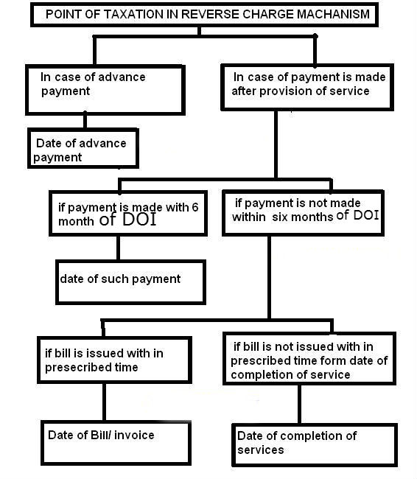
30 days of DOC.
Apply RULE 7 proviso (meaning exception) In case where SP and SR are associated enterprises u/s 92A of INCOME TAX ACT (Eg – Holding and subsidiary companies) and SP is located outside India .

DONOT BOTHER TO CHECK TIME LIMIT OF INVOICE ETC

POT = Date of debit (of expense) in the books of SR
Or whichever is earlier
Date of making payment to SP

Apply RULE 8 in case of payments in respect of copyrights , trademarks ,patents royalties etc (IPR)
- Where amount of consideration is not known at time of entering into agreement for sharing of
IPR and
- SR has to pay consideration to SP on subsequent benefits derived from use of such IPR.
- Remember it`s only temporary transfer of IPR which is liable to service tax because permanent transfer of IPR results in sale on which VAT LAWS APPLIES
- Further there are exemptions on transfer of some IPR like authorship of books, exhibition of films etc. as per mega exemption notification 25/2012.

POT = Date on which payment is received by original right/patent holder(SP)
Whichever is EARLIER
Or
Date on which invoice is issued by SP

Apply RULE 8A where
- DOP
Or
- DOI NOT KNOWN ,The CENTRAL EXCISE OFFICER may ask assessee to provide
Or documents and information and then proceed to do Best Judgment
- BOTH Assessment to determine the POT but after giving the Assesee an OTBH .

PLZ NOTE- In case of advance up to Rs 1000 POT may be opted to be the date of invoice. Further in such case invoice to be issued within 30 days of completion of service rather than within 30 days from date of payment.
This provision really helps credit card services and telecom services where it is common to receive petty advances from customers.

- Point of taxation is the date of payment for
- individuals and
- partnership firms (including LLP)
- up to a turnover of Rs 50 Lac in a financial year provided
- the aggregate value of taxable services did not exceed Rs 50 lac limit in the previous financial year.

