Filing of ST-3 Returns

Description

The registered Assessee can access the ACES application with their user ID and password.

The Assessee can file ST3 return as a Service Provider, Service Recipient or Input Service Distributor. The Assessee can file returns for one or more than one service offered by one premises and for more than one premises as well.

Returns are filed once in six months – for the half-year starting from the 1st of April through the 30th of September, the returns are to be filed by the 25th of October and for the half-year starting from the 1st of October through the 31st of March returns are to be filed by the 25th of April.

Navigational Path

The Form ST-3 can be accessed by the Assessee after he has logged in successfully into the system, through the RET menu item; here RET is the label for returns menu. In the RET menu the Assessee will click on the Fill sub-menu option of the Fill ST3 menu option. As soon as he clicks on the same the system will populate the ST3 form.

The navigation path for the ST-3 form is:
Logged in Assessee RET Fill ST3 Fill

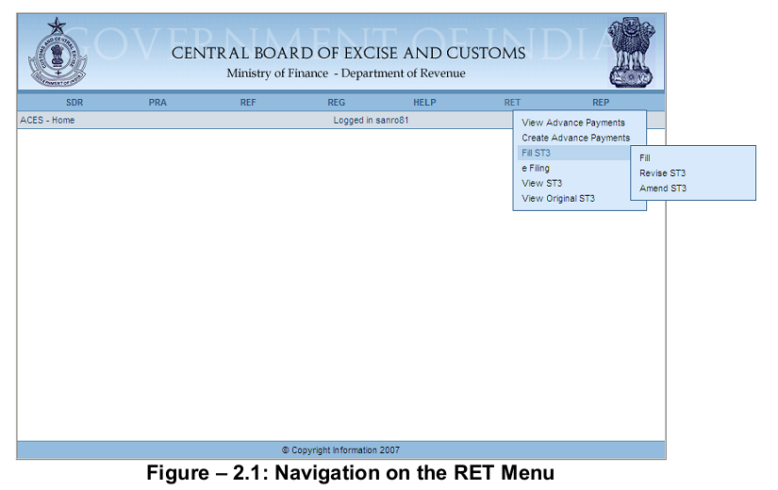
Attachments

There are no attachments required to fill ST-3 Returns.

Approval Flow

There is no approval flow in filing of Service Tax returns.

Operating Instructions

The process goes through the following steps –

- The system displays the form with a list of premises that have been registered by the Assessee. The Assessee can file returns for some or all of the premises at one time.

- The Assessee is allowed to choose a premises code (he can choose one code only at a time) and file returns for this premises:
    - Once the Assessee is through with entering all details pertaining to the service tax liability, duty defrayed using cash and credit, arrears, interest, penalty and other amounts paid, provisional assessments payments made or received by way of refund, for the premises selected he can choose to file returns for another premises.
    - If the Assessee chooses to file returns for other premises, details of the return filed already filed are stored and a fresh screen of an ST-3 form is shown to the Assessee. This screen has a list of premises and the premises for which returns have already been filed.
    - If the Assessee does not have any other registered premises or if he wishes to file returns for other registered premises at a later point of time, the details of the return filed for the premises code selected by the Assessee are stored.

- After selecting a premises code, the Assessee, service tax category wise, can file the return for the premises. For selecting services, there is a Search button which opens up a new popup window containing list of all services from where Assessee can select multiple services. In case the Assessee has started providing new services from the same premises after his registration, he would be able to file returns for this service as well by adding the service to his returns form. The Taxable Service selected should be valid for the period for which return is being filed. If the Assessee is an Input Service Distributor only, he will not be able to select services. He will only enter details of CENVAT Credit Distributed, Name and Place and can save or submit the return.

- The Assessee fills his returns, minor head-wise. In other words – he fills a return for each of the service that he is providing.

- The Assessee files details of the gross amount received, abatement amount claimed, value on which service tax is payable, gross amount for which bills/ invoices/ Challans are issued.

- The system computes the service tax payable.

- For each service liability, the system computes the education cess applicable, Secondary and Higher Education cess payable for the Assessee for that particular return and shows it to the Assessee.

- Once the Assessee has filled in all details pertaining to the first category of service, the system shows the page pertaining to next service.

- The Assessee can indicate the amount that he is paying in cash and through input credit.

- The Assessee then enters similar details for other months as the case is that fall within the return filing period.

- The Assessee would have already deposited a certain amount of cash through GAR-7 challan under the minor head code 00440297 – the serial code for education cess in the service tax major head. The amount that the Assessee enters in his return as paid through cash towards defrayal of education cess liability should be equal to the amount deposited vide the GAR-7 challan for the same purpose.

- The credit on education cess on excisable goods and services can be utilized only for the payment of education cess through credit.

- Next the Assessee can enter details of other payments – viz., arrears, interest, penalties and miscellaneous.

- The Assessee is required to give details of the Challan Identification Numbers (CIN) for each month/ quarter against which he has made the duty payments.

- It is worth mentioning that the arrears are required to have a source document number against them. As stated earlier, these arrears figure in this particular field only when sub-section 1 of section 73 has been duly applied on the returns of the Assessee. Furthermore these arrears are a consolidated figure – more accurately, they indicate a duty liability that had been determined under sub-section 2 of section 73 of the Finance Act. This figure of liability can subsume multiple minor heads as it is contingent upon the view with which the show-cause notice was passed. The Assessee will enter Source Document details for all such amount paid through arrears.

- Next the Assessee enters details of the credit he has availed, utilized and (if applicable) passed on.

- The Assessee will mention CENVAT Credit by entering details of Opening Balance for the first month, Credit taken, and Credit Utilized. The system will compute the “Total credit taken” , “Total credit utilized”,” Closing Balance” and the “Opening Balance” for the subsequent months of the filing period.

- If the Assessee is an Input Service Distributor, he can enter the Details of CENVAT Credit Distributed. The Assessee will enter details of Opening Balance for the first month, Credit taken, and Credit Distributed. The system will compute the Closing Balance and the Opening Balance for the subsequent months of the filing period.

- Finally, the Assessee will enter Name and Place. He has an option to save or submit the Return. If he saves the Return, he can later amend it and submit the same.

- The Assessee cannot modify a return for a premise once filed and submitted. Before submitting the form the Assessee can see the information filled by him to verify whether it is correct or not. If it is incorrect, he has the option to modify the incorrect entry.

- With every submission the system generates an acknowledgement giving a number of the return submitted.

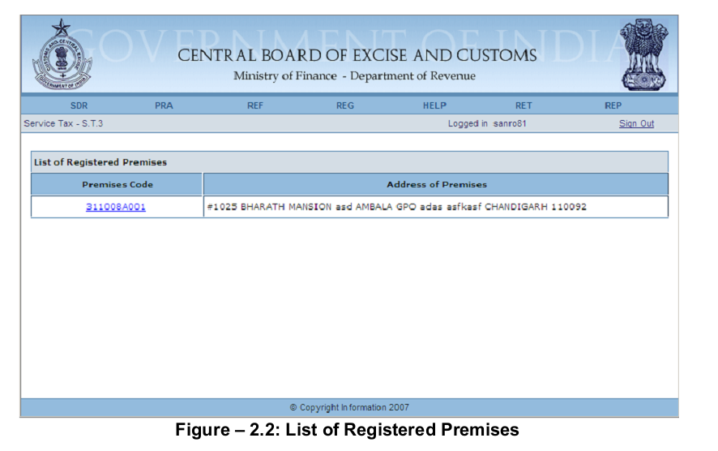

Steps to be followed:

- List of Registered Premises – Premises Code and the Address of Premises registered with the Assessee are automatically populated by the system.

- Click on the Premises Code hyperlink to file ST-3 Return for that particular Premise

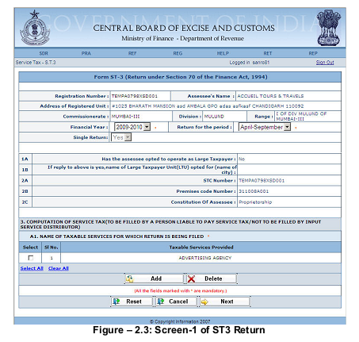

Steps to be followed:

- Registration details of the Assessee are automatically populated by the system
- Fill the Financial Year and period of the Return
- LTU details, Service Code, Premises Code and Constitution of the Assessee are automatically populated by the system
- If the Assessee is a Service Provider or Service Recipient, all taxable services for which Assessee is registered are auto populated here. Assessee can add new services by clicking on Add button.
- Click on Delete to remove the selected Taxable Services Provided from the list
- Click on Next to go to the next screen of the application
- Click on Reset to reset all the entries in the form
- To cancel the process and return back to the homepage click on the Cancel button

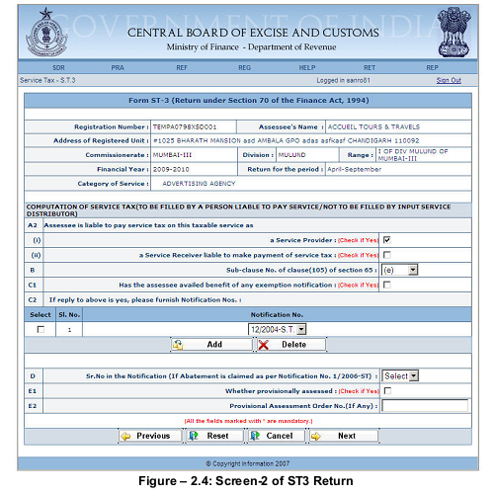

Steps to be followed:

- This screen will appear only if the Assessee is a Service Provider or Service Recipient
- Registration details of the Assessee and Category of Service are automatically populated by the system
- Select whether Assessee is Service Provide, Service Receiver or if he has availed benefits of any exemption notification
- If taxable service is provisionally assessed then select the check box and mention the Provisional Assessment Order No.
- Select the notification number from the dropdown. To add or delete any notification number click on Add or Delete button
- Click on Previous to go to the previous screen of the application
- Click on Next to go to the next screen of the application
- Click on Reset to reset all the entries in the form
- To cancel the process and return back to the homepage click on the Cancel button
- The same page will appear for each of the Service Categories included by the Assessee and has to be filled in same manner

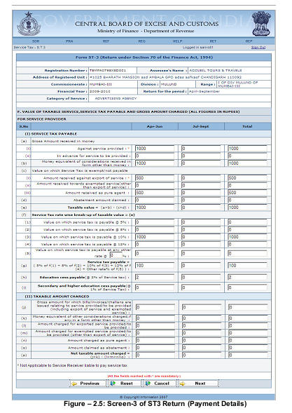

Steps to be followed:

- This screen will appear only if the Assessee is a Service Provider or Service Recipient
- Registration details of the Assessee and return filing period are automatically populated by the system
- Fill the month-wise Payment details against each particular heading.
- Where the service provider or the service recipient is a Partnership or Proprietorship firm the form will show two quarterly columns only.
- If the Assessee is liable to pay service tax on this taxable service as a Service Provider, and has selected the same in previous screen, only the fields for the same will be shown and the same is followed for Service Receiver. If he has selected both, then sections pertaining to both will be shown.
- Click on Next to go to the next screen of the application
- Click on Previous to go back to the previous screen of the application
- Click on Reset to reset all the entries in the form
- To cancel the process and return back to the homepage click on the

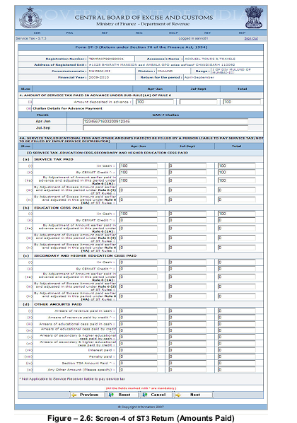

Steps to be followed:

- This screen will appear only if the Assessee is a Service Provider or Service Recipient
- Registration details of the Assessee and return filing period are automatically populated by the system
- Fill the amount deposited by the Assessee in Advance and the GAR 7 Challan number for the corresponding months
- Fill the value of Service tax paid in the respective half-year against the different heads i.e. In cash, by CENVAT credit, by adjustment of excess amount paid earlier etc.
- Fill the value of education cess paid, in the respective half-year against the different heads i.e. in cash, by CENVAT credit, by adjustment of excess amount paid earlier etc.
- Fill the value of secondary and high education cess paid, in the respective half-year against the different heads i.e. In cash, by CENVAT credit, by adjustment of excess amount paid earlier etc.
- Fill the other amount paid i.e. Arrears of revenue paid, interest paid, penalty paid etc. in the respective half-year
- Click on Next to go to the next screen of the application
- Click on Previous to go back to the previous screen of the application
- Click on Reset to reset all the entries in the form
- To cancel the process and return back to the homepage click on the Cancel button

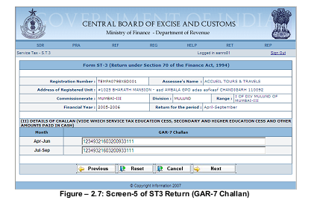

Steps to be followed:

- This screen will appear only if the Assessee is a Service Provider or Service Recipient
- Registration details of the Assessee and return filing period are automatically populated by the system
- Fill the challan numbers vide which the payments were made in cash against the respective months. If there are more than one challan in a month they should be separated by comma
- Click on Next to go to the next screen of the application
- Click on Previous to go back to the previous screen of the application
- Click on Reset to reset all the entries in the form
- To cancel the process and return back to the homepage click on the Cancel button

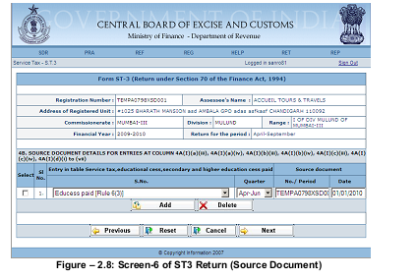

Steps to be followed:

- This screen will appear only if the Assessee is a Service Provider or Service Recipien
- Registration details of the Assessee and return filing period are automatically populated by the system
- Select the type of amount paid and month
- Fill the details of Source Document No. along with the date
- Click on Next to go to the next screen of the application
- Click on Previous to go back to the previous screen of the application
- Click on Reset to reset all the entries in the form
- To cancel the process and return back to the homepage click on the Cancel button

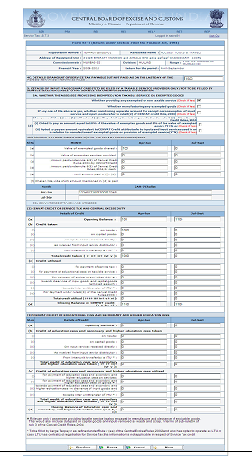
Figure – 2.9: Screen-7 of ST3 Return (Credit Details for Service Tax Provider)

Steps to be followed:

- This screen will appear only if the Assessee is a Service Provider or Service Recipient
- Registration details of the Assessee and return filing period are automatically populated by the system
- Enter the details of amount of service tax payable but not paid as on the last day of the period for which return is filed
- Mention whether Assessee is providing any exempted or non-taxable services or any exempted goods. If any of the option is Yes then mention whether assessee is maintaining separate accounts or not
- Fill the details of CENVAT credit of Service Tax and Central Excise duty
- Fill the details of CENVAT credit of education cess, secondary & higher education cess
- Click on Next to go to the next screen of the application
- Click on Previous to go back to the previous screen of the application
- Click on Reset to reset all the entries in the form
- To cancel the process and return back to the homepage click on the Cancel button

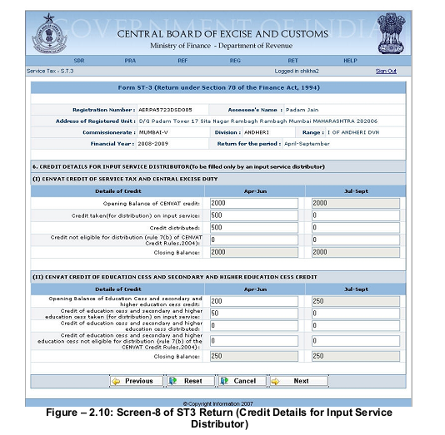

Steps to be followed:

- This screen will only appear if Assessee is an Input Service Distributor
- Registration details of the Assessee, Financial Year as well as Period of filing of Return are automatically populated by the system
- Enter the details of CENVAT credit taken and distributed
- Click on Previous to go back to the previous screen of the application
- Click on Reset to reset all the entries in the form
- To cancel the process and return back to the homepage click on the Cancel button
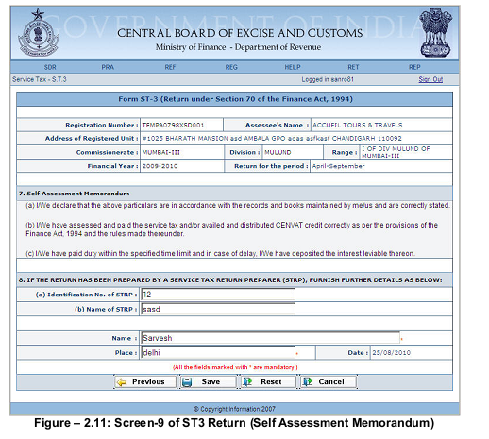

Steps to be followed:

- Registration details of the Assessee and Financial year as well as Period of filing of Return are automatically populated by the system
- Fill the Name and Place in the text boxes available
- Click on Save to go to the confirmation screen of the application
- Click on Previous to go back to the previous screen of the application
- Click on Reset to reset all the entries in the form
- To cancel the process and return back to the homepage click on the Cancel button

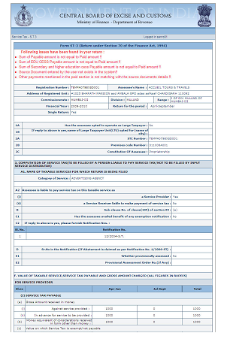
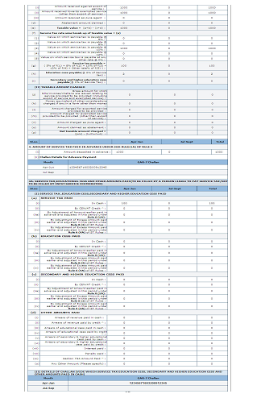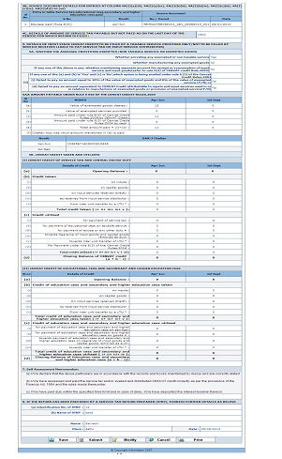

Steps to be followed:

- The list in red represents the issues which need corrections. To amend click on Modify button. Even without modification the return can be submitted
- Click on Save to save the return for any amendments in future
- To submit the ST-3 Return to the department press Submit button
- Click on Cancel button to cancel the process and return back to the Homepage
- Click on Print button to generate a printable version of the application

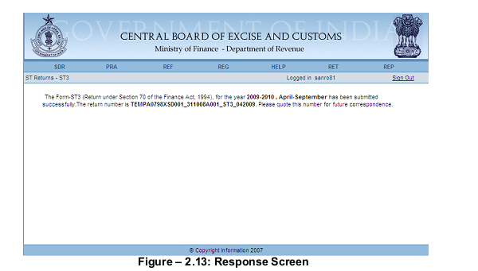

System displays a response message after successful submission of the Return

- System generates a unique source document number for the Return in the format: Registration number Premise Code_ST3_Period of Return
e.g. TEMPA0151XST001_004_ST3_042005

