The user is required to visit website http://www.aces.gov.in. In the homepage user selects Service Tax option and gets a login screen.

For a new user the sequence of steps of registering with the ACES is as following:

User Login page “Register with ACES” screen submit the details.
Steps to be followed:
- Enter the User Name and Password.
- For Assessee the User Name is the login ID given at the time of registration with ACES
- Click on the Logon button to login to the system
- Click on Clear button for entering the User Name and Password afresh

Figure: 2.1 Screen for Login to ACES

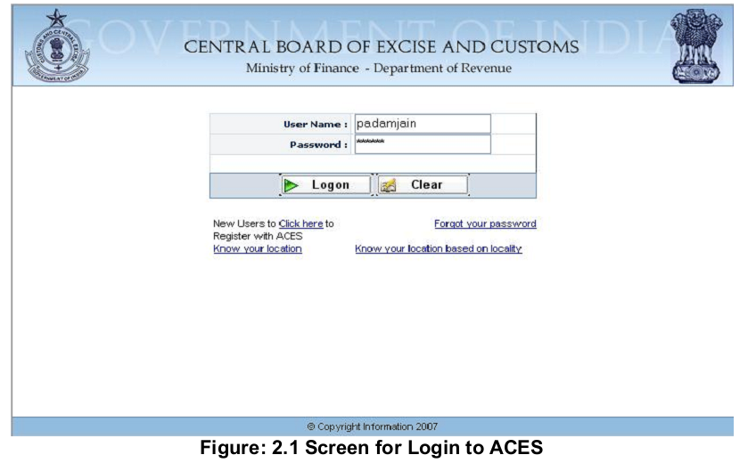

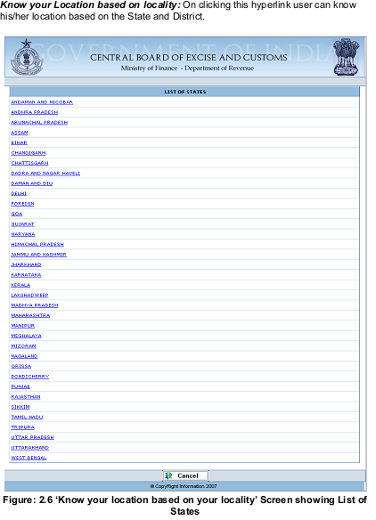
Clicking on State hyperlink, next screen will show the District under the State.

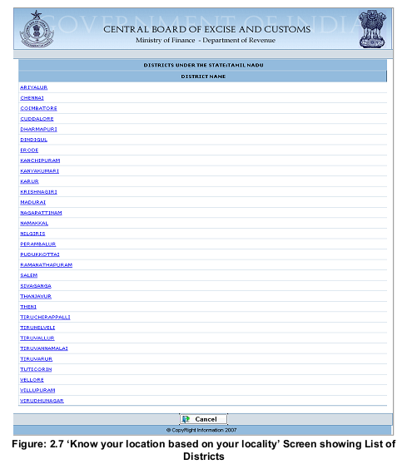
Clicking on District Name hyperlink, next screen will show the Area of Locality under the District.
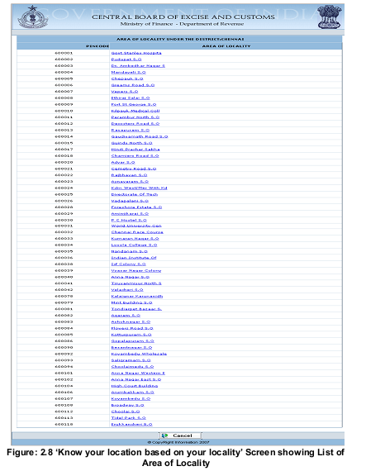
Clicking on Area of Locality hyperlink, next screen will show Location Code, Range,
Division and Commsionerate’s details under the Area of Locality.
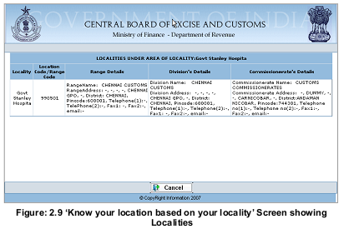
2.1.3 Operating instructions
The screen can be accessed from the login page of the Assessee by clicking on the
Hyperlink “Click here to register with ACES “:

Assessee login page hyperlink for “Click here to register with ACES”

The details that the user needs to submit to the system are:
- User Name
- Email Address for Communication
- Name of the unit
- The first name, middle name and the last name
- Designation of the user
- Phone number of the user

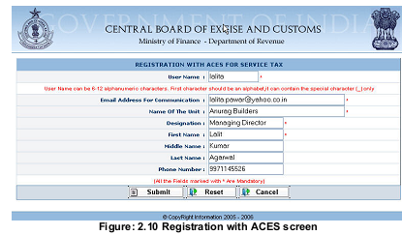

Steps to be followed:

- Enter the details for registration with ACES
- Click on Submit to submit the details and get registered the user with ACES
- Click on Reset to clear the contents of the fields, if required
- Click on Cancel to cancel the process of Registration with ACES

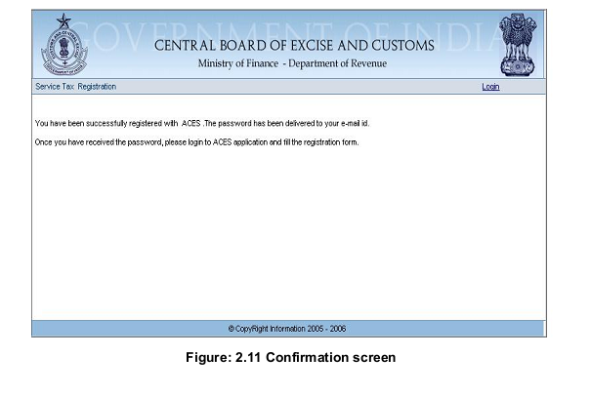

2.4. Filling ST1 form
2.4.1 Description
The ST1 form on ACES is an electronic version of the Registration form filled by assesses of Service Tax.

The registrant fills up the ST1 form with the details about the business, addresses and details of the premises, details of proprietors’/ partners’ /chief executive officers and the details of the Services provided.

2.4.2 Navigational Path
The ST1 form can be accessed by the users after getting logged in successfully into the system, through the ‘Registration’ menu item; here ‘Registration’ is the label for registration menu. In the Registration menu the Pre-Assessee will click on the ‘Fill ST1 form’ menu option.
As soon as the user clicks on the same the system will populate a blank ST1 form for the user on the screen.

The navigation path for the ST1 form is:

Logged in User à ’Registration’ menu à ‘Fill ST1’

2.4.3 Operating Instructions

The ST1 form can be filled by the users registered with ACES, to register their business.
The ST1 form on ACES is divided into four sections and seven screens.

The four sections on the ST1 form are:
- Identification of business requiring registration
- Proprietor/ Partner/ Chief Executive Officer/ Chairman/ Managing Director/ Trustee

Steps to be followed:

· Click on the Fill ST-1 menu option to open a blank ST1 form
Steps to be followed:

· Click on the Fill ST-1 menu option to open a blank ST1 form
Steps to be followed:

· Click on the Fill ST-1 menu option to open a blank ST1 form
Steps to be followed:

· Click on the Fill ST-1 menu option to open a blank ST1 form
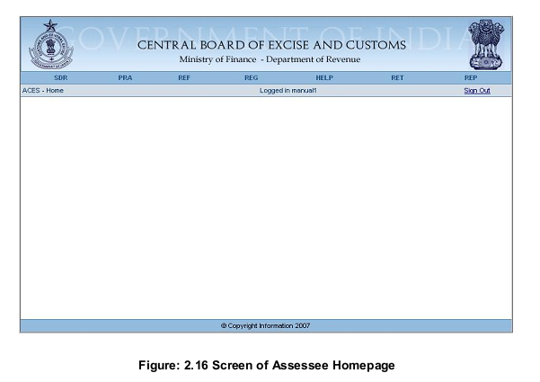
Steps to be followed:
- Click on the Fill ST-1 menu option to open a blank ST1 form
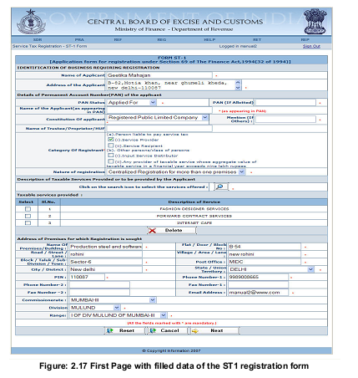

- Enter the details in the fields Assessee name, Address of Registered unit, PAN status, Constitution of Business
- Select the Constitution of Business from the drop down
- Check the business category to which the Assessee belongs there can be multiple selections
- To select the services offered click on the Search button with the magnifying glass to display the pop up with the list of services
- Check mark the appropriate service on the service list pop up and press submit.
- The system will refresh the page and display the list of services on the ST1 form
- Enter the details for the office address of the business premises
- To reset the field values click on Reset, if required
- To cancel the whole process of filing the ST1 form and go back to the homepage click Cancel
- To go to the next screen of ST1 form click on Next

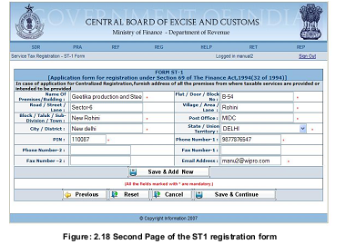

- Enter the details on the second screen of ST1 and press Save & Add New to add another address details of premises covered under the centralized accounting / billing system.
- Click on Previous to go to the previous page of the ST1.
- Click on reset to reset the field values, if required
- Click on Cancel to cancel the process of filling of ST1 and go back to the homepage
- Click on Save & Continue to go to the next screen of ST1

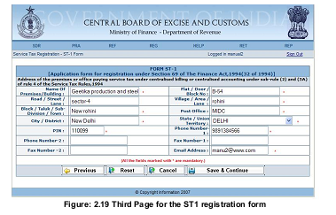
- Enter the details on the third screen of ST1 and press Save & Add New to add address details of premises covered under the centralized accounting / billing system.
- Click on Previous to go to the previous page of the ST1.
- Click on reset to reset the field values, if required
- Click on Cancel to cancel the process of filling of ST1 and go back to the homepage.
- Click on Save & Continue to go to the next screen of ST1

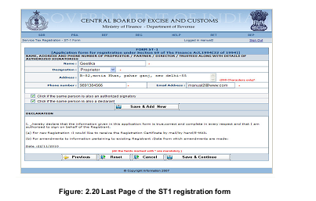

- Enter the details on the fourth screen of ST1 and press Save & Add New to add Name, Address and Phone Number of Proprietor/Partner/Director along with details of Authorized signatories.
- Check the checkbox to make person a authorized signatory
- Check the checkbox to make person a Declarant
- Click on Previous to go to the previous page of the ST1
- Click on reset to reset the field values, if required
- Click on Cancel to cancel the process of filling of ST1 and go back to the homepage
- Click on Next to go to the next screen of ST1

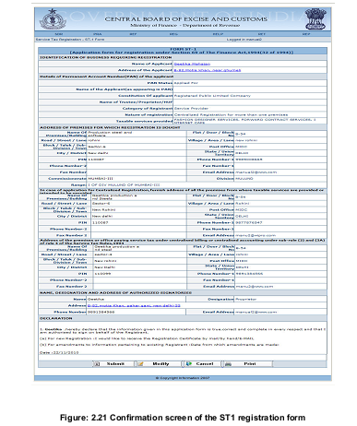

Steps to be followed:-

- Click on Submit to enter the details of ST1 into the database
- Click on Modify to go to the first screen of ST1 and modify the entered details
- Click on Cancel to cancel the process of filing of ST1 and go back to the homepage
- Click on Print to get a printable version of the ST1

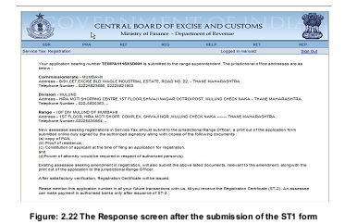

On the successful submission of the ST1 form, a registration number is generated.

The various screens of the ST1 form can be navigated with the help of Next and
Previous buttons.
Each field on every screen of the ST1 has certain validations that should be cleared by the Assessee before moving to the next screen.

