ta21s Iz8
_{TAX CONNECT}

449th Issue: 7th April 2024-13th April 2024
12017

sssss

Knowledge Partner:



TAX CONNECT :

Mumbai : Unit No. 312, Omega Business Park, Near-Kaamgar Hospital, Road No. 33, Wagle Industrial Estate,
Thane (West), Maharashtra – 400604
Bengaluru : 951, 24th Main Road, J P Nagar, Bengaluru, Karnataka – 560078.
Delhi (NCR) : B-139, 2ndFloor, Transport Nagar, Noida-201301 (U.P)
Kolkata : 6, Netaji Subhas Road, 3rd Floor, Royal Exchange Building, Kolkata – 700001
- Room No. 119, 1stFloor, “Diamond Arcade” 1/72, Cal Jessore Road, Kolkata – 700055
- Tobacco House, 1, Old Court House St, Radha Bazar, Corner, Kolkata, West Bengal 700001
Dubai : Azizi Feirouz, 803, 8th Floor, AL Furjan, Opposite Discovery Pavillion, Dubai, UAE

Contact : +91 7003384915

Website : www.taxconnect.co.in
Email : info@taxconnect.co.in

Friends,
Through e-campaign, persons/entities carrying out significant financial transactions are being ‘alerted’ through email/SMS to ‘urge’ them to compute and deposit their due advance tax on or before 15.03.2024. This is being done as a part of ‘taxpayer service’ and ‘easing compliance for taxpayers’. The Income Tax Department has received certain information on specific financial transactions undertaken by persons/entities during Financial Year (F.Y.) 2023-24. On the basis of analysis of the taxes paid so far during the current financial year, the Department has identified such persons/entities where payment of taxes for F.Y. 2023-24 (A.Y. 2024-25) is not commensurate with the financial transactions made by the persons/entities concerned, during the said period.

This information is reflected in the Annual Information Statement (AIS) module and is available to the persons/entities for viewing. For viewing the details of significant transactions, the persons/entities should login to their e-filing account (if already created) and go to the Compliance Portal. On this portal, e-Campaign tab can be accessed to view significant transactions.

So now that Income Tax Department has initiated a service, taxpayers also need to oblige by a quid-pro-quo service. To comply with the same, the following are the suggested steps –

Step 1. Most important is not to ignore this communication

Step 2. Log in to the e-filing income tax return (ITR) websitehttps:// www.incometax.gov.in/iec/foportal/. If you are using the e-filing portal for the first time, make sure to register on it.

Step 3. Click on 'Compliance Portal' button under the 'Pending Actions' tab.

Step 4. A pop-up browser window will open, and it will say that the 'Compliance Portal' is hosted on another web address and on clicking 'Proceed' you are going to leave the e-filing website and get redirected to the 'Compliance Portal' website. Click on the 'Proceed' button.

Step 5. Click on the 'e-campaign' button and access the e- campaign' page on the compliance portal. If there is any transaction that has been identified by the tax department it will show up here.

Step 6. Thereafter you need to follow instructions and ‘view feedback in AIS’

Step 7. Important to note is that it is only mandatory to provide feedback on the transactions where response is ‘expected’. Others marked as ‘optional’ are not mandatory. You can select the ‘bulk response’ section also for each party.

Just to reiterate that we remain available over telecom or e-mail.
Editor:
Vivek Jalan
Partner - Tax Connect Advisory Services LLP
Co-Editor:
Rohit Sharma
Director – Tax Connect Advisory Services LLP

S.NO. | TOPICS | PAGE NO.
1] | TAX CALENDER | 4
2] | INCOME TAX | 5
NOTIFICATION | TIME LIMIT FOR VERIFICATION OF RETURN OF INCOME AFTER UPLOADING
3] | GST | 6-8
INDTRUCTION | GUIDELINES FOR CGST FIELD FORMATIONS IN MAINTAINING EASE OF DOING BUSINESS WHILE ENGAGING IN INVESTIGATION WITH REGULAR TAXPAYERS
ADVISORY | SELF ENABLEMENT FOR E-INVOICING
4] | FEMA | 9-10
CASE LAW | ADJUDICATION MADE UNDER FEMA ACT - NON ISSUANCE OF SHOW CAUSE NOTICE AS WELL AS NON GIVING OF AN OPPORTUNITY OF BEING HEARD WITHIN THE MEANING OF SECTION 16 OF THE ACT R/W RULE 4(1) AND 4(3) OF THE RULES CERTAINLY WOULD AMOUNT TO VIOLATION OF PRINCIPLES OF NATURAL JUSTICE : MADRAS HIGH COURT
5] | CUSTOMS | 11-12
NOTIFICATION | SEEKS TO FULLY EXEMPT THE APPLICABLE EXPORT DUTY ON EXPORTS OF KALANAMAK RICE NOT EXCEEDING 1000 MTS SUBJECT TO THE SPECIFIED CONDITIONS
NOTIFICATION | RATE OF EXCHANGE OF ONE UNIT OF FOREIGN CURRENCY EQUIVALENT TO INDIAN RUPEES
6] | DGFT | 13-16
NOTIFICATION | Amendment in Import Policy Condition for Melon Seeds under ITC (HS) Code 1207 70 90
NOTIFICATION | Extension in import period for Yellow Peas under ITC (HS) Code 07131010
NOTIFICATION | SUPPLY OF ESSENTIAL COMMODITIES TO THE REPUBLIC OF MALDIVES DURING 2024-25
NOTIFICATION | EXPORT OF ONIONS (UNDER HS CODE 0703 10 19) TO UAE
NOTIFICATION | EXPORT OF 1,000 MT OF KALA NAMAK RICE UNDER HS CODE 1006 30 90
7] | TAX PLEADING AND PRACTICE JOURNAL | 17
8] | GST PLEADING AND PRACTICE: WITH SECTION-WISE GST CASES & GST NOTICES AND THEIR REPLIES | 18
9] | HANDBOOK ON GST 2022 | 19
10] | HOW TO HANDLE GST LITIGATION: ASSESSMENT, SCRUTINY, AUDIT & APPEAL | 20
11] | LET’S DISCUSS FURTHER | 21

Due Date | Form/Return/Challan | Reporting Period | Description
7th April | Deposit of Tax deducted/collected | March 2024 | Due date for deposit of Tax deducted/collected by an office of the government for the month of March, 2024. However, all sum deducted by an office of the government shall be paid to the credit of the Central Government on the same day where tax is paid without production of an Income-tax Challan
10th April | GSTR-7 | March 2024 | Monthly return filed by individuals who deduct tax at source or TDS under the Goods and Services Tax (GST)
10th April | GSTR-8 | March 2024 | Monthly return to be filed by e-commerce operators registered under the GST.
11th April | GSTR-1 | March 2024 | Monthly Statement of Outward Supplies to be furnished by all normal registered taxpayers making outward supplies of goods and services or both and contains details of outward supplies of goods and services.
13th April | GSTR-1 (IFF) | March 2024 | Details of B2B Supply of a registered person with turnover upto INR 5 Crores during the preceding year and who has opted for quarterly filing of return under QRMP.
13th April | GSTR-6 | March 2024 | Details of Input Tax Credit (ITC) received and distributed by an Input Service Distributors (ISD).
13th April | GSTR-5 | March 2024 | Summary of outward taxable supplies and tax payable by a non-resident taxable person.

NOTIFICATION
Time limit for verification of return of income after uploading
OUR COMMENTS: The Central Board of Direct Taxes vide notification no. 02/2024 dated 31.03.2024 read with corrigendum notification dated 04.04.2024 notified In pursuance of the powers conferred under Rule 14 of the Centralised Processing of Returns Scheme, 2011, Notification No. 05 of 2022 dated 29.07.2022 was issued by the DGIT(Systems) specifying the time limit for verification of Income Tax Return (ITR) as 30 days from the date of transmitting the data of ITR electronically.
2. It is clarified that:
(i) Where the return of income is uploaded and e-verification/lTR-V is submitted within 30 days of uploading – In such cases the date of uploading the return of income shall be considered as the date of furnishing the return of income.
(ii) Where the return of is uploaded but e-verification or ITR-V is submitted after 30 days of uploading – In such cases the date of e-verification/ITR-V submission shall be treated as the date of furnishing the return of income and all consequences of late filing of return under the Act shall follow, as applicable.
3. The duly verified ITR-V in prescribed format and in the prescribed manner shall be sent either through ordinary or speed post or in any other mode to the following address only:
Centralised Processing Centre,
Income Tax Department,
Bengaluru - 560500, Karnataka.
4. The date on which the duly verified ITR-V is received at CPC shall be considered for the purpose of determination of the 30 days period from the date of uploading of return of income.
5. It is further clarified that where the return of income is not verified within 30 days from the date of uploading or till the due date for furnishing the return of income as per the Income-tax Act, 1961 - whichever is later - such return shall be treated as invalid due to non-verification.
6. It is reiterated for the sake of assessee convenience that e-verification, immediately upon filing of the return is the most desirable action.
7. This Notification shall be applicable for returns of income uploaded/submitted on the e-filing portal (www.incometax.gov.in). This issues by the power conferred to the undersigned under the Rule 14 of Centralized Processing of Returns Scheme, 2011 (CPR Scheme 2011) dated 04.01.2012, notified by the CBDT Notification No. 02/2012- F.No. 142/27/2011-SO(TPL).
8. This notification will come into effect from 01.04.2024.
9. Hindi version to follow.

[For further details please refer the notification]
INSTRUCTION
GUIDELINES FOR CGST FIELD FORMATIONS IN MAINTAINING EASE OF DOING BUSINESS WHILE ENGAGING IN INVESTIGATION WITH REGULAR TAXPAYERS
OUR COMMENTS: The Central Board of Indirect Taxes and Customs vide instruction no 01/2023-24-GST (Inv.) dated 30.03.2024 instructed that the undersigned is directed to say that the matter of CGST field formations following a uniform procedure in undertaking enforcement activities, with or involving regular taxpayers, which incorporates aspects related to the ease of doing business, was considered by Board.
2. Keeping relevant aspects in view, the Board has desired that the following guidelines, henceforth, should be followed in the CGST Zones while engaging in investigation, subject to legal provisions or instructions issued on this behalf:
(a) Within the allocated jurisdiction of Commissionerate under notification No. 2/2017-Central Tax dated 19.06.2017, the (Pr.) Commissioner shall be responsible for developing and approving any intelligence, conducting search, and completing investigation in a case and the relevant subsequent action, including in the divisional formations, etc.
Any information or intelligence which pertains to another CGST field formation, that may have been generated /collected /received /recorded by such field formation (or even developed in the course of an investigation, including with respect to end-availer(s) of ITC), shall be forwarded by the (Pr.) Commissioner to the concerned CGST field formation or DGGI, as the case may be.
(b) Each investigation must be initiated only after the approval of the (Pr.) Commissioner, except in the following situations where the prior written approval of the zonal (Pr.) Chief Commissioner shall be required if investigation is to be initiated and action to be taken in a case falling under any of the following four categories, namely case involving –
i. matters of interpretation seeking to levy tax/ duty on any sector/commodity/ service for the first time, whether in Central Excise or GST;
or
ii. big industrial house and major multinational corporations; or
iii. sensitive matters or matters with national implications; or
iv. matters which are already before GST Council.
In all of above four categories of cases, the concerned CGST field formation should also collect details regarding the prevalent trade practices and nature of transactions carried out from the stakeholders. The implications / impact of such matter should be studied so as to have adequate justification for initiating investigation and taking action.
(c) The fact of initiation of inquiry, if any, already on same subject matter with respect to the same taxpayer/GSTIN by another investigating office or tax administration must be ascertained for purposes of obtaining approval to initiate investigation. The position must be placed before the authority who is to approve initiation of investigation.
(d) There may be a situation where it comes to the Commissionerate’s notice that either the DGGI or the State GST department is also simultaneously undertaking record-based investigation of the same taxpayer on different subject matters. The (Pr.) Commissioner must engage in dialogue with the other investigating office(s) to consider the feasibility of only one of the offices pursuing all these subject matters with respect to the taxpayer, and the other offices consolidating their material with that office. If this outcome is not feasible, the reasons therefor should be confirmed on file by such (Pr.) Commissioner.
(e) There may be the situation where the (Pr.) Commissioner has initiated an investigation with respect to a GSTIN in its jurisdiction, and the issue is relevant to some or all of that taxpayers’ GSTINs registered (under the same PAN) in multiple jurisdictions. If the matter also falls in the charter of DGGI and is not such that DGGI avoids taking up (as it is more appropriately in the purview of return scrutiny or audit etc), then the (Pr.) Commissioner shall expeditiously make a self-contained reference to its zonal (Pr.) Chief Commissioner who shall request the Pr. DG, DGGI to take up the matter in accordance with DGGI guidelines.
(f) There may be the situation where the (Pr.) Commissioner has initiated an investigation with respect to a GSTIN in its jurisdiction, and the issue is relevant to other taxpayers’ GSTINs registered (under multiple PANs) across various CGST jurisdictions. In this scenario, the (Pr.) Commissioner shall within 30 days of initiation of investigation take either of the following two actions with the approval of zonal (Pr.) Chief Commissioner –
i. If description of GSTINs or similar entity types involved (or likely to be involved) across various jurisdictions related to the issue or topic is available, the self-contained reference be shared with each concerned Zone or all the Zones.
ii. In other situations, Pr. DG DGGI shall be requested to issue suitable alert.
(g) The scenario may arise in a CGST Zone where an issue investigated by one of the (Pr.) Commissioners is based on an interpretation of CGST Act/ Rules, notifications, circulars etc, and it is in the direction of proposing non-payment or short payment of tax, however, the background is that the taxpayer(s) is/are following, or have followed, a prevalent trade practice based on particular interpretation on that issue in the sector/industry. This scenario results in more than one interpretation and likelihood of litigation, change in practice etc.
In such cases, it is desirable that the zonal (Pr.) Chief Commissioner make a self-contained reference to the relevant policy wing of the Board i.e. the GST Policy or TRU. The endeavor, to make such reference before concluding investigation, and as much in advance, as is feasible, of the earliest due date for issuing of show cause notice, may be useful in promoting uniformity or avoiding litigation if the matter, after being processed, is amongst those that also gets placed before the GST Council.
(h) In initiating investigation with respect to a listed company or PSU or Corporation or Govt Dept./agency or an Authority established by law, or seeking details (that are record-based and/or are reflected in statutory books of account or filings) from them, the practice to be adopted by the CGST field formation should be of initially addressing official letters (instead of summons) to the designated officer of such entity (detailing the reasons for investigation, and the legal provisions therefor) and requesting the submission of the relevant specified details in a reasonable time period which should be mentioned in the letter. Divergence from this practice at the initial stage must be backed by written reasons.
(i) In such a letter issued for seeking information/documents from regular taxpayer, the reference can be to inquiry "with respect to” or “in connection with” that entity. Further, the letter/summons should disclose the specific nature of the inquiry being initiated/undertaken. The vague (or general) expressions such as that the officer is making inquiry in connection with "GST enquiry" or "evasion of GST" or "GST evasion" etc. must not be mentioned.
(j) Information available digitally/online on GST portal should not be called for under letter/summons from a regular taxpayer. Further, a letter or summons should not be used as a means to seek information filled in formats or proforma (specified by investigation).
(k) The summons in conduct of investigation must not convey requests outside the scope defined for a summons. In the case of GST, the scope of summons is in the wording of section 70 of CGST Act, 2017. Addressing letter/summons with context or content akin to a fishing inquiry is not acceptable.
(l) If a taxpayer has utilized ITC towards payment of GST on its outward supplies, it is not acceptable to seek via summons/letter aspects such as - 'please clarify whether ITC availed and utilized was proper."
(m) In issuing summons, the norm shall be of prior reasoned approval (of officer not below Dy/Asst. Commissioner level) of the content of the summons to be printed by the summoning officer, including in terms of what is being sought and the time frame to be provided being reasonable for its compliance.
(n) Where, for strictly operational reasons, it is not possible to obtain such prior written permission, the approval by such an officer can be verbal, however this all must be confirmed in writing at the earliest opportunity.
(o) Before summoning any information or documents from a regular taxpayer, the relevancy and propriety of what is being sought must be recorded (on e-file), ensuring that it is holistic and result of preparation, and also so as not to have repeated issuance of summons or seeking piecemeal information.
(p) Scanned copy of a statement (recorded under summons) be uploaded in the same e-office file in which approval was obtained to issue summons. Outcome of search/inspection conducted, including panchnama (if any), be also so uploaded. The e-file should be submitted for information to Addl./Jt. Commissioner in not more than 4 working days from date of statement, completion of search/inspection.
(q1) An investigation initiated must reach the earliest conclusion which is not more than one year. It is not necessary to keep investigation pending till limitation in law approaches. Show cause notice should not be delayed after conclusion of investigation. The closure report consequent to the appropriate payment of government dues by the person concerned should also not be delayed and should have a brief self- explanatory narration of the issue and the period involved. Expeditious actions without delay at these stages are part of preventive vigilance ensuring that no room remains for malpractices.
(q2) Conclusion of investigation may also take the form of recording that investigation is not being pursued further as nothing objectionable was found in terms of matter investigated.
Grievance redressal
3. The (Pr.) Commissioner is to be proactive in a manner that prevents complaints from arising in respect of the investigation and related work being undertaken within the jurisdiction.
The Addl./Jt. Commissioner in-charge of investigation is the Grievance Officer whom taxpayers may approach (through letter, email or by appointment) with grievance, if any, related to an ongoing investigation, for appropriate redress. In case the reasonable grievance persists, the (Pr.) Commissioner may consider meeting, by appointment, the taxpayer.
[For further details please refer the instruction]
ADVISORY
SELF ENABLEMENT FOR E-INVOICING
OUR COMMENTS: The GSTIN vide advisory dated 03.04.2024 advised that –
1. If your turnover exceeds INR 5 crores in the financial year 2023-2024, you will be required to start e-Invoicing from the next financial year, i.e., from 1st April 2024 onwards. It may also be noted that same is applicable if the threshold is crossed in any of the proceeding financial years too.
2. For those who meet the notification criteria but have not yet been enabled on the portal, you can self-enable for e-Invoicing by visiting https://einvoice.gst.gov.in and start reporting through any of the 4 new Invoice Registration Portals (IRPs) - from e-Invoice IRP 3 to e-Invoice IRP 6
https://einvoice3.gst.gov.in
https://einvoice4.gst.gov.in
https://einvoice5.gst.gov.in
https://einvoice6.gst.gov.in
3. To report e-Invoices through NIC IRP 1 & 2, taxpayers can self-enable at
https://einvoice1.gst.gov.in
https://einvoice2.gst.gov.in

[For further details please refer the advisory]
CASE LAW
ADJUDICATION MADE UNDER FEMA ACT - NON ISSUANCE OF SHOW CAUSE NOTICE AS WELL AS NON GIVING OF AN OPPORTUNITY OF BEING HEARD WITHIN THE MEANING OF SECTION 16 OF THE ACT R/W RULE 4(1) AND 4(3) OF THE RULES CERTAINLY WOULD AMOUNT TO VIOLATION OF PRINCIPLES OF NATURAL JUSTICE : MADRAS HIGH COURT
OUR COMMENTS: It was held that The mode of service of notice has been clearly demonstrated at Rule 14, i.e., 3 methods, namely 14(a), 14(b) and 14(c). At least Rule 14(b) and 14(c), the notices have been served on these noticees in their last known address or the address where they carried on business last.
Merely because at the time of serving the notice, these noticees were not available at the address at Bengaluru would not ipso facto entile them to claim immunity that the notices served on them at the Bengaluru address cannot be construed as a notice within the meaning of Section 16 r/w Rule 4(1) and Rule 14(b) or (c) of the Rules.
Therefore, this Court have no hesitation to hold that, notice as contemplated under the Act as well as the Rules as discussed herein above have been served on these noticees.
Under Section 42(1), if a person committing a contravention who is a company, every person who at the time of contravention was committed was incharge of and was responsible to the company for the conduct of the business of the company as well as the company, shall be deemed to be guilty of the contravention and shall be liable to be proceed against and punished accordingly.
Insofar as the application of Section 42(1) against these noticees are concerned, it was the vehement contention of Mr.Shah, that the two Noticee namely Noticee No.17 and 20 were the nominee Directors, i.e., Non-executive Directors of the first Noticee company on behalf of the fourth Noticee company. When their very appointment as a Director itself is a mere nominee on behalf of the fourth noticee company as a Non-Executive Directors, therefore they are not incharge of and was responsible to the conduct of the business of the company as well as the company.
Therefore assuming that, any contravention that has been made by the first Noticee company, for which these noticees namely Noticee No.17 and 20 cannot be found fault with. Therefore u/s 42(1) no contravention cannot be attributable against these Noticees. Insofar as this contention of the learned counsel appearing for the petitioners are concerned, whether they were the Non-Executive Directors or nominee Directors and during the relevant point of time whether they were in the helm of affairs or the company or not, whether the contravention that has been made by the first Noticee company would amount to the contraventions of the persons like Noticee No.17 and 20 also, for which, they are also to be proceeded against and be punished by imposing penalty or not, are all the matters for adjudication which have been adjudicated and decided by the Adjudicating Authority through the impugned order.
As against the impugned order, an appeal has been provided before the Appellate Tribunal under Section 19 of the Act. Even if there is any failure before the Appellate Tribunal and it goes against the interest of these noticees, again a further appeal is provided under Section 35 of the FEMA Act, where Second Appeal can be preferred before this Court (High Court).
When such a hierarchy of appellate forum is provided under the Act itself, whether the jurisdiction that has been conferred under the Act, especially u/s 35 of the Act to the appellate side of this Court, whether can be taken away by entertaining these writ petition is a question, for which the answer is in the negative. The reason being that, the law which has been held by law courts with regard to the exhaustion of alternative remedy is well settled. Though it is not a hard and fast rule that each and every case, the exhaustion of alternative remedy shall stand in the way in entertaining the case under the extraordinary jurisdiction of this Court under Article 226 of the Constitution, still limitations are there for the High Courts who are empowered to issue prerogative writs under Article 226 of the Constitution of India.
While exercising such extraordinary jurisdiction under Article 226, the High Court on the one side cannot take away or absolve the appellate jurisdiction being exercised by the same High Court under the provisions of the statute which is special in nature.
Here in the case in hand, ultimately the aggrieved party can approach this Court by filing the Second Appeal under Section 35 of the Act, instead, if these writ petitions are entertained and the impugned order of adjudication is challenged and a decision is made on the merits of the issue, certainly that will amount to interfering or transgressing the appellate jurisdiction of this Court, which normally the court would not do in exercising the extraordinary jurisdiction under Article 226 of the Constitution.
We do hold that, absolutely there has been no quarrel on the said principle stated by the learned Judge in the said Judgment. However in the facts of the present case, what is the uncurable defect, that has been committed by the original authority in the present case is the question. As we held above, the notice, i.e., show cause notice had already been served properly under the mode as contemplated under the Act as well as the Rule. Therefore, first of all it cannot be construed that the principles of natural justice has been violated. Assuming that, because of the enquiry notice that has not been served on the noticees as claimed by them, whether any injury is caused by virtue of passing of adjudication order, certainly those issues can be canvassed before the Appellate Tribunal challenging the order of adjudication. Hence, we do not find that any uncurable defect or injustice caused to the noticees at the adjudication stage and therefore, that cannot be stated that such a defect, if any, cannot be cured by the appellate forum.
We have held that, as contemplated under Section 16 r/w Rule 4 and 14 of the Rules, show cause notice since have been served on all the petitioners herein, i.e., Noticee No.4,17 and 20, on the alleged ground of violation of principles of natural justice, these writ petitions cannot be entertained especially in applying the principle as laid down by the Hon’ble Supreme Court in the Radha Krishan Industries case cited supra.
Despite the above, it is open to the petitioners to raise these point of the violation of principles of natural justice before the Appellate Tribunal in case still the petitioners feel that the issue also can be adjudicated as one of the issue before the Appellate Tribunal. That apart, insofar as the merits of the case is concerned, as we held above, we do not want to hold anything on the merits of the case, because that will have a bearing on the cause of the petitioners, when they approach the Tribunal by filing the appeal. WP dismissed. However it is open to the petitioners to approach the Appellate Tribunal by filing appropriate appeal against the impugned order of adjudication u/s 19 of the FEMA Act.

NOTIFICATION
Seeks to fully exempt the applicable export duty on exports of Kalanamak rice not exceeding 1000 MTs subject to the specified conditions
OUR COMMENTS: The Ministry of Finance, Department of Revenue vide notification no 22/2024-Customs dated 02.04.2024 notified In exercise of the powers conferred by sub-section (1) of section 25 of the Customs Act, 1962 (52 of 1962), the Central Government, on being satisfied that it is necessary in the public interest so to do, hereby exempts the goods of the description specified in column (3) of the Table below, falling within the tariff item of the Second Schedule to the Customs Tariff Act, 1975 (51 of 1975), specified in the corresponding entry in column (2) of the said Table, when exported out of India, from so much of the duty of customs leviable thereon under the said Second Schedule as is in excess of the amount calculated at the rate specified in the corresponding entry in column (4) of the said Table, subject to the conditions specified in the corresponding entry in column (5) of the said Table, namely: –
TABLE
Sl. No. | Tariff item | Description of goods | Rate | Conditions
(1) | (2) | (3) | (4) | (5)
1. | 1006 30 90 | Kala namak rice | Nil | If,  (a) Goods are exported through the customs stations, namely, Varanasi Air Cargo, JNCH, CH Kandla, LCS Nepalgunj Road, LCS Sonauli or LCS Barhni;  (b) the total quantity of such goods exported through the afore-mentioned customs stations taken collectively, shall not exceed one thousand metric tonnes; and  (c) the exporter furnishes a certificate to the Deputy Commissioner of Customs or the Assistant Commissioner of Customs, as the case may be, from the Director, Agriculture Marketing & Foreign Trade, Lucknow, Uttar Pradesh, certifying the item and quantity of Kala namak rice to be exported.
2. This notification shall come into force on the 3rd day of April, 2024.
[For further details please refer the notification]
NOTIFICATION
Rate of exchange of one unit of foreign currency equivalent to Indian rupees
OUR COMMENTS: The Ministry of Finance, Department of Revenue vide notification no 27/2024-Customs(N.T) dated 04.04.2024 notified In exercise of the powers conferred by section 14 of the Customs Act, 1962 (52 of 1962), and in supersession of the Notification No. 24/2024-Customs(N.T.), dated 26th March, 2024 except as respects things done or omitted to be done before such supersession, the Central Board of Indirect Taxes and Customs hereby determines that the rate of exchange of conversion of each of the foreign currencies specified in column (2) of each of Schedule I and Schedule II annexed hereto, into Indian currency or vice versa, shall, with effect from 5th April, 2024, be the rate mentioned against it in the corresponding entry in column (3) thereof, for the purpose of the said section, relating to imported and export goods.
SCHEDULE-I
Sl. No. | Foreign Currency | Rate of exchange of one unit of foreign currency equivalent to Indian rupees
(1) | (2) | (3)
 |  | (a) | (b)
 |  | (ForImported Goods) | (ForExport Goods)
1. | Australian Dollar | 56.10 | 53.70
2. | Bahraini Dinar | 230.05 | 213.30
3. | Canadian Dollar | 62.75 | 60.75
4. | Chinese Yuan | 11.75 | 11.35
5. | Danish Kroner | 12.30 | 11.95
6. | EURO | 92.05 | 88.95
7. | HongKong Dollar | 10.80 | 10.50
8. | Kuwaiti Dinar | 280.2 | 262.80
9. | NewZealand Dollar | 51.45 | 49.10
10. | Norwegian Kroner | 7.90 | 7.70
11. | Pound Sterling | 107.35 | 103.90
12. | Qatari Riyal | 23.65 | 22.25
13. | SaudiArabian Riyal | 23.00 | 21.65
14. | Singapore Dollar | 62.90 | 60.95
15. | SouthAfrican Rand | 4.60 | 4.35
16. | Swedish Kroner | 7.95 | 7.75
17. | Swiss Franc | 94.15 | 90.70
18. | Turkish Lira | 2.70 | 2.55
19. | UAE Dirham | 23.45 | 22.05
20. | US Dollar | 84.35 | 82.60
SCHEDULE-II
Sl. No. | Foreign Currency | Rate of exchange of 100 units of foreign currency equivalent to Indian rupees
(1) | (2) | (3)
 |  | (a) | (b)
 |  | (For Imported Goods) | (For Export Goods)
1. | Japanese Yen | 55.85 | 54.20
2. | Korean Won | 6.40 | 6.00
[For further details please refer the notification]

NOTIFICATION
Amendment in Import Policy Condition for Melon Seeds under ITC (HS) Code 1207 70 90
OUR COMMENTS: The Ministry of Commerce and Industry vide notification no. 05/2023 dated 05.04.2024 notified In exercise of powers conferred by Section 3 and section 5 of FT (D&R) Act, 1992, read with paragraph 1.02 and 2.01 of the Foreign Trade Policy (FTP) 2023, as amended from time to time, the Central Government hereby amends the policy condition under ITC (HS) 1207 70 90 of Chapter 12 of ITC (HS) 2022, Schedule-I (Import Policy) as under:s is issued with the approval of the Minister of Commerce & Industry.
ITC(HS) Code & Description | Import Policy | Existing Policy Condition | Revised Policy Condition
12077090  Melon Seeds -Other | Restricted | Imports subject to Policy Condition (4) of the Chapter. | i. Imports subject to Policy Condition (4) of the Chapter.  ii. Import Policy of Melon Seeds is 'Free' with effect from 01st May 2024 up to 30th June 2024. Consignments with 'shipped on board' Bill of lading issued till 30th June 2024 shall be treated as "Free" to import.  iii. Imports shall be permitted only on 'Actual User' basis to Processors of Melon Seeds only.  iv. Imports shall be permitted only against a valid FSSAI Manufacturer Licence for Melon Seeds in line with FSSAI Order RCD-12005/1/2021 -Regulatory-FSSAI-Part(2) (E-1638) dated 15.03.2024.  v. All imports shall be subject to compulsory registration under Melon Seeds Import Monitoring System (MS-IMS).
2. Procedure in regard to prior registration of Melon Seed Consignments under MS-IMS shall be notified separately.
3. The existing 'Restricted' Import Policy, as it stands prior to the issuance of this Notification, shall be in effect starting from 1st July 2024, unless expressly amended by subsequent notification.
Effect of this Notification: Import of Melon Seeds under ITC(HS) code 12077090 is 'Free' with effect from 1st May 2024 till 30th June 2024, on 'Actual User' basis to Processors of Melon Seeds having a valid FSSAI Manufacturing Licence in line FSSAI Order dated 15.03.2024. Goods imported/shipped/arrived but not cleared from Customs prior to 1st May 2024 may also be cleared during 1.5.2024 to 30.6.2024.
This is issued with the approval of the Minister of Commerce & Industry.
[For further details please refer the notification]
NOTIFICATION
Extension in import period for Yellow Peas under ITC (HS) Code 07131010
OUR COMMENTS: The Ministry of Commerce and Industry vide notification no. 04/2023 dated 05.04.2024 notified In exercise of powers conferred by Section 3 and Section 5 of Foreign Trade (Development & Regulation) Act, 1992, read with paragraph 1.02 and 2.01 of the Foreign Trade Policy (FTP) 2023, as amended from time to time, and in continuation to Notification No. 50/2023 dated 08.12.2023 and No. 61/2023 dated 23.02.2024, the Central Government hereby amends Import Policy Conditions for Yellow Peas under ITC(HS) Code 07131010 of Chapter 07 of ITC(HS), 2022, Schedule -I (Import Policy) as under:- (Changes made are in bold letters)
ITC (HS) Code & Item Description | Existing Policy Condition | Revised Policy Condition
07131010-Yellow Peas | a) Import is 'Free' without the MIP condition and without Port Restriction, for Import consignments where Bill of Lading (Shipped on Board) has been issued on or before 30th April 2024.  b) Imports where Bill of Lading (Shipped on Board) is issued after 30th April 2024 shall be 'Restricted' and associated Import Policy Conditions as existing prior to DGFT Notification 50/2023 dated 08.12.2023 shall come into force.  c) All Import of Yellow Peas where Bill of Lading (Shipped on Board) is dated on or before 30th April 2024 shall be subject to compulsory registration under the Import Monitoring System. | a) Import is 'Free' without the MIP condition and without Port Restriction, for Import consignments where Bill of Lading (Shipped on Board) has been issued on or before 30th June 2024.  b) Imports where Bill of Lading (Shipped on Board) is issued after 30th June 2024 shall be 'Restricted' and associated Import Policy Conditions as existing prior to the DGFT Notification 50/2023 dated 08.12.2023 shall come into force.  c) All imports of Yellow Peas where Bill of Lading (Shipped on Board) is dated on or before 30th June 2024 shall be subject to compulsory registration under the online Import Monitoring System.
Effect of the Notification: Import of Yellow Peas under ITC (HS) Code 07131010 is "Free" without the MIP condition and without Port Restriction, subject to registration under online Import Monitoring System, with immediate effect for all import consignments where Bill of Lading (Shipped on Board) is issued on or before 30th June 2024.
This is issued with the approval of the Minister of Commerce & Industry.
[For further details please refer the notification]
NOTIFICATION
Supply of essential commodities to the Republic of Maldives during 2024-25
OUR COMMENTS: The Ministry of Commerce and Industry vide notification no. 03/2023 dated 05.04.2024 notified In exercise of the powers conferred by Section 3 read with Section 5 of the Foreign Trade (Development & Regulation) Act, 1992 (No. 22 of 1992), as amended, read with paragraph 1.02 and 2.01 of the Foreign Trade Policy (FTP), 2023, the Central Government hereby allows export of the following quantities of Eggs, Potatoes, Onions, Rice, Wheat Flour, Sugar, Dal, Stone Aggregate and River Sand to the Republic of Maldives during 2024-25, under bilateral trade agreement between Government of India and Government of Maldives :
S. No. | Commodity | Unit | Quantity to be allowed for FY 2024-25
1. | Eggs | Nos. | 427,536,904.20
2. | Potatoes | MT | 21,513.08
3. | Onions | MT | 35,749.13
4. | Rice | MT | 124, 218.36
5. | Wheat Flour | MT | 109,162.96
6. | Sugar |  | 64,494.33
7. | Dal | MT | 224.48
8. | Stone Aggregate | MT | 1,000 000.00
9. | River Sand | MT | 1,000 000.00
2. Export of the above items to the Republic of Maldives shall be exempted from any existing or future restriction/prohibition during 2024-25.
3. For the export of above quantity of River Sand and Stone Aggregate, CAPEXIL shall ensure that the suppliers/extractors have obtained appropriate clearances and mining of the sand is not undertaken in the Coastal Regulation Zone Area, which is prohibited under the Coastal Regulation Zone notification.
4. In addition to above, export of River Sand and Stone Aggregate will be allowed subject to the exporter obtaining necessary environmental clearances/No Objection Certificate from the designated nodal authority of respective State Governments from where the River Sand is obtained. This permission will also be subject to any State legislation/judicial orders relating to mining of 'River Sand' and 'Stone Aggregate'
5. Effect of this notification:
Export of Eggs, Potatoes, Onions, Rice, Wheat Flour, Sugar, Dal, Stone Aggregate and River Sand have been permitted to the Republic of Maldives under bilateral trade agreement between Government of India and Government of Maldives during 2024-25 as per the quantities indicated in the Table at Para I above. The export of above items to Republic of Maldives will be exempted from any existing or future restriction/prohibition on export.
[For further details please refer the notification]

NOTIFICATION
Export of Onions (under HS code 0703 10 19) to UAE
OUR COMMENTS: The Ministry of Commerce and Industry vide notification no. 02/2023 dated 03.04.2024 notified In exercise of powers conferred by Section 3 read with section 5 of the Foreign Trade (Development & Regulation) Act, 1992 (No. 22 of 1992), as amended, read with Para 1.02 and 2.01 of the Foreign Trade Policy, 2023 and in accordance with the provision contained in Para 2 of Notification No. 81/2023 dt. 22.03.2024. the Central Government permits export of additional 10,000 MT of onions (under HS code 0703 10 19) to UAE through National Cooperative Exports Limited (NCEL) over and above the quota notified vide DGFT Notification No. 65/2023 dt. 01.03.2024.
2. Effect of the Notification:
Export of additional 10,000 MT of onions (under HS code 0703 10 19) to UAE through National Cooperative Exports Limited (NCEL) over and above the quota notified vide DGFT Notification No. 65/2023 dt. 01.03.2024 is allowed.
[For further details please refer the notification]

NOTIFICATION
Export of 1,000 MT of Kala Namak rice under HS Code 1006 30 90
OUR COMMENTS: The Ministry of Commerce and Industry vide notification no. 01/2023 dated 02.04.2024 notified The Central Government, in exercise of powers conferred by Section 3 read with section 5 of the Foreign Trade (Development & Regulation) Act, 1992 (No. 22 of 1992), as amended, read with Para 1.02 and 2.01 of the Foreign Trade Policy, 2023, hereby incorporates the following Policy conditions for export of Kala Namak rice against ITC (HS) code 1006 30 90 of Chapter 10 of Schedule 2 of the ITC (HS) Export Policy, as under:
ITC HS Codes | Description | Export Policy | Policy Conditions
1006 30 90 | Non-basmati white rice (Semi-milled or wholly milled rice, whether or not polished or glazed: Other) | Prohibited | Exports up to an aggregate quantity not exceeding one thousand metric tonnes of Kala Namak rice is allowed through the following customs stations, taken together, from the date on which this notification enters into force, namely:  1. Varanasi Air Cargo, Uttar Pradesh  2. JNCH, Maharashtra  3. CH Kandla, Gujarat  4. LCS Nepalgunj Road  5. LCS Sonauli  6. LCS Barhni  Further, authorized signatory for certification of the Kala Namak rice and its quantity will be Director, Agriculture Marketing & Foreign Trade Lucknow.
2. Effect of this Notification:
Exports up to an aggregate quantity not exceeding one thousand metric tonnes of Kala Namak rice is allowed through the specified customs stations, taken together, from the date on which this notification enters into force. Authorized signatory for certification of Kala Namak rice and its quantity will be Director, Agriculture Marketing & Foreign Trade, Lucknow.
[For further details please refer the notification]

:IN STANDS

TAX PLEADING AND PRACTICE JOURNAL
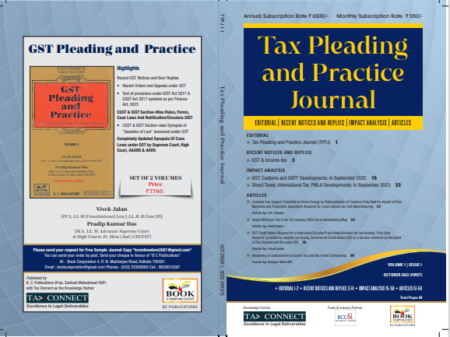

CONTENTS
- Recent Notices and replies on GST & Income Tax
- Impact Analysis on GST, Customs and DGFT Developments: In September 2023
- Impact Analysis on Direct Taxes, International Tax, PMLA Developments: In September 2023
- Articles

Author:
Vivek Jalan
[FCA, LL.M (Constitutional Law), LL.B, B.Com(H)]

S.K. Panda
[IRS-Retd.; Ex-Member CBIC & Special Secretary – GoI]

P.K. Das
[IRS-Retd.; Ex-Member CBDT & Special Secretary – GoI]

Published by: In Association With:
BOOK CORPORATION TAX CONNECT ACADEMY
4, R. N. Mukherjee Road 6, Netaji Subhas Road,
Kolkata 700001 Kolkata 700001
Phones: (033) 64547999 Cell: 7003384915
Cell: 9830010297, 9331018333 Order by email: info@taxconnect.co.in
Order by email:bookcorporation@gmail.com Website : www.taxconnect.co.in
Website :www.bookcorporation.com

:IN STANDS

GST PLEADING AND PRACTICE: With Section-wise GST Cases & GST Notices and their Replies
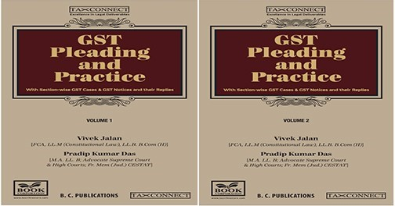

ABOUT THE BOOK: This publication includes:
- Recent GST Notices and their Replies
• Recent Orders and Appeals under GST
• Text of provisions under IGST Act 2017 & CGST Act 2017 updated as per Finance Act, 2023

- CGST & IGST Section-Wise Rules, Forms, Case Laws And Notification/Circulars GIST
• CGST & IGST Section-wise Synopsis of “Question of Law” answered under GST

- Completely Updated Synopsis Of Case Laws under GST by Supreme Court, High Court, AAARS & AARS

Authors:
Vivek Jalan
[FCA, LL.M (Constitutional Law), LL. B, B. Com(H)]

Pradip Kumar Das
[M.A. LL. B; Advocate Supreme Court & High Courts; Fr. Mem (Jud.) CESTAT]

Published by: In Association With:
BOOK CORPORATION TAX CONNECT ACADEMY
4, R. N. Mukherjee Road 6, Netaji Subhas Road,
Kolkata 700001 Kolkata 700001
Phones: (033) 64547999 Cell: 7003384915
Cell: 9830010297, 9331018333 Order by email: info@taxconnect.co.in
Order by email:bookcorporation@gmail.com Website : www.taxconnect.co.in
Website :www.bookcorporation.com
:IN STANDS

HANDBOOK ON GST 2022
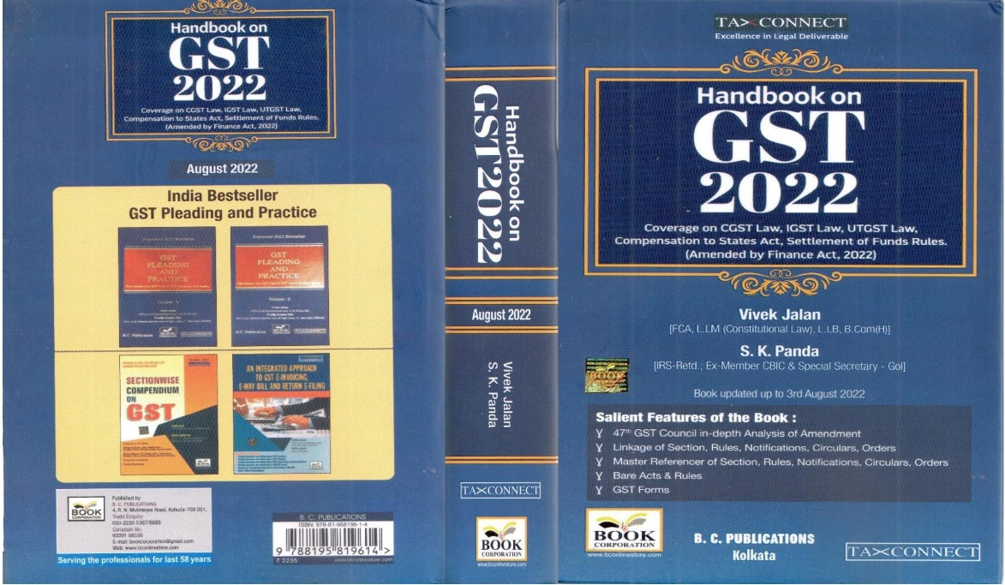

CONTENTS
- 47th GST Council in-depth Analysis of Amendment
- Linkage of Section, Rules, Notifications, Circulars, Orders
- Master Reference of Section, Rules, Notifications, Circulars, Orders
- Bare Acts & Rules
- GST Forms
Author:
Vivek Jalan
[FCA, LL.M (Constitutional Law), LL.B, B.Com(H)]

S.K. Panda
[IRS-Retd.; Ex-Member CBIC & Special Secretary – GoI]

Published by: In Association With:
BOOK CORPORATION TAX CONNECT ACADEMY
4, R. N. Mukherjee Road 6, Netaji Subhas Road,
Kolkata 700001 Kolkata 700001
Phones: (033) 64547999 Cell: 7003384915
Cell: 9830010297, 9331018333 Order by email: info@taxconnect.co.in
Order by email:bookcorporation@gmail.com Website : www.taxconnect.co.in
Website :www.bookcorporation.com

:IN STANDS

How to Handle GST LITIGATION: Assessment, Scrutiny, Audit & Appeal
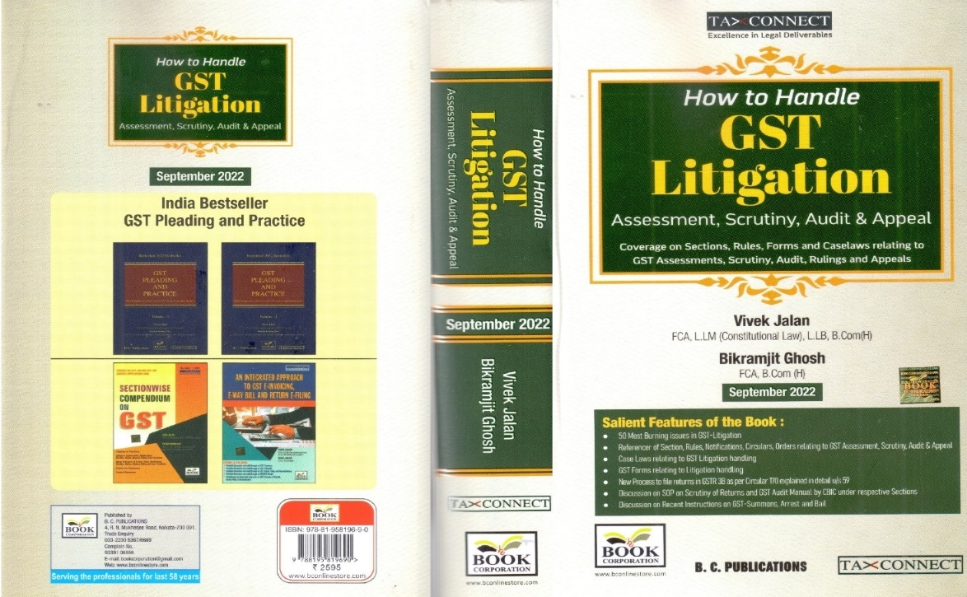

CONTENTS
1. 50 Most Burning issues in GST-Litigation
2. Reference of Section, Rules, Notifications, Circulars, Orders relating to GST Assessment, Scrutiny, Audit & Appeal
3. Case Laws relating to GST Litigation handling
4. GST Forms relating to Litigation handling
5. New process to file returns in GSTR 3B as per circular 170 explained in details u/s 59
6. Discussion on SOP on Scrutiny of Returns and GST Audit Manual by CBIC under respective Sections
7. Discussion on Recent Instruction on GST-Summons, Arrest and Bail

Authors:
Vivek Jalan
[FCA, LL.M (Constitutional Law), LL. B, B. Com(H)]

Bikramjit Ghosh
[FCA, B. Com(H)]

Published by: In Association With:
BOOK CORPORATION TAX CONNECT ACADEMY
4, R. N. Mukherjee Road 6, Netaji Subhas Road,
Kolkata 700001 Kolkata 700001
Phones: (033) 64547999 Cell: 7003384915
Cell: 9830010297, 9331018333 Order by email: info@taxconnect.co.in
Order by email:bookcorporation@gmail.com Website : www.taxconnect.co.in
Website :www.bookcorporation.com

LET’S DISCUSS FURTHER!



OUR OFFICES:
MUMBAI
Unit No. 312, Omega Business Park, Near Kaamgar Hospital, Road No. 33, Wagle Industrial Estate, Thane West,
Maharashtra- 400604

Contact Person: Neha Resham

Email:neha.resham@taxconnectnorth.co.in
BENGALURU
951, 24th Main Road, J P Nagar, Bengaluru, Karnataka – 560078.

Contact Person: Anil Pal

Email:anil.pal@taxconnectdelhi.co.in

DELHI (NCR)
B-139, 2nd Floor, Transport Nagar,
Noida-201301 (U.P)

Contact Person: Poonam Khemka

Email:poonam.khemka@taxconnect.co.in



KOLKATA
6, Netaji Subhas Road, 3rd Floor, Royal Exchange Building,
Kolkata - 700001

Contact Person: Mainak Sen Gupta

Email:mainak.sengupta@taxconnectdelhi.co.in
DUBAI
Azizi Feirouz, 803, 8th Floor, AL Furjan, Opposite Discovery Pavillion,
Dubai, UAE

Contact Person: Rohit Sharma

Email:rohit.sharma@taxconnect.co.in

KOLKATA
R No 119; 1st Floor; Diamond Arcade; 1/72, Cal Jessore Road,
Kolkata – 700055

Contact Person: Uttam Kumar Singh

Email:uttam.singh@taxconnect.co.in

Disclaimer:
This e-bulletin is for private circulation only. Views expressed herein are of the editorial team and are based on the information, explanation and documents available on Government portal platforms. Tax Connect or any of its employees do not accept any liability whatsoever direct or indirect that may arise from the use of the information contained herein. No matter contained herein may be reproduced without prior consent of Tax Connect. While this e-article has been prepared on the basis of published/other publicly available information considered reliable, we do not accept any liability for the accuracy of its contents.
Tax Connect 2024. All rights reserved.

