21s Iz8
_{TAX CONNECT}

444th Issue: 3rd March 2024-9th March 2024
12017

sssss

Knowledge Partner:



TAX CONNECT :

Mumbai : Unit No. 312, Omega Business Park, Near-Kaamgar Hospital, Road No. 33, Wagle Industrial Estate,
Thane (West), Maharashtra – 400604
Bengaluru : 951, 24th Main Road, J P Nagar, Bengaluru, Karnataka – 560078.
Delhi (NCR) : B-139, 2ndFloor, Transport Nagar, Noida-201301 (U.P)
Kolkata : 6, Netaji Subhas Road, 3rd Floor, Royal Exchange Building, Kolkata – 700001
- Room No. 119, 1stFloor, “Diamond Arcade” 1/72, Cal Jessore Road, Kolkata – 700055
- Tobacco House, 1, Old Court House St, Radha Bazar, Corner, Kolkata, West Bengal 700001
Dubai : Azizi Feirouz, 803, 8th Floor, AL Furjan, Opposite Discovery Pavillion, Dubai, UAE

Contact : +91 7003384915

Website : www.taxconnect.co.in
Email : info@taxconnect.co.in

Friends,
The Income Tax Department plays hot and cold at the same time in the matter of Non-Residents moving out of their own countries for being employed in another Country. They wish to tax in India, expatriates who become residents of India on the income earned by them from all over the world. On the other hand, they also wish to tax salaried Indian Non-Residents who are deputed to work outside India by holding that since these individuals are employed by Indian Companies, so their salaries will be taxed in India as the salaries are received in Indian Bank Accounts.

Under the Indian tax laws, the tax incidence arises on the basis of residential status, which in turn depends on the number of days stayed in India. A tax resident of India is subject to tax on his worldwide income.

However, a non-resident is subject to tax in India only under two situations, i.e.
(i) income accrued in India and
(ii) “income received” in India.

Hence, in case of non-resident, income is considered as taxable in India even if it is “received” in India (though employment done abroad).

The important point here is that the terms “income received” and “amount received” are qualitatively different. The “salary amount” of NRIs is received in India in case of NRIs but the “salary income” is received outside India. Such employee had the lawful right to receive salary outside India. The salary income is at the employee’s disposal outside India, and he merely exercises his right to “receive the amount” or “transfer the amount” to India. This was the decision of the ITAT Delhi in the case of Devi Dayal.

The field authorities also try to dispute the taxability of NRI salaries on account of the following-

1. Non-furnishing of Tax Residency Certificate (TRC) of the Country of employment

2. Non-furnishing of proof of payment of taxes in the Country of employment.

Hence, to avoid disputes at the field formation level we suggest the following –

1. The Employee agreements should be properly structured. These agreements may bring out the point that the salary for services rendered overseas is being credited to a bank account in India, at the employee request for the sake of convenience. It may be a better option to pay the salaries in the foreign bank account of the employee itself.

2. While in these cases Tax Residency Certificate (TRC) of the Country of employment is not required as there is no DTAA benefit being claimed, but the income itself is exempt; However, it is advisable to have a TRC and produce before the Indian Tax Authorities to avoid disputes at the field formation level.

Just to reiterate that we remain available over telecom or e-mail.

Editor:
Vivek Jalan
Partner - Tax Connect Advisory Services LLP

Co-Editor:
Rohit Sharma
Director – Tax Connect Advisory Services LLP

S.NO. | TOPICS | PAGE NO.
1] | TAX CALENDER | 4
2] | INCOME TAX | 5-6
NOTIFICATION | PANJAB UNIVERSITY, CHANDIGARH UNDER THE CATEGORY OF ‘UNIVERSITY, COLLEGE OR OTHER INSTITUTION’ FOR ‘SCIENTIFIC RESEARCH’ FOR THE PURPOSES OF CLAUSE (II) OF SUB-SECTION (1) OF SECTION 35
NOTIFICATION | EXEMPTION FROM SPECIFIED INCOME U/S 10(46) TO UTTAR PRADESH REAL ESTATE REGULATORY AUTHORITY
NOTIFICATION | EXEMPTION FROM SPECIFIED INCOME U/S 10(46) TO Karnataka Urban Water Supply and Drainage Board
3] | GST | 7-8
PRESS RELEASE | ₹1,49,577 CRORE GROSS GST REVENUE COLLECTED IN FEBRUARY 2023; 12% HIGHER THAN GST REVENUES IN SAME MONTH LAST YEAR
CASE LAW | ITC CANNOT BE REVERSED SOLELY ON GROUND THAT GST REGISTRATION OF SUPPLIER WAS CANCELLED WITH RETROSPECTIVE EFFECT : MADRAS HIGH COURT
4] | FEMA | 9
CASE LAW | VIOLATION UNDER FERA - CHARGE U/S. 56 OF FERA - COMPANY BEING IN LIQUIDATION - OFFENCES BY COMPANIES U/S 68 OF FERA : DELHI HIGH COURT
5] | CUSTOMS | 10-11
NOTIFICATION | FIXATION OF TARIFF VALUE OF EDIBLE OILS, BRASS SCRAP, ARECA NUT, GOLD AND SILVER
NOTIFICATION | SEEKS TO AMEND NOTIFICATION NO. 14/2019-CUSTOMS(ADD) DATED 25.03.2019, IN ORDER TO CHANGE THE NAME OF THE PRODUCER FROM 'M/S MITSUI PHENOLS SINGAPORE PTE. LTD' TO 'M/S INEOS PHENOL SINGAPORE PTE. LTD' PURSUANT TO DGTR RECOMMENDATION
6] | DGFT | 12-13
NOTIFICATION | EXPORT OF ONIONS (UNDER HS CODE 0703 10 19) TO UAE
NOTIFICATION | EXPORT OF FOOD COMMODITIES THROUGH NATIONAL COOPERATIVE EXPORTS LIMITED
NOTIFICATION | EXPORT OF ONIONS (UNDER HS CODE 0703 10 19) TO BANGLADESH
NOTIFICATION | AMENDMENT IN PARA 2.39 OF THE FOREIGN TRADE POLICY, 2023- - MERCHANTE TRADE IN FOREIGN COUNTRY ALLOWED, EXCEPT CITES/SCOMET GOODS
7] | TAX PLEADING AND PRACTICE JOURNAL | 14
8] | GST PLEADING AND PRACTICE: WITH SECTION-WISE GST CASES & GST NOTICES AND THEIR REPLIES | 15
9] | HANDBOOK ON GST 2022 | 16
10] | HOW TO HANDLE GST LITIGATION: ASSESSMENT, SCRUTINY, AUDIT & APPEAL | 17
11] | LET’S DISCUSS FURTHER | 18

Due Date | Form/Return/Challan | Reporting Period | Description
7th March | deposit of Tax deducted/collected | February’2024 | ​Due date for deposit of Tax deducted/collected for the month of February, 2024. However, all sum deducted/collected by an office of the government shall be paid to the credit of the Central Government on the same day where tax is paid without production of an Income-tax Challan

NOTIFICATION
Panjab University, Chandigarh under the category of ‘University, college or other institution’ for ‘Scientific Research’ for the purposes of clause (ii) of sub-section (1) of section 35
OUR COMMENTS: The Central Board of Direct Taxes vide notification no. 23/2024 dated 26.02.2024 notified In exercise of the powers conferred by clause (ii) of sub-section (1) of section 35 of the Income-tax Act, 1961 (43 of 1961) read with Rules 5C and 5E of the Income-tax Rules, 1962, the Central Government hereby approves ‘Panjab University, Chandigarh (PAN: AAAJP0325R) under the category of ‘University, college or other institution’ for ‘Scientific Research’ for the purposes of clause (ii) of sub-section (1) of section 35 of the Income-tax Act, 1961 read with rules 5C and 5E of the Income-tax Rules, 1962.
2. This Notification shall apply with effect from the date of publication in the Official Gazette (i.e. from the Previous Year 2023-24) and accordingly shall be applicable for Assessment Years 2024-2025 to 2028-2029.
[For further details please refer the notification]

NOTIFICATION
Exemption from specified income U/s 10(46) TO Uttar Pradesh Real Estate Regulatory Authority
OUR COMMENTS: The Central Board of Direct Taxes vide Notification No. 25/2024 dated 01.03.2024 notified In exercise of the powers conferred by clause (46) of section 10 of the Income-tax Act, 1961 (43 of 1961), the Central Government hereby notifies for the purposes of the said clause, ‘Uttar Pradesh Real Estate Regulatory Authority’ (PAN AAAGU0671E), an Authority constituted by the State Government of Uttar Pradesh, in respect of the following specified income arising to that Authority, namely:-
(a) Amount received as Grant-in-aid or loan/advance from Government;
(b) Fee/penalty received from builders/developers, agents or any other stakeholders as per the provisions of the Real Estate (Regulation and Development) Act, 2016;
(c) Fee received under Right to Information Act, 2005; and
(d) Interest earned on bank deposits.
2. This notification shall be effective subject to the conditions that Uttar Pradesh Real Estate Regulatory Authority,-
(a) shall not engage in any commercial activity;
(b) activities and the nature of the specified income shall remain unchanged throughout the financial years; and
(c) shall file return of income in accordance with the provision of clause (g) of sub-section (4C) of section 139 of the Income-tax Act, 1961.
3. This notification shall be deemed to have been applied for the assessment years 2021-2022, 2022-2023 and 2023-2024 relevant for financial years 2020-2021, 2021-2022 and 2022-2023, respectively.
[For further details please refer the notification]

NOTIFICATION
Exemption from specified income U/s 10(46) TO Karnataka Urban Water Supply and Drainage Board
OUR COMMENTS: The Central Board of Direct Taxes vide Notification No. 26/2024 dated 01.03.2024 notified In exercise of the powers conferred by clause (46) of section 10 of the Income-tax Act, 1961 (43 of 1961), the Central Government hereby notifies for the purposes of the said clause, ‘Karnataka Urban Water Supply and Drainage Board’ (PAN: AAATK5837F), a Board constituted under the Karnataka Urban Water Supply and Drainage Board Act, 1973 (Karnataka Act No. 25 of 1974), in respect of the following specified income arising to that Board, namely:
(a) Establishment, administrative, supervision, water charges and rent collected as per the Karnataka Urban Water Supply and Drainage Board Act, 1973 (Karnataka Act No. 25 of 1974);
(b) Forfeiture of earnest money deposit as per the Karnataka Urban Water Supply and Drainage Board Act, 1973 (Karnataka Act No. 25 of 1974);
(c) Penalty, Sale of Scrap, Storage charges and Survey charges as per the Karnataka Urban Water Supply and Drainage Board Act, 1973 (Karnataka Act No. 25 of 1974) and
(d) Interest earned on bank deposits.
2. This notification shall be effective subject to the conditions that Karnataka Urban Water Supply and Drainage Board-
(a) shall not engage in any commercial activity;
b) activities and the nature of the specified income shall remain unchanged throughout the financial years; and
(c) shall file return of income in accordance with the provision of clause (g) of sub-section (4C) of section 139 of the Income-tax Act, 1961.
3. This notification shall be deemed to have been applied for assessment years 2021-2022, 2022-2023 and 2023-2024 relevant for the financial years 2020-2021, 2021-2022 and 2022-2023, respectively.
[For further details please refer the notification]

PRESS RELEASE
₹1,49,577 CRORE GROSS GST REVENUE COLLECTED IN FEBRUARY 2023; 12% HIGHER THAN GST REVENUES IN SAME MONTH LAST YEAR

OUR COMMENTS: The Central Board of Indirect Taxes and Customs vide press release dated 01.03.2024 to inform that The gross GST revenue collected in the month of February 2023 is ₹1,49,577 crore of which CGST is ₹27,662 crore, SGST is ₹34,915 crore, IGST is ₹75,069 crore (including ₹35,689 crore collected on import of goods) and Cess is ₹11,931 crore (including ₹792 crore collected on import of goods)
The government has settled ₹34,770 crore to CGST and ₹29,054 crore to SGST from IGST as regular settlement. The total revenue of Centre and the States after regular settlements in the month of February 2023 is ₹62,432 crore for CGST and ₹63,969 crore for the SGST. In addition, Centre had also released balance GST compensation of ₹16,982 crore for the month of June 2022 and ₹16,524 crore to States/UTs which have sent AG certified figures for previous period.
The revenues for the month of February 2023 are 12% higher than the GST revenues in the same month last year, which was Rs. 1,33,026 crore. During the month, revenues from import of goods was 6% higher and the revenues from domestic transaction (including import of services) are 15% higher than the revenues from these sources during the same month last year. This month witnessed the highest cess collection of ₹11,931 crore since implementation of GST. Normally, February being a 28 day month, witnesses a relatively lower collection of revenue.
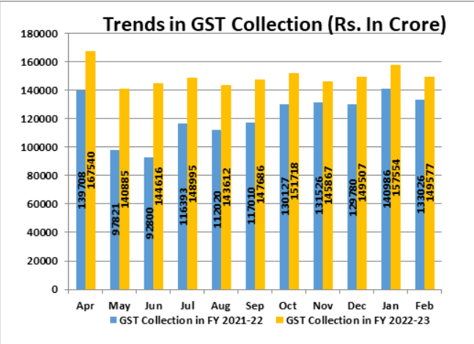
The chart below shows trends in monthly gross GST revenues during the current year. The table shows the state-wise figures of GST collected in each State during the month of February 2023 as compared to February 2022.

[For further details please refer the press release]

CASE LAW
ITC CANNOT BE REVERSED SOLELY ON GROUND THAT GST REGISTRATION OF SUPPLIER WAS CANCELLED WITH RETROSPECTIVE EFFECT : MADRAS HIGH COURT
OUR COMMENTS: Recently the Hon’ble Madras High Court held that the claim of Input Tax Credit (ITC) cannot be solely rejected on the ground that the supplier’s GST registration was cancelled with retrospective effect.
Facts of the Case:
The petitioner asserts that he had purchased goods in 2017-2018 and that such purchases are supported by tax invoices, e-way bills, transport documents and proof of payment to the supplier through regular banking channels. In spite of submitting all these documents, it is stated that the ITC was reversed solely on the ground that the registration of the petitioner’s supplier was cancelled with retrospective effect.
Observation of the Court:
The petitioner purchased goods in 2017-2018 and, at the highest, the petitioner may be called upon to produce evidence of the existence of the supplier at the relevant point of time.
In addition, the petitioner may be called upon to prove that the transaction was genuine by providing relevant documents such as tax invoices, e-way bills, lorry receipts, delivery challans, proof for payment and the like. In the case at hand, it appears that the petitioner submitted such documents but these documents were disregarded.
The assessing officer is directed to consider whether the transaction was genuine by examining all relevant documents in that regard. The ITC claim shall not be rejected upon such reconsideration solely on the ground that the supplier’s GST registration was cancelled with retrospective effect.
Order of Court
Hence, the impugned assessment order was quashed and the matter was remanded for reconsideration.

CASE LAW
VIOLATION UNDER FERA - CHARGE U/S. 56 OF FERA - COMPANY BEING IN LIQUIDATION - OFFENCES BY COMPANIES U/S 68 OF FERA : DELHI HIGH COURT
OUR COMMENTS: It was held that As per Section 305 CrPC Procedure when corporation or registered society is an accused would show that where the accused person is a company, it may appoint a representative for the purpose of the trial, and where such representative appears, any requirement of the CrPC that anything shall be done in the presence of the accused or shall be read or stated or explained to the accused, shall be construed as a requirement that that thing shall be done in the presence of the representative or read or stated or explained to such representative. Sub-Section (4) of Section 305 CrPC states that where the representative of a company does not appear, any such requirement as is referred to in sub-Section (3) of Section 305 CrPC shall not apply.
In the present case, there is no authorization of the petitioner to represent the Company in the trial. In fact, the Company is in liquidation and a Provisional Liquidator already stands appointed for the Company.
In terms of Section 457 of the Companies Act, 1956 (as was then applicable), it is only the Provisional Liquidator or person authorized by the Provisional Liquidator, who could represent the Company in the trial. The petitioner, therefore, cannot be said to be representing the Company. It is another thing to say that he would face the trial in his individual capacity as an accused, but another thing to say that he would also face the trial as a representative of the Company.
Though the above issue was flagged before the learned Trial Court, as is reflected in the Orders the learned Trial Court proceeded to frame the charge against the Company taking the petitioner herein to be representing the Company. The same cannot, therefore, be sustained.
Conclusion & Directions - Trial Court has clearly erred in framing the charge against the Company through the petitioner. The charge against the Company has to be through the Provisional Liquidator appointed for the Company. The impugned order dated 03.08.2007 shall stand modified to this limited extent. It is clarified that the charges framed against the petitioner in his individual capacity have not been interfered with by this Court.

NOTIFICATION
Fixation of Tariff Value of Edible Oils, Brass Scrap, Areca Nut, Gold and Silver
OUR COMMENTS: The Ministry of Finance, Department of Revenue vide notification no 16/2024-Customs(N.T) dated 29.02.2024 notified In exercise of the powers conferred by sub-section (2) of section 14 of the Customs Act, 1962 (52 of 1962), the Central Board of Indirect Taxes & Customs, being satisfied that it is necessary and expedient to do so, hereby makes the following amendments in the notification of the Government of India in the Ministry of Finance (Department of Revenue), No. 36/2001-Customs (N.T.), dated the 3rd August, 2001, published in the Gazette of India, Extraordinary, Part-II, Section-3, Sub-section (ii), vide number S. O. 748 (E), dated the 3rd August, 2001, namely:-
In the said notification, for TABLE-1, TABLE-2, and TABLE-3 the following Tables shall be substituted, namely: -
“TABLE-1
Sl. No. | Chapter/ heading/ sub-heading/tariff item | Description of goods | Tariff value (US $Per Metric Tonne)
(1) | (2) | (3) | (4)
1 | 1511 10 00 | Crude Palm Oil | 891
2 | 1511 90 10 | RBD Palm Oil | 902
3 | 1511 90 90 | Others - Palm Oil | 897
4 | 1511 10 00 | Crude Palmolein | 907
5 | 1511 90 20 | RBD Palmolein | 910
6 | 1511 90 90 | Others - Palmolein | 909
7 | 1507 10 00 | Crude Soya bean Oil | 903
8 | 7404 00 22 | Brass Scrap (all grades) | 4937
TABLE-2
Sl. No. | Chapter/ heading/ sub-heading/tariff item | Description of goods | Tariff value (US $)
(1) | (2) | (3) | (4)
1. | 71 or 98 | Gold, in any form, in respect of which the benefit of entries at serial number 356 of the Notification No. 50/2017-Customs dated 30.06.2017 is availed | 654 per 10  grams
2. | 71 or 98 | Silver, in any form, in respect of which the benefit of entries at serial number 357 of the Notification No. 50/2017-Customs dated 30.06.2017 is availed | 724 per kilogram
3. | 71 | (i) Silver, in any form, other than medallions and silver coins having silver content not below 99.9% or semimanufactured forms of silver falling under sub-heading 7106 92;  (ii) Medallions and silver coins having silver content not below 99.9% or semi-manufactured forms of silver falling under sub-heading 7106 92, other than imports of such goods through post, courier or baggage.  Explanation. - For the purposes of this entry, silver in any form shall not include foreign currency coins, jewellery made of silver or articles made of silver. | 724 per kilogram
4. | 71 | (i) Gold bars, other than tola bars, bearing manufacturer's or refiner's engraved serial number and weight expressed in metric units;  (ii) Gold coins having gold content not below 99.5% and gold findings, other than imports of such goods through post, courier or baggage.  Explanation. - For the purposes of this entry, "gold findings" means a small component such as hook, clasp, clamp, pin, catch, screw back used to hold the whole or a part of a piece of Jewellery in place. | 654 per 10 grams
TABLE-3
Sl. No. | Chapter/heading/sub-heading/tariff item | Description of goods | Tariff value (US $ Per Metric Ton)
(1) | (2) | (3) | (4)
1 | 080280 | Areca nuts | 6259 (i.e., no change)"
2. This notification shall come into force with effect from the 01st day of March, 2024.
[For further details please refer the notification]
NOTIFICATION
Seeks to amend notification No. 14/2019-Customs(ADD) dated 25.03.2019, in order to change the name of the producer from 'M/s Mitsui Phenols Singapore Pte. Ltd' to 'M/s INEOS Phenol Singapore Pte. Ltd' pursuant to DGTR recommendation
OUR COMMENTS: The Ministry of Finance, Department of Revenue vide notification no 02/2024-Customs(A.D.D) dated 28.02.2024 notified Whereas, in the matter of ‘Acetone’ (hereinafter referred to as the subject goods), originating in, or exported from European Union, Singapore, South Africa and United States of America (hereinafter referred to as the subject countries), falling under tariff item 2914 11 00 of the First Schedule to the Customs Tariff Act, 1975 (51 of 1975) (hereinafter referred to as the Customs Tariff Act), and imported into India, the designated authority in its final findings, published in the Gazette of India, Extraordinary, Part I, Section 1, dated the 5th March, 2019, vide notification number 7/26/2018-DGAD, dated the 5th March, 2019, had come to the conclusion that –
(i) the product under consideration continues to be imported at the dumped prices from the subject countries;
(ii) the domestic industry has suffered continued injury on account of dumped imports;
(iii) the continued injury to the domestic industry in on account of dumped imports and is likely to continue if the anti-dumping duties from subject countries are ceased,
and had recommended imposition of definitive anti-dumping duty on imports of the subject goods, originating in, or exported from the subject countries and imported into India, in order to remove injury to the domestic industry;
And whereas, on the basis of the aforesaid final findings of the designated authority, the Central Government had imposed the anti-dumping duty on the subject goods, vide notification of the Government of India, Ministry of Finance (Department of Revenue), No. 14/2019-Customs (ADD), dated the 25th March, 2019, published in the Gazette of India, Extraordinary, Part II, Section 3, Sub-section (i), vide number G.S.R. 237(E), dated the 25th March, 2019;
And whereas, M/s INEOS Phenol Singapore Pte. Ltd. has requested the designated authority for changing the name of producer from ‘M/s Mitsui Phenols Singapore Pte. Ltd.’ to ‘M/s INEOS Phenol Singapore Pte. Ltd.’ in the duty table of the final findings, published in the Gazette of India, Extraordinary, Part I, Section 1, dated the 5th March, 2019, vide notification number 7/26/2018-DGAD, dated the 5th March, 2019;
And whereas, the designated authority, vide notification No. 7/09/2023-DGTR, dated the 22nd December, 2023, published in the Gazette of India, Extraordinary, Part I, Section 1, dated the 22nd December, 2023, has held that the name of the producer or exporter Mitsui Phenols Singapore Pte. Ltd. has been changed to INEOS Phenol Singapore Pte. Ltd. and recommended that the name of the producer, viz., “M/s Mitsui Phenols Singapore Pte. Ltd.” be amended to “M/s INEOS Phenol Singapore Pte. Ltd.” in its final findings notification No. 7/26/2018-DGAD, dated the 5th March, 2019.
Now, therefore, in exercise of the powers conferred by sub-sections (1) and (5) of section 9A of the Customs Tariff Act read with rules 18, 20 and 23 of the Customs Tariff (Identification, Assessment and Collection of Antidumping Duty on Dumped Articles and for Determination of Injury) Rules, 1995, the Central Government, after considering the aforesaid notification No. 7/09/2023-DGTR, dated the 22nd December, 2023 of the Designated Authority, hereby makes the following amendments in the notification of the Government of India, Ministry of Finance (Department of Revenue), No. 14/2019-Customs (ADD), dated the 25th March, 2019, published in the Gazette of India, Extraordinary, Part II, Section 3, Sub-section (i), vide number G.S.R. 237(E), dated the 25th March, 2019, namely:-
In the said notification, in the TABLE, against serial number 1, in column (5), for the entry, the entry “M/s INEOS Phenol Singapore Pte. Ltd.” shall be substituted.
[For further details please refer the notification]

NOTIFICATION
Export of Onions (under HS code 0703 10 19) to UAE
OUR COMMENTS: The Ministry of Commerce and Industry vide notification no. 65/2023 dated 01.03.2024 notified In exercise of powers conferred by Section 3 read with section 5 of the Foreign Trade (Development Regulation) Act, 1992 (No. 22 of 1992), as amended, read with Para 1.02 and 2.01 of the Foreign Trade Policy, 2023 and in accordance with the provision contained in Para 3 of Notification No. 49/2023 dt- 07.12.2023, the Central Government permits export of 14,400 MT of onions (under HS code 0703 10 19), with a quantity ceiling of 3600 MT quarterly, to UAE through National Cooperative Exports Limited (NCEL).
2. Effect of the Notification:
Export of 14,400 MT of onions (under HS Code 0703 10 19), with a quantity ceiling of 3600 MT quarterly, to UAE through National Cooperative Exports Limited (NCEL) is notified.
[For further details please refer the notification]
NOTIFICATION
Export of food commodities through National Cooperative Exports Limited
OUR COMMENTS: The Ministry of Commerce and Industry vide notification no. 64/2023 dated 01.03.2024 notified In exercise of powers conferred by Section 3 read with section 5 of the Foreign Trade (Development & Regulation) Act, 1992 (No. 22 of 1992), as amended, read with Para 1.02 and 2.01 of the Foreign Trade Policy, 2023 and in accordance with the provision contained in Para 2 (iv) of Notification No. 20/2023 dated 20.07.2023 and Notification No. 07/2023 dated 24.05.2023, export of following food commodities are permitted through National Cooperative Exports Limited (NCEL): -
S.No. | Commodity name | HS code | Country Name | Quantity
1 | Non-Basmati White Rice | 10063090 | Tanzania (Zanzibar) | 30,000 MT

S. No. | Commodity name | HS code | Country Name | Quantity
1 | Broken Rice | 10064000 | Djibouti | 30,000 MT
2 | Broken Rice | 10064000 | Guinea Bissau | 50,000 MT
Effect of the Notification:
Export of above-mentioned food commodities are permitted through National Cooperative Exports Limited (NCEL).
[For further details please refer the notification]
NOTIFICATION
Export of Onions (under HS code 0703 10 19) to Bangladesh
OUR COMMENTS: The Ministry of Commerce and Industry vide notification no. 63/2023 dated 01.03.2024 notified In exercise of powers conferred by Section 3 read with section 5 of the Foreign Trade (Development Regulation) Act, 1992 (No. 22 of 1992), as amended, read with Para 1.02 and 2.01 of the Foreign Trade Policy, 2023 and in accordance with the provision contained in Para 3 of Notification No. 49/2023 dt- 07.12.2023, the Central Government permits export of 14,400 MT of onions (under HS code 0703 10 19), with a quantity ceiling of 3600 MT quarterly, to UAE through National Cooperative Exports Limited (NCEL).
2. Effect of the Notification:
Export of 14,400 MT of onions (under HS Code 0703 10 19), with a quantity ceiling of 3600 MT quarterly, to UAE through National Cooperative Exports Limited (NCEL) is notified.
[For further details please refer the notification]
NOTIFICATION
Amendment in Para 2.39 of the Foreign Trade Policy, 2023- MerchantE Trade in Foreign Country Allowed, Except CITES/SCOMET Goods
OUR COMMENTS: The Ministry of Commerce and Industry vide notification no. 62/2023 dated 29.02.2024 notified In exercise of powers conferred by Section 5 of Foreign Trade (Development & Regulation) Act, 1992, read with paragraph 1.02 of the Foreign Trade Policy, 2023, as amended from time to time, the Central Government hereby amends Para 2.39 of Foreign Trade Policy, 2023 as under:
Existing Para | Revised Para
Merchanting trade involving shipment of goods from one foreign country to another foreign country without touching Indian ports, involving an Indian intermediary is allowed subject to compliance with RBI guidelines, except for goods/items in the CITES and SCOMET list. | Merchanting trade involving shipment of goods from one foreign country to another foreign country without touching Indian ports, or shipment of goods within one specific foreign country, involving an Indian intermediary is allowed subject to compliance with RBI guidelines, except for goods in the CITES, or under SCOMET.
Effect of the Notification: Merchanting Trade carried out within one specific foreign country is permitted subject to compliance with RBI guidelines, except for goods listed in the CITES Appendices, or under SCOMET.
This is issued with the approval of Minister of Commerce & Industry.
[For further details please refer the notification]

:IN STANDS

TAX PLEADING AND PRACTICE JOURNAL
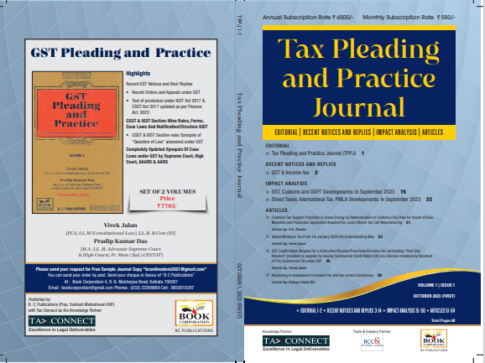

CONTENTS
- Recent Notices and replies on GST & Income Tax
- Impact Analysis on GST, Customs and DGFT Developments: In September 2023
- Impact Analysis on Direct Taxes, International Tax, PMLA Developments: In September 2023
- Articles

Author:
Vivek Jalan
[FCA, LL.M (Constitutional Law), LL.B, B.Com(H)]

S.K. Panda
[IRS-Retd.; Ex-Member CBIC & Special Secretary – GoI]

P.K. Das
[IRS-Retd.; Ex-Member CBDT & Special Secretary – GoI]

Published by: In Association With:
BOOK CORPORATION TAX CONNECT ACADEMY
4, R. N. Mukherjee Road 6, Netaji Subhas Road,
Kolkata 700001 Kolkata 700001
Phones: (033) 64547999 Cell: 7003384915
Cell: 9830010297, 9331018333 Order by email: info@taxconnect.co.in
Order by email:bookcorporation@gmail.com Website : www.taxconnect.co.in
Website :www.bookcorporation.com

:IN STANDS

GST PLEADING AND PRACTICE: With Section-wise GST Cases & GST Notices and their Replies
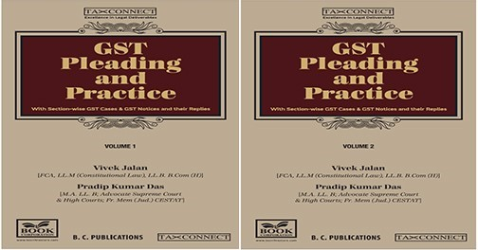

ABOUT THE BOOK: This publication includes:
- Recent GST Notices and their Replies
• Recent Orders and Appeals under GST
• Text of provisions under IGST Act 2017 & CGST Act 2017 updated as per Finance Act, 2023

- CGST & IGST Section-Wise Rules, Forms, Case Laws And Notification/Circulars GIST
• CGST & IGST Section-wise Synopsis of “Question of Law” answered under GST

- Completely Updated Synopsis Of Case Laws under GST by Supreme Court, High Court, AAARS & AARS

Authors:
Vivek Jalan
[FCA, LL.M (Constitutional Law), LL. B, B. Com(H)]

Pradip Kumar Das
[M.A. LL. B; Advocate Supreme Court & High Courts; Fr. Mem (Jud.) CESTAT]

Published by: In Association With:
BOOK CORPORATION TAX CONNECT ACADEMY
4, R. N. Mukherjee Road 6, Netaji Subhas Road,
Kolkata 700001 Kolkata 700001
Phones: (033) 64547999 Cell: 7003384915
Cell: 9830010297, 9331018333 Order by email: info@taxconnect.co.in
Order by email:bookcorporation@gmail.com Website : www.taxconnect.co.in
Website :www.bookcorporation.com
:IN STANDS

HANDBOOK ON GST 2022
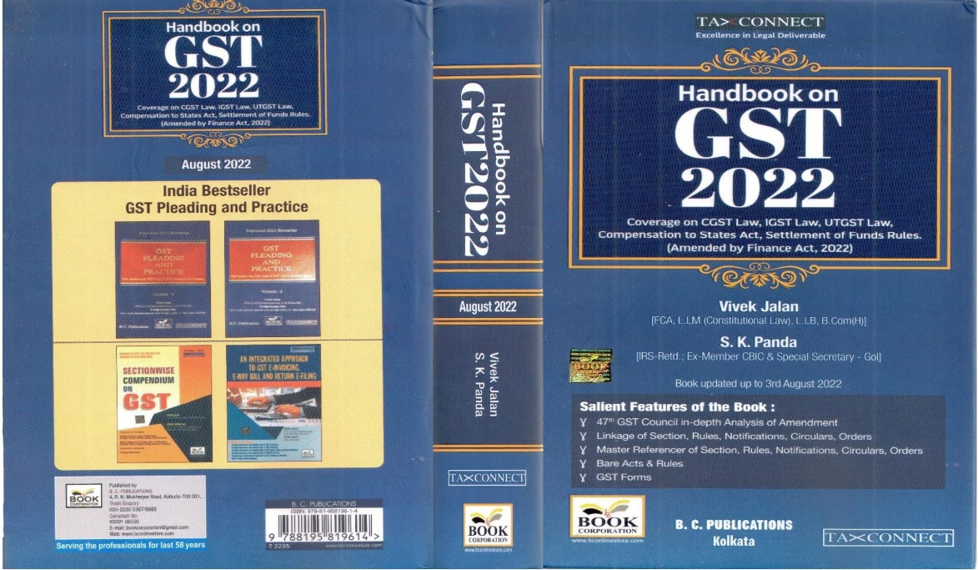

CONTENTS
- 47th GST Council in-depth Analysis of Amendment
- Linkage of Section, Rules, Notifications, Circulars, Orders
- Master Reference of Section, Rules, Notifications, Circulars, Orders
- Bare Acts & Rules
- GST Forms
Author:
Vivek Jalan
[FCA, LL.M (Constitutional Law), LL.B, B.Com(H)]

S.K. Panda
[IRS-Retd.; Ex-Member CBIC & Special Secretary – GoI]

Published by: In Association With:
BOOK CORPORATION TAX CONNECT ACADEMY
4, R. N. Mukherjee Road 6, Netaji Subhas Road,
Kolkata 700001 Kolkata 700001
Phones: (033) 64547999 Cell: 7003384915
Cell: 9830010297, 9331018333 Order by email: info@taxconnect.co.in
Order by email:bookcorporation@gmail.com Website : www.taxconnect.co.in
Website :www.bookcorporation.com

:IN STANDS

How to Handle GST LITIGATION: Assessment, Scrutiny, Audit & Appeal
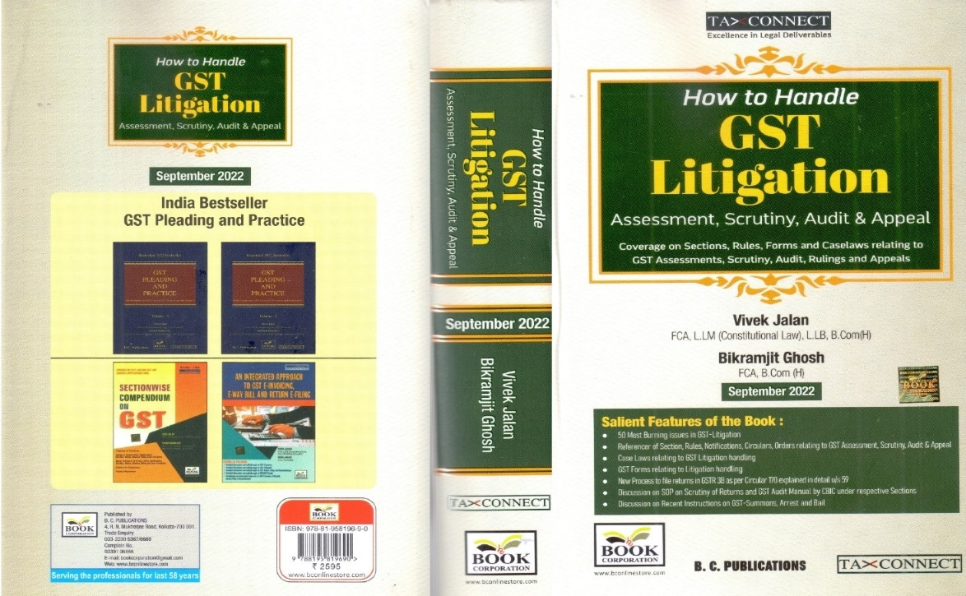

CONTENTS
1. 50 Most Burning issues in GST-Litigation
2. Reference of Section, Rules, Notifications, Circulars, Orders relating to GST Assessment, Scrutiny, Audit & Appeal
3. Case Laws relating to GST Litigation handling
4. GST Forms relating to Litigation handling
5. New process to file returns in GSTR 3B as per circular 170 explained in details u/s 59
6. Discussion on SOP on Scrutiny of Returns and GST Audit Manual by CBIC under respective Sections
7. Discussion on Recent Instruction on GST-Summons, Arrest and Bail

Authors:
Vivek Jalan
[FCA, LL.M (Constitutional Law), LL. B, B. Com(H)]

Bikramjit Ghosh
[FCA, B. Com(H)]

Published by: In Association With:
BOOK CORPORATION TAX CONNECT ACADEMY
4, R. N. Mukherjee Road 6, Netaji Subhas Road,
Kolkata 700001 Kolkata 700001
Phones: (033) 64547999 Cell: 7003384915
Cell: 9830010297, 9331018333 Order by email: info@taxconnect.co.in
Order by email:bookcorporation@gmail.com Website : www.taxconnect.co.in
Website :www.bookcorporation.com

LET’S DISCUSS FURTHER!



OUR OFFICES:
MUMBAI
Unit No. 312, Omega Business Park, Near Kaamgar Hospital, Road No. 33, Wagle Industrial Estate, Thane West,
Maharashtra- 400604

Contact Person: Priyanka Vishwakarma
Email:priyanka.vishwakarma@taxconnect.co.in
BENGALURU
951, 24th Main Road, J P Nagar, Bengaluru, Karnataka – 560078.

Contact Person: Anil Pal

Email:anil.pal@taxconnectdelhi.co.in

DELHI (NCR)
B-139, 2nd Floor, Transport Nagar,
Noida-201301 (U.P)

Contact Person: Poonam Khemka

Email:poonam.khemka@taxconnect.co.in



DUBAI
Azizi Feirouz, 803, 8th Floor, AL Furjan, Opposite Discovery Pavillion,
Dubai, UAE

Contact Person: Rohit Sharma

Email:rohit.sharma@taxconnect.co.in

KOLKATA
R No 119; 1st Floor; Diamond Arcade; 1/72, Cal Jessore Road,
Kolkata – 700055

Contact Person: Uttam Kumar Singh

Email:uttam.singh@taxconnect.co.in
KOLKATA
6, Netaji Subhas Road, 3rd Floor, Royal Exchange Building,
Kolkata - 700001

Contact Person: Tithly Roy

Email:tithly.roy@taxconnect.co.in

Disclaimer:
This e-bulletin is for private circulation only. Views expressed herein are of the editorial team and are based on the information, explanation and documents available on Government portal platforms. Tax Connect or any of its employees do not accept any liability whatsoever direct or indirect that may arise from the use of the information contained herein. No matter contained herein may be reproduced without prior consent of Tax Connect. While this e-article has been prepared on the basis of published/other publicly available information considered reliable, we do not accept any liability for the accuracy of its contents.
Tax Connect 2024. All rights reserved.

