21s Iz8
_{TAX CONNECT}

443rd Issue: 25th February 2024-2nd March 2024
12017

sssss

Knowledge Partner:



TAX CONNECT :

Mumbai : Unit No. 312, Omega Business Park, Near-Kaamgar Hospital, Road No. 33, Wagle Industrial Estate,
Thane (West), Maharashtra – 400604
Bengaluru : 951, 24th Main Road, J P Nagar, Bengaluru, Karnataka – 560078.
Delhi (NCR) : B-139, 2ndFloor, Transport Nagar, Noida-201301 (U.P)
Kolkata : 6, Netaji Subhas Road, 3rd Floor, Royal Exchange Building, Kolkata – 700001
- Room No. 119, 1stFloor, “Diamond Arcade” 1/72, Cal Jessore Road, Kolkata – 700055
- Tobacco House, 1, Old Court House St, Radha Bazar, Corner, Kolkata, West Bengal 700001
Dubai : Azizi Feirouz, 803, 8th Floor, AL Furjan, Opposite Discovery Pavillion, Dubai, UAE

Contact : +91 7003384915

Website : www.taxconnect.co.in
Email : info@taxconnect.co.in

Friends,
In the Interim Budget 2024-25, The finance minister proposed to withdraw direct tax demands up to INR 25000 pertaining to the period up to tax year 2009-10 and up to INR 10000 for tax years 2010-11 to 2014-15. Vide Order F. No. 375/02/2023- IT-Budget dated 13th February 2024 the CBDT has implemented the proposal on remission or extinguishment of small tax demands outstanding as on 31 January 2024 under the Income Tax Act 1961 (ITA) or Wealth Tax Act, 1957 or Gift Tax Act 1958. However, as always, the actual scheme has certain surprises, additions, deletions, and modifications. The salient features of the scheme are as follows –

A. The outstanding as on January 31, 2024, will be considered as follows: -

Assessment Year/s (A.Y.) to which the  entries of outstanding tax demands as  on  January 31, 2024, pertain | Monetary limit of entries of outstanding  tax demands which are to be remitted  and  extinguished (in Rupees)
(1) | (2)
Up to A.Y. 2010-11 | each demand entry up to Rs. 25,000/-
A.Y. 2011-12 to A.Y. 2015-16 | each demand entry up to Rs. 10,000/-

B. Now the surprise elements - The remission and extinguishment of above outstanding tax demand shall be subject to the maximum ceiling of Rs. 1,00,000/- for any specific taxpayer/ assesses for the demand entries consisting of tax demands under Income-tax Act, 1961 or corresponding provisions of Wealth-tax Act, 1957 or Gift-tax Act, 1958; stand-alone Interest, penalty, fee, cess or surcharge thereon under various provisions of the Income-tax Act, 1961 or corresponding provisions, if any, of Wealth-tax Act, 1957 or Gift-tax Act, 1958.

However, where tax demands meet remission and extinguishment, interest need not be considered for the calculation of the ceiling limit.

C. No TDS or TCS demands under Income Tax shall be considered in this scheme.

D. The scheme shall be implemented by Centralized Processing Centre (CPC) preferably within two months.

E. Remission/extinguishment of demand will be undertaken in a chronological manner for the tax years and fraction of demand shall be ignored.

F. Withdrawal/remission of tax demands under this Order will not give any right to the taxpayers to claim credit or refund of waived amount and will not grant immunity from any ongoing litigation.

Just to reiterate that we remain available over telecom or e-mail.

Editor:
Vivek Jalan
Partner - Tax Connect Advisory Services LLP

Co-Editor:
Rohit Sharma
Director – Tax Connect Advisory Services LLP

S.NO. | TOPICS | PAGE NO.
1] | TAX CALENDER | 4
2] | INCOME TAX | 5-6
NOTIFICATION | CORRIGENDUM TO NOTIFICAION RELATING TO INCOME-TAX (SECOND AMENDMENT) RULES, 2024 - MODES OF FILING OF ITR AND SUBSTITUTION OF ITR-2, ITR-3 AND ITR-5 FORMS
3] | GST | 7
NOTIFICATION | SEEKS TO NOTIFY “PUBLIC TECH PLATFORM FOR FRICTIONLESS CREDIT” AS THE SYSTEM WITH WHICH INFORMATION MAY BE SHARED BY THE COMMON PORTAL BASED ON CONSENT UNDER SUB-SECTION (2) OF SECTION 158A OF THE CENTRAL GOODS AND SERVICES TAX ACT, 2017
CASE LAW | GST ON POST SALE DISCOUNT – FIRST RELIEF BY MADRAS HIGH COURT
4] | FEMA | 8
CASE LAW | VALIDITY OF ADJUDICATION PROCEEDING AS CONTEMPLATED IN SECTION 13 OF FEMA - LIMITATION FOR INITIATION OF THE ADJUDICATORY PROCEEDING FOR IMPOSITION OF PENALTY - PROCEEDINGS ARE AGAINST A COMPANY : ALLAHABAD HIGH COURT
5] | CUSTOMS | 9-11
NOTIFICATION | SEEKS TO AMEND NOTIFICATION NO. 55/2022 - CUSTOMS, DATED 31.10.2022 AND NOTIFICATION NO. 64/2023 - CUSTOMS, DATED 07.12.2023, IN ORDER TO REMOVE END DATE ON EXPORT DUTY ON PARBOILED RICE AND TO PRESCRIBE SPECIFIED CONDITION ON IMPORTS OF YELLOW PEAS
NOTIFICATION | APPOINTMENT OF COMMON ADJUDICATING AUTHORITY FOR THE PURPOSE OF ADJUDICATION OF FINALIZATION OF PROVISIONAL ASSESSMENT IN SVB CASE W.R.T. M/S ROYAL CANIN INDIA PVT. LTD
NOTIFICATION | SEEKS TO AMEND NOTIFICATION 11/2021-CUS DATED 01.02.2021 IN ORDER TO EXEMPT AIDC ON GOODS FALLING UNDER TARIFF ITEM 5201 00 25
NOTIFICATION | SEEKS TO AMEND NOTIFICATION 50/2017-CUSTOMS DATED 30.06.2017 RELATING TO EFFECTIVE RATES OF CUSTOMS DUTY AND IGST FOR GOODS IMPORTED INTO INDIA
6] | DGFT | 12
NOTIFICATION | EXTENSION IN IMPORT PERIOD FOR YELLOW PEAS UNDER ITC (HS) CODE 07131010 OF CHAPTER 07 OF ITC (HS), 2022, SCHEDULE -L (IMPORT POLICY)
7] | TAX PLEADING AND PRACTICE JOURNAL | 13
8] | GST PLEADING AND PRACTICE: WITH SECTION-WISE GST CASES & GST NOTICES AND THEIR REPLIES | 14
9] | HANDBOOK ON GST 2022 | 15
10] | HOW TO HANDLE GST LITIGATION: ASSESSMENT, SCRUTINY, AUDIT & APPEAL | 16
11] | LET’S DISCUSS FURTHER | 17

Due Date | Form/Return/Challan | Reporting Period | Description
25th February | PMT-06 | January’ 2024 | Due Date of payment of GST for a taxpayer with Aggregate turnover up to INR 5 crores during the previous year and who has opted for Quarterly filing of return under QRMP.
28th February | GSTR-11 | January’ 2024 | Statement of inward supplies having Unique Identification Number (UIN) for claiming GST refund

NOTIFICATION
CORRIGENDUM TO NOTIFICAION RELATING TO Income-tax (Second Amendment) Rules, 2024 - Modes of filing of ITR and Substitution of ITR-2, ITR-3 and ITR-5 forms
OUR COMMENTS: The Central Board of Direct Taxes vide notification no. 22/2024 dated 21.02.2024 notified that in the notification of the Government of India, Ministry of Finance, Department of Revenue (Central Board of Direct Taxes), published in the Gazette of India, Extraordinary, Part II, Section 3, sub-section (i), vide number G.S.R. 83(E), dated 31st January, 2024:––
(i) at page number 148, in item 1, for the bracket, figures and words “(1) These rules may be called the Income-tax (Amendment) Rules, 2024.”, the bracket, figures and words “(1) These rules may be called the Income-tax (Second Amendment) Rules, 2024.” shall be substituted;
(ii) at page number 171, in Form ITR-2, in Schedule 80DD, a new column, “Amount (Rs.)” shall be inserted and accordingly, for the Schedule 80DD, the following schedule shall be substituted, namely: ––
“Schedule 80DD | Details of deduction in respect of maintenance including medical treatment of a dependent who is a person with disability
Nature of disability | Type of dependent | PAN of the dependent | Aadhaar of the dependent | Date of filing of Form 10IA | Ack. No. of Form 10IA filed | UDID Number  (If available) | Amount (Rs.)
1. Dependent person with disability  2. Dependent person with severe disability | 1. Spouse  2. Son  3. Daughter  4. Father  5. Mother  6. Brother  7. Sister  8. Member of the HUF (in case of HUF)”;
(iii) at page number 229, in Form ITR-3, in Schedule 80DD, a new column, “Amount (Rs.)” shall be inserted and accordingly, for the Schedule 80DD, the following schedule shall be substituted, namely: ––
“Schedule 80DD | Details of deduction in respect of maintenance including medical treatment of a dependent who is a person with disability
Nature of disability | Type of dependent | PAN of the dependent | Aadhaar of the dependent | Date of filing of Form 10IA | Ack. No. of Form 10IA filed | UDID Number  (If available) | Amount (Rs.)
1. Dependent person  with disability  2. Dependent person  with severe disability | 1. Spouse  2. Son  3. Daughter  4. Father  5. Mother  6. Brother  7. Sister  8. Member of the HUF (in case of HUF)”;
(iv) at page number 230, in Form ITR-3, in Schedule 80U, a new column, “Amount (Rs.)” shall be inserted and accordingly, for the Schedule 80U, the following schedule shall be substituted, namely:––
“Schedule 80U | Details of deduction in case of a person with disability
Nature of disability | Date of filing of  Form 10IA | Ack. No. of Form 10IA  filed | UDID Number (If available) | Amount (Rs.)
1. Self with disability
2. Self with severe disability”;
(v) at page number 271, in Form ITR-5, in schedule CG, in row B, in sub-row (1), in item (d), for the figures, letters and symbols “54EC/54G/54GA”, the figures, letters and symbols “54D/54EC/54G/54GA” shall be substituted;
(vi) at page number 274, in Form ITR-5, in Schedule CG, in row B, in sub-row (10), in the table below item (a), in row (ii), for the figures, letters and symbols “54D/54G/54GA/54GB”, the figures, letters and symbols “54D/54G/54GA” shall be substituted.
[For further details please refer the notification]

NOTIFICATION
SEEKS TO NOTIFY “PUBLIC TECH PLATFORM FOR FRICTIONLESS CREDIT” AS THE SYSTEM WITH WHICH INFORMATION MAY BE SHARED BY THE COMMON PORTAL BASED ON CONSENT UNDER SUB-SECTION (2) OF SECTION 158A OF THE CENTRAL GOODS AND SERVICES TAX ACT, 2017
OUR COMMENTS: The Central Board of Indirect Taxes and Customs vide notification no. 06/2024-Centrl Tax dated 22.02.2024 notified In exercise of the powers conferred by section 158A of the Central Goods and Services Tax Act, 2017 (12 of 2017) and section 20 of the Integrated Goods and Services Tax Act, 2017 (13 of 2017), the Central Government, on the recommendations of the Council, hereby notifies “Public Tech Platform for Frictionless Credit” as the system with which information may be shared by the common portal based on consent under sub-section (2) of Section 158A of the Central Goods and Services Tax Act, 2017 (12 of 2017).
Explanation.— For the purpose of this notification, “Public Tech Platform for Frictionless Credit” means an enterprise-grade open architecture information technology platform, conceptualised by the Reserve Bank of India as part of its “Statement on Developmental and Regulatory Policies” dated the 10th August, 2023 and developed by its wholly owned subsidiary, Reserve Bank Innovation Hub, for the operations of a large ecosystem of credit, to ensure access of information from various data sources digitally and where the financial service providers and multiple data service providers converge on the platform using standard and protocol driven architecture, open and shared Application Programming Interface (API) framework.

CASE LAW
GST ON POST SALE DISCOUNT – FIRST RELIEF BY MADRAS HIGH COURT
OUR COMMENTS: Recently the Madras High Court held that if a discount offered on a supply is also directly linked to subsidy by a 3rd party, the value of such subsidy will be includible in the “transaction value” of the supply. In other words, a discount linked to the subsidy alone can form part of the “transaction value”. Facts- The petitioner is engaged in retail sale of mobile phones. The department had issued notices to the petitioner in DRC-01. Notably, in the impugned orders, it has been concluded that discount on the value of supply can be allowed only in the cases specified in Section 15(3)(a) and (b) of the respective GST enactments. It has been concluded in the impugned orders that the wordings of Section 15(3)(b) of the respective GST enactments clearly state that value of supply shall not include any discount, which is given after the supply has been effected.
Conclusion- If the value of supply is subsidised by a 3rd party, the transaction value of the supply will include the value of such subsidy. Only if the price is subsidised by the Central Government or the State Government, the value of supply will not include such subsidy. If a discount offered on a supply is also directly linked to subsidy by a 3rd party, the value of such subsidy will be includible in the “transaction value” of the supply. A discount by itself will not qualify as subsidy. However, a discount offered by a distributor or a supplier or the manufacturer to buyer/recipient simplicitor cannot form part of the “transaction value” unless such a discount is offered on account of the subsidy for such supplies by a 3rd party. In other words, a discount linked to the subsidy alone can form part of the “transaction value”.

CASE LAW
VALIDITY OF ADJUDICATION PROCEEDING AS CONTEMPLATED IN SECTION 13 OF FEMA - LIMITATION FOR INITIATION OF THE ADJUDICATORY PROCEEDING FOR IMPOSITION OF PENALTY - PROCEEDINGS ARE AGAINST A COMPANY : ALLAHABAD HIGH COURT
OUR COMMENTS: It was held that In the instant case, information was sought from the petitioner in the year 2017 and when, despite letters, information was not provided and a prima facie case with regard to contravention of the provisions of FEMA, 1999 was made out, a complaint was filed in the year 2020 on which the impugned notice has been issued. The facts of the present case are therefore totally distinguishable from those which were there before the Bombay High Court in the case of Sanghvi Reconditioners Pvt. Ltd.[2017 (12) TMI 906 - BOMBAY HIGH COURT]
In the instant case, as we have already noticed, the information in respect of default by the petitioner company cannot be deemed to be with the Directorate of Enforcement, that is the prosecuting agency, therefore, the reasonable period to commence the adjudicatory proceeding would be counted from the date when that information was received by the prosecuting agency. As this is a pure question of fact and it is not shown to us that the default had been in the knowledge of the prosecuting agency far in excess of the reasonable period, the issue whether there had been an unreasonable delay in drawing adjudicatory proceeding would have to be raised and dealt with at the appropriate stage of the adjudicatory proceeding and not at this stage, while addressing a challenge to the show-cause notice because the show-cause notice, by disclosing the institution of the complaint and specifying the contravention of the provisions of FEMA, discloses all the necessary requirements to warrant initiation of adjudicatory proceeding against the petitioner.
As we find that the complaint discloses all the necessary ingredients to make out a prima facie case with regard to contravention of the provisions of FEMA, the impugned show-cause notice issued for adjudication of that complaint does not suffer from any legal infirmity which may justify its quashing, as has been prayed for.
The petition is dismissed.
NOTIFICATION
Seeks to amend notification No. 55/2022 - Customs, dated 31.10.2022 and notification No. 64/2023 - Customs, dated 07.12.2023, in order to remove end date on export duty on Parboiled Rice and to prescribe specified condition on imports of Yellow Peas
OUR COMMENTS: The Ministry of Finance, Department of Revenue vide notification no 12/2024-Customs(Tariff) dated 21.02.2024 notified In exercise of the powers conferred by sub-section (1) of section 25 of the Customs Act, 1962 (52 of 1962) read with section 124 of the Finance Act, 2021 (13 of 2021), the Central Government, on being satisfied that it is necessary in the public interest so to do, hereby amends the following notifications of the Government of India in the Ministry of Finance (Department of Revenue), specified in column (2) of the Table below, to the extent specified in the corresponding entries in column (3) of the said Table, namely:-
TABLE
S. No. | Notification No. and Date | Amendments
(1) | (2) | (3)
1. | 55/2022-Customs, dated the 31st October, 2022, published in the Gazette of India, Extraordinary, Part II, Section 3, Sub-section (i), vide number G.S.R. 796(E)., dated the 31st October, 2022 | In the said notification, -  i. in the Table, S. No. 2A and the entries relating thereto shall be omitted;  ii. in the Annexure, condition number 5 shall be omitted
2 | 64/2023-Customs, dated the 07th December, 2023, published in the Gazette of India, Extraordinary, Part II, Section 3, Sub-section (i), vide number G.S.R. 884(E)., dated the 07th December, 2023 | In the said notification,  (i) in the opening paragraph, for the words and figures “leviable thereon under the said section of the Finance Act, 2021 (13 of 2021), namely:-”, the words and figures “leviable thereon under the said section of the Finance Act, 2021 (13 of 2021), subject to the condition as specified in column (4) of the said Table, namely:-” shall be substituted;  (ii) for the Table and paragraph 2, the following Table shall be substituted, namely:-  “Table
  Sl. No. | Tariff  Item | Description  of goods | Condition
  (1) | (2) | (3) | (4)
  1. | 0713 10 10 | Yellow Peas | In respect of the said goods, the Bill of Lading is issued on or before 30th day of April, 2024.”.
2. This notification shall come into force on the 22nd day of February, 2024.
[For further details please refer the notification]
NOTIFICATION
Appointment of Common Adjudicating Authority for the purpose of adjudication of finalization of Provisional Assessment in SVB case w.r.t. M/s Royal Canin India Pvt. Ltd
OUR COMMENTS: The Ministry of Finance, Department of Revenue vide notification no 14/2024-Customs(N.T) dated 21.02.2024 notified In exercise of the powers conferred by sub-section (1) of section 4, read with section 3 and sub-sections (1) and (1A) of section 5 of the Customs Act, 1962 (52 of 1962), the Central Board of Indirect Taxes and Customs, hereby appoints officer mentioned in column (4) of the Table below to exercise the powers and discharge duties conferred or imposed on officers mentioned in column (3) of the said Table in respect of Noticee mentioned in column (1) of the Table, for purpose of adjudication of show cause notices mentioned in column (2) therein, namely:-
TABLE
Name of the Noticee and Address | Show Cause Notice Number and Date | Name of Adjudicating Authorities | Common Adjudicating  Authority appointed
(1) | (2) | (3) | (4)
M/s Royal Canin India Pvt Ltd | (i) F.No. S/3-Misc-149/2022-23-CRC-II-ACC dated 04.07.2023 | (i) Assistant Commissioner of Customs, CRC-II, Refund, ACC, Mumbai | Deputy Commissioner, Group I/IA, JNCH, Nhava Sheva
M/s Royal Canin India Pvt Ltd | (ii) SCN No. 2456/2022- 23/DC/Gr.1/1A/NS- 1/CAC/JNCH dated 14.03.2023 | (ii) Deputy Commissioner of Cutoms, Group-1/1A, JNCH | Deputy Commissioner, Group I/IA, JNCH, Nhava Sheva
[For further details please refer the notification]
NOTIFICATION
Seeks to amend Notification 11/2021-Cus dated 01.02.2021 in order to exempt AIDC on goods falling under tariff item 5201 00 25
OUR COMMENTS: The Ministry of Finance, Department of Revenue vide notification no 11/2024-Customs dated 19.02.2024 notified In exercise of the powers conferred by sub-section (1) of section 25 of the Customs Act, 1962 (52 of 1962), read with section 124 of the Finance Act, 2021 (13 of 2021), the Central Government, on being satisfied that it is necessary in the public interest so to do, hereby makes the following further amendments in the notification of the Government of India in the Ministry of Finance (Department of Revenue) No. 11/2021 – Customs, dated the 1st February, 2021, published in the Gazette of India, Extraordinary, Part II, Section 3, Sub-section (i), vide number G.S.R. 69(E), dated the 1st February, 2021, namely:-
In the said notification, in the Table, for serial number 14 and the entries relating thereto, the following S. No. and entries shall be substituted, namely: -
(1) | (2) | (3) | (4)
“14. | 5201  (other than 5201 00 25) | All goods  (Other than goods of staple length exceeding 32.0 mm ) | 5%”.
2. This notification shall come into force on the 20th of February, 2024.
[For further details please refer the notification]
NOTIFICATION
Seeks to amend Notification 50/2017-CusTOMS dated 30.06.2017 RELATING TO Effective rates of customs duty and IGST for goods imported into India
OUR COMMENTS: The Ministry of Finance, Department of Revenue vide notification no 10/2024-Customs dated 19.02.2024 notified In exercise of the powers conferred by sub-section (1) of section 25 of the Customs Act, 1962 (52 of 1962) and sub-section (12) of section 3 of the Customs Tariff Act, 1975 (51 of 1975), the Central Government, on being satisfied that it is necessary in the public interest so to do, hereby makes the following further amendments in the notification of the Government of India in the Ministry of Finance (Department of Revenue), No. 50/2017-Customs, dated the 30th June, 2017, published in the Gazette of India, Extraordinary, Part II, Section 3, Sub-section (i), vide number G.S.R. 785(E), dated the 30th June, 2017, namely:-
In the said notification, in the Table, -
(1) after S. No. 3 and the entries relating thereto, the following S. No. and entries shall be inserted, namely: -
(1) | (2) | (3) | (4) | (5) | (6)
“3AA. | 0207 25 00;  0207 27 00 | Meat and edible offal, of turkeys, frozen | 5% | - | -”;
(2) after S. No. 32A and the entries relating thereto, the following S. Nos. and entries shall be inserted, namely: -
(1) | (2) | (3) | (4) | (5) | (6)
“32AA. | 0810 40 00 | Cranberries, fresh;  Blueberries, fresh | 10% | - | -
32AB. | 0811 90 | Cranberries, frozen;  Blueberries, frozen | 10% | - | -
32AC. | 0813 40 90 | Cranberries, dried;  Blueberries, dried | 10% | - | -”;
(3) after S. No. 90 and the entries relating thereto, the following S. Nos. and entries shall be inserted, namely: -
(1) | (2) | (3) | (4) | (5) | (6)
“90A. | 2008 93 00 | Cranberries, otherwise prepared or preserved, whether or not containing added sugar or other sweetening matter or spirit, not elsewhere specified or included | 5% | - | -
90B. | 2008 99 | Blueberries, otherwise prepared or preserved, whether or not containing added sugar or other sweetening matter or spirit, not elsewhere specified or included | 10% | - | -”;
(4) against S. No. 100, in column (2), for the entry, the entry “2202 99” shall be substituted;
(5) after S. No. 304A and the entries relating thereto, the following S. No. and entries shall be inserted, namely: -
(1) | (2) | (3) | (4) | (5) | (6)
“304B. | 5201 00 25 | Other: of staple length exceeding 32.0 mm | Nil | - | -’’.
2. This notification shall come into force on the 20th of February, 2024.
[For further details please refer the notification]

NOTIFICATION
Extension in Import Period for Yellow Peas under ITC (HS) Code 07131010 of Chapter 07 of ITC (HS), 2022, Schedule -l (Import Policy)
OUR COMMENTS: The Ministry of Commerce and Industry vide notification no. 61/2023 dated 23.02.2024 notified ln exercise of powers conferred by Section 3 and Section 5 of Foreign Trade (Development & Regulation) Act, 1992, read with paragraph 1.02 and 2.01 of the Foreign Trade Policy (FTP) 2023, as amended from time to time, and in continuation to Notification No. 50/2023 dated 08.12.2023, the Central Government hereby amends Import Policy conditions for Yellow Peas under ITC(HS) Code 07131010 of Chapter 07 of ITC(HS), 2022, Schedule -l (Import Policy) as under-
ITC(HS) Code  Description | Existing Policy Condition | Revised Policy Condition
07131010 --Yellow Peas | a) Import is 'Free' without the MIP condition and without Port Restriction, for the period up to 31st March 2024. Import consignments where Customs out-of-charge is issued after 31st March 2024 shall not be considered as 'Free'.  b) With effect from 1st April 2024, the 'Restricted' Import Policy and associated Policy conditions as existing prior to this Notification shall come into force.  c) All import of Yellow Peas during this period up to 31st March 2024 shall be allowed subject to compulsory registration under the Import Monitoring System. | a) Import is 'Free' without the MIP condition and without Port Restriction, for Import consignments where Bill of Lading (Shipped on Board) has been issued on or before 30th April 2024.  b) Imports where Bill of Lading (Shipped on Board) is issued after 30th April 2024 shall be 'Restricted' and associated Import Policy Conditions as existing prior to DGFT Notification 50/2023 dated 08.12.2023 shall come into force.  c) All Import of Yellow Peas where Bill of Lading (Shipped on Board) is dated on or before 30th April 2024 shall be subject to compulsory registration and uploading the copy of Bills of Lading under the Import Monitoring System.
2. Revised Procedures in regard to prior registration of Yellow Peas consignments under the Import Monitoring System shall be notified separately.
Effect of the Notification: Import of Yellow Peas under ITC(HS) Code 07131010 is "Free" without the MIP condition and without Port Restriction, subject to registration under the Import Monitoring system, with immediate effect for all Import Consignments where Bill of Lading (Shipped on Board) is issued on or before 30th April 2024.
This is issued with the approval of the Minister of Commerce & Industry.
[For further details please refer the notification]

:IN STANDS

TAX PLEADING AND PRACTICE JOURNAL
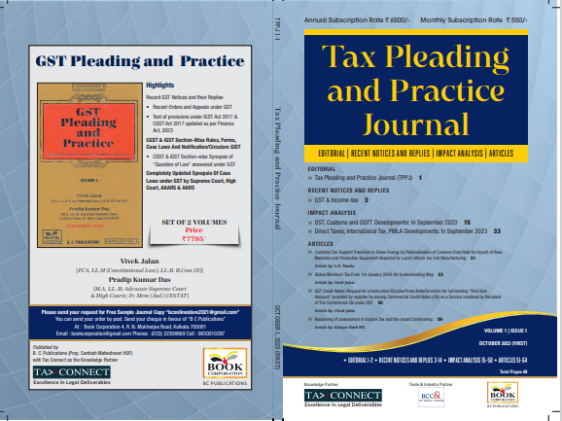

CONTENTS
- Recent Notices and replies on GST & Income Tax
- Impact Analysis on GST, Customs and DGFT Developments: In September 2023
- Impact Analysis on Direct Taxes, International Tax, PMLA Developments: In September 2023
- Articles

Author:
Vivek Jalan
[FCA, LL.M (Constitutional Law), LL.B, B.Com(H)]

S.K. Panda
[IRS-Retd.; Ex-Member CBIC & Special Secretary – GoI]

P.K. Das
[IRS-Retd.; Ex-Member CBDT & Special Secretary – GoI]

Published by: In Association With:
BOOK CORPORATION TAX CONNECT ACADEMY
4, R. N. Mukherjee Road 6, Netaji Subhas Road,
Kolkata 700001 Kolkata 700001
Phones: (033) 64547999 Cell: 7003384915
Cell: 9830010297, 9331018333 Order by email: info@taxconnect.co.in
Order by email:bookcorporation@gmail.com Website : www.taxconnect.co.in
Website :www.bookcorporation.com

:IN STANDS

GST PLEADING AND PRACTICE: With Section-wise GST Cases & GST Notices and their Replies
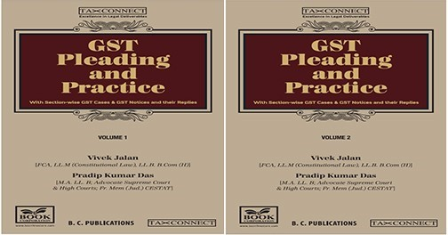

ABOUT THE BOOK: This publication includes:
- Recent GST Notices and their Replies
• Recent Orders and Appeals under GST
• Text of provisions under IGST Act 2017 & CGST Act 2017 updated as per Finance Act, 2023

- CGST & IGST Section-Wise Rules, Forms, Case Laws And Notification/Circulars GIST
• CGST & IGST Section-wise Synopsis of “Question of Law” answered under GST

- Completely Updated Synopsis Of Case Laws under GST by Supreme Court, High Court, AAARS & AARS

Authors:
Vivek Jalan
[FCA, LL.M (Constitutional Law), LL. B, B. Com(H)]

Pradip Kumar Das
[M.A. LL. B; Advocate Supreme Court & High Courts; Fr. Mem (Jud.) CESTAT]

Published by: In Association With:
BOOK CORPORATION TAX CONNECT ACADEMY
4, R. N. Mukherjee Road 6, Netaji Subhas Road,
Kolkata 700001 Kolkata 700001
Phones: (033) 64547999 Cell: 7003384915
Cell: 9830010297, 9331018333 Order by email: info@taxconnect.co.in
Order by email:bookcorporation@gmail.com Website : www.taxconnect.co.in
Website :www.bookcorporation.com
:IN STANDS

HANDBOOK ON GST 2022
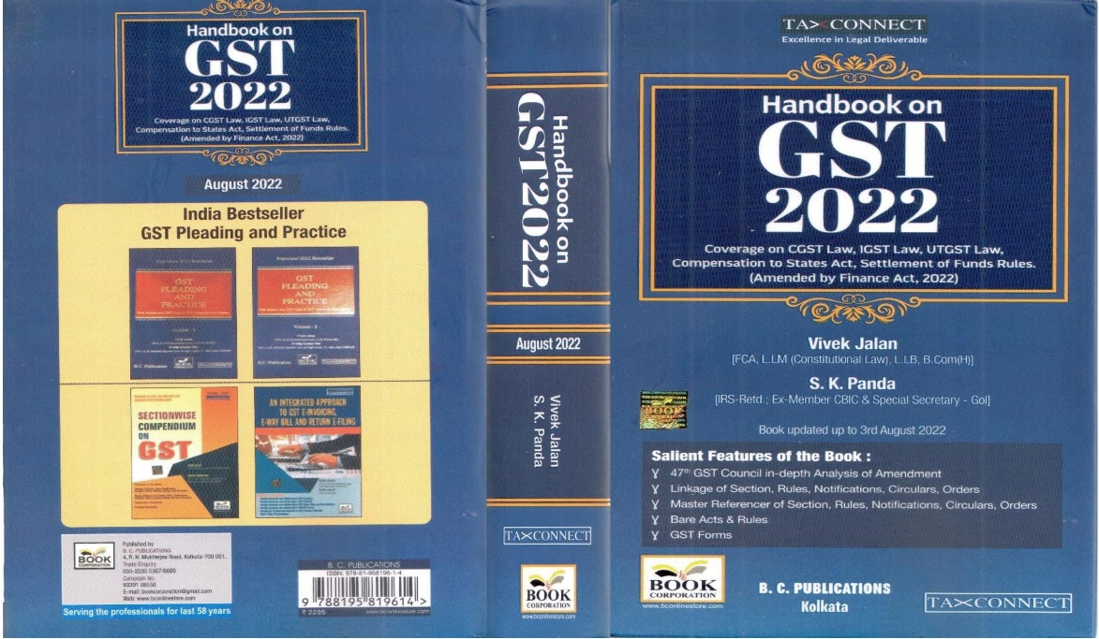

CONTENTS
- 47th GST Council in-depth Analysis of Amendment
- Linkage of Section, Rules, Notifications, Circulars, Orders
- Master Reference of Section, Rules, Notifications, Circulars, Orders
- Bare Acts & Rules
- GST Forms
Author:
Vivek Jalan
[FCA, LL.M (Constitutional Law), LL.B, B.Com(H)]

S.K. Panda
[IRS-Retd.; Ex-Member CBIC & Special Secretary – GoI]

Published by: In Association With:
BOOK CORPORATION TAX CONNECT ACADEMY
4, R. N. Mukherjee Road 6, Netaji Subhas Road,
Kolkata 700001 Kolkata 700001
Phones: (033) 64547999 Cell: 7003384915
Cell: 9830010297, 9331018333 Order by email: info@taxconnect.co.in
Order by email:bookcorporation@gmail.com Website : www.taxconnect.co.in
Website :www.bookcorporation.com

:IN STANDS

How to Handle GST LITIGATION: Assessment, Scrutiny, Audit & Appeal
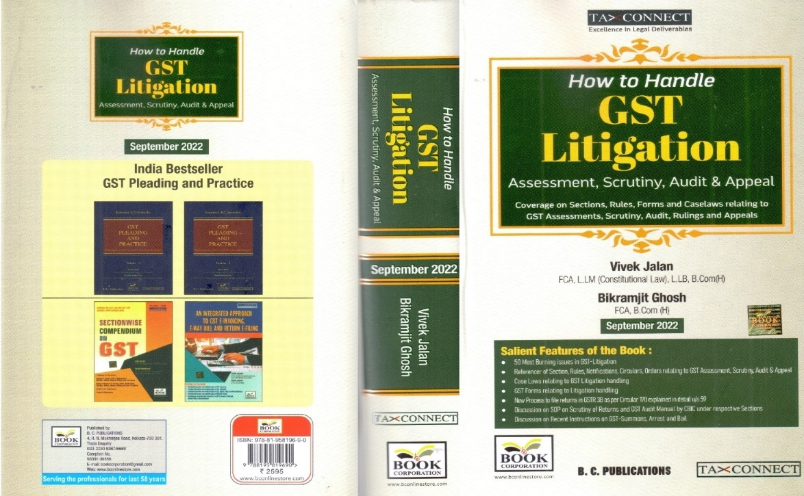

CONTENTS
1. 50 Most Burning issues in GST-Litigation
2. Reference of Section, Rules, Notifications, Circulars, Orders relating to GST Assessment, Scrutiny, Audit & Appeal
3. Case Laws relating to GST Litigation handling
4. GST Forms relating to Litigation handling
5. New process to file returns in GSTR 3B as per circular 170 explained in details u/s 59
6. Discussion on SOP on Scrutiny of Returns and GST Audit Manual by CBIC under respective Sections
7. Discussion on Recent Instruction on GST-Summons, Arrest and Bail

Authors:
Vivek Jalan
[FCA, LL.M (Constitutional Law), LL. B, B. Com(H)]

Bikramjit Ghosh
[FCA, B. Com(H)]

Published by: In Association With:
BOOK CORPORATION TAX CONNECT ACADEMY
4, R. N. Mukherjee Road 6, Netaji Subhas Road,
Kolkata 700001 Kolkata 700001
Phones: (033) 64547999 Cell: 7003384915
Cell: 9830010297, 9331018333 Order by email: info@taxconnect.co.in
Order by email:bookcorporation@gmail.com Website : www.taxconnect.co.in
Website :www.bookcorporation.com

LET’S DISCUSS FURTHER!



OUR OFFICES:
MUMBAI
Unit No. 312, Omega Business Park, Near Kaamgar Hospital, Road No. 33, Wagle Industrial Estate, Thane West,
Maharashtra- 400604

Contact Person: Priyanka Vishwakarma
Email:priyanka.vishwakarma@taxconnect.co.in
BENGALURU
951, 24th Main Road, J P Nagar, Bengaluru, Karnataka – 560078.

Contact Person: Anil Pal

Email:anil.pal@taxconnectdelhi.co.in

DELHI (NCR)
B-139, 2nd Floor, Transport Nagar,
Noida-201301 (U.P)

Contact Person: Poonam Khemka

Email:poonam.khemka@taxconnect.co.in



DUBAI
Azizi Feirouz, 803, 8th Floor, AL Furjan, Opposite Discovery Pavillion,
Dubai, UAE

Contact Person: Rohit Sharma

Email:rohit.sharma@taxconnect.co.in

KOLKATA
R No 119; 1st Floor; Diamond Arcade; 1/72, Cal Jessore Road,
Kolkata – 700055

Contact Person: Uttam Kumar Singh

Email:uttam.singh@taxconnect.co.in
KOLKATA
6, Netaji Subhas Road, 3rd Floor, Royal Exchange Building,
Kolkata - 700001

Contact Person: Tithly Roy

Email:tithly.roy@taxconnect.co.in

Disclaimer:
This e-bulletin is for private circulation only. Views expressed herein are of the editorial team and are based on the information, explanation and documents available on Government portal platforms. Tax Connect or any of its employees do not accept any liability whatsoever direct or indirect that may arise from the use of the information contained herein. No matter contained herein may be reproduced without prior consent of Tax Connect. While this e-article has been prepared on the basis of published/other publicly available information considered reliable, we do not accept any liability for the accuracy of its contents.
Tax Connect 2024. All rights reserved.

